ASSESSING THE SIMULTANEOUS INTERACTIONS BETWEEN VIX AND S&P500 RETURNS: A Case of COVID-19 and Russia-Ukraine Conflict
Swithun Michaelangelo Chiziko
Submitted in partial fulfilment of the requirements for the degree of Masters of Applied Economics School of Accounting, Economics and Finance Curtin University
June 2020
Presentation Link: https://drive.google.com/drive/folders/1p5OTcFciNpM84O_Wq368eTPkDEkGFqiS?usp=sharing

To the best of my knowledge and belief this report contains no material previously published by any other person except where due acknowledgment has been made. This report contains no material which has been accepted for the award of any other degree or diploma in any university.
Signature: ……Swithun Michaelangelo Chiziko…… Date: ………21/06/2022……….….

ABSTRACT
The aim of this paper is to assess the simultaneous reaction to the S&P500 returns and the VIX index to sentiment index proxies and to each other. Using the LASSO we determine that the S&P500 daily returns, market turnover, average daily trade volume, share of equity issuances, number of ipos and the covid lockdown dummy variable were significant in the model predicting randomised out-of-sample data with an MSE of 29.04605. The VAR yields insignificant results to determine the impact response functions of VIX a shock from the significant variables. We find a hedging opportunity present between VIX futures and the S&P500 due to the confirmed negative correlation between their conditional variances that average at about -0.8 through the timeline between March 2020 and March 2022.

Acknowledgements
I thank all participants at Curtin University for affording me access the data that was used in this report and Dr. Zhiyue Sun for being an avid listener and guide throughout the entire process of compiling the findings in this report.

Table of Contents
ABSTRACT iii
Acknowledgements iv
1.0 INTRODUCTION 1
2.0 LITERATURE REVIEW 1
3.0 DATA SELECTION, DESCRIPTION AND METHODOLOGY 5
3.1 DATA SELECTION 5
3.2 DATA DESCRIPTION 6
3.2.1 Share of Equity Issuances 6
3.2.2 Closed-end Fund Discount 7
3.2.3 Trade Volume 8
3.2.4 Market Turnover 9
3.2.5 Number of IPOs 9
3.2.6 Average First Day Returns of IPOs 9
3.2.7 Covid Lockdown 10
3.2.8 Russia Ukraine Conflict 10
3.2.9 S&P500 returns 10
3.3 MODEL DECRIPTIONS AND METHODOLOGY 10
3.3.1 LASSO REGRESSION 10
3.3.1 VAR MODEL 11
3.3.2 GARCH MODELS - GJR-GARCH 11
4.0 RESULTS 15
5.0 CHALLENGES AND FUTURE CONSIDERATIONS 19
5.0 CONCLUSION 19
REFERENCES 20

Figure 3.1: Scatter Plot Share of Equity Issuances vs Returns 11
Figure 3.2: Share of Equity Issuances Line Chart 12
Figure 3.3: Relationship Between Trade Volume and VIX 13
Figure 3.4: Plot of first log difference of VIX Index 18
Figure 3.5: Plot of S&P500 Returns 19
Table 3.1: Showing Serial Correlation Test 16

INTRODUCTION
On March 10 2020, the WHO officially declared that the world was in a state of a global pandemic (REGULY 2020). Over the next two years there would be fluctuations in the stock market due to global policies adopted in reaction to the covid -19 pandemic. Two and a half years in, as the effects of pandemic measures continue to persist, and most countries having not yet officially declared endemic status, we faced a new crisis on the 24th of February 2022 when Russia invaded Ukraine, pushing commodity prices higher and causing massive inflation in many parts of the world (MCNEILL 2022). The two events offer an opportunity to look at the relationship between volatility of the market and its effects on stock returns.
To our knowledge, there has been very little research aimed at observing the hedging properties of VIX by looking at the spill over effects of the index on S&P500 during the recent two crises. It may be intuitive to suggest that market factors that have been highlighted to affect implied volatility in VIX may also affect S&P500 returns. Our research aims to explore this idea in hopes of finding an opposing relationship in their reactions and whether the interaction between VIX and S&P500 returns can remain persistent enough to provide a predictable relationship in the case of the Russia-Ukraine conflict and the COVID-19 pandemic that can provide hedging potential.

2.0 LITERATURE REVIEW
Smales (2017) believes implied volatility (VIX) to be the most preferred measure of market sentiment and contains properties that are valuable in explaining what drives stock returns both in a size/firm value dimension as well as by industry, demonstrating a causal link between VIX and returns. Chen and Huang (2021) shows that investor sentiment and VIX shows strong predictive power with regards to crude oil assets but are almost entirely insignificant in predicting natural gas spot and futures contract pricing. The study focuses on the linkages between US VIX and other global volatility indexes among the G7 and BRIC countries during the GFC and the COVID-19 pandemic and determines that the fear in the stock market spreads across multiple markets with the greatest impact coming from US news in the GFC whereas during COVID-19, that impact is largely spread out among European countries. Our study focuses on the implications of the linkages between the VIX index and the US S&P500 returns and whether they remain persistent throughout the course of the two crises mentioned in the introduction. It narrows the scope from spill over effects between international market implied volatility indexes to spill over effects between US VIX index and S&P500 market returns.
Dima et al. (2021) show that during periods of high uncertainty in the early onset of the 2020 pandemic period, investors generally switched to financial assets that insulate them from volatility, some of which are connected to the VIX. The research finds that sentiment adjusts as investors move to maximise their own self-interest which is largely the case regardless of a shock, leading to no real fundamental changes in investor decisions as per the data in the study. What was interesting was that the study found that different crises could not necessarily be used to predict changes in market efficiency for other crises because the impact depending on the determinants of the financial instability were non-uniform. Our present research paper extends the study to the Russia-Ukraine conflict and computes a hedge ratio using the GARCH family models.
Cheng (2020) points out the puzzle that was the slow rise in VIX futures prices until up to a month after US border closures in mid-April 2020 with price forecasts remaining higher than actual prices throughout the period. This gives some explanation to Dima et al. (2020) finding that investor decisions may have switched to maximise their own self-interest but the response was initially slow. He notes however that trading strategies based on the forecasts gained profits when the market volatility and crash inevitably came to reflect the unfavourable market forces brewing at the time. The research focuses on the lag response of investor behaviour to the news of the early border closures. Our study extends the timeline from the early onset to the Russia Ukraine crisis while specifically looking into the interaction between VIX and returns during the lockdown and whether there is a difference in sentiment and interaction between VIX and S&P500 returns in the pre-lockdown, during lockdown and post lockdown phases.
Wang et al. (2021) find that the USD and VIX negatively impact S&P500 returns but that the Equity Market Volatility (EMV) market tracker, a tracker that links economic, political, and national security news to the VIX index has a positive association with stock market returns. The authors use linear based models in (OLS) and least angles regression (LARS) to create a pricing model to predict stock prices. The determinants of returns used are the gold log returns, Brent crude oil log returns, trade weighted USD index log returns, volatility index (VIX) and text mining tools to incorporate the newspaper based EMV into their model. Our study uses the Baker and Wurgler (2006) proposed sentiment proxies and uses OLS as well as LASSO regression to determine the multivariate significance of the lockdown period specifically. We also extend the research to investigate the significance of the proxies using VAR impulse response functions post lockdown and into the Russia Ukraine conflict.
Vera-Valdes (2021) finds that several measures of volatility became non-stationary due to a persistence of long-term effects on financial volatility as a result of the COVID-19 pandemic across several international markets. The experiment yielded significant long memory parameters as it pertained to VIX and realised volatility. Grima et al. (2021) find cointegration between VIX and the major stock indexes in the world as well as between VIX and COVID-19 pandemic deaths. The study concludes that the reporting of new COVID-19 cases had more of a stronger impact on VIX in the United States than did actual COVID-19 deaths. The study focuses on the implications on the COVID-19 reports on deaths. Our research study adds to this research by separating between the impact of the different lockdown and mandate phases during the pandemic as well as the implications of the Russia Ukraine conflict.
Baek et al. (2020) use Markov Switching CAPM Model and machine learning tools to identify determinants of high volatility. With respect to VIX as a measure of volatility, the authors find that the reporting of COVID-19 deaths was followed by a direct rise in the VIX price while reports of recoveries were followed by a direct decline in the VIX price. The intriguing findings on the impact of news on investor behaviour in their data suggest that the significance of both positive and negative reporting on COVID-19 deaths and recoveries was more impactful in raising total market risk than price fluctuations in the price level of VIX. The data explains the period between the 2nd January 2020 to 30th April 2020. Rahman et al. (2021) reiterates this, finding that S&P500 has a positive association with COVID-19 recoveries and number of deaths reported whereas VIX seems to have a negative association using out-of-sample daily data experiment from January 2012 to December 2020. Our investigation adds to the literature by exploring the unique impact of the US border closure throughout its duration from 15 March 2020 to 8 November 2021.
Sharma and Malik (2022) use the Autoregressive Distributed Lag (ARDL) model on daily data from 23 January 2020 to 24 August 2020 to investigate the long-run and short-run interactions between COVID-19 deaths, VIX, stock returns and brent crude oil prices on BRICS countries. The authors find a mutual two-way granger causality between VIX and stock returns and for the most part, a short-run decline in stock returns with the exception of Russia which experienced long-run effects as oil prices declined. It is well noted to be particularly true in the case of Russia because of its economy being heavily reliant on oil and gas production. Once again, our investigation focuses on S&P returns and the co-movement of conditional variances between VIX and returns during and throughout the duration of the COVID-19 pandemic from 15 March 2020 to 8 November 2021 which marks the period of the border closures in the US.
While most research focuses on the COVID -19 pandemic as a period either in its entirety or based on initial reactions at the onset of the pandemic, we observe that we have not been able to find research focusing solely on the COVID-19 lockdown in the US that has come and passed, more specifically, the international border closure period in the US. We also note that to the best of our knowledge, we were unable to find studies using VAR to look at the impact of sentiment proxies outlined by Baker and Wurgler (2006) on VIX and S&P500 during the timeline subject to our research. There are many measures of sentiment, understanding how significant certain measures capture the effect on returns and volatility could prove essential in predicting market efficiencies and investor responses. We also note that while papers have loosely alluded to the negative relationship between returns and implied volatility, to the best of our knowledge there has not been research explicitly exploring a minimum hedge ratio and exploring as to whether or not that relationship remained consistent throughout the pandemic period and also the period months following the start of the Russia-Ukraine conflict.
Following the development of healthy treatments aimed at curtailing the impact of COVID-19 on the world at large, before any full recovery and return to normalcy was even outrightly expressed, the world faced yet another crisis when Russia invaded Ukraine in February 2022. The result was a barrage of sanctions by the West towards Russia which would inevitably cause S&P500 futures to decline. Defensive stocks and stocks in the energy sector would see a rally as oil prices would increase (Jain and Randewich 2022). Both the DOW and S&P500 saw their first down quarter in two years since the advent of the pandemic. The peace talks between Russia and Ukraine would have an impact on investor sentiment, drawing market forces into moments of hope to seeing a quick end to the tragic occurrences taking place. Much like its movements with the COVID-19 pandemic, the VIX remained largely confusing in its fluctuation. Only a month later into its conflict, towards the end of March, the VIX Index dropped from $22.3 to $20.1 and crude oil fell to $100.62 from $113.47. This followed President Joe Bidens announcement of the release of strategic petroleum reserves. One can see how the impact of such government interventions can have on market efficiency and make market factors very hard to predict. This makes putting a number on what affects investor sentiment can often be a tedious task given the varying nature of determinants to financial market volatility at any particular time. The slow response to VIX from the pandemic speaks to a lag factor in how investors respond to negative news at least with regard to the pandemic (lplresearch 2022).

3.0 DATA SELECTION, DESCRIPTION AND METHODOLOGY

3.1 DATA SELECTION
Investor sentiment has often been used to gauge the behavioural response of institutional and private investors to fluctuation in the stock market. Researchers have found that the volatility in stock market performance can be used by arbitrageurs to capitalise on the movements in order to increase returns. For instance, Lei et al. (2012) indicates that so called “noise traders” impact the variability of trade volume by increasing the volatility of liquidity added in the market. They find that this often affords investors the ability to time their trades as trade volumes become volatile.
The 2006, 2007 study done by Baker and Wurgler (2007) proposed 6 variables to create a sentiment index. These variables were closed-end fund discount, logarithm of the market turnover ratio, number of IPOs, the average first-day return of IPOs, the share of equity issues as a percentage of all total issues considered to be debt and equity, and finally, dividend premium which measures the difference in book-to-market ratios between dividend paying and non-dividend paying stocks. These variables have been widely used successfully in later research since then to predict volatility. The research by Baker and Wurgler (2007) found that as investor sentiment increased, the returns of small-cap stocks and growth stocks would decrease as investors sought to move investment towards less riskier assets.
Yao and Li (2020) show that over a longer period of time, investor sentiment is affected mainly by fluctuations in the market, which may be related to the existence of cyclical fluctuations in the market and futures arbitrage. The study uses Thermal Optimal Path Method and constructs a sentiment index using the Relative strength Index which measures whether a market is overbought or oversold over a specified trading period by looking at whether there was an overall gain or loss in returns on a particular day. The investigation also uses a psychological line Index that measures the number of days when a stock price maintains a consecutively higher valuation from a time t-n until that trajectory subsides at a time t. Trading Volume and finally Adjusted turnover ratio makeup the four factors used to create the sentiment index.
Our paper uses the works of Baker and Wurgler (2007) as well as Yao and Li (2020) to investigate the simultaneous responses of S&P500 returns and VIX to the factors characterising investor sentiment. We exclude the dividend premium as Baker and Wurgler (2000) found it to be insignificant in their data. The frequency of the data that was available was also anticipated to pose some difficulty in the modelling stages but a possible solution was interpolation which was utilised as it pertained to the share of equity issuances.

3.2 DATA DESCRIPTION

3.2.1 Share of Equity Issuances
The data was calculated via the numbers made available via the United States government Federal Reserve website. This share represents the proportion of equity issues from a total of debt plus equity issues. The data provided is monthly data. We use interpolation to transform it into daily data to match the frequency of the other variables.
The amount of debt-to-equity financing has been known to have a close relationship to stock returns. Baker and Wurgler (2000) illustrate that during periods of high equity share, stock market returns tend to be high and likewise in periods of low equity share, stock market returns tend to be low. Figure 3.1 shows this to be the case as perhaps there is a dilution of returns due to new IPOs.
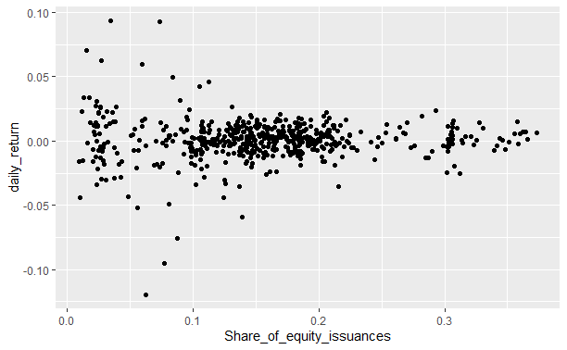
Figure 3.1: Scatter Plot Share of Equity Issuances vs Returns
Figure 3.2 below shows the trend of rising share of equity to debt. We observe a rise in the share of debt issues increases following initial reports of covid closures. This may be as a result of changes in monetary policy and a rise in government bond issues. Early 2021 shows the share in equities pick up, a boost most likely from the result of the presidential election. Optimism was high for a return to normalcy as the president elect promised to control the pandemic situation. As previous literature points out, news of deaths resulted in a negative sentiment while news of recoveries led to positive sentiment.
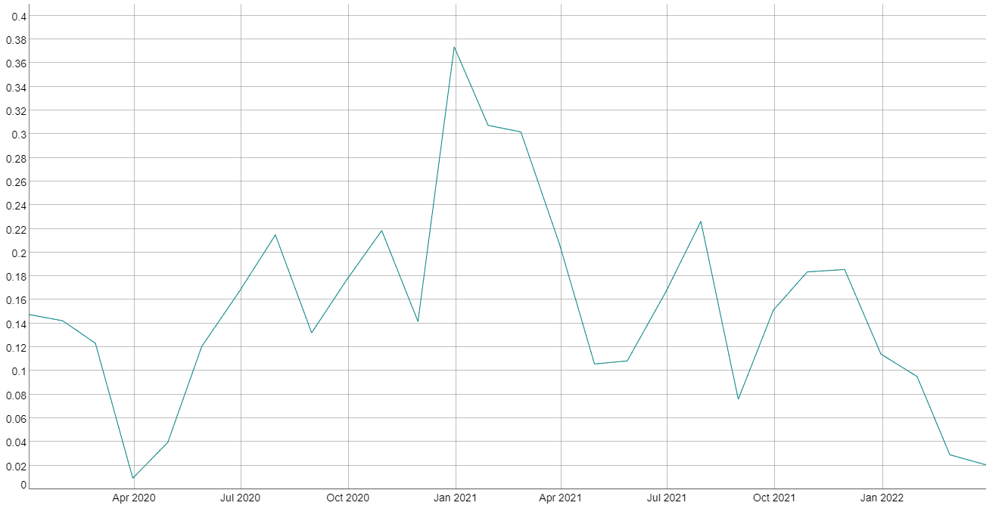
Figure 3.2: Share of Equity Issuances Line Chart

3.2.2 Closed-end Fund Discount
As stipulated by Baker and Wurgler (2006), the following formula shows how we calculated the final discount result for closed-end funds:
$${VWD}_{t}=\sum_{t=1}^{n_{t}}{W_{t}{DISC}_{it}}$$
where,
$W_{i}=\frac{{NAV}_{it}}{\sum_{t=1}^{n_{t}}{{NAV}_{it}}}, { NAV}_{it}$=net asset value of fund i at end of period t
$${DISC}_{it}=\frac{{NAV}_{it}-{SP}_{it}}{{NAV}_{it}}×100$$
${SP}_{it}$ = stock price of fund i at end of period t
$n_{t}$ = the number of funds with available ${DISC}_{it}$ and ${NAV}_{it}$ data i at end of period t
We then calculated the change in value weighted discount and defined the equation as follows:
$${∆VWD}_{t}={VWD}_{t}- {VWD}_{t-1}$$

The data available was monthly data. Because the daily data was not available, we used interpolation to produce a daily dataset. We originally found 253 closed end fund data. Of the 253, Net Asset Value data was only found for 151 of them.

3.2.3 Trade Volume
Baker and Stein (2004) explain how trading volume can act as an indicator for investor sentiment because of the information it carries about market activity. Liao et al. (2011) use individual stock trade volume and S&P500 index trading volume as sentiment indicators. This paper uses average trading volume of all S&P500 individual stocks on a daily frequency. The diagram below shows this relationship to be true as volatility increases the more liquidity is injected into the market. The trade volume was adapted from the WRDS website from their Compustat North America page.
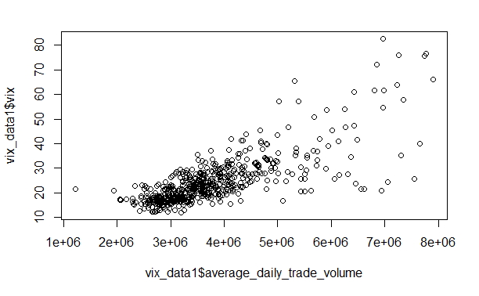
Figure 3.3: Relationship Between Trade Volume and VIX

3.2.4 Market Turnover
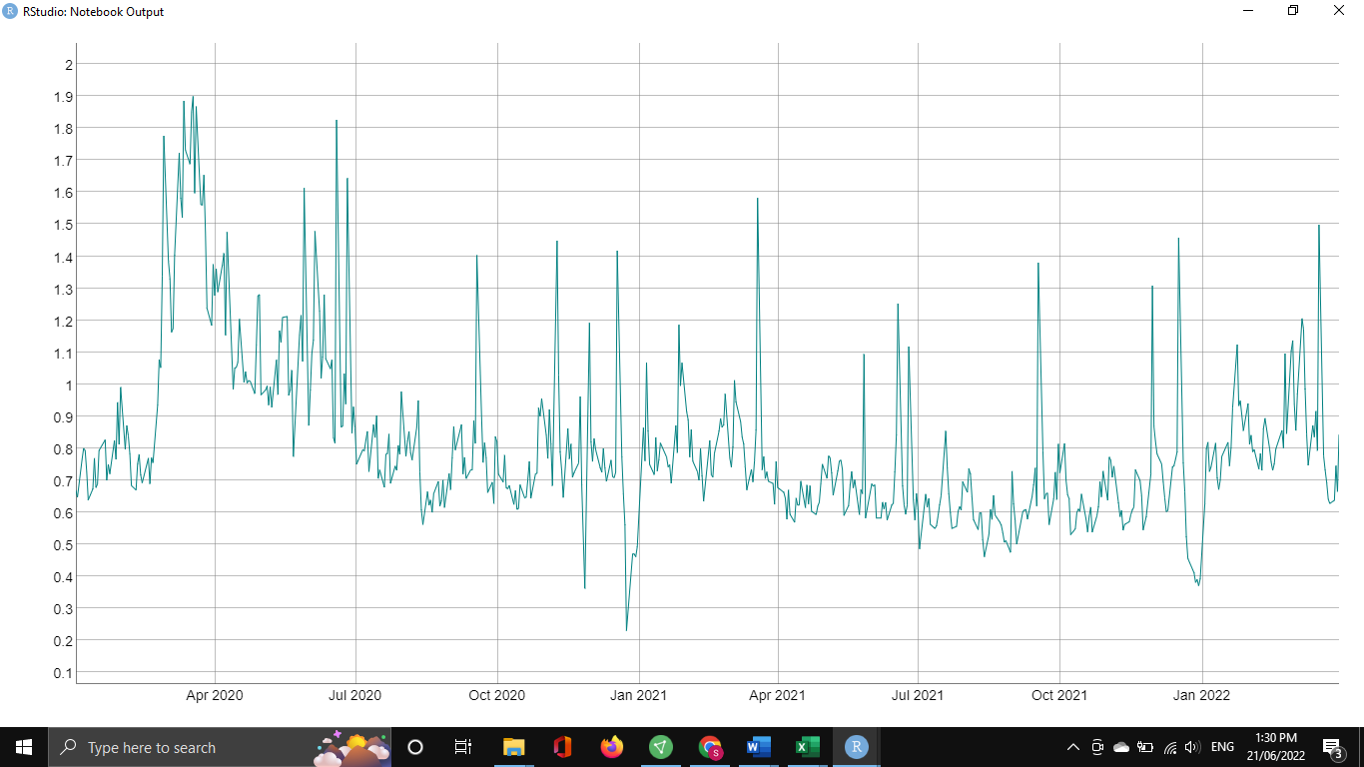
Figure 3.2: Line Chart of Market Turnover
We define market turnover as representing the average turnover ratio of all the common stocks on a given day. This was calculated as Volume/Total Shares Outstanding. To calculate this, code from the support section of WRDS was used. We observe peak volume at the initial onset of border closure announcements in March 2020 with the biggest dip at the end of December 2020.

3.2.5 Number of IPOs
The number of IPOs data collected from the WRDS’s SAS library. The number reflects all new common stocks listed on the NASDAQ and NYSE. Data was collected from WRDS Compustat North America.

3.2.6 Average First Day Returns of IPOs
The average first day return returns are calculated using the IPOs found in section 3.2.5. We queried the opening price and closing prices for each day.
𝑅𝑖,𝑡 = (𝑃𝑖,𝑡- 𝑃𝑖,𝑡−1/𝑃𝑖,𝑡−1),
where 𝑅𝑖,𝑡 is the return on an asset 𝑖 at period t and 𝑃𝑖,𝑡 is the close price of asset 𝑖 in period t and 𝑃𝑖,𝑡−1 is the close price of asset 𝑖 in period t-1. The returns of each asset in the portfolio were summed up to calculate the average first day return.

3.2.7 Covid Lockdown
Covid Lockdown was represented as a dummy variable with 0 representing all time before 10 March 2020 and after 8 November 2021.

3.2.8 Russia Ukraine Conflict
The Russia Ukraine conflict was represented as a dummy variable with 0 representing all time before 24th of February 2022. Our data sample ends on the 30th of March.

3.2.9 S&P500 returns
The returns were calculated using code offered

3.3 MODEL DECRIPTIONS AND METHODOLOGY

3.3.1 LASSO REGRESSION
We use LASSO regression to surmise the significance of the variables in the sentiment index. Formerly known as the least absolute shrinkage and selection operator (LASSO), the main purpose of LASSO traditionally has been for feature selection and regularisation. Put forward by Tibshirani (1996), the LASSO is a form of least squares that uses the L1 penalisation function and shrinks the regression coefficients by a constant controlling factor λ, reducing some to zero. LASSO offers improves prediction and accuracy. If a group of predictors are highly correlated, LASSO picks only one of them and reduces the coefficients of the others to zero. Due to the shrinkage of coefficients, variance of the estimates decreases producing easily interpretable models.
Our aim with using LASSO is for feature selection of factors and eliminating those that are not contributing to explaining VIX within the context of our data.
Table 3.0 shows what was found significant with LASSO regression.
Table 3.0: Significance code LASSO regression
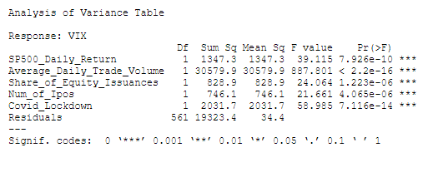

The intuition here is that if VIX measures sentiment, then perhaps a sentiment index formulated in old literature can be used to explain VIX. We include all the factors outlined in section 3.2. Should we find factors that are significant in the process, we can then run a Vector Autoregressive model or Vector Error Correction Model experiment in order to determine impulse response function and analyse the response of VIX to the most significant factors identified by the LASSO process.

3.3.1 VAR MODEL
VAR, or the Vector Autoregressive model can be used to show the impact of a shock from one variable to another. Due the detection of serial correlation, the following model was not included in this paper. Below are the results of the serial correlation test.
Table 3.2: Showing Serial Correlation Test

3.3.2 GARCH MODELS - GJR-GARCH
Volatility occurs across time and can often be seen as a proxy for risk and stocks with higher risk are associated with higher returns. Many researchers have looked at modelling volatility using the GARCH model. When looking at returns, there are periods in the life of any given stock where volatility becomes highly elevated. Often times these periods can involve reoccurring spurts lasting a few days where a stock experiences volatility in returns before going back to normal. Such activity is often referred to as volatility clustering. Research finds that during periods of volatility clustering, stock returns tend to have patterns of varying peaks and troughs. This phenomenon of non-constant variance in volatility is known as heteroscedasticity. If the return on a stock at time t is impacted by the return at time t -1, it is said that a time series is autocorrelated. When a time series is highly autocorrelated, there can be an eruption of price of return movements due to news that can last a number of days throughout the week. Historically, conventional linear models failed to capture this attribute as the correlation between one day and the next becomes conditional to news or shocks in the market on any given day and thus, a generalised autoregressive conditional heteroscedastic (GARCH) model is often used to track such behaviour in stock returns (Stavroyiannis 2017).
Hansen et al. (2021) utilise GARCH and EGARCH and propose a superior model for tracking the price of VIX simultaneously with returns which they refer to as the realised GARCH model. Liu and Quao (2015) use Threshold GARCH (1,1) and find traditional GARCH parameters to be below market VIX by roughly 20 – 30% in tracking VIX out of sample prices. Bilyk et al. (2020) find that using daily data over a seven year period strategy based on fGARCH, TGARCH and GJR-GARCH outperformed standard GARCH and EGARCH models in forecasting performance of VIX futures prices. Chang, Hseih and McAleer (2018) use VAR to show the impact of VIX on ETF returns and find that VIX returns have a significant short run impact on ETF returns, particularly European EFT returns. They find that this impact was a lot more pronounced on the S&P 500 returns.
In the family of GARCH models, our study uses DCC GJR-GARCH model to investigate the dynamic conditional correlation of the variances of S&P500 and the VIX. The GARCH model is a variance model. The name takes after its developers namely, Glosten, Jagannathan & Runkle (1993). Generally speaking, most traditional GARCH models tend to require the natural logarithm of a series in order to best produce reliably desired outcomes. The GJR-GARCH is easier to work with in that it can accommodate level data making it much easier to implement.
The standard GARCH model is a symmetric model meaning that it is used to observe when the volatility of a particular equity in the market has equal variability in both declining and rising market conditions. The GJR-GARCH is an example of an asymmetric model. This follows a phenomenon that an equity’s market volatility responds with greater effect to negative shocks in the market than to positive ones.
A GJR-GARCH model of order (1,1) can be expressed using the following equation:
$$σ_{t}^{2}=ω+αε_{t-1}^{2}+γI_{t-1}ε_{t-1}^{2}+{βσ}_{t-1}^{2}$$
where:
$σ_{t}^{2}$ is the conditional forecasted variance based on today’s date.
$ω$ is the intercept of the variance or the unconditional variance.
$α_{1}ε_{t-1}^{2}$ this represents the variance that is dependent on the lag of previous error terms.
$γ$is the asymmetric volatility that gives us what is known as the leverage effect.
$β$ is the coefficient of the forecasted variance.
$σ_{t-1}^{2}$ is yesterday’s forecasted variance.
We employ a multivariate DCC GJR-GARCH (1,1) model in order to determine the conditional covariance and correlation between VIX and S&P500 returns. This allows us to analyse how the variability between the two series behaves over time and whether there is some spill over effects that where not clearly detected with the VAR impulse response function (Stavroyiannis 2017).
The following steps are taken:
- Perform Stationarity Tests
- Inspect data for volatility clustering
- Check for ARCH effects of each series
- Investigate that standard GARCH requirements apply
- Estimate Univariate GJR-GARCH model
- Determine significance of Univariate coefficients.
- Determine persistence (Leverage effects) of multivariate model.
- Plot conditional variance correlation time series
- Determine possible Hedge ratio
If $γ$ = 0, then volatility is symmetrical.
If $γ$ > 0, then volatility is more sensitive to negative shocks than to positive ones.
If $γ$ < 0, then volatility is more responsive to positive shocks than to negative ones.
Persistence of volatility is said to be present where $α+ β+ γ/2$ < 1.
For a valid GARCH model, the following need apply as per the standard GARCH model:
$ω>0$, $α>0$, $β>0$ and $α+ β$ < 1,
that is to say that the model is non-negative when all coefficients are greater than 1 as volatility cannot be negative and it exhibits properties of stability and stationarity when $α+ β$ < 1 (Stavroyiannis 2017).
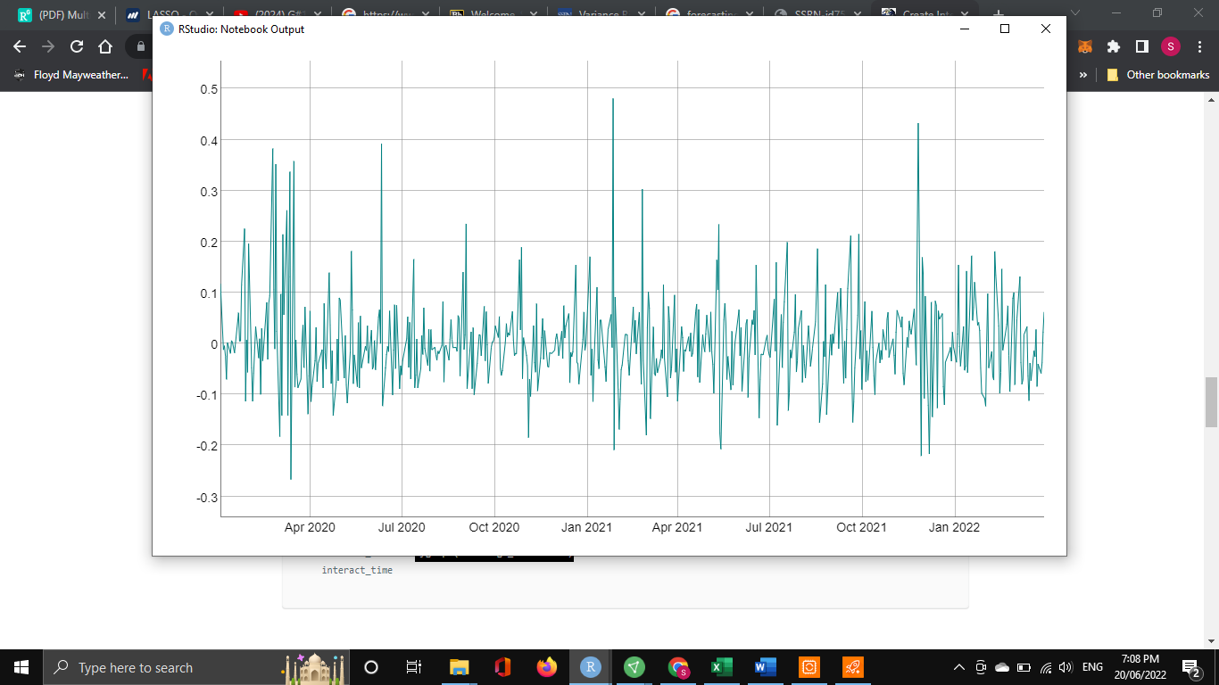
Figure 3.4: Plot of first log difference of VIX Index
From the plot above in Figure 3.4, we determine that there is volatility clustering as we observe the tendency for there to be periods where lower volatility begets lower volatility and vice versa for high volatility. The same is observed for the S&P500 below in Figure 3.5:
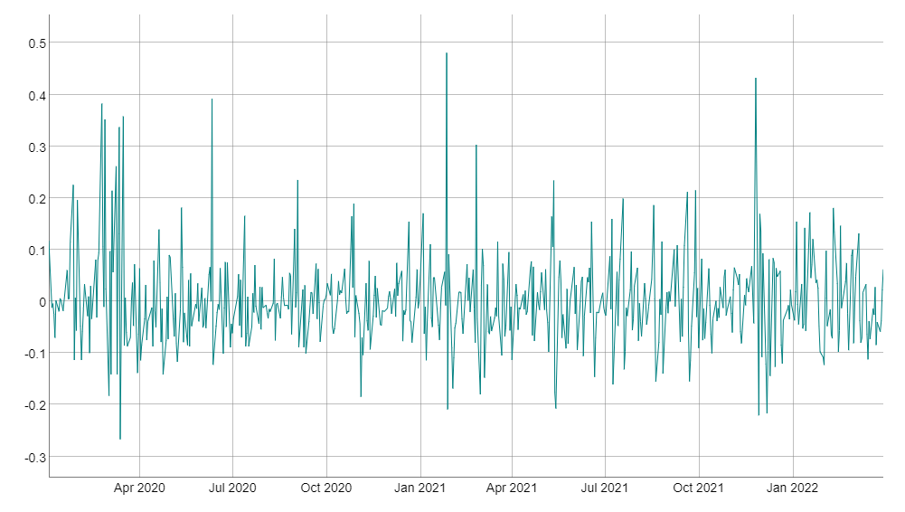
Figure 3.5: Plot of S&P500 Returns
Stationarity Test Results
The stationarity test for our VIX time series is stationary with a confidence level of 95% as shown in Table 3.2 below.
Table 3.2: Dickey-Fuller Test VIX
We also conclude that our S&P500 time series is stationary with a confidence level of 95% as shown in Table 3.3 below.
Table 3.3: Dickey-Fuller Test S&P500

4.0 RESULTS
The LASSO results confirm the significance of four variables namely S&P500 daily returns, market turnover, average daily trade volume, share of equity issuances, number of ipos and the covid lockdown dummy variable and confirm them to be significant with a confidence level of 95%. Table 4.1 shows our findings using the model with the significant variables using LASSO.

Table 4.1: LASSO Out-of-Sample Results
STATISTIC | VALUE
MSE | 29.04605
RSME | 5.389439
Rquare | 0.6808836
We also note that using market turnover and average daily trade volume interchangeably in the model did not yield a significant change in the MSE. In relation to our data, we can confirm the significance of 3 of the 5 Baker and Wurgler (2006) sentiment proxies in market turnover, share of equity issuances and number of ipos.
The MSE (Mean squared error) measures the differences or distances between the observed values and the predicted ones. It squares the differences to avoid negatives charging a higher penalty of the difference is greater. Often time a smaller MSE means a good model with 0 meaning you have a perfect model where there are virtually no errors present. Our findings show a high MSE and RSME which is the square root of MSE using the values originally observed as opposed to their squared format. Finally, the rsquare suggests that our model explains about 68% of the variance in our out of sample data experiment. We can attribute this to the inability of LASSO to deal with data that may have non-constant variance, though it is still useful for inferencing purposes.
Table 4.2: DCC GJR-GARCH Parameter Results
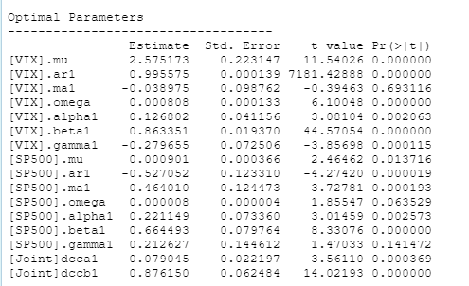

Table 4.2 above shows the results of the DCC and Univariate GJR-GARCH. We observe a negative gamma for VIX but still significant. We observe that the alpha and betas of both models to be significant with a confidence level of 95%.

Table 4.3: Leverage and Stationarity of Models
 | Stationarity of Model (alpha + beta) < 1 | Leverage Effect  (alpha + beta + gamma/2) < 1
VIX | 0.990153 | 0.8503255
SP500 | 0.885642 | 0.9919555
Joint | 0.955195

From Table 4.3, will observe both long term and short-term significance in the spill over effects in volatility between VIX and S&P500 with a confidence level of 95% are joint beta and alpha are significant. We observe the negative gamma which was interpreted by Stavroyiannis (2017) on his research paper on gold spot price as perhaps signifying the hedge properties of gold. We surmise that this may be true with regard to VIX futures as investors used then to hedge against declining returns. We also observe the leverage effect and stationarity being present.
We observe the following results from the GARCH experiment. Figure 4.1 below shows the conditional variance through time. We find that the volatility of the S&P500 peaks much higher than the peak volatility observed in VIX within the first 100 days of the pandemic on precisely day 51. From our time series we note that this is the 16th of March 2020, the day after the announcement of US border closures in the US on the 15th. This remains peak volatility for both series throughout the timeline. Figure 4.1 shows a strong reaction to the initial news by S&P500 while VIX sees greater variability over time as the S&P returns mostly stabilises throughout the pandemic as per our data. This matches the findings of our gamma coefficient as it is greater than zero for returns, thus, they have a stronger response to the initial pandemic news. From the variability in VIX we can deduce that VIX responds more often and with greater variability to positive stimuli than do returns with respect to the data observed in this experiment but the S&P500 responds less sensitively overtime but exhibits heightened responses to initial negative news.

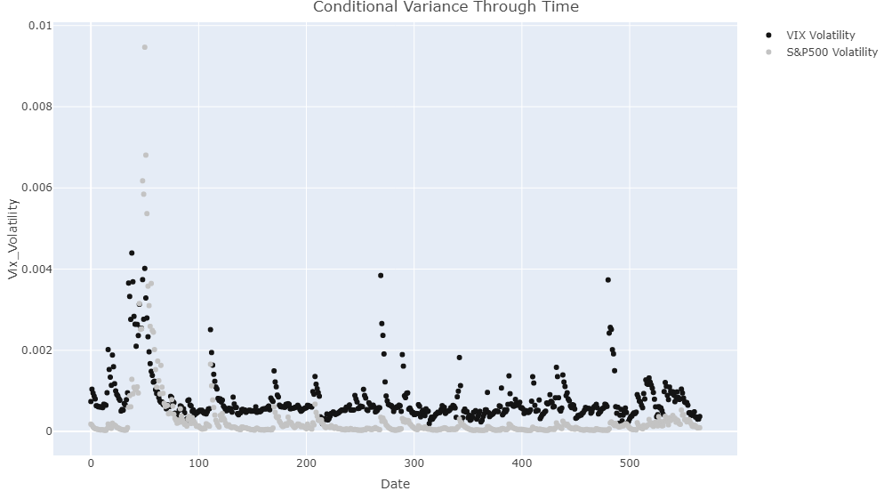
Figure 4.1: Comparison of Conditional Variance through time

The scatter plot in Figure 4.2 below confirms this as the peak is seen to be at 0.009466 for S&P500 while it peaks at about 0.0044 foe the VIX. It shows a convergence in the conditional variances between the two series on the lower bounds of the variance.

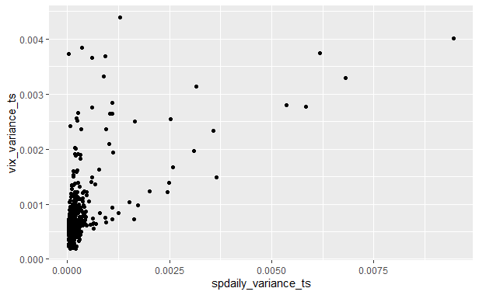
Figure 4.2: Scatter Plot of VIX Index and S&P500 conditional variances

The Figure 4.3 below shows that the correlation of conditional variances remains in the high negatives throughout most of the pandemic period showing the strong negative relationship between volatility and returns researched in previous literature.
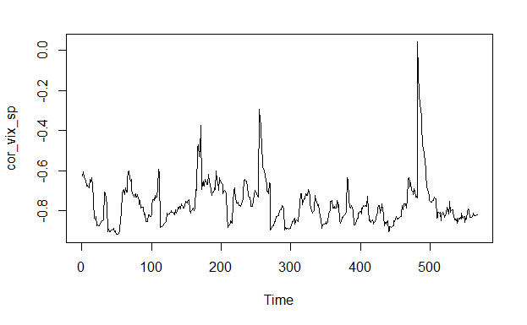
Figure 4.3: Chart Showing Correlation of Conditional Variance

We observe very little significant changes following the Russia-Ukraine crisis period. The Chart illustrates how the reduction in correlation corresponds to Figure 3 as it closes in on 0 on three main spikes observed on days 170, 269 and 480 which uncoincidentally correspond to 2 September 2020, 26 January 2021 and 24 November 2021 respectively. A comparison of the two crises would be required to gain a reasonable understanding and develop the literature to investigate the change in sentiment between the two time periods of COVID-19 and Russia-Ukraine conflict. Our research finds that the variability between VIX futures and S&P500 returns are highly correlated throughout the course of the pandemic and can look at the share of debts to equity issued, number of new ipos, trade volume and market turnover to get some kind of insight on the direction of the sentiment of in the market.

5.0 CHALLENGES AND FUTURE CONSIDERATIONS
The challenges facing any investigation can be vast. One of our very obvious challenges was the lack of data in the case of the Russia-Ukraine conflict’s impact on the VIX index and S&P500. Consideration for the overlapping nature of the two crises and their impact on the stock market could also be another point of study and both events are still ongoing at present. Forecasting the models can also prove to be difficult seeing as there is not much asymptotic literature on the results of GARCH models to determine the significance of forecasts that are looking period ahead of the present. Another difficulty was in the lack of data on CEFs. The amount of data missing on Net Asset Value begs the question of the viability of using it as a proxy for CEF discounts when only data of about 60% of the CEFs was missing. The outcomes of this paper show a potential hedging opportunity that could be explored with regards to a particular crisis period. The change in the variance of a particular portfolio can be used to compare the impact of hedging. Calculate the minimum variances and change in returns of a portfolio hedged by VIX futures and one that is unhedged across different forecast horizons is certainly one to consider in future studies. Lastly, considering structural breaks in the VAR model or a VEC model could help mitigate some of the errors in our analysis as far as impulse response functions are concerned. A mis-specified VAR model could often lead to spurious regression.

5.0 CONCLUSION
Through our research, with respect to our data we can confirm the significance of 3 of the factors outlined in the Baker and Wurlger (2006) sentiment index research. Using the VAR model failed to produce useful results on the impact of these sentiment indicators on the VIX index. This may be attributed to spurious regression as the VAR model failed the ARCH test for non-constant variance and normality of residuals. The GJR-GARCH model confirms the nature of the negatively correlated relationship between the conditional variance in S&P500 and the VIX index. The negative gamma in the VIX index may be attributed to the movement of corporate assets into VIX as a safe haven or hedge against market volatility and loss of returns (Stavroyiannis 2017). S&P500 was initially more sensitive to the news of border closure than the VIX confirming an asymmetric response towards the negative whereas VIX towards the positive. As the correlation of the conditional variances of both series average around -0.8, we observe a joint persistence and spill over effect in the long-term and short-term volatilities of the two as evidenced by the significant joint betas and gammas.

REFERENCES

Baek, Seungho, Sunil K. Mohanty, and Mina Glambosky. 2020. "COVID-19 and Stock Market Volatility: An Industry Level Analysis." Finance Research Letters 37 (11): 101748. doi:https://doi.org/10.1016/j.frl.2020.101748. https://www.proquest.com/scholarly-journals/covid-19-stock-market-volatility-industry-level/docview/2440904326/se-2?accountid=10382.
Baker, Malcolm and Jeffrey Wurgler. 2000. "The Equity Share in New Issues and Aggregate Stock Returns." The Journal of Finance 55 (5) (10): 2219-2257. https://www.proquest.com/scholarly-journals/equity-share-new-issues-aggregate-stock-returns/docview/194717447/se-2?accountid=10382.
Baker, Malcolm and Jeffrey Wurgler. 2006. " Investor Sentiment and the Cross-Section of Stock Returns." The Journal of Finance 61 (4): 1645-1680. https://doi.org/10.1111/j.1540-6261.2006.00885.x.
Baker, Malcolm and Jeremy C. Stein. 2004. " Market liquidity as a sentiment indicator." Journal of Financial Markets 7 (3): 271-299. https://doi.org/10.1016/j.finmar.2003.11.005.
Bilyk, Oleh, Paweł Sakowski, and Robert Ślepaczuk. 2020. Investing in VIX Futures Based on Rolling GARCH Models Forecasts. St. Louis: Federal Reserve Bank of St Louis. https://www.proquest.com/working-papers/investing-vix-futures-based-on-rolling-garch/docview/2586446942/se-2.
Chen, Tong and Zhuo Huang. 2021. "Pricing VIX Options with Realized Volatility." The Journal of Futures Markets 41 (8) (08): 1180-1200. doi:https://doi.org/10.1002/fut.22201. https://www.proquest.com/scholarly-journals/pricing-vix-options-with-realized-volatility/docview/2552119007/se-2?accountid=10382.
Cheng, Ing-Haw. 2020. "Pricing VIX Options with Realized Volatility." The Review of Asset Pricing Studies 10 (4): 635–668. https://doi.org/10.1093/rapstu/raaa010.
Chia-Lin, Chang, Hsieh Tai-Lin, and Michael McAleer. 2018. "Connecting VIX and Stock Index ETF with VAR and Diagonal BEKK." Journal of Risk and Financial Management 11 (4): 58. doi:https://doi.org/10.3390/jrfm11040058. https://www.proquest.com/scholarly-journals/connecting-vix-stock-index-etf-with-var-diagonal/docview/2582803721/se-2.
Dima, Bogdan, Ştefana Maria Dima, and Roxana Ioan. 2021. "Remarks on the Behaviour of Financial Market Efficiency during the COVID-19 Pandemic. the Case of VIX." Finance Research Letters 43 (11): 101967. doi:https://doi.org/10.1016/j.frl.2021.101967. https://www.proquest.com/scholarly-journals/remarks-on-behaviour-financial-market-efficiency/docview/2601486781/se-2?accountid=10382.
Glosten, Lawrence R., Ravi Jagannathan, and David E. Runkle. 1993. "On the Relation between the Expected Value and the Volatility of the Nominal Excess Return on Stocks." Journal of Finance 48 (5) (12): 1779-1801. https://www.proquest.com/scholarly-journals/on-relation-between-expected-value-volatility/docview/38480705/se-2.
Grima, Simon, Letife Özdemir, Ercan Özen, and Inna Romānova. 2021. "The Interactions between COVID-19 Cases in the USA, the VIX Index and Major Stock Markets." International Journal of Financial Studies 9 (2): 26. doi:https://doi.org/10.3390/ijfs9020026. https://www.proquest.com/scholarly-journals/interactions-between-covid-19-cases-usa-vix-index/docview/2544496352/se-2.
Jain, Devik and Noel Randewich. 2022. “Wall Street ends sharply lower as Ukraine crisis sows fear”. Reuters, March 2, 2022. https://www.reuters.com/business/futures-fall-russia-ukraine-crisis-escalates-2022-03-01/
Lei, Violet U. T. and So, Simon M. S. and Zou, Maggie. 2012. Investor Sentiment - Relationship between VIX and Trading Volume. SSRN. http://dx.doi.org/10.2139/ssrn.2136802
Liu, Qiang, Qiao Gaoxiu and Shuxin Guo. 2015 Variance Risk Premium and VIX Pricing: A Simple GARCH Approach. Sichuan: Southwestern University. http://dx.doi.org/10.2139/ssrn.2155993
lplresearch. 2022. “What Is the VIX Index And How Has It Responded To Russia-Ukraine Conflict?. Macro Market Movers, Accessed May 2022. https://lplresearch.com/2022/02/25/what-is-the-vix-index-and-how-has-it-responded-to-russia-ukraine-conflict/.
MCNEILL, ALAS TAIR. 2022. "MP Urges More Sanctions as Russia Invades Ukraine: Smith's Plea to Parliament." Stirling Observer, Feb 25, 6. https://www.proquest.com/newspapers/mp-urges-more-sanctions-as-russia-invades-ukraine/docview/2632246944/se-2?accountid=10382.
Peter, Reinhard Hansen, Zhuo Huang, Tong Chen, and Tianyi Wang. 2021. Realized GARCH, CBOE VIX, and the Volatility Risk Premium. Ithaca: Cornell University Library, arXiv.org. https://www.proquest.com/working-papers/realized-garch-cboe-vix-volatility-risk-premium/docview/2609530077/se-2.
Rahman, Mohammad Mazibar, Chi Guotai, Anupam Das Gupta, Mahmud Hossain and Mohammad Zoynul Abedin. 2021. Impact of early COVID-19 pandemic on the US and European stock markets and volatility forecasting, Economic Research-Ekonomska Istraživanja, doi: 10.1080/1331677X.2021.1997626
REGULY, ERIC. 2020. "WHO Declares Coronavirus a Pandemic as Italy Shuts Down: GLOBAL CRISIS." The Globe and Mail, Mar 12. https://www.proquest.com/newspapers/who-declares-coronavirus-pandemic-as-italy-shuts/docview/2376109911/se-2?accountid=10382.
Sharma, Sakshi, and Kunjana Malik. “Comovement of Fear Index, Stock Returns, Brent Oil Prices in BRIC Countries: The Case of COVID-19.” The Indian Economic Journal, (March 2022). https://doi.org/10.1177/00194662221082188.
Smales, Lee.A. 2022. “Spreading the fear: The central role of CBOE VIX in global stock market uncertainty”. Global Finance Journal 51 (100679). https://doi.org/10.1016/j.gfj.2021.100679.
Stavroyiannis, Stavros. 2017. A Note on the Nelson Cao Inequality Constraints in the GJR-GARCH Model: Is there a Leverage Effect?. Ithaca: Cornell University Library, arXiv.org. https://www.proquest.com/working-papers/note-on-nelson-cao-inequality-constraints-gjr/docview/2074239634/se-2.
Tibshirani, R. 1996. "Regression Shrinkage and Selection Via the Lasso." Journal of the Royal Statistical Society 58 (1): 267-288. https://www.proquest.com/scholarly-journals/regression-shrinkage-selection-via-lasso/docview/38901058/se-2?accountid=10382.
Vera-Valdes, J. Eduardo. 2022. “The persistence of financial volatility after COVID-19”. Finance Research Letters 44 (102056). https://doi.org/10.1016/j.frl.2021.102056.
Wang, Qing, Mo Bai, and Mai Huang. 2021. "Empirical Examination on the Drivers of the U.S. Equity Returns in the during the COVID-19 Crisis." Frontiers in Public Health 9: 679475. doi:https://doi.org/10.3389/fpubh.2021.679475. https://www.proquest.com/scholarly-journals/empirical-examination-on-drivers-u-s-equity/docview/2538049488/se-2?accountid=10382.

Source: adapted from monthly data at https://www.federalreserve.gov/data/corpsecure/current.htm. The calculated only included Bonds plus Stocks as the total. The stocks share of that total was what we defined as the share of equities issued that month.
Source: adapted from WRDS SAS query https://wrds-www.wharton.upenn.edu/pages/support/applications/programming-examples-and-other-topics/guide-closed-end-funds/#accessing-closed-end-fund-data-through-wrds
Source: adapted from WRDS https://wrds-www.wharton.upenn.edu/pages/get-data/compustat-capital-iq-standard-poors/compustat/north-america-daily/security-daily/
Source: adapted from WRDS. Accessed 5 May 2022. https://wrds-www.wharton.upenn.edu/pages/support/manuals-and-overviews/i-b-e-s/ibes-estimates/wrds-research-notes/measuring-divergence-investors-opinion/
Source: adapted from WRDS https://wrds-www.wharton.upenn.edu/pages/get-data/compustat-capital-iq-standard-poors/compustat/north-america-daily/security-daily/

