

Subscribe to DeepL Pro to edit this document.  
Visit [www.DeepL.com/pro](https://www.deepl.com/pro?cta=edit-document) for more information.

Combinatorial optimization model based on genetic algorithm

summaries

In this paper, in order to solve the air conditioner, air purifier, humidifier three independent devices have a large footprint and there are more safety hazards and other issues, according to the three different optimal situation using genetic algorithms for the combination of optimization of a three-in-one product.

For Problem 1, the optimal air conditioner appearance parameters are solved using Python based on genetic algorithm after 50 iterations: radius 0.25 meters and height 0.5 meters. Based on the basic physical principles, a heat conduction model is established, and the finite difference method is utilized to solve to derive the indoor temperature change with time and space in the integrated case. Numerical simulation combined with Computational Fluid Dynamics (CFD) software ANSYS FLUENT software can verify that the above air conditioning appearance is the optimal solution.

For Problem 2, the same genetic algorithm is used to obtain the optimal appearance parameters of the air purifier: a radius of 0.48 meters and a height of 1.9 meters. Based on Fick's second law, a model of gas concentration change in three-dimensional space is established to simulate the change of pollutant concentration in the room when the purifier is in operation. Finally, the above air purifier appearance is verified as the optimal solution.

For problem 3, particle swarm optimization algorithm converges faster compared to genetic algorithm, so particle swarm optimization algorithm is used in this problem. Based on the particle swarm optimization algorithm 50 iterations can calculate the optimal humidifier appearance: radius 0, 18 meters, height 1 meter. A similar principle is used to simulate the indoor humidification effect with the second question. Finally, the above humidifier appearance is verified as the optimal solution.

For problem four, combined with the first three questions of the model and the results, the genetic algorithm is used to optimize the combination model, which can obtain the best shape and size of the three-in-one product as a cylinder with a radius of 0.25 m and a height of 0.4807 m. The three-in-one product can be used to optimize the combination model.

**Keywords: ANSYS Fluent, Genetic Algorithm, Particle Swarm Algorithm, Aerodynamics, Laplace Operator**

I. Presentation of the issue

1.1 Background analysis

As technology continues to advance, so does the demand for quality of life. As environmental appliances such as air conditioners, humidifiers and air purifiers become more prevalent in homes, many challenges arise. These challenges include the need for multiple power sources and the consequent proliferation of wiring, which not only poses safety issues due to the increased number of wires, but also poses the risk of power overload due to the total power consumption of these appliances. In this paper, to address these complexities, a 3-in-1 product that integrates the functions of an air conditioner, a humidifier and an air purifier has been created to provide a total solution to these challenges.

1.2 Restatement of the problem

With the improvement of the quality of life, three-in-one products of air conditioners, air purifiers and humidifiers gradually come into the public eye. Now it is necessary to collect and study the data related to air conditioners, air purifiers and humidifiers in the market, and establish a mathematical model to optimize the appearance of three-in-one air conditioners.

Problem 1: In order to optimize the performance of air conditioners, it is necessary to comprehensively analyze the effects of air conditioner placement, the location and number of air inlets and outlets, the direction and angle of air outlets, as well as the air speed and air volume on the efficiency of air conditioners. On this basis, the air conditioner shape optimization model is established by simulating the indoor temperature changes with time and space under different conditions in summer and winter, further considering the diversity of air conditioner shapes to. The goal is to design the optimal shape and size of the air conditioner under the integrated situation.

Problem 2: In order to maximize the purification effect of an air purifier, the effect of shape on purification efficiency needs to be analyzed and an optimization model needs to be developed based on this. Considering various shapes of air purifiers, the optimal shape and size in which the best purification effect can be achieved is designed and drawn through simulation and evaluation.

Problem 3: In order to improve the humidification efficiency of air humidifiers, it is necessary to analyze the effect of humidifier shape on its performance. The shape and dimensions of the humidifier are designed and plotted by building a model that integrates the shape of the humidifier and simulating to evaluate the effect of its action.

Question 4: In order to design a high-efficiency device that combines an air conditioner, a humidifier and an air purifier in one unit, a three-in-one product that maximizes energy efficiency, human comfort, purification and humidification is designed and its shape and dimensions are plotted in conjunction with the models and results of the previous 3 questions.

2.1 Analysis of question one

When considering the design of air conditioner appearance, it is necessary to analyze the influence of various factors on the operation efficiency of the air conditioner, such as the placement of the air conditioner, the position and number of air inlets and outlets, the direction and angle, the wind speed and the wind volume, etc., and then explore the changes of the indoor temperature over time and space under different conditions in summer and winter, respectively. Finally, considering the influence of different shapes on the efficiency of air conditioning, a genetic algorithm can be used to establish an optimization model for the appearance of air conditioning, analyze the temperature field in the room by displaying the finite difference method, and study the time for the air conditioning to reach the target temperature. And combined with ANSYS Fluent simulation results, the air conditioner appearance design can be proved to be the best solution.

2.2 Analysis of question two

When considering the design of the appearance of the air purifier, it is necessary to consider the influence of different shapes on the purification effect of the air purifier. genetic algorithm can be used to establish the shape optimization model of the air purifier, and the process of the indoor pollutant concentration is studied through the Fick's second law to analyze the optimal CADR that can be achieved. and the shape and size parameters are drawn according to the obtained data.

2.3 Analysis of question three

When considering the design of the appearance of the humidifier, it is necessary to consider the impact of the humidification effect of different shapes of humidifiers, particle swarm algorithm can be used to establish the shape optimization model of the humidifier, and the same through the Fick's second law to study the indoor humidity, to assess the humidity percentage in the space and the change of the average humidity with the time, in order to achieve the best purification effect. And the shape and size parameters are drawn based on the data obtained.

2.4 Analysis of question four

When considering a 3-in-1 product that integrates an air conditioner, air purifier, and humidifier by combining the appearance of the first 3 questions, it can be implemented through genetic algorithm simulation, aiming to maximize energy efficiency, improve human comfort, enhance air purification, and optimize humidification performance.

III. Model assumptions

Assumption 1: The change of indoor temperature is only affected by the external temperature, the air conditioner outlet temperature and the airflow rate of the air conditioner, ignoring the feedback effect of the temperature change of the wall on the indoor temperature.

Hypothesis 2: It is assumed that the air flow rate is constant for all equipment inlets and outlets.

Assumption 3: It is assumed that indoor gases are ideal gases whose physical properties do not change with the environment.

IV. Description of symbols

Symbolic description of the main variables involved in this paper:

|  |  |  |
| --- | --- | --- |
| notation | hidden meaning | unit (of measure) |
| w(X,Y,Z) | Weighting of a reference object's distance from a point in space |  |
| Δt | time step |  |
| CARD | Purification efficiency |  |
|  | Temperature at time period n |  |
|  | Temperature at time period n+1 |  |
|  | Concentration at time period n |  |
|  | Concentration at time period n+1 |  |
|  | Humidity at time period n |  |
|  | Humidity for n+1 time period |  |

Note: Undeclared variables are specified as they appear in symbols

V. Modeling and Solving

5.1 Establishment and solution of heat conduction model based on display finite difference method

The optimal air conditioner shape and size are derived by genetic algorithm, and the heat transfer model is solved using explicit finite difference method to study the effect of indoor temperature regulation.

5.1.1 Preparation of a heat transfer model based on the display finite difference method

In three-dimensional space, a three-dimensional right-angle coordinate system is established with a certain right-angle vertex on the ground as the origin.

Since the grid and boundary conditions have been fixed, the Reynolds number in the equations can be calculated before simulating the target field. The Reynolds number at the inlet is calculated to be 26666.67, which is much larger than the minimum threshold for turbulence, 4000.Therefore, the indoor airflow can be regarded as a turbulent motion, and the real flow field that reaches the stable equilibrium stage can be simulated by the finite difference method.



where is the characteristic velocity of the fluid, is the characteristic length of the fluid, is the density of the fluid, and is the viscosity factor.

Based on the Euclidean distance formula



The distance from any point to the air conditioner in the space can be calculated. Substituting the above equation for into the Gaussian function calculates the weights of each grid node in the space and simulates the ability of the purifier to reduce pollutant concentrations at different distances.



From the relevant literature, it is known that the air conditioner shape is set in a cylindrical shape, which operates 360° to the periphery and is located in the center of the space where the best results are achieved.

5.1.2 Modeling of heat transfer based on the explicit finite difference method

The optimal air conditioner size can be derived according to the genetic algorithm. The basic process is shown below.

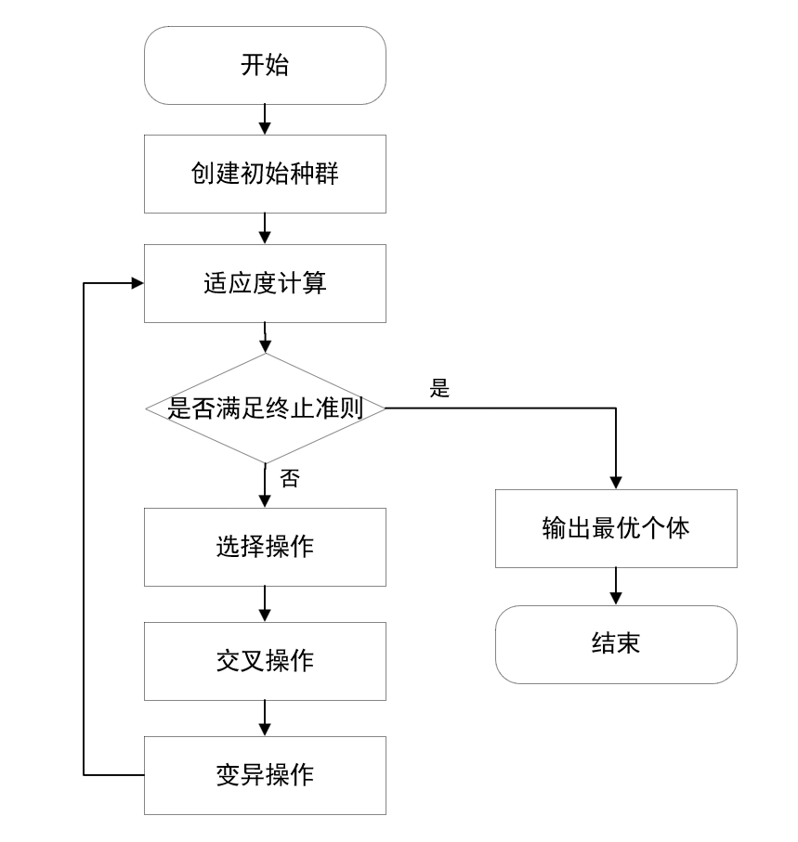

First, a set of design options are randomly generated, each design option is an individual, and all the air-conditioning design options are the initial population.

The objective of the fitness function is to evaluate the advantages and disadvantages of each air conditioning design option, taking into account aspects such as the volume of the air conditioner and the effect of the air conditioner on the temperature of the space. The volume of the air conditioner can be calculated by means of a cylinder.



Where radius is the radius of the air conditioner and h is the height of the air conditioner.

The effect of air conditioning on space temperature can be modeled by a decay function. Its range of influence is affected by the radius radius of the air conditioner.



Where is the updated temperature field, is the current temperature field, and is the air outlet temperature of the air conditioner.

After the temperature field is updated, the temperature deviation can be calculated:

Temperature Deviation=

The overall temperature deviation obtained by the above summation is used as the degree of adaptation, where a smaller degree of adaptation indicates a better design.

The selection operation can be performed using a tournament selection algorithm, in which a number of individuals are randomly selected from the population at a time for comparison, and the individual with the highest fitness is selected to go into the next generation. Its simulation formula is:



The crossover operation generates new individuals by selecting two of the screened individuals as parents and exchanging some of the genes in both of them. That is, in two of the designs under screening, some of the design parameters are exchanged to generate a new design. The mutation operation is based on the Gaussian distribution to change some parameters of the individual design in small magnitude immediately.

After several computational iterations, the termination criterion is to reach the target temperature. The best individual that meets the conditions is derived, i.e., the design of the air conditioner. The results obtained above are used as the basic parameters of the air conditioner to study its operation in the room.

The temperature change modeled by this process is based on the heat transfer equation, a partial differential equation of the following form



where is the density of the material, is the specific heat capacity of the material, is the thermal conductivity of the material, and is the Joule heat source.

Since the heat source term is not considered, the above equation can be written as





5.1.3 Solution of heat conduction model based on explicit finite difference method

In the genetic algorithm for iterative solution, so that the volume of air conditioning does not exceed 0.1m³, the selection of the operation to choose three individuals for comparison, the choice of the number of iterations is 50 times. The design scheme is obtained as shown below

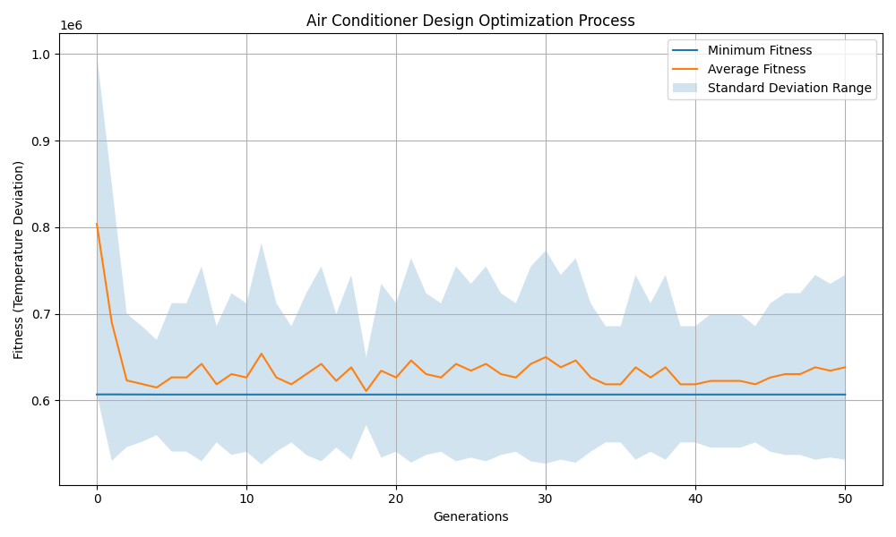

Combining the Python results yields an optimal radius for the air conditioner of 0.25 m and a height of 0.5 m. Its design is shown below.

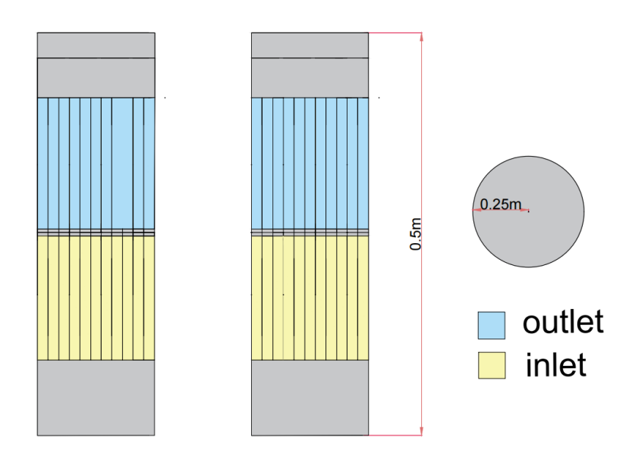

In solving the heat equation for the operation of an air conditioner, time and space can be discretized by the finite difference method. is the time step and is the space step, and the space is divided into small grid points at which the temperature is calculated. The time variables are discretized by forward difference and the space vectors are discretized first by forward difference and then by backward difference.

Then the value of the temperature at the grid point in 3D space at the next time step can be expressed by the following equation



Among them.

where is the next time step at , is the current time step at , and is the Laplace operator.

In summer, the boundary temperature was set to 35°C and the air conditioning temperature to 24°C. After the air conditioner works for half a minute, after 5 minutes and after 10 minutes, the indoor temperature distribution is shown in the figure below.

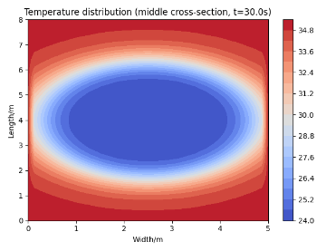

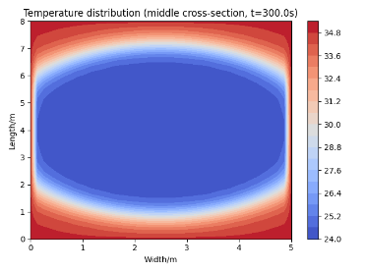

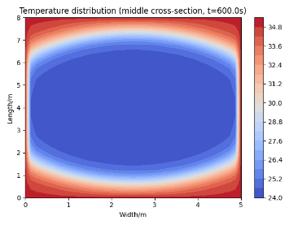

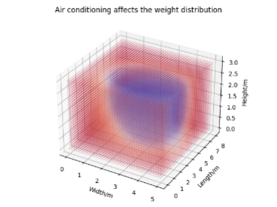

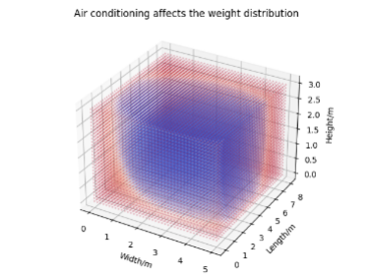

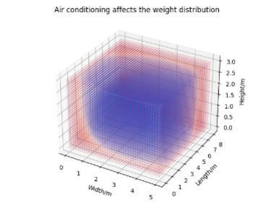

With time, the temperature of the indoor two-dimensional thermal field decreases gradually from the location of the air conditioner in all directions, and the temperature of the three-dimensional scattering points decreases gradually from the location of the air conditioner in all directions within the space. The average indoor temperature over time is plotted below.

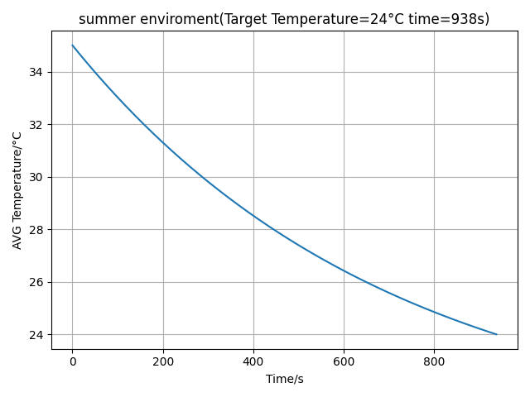

According to the Python calculations, it can be seen that when the time is 938s, the average indoor temperature reaches 24°C, which is in line with the expected indoor temperature.

In summer, the boundary temperature was set to 5°C and the air conditioning temperature was 24°C. After the air conditioner works for 30s, 300s and 600s, the indoor temperature distribution is shown below.

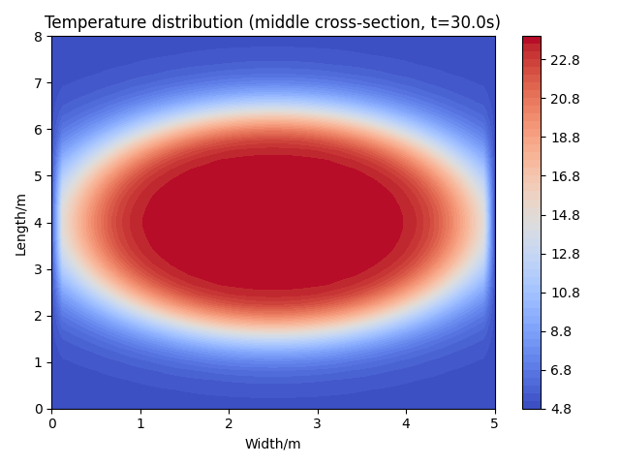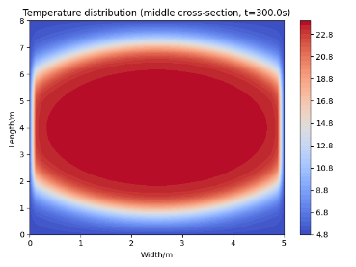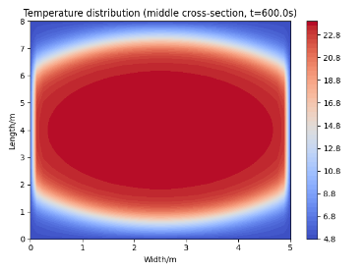

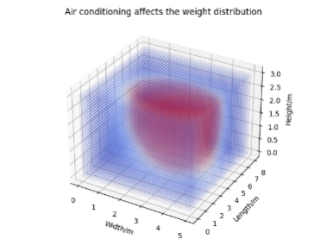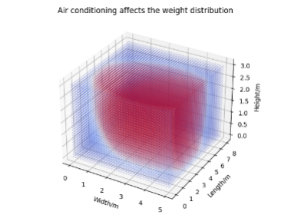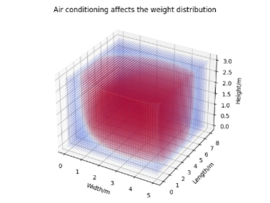

With time, the temperature of the indoor two-dimensional thermal field gradually increases from the location of the air conditioner in all directions, and the temperature of the three-dimensional scattering points gradually increases from the location of the air conditioner in all directions within the space. The average indoor temperature over time is plotted below.

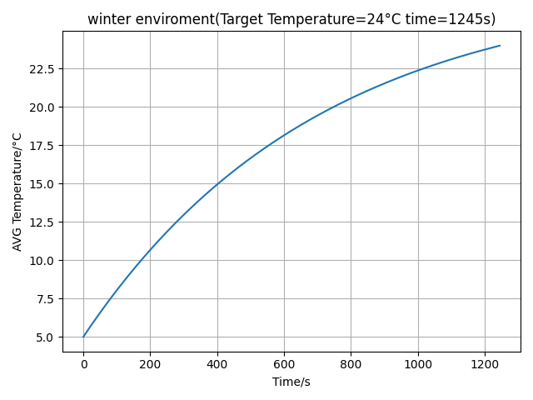

According to the Python calculations, it can be seen that when the time is 1245s, the average indoor temperature reaches 24°C, which is in line with the expected indoor temperature.

In addition, the ANSYS FLUENT simulation was used to simulate the temperature change in the room after 5 minutes in summer, and the following figure shows the top-view thermal map at the height of the air conditioning outlet, and the blank space is the position of the air conditioning placement.

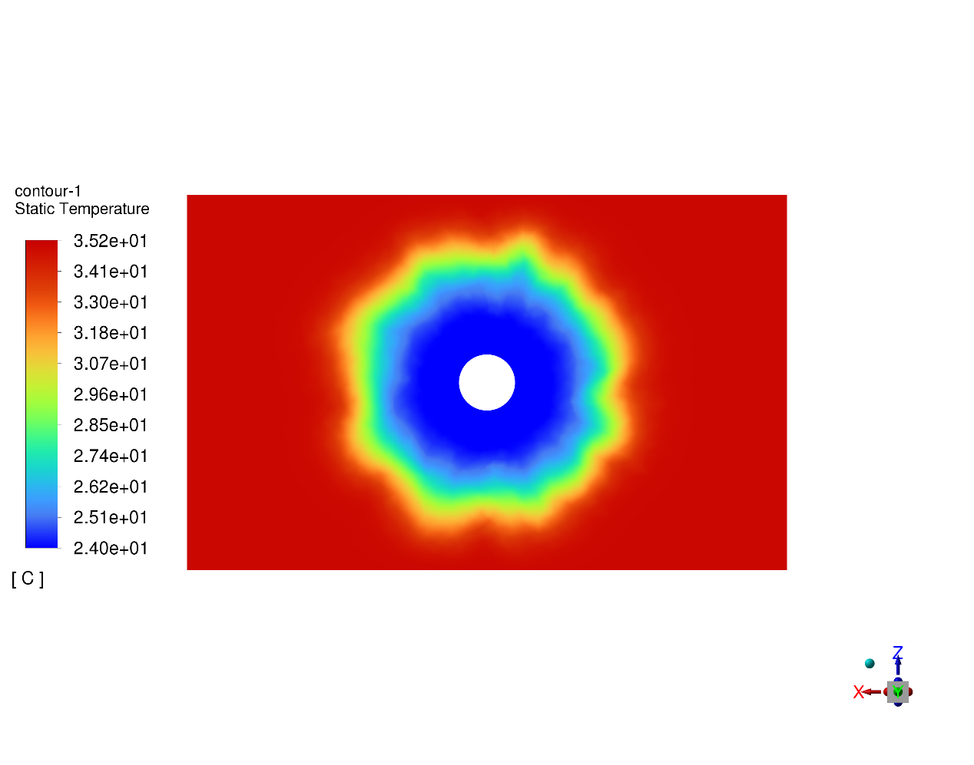

The top view change in room temperature after 10 minutes is shown below

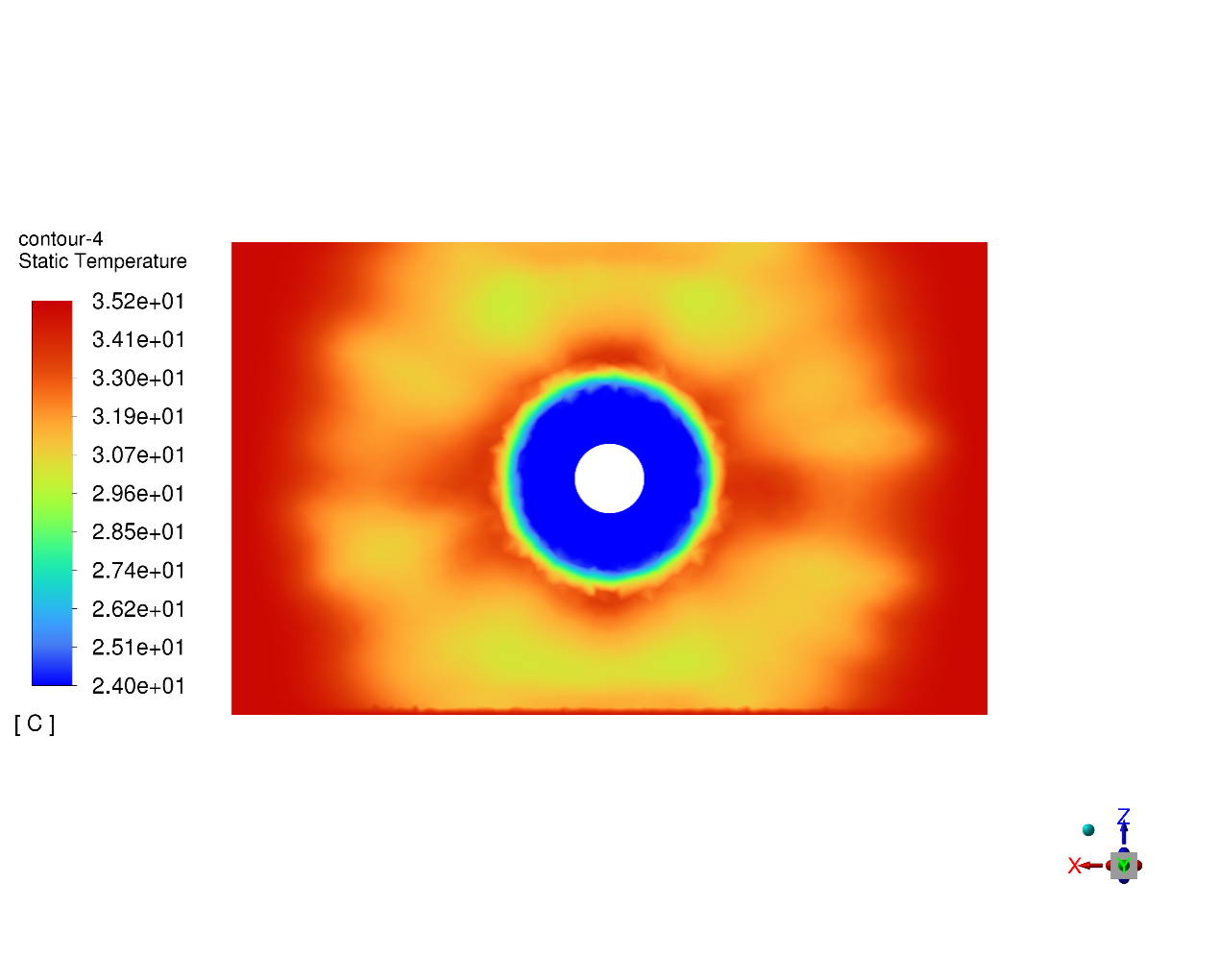

In winter, the change in room temperature after 5 minutes is shown below.

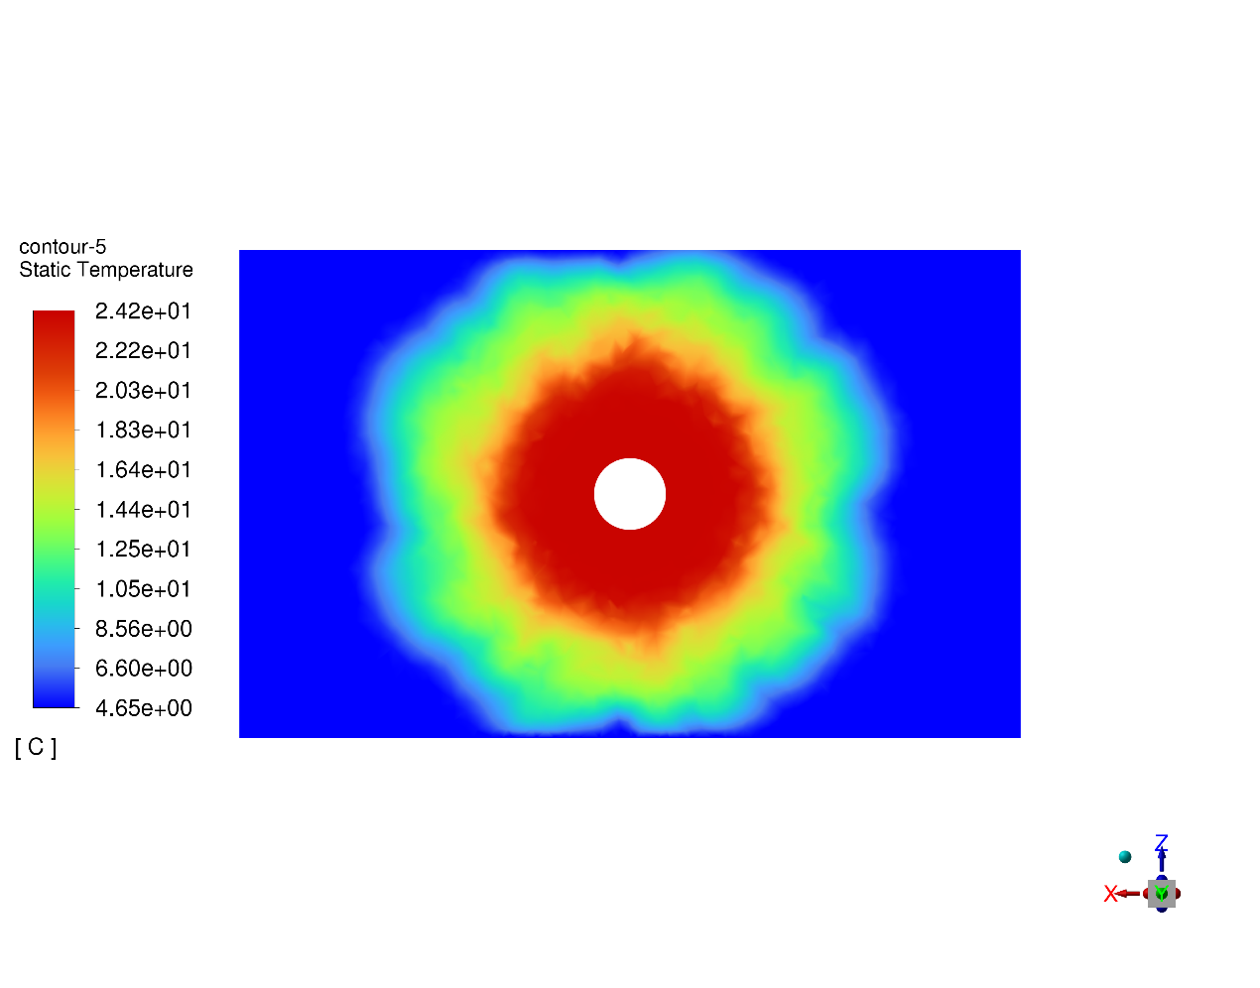

The temperature change in the room after 10 minutes is shown below.

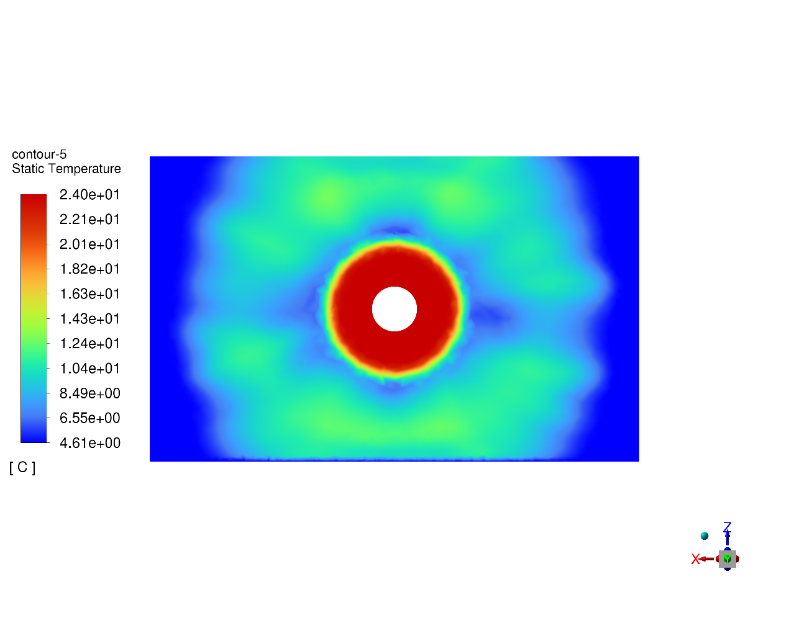

From the analysis of the results of ANSYS simulation of the indoor temperature field changes, it can be seen that in a certain time, the indoor thermal field changes in line with the Python simulation of the expected two-dimensional thermal field and the plotted temperature change over time graph, which is consistent with the expected results

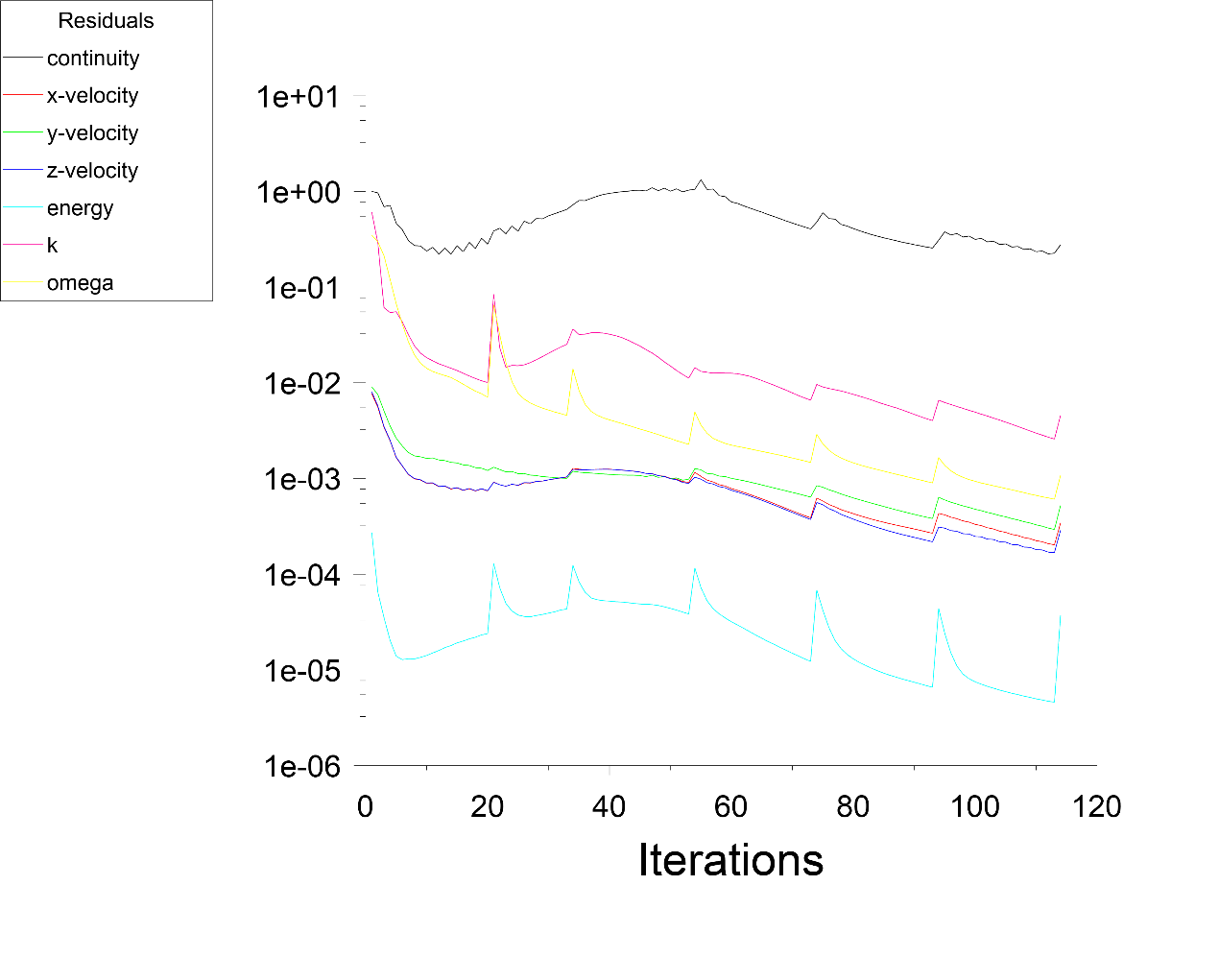

According to the residual table of ANSYS, it can be seen that as the number of iterations increases, the residuals of all physical quantities are decreasing, and the numerical solution is gradually converging to a stable solution, indicating that the solution is good. Where, continuity denotes the continuity equation, x-velocity, y-velocity, z-velocity denotes the velocity of the fluid in the three spatial directions of X, Y, Z, energy denotes the energy equation, k denotes the turbulent kinetic energy, omega denotes the turbulence frequency

The combined Python and Computational Fluid Dynamics (CFD) software ANSYS FLUENT simulation results show that the exterior design and related parameters of the air conditioner are in line with the expected situation.

5.1.4 Advantages and Disadvantages of Explicit Finite Difference Method Based Heat Transfer Modeling

Advantage: 1. The genetic algorithm used has global search capability to avoid falling into the trap of local optimal solution.

2. shows that the update of each grid point of the finite difference method is independent and suitable for parallel computation.

Disadvantages: 1. Genetic algorithms are dependent on the selection of the initial population and the potential capacity of parallel mechanisms is underutilized.

5.2 Concentration-diffusion modeling and solution based on Fick's second law

Genetic algorithm to find the optimal air purifier shape and size and Fick's second law to explore the process of indoor pollutant concentration.

5.2.1 Preparation of a concentration-diffusion model based on Fick's second law

Also based on the Euclidean distance formula, the distance from any point in the space to the air humidifier can be calculated, and substituted into the Gaussian function to calculate the weights of each grid node in the space to simulate the ability of the purifier to reduce the concentration of pollutants at different distances.

According to the relevant literature and market research statistics analysis, it is known that the shape of the air purifier is cylindrical as the optimal shape.

5.2.2 Modeling of concentration diffusion based on Fick's second law

The optimal air purifier shape and size can be derived based on genetic algorithm. An initial set of design options is first randomly generated, and all possible purifier design options are the initial population. Each individual consists of several design parameters such as diameter, height, number of filter layers, number of air inlets, and number of air outlets.



where each Xi is a vector of individual design parameters:



Where means diameter, means height, means number of filter layers, means number of air inlets, and means number of air outlets.

The fitness of each individual can be measured by the purification efficiency (CADR) in terms of CADR termination criterion:





included among these







Where is the air output of the purifier, which is proportional to the number of air outlets ; is the purification efficiency.

The better design solution is then selected from the current population based on the fitness, here again the tournament selection algorithm is used. This is followed by a mutation operation to solve for the optimal shape and size.

The optimal shape, size, position and clean air output ratio of the purifier obtained above are used as the basic parameters to simulate the actual working condition of the air purifier.

where is the volume of the test chamber, is the measured decay rate, is the natural decay rate, and is the test time.

Based on Fick's second law, the rate of change of concentration with time at distance x is equal to the negative of the rate of change of diffusive flux with distance at that location during unsteady state diffusion. The basic equation is as follows



For three-dimensional diffusion, Fick's second law can be expressed as



With the above formulation, the dispersion of pollutants from high to low concentrations can be modeled using the Laplace operator and approximated by the finite difference method.





where is the current diffusion concentration, is the diffusion concentration at the next time step, and D is the diffusion coefficient. where D can be treated as a constant quantity.

The purification efficiency of the air purifier will be affected by the difference in the location of the spatial grid nodes, which will lead to the corresponding weight change and thus affect the purification effect. After being filtered by the purifier, the new pollutant concentration should be



Where, is the efficiency of the purifier and w(X,Y,Z) is the purifier impact weight for each grid point

5.2.3 Concentration-diffusion model solution based on Fick's second law

Let the initial population size in the genetic algorithm be n=100. after 50 iterations of simulating the genetic algorithm in Python, the following image is obtained.

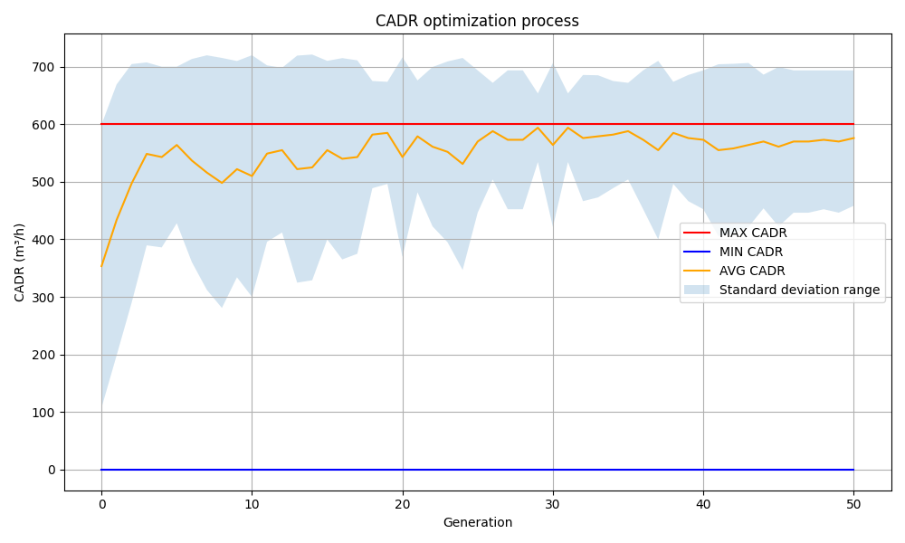

According to Python and combined with the image analysis can be obtained, the maximum value of CADR is 600 , the minimum value of CADR is 0, in order to ensure the results of the operation, here take the average value of CADR 550 .

The optimal air purifier can be obtained with a radius of 0,12 meters, a height of 1.9 meters, 8 filters, 2 air inlets at the top and 4 air outlets at the end, and a CARD=550 . Its exterior design is shown in the following figure

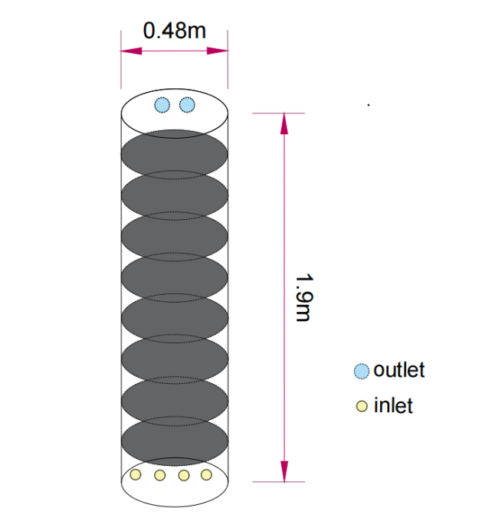

It was calculated that the best air purification effect was achieved by placing the air purifier at the position (2.5, 4, 1.5) in the space. The distribution of air purification after 30s, 300s and 600s of operation in the room is shown below.

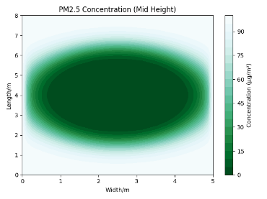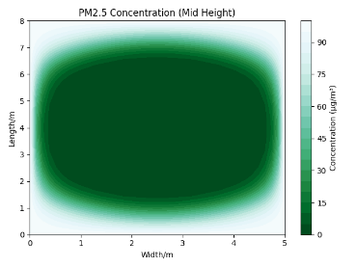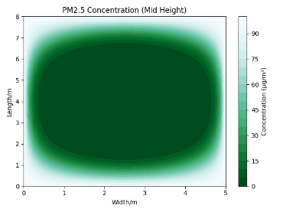

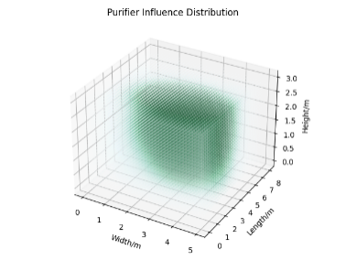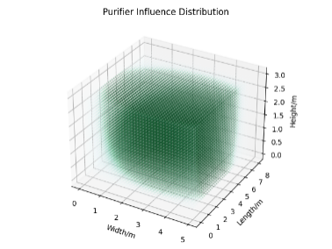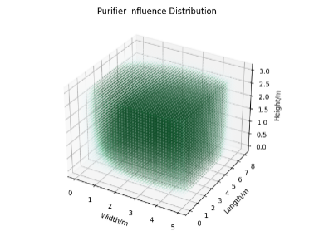

With the passage of time, the indoor two-dimensional air purification range gradually spreads from the location of the air purifier to the surrounding area, and the air purification range in the three-dimensional scattering point gradually spreads from the location of the air purifier to all directions in the space. The desired effect is met.

5.2.4 Advantages and disadvantages of concentration-diffusion models based on Fick's second law

Strengths: 1. Ability to describe unsteady diffusion processes where concentration varies with time and position according to Fick's second law.

Disadvantages: 1. Fick's second law is a macroscopic image-only relational equation that does not address the microscopic processes of atomic motion within a diffusion system and does not fully capture all the physical phenomena of the diffusion process.

5.3 Air humidity modeling and solution based on particle swarm algorithm

Particle swarm algorithm based appearance solving and come to use the finite difference method for simulating the process of humidifier while working in the room.

5.3.1 Preparation of air humidity model based on particle swarm algorithm

The initial humidity at the wall is set to 0.2g/m³ to ensure that the humidity does not appear to penetrate the wall. According to the relevant literature and market research statistics analysis it is known that the shape of the humidifier is cylindrical as the optimal shape.

5.3.2 Modeling of air humidity based on particle swarm algorithm

Due to the slow convergence of genetic algorithm, this question uses particle swarm algorithm to search for the best humidifier design parameters by updating the particles. Its basic flow is shown in the following figure

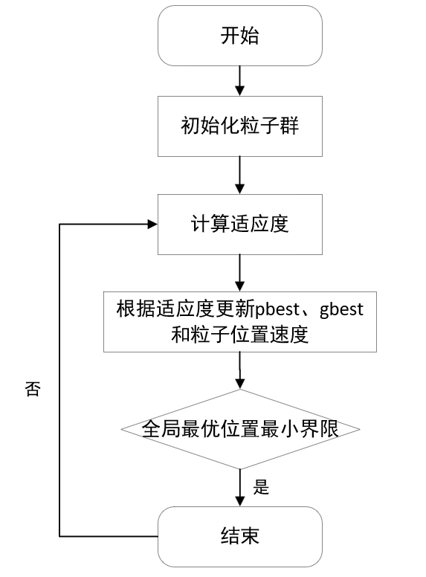

The particle swarm is initialized first, and each particle represents a humidifier design whose fitness is evaluated by the humidity effect of the humidifier design, with the goal of maximizing the humidity effect. The formula for the humidity effect is as follows:

Humidity Effect = × Air Velocity × Target Humidity Difference

In each iteration, the particles are adjusted according to their current position and velocity and updated by the influence of neighboring particles to achieve the air target humidity of 0.6 g/m³. The equation for updating the position of the particle is as follows:





Where, is the velocity of the particle in each iteration, is the position of the particle, is the optimal position of a single particle, is the optimal position of the whole particle, is the inertia weight, and are the acceleration constants, and and are random numbers in the range of [0,1].

After several iterations, the optimal exterior size of the humidifier can be derived.

The optimal humidifier parameters obtained above were substituted into the simulation of the indoor humidification process. Within a single time step , the modification process is also investigated using Fick's second law. The humidity field is updated according to the influence of the humidifier and the process of humidity diffusion. The humidity diffusion is calculated by the Laplace operator and the update equation of the humidity field is given by



where D is the diffusion coefficient of humidity.

5.3.3 Particle Swarm Algorithm Based Solving of Air Humidity Models

The initial particle swarm is set to 50, and the action radius of the humidifier is 1. The 50 iterations of the particles obtained by the particle swarm algorithm are shown in the figure below.

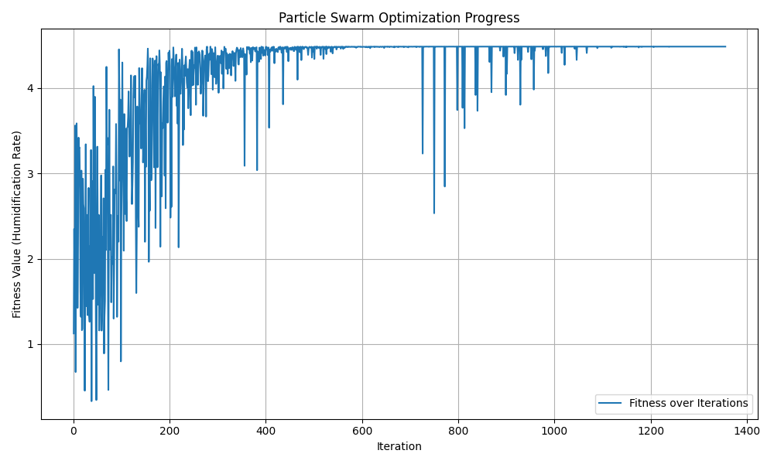

The optimal solution is calculated and simulated by Python with a humidifier height of 1m, a radius of 0.18m, and a humidification rate of 4.48. The design diagram is shown below

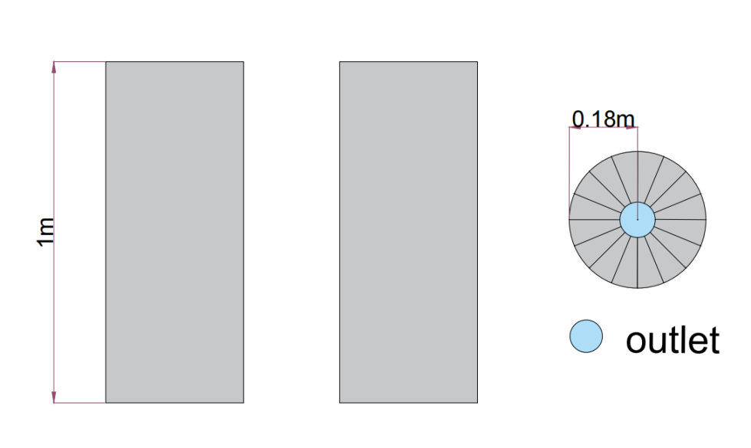

Set the time step and set the target humidity to 0.6 g/m³. The finite difference method similar to the problem class is used to simulate the diffusion process of humidity from high concentration to low concentration. The humidity field distribution after 30s, 300s and 600s of humidity field simulation is shown below.

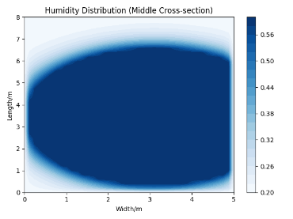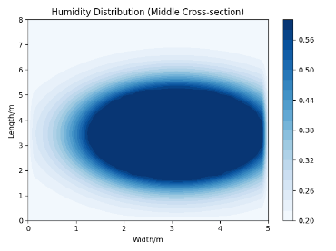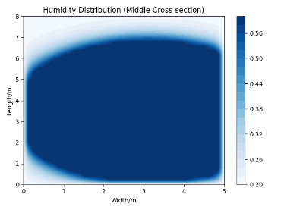

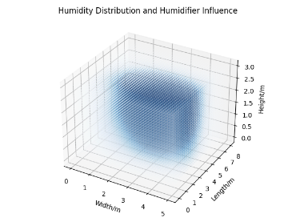

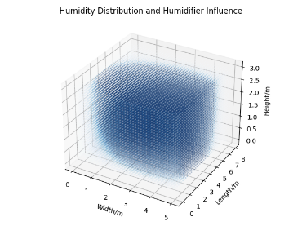

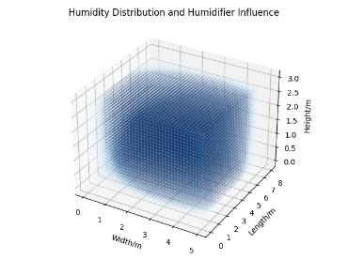

Over time, the humidity in the indoor two-dimensional humidity field gradually spreads from the humidifier's location to the surrounding area, and the humidity in the three-dimensional scattering point gradually spreads from the humidifier's location to all directions within the space. Some of the indoor time to humidity percentage and average humidity data are shown in the table below.

Inserting tables

5.3.4 Advantages and Disadvantages of Particle Swarm Algorithm Based Air Humidity Modeling for Problem 3

Advantages: 1. Ability to search over a large range and avoid entering local optimal solutions.

2. Fast convergence, can quickly find a better solution

Disadvantages: 1. May result in a less refined search capability due to insufficient particle swarm diversity.

5.4 Combinatorial optimization model building and solution based on genetic algorithm

Optimization of three-in-one products using genetic algorithms to obtain optimal appearance dimensions.

5.4.1 Preparation of Combinatorial Optimization Model Based on Genetic Algorithm

Placing the humidifier above the vertical air conditioner will accelerate the diffusion of the water mist in the humidifier by utilizing the wind blowing from the air conditioner, resulting in a more uniform indoor humidity. Therefore, it was chosen to place the humidifier above the vertical air conditioner during the design.

In the choice of shape, since the first three questions are in cylindrical shape, the cylindrical shape is directly used in the setting of the 3-in-1 product.

5.4.2 Establishment of Combinatorial Optimization Model Based on Genetic Algorithm

For the design of three-in-one products, genetic algorithms can be used to simultaneously optimize multiple design parameters for all three devices.

The optimization objective is to minimize the temperature deviation and maximize the humidity control while satisfying the volume constraints. The constraints consider the radius, number of inlet and outlet ports, and location of the air conditioner, radius, number of filter layers, number of inlet and outlet ports, and location of the purifier, and radius, number of inlet and outlet ports, and location of the humidifier. Optimization is done by genetic algorithm.

Similar to the genetic algorithm described above, the population size is initialized first. In considering the fitness function, the temperature deviation, humidity control effect and device size are taken into account.

For temperature deviation

Temperature Deviation=

For temperature control

Humidity Deviation=

For volume limitation



The final fitness function can be expressed by weighting and combining all of the above terms

Fitness=w1*Temperature Deviation+w2*Humidity Deviation+w3*Volume Deviation

where w1,w2,w3 are the weighting coefficients.

After that the selection operation uses tournament selection to enter the screened individuals into the crossover and mutation operation. After that it is chosen whether to enter the selection operation or not according to the optimization objective. The optimal size result can be obtained after performing several iterations.

5.4.3 Genetic Algorithm Based Combinatorial Optimization Model Solving

Let the initial population size be 100, and simulate the genetic algorithm through Python after 50 iterations image as follows.

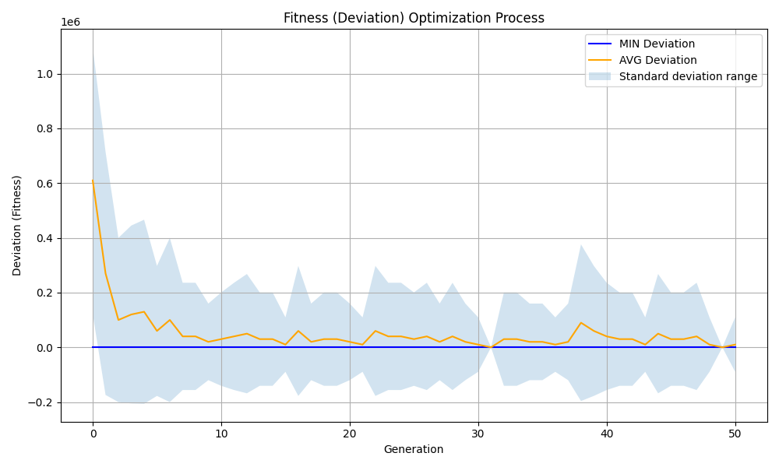

The optimal solution is 0.2884 m height for the air conditioner, 0.0961 m height for the purifier, 0.0961 m height for the humidifier, 0.4807 m height for the total equipment, and 0.0944 m³ total volume. Its shape design scheme is shown below.

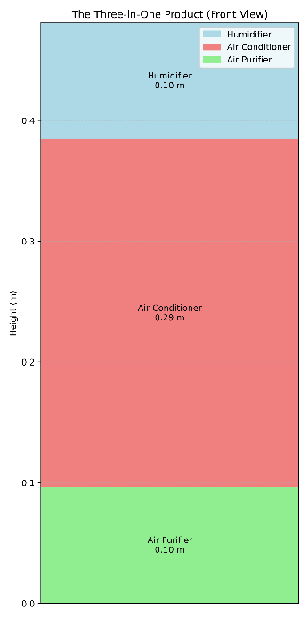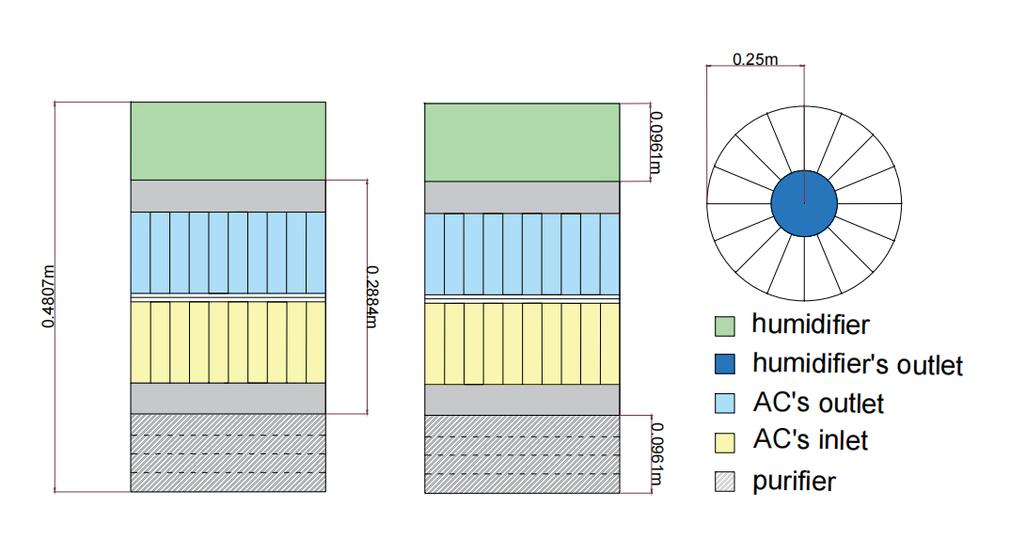

5.4.4 Advantages and Disadvantages of Combinatorial Optimization Models Based on Genetic Algorithms

Strengths: 1. Higher flexibility to consider multiple objectives and meet the needs of different stakeholders

Disadvantages: 1. Slow convergence in the face of large computational volumes.

VIII. References

talk without further ado

[How to properly cite references] <https://www.bilibili.com/video/BV1VW4y1b7HC/?share_source=copy_web&vd_source=d97b5990e9fc8e58e092f34d04bc1109>

[How are references cited in a paper, and are you using them correctly? <https://www.bilibili.com/video/BV1cL4y177Ru/?share_source=copy_web&vd_source=d97b5990e9fc8e58e092f34d04bc1109>

appendice

Putting formulas and graphs, etc., this version does not have a one-click public import for the time being