



《网络空间安全技术》
课程报告

报告题目： 访问控制技术综合验证实验
学 号： 2023112621
姓 名： 程泽凯
班 级： 计算机2023-04班
学院名称： 计算机与人工智能学院
授课教师： 郑丹阳

一、实验名称
访问控制技术综合验证实验：访问矩阵、ACL / DAC、RBAC、MAC 标签控制、ABAC 条件策略、策略冲突处理与审计日志分析。
二、实验目的
- 理解访问控制在信息安全体系中的作用，区分鉴别 Authentication 与授权 Authorization 的不同目标。
- 掌握主体、客体、操作、权限、策略、上下文、授权决策和审计日志等核心概念。
- 能够用程序实现访问矩阵、ACL / DAC、RBAC、MAC 和 ABAC 等典型访问控制模型。
- 能够构造允许、拒绝、未定义主体、未定义客体、角色冲突、标签不满足、属性不满足等测试用例。
- 能够记录授权过程并从审计日志中统计拒绝原因、敏感资源访问和重复失败主体。
三、实验原理
1. 访问控制基本过程
访问控制回答“某个主体能否对某个客体执行某个操作”的问题。系统通常先完成身份鉴别，再根据策略执行授权判断。一次完整授权过程包括：构造访问请求、匹配策略、形成 Permit 或 Deny 决策、给出原因、写入审计日志。
2. 典型模型原理
模型 | 核心思想 | 本实验关注点
访问矩阵 | 用主体-客体二维矩阵保存操作集合。 | 理解 subject、object、action 三元关系和默认拒绝。
ACL / DAC | 在资源侧保存访问控制列表，由资源所有者或管理员授予权限。 | 验证用户条目、组条目、未命中默认拒绝和授权变更。
RBAC | 用户通过角色获得权限，权限授予角色而非直接授予用户。 | 实现角色激活、角色继承、互斥角色、职责分离。
MAC 标签控制 | 依据主体安全等级与客体安全标签执行强制规则。 | 验证 no read up、no write down 和标签等级比较。
ABAC | 综合主体、客体、操作和环境属性进行条件判断。 | 设计部门、设备状态、风险等级、时间窗口等动态条件。
策略冲突组合 | 同一请求可能同时命中允许和拒绝策略。 | 比较 deny-overrides、permit-overrides、first-applicable。
表 1 访问控制模型原理
3. 访问控制原理图
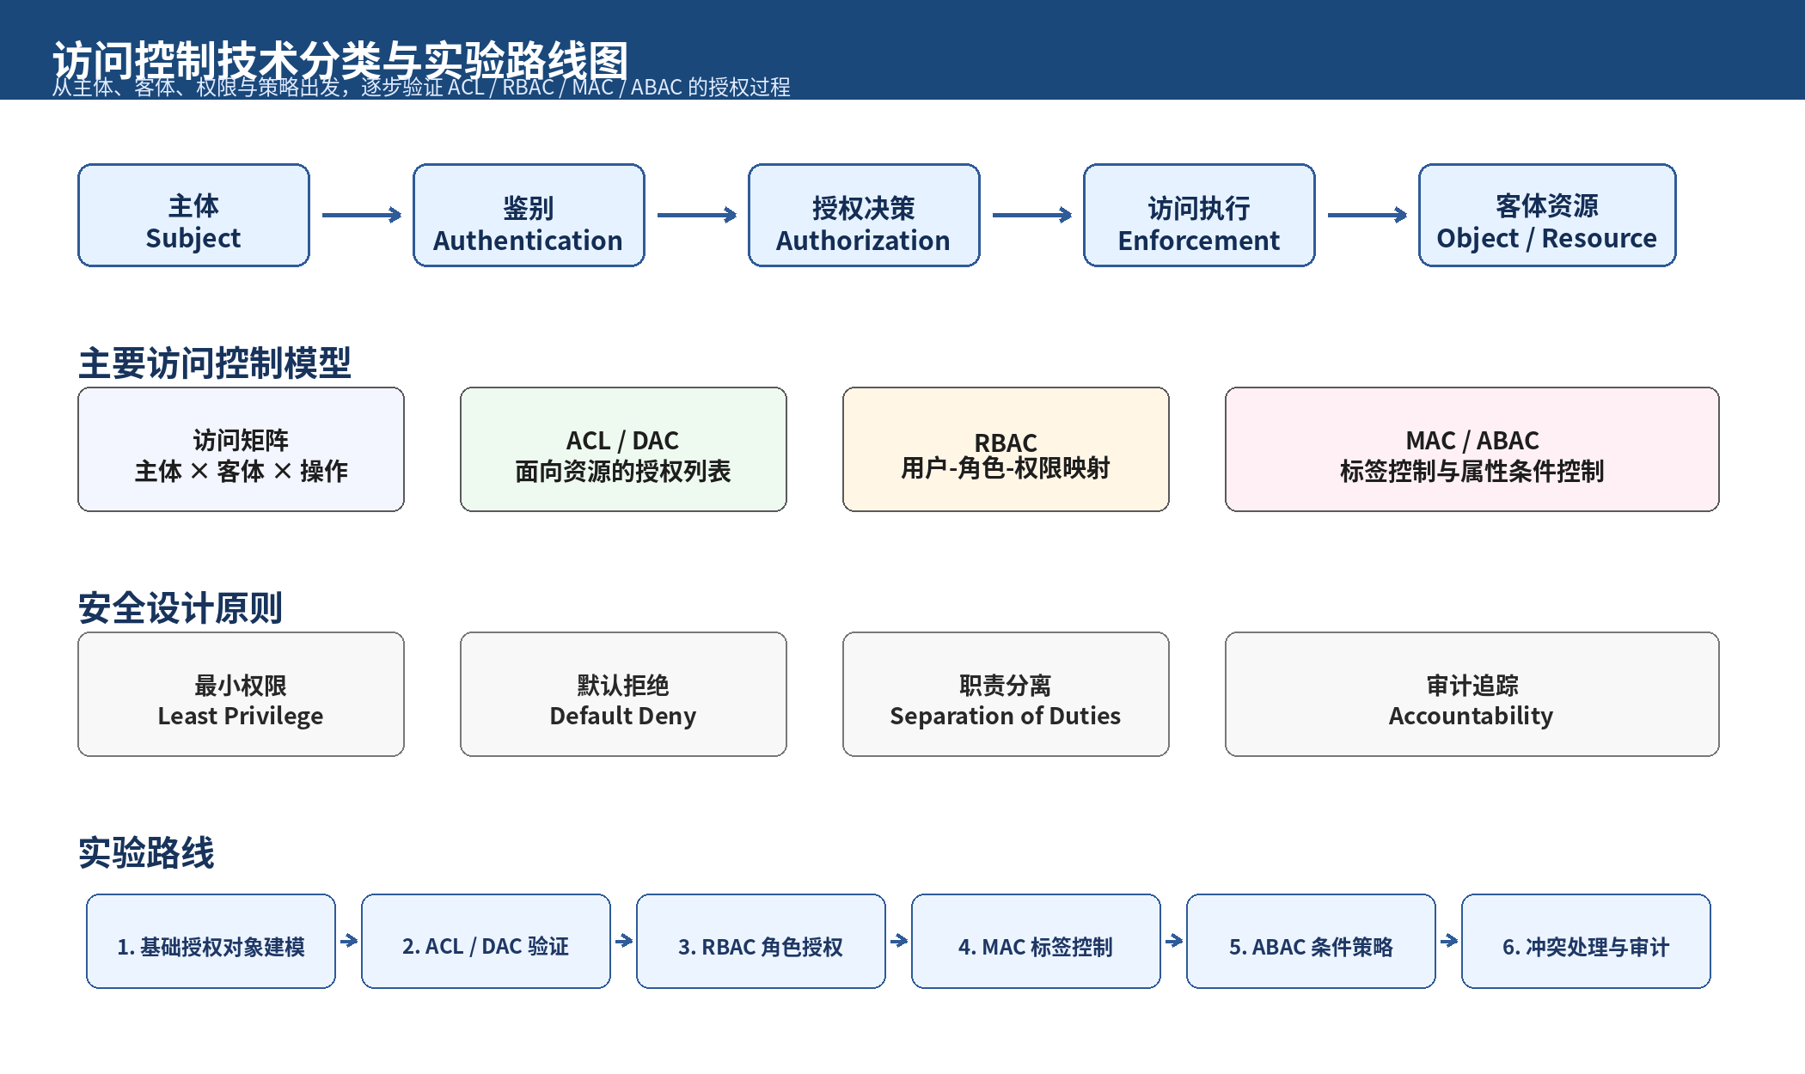
图 1 访问控制技术分类与实验路线图
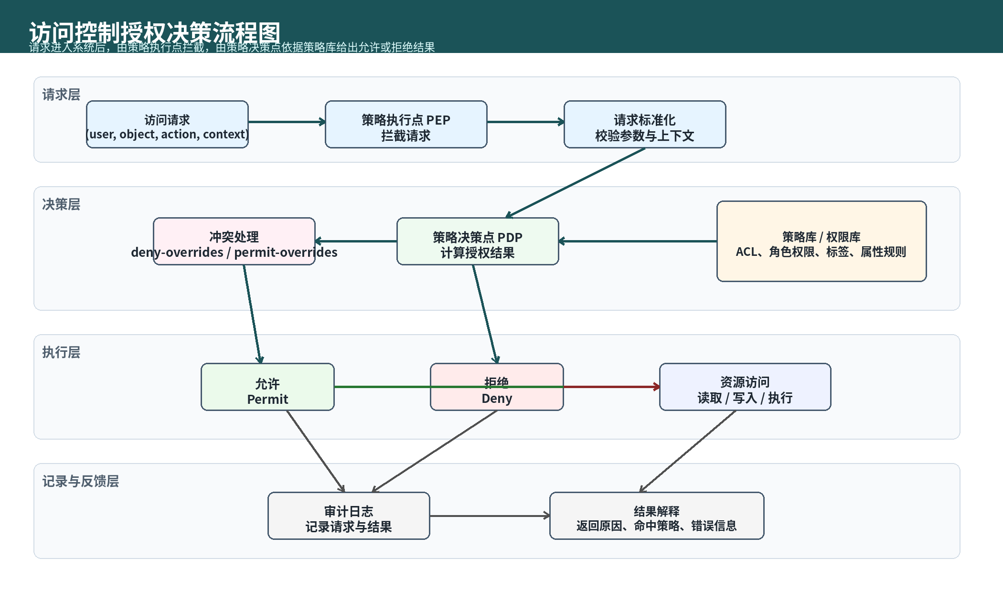
图 2 访问控制授权决策路线图
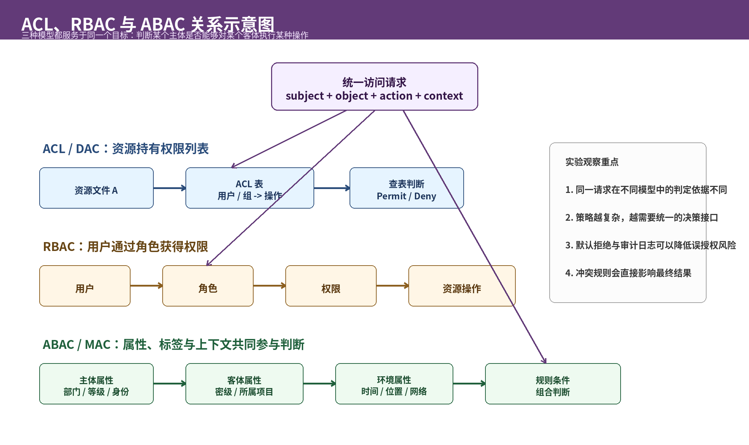
图 3 ACL、RBAC 与 ABAC 关系示意图
类别 | 建议配置
操作系统 | Windows
编程语言 | Python 3.11。
主要库 | dataclasses、typing、json、datetime、copy、uuid、os。
开发工具 | VS Code / PyCharm / Jupyter Notebook。
实验数据 | 教学用用户、资源、角色、权限、标签和属性策略，不使用真实账号或真实系统资源。
表 2 实验环境表
四、实验环境

五、实验内容与任务要求
实验编号 | 实验名称 | 任务要求 | 输出材料
实验1 | 基础访问矩阵实验 | 建立主体-客体-操作矩阵；测试已授权、未授权、未知主体和未知客体。 | 访问矩阵配置、请求结果表。
实验2 | ACL / DAC 实验 | 为资源配置 ACL 条目；验证用户条目、组条目和默认拒绝。 | ACL 表、允许/拒绝结果、DAC 变更记录。
实验3 | RBAC 实验 | 建立用户-角色、角色-权限和角色继承关系；验证互斥角色约束。 | 角色表、权限表、会话激活结果。
实验4 | MAC 标签控制实验 | 设置主体安全等级和客体安全标签；验证读写规则。 | 标签比较表、访问结果。
实验5 | ABAC 条件策略实验 | 设计部门、时间、设备状态、风险等级等条件策略。 | 属性表、策略命中结果。
实验6 | 策略冲突与组合实验 | 构造 Permit 与 Deny 同时命中的冲突样例；比较组合算法。 | 冲突样例和最终决策。
实验7 | 审计日志与异常访问分析 | 记录每次请求的时间、主体、客体、操作、模型、结果、原因。 | JSONL 审计日志和统计分析。
表 3 实验任务表

六、程序设计要求
建议采用模块化结构，将数据模型、策略存储、不同访问控制模型和审计模块拆分。下面只给出 function 构造结构，具体策略内容和输出答案由学生根据实验任务自行完成。

6.1 目录结构
access_control_lab/
|
|-- models.py # 主体、客体、请求、决策等数据结构
|-- policy_store.py # 策略加载与存储
|-- matrix_model.py # 访问矩阵模型
|-- acl_model.py # ACL / DAC 模型
|-- rbac_model.py # RBAC 模型
|-- mac_model.py # MAC 标签控制模型
|-- abac_model.py # ABAC 条件策略模型
|-- decision_engine.py # 统一授权决策入口
|-- audit_logger.py # 审计日志模块
|-- test_cases.py # 实验测试用例
|-- main.py # 实验主程序
└-- report_notes.md # 实验记录与分析

6.2 数据模型模块 models.py
1 from dataclasses import dataclass, field
2 from typing import Any, Dict, Optional, Set
3
4 PERMIT = "Permit"
5 DENY = "Deny"
6
7 @dataclass
8 class Subject:
9 """
10 功能：表示访问主体
11 字段建议：
12 subject_id - 主体唯一标识
13 groups - 所属用户组
14 roles - 可分配角色
15 attrs - 主体属性，例如部门、岗位、等级
16 """
17 subject_id: str
18 groups: Set[str] = field(default_factory=set)
19 roles: Set[str] = field(default_factory=set)
20 attrs: Dict[str, Any] = field(default_factory=dict)
21
22 @dataclass
23 class Resource:
24 """
25 功能：表示被访问客体
26 字段建议：
27 resource_id - 客体唯一标识
28 owner - 资源所有者
29 resource_type - 资源类型
30 label - 安全标签或完整性标签
31 attrs - 客体属性
32 """
33 resource_id: str
34 owner: str
35 resource_type: str
36 label: Optional[str] = None
37 attrs: Dict[str, Any] = field(default_factory=dict)
38
39 @dataclass
40 class AccessRequest:
41 """
42 功能：封装一次访问请求
43 """
44 subject_id: str
45 resource_id: str
46 action: str
47 context: Dict[str, Any] = field(default_factory=dict)
48
49 @dataclass
50 class AccessDecision:
51 """
52 功能：表示授权判断结果
53 字段建议：
54 effect - Permit 或 Deny
55 reason - 判定原因
56 matched_policy - 命中的策略标识
57 """
58 effect: str
59 reason: str
60 matched_policy: Optional[str] = None

6.3 策略存储模块 policy_store.py
1 import json
2 from pathlib import Path
3
4 from models import Resource, Subject
5
6 def _read_json(path: str):
7 with Path(path).open("r", encoding="utf-8") as handle:
8 return json.load(handle)
9
10 def load_subjects(path: str) -> dict:
11 """
12 功能：加载主体数据
13 输入：主体配置文件路径
14 输出：subject_id -> Subject 的映射
15 """
16 data = _read_json(path)
17 return {
18 item["subject_id"]: Subject(
19 subject_id=item["subject_id"],
20 groups=set(item.get("groups", [])),
21 roles=set(item.get("roles", [])),
22 attrs=item.get("attrs", {}),
23 )
24 for item in data
25 }
26
27 def load_resources(path: str) -> dict:
28 """
29 功能：加载资源数据
30 输出：resource_id -> Resource 的映射
31 """
32 data = _read_json(path)
33 return {
34 item["resource_id"]: Resource(
35 resource_id=item["resource_id"],
36 owner=item["owner"],
37 resource_type=item["resource_type"],
38 label=item.get("label"),
39 attrs=item.get("attrs", {}),
40 )
41 for item in data
42 }
43
44 def load_acl_policies(path: str) -> dict:
45 """
46 功能：加载 ACL 策略
47 输出：resource_id -> ACL 条目列表
48 """
49 return _read_json(path)
50
51 def load_rbac_policies(path: str) -> dict:
52 """
53 功能：加载 RBAC 策略
54 包括用户-角色、角色-权限、角色继承、互斥角色等
55 """
56 return _read_json(path)
57
58 def load_mac_policies(path: str) -> dict:
59 """
60 功能：加载 MAC 标签规则
61 """
62 return _read_json(path)
63
64 def load_abac_policies(path: str) -> list:
65 """
66 功能：加载 ABAC 条件策略
67 """
68 return _read_json(path)

6.4 访问矩阵模块 matrix_model.py
1 from models import AccessDecision, DENY, PERMIT
2
3 def build_access_matrix(subjects: dict, resources: dict, permissions: list) -> dict:
4 """
5 功能：构造访问矩阵
6 输出结构示例：
7 matrix[subject_id][resource_id] = set(actions)
8 """
9 matrix = {
10 subject_id: {resource_id: set() for resource_id in resources}
11 for subject_id in subjects
12 }
13 for item in permissions:
14 subject_id = item["subject_id"]
15 resource_id = item["resource_id"]
16 actions = set(item.get("actions", []))
17 matrix.setdefault(subject_id, {}).setdefault(resource_id, set()).update(actions)
18 return matrix
19
20 def check_matrix_access(request, matrix: dict):
21 """
22 功能：基于访问矩阵判断请求是否允许
23 输出：AccessDecision
24 """
25 if request.subject_id not in matrix:
26 return AccessDecision(DENY, "UNKNOWN_SUBJECT", "matrix-default-deny")
27 known_resources = {resource_id for row in matrix.values() for resource_id in row}
28 if request.resource_id not in known_resources:
29 return AccessDecision(DENY, "UNKNOWN_RESOURCE", "matrix-default-deny")
30 allowed_actions = matrix.get(request.subject_id, {}).get(request.resource_id, set())
31 if request.action in allowed_actions:
32 return AccessDecision(PERMIT, "MATRIX_ACTION_ALLOWED", "matrix-cell")
33 return AccessDecision(DENY, "MATRIX_ACTION_NOT_GRANTED", "matrix-default-deny")
34
35 def update_matrix_permission(matrix: dict, subject_id: str, resource_id: str, action: str, effect: str):
36 """
37 功能：修改访问矩阵中的权限
38 说明：effect 可用于表示授予或撤销
39 """
40 actions = matrix.setdefault(subject_id, {}).setdefault(resource_id, set())
41 if effect.lower() in {"grant", "permit", "allow"}:
42 actions.add(action)
43 elif effect.lower() in {"revoke", "deny", "remove"}:
44 actions.discard(action)
45 else:
46 raise ValueError(f"unsupported matrix update effect: {effect}")
47 return matrix

6.5 ACL / DAC 模块 acl_model.py
1 from models import AccessDecision, DENY, PERMIT
2
3 def match_acl_entry(request, subject, acl_entry: dict) -> bool:
4 """
5 功能：判断某条 ACL 条目是否匹配当前请求
6 检查点：
7 1. 主体是否匹配用户或用户组
8 2. 操作是否包含在条目中
9 3. 条目是否适用于目标资源
10 """
11 if request.action not in set(acl_entry.get("actions", [])):
12 return False
13 principal_type = acl_entry.get("type", "user")
14 grantee = acl_entry.get("grantee")
15 if principal_type == "user":
16 return request.subject_id == grantee
17 if principal_type == "group":
18 return grantee in subject.groups
19 return False
20
21 def check_acl_access(request, subjects: dict, resources: dict, acl_policies: dict):
22 """
23 功能：基于 ACL 进行访问控制判断
24 注意：未命中任何允许规则时，应采用默认拒绝
25 输出：AccessDecision
26 """
27 if request.subject_id not in subjects:
28 return AccessDecision(DENY, "UNKNOWN_SUBJECT", "acl-default-deny")
29 if request.resource_id not in resources:
30 return AccessDecision(DENY, "UNKNOWN_RESOURCE", "acl-default-deny")
31
32 subject = subjects[request.subject_id]
33 entries = acl_policies.get(request.resource_id, [])
34 for entry in entries:
35 if match_acl_entry(request, subject, entry):
36 effect = entry.get("effect", PERMIT)
37 policy_id = entry.get("id", f"acl:{request.resource_id}:{entry.get('grantee')}")
38 if effect == DENY:
39 return AccessDecision(DENY, "ACL_EXPLICIT_DENY", policy_id)
40 return AccessDecision(PERMIT, "ACL_ENTRY_ALLOWED", policy_id)
41 return AccessDecision(DENY, "ACL_NO_MATCH_DEFAULT_DENY", "acl-default-deny")
42
43 def grant_acl_permission(acl_policies: dict, resource_id: str, grantee: str, actions: set):
44 """
45 功能：在模拟策略表中授予权限
46 说明：用于 DAC 实验，不修改真实系统权限
47 """
48 entries = acl_policies.setdefault(resource_id, [])
49 entry = {
50 "id": f"dac-grant-{resource_id}-{grantee}",
51 "type": "user",
52 "grantee": grantee,
53 "actions": sorted(actions),
54 "effect": PERMIT,
55 }
56 entries.append(entry)
57 return entry
58
59 def revoke_acl_permission(acl_policies: dict, resource_id: str, grantee: str, actions: set):
60 """
61 功能：撤销 ACL 权限
62 """
63 target = set(actions)
64 for entry in acl_policies.get(resource_id, []):
65 if entry.get("grantee") == grantee:
66 remaining = set(entry.get("actions", [])) - target
67 entry["actions"] = sorted(remaining)
68 return acl_policies

6.6 RBAC 模块 rbac_model.py
1 from models import AccessDecision, DENY, PERMIT
2
3 def get_user_roles(subject, rbac_policy: dict) -> set:
4 """
5 功能：获取用户可用角色集合
6 """
7 assigned = set(rbac_policy.get("user_roles", {}).get(subject.subject_id, []))
8 return assigned | set(subject.roles)
9
10 def expand_role_hierarchy(roles: set, rbac_policy: dict) -> set:
11 """
12 功能：处理角色继承关系，得到完整有效角色集合
13 """
14 expanded = set(roles)
15 hierarchy = rbac_policy.get("role_hierarchy", {})
16 changed = True
17 while changed:
18 changed = False
19 for role in list(expanded):
20 for inherited in hierarchy.get(role, []):
21 if inherited not in expanded:
22 expanded.add(inherited)
23 changed = True
24 return expanded
25
26 def check_separation_of_duty(active_roles: set, rbac_policy: dict) -> bool:
27 """
28 功能：检查互斥角色或职责分离约束
29 返回：是否满足约束
30 """
31 for rule in rbac_policy.get("mutually_exclusive_roles", []):
32 if set(rule).issubset(active_roles):
33 return False
34 return True
35
36 def collect_permissions(active_roles: set, rbac_policy: dict) -> set:
37 """
38 功能：汇总角色对应的权限集合
39 """
40 permissions = set()
41 for role in active_roles:
42 for item in rbac_policy.get("role_permissions", {}).get(role, []):
43 permissions.add((item["resource_id"], item["action"]))
44 return permissions
45
46 def check_rbac_access(request, subjects: dict, resources: dict, rbac_policy: dict, active_roles: set):
47 """
48 功能：基于 RBAC 判断访问请求
49 输出：AccessDecision
50 """
51 if request.subject_id not in subjects:
52 return AccessDecision(DENY, "UNKNOWN_SUBJECT", "rbac-default-deny")
53 if request.resource_id not in resources:
54 return AccessDecision(DENY, "UNKNOWN_RESOURCE", "rbac-default-deny")
55
56 allowed_roles = get_user_roles(subjects[request.subject_id], rbac_policy)
57 if not active_roles.issubset(allowed_roles):
58 return AccessDecision(DENY, "RBAC_ROLE_NOT_ASSIGNED", "rbac-role-check")
59
60 effective_roles = expand_role_hierarchy(active_roles, rbac_policy)
61 if not check_separation_of_duty(effective_roles, rbac_policy):
62 return AccessDecision(DENY, "RBAC_MUTUALLY_EXCLUSIVE_ROLES", "rbac-sod")
63
64 permissions = collect_permissions(effective_roles, rbac_policy)
65 if (request.resource_id, request.action) in permissions:
66 return AccessDecision(PERMIT, "RBAC_PERMISSION_ALLOWED", "rbac-role-permission")
67 return AccessDecision(DENY, "RBAC_PERMISSION_NOT_GRANTED", "rbac-default-deny")

6.7 MAC 标签控制模块 mac_model.py
1 from models import AccessDecision, DENY, PERMIT
2
3 def compare_security_label(subject_label: str, object_label: str, label_order: list) -> int:
4 """
5 功能：比较主体标签和客体标签的等级关系
6 输出：
7 正数 / 0 / 负数可分别表示高于、等于、低于
8 """
9 if subject_label not in label_order or object_label not in label_order:
10 raise ValueError("unknown security label")
11 return label_order.index(subject_label) - label_order.index(object_label)
12
13 def check_confidentiality_rule(action: str, subject_label: str, object_label: str, mac_policy: dict) -> bool:
14 """
15 功能：检查保密性方向的标签访问规则
16 注意：具体规则由实验要求指定，不在说明书中给固定答案
17 """
18 diff = compare_security_label(subject_label, object_label, mac_policy["label_order"])
19 if action == "read":
20 return diff >= 0
21 if action == "write":
22 return diff <= 0
23 return True
24
25 def check_integrity_rule(action: str, subject_label: str, object_label: str, mac_policy: dict) -> bool:
26 """
27 功能：检查完整性方向的标签访问规则
28 """
29 if not mac_policy.get("enforce_integrity", False):
30 return True
31 diff = compare_security_label(subject_label, object_label, mac_policy["label_order"])
32 if action == "read":
33 return diff <= 0
34 if action == "write":
35 return diff >= 0
36 return True
37
38 def check_mac_access(request, subjects: dict, resources: dict, mac_policy: dict):
39 """
40 功能：基于 MAC 标签规则判断访问请求
41 输出：AccessDecision
42 """
43 if request.subject_id not in subjects:
44 return AccessDecision(DENY, "UNKNOWN_SUBJECT", "mac-default-deny")
45 if request.resource_id not in resources:
46 return AccessDecision(DENY, "UNKNOWN_RESOURCE", "mac-default-deny")
47
48 subject_label = subjects[request.subject_id].attrs.get("clearance", "public")
49 object_label = resources[request.resource_id].label or "public"
50 try:
51 confidentiality_ok = check_confidentiality_rule(
52 request.action, subject_label, object_label, mac_policy
53 )
54 integrity_ok = check_integrity_rule(request.action, subject_label, object_label, mac_policy)
55 except ValueError:
56 return AccessDecision(DENY, "MAC_UNKNOWN_LABEL", "mac-label-order")
57
58 if not confidentiality_ok:
59 if request.action == "read":
60 return AccessDecision(DENY, "MAC_NO_READ_UP", "mac-confidentiality")
61 if request.action == "write":
62 return AccessDecision(DENY, "MAC_NO_WRITE_DOWN", "mac-confidentiality")
63 return AccessDecision(DENY, "MAC_CONFIDENTIALITY_DENY", "mac-confidentiality")
64 if not integrity_ok:
65 return AccessDecision(DENY, "MAC_INTEGRITY_DENY", "mac-integrity")
66 return AccessDecision(PERMIT, "MAC_LABEL_RULE_ALLOWED", "mac-label-rule")

6.8 ABAC 模块 abac_model.py
1 from datetime import time
2
3 from models import AccessDecision, DENY, PERMIT
4
5 def build_attribute_context(request, subject, resource) -> dict:
6 """
7 功能：合并主体属性、客体属性、操作和环境属性
8 输出：用于策略判断的上下文字典
9 """
10 return {
11 "subject": {"id": subject.subject_id, **subject.attrs},
12 "resource": {
13 "id": resource.resource_id,
14 "owner": resource.owner,
15 "type": resource.resource_type,
16 "label": resource.label,
17 **resource.attrs,
18 },
19 "action": request.action,
20 "environment": dict(request.context),
21 }
22
23 def _get_path(data: dict, path: str):
24 current = data
25 for part in path.split("."):
26 if not isinstance(current, dict) or part not in current:
27 return None
28 current = current[part]
29 return current
30
31 def _to_time(value):
32 if isinstance(value, time):
33 return value
34 if isinstance(value, str):
35 hour, minute = value.split(":")[:2]
36 return time(int(hour), int(minute))
37 return value
38
39 def evaluate_condition(condition: dict, attr_context: dict) -> bool:
40 """
41 功能：判断单条属性条件是否成立
42 说明：可支持等于、包含、范围比较、时间窗口等基本条件
43 """
44 left = _get_path(attr_context, condition["attr"])
45 op = condition.get("op", "eq")
46 right = condition.get("value")
47 if isinstance(right, str) and right.startswith("$"):
48 right = _get_path(attr_context, right[1:])
49
50 if op == "eq":
51 return left == right
52 if op == "ne":
53 return left != right
54 if op == "in":
55 return left in right
56 if op == "contains":
57 return right in left if left is not None else False
58 if op == "lte":
59 return left <= right
60 if op == "gte":
61 return left >= right
62 if op == "between":
63 low, high = right
64 return low <= left <= high
65 if op == "time_between":
66 current = _to_time(left)
67 start = _to_time(right[0])
68 end = _to_time(right[1])
69 return start <= current <= end
70 raise ValueError(f"unsupported condition operator: {op}")
71
72 def match_abac_policy(policy: dict, attr_context: dict) -> bool:
73 """
74 功能：判断一条 ABAC 策略是否匹配当前请求
75 """
76 target = policy.get("target", {})
77 for key, expected in target.items():
78 actual = _get_path(attr_context, key)
79 if isinstance(expected, list):
80 if actual not in expected:
81 return False
82 elif actual != expected:
83 return False
84 return all(evaluate_condition(item, attr_context) for item in policy.get("conditions", []))
85
86 def _combine(matches: list, combining_alg: str):
87 if not matches:
88 return AccessDecision(DENY, "ABAC_NO_POLICY_MATCH_DEFAULT_DENY", "abac-default-deny")
89 if combining_alg == "deny_overrides":
90 for policy in matches:
91 if policy["effect"] == DENY:
92 return AccessDecision(DENY, "ABAC_DENY_OVERRIDES", policy["id"])
93 return AccessDecision(PERMIT, "ABAC_POLICY_ALLOWED", matches[0]["id"])
94 if combining_alg == "permit_overrides":
95 for policy in matches:
96 if policy["effect"] == PERMIT:
97 return AccessDecision(PERMIT, "ABAC_PERMIT_OVERRIDES", policy["id"])
98 return AccessDecision(DENY, "ABAC_POLICY_DENIED", matches[0]["id"])
99 if combining_alg == "first_applicable":
100 first = matches[0]
101 reason = "ABAC_FIRST_APPLICABLE_PERMIT" if first["effect"] == PERMIT else "ABAC_FIRST_APPLICABLE_DENY"
102 return AccessDecision(first["effect"], reason, first["id"])
103 raise ValueError(f"unsupported combining algorithm: {combining_alg}")
104
105 def check_abac_access(request, subjects: dict, resources: dict, abac_policies: list, combining_alg: str):
106 """
107 功能：基于 ABAC 策略集合进行授权判断
108 combining_alg 可取：deny_overrides、permit_overrides、first_applicable 等
109 输出：AccessDecision
110 """
111 if request.subject_id not in subjects:
112 return AccessDecision(DENY, "UNKNOWN_SUBJECT", "abac-default-deny")
113 if request.resource_id not in resources:
114 return AccessDecision(DENY, "UNKNOWN_RESOURCE", "abac-default-deny")
115
116 attr_context = build_attribute_context(request, subjects[request.subject_id], resources[request.resource_id])
117 matches = [policy for policy in abac_policies if match_abac_policy(policy, attr_context)]
118 return _combine(matches, combining_alg)

6.9 统一决策引擎 decision_engine.py
1 from models import AccessDecision, DENY, PERMIT
2
3 from abac_model import check_abac_access
4 from acl_model import check_acl_access
5 from mac_model import check_mac_access
6 from matrix_model import check_matrix_access
7 from rbac_model import check_rbac_access
8
9 def authorize(request, model_name: str, subjects: dict, resources: dict, policies: dict, **kwargs):
10 """
11 功能：统一访问控制入口
12 输入：
13 request - AccessRequest
14 model_name - matrix / acl / rbac / mac / abac
15 subjects - 主体集合
16 resources - 资源集合
17 policies - 策略集合
18 输出：AccessDecision
19 """
20 if model_name == "matrix":
21 return check_matrix_access(request, policies["matrix"])
22 if model_name == "acl":
23 return check_acl_access(request, subjects, resources, policies["acl"])
24 if model_name == "rbac":
25 return check_rbac_access(
26 request,
27 subjects,
28 resources,
29 policies["rbac"],
30 active_roles=set(kwargs.get("active_roles", set())),
31 )
32 if model_name == "mac":
33 return check_mac_access(request, subjects, resources, policies["mac"])
34 if model_name == "abac":
35 return check_abac_access(
36 request,
37 subjects,
38 resources,
39 policies["abac"],
40 kwargs.get("combining_alg", "deny_overrides"),
41 )
42 raise ValueError(f"unsupported model_name: {model_name}")
43
44 def combine_decisions(decisions: list, algorithm: str):
45 """
46 功能：组合多个模型或多条策略的判断结果
47 用于策略冲突实验
48 """
49 if not decisions:
50 return AccessDecision(DENY, "NO_DECISION_DEFAULT_DENY", "combiner")
51 if algorithm == "deny_overrides":
52 for decision in decisions:
53 if decision.effect == DENY:
54 return AccessDecision(DENY, "COMBINE_DENY_OVERRIDES", decision.matched_policy)
55 return AccessDecision(PERMIT, "COMBINE_ALL_PERMIT", decisions[0].matched_policy)
56 if algorithm == "permit_overrides":
57 for decision in decisions:
58 if decision.effect == PERMIT:
59 return AccessDecision(PERMIT, "COMBINE_PERMIT_OVERRIDES", decision.matched_policy)
60 return AccessDecision(DENY, "COMBINE_ALL_DENY", decisions[0].matched_policy)
61 if algorithm == "first_applicable":
62 first = decisions[0]
63 return AccessDecision(first.effect, "COMBINE_FIRST_APPLICABLE", first.matched_policy)
64 raise ValueError(f"unsupported combination algorithm: {algorithm}")
65
66 def explain_decision(request, decision) -> str:
67 """
68 功能：生成授权结果解释文本
69 """
70 return (
71 f"{request.subject_id} -> {request.resource_id} {request.action}: "
72 f"{decision.effect}, reason={decision.reason}, policy={decision.matched_policy}"
73 )

6.10 审计日志模块 audit_logger.py
1 import json
2 import uuid
3 from collections import Counter
4 from datetime import datetime, timezone
5 from pathlib import Path
6
7 def create_audit_record(request, decision, model_name: str, extra: dict = None) -> dict:
8 """
9 功能：构造审计日志记录
10 字段建议：
11 time、request_id、subject、resource、action、model、decision、reason
12 """
13 record = {
14 "time": datetime.now(timezone.utc).isoformat(),
15 "request_id": str(uuid.uuid4()),
16 "subject": request.subject_id,
17 "resource": request.resource_id,
18 "action": request.action,
19 "model": model_name,
20 "decision": decision.effect,
21 "reason": decision.reason,
22 "matched_policy": decision.matched_policy,
23 }
24 if extra:
25 record["extra"] = extra
26 return record
27
28 def write_audit_log(record: dict, path: str):
29 """
30 功能：写入审计日志
31 """
32 target = Path(path)
33 target.parent.mkdir(parents=True, exist_ok=True)
34 with target.open("a", encoding="utf-8") as handle:
35 handle.write(json.dumps(record, ensure_ascii=False) + "\n")
36
37 def summarize_audit_log(path: str) -> dict:
38 """
39 功能：统计访问结果、拒绝原因、敏感资源访问次数等
40 """
41 records = []
42 target = Path(path)
43 if not target.exists():
44 return {}
45 with target.open("r", encoding="utf-8") as handle:
46 for line in handle:
47 line = line.strip()
48 if line:
49 records.append(json.loads(line))
50
51 decisions = Counter(item["decision"] for item in records)
52 deny_reasons = Counter(item["reason"] for item in records if item["decision"] == "Deny")
53 sensitive_ids = {"payroll", "strategy_doc"}
54 sensitive_count = sum(1 for item in records if item["resource"] in sensitive_ids)
55 failures = Counter(item["subject"] for item in records if item["decision"] == "Deny")
56 repeat_failures = {subject: count for subject, count in failures.items() if count >= 2}
57
58 return {
59 "total_requests": len(records),
60 "permit_requests": decisions.get("Permit", 0),
61 "deny_requests": decisions.get("Deny", 0),
62 "most_common_deny_reason": deny_reasons.most_common(1)[0][0] if deny_reasons else "",
63 "sensitive_resource_access_count": sensitive_count,
64 "repeat_failed_subjects": repeat_failures,
65 "deny_reason_counts": dict(deny_reasons),
66 }

6.11 主程序 main.py
1 import json
2 from pathlib import Path
3
4 from abac_model import check_abac_access
5 from acl_model import check_acl_access, grant_acl_permission
6 from audit_logger import create_audit_record, summarize_audit_log, write_audit_log
7 from mac_model import check_mac_access
8 from matrix_model import build_access_matrix, check_matrix_access, update_matrix_permission
9 from rbac_model import check_rbac_access
10 from test_cases import base_data, build_matrix_permissions, clone_policies, experiment_rows
11
12 BASE_DIR = Path(__file__).resolve().parent
13 AUDIT_LOG = BASE_DIR / "audit_log.jsonl"
14 RESULTS_JSON = BASE_DIR / "experiment_results.json"
15
16 def _reset_audit_log():
17 AUDIT_LOG.write_text("", encoding="utf-8")
18
19 def _record(records: list, test_id: str, scene: str, request, expected: str, actual, model_name: str, extra=None):
20 consistent = "是" if expected == actual.effect else "否"
21 row = {
22 "测试编号": test_id,
23 "测试场景": scene,
24 "输入条件": f"subject={request.subject_id}, resource={request.resource_id}, action={request.action}, context={request.context}",
25 "期望结果": expected,
26 "实际结果": f"{actual.effect} ({actual.reason})",
27 "是否一致": consistent,
28 "结果分析": actual.reason,
29 }
30 records.append(row)
31 audit_record = create_audit_record(request, actual, model_name, extra=extra)
32 audit_record["test_id"] = test_id
33 write_audit_log(audit_record, str(AUDIT_LOG))
34 return row
35
36 def run_matrix_experiment():
37 """执行访问矩阵实验"""
38 subjects, resources, _ = base_data()
39 matrix = build_access_matrix(subjects, resources, build_matrix_permissions())
40 records = []
41 for test_id, scene, request, expected in experiment_rows()["matrix"]:
42 if test_id == "MX-05":
43 update_matrix_permission(matrix, request.subject_id, request.resource_id, request.action, "grant")
44 decision = check_matrix_access(request, matrix)
45 _record(records, test_id, scene, request, expected, decision, "matrix")
46 return records
47
48 def run_acl_experiment():
49 """执行 ACL / DAC 实验"""
50 subjects, resources, policies = base_data()
51 acl_policies = clone_policies(policies)["acl"]
52 records = []
53 for test_id, scene, request, expected in experiment_rows()["acl"]:
54 if test_id == "AC-04":
55 grant_acl_permission(acl_policies, request.resource_id, request.subject_id, {request.action})
56 decision = check_acl_access(request, subjects, resources, acl_policies)
57 _record(records, test_id, scene, request, expected, decision, "acl")
58 return records
59
60 def run_rbac_experiment():
61 """执行 RBAC 实验"""
62 subjects, resources, policies = base_data()
63 records = []
64 for test_id, scene, request, expected, active_roles in experiment_rows()["rbac"]:
65 decision = check_rbac_access(request, subjects, resources, policies["rbac"], active_roles)
66 _record(records, test_id, scene, request, expected, decision, "rbac", {"active_roles": sorted(active_roles)})
67 return records
68
69 def run_mac_experiment():
70 """执行 MAC 标签控制实验"""
71 subjects, resources, policies = base_data()
72 records = []
73 for test_id, scene, request, expected in experiment_rows()["mac"]:
74 decision = check_mac_access(request, subjects, resources, policies["mac"])
75 _record(records, test_id, scene, request, expected, decision, "mac")
76 return records
77
78 def run_abac_experiment():
79 """执行 ABAC 条件策略实验"""
80 subjects, resources, policies = base_data()
81 records = []
82 for test_id, scene, request, expected in experiment_rows()["abac"]:
83 decision = check_abac_access(request, subjects, resources, policies["abac"], "deny_overrides")
84 _record(records, test_id, scene, request, expected, decision, "abac", {"combining_alg": "deny_overrides"})
85 return records
86
87 def run_conflict_experiment():
88 """执行策略冲突与组合实验"""
89 subjects, resources, policies = base_data()
90 records = []
91 for test_id, scene, request, expected, algorithm in experiment_rows()["conflict"]:
92 decision = check_abac_access(request, subjects, resources, policies["abac"], algorithm)
93 _record(records, test_id, scene, request, expected, decision, "abac-conflict", {"combining_alg": algorithm})
94 return records
95
96 def run_audit_analysis():
97 """执行审计日志分析"""
98 return summarize_audit_log(str(AUDIT_LOG))
99
100 def main():
101 """
102 实验入口：
103 1. 初始化主体、客体与策略
104 2. 构造测试请求
105 3. 分别调用各访问控制模型
106 4. 输出授权结果与审计日志
107 5. 生成实验分析数据
108 """
109 _reset_audit_log()
110 results = {
111 "访问矩阵实验": run_matrix_experiment(),
112 "ACL / DAC 实验": run_acl_experiment(),
113 "RBAC 实验": run_rbac_experiment(),
114 "MAC 标签控制实验": run_mac_experiment(),
115 "ABAC 条件策略实验": run_abac_experiment(),
116 "策略冲突与组合实验": run_conflict_experiment(),
117 }
118 summary = run_audit_analysis()
119 RESULTS_JSON.write_text(
120 json.dumps({"results": results, "audit": summary}, ensure_ascii=False, indent=2),
121 encoding="utf-8",
122 )
123 print("Access control experiments completed.")
124 print(json.dumps(summary, ensure_ascii=False, indent=2))
125
126 if __name__ == "__main__":
127 main()
七、实验结果记录表
填写说明：以下表格用于学生记录程序实际运行结果。任务书不提供参考答案。实际结果应写出返回值、原因码、关键状态变化和日志字段摘要；“是否一致”用于判断实际输出是否符合自己预设的期望；“结果分析”应写明通过或拒绝的直接原因。
1. 访问矩阵实验
测试编号 | 测试场景 | 输入条件 | 期望结果 | 实际结果 | 是否一致 | 结果分析
MX-01 | 已授权主体访问已授权客体 | 主体、客体、操作均存在，矩阵单元格中包含该操作。 | Permit | Permit (MATRIX_ACTION_ALLOWED) | 是 | 访问矩阵单元格包含该操作，授权通过。
MX-02 | 主体存在但矩阵未授权 | 主体和客体存在，但矩阵中没有对应操作权限。 | Deny | Deny (MATRIX_ACTION_NOT_GRANTED) | 是 | 矩阵中没有对应操作权限，按默认拒绝处理。
MX-03 | 未知主体访问 | 请求中的 subject_id 不在主体表中。 | Deny | Deny (UNKNOWN_SUBJECT) | 是 | 主体表中不存在该 subject_id，授权失败。
MX-04 | 未知客体访问 | 请求中的 resource_id 不在资源表中。 | Deny | Deny (UNKNOWN_RESOURCE) | 是 | 资源表中不存在该 resource_id，授权失败。
MX-05 | 修改矩阵后重新验证 | 先更新矩阵权限，再提交同类访问请求。 | Permit | Permit (MATRIX_ACTION_ALLOWED) | 是 | 访问矩阵单元格包含该操作，授权通过。
表 4 访问矩阵实验

2. ACL / DAC 实验
测试编号 | 测试场景 | 输入条件 | 期望结果 | 实际结果 | 是否一致 | 结果分析
AC-01 | 用户 ACL 直接授权 | 资源 ACL 中存在指定用户的允许条目。 | Permit | Permit (ACL_ENTRY_ALLOWED) | 是 | 资源 ACL 中存在匹配的用户或组允许条目。
AC-02 | 组 ACL 授权 | 主体属于被 ACL 授权的用户组。 | Permit | Permit (ACL_ENTRY_ALLOWED) | 是 | 资源 ACL 中存在匹配的用户或组允许条目。
AC-03 | 未命中 ACL 默认拒绝 | 主体不属于任何被授权用户或组。 | Deny | Deny (ACL_NO_MATCH_DEFAULT_DENY) | 是 | 未命中任何 ACL 允许条目，默认拒绝。
AC-04 | 资源侧 ACL 授权写操作 | 由资源所有者或管理员为主体授予写权限后访问。 | Permit | Permit (ACL_ENTRY_ALLOWED) | 是 | 资源 ACL 中存在匹配的用户或组允许条目。
AC-05 | 非授权组访问敏感资源 | 主体不属于敏感资源允许访问的组。 | Deny | Deny (ACL_NO_MATCH_DEFAULT_DENY) | 是 | 未命中任何 ACL 允许条目，默认拒绝。
表 5 ACL/DAC实验

3. RBAC 实验
测试编号 | 测试场景 | 输入条件 | 期望结果 | 实际结果 | 是否一致 | 结果分析
RB-01 | 角色具备资源写权限 | 用户激活 developer 等角色后访问对应资源。 | Permit | Permit (RBAC_PERMISSION_ALLOWED) | 是 | 激活角色汇总后的权限集合包含目标资源和操作。
RB-02 | 角色具备审计读取权限 | 用户激活 auditor 等角色后读取审计或策略类资源。 | Permit | Permit (RBAC_PERMISSION_ALLOWED) | 是 | 激活角色汇总后的权限集合包含目标资源和操作。
RB-03 | 低权限角色访问未授权资源 | guest 等角色尝试访问高权限资源。 | Deny | Deny (RBAC_PERMISSION_NOT_GRANTED) | 是 | 低权限角色没有目标资源操作权限。
RB-04 | 互斥角色同时激活 | 同一会话中同时激活被设置为互斥的角色。 | Deny | Deny (RBAC_MUTUALLY_EXCLUSIVE_ROLES) | 是 | 会话同时激活互斥角色，违反职责分离约束。
RB-05 | 管理角色执行审批操作 | manager 等角色执行 approve 操作。 | Permit | Permit (RBAC_PERMISSION_ALLOWED) | 是 | 激活角色汇总后的权限集合包含目标资源和操作。
表 6 RBAC实验

4. MAC 标签控制实验
测试编号 | 测试场景 | 输入条件 | 期望结果 | 实际结果 | 是否一致 | 结果分析
MA-01 | 同级标签读取 | 主体标签与客体标签相同，执行 read 操作。 | Permit | Permit (MAC_LABEL_RULE_ALLOWED) | 是 | 主体等级与客体标签满足 MAC 读写规则。
MA-02 | 低级别主体向上读取 | 低等级主体读取高等级客体。 | Deny | Deny (MAC_NO_READ_UP) | 是 | 低级别主体读取高级别客体，违反 no read up。
MA-03 | 高级别主体读取低级别客体 | 高等级主体读取低等级客体。 | Permit | Permit (MAC_LABEL_RULE_ALLOWED) | 是 | 主体等级与客体标签满足 MAC 读写规则。
MA-04 | 高级别主体向下写 | 高等级主体写入低等级客体。 | Deny | Deny (MAC_NO_WRITE_DOWN) | 是 | 高级别主体写入低级别客体，违反 no write down。
MA-05 | public 主体读取 public 客体 | 主体和客体均为 public 标签。 | Permit | Permit (MAC_LABEL_RULE_ALLOWED) | 是 | 主体等级与客体标签满足 MAC 读写规则。
表 7 MAC标签控制实验

5. ABAC 条件策略实验
测试编号 | 测试场景 | 输入条件 | 期望结果 | 实际结果 | 是否一致 | 结果分析
AB-01 | 部门、设备、风险均满足 | 主体部门、资源部门、设备状态和风险等级均满足策略。 | Permit | Permit (ABAC_POLICY_ALLOWED) | 是 | 请求属性满足允许策略，授权通过。
AB-02 | 设备状态不满足 | 设备状态为 unmanaged 或不可信。 | Deny | Deny (ABAC_DENY_OVERRIDES) | 是 | 同时命中允许和拒绝策略，deny-overrides 返回拒绝。
AB-03 | 财务部门办公时间访问 | 财务主体在办公时间从允许位置访问工资表。 | Permit | Permit (ABAC_POLICY_ALLOWED) | 是 | 请求属性满足允许策略，授权通过。
AB-04 | 超出办公时间访问 | 访问时间不在策略允许窗口内。 | Deny | Deny (ABAC_NO_POLICY_MATCH_DEFAULT_DENY) | 是 | 属性条件不满足任何允许策略，默认拒绝。
AB-05 | 敏感资源缺少二次验证 | 访问敏感资源但主体未通过 MFA。 | Deny | Deny (ABAC_DENY_OVERRIDES) | 是 | 同时命中允许和拒绝策略，deny-overrides 返回拒绝。
表 8 ABAC条件策略实验

6. 策略冲突与组合实验
测试编号 | 测试场景 | 输入条件 | 期望结果 | 实际结果 | 是否一致 | 结果分析
CF-01 | deny-overrides 冲突处理 | 同一请求同时命中 Permit 和 Deny，组合算法为 deny-overrides。 | Deny | Deny (ABAC_DENY_OVERRIDES) | 是 | 同时命中允许和拒绝策略，deny-overrides 返回拒绝。
CF-02 | permit-overrides 冲突处理 | 同一请求同时命中 Permit 和 Deny，组合算法为 permit-overrides。 | Permit | Permit (ABAC_PERMIT_OVERRIDES) | 是 | 同时命中允许和拒绝策略，permit-overrides 返回允许。
CF-03 | first-applicable 冲突处理 | 按策略顺序采用第一条可适用策略。 | Permit | Permit (ABAC_FIRST_APPLICABLE_PERMIT) | 是 | 按策略顺序采用第一条适用的 Permit 策略。
表 9 策略冲突与组合实验

7. 审计日志统计记录
统计项 | 学生填写记录值 | 分析说明
总请求数 | 28 | 统计所有实验场景产生的访问请求数量。
允许请求数 | 15 | 统计最终结果为 Permit 的请求数量。
拒绝请求数 | 13 | 统计最终结果为 Deny 的请求数量。
最常见拒绝原因 | ABAC_DENY_OVERRIDES | 根据日志中的 reason 字段统计。
敏感资源访问次数 | 12 | 统计 payroll、strategy_doc 等敏感资源相关请求。
重复失败主体 | alice(4)、dave(4)、bob(2) | 统计多次出现拒绝结果的主体。
表 10 审计日志统计记录

八、思考题
1. 为什么身份鉴别成功并不等于访问一定被允许？
身份鉴别的作用是确认“用户是谁”，而访问控制的作用是判断“这个用户能不能做某件事”。二者属于不同的安全环节。
例如，用户登录系统时输入了正确的用户名和密码，说明系统确认了该用户的身份，即身份鉴别成功。但是，该用户是否能访问某个文件、修改某条数据、进入某个管理页面，还要继续检查其权限。如果该用户只是普通用户，而请求访问管理员功能，即使登录成功，也应该被拒绝。
因此，身份鉴别解决的是身份真实性问题，访问控制解决的是权限授权问题。只有身份合法且权限满足要求，访问才应被允许。
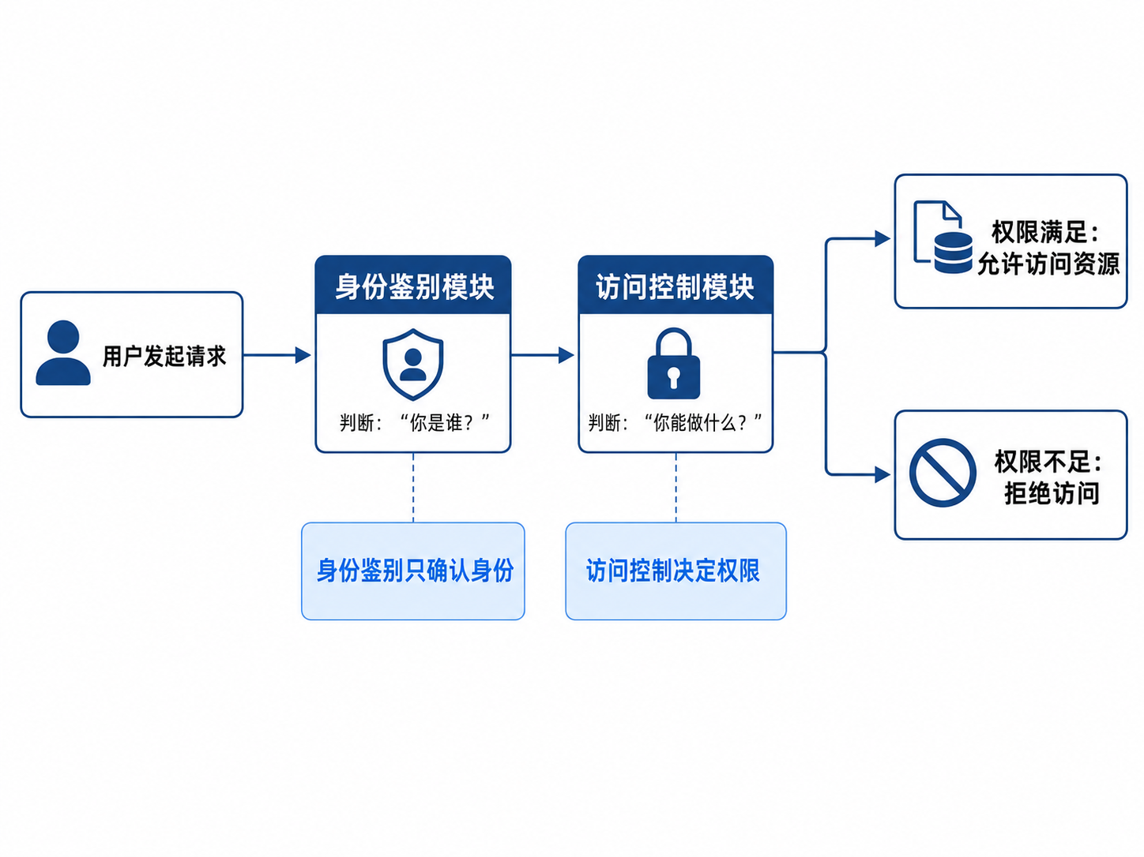
图 4 身份验证流程图

- 访问矩阵、ACL 和 RBAC 在权限维护上的主要差异是什么？
访问矩阵是一种理论模型，用二维表描述“主体—客体—权限”的关系。矩阵的行表示用户或进程，列表示文件、数据库等资源，单元格中记录对应权限。它表达清晰，但在真实系统中如果用户和资源很多，矩阵会非常庞大，维护成本较高。
ACL，即访问控制列表，是从“资源”的角度维护权限。每个资源保存一张列表，记录哪些用户或用户组可以访问该资源，以及具有什么权限。ACL 适合资源数量明确、需要针对单个资源细粒度控制的场景，但当用户权限频繁变化时，需要逐个修改多个资源上的 ACL，维护较麻烦。
RBAC，即基于角色的访问控制，是从“角色”的角度维护权限。系统先给角色分配权限，再把用户分配到角色中。例如“教师”“学生”“管理员”等角色分别拥有不同权限。RBAC 的优点是便于统一管理，用户变动时只需要调整角色归属，不必逐项修改资源权限，适合组织结构较稳定的系统。
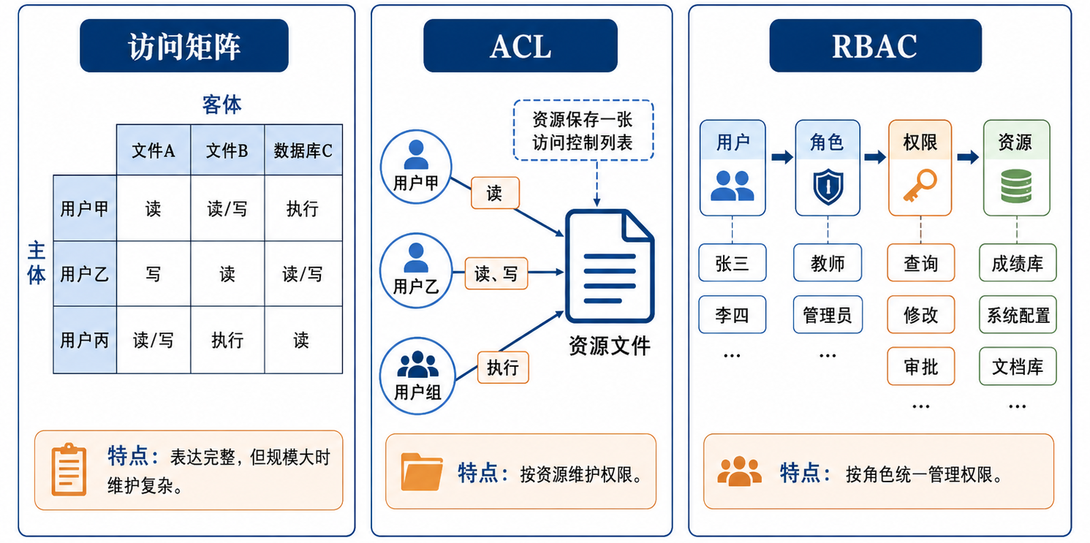
图 5 访问矩阵、ACL、RBAC对比图
简言之：访问矩阵偏理论描述，ACL 以资源为中心，RBAC 以角色为中心。

- 为什么真实系统常采用默认拒绝策略？
默认拒绝策略是指：如果系统没有明确允许某个访问请求，就默认拒绝。真实系统采用这种策略，主要是为了降低误授权风险。
在复杂系统中，用户、资源和权限规则都很多，如果采用默认允许策略，一旦管理员遗漏了某些限制条件，就可能导致未经授权的用户访问敏感资源。而默认拒绝策略要求所有访问必须有明确授权，能够减少因配置错误、权限遗漏或规则冲突带来的安全隐患。
这种策略符合“最小权限原则”，即用户只拥有完成任务所必需的权限，不额外开放不必要的访问能力。因此，在安全要求较高的系统中，默认拒绝比默认允许更加可靠。
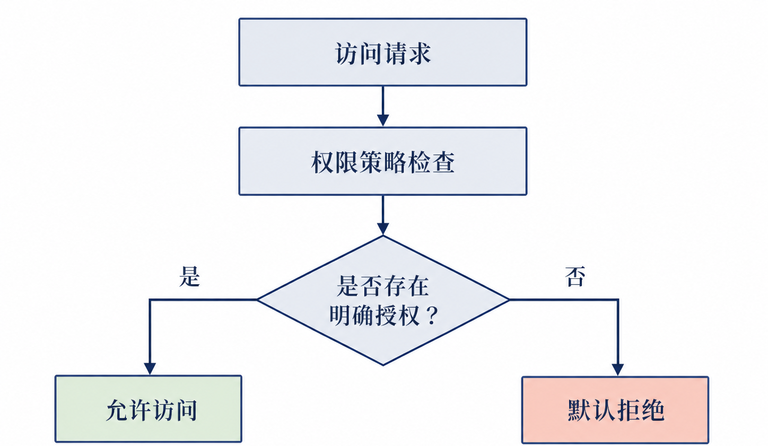
图 6 默认拒绝策略流程图

- 角色继承可能带来哪些安全风险？如何缓解？
角色继承是指高级角色自动继承低级角色的权限。例如“系统管理员”继承“普通用户”的权限。这种机制可以减少重复配置，但也可能带来权限扩散风险。
主要风险包括：第一，继承关系设计不合理时，高级角色可能获得过多权限，违反最小权限原则。第二，如果低级角色被错误地赋予了敏感权限，那么所有继承它的高级角色也会受到影响。第三，复杂的多级继承可能导致权限来源难以追踪，增加审计和排查难度。第四，角色之间如果存在职责冲突，继承可能导致同一用户同时拥有不应同时具备的权限。
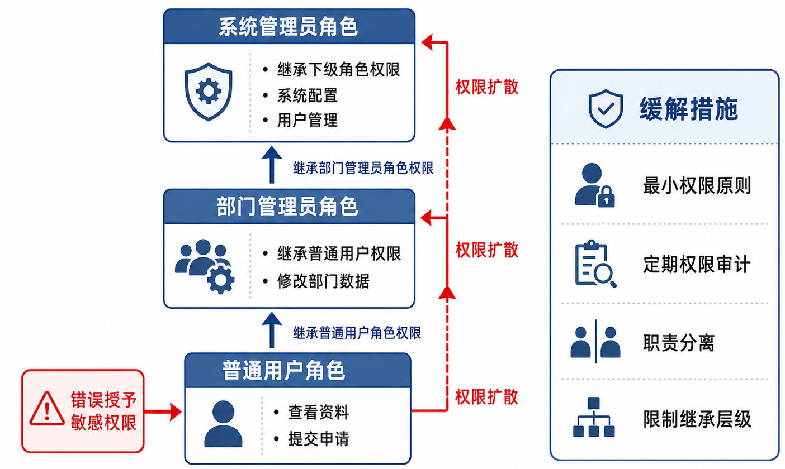
图 7 角色继承风险图
缓解方法包括：合理设计角色层级，避免过深、过复杂的继承关系；定期审查角色权限，清理不必要权限；采用最小权限原则，只授予完成工作所需的权限；设置职责分离规则，避免同一角色或用户同时拥有互相冲突的权限；在系统中记录权限来源，便于审计和追踪。

- MAC 与 ABAC 分别适合什么场景？
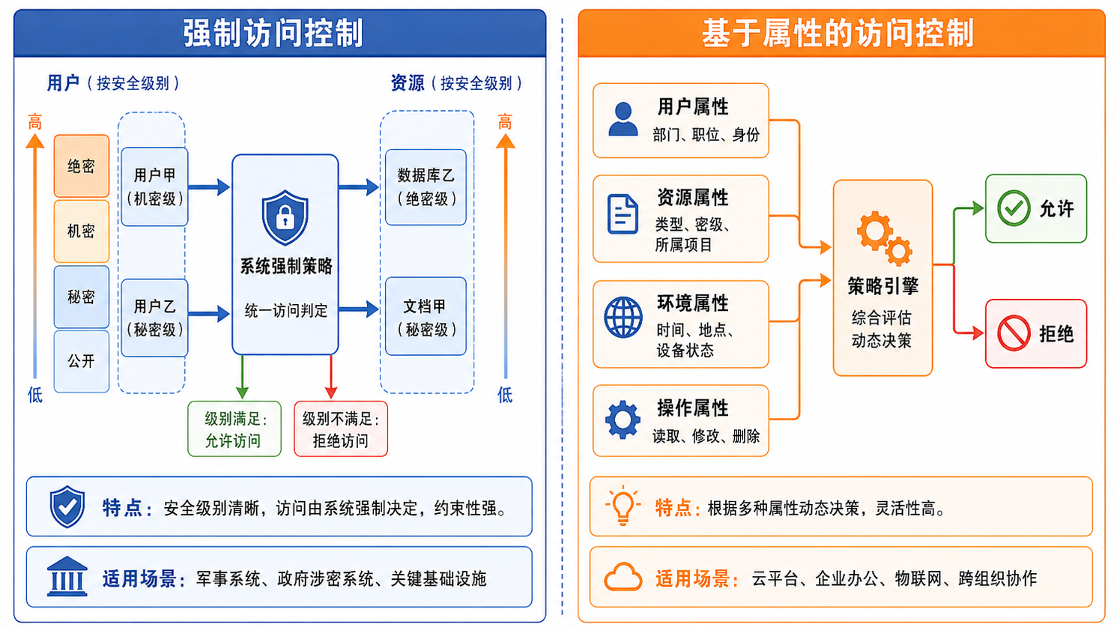
图 8 MAC与ABAC场景图
MAC 是强制访问控制，权限由系统安全策略统一决定，用户不能随意修改。它通常适合安全等级严格、保密要求高的场景，例如军事系统、政府涉密系统、核心数据库和关键基础设施系统。在这些场景中，访问权限往往按照安全级别划分，如“公开、秘密、机密、绝密”，用户只能访问其安全级别允许范围内的数据。
ABAC 是基于属性的访问控制，它根据用户属性、资源属性、环境属性和操作属性进行动态判断。例如用户部门、职位、资源类型、访问时间、访问地点、设备状态等都可以作为判断条件。ABAC 适合权限规则复杂、访问条件动态变化的场景，例如云平台、企业办公系统、物联网系统和跨组织协作系统。
简单来说，MAC 适合高安全、强约束、等级分明的系统；ABAC 适合规则灵活、条件多变、需要动态授权的系统。

- 审计日志中哪些字段不可缺少？为什么？
审计日志的作用是记录系统中发生了什么、是谁做的、什么时候做的、结果如何。因此，关键字段不可缺少。
一般应包含以下字段：
字段 | 作用
用户身份 | 记录是谁发起了访问请求，便于责任追踪
时间戳 | 记录事件发生时间，便于还原攻击过程和分析时间线
操作类型 | 说明用户执行了什么操作，例如登录、读取、修改、删除
访问对象 | 说明用户访问了哪个资源，例如文件、接口、数据库记录
访问结果 | 记录请求是成功还是失败，便于发现异常行为
失败原因 | 说明拒绝原因，例如权限不足、身份失败、策略不匹配
来源地址 | 记录请求来源，如 IP 地址或设备信息，便于定位异常来源
会话或请求编号 | 用于关联同一用户的一系列操作，方便审计分析
表 11 审计日志字段表
这些字段能够帮助系统管理员进行安全追踪、异常检测、责任认定和事故复盘。如果日志字段不完整，即使系统检测到异常，也可能无法判断攻击来源、影响范围和具体原因，从而降低安全防护和取证能力。

