实验九：Bagging集成学习
姓名： 程泽凯 | 学号：2023112621 | 分数
实验目的
理解自助采样方法，理解Bagging集成方法的思想。学会将多个决策树采用Bagging集成方法集成为随机森林模型，学会随机森林的训练和预测方法。
实验内容
编程实现随机森林模型，对手写数字识别数据集进行分类。基模型采用决策树模型，划分属性指标采用信息熵指标，随机选取属性子集数目为100：
model=tree.DecisionTreeClassifier(random_state=1,criterion='entropy',max_features=100)
model.fit(train_x,train_y)
将决策树数量$T$依次设置为$1,2,…,20$，计算随机森林在测试集上的精度，并绘制随机森林精度随基模型数量增加的变化曲线。
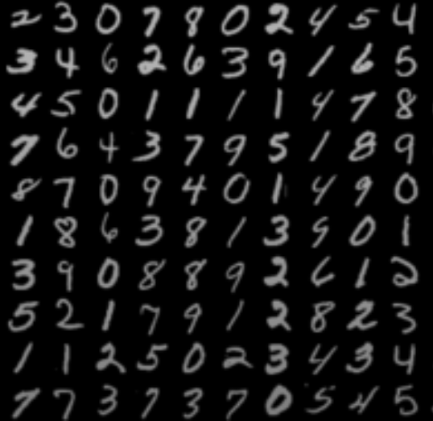
实验结果
- 测试集上精度（结果保留2位小数）
$$T$$ | 1 | 2 | 3 | 4 | 5 | 6 | 7 | 8 | 9 | 10
精度 | 0.83 | 0.83 | 0.89 | 0.91 | 0.92 | 0.93 | 0.94 | 0.94 | 0.94 | 0.95
$$T$$ | 11 | 12 | 13 | 14 | 15 | 16 | 17 | 18 | 19 | 20
精度 | 0.95 | 0.95 | 0.95 | 0.96 | 0.96 | 0.96 | 0.96 | 0.96 | 0.96 | 0.96
- 精度随$T$增加的变化曲线
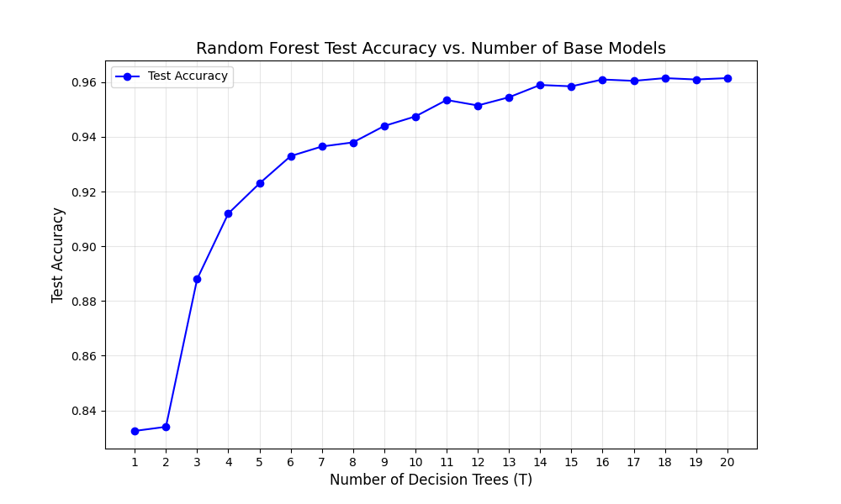
实验代码
import numpy as np
import matplotlib.pyplot as plt
from sklearn import tree
# read data from files
train_data = np.loadtxt('experiment_05_training_set.csv',delimiter=',')
test_data = np.loadtxt('experiment_05_testing_set.csv',delimiter=',')
num_train = train_data.shape[0]
num_test = test_data.shape[0]
train_x = train_data[:,:-1]/255
train_y = train_data[:,-1].reshape((num_train,1))
test_x = test_data[:,:-1]/255
test_y = test_data[:,-1].reshape((num_test,1))

import numpy as np
import matplotlib.pyplot as plt
from sklearn import tree
from sklearn.metrics import accuracy_score

train_data = np.loadtxt('experiment_09_training_set.csv', delimiter=',')
test_data = np.loadtxt('experiment_09_testing_set.csv', delimiter=',')

num_train = train_data.shape[0]
num_test = test_data.shape[0]

train_x = train_data[:, :-1] / 255
train_y = train_data[:, -1].reshape((num_train, 1))
test_x = test_data[:, :-1] / 255
test_y = test_data[:, -1].reshape((num_test, 1))

def bagging_random_forest(T, train_x, train_y, test_x, test_y):
num_samples = train_x.shape[0]
tree_models = []
predictions = []

rng = np.random.default_rng(seed=1)

for _ in range(T):
sample_indices = rng.choice(num_samples, num_samples, replace=True)
bootstrap_x = train_x[sample_indices]
bootstrap_y = train_y[sample_indices]

dt = tree.DecisionTreeClassifier(
random_state=rng.integers(0, 1000),
criterion='entropy',
max_features=100
)
dt.fit(bootstrap_x, bootstrap_y.ravel())

tree_models.append(dt)
pred = dt.predict(test_x)
predictions.append(pred)

predictions = np.array(predictions).T
predictions = predictions.astype(np.int64)
final_pred = np.array([np.bincount(row).argmax() for row in predictions])

test_acc = accuracy_score(test_y.ravel().astype(np.int64), final_pred)

return test_acc

T_range = range(1, 21)
acc_list = []

for T in T_range:
acc = bagging_random_forest(T, train_x, train_y, test_x, test_y)
acc_list.append(acc)
print(f"决策树数量T={T}时，测试集精度={acc:.2f}")

plt.figure(figsize=(10, 6))
plt.plot(T_range, acc_list, marker='o', linestyle='-', color='b', label='Test Accuracy')
plt.xlabel('Number of Decision Trees (T)', fontsize=12)
plt.ylabel('Test Accuracy', fontsize=12)
plt.title('Random Forest Test Accuracy vs. Number of Base Models', fontsize=14)
plt.xticks(T_range)
plt.grid(True, alpha=0.3)
plt.legend()
plt.show()

