实验五：神经网络
姓名： 程泽凯 | 学号：2023112621 | 分数
实验目的
理解神经网络计算框架，包括前馈神经网络、激活函数、损失函数、反向传播过程等，学会使用标准梯度下降和随机梯度下降法对神经网络进行训练，学会分析不同学习率对梯度下降算法收敛性影响。
实验内容
给定手写数字数据集，采用如下全连接神经网络进行分类。输入层784个节点，隐层12个节点，输出层10个节点，隐层和输出层均采用sigmoid激活函数，损失函数为平方损失函数。采用给定的数据初始化权重和阈值参数。
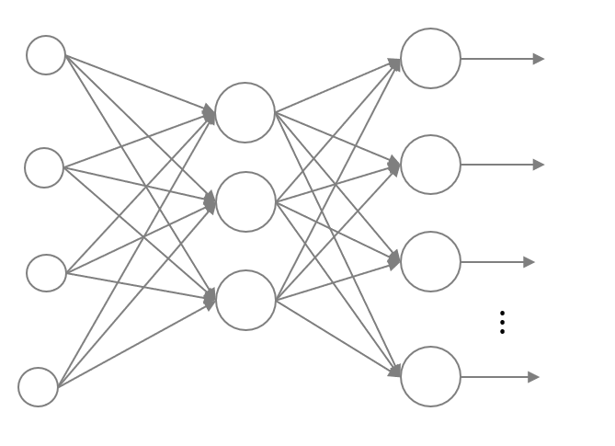
采用小批次梯度下降算法训练神经网络，批次大小依次设置为1，10，100，1000。最大迭代轮次(epoch)设为100，学习率依次设置为10，1，0.1，0.01。绘制总损失函数（所有样本的损失之和）迭代曲线，其中横坐标为轮次(epoch)，纵坐标为总损失值。将不同学习率的迭代曲线画中同一张图中。并计算不同学习率的模型在迭代100个epoch后在训练集上的损失值（结果保留整数），以及测试集上的精度（结果保留4位小数）。
实验结果
随机梯度下降，不同学习率的总损失迭代曲线（横坐标epoch从0到100）：
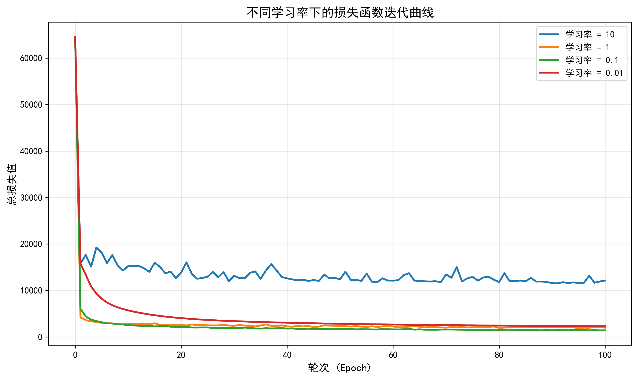
小批次梯度下降，批次大小10，不同学习率的总损失迭代曲线（横坐标epoch从0到100）：
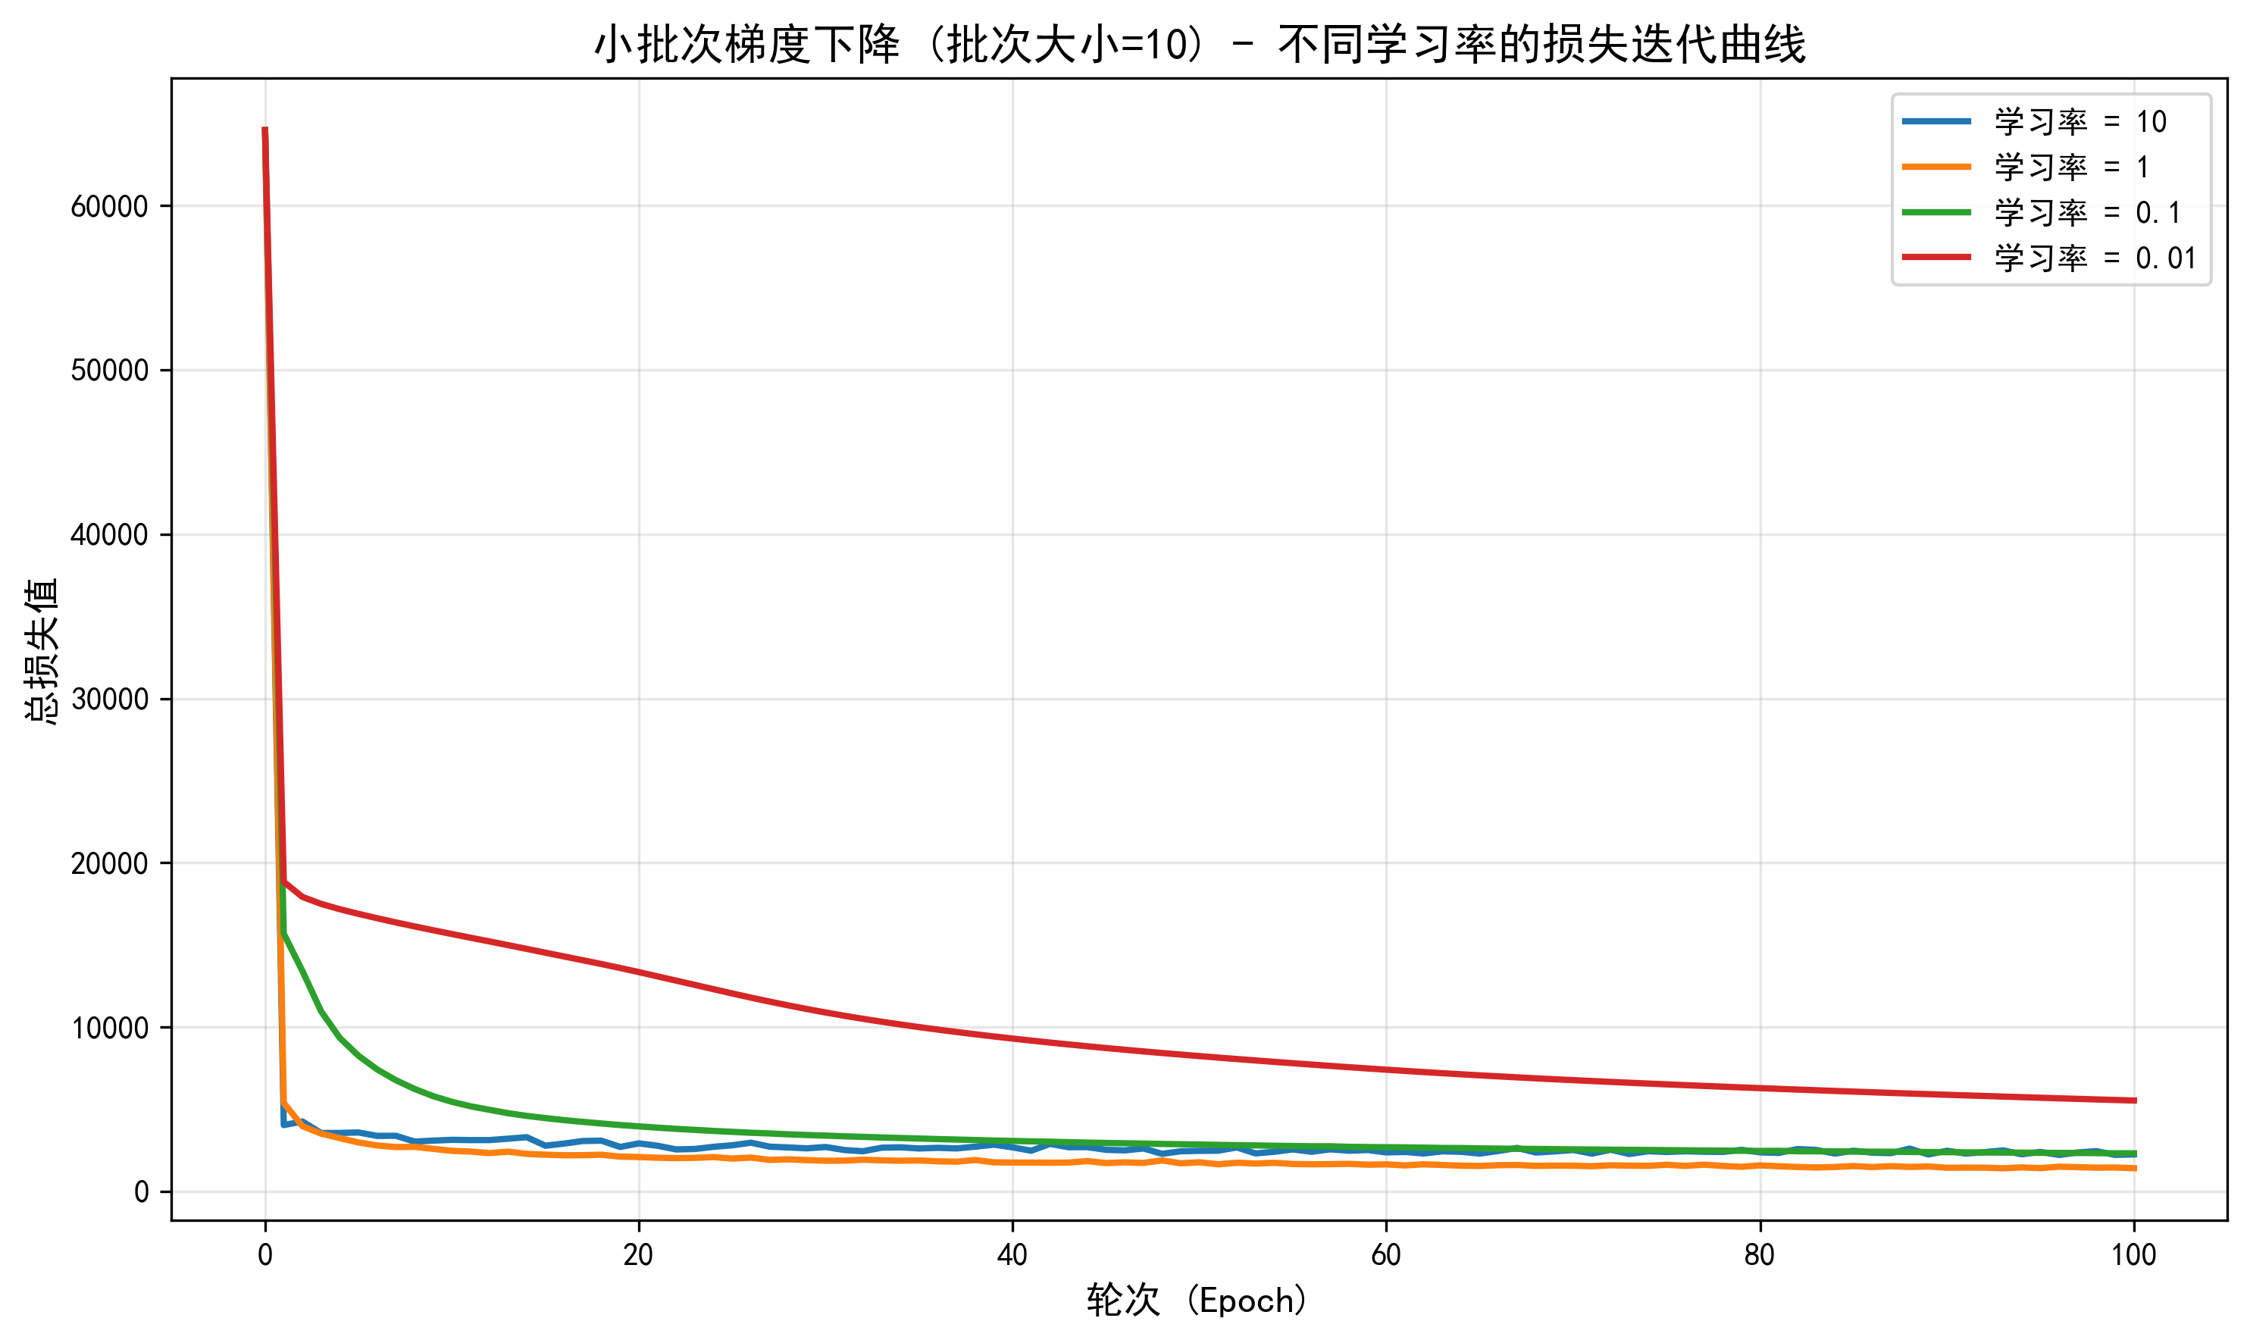
小批次梯度下降，批次大小100，不同学习率的总损失迭代曲线（横坐标epoch从0到100）：
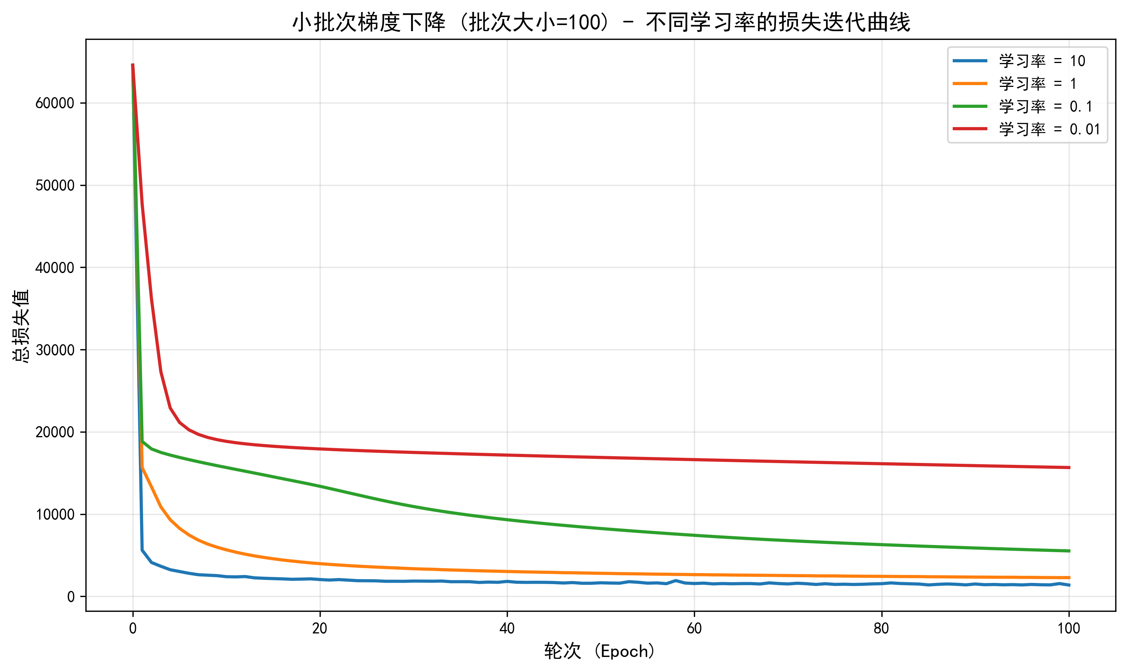
小批次梯度下降，批次大小1000，不同学习率的总损失迭代曲线（横坐标epoch从0到100）：
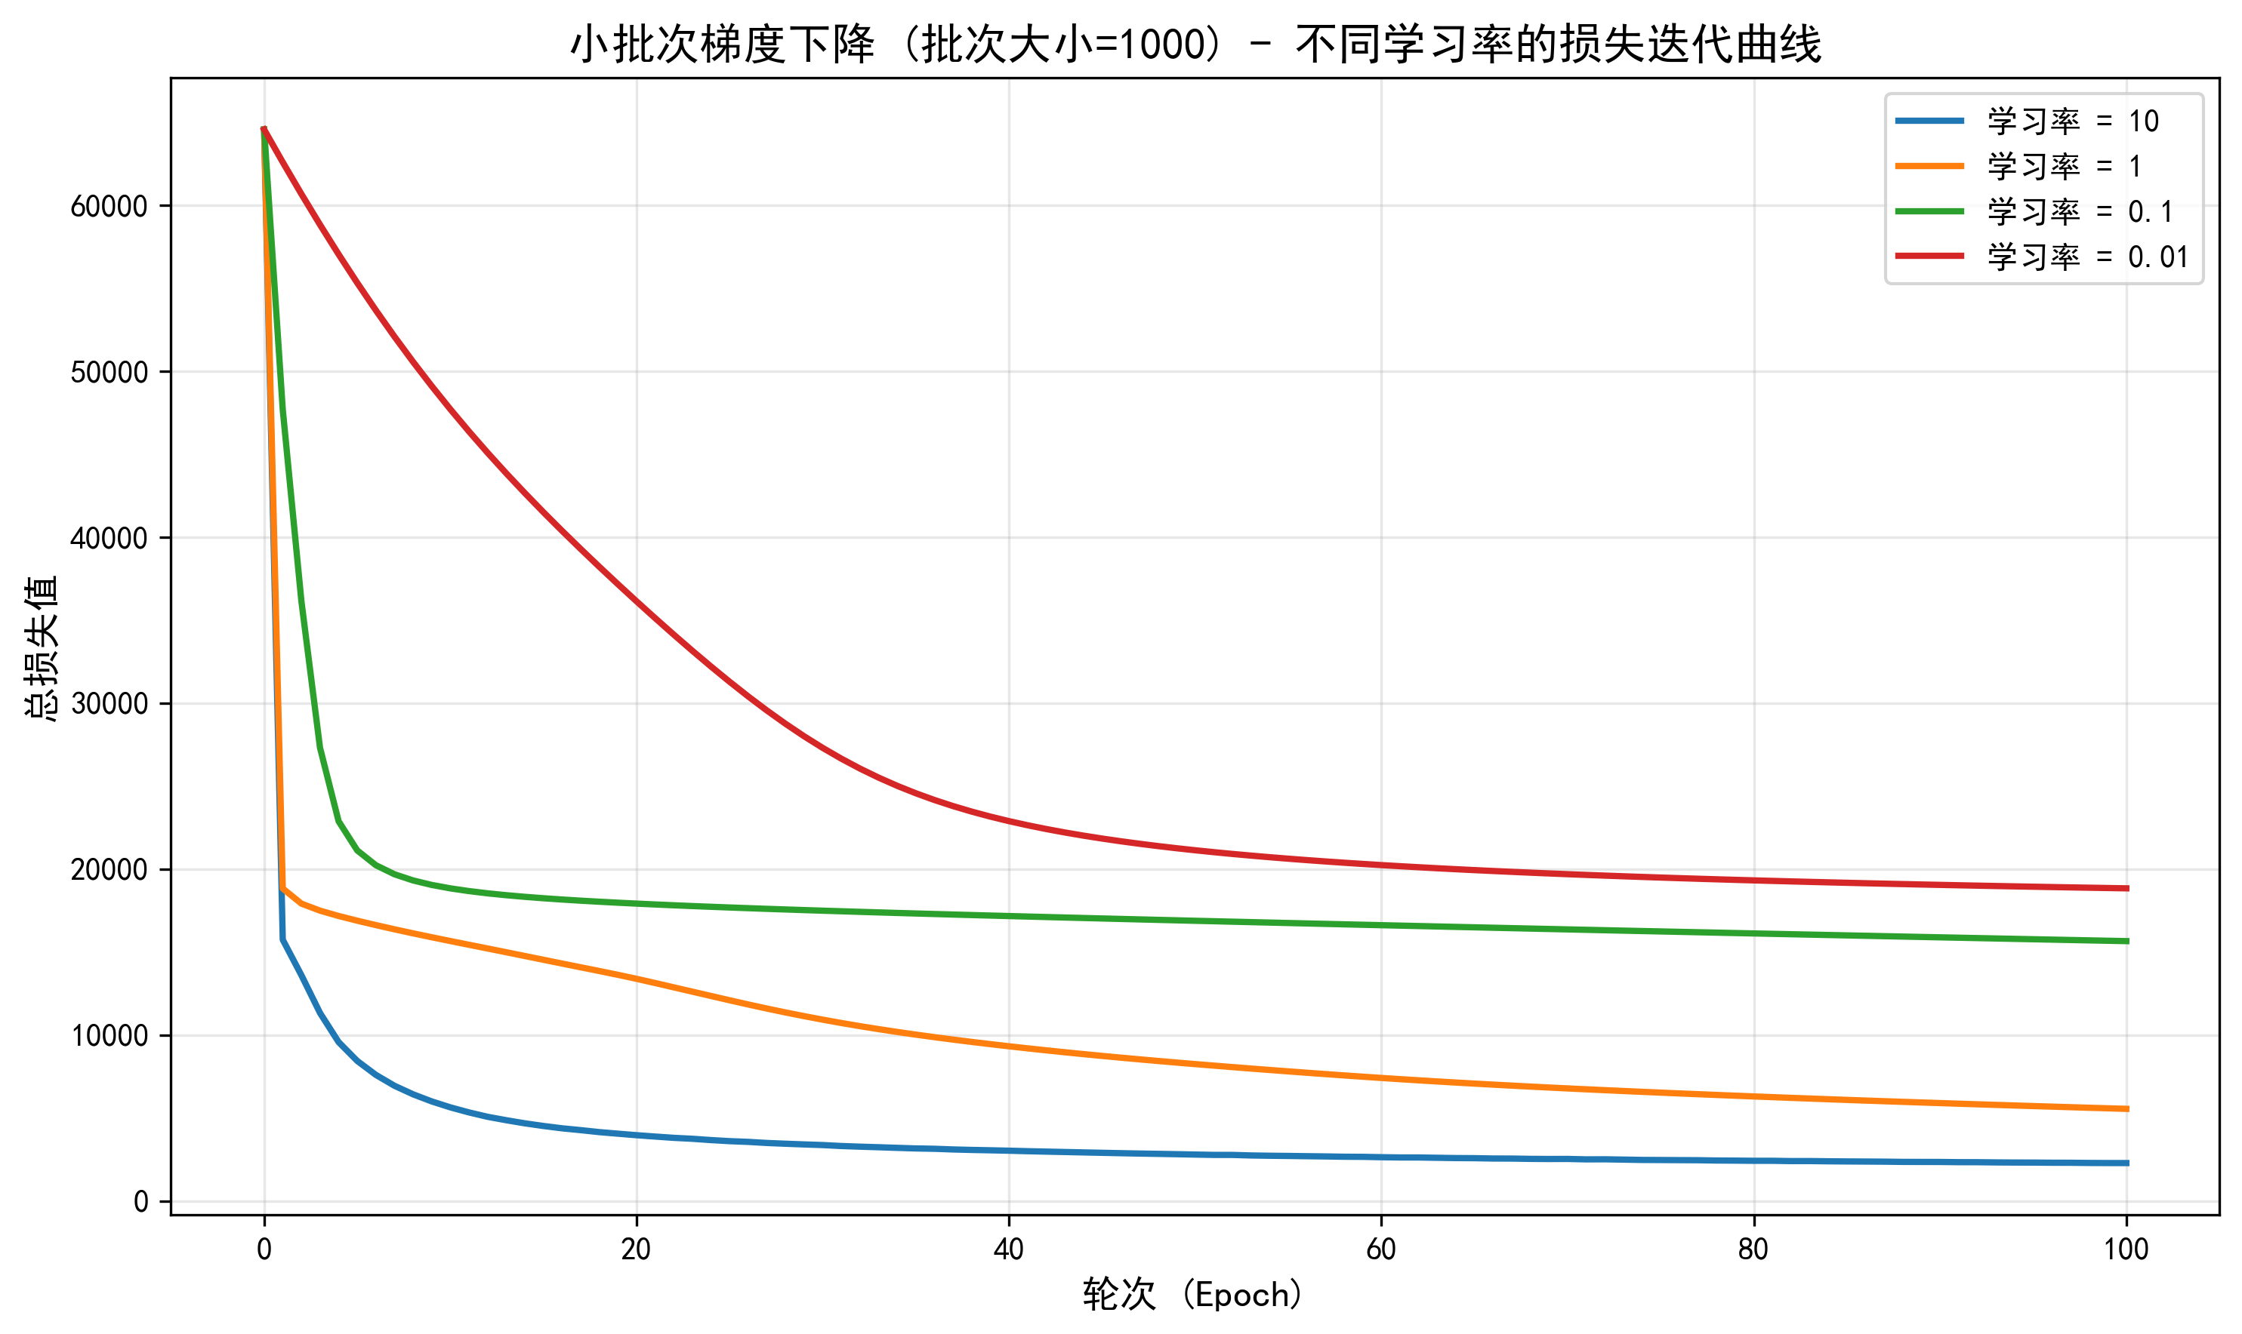
不同学习率的模型在迭代100个epoch后在训练集上的损失值（结果保留整数），以及测试集上的精度（结果保留4位小数）：
学习率 | 批次大小1 |  | 批次大小10 |  | 批次大小100 |  | 批次大小1000
学习率 | 迭代100个epoch损失 | 测试集上的精度 | 迭代100个epoch损失 | 测试集上的精度 | 迭代100个epoch损失 | 测试集上的精度 | 迭代100个epoch损失 | 迭代100个epoch损失
10 | 16624 | 0.2990 | 2253 | 0.9140 | 1372 | 0.9200 | 2279 | 0.9010
1 | 2251 | 0.9140 | 1413 | 0.9105 | 2273 | 0.8970 | 5548 | 0.8255
0.1 | 1380 | 0.9150 | 2318 | 0.8980 | 5520 | 0.8235 | 15659 | 0.3530
0.01 | 2285 | 0.8990 | 5532 | 0.8220 | 15659 | 0.3530 | 18841 | 0.1685
实验代码
import numpy as np
import matplotlib.pyplot as plt
# read data from files
train_data = np.loadtxt('experiment_05_training_set.csv',delimiter=',')
test_data = np.loadtxt('experiment_05_testing_set.csv',delimiter=',')
num_train = train_data.shape[0]
num_test = test_data.shape[0]
train_x = train_data[:,:-1]/255
train_y = train_data[:,-1]
test_x = test_data[:,:-1]/255
test_y = test_data[:,-1]
# initialization
data = np.load('initial_parameters.npz')
theta = data['arr_0']
V = data['arr_1']
b = data['arr_2']
W = data['arr_3']

# one-hot encoding
one_hot_h = np.zeros((num_train,10))
one_hot_h[np.arange(num_train),train_y.astype(int)] = 1

import numpy as np
import matplotlib.pyplot as plt
import os
import pickle

# 设置中文字体
plt.rcParams['font.sans-serif'] = ['SimHei']
plt.rcParams['axes.unicode_minus'] = False

# 读取数据
train_data = np.loadtxt('experiment_05_training_set.csv', delimiter=',')
test_data = np.loadtxt('experiment_05_testing_set.csv', delimiter=',')
num_train = train_data.shape[0]
num_test = test_data.shape[0]
train_x = train_data[:, :-1] / 255
train_y = train_data[:, -1]
test_x = test_data[:, :-1] / 255
test_y = test_data[:, -1]

# one-hot编码
one_hot_train = np.zeros((num_train, 10))
one_hot_train[np.arange(num_train), train_y.astype(int)] = 1

# Sigmoid激活函数
def sigmoid(x):
return 1 / (1 + np.exp(-np.clip(x, -500, 500)))

# 前向传播（单个样本）
def forward_single(x, W, b, V, theta):
z = W.T @ x.reshape(-1, 1) - b
a = sigmoid(z)
t = V.T @ a - theta
y = sigmoid(t)
return y, a

# 反向传播（单个样本）
def backward_single(x, y, target, a, W, b, V, theta, learning_rate):
# 计算梯度
delta_y = (y - target) * y * (1 - y)
grad_theta = -delta_y
grad_V = a @ delta_y.T

delta_a = (V @ delta_y) * a * (1 - a)
grad_b = -delta_a
grad_W = x.reshape(-1, 1) @ delta_a.T

# 更新参数
theta = theta - learning_rate * grad_theta
V = V - learning_rate * grad_V
b = b - learning_rate * grad_b
W = W - learning_rate * grad_W

return W, b, V, theta

# 计算总损失
def compute_total_loss(X, Y_onehot, W, b, V, theta):
total_loss = 0
for i in range(X.shape[0]):
y, _ = forward_single(X[i], W, b, V, theta)
target = Y_onehot[i].reshape(-1, 1)
total_loss += 0.5 * np.sum((y - target) ** 2)
return total_loss

# 计算测试集精度
def compute_accuracy(X, Y, W, b, V, theta):
correct = 0
for i in range(X.shape[0]):
y, _ = forward_single(X[i], W, b, V, theta)
pred = np.argmax(y)
if pred == Y[i]:
correct += 1
return correct / X.shape[0]

# 保存训练进度
def save_checkpoint(lr, epoch, W, b, V, theta, loss_history, checkpoint_dir='checkpoints'):
if not os.path.exists(checkpoint_dir):
os.makedirs(checkpoint_dir)

checkpoint = {
'epoch': epoch,
'W': W,
'b': b,
'V': V,
'theta': theta,
'loss_history': loss_history,
'learning_rate': lr
}

filename = os.path.join(checkpoint_dir, f'checkpoint_lr_{lr}_epoch_{epoch}.pkl')
with open(filename, 'wb') as f:
pickle.dump(checkpoint, f)
print(f" 已保存检查点: {filename}")

# 加载训练进度
def load_checkpoint(lr, checkpoint_dir='checkpoints'):
if not os.path.exists(checkpoint_dir):
return None

# 查找该学习率的所有检查点
checkpoints = [f for f in os.listdir(checkpoint_dir)
if f.startswith(f'checkpoint_lr_{lr}_') and f.endswith('.pkl')]

if not checkpoints:
return None

# 找到最新的检查点(epoch最大的)
latest_checkpoint = max(checkpoints,
key=lambda x: int(x.split('_epoch_')[1].split('.pkl')[0]))

filepath = os.path.join(checkpoint_dir, latest_checkpoint)
with open(filepath, 'rb') as f:
checkpoint = pickle.load(f)

print(f" 加载检查点: {filepath}")
print(f" 从第 {checkpoint['epoch']} 轮继续训练")
return checkpoint

# 训练函数(支持断点续训)
def train_sgd(train_x, one_hot_train, W_init, b_init, V_init, theta_init,
learning_rate, epochs, test_x=None, test_y=None,
checkpoint=None, save_interval=10):
# 如果有检查点,从检查点恢复
if checkpoint is not None:
W = checkpoint['W'].copy()
b = checkpoint['b'].copy()
V = checkpoint['V'].copy()
theta = checkpoint['theta'].copy()
loss_history = checkpoint['loss_history'].copy()
start_epoch = checkpoint['epoch']
else:
# 从初始参数开始
W = W_init.copy()
b = b_init.copy()
V = V_init.copy()
theta = theta_init.copy()
loss_history = []
start_epoch = 0

# 计算初始损失(第0次)
initial_loss = compute_total_loss(train_x, one_hot_train, W, b, V, theta)
loss_history.append(initial_loss)

for epoch in range(start_epoch, epochs):
# 随机打乱样本顺序
indices = np.random.permutation(num_train)

# 对每个样本进行SGD更新
for idx in indices:
x = train_x[idx]
target = one_hot_train[idx].reshape(-1, 1)

# 前向传播
y, a = forward_single(x, W, b, V, theta)

# 反向传播并更新参数
W, b, V, theta = backward_single(x, y, target, a, W, b, V, theta, learning_rate)

# 计算当前epoch的总损失
total_loss = compute_total_loss(train_x, one_hot_train, W, b, V, theta)
loss_history.append(total_loss)

# 定期保存检查点
if (epoch + 1) % save_interval == 0:
save_checkpoint(learning_rate, epoch + 1, W, b, V, theta, loss_history)

return W, b, V, theta, loss_history

# 小批次梯度下降训练函数
def train_minibatch(train_x, one_hot_train, W_init, b_init, V_init, theta_init,
learning_rate, epochs, batch_size, test_x=None, test_y=None,
checkpoint=None, save_interval=10):
# 如果有检查点,从检查点恢复
if checkpoint is not None:
W = checkpoint['W'].copy()
b = checkpoint['b'].copy()
V = checkpoint['V'].copy()
theta = checkpoint['theta'].copy()
loss_history = checkpoint['loss_history'].copy()
start_epoch = checkpoint['epoch']
else:
# 从初始参数开始
W = W_init.copy()
b = b_init.copy()
V = V_init.copy()
theta = theta_init.copy()
loss_history = []
start_epoch = 0

# 计算初始损失(第0次)
initial_loss = compute_total_loss(train_x, one_hot_train, W, b, V, theta)
loss_history.append(initial_loss)

num_samples = train_x.shape[0]

for epoch in range(start_epoch, epochs):
# 随机打乱样本顺序
indices = np.random.permutation(num_samples)

# 按批次处理
for i in range(0, num_samples, batch_size):
batch_indices = indices[i:i+batch_size]

# 初始化批次梯度累加器
grad_W = np.zeros_like(W)
grad_b = np.zeros_like(b)
grad_V = np.zeros_like(V)
grad_theta = np.zeros_like(theta)

# 对批次中的每个样本计算梯度
for idx in batch_indices:
x = train_x[idx]
target = one_hot_train[idx].reshape(-1, 1)

# 前向传播
y, a = forward_single(x, W, b, V, theta)

# 计算梯度
delta_y = (y - target) * y * (1 - y)
grad_theta += -delta_y
grad_V += a @ delta_y.T

delta_a = (V @ delta_y) * a * (1 - a)
grad_b += -delta_a
grad_W += x.reshape(-1, 1) @ delta_a.T

# 使用批次平均梯度更新参数
batch_len = len(batch_indices)
W = W - learning_rate * grad_W / batch_len
b = b - learning_rate * grad_b / batch_len
V = V - learning_rate * grad_V / batch_len
theta = theta - learning_rate * grad_theta / batch_len

# 计算当前epoch的总损失
total_loss = compute_total_loss(train_x, one_hot_train, W, b, V, theta)
loss_history.append(total_loss)

# 定期保存检查点
if (epoch + 1) % save_interval == 0:
save_checkpoint(f"{learning_rate}_batch{batch_size}", epoch + 1, W, b, V, theta, loss_history)

return W, b, V, theta, loss_history

# 加载初始参数
data = np.load('initial_parameters.npz')
theta_init = data['arr_0']
V_init = data['arr_1']
b_init = data['arr_2']
W_init = data['arr_3']

print(f"参数维度: W{W_init.shape}, b{b_init.shape}, V{V_init.shape}, theta{theta_init.shape}")
print(f"训练集样本数: {num_train}, 测试集样本数: {num_test}")
print("\n开始小批次梯度下降训练...\n")

# 不同的学习率和批次大小
learning_rates = [10, 1, 0.1, 0.01]
batch_sizes = [1, 10, 100, 1000]
epochs = 100

# 存储所有结果
all_results = {}

# 对每个批次大小进行实验
for batch_size in batch_sizes:
print(f"\n{'='*70}")
print(f"批次大小: {batch_size}")
print(f"{'='*70}")

results = {}

# 对每个学习率进行训练
for lr in learning_rates:
print(f"训练中: 批次大小={batch_size}, 学习率={lr}...")

# 训练(不使用检查点,每次重新训练)
W, b, V, theta, loss_history = train_minibatch(
train_x, one_hot_train, W_init, b_init, V_init, theta_init,
lr, epochs, batch_size, test_x=test_x, test_y=test_y,
checkpoint=None, save_interval=50
)

# 计算最终训练集损失
final_train_loss = compute_total_loss(train_x, one_hot_train, W, b, V, theta)

# 计算测试集精度
test_accuracy = compute_accuracy(test_x, test_y, W, b, V, theta)

results[lr] = {
'loss_history': loss_history,
'final_train_loss': final_train_loss,
'test_accuracy': test_accuracy,
'W': W, 'b': b, 'V': V, 'theta': theta
}

print(f"完成: 批次大小={batch_size}, 学习率={lr}, 训练集损失={int(final_train_loss)}, 测试集精度={test_accuracy:.4f}")

all_results[batch_size] = results

# 绘制当前批次大小的损失曲线
plt.figure(figsize=(10, 6))
for lr in learning_rates:
plt.plot(range(0, epochs + 1), results[lr]['loss_history'],
label=f'学习率 = {lr}', linewidth=2)

plt.xlabel('轮次 (Epoch)', fontsize=12)
plt.ylabel('总损失值', fontsize=12)
plt.title(f'小批次梯度下降 (批次大小={batch_size}) - 不同学习率的损失迭代曲线', fontsize=14)
plt.legend(fontsize=10)
plt.grid(True, alpha=0.3)
plt.tight_layout()
plt.savefig(f'loss_curves_batch{batch_size}.png', dpi=300, bbox_inches='tight')
plt.show()
print(f"\n已保存图片: loss_curves_batch{batch_size}.png")

# 打印完整的结果汇总表格
print("\n" + "="*80)
print("最终结果汇总 - 所有批次大小和学习率")
print("="*80)
print(f"{'批次大小':<10} {'学习率':<10} {'训练集损失(整数)':<20} {'测试集精度':<15}")
print("-"*80)
for batch_size in batch_sizes:
for lr in learning_rates:
train_loss = int(all_results[batch_size][lr]['final_train_loss'])
test_acc = all_results[batch_size][lr]['test_accuracy']
print(f"{batch_size:<10} {lr:<10} {train_loss:<20} {test_acc:.4f}")
print("="*80)

# 保存所有结果到文件
print("\n正在保存结果...")
with open('training_results.pkl', 'wb') as f:
pickle.dump(all_results, f)
print("所有结果已保存到: training_results.pkl")

# 同时保存为易读的文本文件
with open('training_results.txt', 'w', encoding='utf-8') as f:
f.write("="*80 + "\n")
f.write("训练结果汇总 - 所有批次大小和学习率\n")
f.write("="*80 + "\n")
f.write(f"{'批次大小':<10} {'学习率':<10} {'训练集损失':<20} {'测试集精度':<15}\n")
f.write("-"*80 + "\n")
for batch_size in batch_sizes:
for lr in learning_rates:
train_loss = int(all_results[batch_size][lr]['final_train_loss'])
test_acc = all_results[batch_size][lr]['test_accuracy']
f.write(f"{batch_size:<10} {lr:<10} {train_loss:<20} {test_acc:.4f}\n")
f.write("="*80 + "\n")
print("结果摘要已保存到: training_results.txt\n")

