实验六：支持向量机
姓名： 程泽凯 | 学号：2023112621 | 分数
实验目的
理解和掌握支持向量机基本原理和方法，理解数据线性可分性，理解支持向量机对偶问题，理解支持向量机核函数等概念，掌握间隔、支持向量、对偶、核函数等概念及计算方法。
实验内容
基于给定数据集，编程实现线性支持向量机模型，采用scipy库里的scipy.optimize.minimize方法求解凸二次规划问题。模型初始参数随机生成。绘制最终分类超平面，给出最终支持向量机表达式和模型在测试集上的精度。
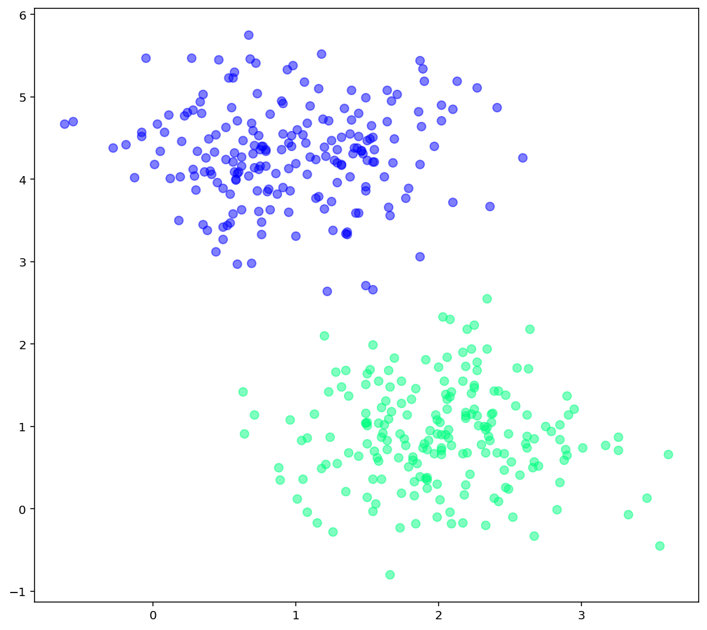
结果结果
- 分类超平面图
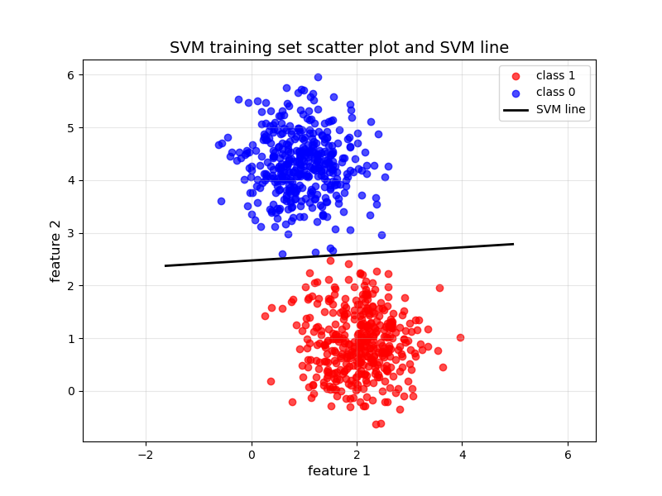

- 支持向量机表达式（参数保留两位小数）：
0.70X1+(-11.27)X2+27.89=0

- 测试集上精度（保留两位小数）：acc: 0.99
实验代码
import numpy as np
import matplotlib.pyplot as plt
from scipy.optimize import LinearConstraint, minimize
train_data = np.loadtxt('experiment_06_training_set.csv',delimiter=',')
test_data = np.loadtxt('experiment_06_testing_set.csv',delimiter=',')
num_train = train_data.shape[0]
num_test = test_data.shape[0]
train_x = train_data[:,:-1]
train_y = train_data[:,-1].reshape((num_train,1))
test_x = test_data[:,:-1]
test_y = test_data[:,-1].reshape((num_test,1))

import numpy as np
import matplotlib.pyplot as plt
import scipy
from scipy.optimize import LinearConstraint, minimize
train_data = np.loadtxt('experiment_06_training_set.csv',delimiter=',')
test_data = np.loadtxt('experiment_06_testing_set.csv',delimiter=',')
num_train = train_data.shape[0]
num_test = test_data.shape[0]
train_x = train_data[:,:-1]
train_y = train_data[:,-1].reshape((num_train,1))
test_x = test_data[:,:-1]
test_y = test_data[:,-1].reshape((num_test,1))

def svm_minimize(W):
return 0.5*W[:2].T@W[0:2]

W = np.zeros((3))
x1= np.hstack((train_x,np.ones((num_train,1))))
y1= train_y
A = x1 * y1

svm_constraint=LinearConstraint(A=A, lb=np.ones(train_x.shape[0]), ub=np.inf)
result = minimize(fun=svm_minimize,x0=W,args=(),constraints=svm_constraint)
W = result.x
print(W)

train_x_class1 = train_x[train_y.flatten() == 1]
train_x_class0 = train_x[train_y.flatten() == -1]
w1, w2, b = W

plt.figure(figsize=(8, 6))
plt.scatter(train_x_class1[:, 0], train_x_class1[:, 1], c='red',label='class 1',alpha=0.7)
plt.scatter(train_x_class0[:, 0], train_x_class0[:, 1], c='blue',label='class 0',alpha=0.7)

x1_min, x1_max = train_x[:, 0].min() - 1, train_x[:, 0].max() + 1
x1_range = np.linspace(x1_min, x1_max, 100)
x2_boundary = (-w1 * x1_range - b) / w2

plt.plot( x1_range,x2_boundary, 'k-',linewidth=2,label='SVM line')
plt.xlabel('feature 1', fontsize=12)
plt.ylabel('feature 2', fontsize=12)
plt.title('SVM training set scatter plot and SVM line', fontsize=14)
plt.legend(fontsize=10)
plt.grid(alpha=0.3)
plt.axis('equal')
plt.show()

def predict(x, w, b):
y_test = x @ np.array([w[0], w[1]]) + b
return np.sign(y_test)
acc = 0
y_test = predict(test_x, W[:2], W[2])
for i in range(test_y.shape[0]):
if y_test[i] == test_y[i]:
acc += 1
acc = acc / test_y.shape[0]
print(f"acc: {acc:.4f} ")

