实验八：Boosting集成学习
姓名： 程泽凯 | 学号：2023112621 | 分数
实验目的
理解Boosting集成思想，掌握AdaBoost集成策略，学会决策树模型的集成方法，学会AdaBoost集成模型的构建方法和预测方法。
实验内容
编程实现AdaBoost集成方法，对如下数据集进行分类。基模型采用sklearn库里的决策树模型，划分属性指标采用信息熵指标，决策树最大深度设置为2：
model = tree.DecisionTreeClassifier(random_state=1,criterion='entropy',max_depth = 2)
model.fit(train_x,train_y,sample_weights)
将基模型数量$T$依次设置为$1,2,…,20$，计算集成模型在测试集上的精度，并绘制集成模型在测试集上精度随基模型数量增加的变化曲线。
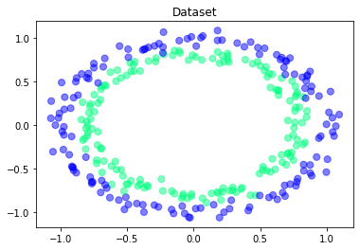
实验结果
- 测试集上精度（结果保留2位小数）
$$T$$ | 1 | 2 | 3 | 4 | 5 | 6 | 7 | 8 | 9 | 10
精度 | 0.68 | 0.68 | 0.83 | 0.83 | 0.83 | 0.83 | 0.83 | 0.83 | 0.83 | 0.83
$$T$$ | 11 | 12 | 13 | 14 | 15 | 16 | 17 | 18 | 19 | 20
精度 | 0.83 | 0.83 | 0.84 | 0.84 | 0.84 | 0.86 | 0.86 | 0.89 | 0.89 | 0.91
- 精度随$T$增加的变化曲线
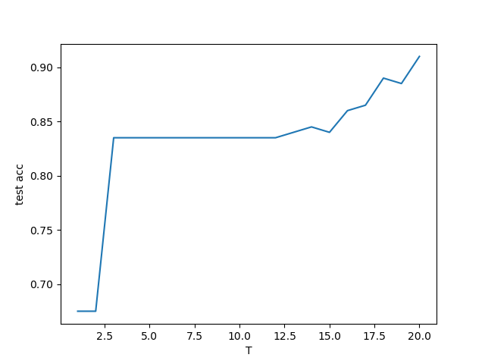
实验代码
import numpy as np
import matplotlib.pyplot as plt
from sklearn import tree
# read data from files
load_data1 = np.loadtxt('experiment_08_training_set.csv',delimiter=',')
load_data2 = np.loadtxt('experiment_08_testing_set.csv',delimiter=',')
train_x = load_data1[:,:-1]
train_y = load_data1[:,-1]
test_x = load_data2[:,:-1]
test_y = load_data2[:,-1]

T = 20
test_errors = []
test_accs = []
for t in range(T):
# print(train_x.shape)
sample_weights = np.full(train_x.shape[0],1/train_x.shape[0])
a = np.zeros(t+1)
models = []
train_errors = []
for i in range(t+1):
model = tree.DecisionTreeClassifier(random_state=1,criterion='entropy',max_depth = 2)
model.fit(train_x,train_y,sample_weight=sample_weights)
models.append(model)
train_pred_y = model.predict(train_x)
train_error = 0
for j in range(train_x.shape[0]):
train_error += (train_pred_y[j] != train_y[j]) * sample_weights[j]

a[i] = 0.5 * np.log((1 - train_error) / train_error)
train_errors.append(train_error)
sample_weights = sample_weights * np.exp(-a[i] * train_y * train_pred_y)
sample_weights = sample_weights / np.sum(sample_weights)

result = np.zeros(test_x.shape[0])
for i in range(t+1):
test_pred_y = models[i].predict(test_x)
result += a[i] * test_pred_y
test_pred_y = np.sign(result)
test_error = np.sum(test_pred_y != test_y) / test_y.shape[0]
test_acc = 1 - test_error
test_accs.append(test_acc)
print('t = %d,test acc=%.2f' % (t+1, test_acc))
test_errors.append(test_error)

plt.plot(range(1,T+1),test_accs)
plt.xlabel('T')
plt.ylabel('test acc')
plt.show()

