实验十：聚类算法
姓名： 程泽凯 | 学号：2023112621 | 分数
实验目的
了解无监督任务范式概念，理解聚类任务，理解k-means聚类算法的计算流程，学会k-means聚类算法基本原理和实现方法。
实验内容
编程实现k均值聚类算法，对如下数据进行聚类。选取k=5，从样本中选出索引为21，38，53，287，350的5个点作为初始聚类中心，设置迭代次数为10，并在迭代过程中计算每次聚类结果的loss值：
$$loss=\sum_{i=1}^{k}{\sum_{x∈C_{i}}{{\left\|x−u^{\left(i\right)}\right\|}^{2}}}$$
绘制最终聚类结果图，用不同颜色表示不同的类。绘制loss值随迭代次数增加的变化曲线图。
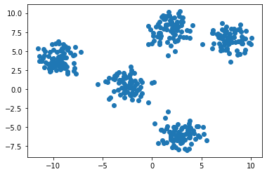
结果分析
- 聚类结果图
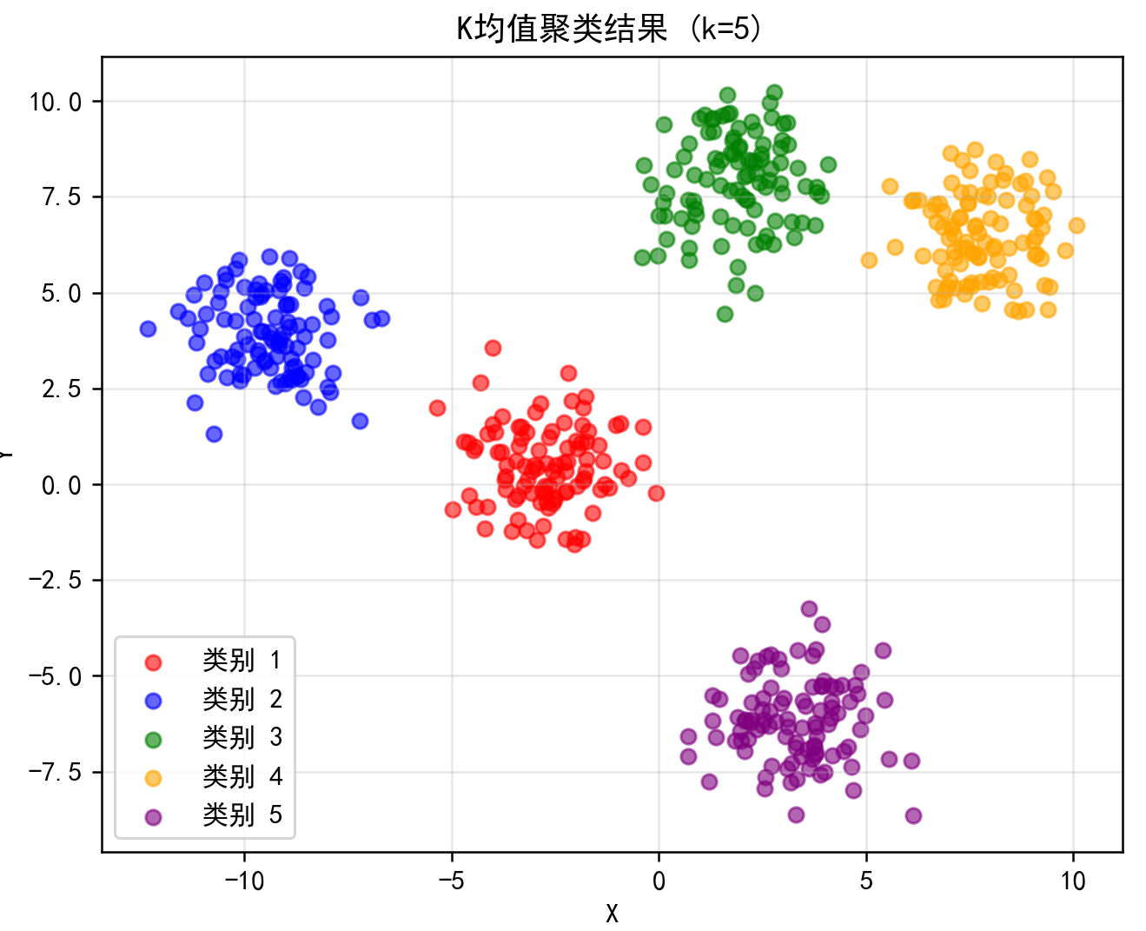
- Loss随迭代次数增加的变化曲线图
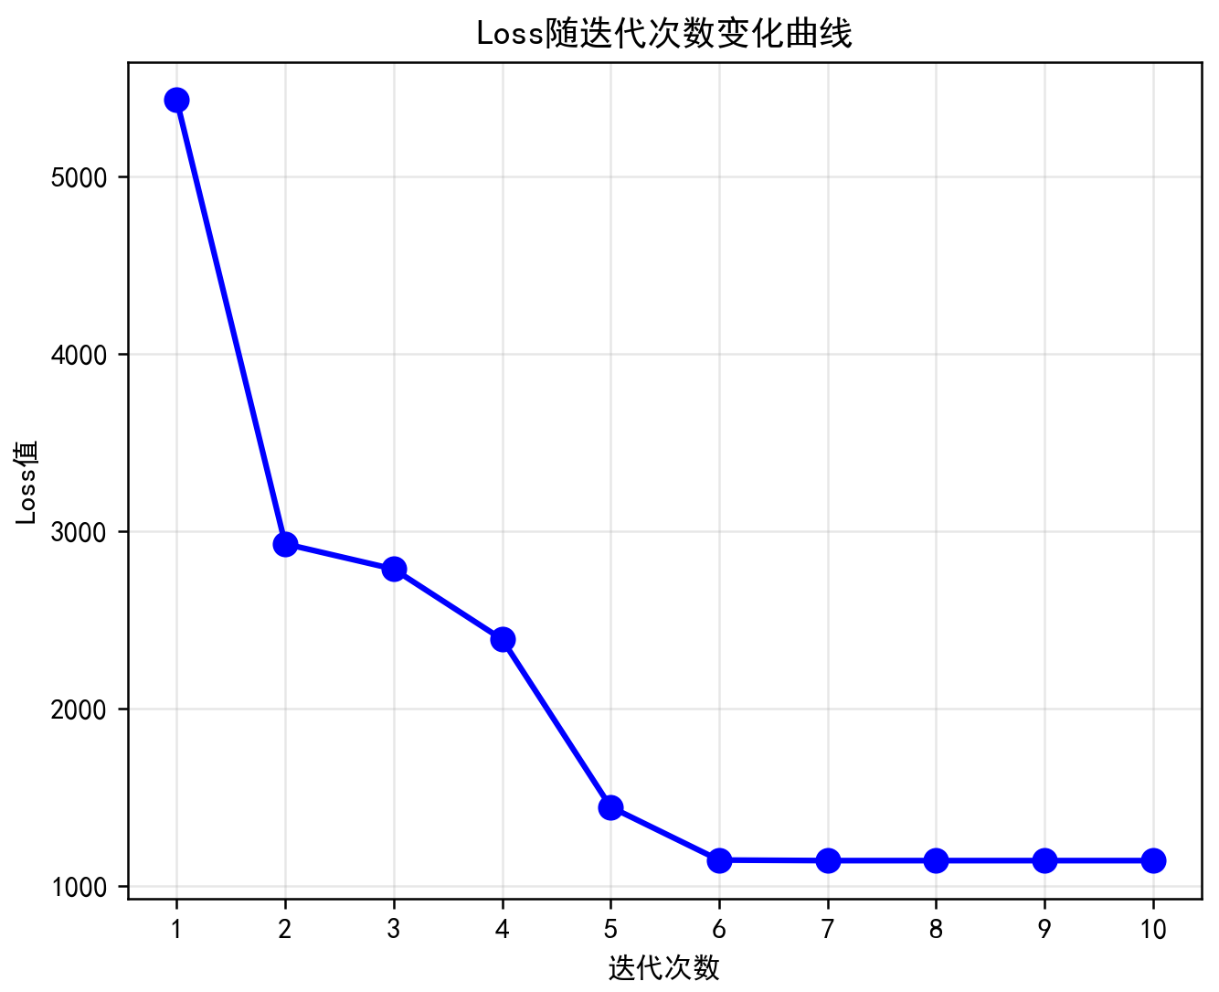
实验代码
import numpy as np
import matplotlib.pyplot as plt
# read data from files
train_x = np.loadtxt('experiment_10_training_set.csv',delimiter=',')

plt.rcParams['font.sans-serif'] = ['SimHei', 'Microsoft YaHei', 'DejaVu Sans']
plt.rcParams['axes.unicode_minus'] = False

def kmeans(data, k, initial_indices, max_iter=10):
n_samples = data.shape[0]
centers = data[initial_indices].copy()
loss_history = []
for iteration in range(max_iter):
distances = np.zeros((n_samples, k))
for i in range(k):
distances[:, i] = np.sum((data - centers[i]) ** 2, axis=1)
labels = np.argmin(distances, axis=1)

loss = 0
for i in range(n_samples):
loss += distances[i, labels[i]]
loss_history.append(loss)
print(f"迭代 {iteration + 1}: Loss = {loss:.4f}")
new_centers = np.zeros_like(centers)
for i in range(k):
cluster_points = data[labels == i]
if len(cluster_points) > 0:
new_centers[i] = cluster_points.mean(axis=0)
else:
new_centers[i] = centers[i]

centers = new_centers

return labels, centers, loss_history

k = 5
initial_indices = [21, 38, 53, 287, 350]
max_iter = 10

print("初始聚类中心索引:", initial_indices)
print("初始聚类中心坐标:")
for i, idx in enumerate(initial_indices):
print(f" 中心{i+1} (索引{idx}): {train_x[idx]}")
print()

labels, centers, loss_history = kmeans(train_x, k, initial_indices, max_iter)

plt.figure(figsize=(12, 5))

plt.subplot(1, 2, 1)
colors = ['red', 'blue', 'green', 'orange', 'purple']
for i in range(k):
cluster_points = train_x[labels == i]
plt.scatter(cluster_points[:, 0], cluster_points[:, 1],
c=colors[i], label=f'类别 {i+1}', alpha=0.6, s=30)

plt.xlabel('X')
plt.ylabel('Y')
plt.title('K均值聚类结果 (k=5)')
plt.legend()
plt.grid(True, alpha=0.3)

# 子图2: Loss变化曲线
plt.subplot(1, 2, 2)
plt.plot(range(1, max_iter + 1), loss_history, 'b-o', linewidth=2, markersize=8)
plt.xlabel('迭代次数')
plt.ylabel('Loss值')
plt.title('Loss随迭代次数变化曲线')
plt.grid(True, alpha=0.3)
plt.xticks(range(1, max_iter + 1))

plt.tight_layout()
plt.savefig('kmeans_result.png', dpi=150, bbox_inches='tight')
plt.show()

print("\n最终聚类中心:")
for i in range(k):
count = np.sum(labels == i)
print(f" 类别{i+1}: 中心={centers[i]}, 样本数={count}")

print(f"\n最终Loss值: {loss_history[-1]:.4f}")
print("\n结果图已保存为 kmeans_result.png")

