实验二：线性回归
姓名： 程泽凯 | 学号：2023112621 | 分数
实验目的
理解和掌握线性回归模型基本原理和方法，学会使用线性回归模型对问题进行建模和预测，掌握拟合问题模型评估方法。
实验内容
- 假设线性模型为$y=w_{1}x+w_{2}$，在给定数据集上训练模型，得到模型参数，计算模型在测试集上均方误差，并将训练数据、测试数据、训练模型绘制在一张图中。
- 假设二次线性模型为$y=w_{1}x^{2}+w_{2}x+w_{3}$，在给定数据集上训练模型，得到模型参数，计算模型在测试集上均方误差，并将训练数据、测试数据、训练模型绘制在一张图中。
结果分析
- 模型参数为（结果保留两位小数）：w1 = -9.72 w2=208.60
测试集均方误差为（结果保留两位小数）：12.37
绘图结果为：
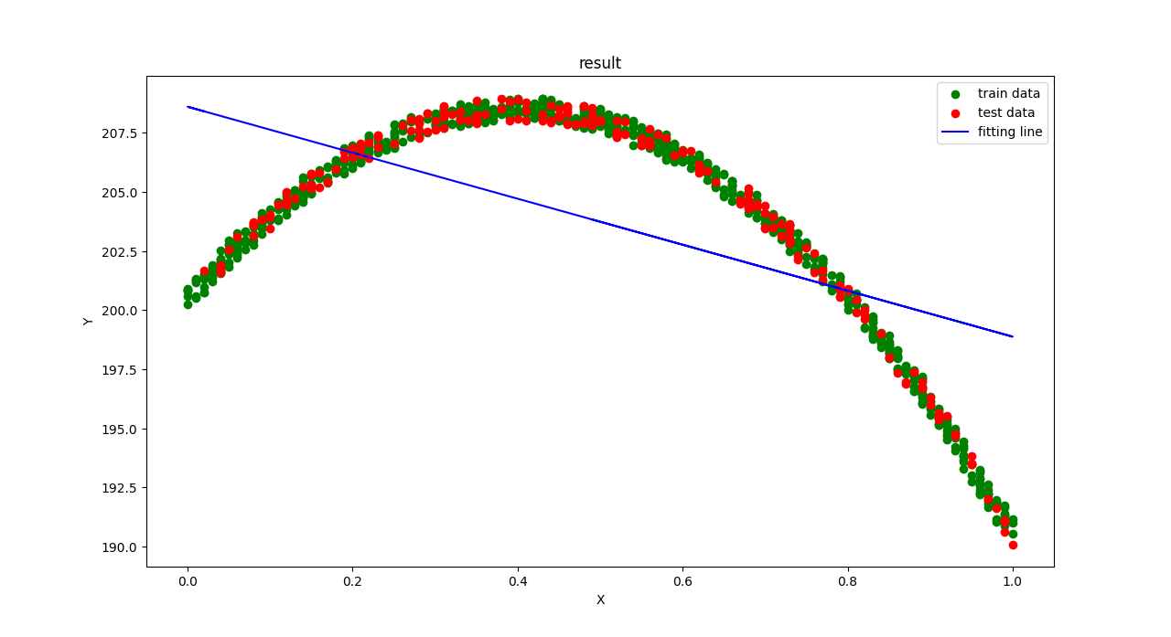
- 模型参数为（结果保留两位小数）：w1=-50.05 w2=40.12 w3=200.45
测试集均方误差为（结果保留两位小数）：0.09
绘图结果为：
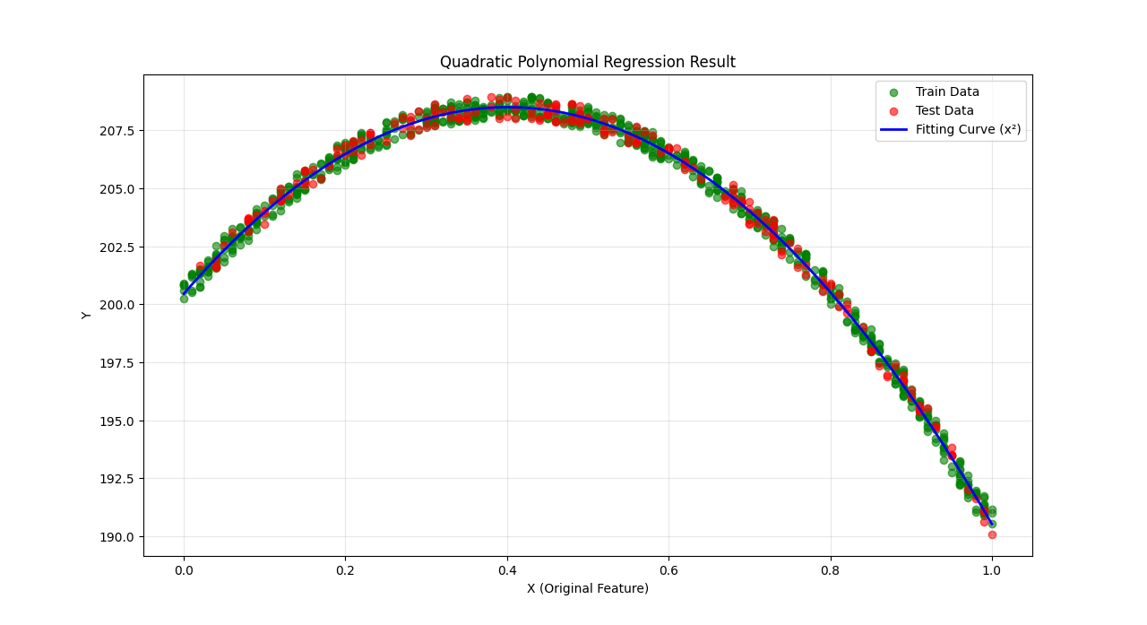
实验代码
- 问题1代码
import numpy as np
import matplotlib.pyplot as plt
# read data from files
load_data1 = np.loadtxt('experiment_02_training_set.csv',delimiter=',')
load_data2 = np.loadtxt('experiment_02_testing_set.csv',delimiter=',')
num_train = load_data1.shape[0]
num_test = load_data2.shape[0]
# split the data
train_x = load_data1[:,0].reshape((num_train,1))
train_y = load_data1[:,1].reshape((num_train,1))
test_x = load_data2[:,0].reshape((num_test,1))
test_y = load_data2[:,1].reshape((num_test,1))

one_col = np.ones(train_x.shape[0]).reshape((train_x.shape[0],1))
x = train_x
x = np.hstack((x,one_col))
xt = x
xt = xt.T
y = train_y

w = np.linalg.inv(xt@x)@xt@y
print(w)
y_pred = np.zeros(test_x.shape[0]).reshape((test_x.shape[0],1))
total_err = 0

one_coltest = np.ones(test_x.shape[0]).reshape((test_x.shape[0],1))

test_x = np.hstack((test_x,one_coltest))
for i in range(test_x.shape[0]):
y_pred[i] = test_x[i]@w
total_err +=(y_pred[i]-test_y[i])**2
mse = total_err/test_x.shape[0]
print(mse)

y_pred_train = np.zeros(train_x.shape[0]).reshape((train_x.shape[0],1))
for i in range(train_x.shape[0]):
y_pred_train[i] = x[i]@w

plt.scatter(train_x, train_y, label='train data', color='green' )
plt.scatter(test_x[:,0], test_y, label='test data', color='red' )
plt.plot(train_x, y_pred_train, label='fitting line',color='blue')
plt.xlabel('X')
plt.ylabel('Y')
plt.title('result')
plt.legend()
plt.show()

- 问题2代码
import numpy as np
import matplotlib.pyplot as plt
# read data from files
load_data1 = np.loadtxt('experiment_02_training_set.csv',delimiter=',')
load_data2 = np.loadtxt('experiment_02_testing_set.csv',delimiter=',')
num_train = load_data1.shape[0]
num_test = load_data2.shape[0]
# split the data
train_x = load_data1[:,0].reshape((num_train,1))
train_y = load_data1[:,1].reshape((num_train,1))
test_x = load_data2[:,0].reshape((num_test,1))
test_y = load_data2[:,1].reshape((num_test,1))

xt = x_train.T
w = np.linalg.inv(xt @ x_train) @ xt @ train_y
print("二次多项式回归参数 w (w2, w1, w0):")
print(w)

test_x_sq = test_x_raw ** 2
one_col_test = np.ones(num_test).reshape((num_test, 1))
x_test = np.hstack((test_x_sq, test_x_raw, one_col_test))

y_pred_test = np.zeros(num_test).reshape((num_test, 1))
total_err = 0
for i in range(num_test):
y_pred_test[i] = x_test[i] @ w
total_err += (y_pred_test[i] - test_y[i]) ** 2
mse = total_err / num_test
print("测试集 MSE:", mse)

y_pred_train = np.zeros(num_train).reshape((num_train, 1))
for i in range(num_train):
y_pred_train[i] = x_train[i] @ w

sorted_idx = np.argsort(train_x_raw.flatten())
sorted_train_x = train_x_raw[sorted_idx]
sorted_train_y_pred = y_pred_train[sorted_idx]

plt.figure(figsize=(10, 6))
plt.scatter(train_x_raw, train_y, label='Train Data', color='green', alpha=0.6)
plt.scatter(test_x_raw, test_y, label='Test Data', color='red', alpha=0.6)
plt.plot(sorted_train_x, sorted_train_y_pred, label='Fitting Curve (x²)', color='blue', linewidth=2) # 平滑曲线

plt.xlabel('X (Original Feature)')
plt.ylabel('Y')
plt.title('Quadratic Polynomial Regression Result')
plt.legend()
plt.grid(alpha=0.3)
plt.show()

