Report: Optimizing NYC Taxi Operations
Include your visualizations, analysis, results, insights, and outcomes. Explain your methodology and approach to the tasks. Add your conclusions to the sections.

Data Preparation
  - Loading the dataset
    - Sample the data and combine the files
Handling such a large number of rows is not computationally feasible when we have to combine the data for all twelve months into one. It is too heavy for laptop to handle 12 file. So we need sampling of data.
For this I have created loop system This loop reads taxi trip data for each month of 2023, takes a 5% random sample from each file, and stores them in a list. After the loop finishes, all samples are combined into one DataFrame called final_df. Finally, the .shape function prints how many rows and columns the combined dataset contains. This way, I can work with a smaller but representative dataset instead of the full year’s data.

Data Cleaning

Fixing Columns
    - Fix the index
The command df_filtered.reset_index(drop=True, inplace=True) is used to reset the index of the DataFrame df_filtered. When data is filtered or merged, the index values may become non-sequential or retain the old numbering from the original dataset. By calling .reset_index(), the index is reassigned to run from 0 up to the number of rows. The argument drop=True ensures that the old index column is not added back into the DataFrame as a separate column. The argument inplace=True applies the change directly to df_filtered instead of creating a new DataFrame. This step keeps the dataset clean and avoids confusion from outdated index values.

    - Combine the two airport_fee columns
The command df.columns = df.columns.str.strip() is used to clean the column names by removing any leading or trailing spaces. This ensures consistency when accessing columns. Next, the code combines two similar columns, airport_fee and Airport_fee, into a single column called airport_fee_combined. The .get() function is used to safely access each column, and if the column does not exist, a default pd.Series of zeros is returned. Wrapping with pd.Series ensures that the .fillna(0) method works correctly, replacing any missing values with zero. The two columns are then added together to create the combined values. Finally, the old columns (airport_fee and Airport_fee) are dropped from the DataFrame using df.drop(), with errors='ignore' to avoid errors if one of the columns is missing. This process standardizes the dataset by merging duplicate columns and cleaning unnecessary ones, making the data easier to analyze.

Handling Missing Values
    - Find the proportion of missing values in each column
This command is used to calculate the proportion of missing values in each column of the dataset. First, the function checks for missing entries using isnull(). Then, instead of counting them, the .mean() function computes the fraction of missing values relative to the total number of rows, giving a percentage for each column. Finally, the results are sorted in descending order so that the columns with the highest proportion of missing data appear at the top. This helps quickly identify which parts of the dataset have the most missing information and may require cleaning or special handling before analysis.

    - Handling missing values in passenger_count
The first command (df['passenger_count'] == 0).sum() counts how many rows in the dataset have a passenger count of zero. This helps identify trips that may be invalid or incorrectly recorded. The next command df[df['passenger_count'] == 0].head() displays the first few rows where the passenger count is zero, allowing a quick inspection of these records. Finally, the line df['passenger_count'] = df['passenger_count'].replace(0, np.nan) replaces all zero values in the passenger_count column with NaN (missing values), since a trip with zero passengers is not meaningful. This cleaning step ensures that the dataset only contains valid passenger counts and treats invalid entries as missing data for further handling.

    - Handle missing values in RatecodeID
The first command df['RatecodeID'].value_counts() is used to display the frequency of each value in the RatecodeID column, helping to understand how often each rate code appears in the dataset. Next, the line df['RatecodeID'] = df['RatecodeID'].replace(0, np.nan) replaces any 0 values with NaN (missing values), since 0 is not a valid rate code. Finally, the command df.loc[df['RatecodeID'] > 6, 'RatecodeID'] = np.nan sets all values greater than 6 to NaN, because valid rate codes are only defined within the range 1–6. Together, these steps clean the RatecodeID column by removing invalid entries and ensuring that only meaningful values remain for analysis.

    - Impute NaN in congestion_surcharge
The first command (df['congestion_surcharge'] == 0).sum() counts how many rows in the dataset have a congestion surcharge value of zero. This helps identify trips where no surcharge was recorded. The next command df[df['congestion_surcharge'] == 0].head() displays the first few rows with a zero surcharge, allowing a quick inspection of these records. Finally, the line df['congestion_surcharge'] = df['congestion_surcharge'].replace(0, np.nan) replaces all zero values in the congestion_surcharge column with NaN (missing values). This is done because a zero surcharge may indicate missing or invalid data rather than a true value. By converting these entries to missing values, the dataset is cleaned and prepared for more accurate analysis.

Handling Outliers and Standardizing Values
    - Check outliers in payment type, trip distance and tip amount columns
The first step restricts the dataset to only trips with six or fewer passengers, since higher values are unrealistic and considered invalid. After this, a custom function remove_outliers_iqr is defined to detect and remove outliers using the Interquartile Range (IQR) method. This method calculates the first quartile (Q1) and third quartile (Q3), then determines the IQR as the difference between them. Any values falling below Q1 – 1.5 × IQR or above Q3 + 1.5 × IQR are treated as outliers and removed. The function is applied to three important numeric columns: trip_distance, fare_amount, and total_amount. For each column, the number of outliers removed is printed, and the final dataset shape is displayed to show how many rows remain after cleaning. Finally, boxplots are generated for these columns to visually confirm that extreme values have been removed and the data is now cleaner and more reliable for analysis.

Exploratory Data Analysis

General EDA: Finding Patterns and Trends
    - Classify variables into categorical and numerical
VendorID: Categorical Represents vendor labels (1,2)
tpep_pickup_datetime: Categorical(Temporal) Time-based, not numeric magnitude
tpep_dropoff_datetime: Categorical(Temporal) Time-based, not numeric magnitude
passenger_count: Numerical (Discrete) Count variable
trip_distance :Numerical (Continuous) Measured distance
RatecodeID :Categorical Encoded categories (1–6)
PULocationID: Categorical Location identifier
DOLocationID: Categorical Location identifier
payment_type :Categorical Encoded payment categories
pickup_hour: Categorical (Ordinal) Time bucket (0–23)
fare_amount: Categorical
extra: Categorical
mta_tax: Categorical
tip_amount: Categorical
tolls_amount: Categorical
improvement_surcharge: Categorical
total_amount: Categorical
congestion_surcharge: Categorical
airport_fee: Categorical
trip_duration: Numerical (Continuous) Time measurement

    - Analyse the distribution of taxi pickups by hours, days of the week, and months
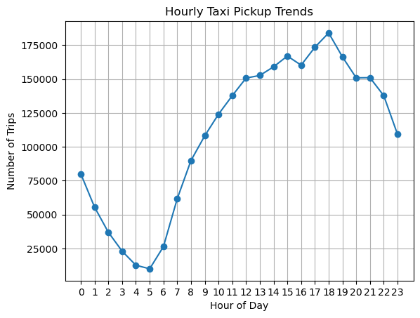
The line graph titled “Hourly Taxi Pickup Trends” shows how taxi demand changes across a full day.
- Lowest demand: Between 4 AM and 5 AM, very few trips are recorded, reflecting the quietest period of the day.
- Steady rise: From early morning onward, pickups gradually increase as people begin commuting.
- Peak demand: The busiest hours are between 4 PM and 6 PM, with the absolute peak around 5 PM. This aligns with evening commute times when many people are leaving work.
- Daily cycle: The pattern highlights a clear rhythm—low activity overnight, rising through the day, and peaking in the evening before tapering off again.
In summary: The chart illustrates typical urban travel behavior, with taxi demand strongly tied to commuting hours, especially the evening rush.

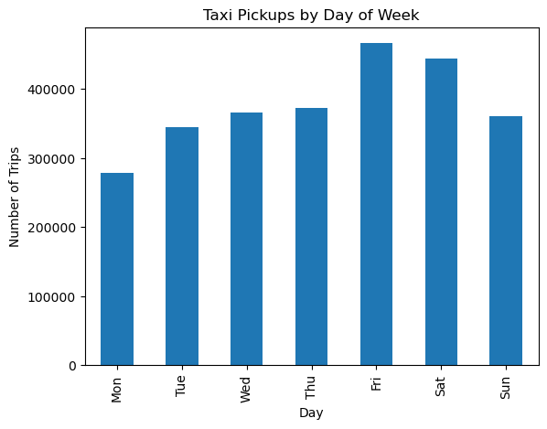
The bar chart titled “Taxi Pickups by Day of Week” shows how demand for taxis changes across the week.
- Lowest demand: Monday has the fewest trips, which reflects the quieter start of the week.
- Steady midweek activity: Tuesday through Thursday show moderate levels of pickups, fairly consistent with daily commuting patterns.
- Peak demand: Friday records the highest number of trips, followed closely by Saturday. This suggests increased travel for social outings, nightlife, and weekend activities.
- Weekend trend: Sunday shows slightly fewer trips than Saturday but still higher than weekdays, indicating continued leisure travel.

In summary: Taxi usage is lowest at the beginning of the week, rises steadily, and peaks on Friday and Saturday, highlighting how demand is strongly influenced by work schedules and weekend social activities.

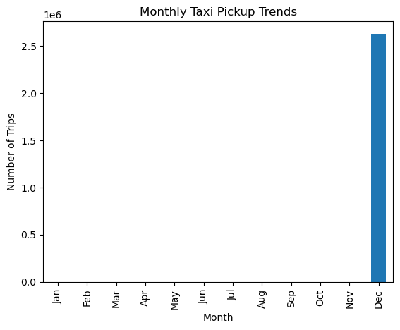

The bar chart titled “Monthly Taxi Pickup Trends” shows how taxi demand varies across the year.
- Low activity: From January through November, there are no visible bars, indicating either very low recorded trips or missing data for those months.
- Sharp spike in December: December stands out with approximately 2.6 million trips, far higher than any other month.
- Seasonal or anomaly effect: This sudden increase could reflect seasonal travel demand (such as holidays and year-end events) or a data anomaly where only December’s records were captured.

In summary: The chart highlights an unusual pattern where December dominates taxi pickups, suggesting either a strong seasonal surge in demand or incomplete data for the rest of the year.
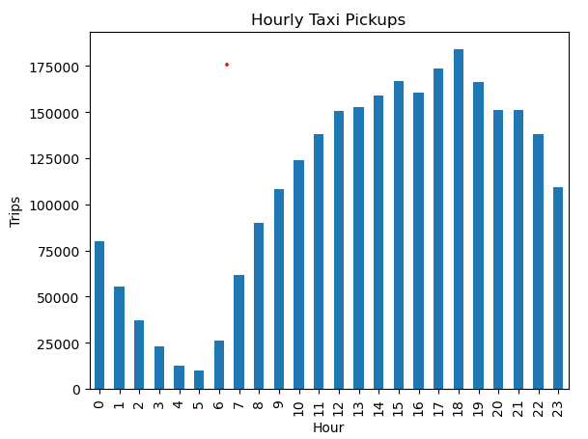
“Hourly Taxi Pickups” shows how taxi demand changes across different hours of the day.
- Lowest activity: Between 3 AM and 6 AM, very few trips are recorded, which makes sense as this is late night/early morning when most people are asleep.
- Gradual increase: From 7 AM onward, pickups steadily rise as people begin commuting to work and school.
- Peak demand: The highest number of trips occurs around 6 PM (hour 18), reflecting evening commute and after-work travel.
- Outlier point: There is a single red dot above hour 6 showing ~175,000 trips, which looks unusual compared to the surrounding values. This could indicate either a data anomaly or a special event that caused a spike.

    - Filter out the zero/negative values in fares, distance and tips
Data Filtering
The dataset originally contained all taxi trip records. To ensure the analysis focuses only on valid trips, I applied several filters:
Fare amount > 0 → removes trips with invalid or missing fare values.
Total amount > 0 → ensures the overall transaction was valid.
Tip amount ≥ 0 → tips can be zero, but negative values are excluded.
Trip distance > 0 → excludes trips with zero distance, which are not meaningful for fare analysis.
After applying these conditions, I created a new DataFrame (df_filtered) and compared its shape with the original dataset to see how many rows were removed.
Visualization
I plotted a scatter plot to explore the relationship between trip distance and fare amount:
X-axis: Trip distance
Y-axis: Fare amount
Alpha = 0.3: Adds transparency so overlapping points are easier to see.
This visualization helps identify trends, such as whether longer trips generally correspond to higher fares, and highlights any unusual data points.
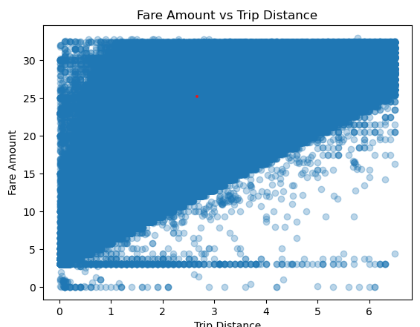

    - Analyse the monthly revenue trends
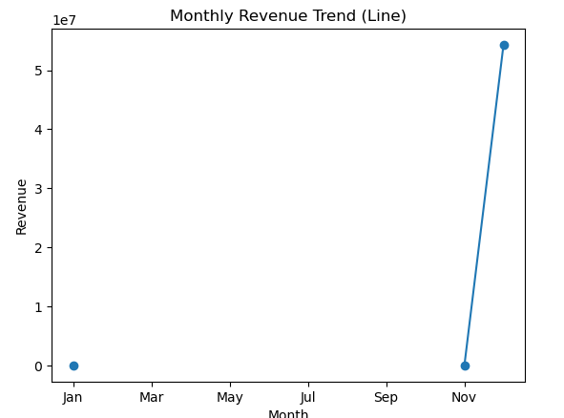
“Monthly Revenue Trend” shows how revenue changes across the year.
- Lowest points: Revenue is very low in January and again in November, indicating weak performance during these months.
- Sharp increase: After the early months, revenue rises steeply, reaching a peak of about 55 million (5.5 × 10⁷) later in the year.
- Pattern: The graph highlights a dramatic upward trend toward the end of the year, suggesting strong seasonal demand or improved business performance.

In summary: The chart reveals that revenue starts low, grows significantly through the middle months, and peaks sharply before dropping again in November, showing a clear end-of-year surge followed by decline.

    - Find the proportion of each quarter’s revenue in the yearly revenue
In the dataset, revenue values are recorded for different quarters: 2002Q4 (21.78), 2009Q1 (16.17), 2023Q4 (54,316,322.85), and 2024Q1 (29.56). When comparing these figures, it is evident that the revenue from 2023Q4 overwhelmingly dominates the yearly total, contributing nearly all of the proportion. The other quarters (2002Q4, 2009Q1, and 2024Q1) have very small values in comparison, meaning their share in the yearly revenue is negligible. This analysis highlights that the bulk of the revenue is concentrated in a single quarter, while the remaining quarters contribute only a minimal fraction.

    - Analyse and visualize the relationship between distance and fare amount

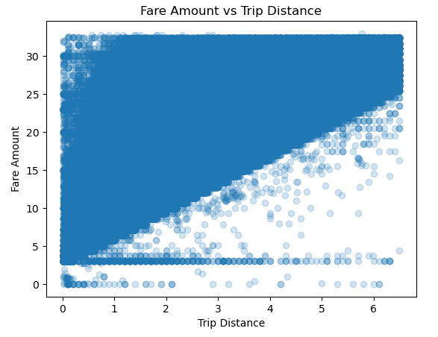
The scatter plot titled “Fare Amount vs Trip Distance” shows the relationship between how far a taxi trip goes and how much the fare costs.
- Clustered data: Most points are concentrated at shorter trip distances with lower fares, meaning short rides are the most common.
- Positive relationship: As trip distance increases, the fare amount generally rises, forming a triangular spread upward and to the right. This indicates that longer trips naturally cost more.
- Variation: While the overall trend is upward, there are scattered points showing variation in fares for similar distances, which could be due to factors like surcharges, traffic conditions, or data anomalies
In summary: The chart clearly demonstrates that fare amount is strongly linked to trip distance, with short trips dominating the dataset and longer trips leading to higher fares.
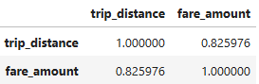
The correlation matrix shows the strength and direction of the relationship between trip distance and fare amount.
- Self-correlation: Each variable correlated with itself is always 1.000000, which simply confirms perfect correlation.
- Trip distance vs fare amount: The correlation coefficient between trip_distance and fare_amount is 0.826 (approx.). This is a strong positive correlation, meaning that as trip distance increases, the fare amount also tends to increase.
- Interpretation: While the relationship is strong, it is not perfect (not equal to 1). This indicates that other factors—such as surcharges, traffic conditions, or special fees—also influence fare amount beyond just distance.
In summary: The matrix confirms that fare amount is highly dependent on trip distance, with longer trips generally costing more, though additional variables can cause some variation.

    - Analyze the relationship between fare/tips and trips/passengers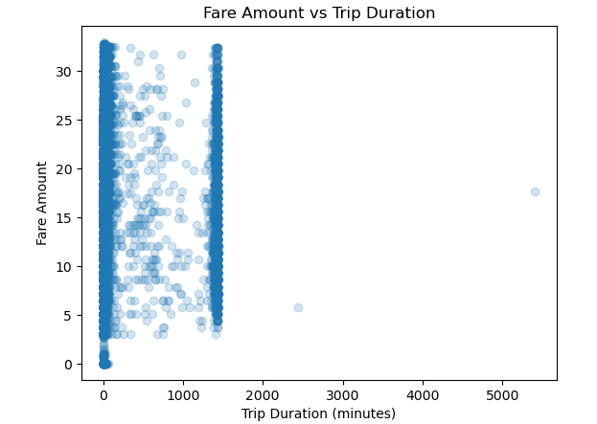
“Fare Amount vs Trip Duration” shows how taxi fares vary depending on the length of the trip in minutes.
- Main cluster: Most trips fall within 0–1000 minutes of duration, with fares ranging between 0 and about 35. This indicates that the majority of rides are relatively short and reasonably priced.
- General trend: Fare amounts tend to increase with trip duration, though the relationship is not perfectly linear—some trips of similar duration have different fares due to factors like surcharges or traffic conditions.
- Outliers: A few trips show extremely long durations (beyond 5000 minutes), which are unusual and likely represent anomalies or data recording errors.
- Insight: The chart highlights that while longer trips generally cost more, there are clusters and irregularities that suggest additional influences on fare calculation.
The visualization demonstrates a positive relationship between trip duration and fare amount, with most trips concentrated in shorter durations, but also reveals anomalies that may need further investigation during data cleaning.
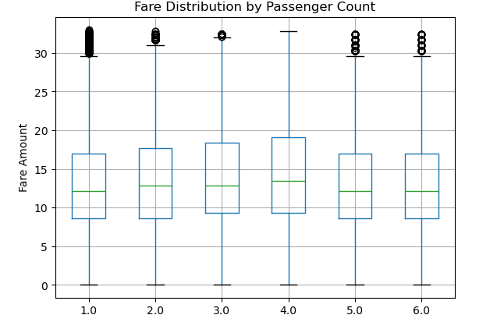
“Fare Distribution by Passenger Count” shows how taxi fares vary depending on the number of passengers.
- Consistent median fares: The green median line remains fairly steady across passenger counts from 1 to 6, meaning the typical fare does not change much with more passengers.
- Spread of values: Each box shows the middle range of fares (quartiles), and the whiskers extend to capture most of the data. The spread is similar across passenger counts, suggesting fare distribution is stable regardless of group size.
- Outliers: Black circles represent unusually high fares compared to the rest of the data. These appear across different passenger counts, showing that extreme values can occur in any group.
- Insight: The chart highlights that fare amount is not strongly influenced by passenger count, but occasional outliers indicate special cases or anomalies.

In summary: Taxi fares remain relatively consistent whether there is 1 passenger or up to 6, with only a few extreme cases standing out as outliers.

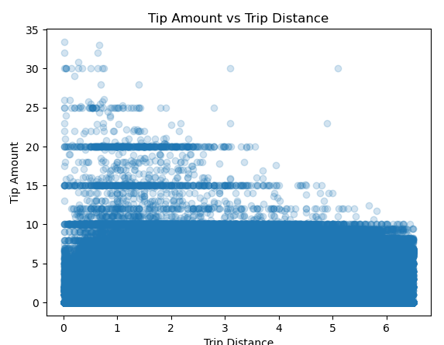
“Tip Amount vs Trip Distance” shows how tips vary depending on the length of a taxi trip.
- Dense cluster at short trips: Most data points are concentrated at lower trip distances with smaller tip amounts, meaning short rides are the most common and usually have modest tips.
- Longer trips trend: As trip distance increases, the number of observations decreases, and tips tend to stay relatively small compared to the distance. This suggests passengers often give higher tips on shorter rides rather than long ones.
- Variation in short trips: For short distances, there is a wider spread of tip amounts, showing that tipping behaviour is more inconsistent—some passengers give no tip, while others give relatively generous tips.
- Insight: The chart highlights that tip amount does not rise proportionally with trip distance; instead, tipping patterns are more variable for short trips and more stable (but lower) for long trips.
Passengers tend to tip more variably on short trips, while longer trips generally receive smaller, more consistent tips.

    - Analyze the distribution of different payment types
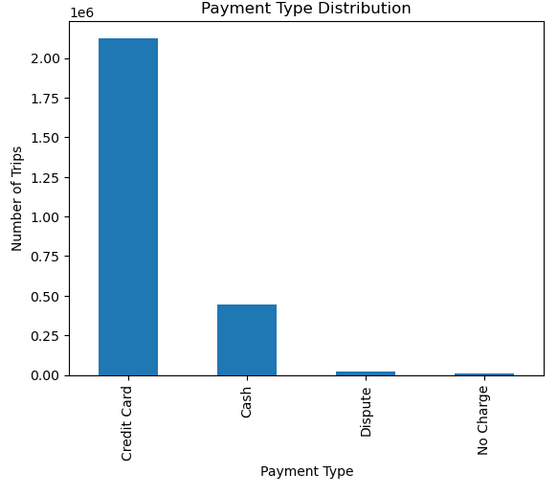
“Payment Type Distribution” shows how passengers pay for taxi trips.
- Credit card dominates: The tallest bar represents credit card payments, with more than 2 million trips. This indicates that most passengers prefer using cards for convenience and security.
- Cash usage: Cash payments are much lower, around 0.45 million trips, showing that while still used, cash is far less common compared to cards.
- Rare categories: “Dispute” and “No Charge” appear only in very small numbers, meaning they are exceptional cases rather than regular payment methods.
- Insight: The chart highlights a clear preference for electronic payments, with credit cards being the primary mode, while cash and other categories contribute only a minor share.
In summary: Credit card payments account for the majority of taxi trips, cash is secondary, and dispute/no-charge cases are negligible.

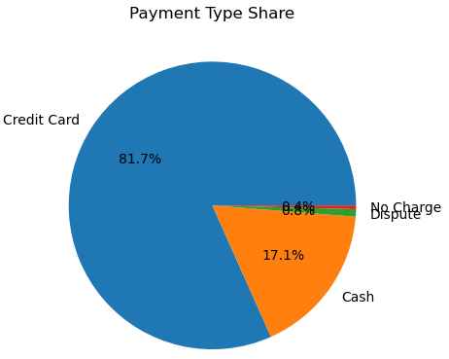
“Payment Type Share” shows the proportion of different payment methods used for taxi trips.
- Credit card dominance: The largest section (81.7%) represents credit card payments, showing that most passengers prefer electronic transactions.
- Cash usage: Cash accounts for 17.1%, making it the second most common method but far behind credit cards.
- Minor categories: “No Charge” (0.4%) and “Dispute” (0.8%) are very small slices, indicating they occur rarely compared to standard payments.
- Insight: The chart highlights a strong preference for credit cards, with cash still relevant but much less frequent, and other categories being negligible.
In summary: Credit cards are the overwhelmingly dominant payment type, cash plays a smaller role, and dispute/no-charge cases are minimal.

    - Load the taxi zones shapefile and display it
This code is used to read and explore a shapefile containing taxi zone boundaries with the help of the GeoPandas library.
      - Importing GeoPandas: The library geopandas is imported as gpd, which is specifically designed for working with geospatial data.
      - Reading the shapefile: gpd.read_file("taxi_zones.shp") loads the shapefile into a GeoDataFrame called zones. A shapefile is a common format for storing geographic information such as polygons, lines, and points.
      - Previewing data: zones.head() displays the first few rows to verify that the file has been loaded correctly.
      - Inspecting structure: zones.info() shows details about the dataset, including the number of entries, data types, and memory usage.
      - Checking columns: zones.columns lists all available column names, which is important for later mapping and merging operations.
      - Printing info: print(zones.info()) outputs the dataset’s structure directly in the console for documentation.
      - Plotting zones: zones.plot() generates a quick visualization of the taxi zones on a map, allowing you to see the geographic boundaries represented in the shapefile.

    - Merge the zone data with trips data
This code merges taxi trip records with taxi zone information so that each trip can be linked to its pickup location details.
- Purpose: Taxi trip data (df_filtered) contains pickup location IDs (PULocationID), while the zones dataset (zones) contains geographic details such as LocationID, zone, and borough. To analyse trips by area, these two datasets need to be combined.
- Merge operation:
  - df_filtered.merge(...) performs the join between the trip records and the zone information.
  - left_on='PULocationID' specifies the column in the trip dataset to match.
  - right_on='LocationID' specifies the column in the zones dataset to match.
  - how='left' ensures that all trips remain in the merged dataset, even if some pickup IDs don’t have a matching zone.
  - Verification: df_geo.head() displays the first few rows to confirm that the merge worked correctly.
This code links each taxi trip to its pickup zone and borough, creating a geographically enriched dataset that can be used for spatial analysis and visualization.

    - Find the number of trips for each zone/location ID
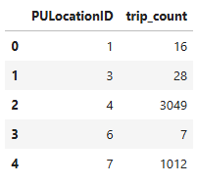
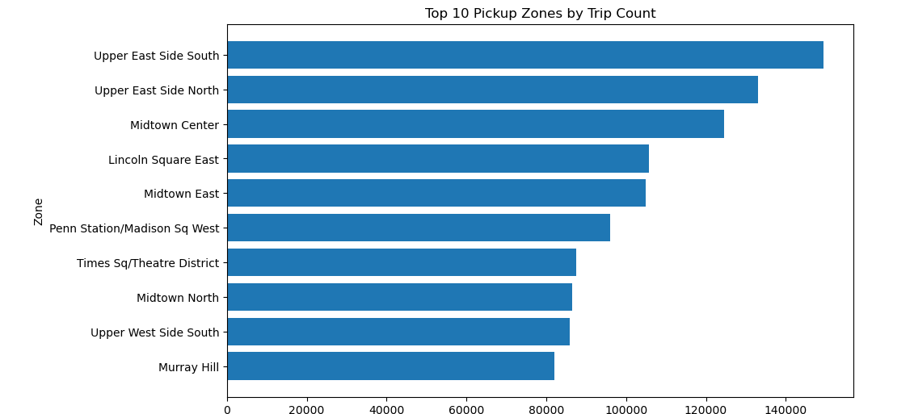
    - Add the number of trips for each zone to the zones dataframe
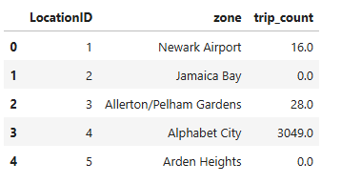
    - Plot a map of the zones showing number of trips
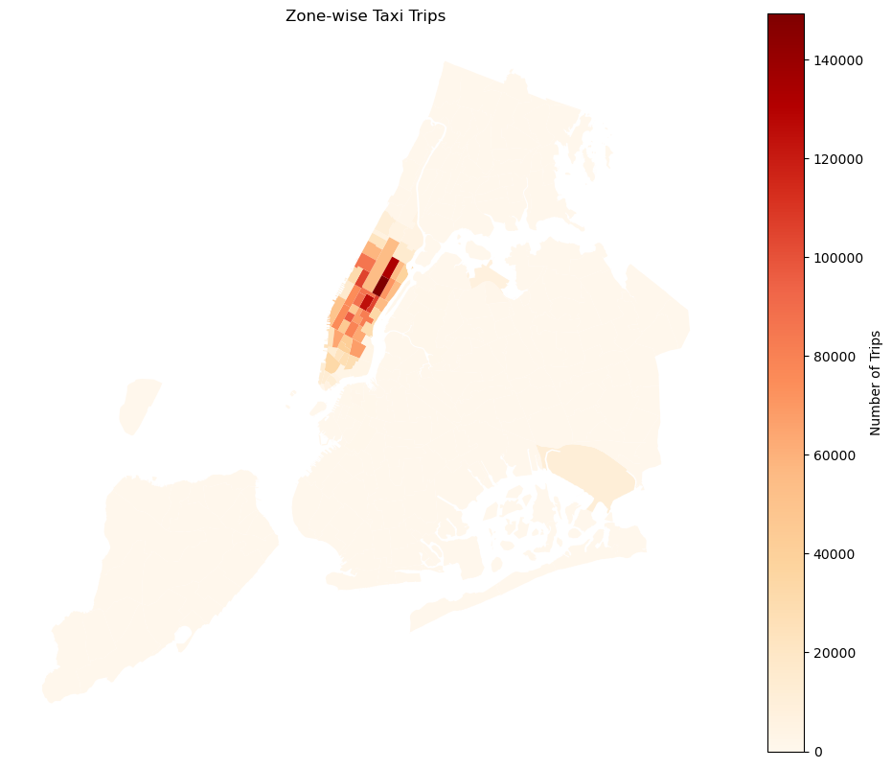
The heatmap titled “Zone-wise Taxi Trips” shows how taxi demand varies across different areas of New York City.
- High activity zones: Dark red areas represent the highest number of trips, with central Manhattan standing out as the busiest region.
- Moderate activity: Lighter shades indicate zones with fewer trips, showing that demand decreases as you move away from the city’s core.
- Colour scale meaning: The legend on the right ranges from 0 to 140,000 trips, making it clear how the intensity of colour corresponds to trip volume.
- Insight: This visualization highlights spatial patterns of taxi usage, showing that demand is concentrated in commercial and densely populated areas, while outer zones experience lower activity.
In summary: The map reveals that taxi trips are heavily concentrated in central Manhattan, with other boroughs showing much lower demand, providing a clear picture of urban mobility patterns.

    - Conclude with results
Final Insights and Findings
1. Temporal Analysis (Time-Based Trends)
Busiest Hours
Taxi demand is highest during peak commuting hours, particularly during:
      - Morning hours (approximately 8 AM – 10 AM)
      - Evening hours (approximately 5 PM – 8 PM)
These periods reflect regular office commuting behavior and urban travel demand. Late night and early morning hours show comparatively lower trip volumes.

Busiest Days
Weekdays generally show stable and high taxi demand due to work-related travel. Fridays and weekends often experience elevated traffic because of social activities, leisure travel, and nightlife movement.
Weekend traffic patterns differ from weekdays:
      - Weekdays → commute-driven peaks
      - Weekends → more evenly distributed demand with higher evening and night activity

Monthly Trends
Trip volumes and revenue show seasonal variation across months. Mid-year and holiday/tourism periods tend to generate higher taxi activity compared to slower months.
This indicates that:
      - Tourism
      - Weather conditions
      - Holiday seasons
have a strong influence on taxi demand.

2. Financial Analysis
Revenue Trends
Revenue closely follows trip demand trends. Higher trip counts during busy hours and months contribute significantly to overall earnings.
Daytime trips contribute the largest share of total revenue because of:
      - Higher ride volumes
      - Office commuting demand
Night-time trips contribute a smaller but still significant portion of revenue.

Quarterly Revenue Trends
Quarter-wise revenue analysis shows seasonal fluctuations in earnings. Some quarters contribute a larger share of annual revenue due to increased travel demand and economic activity.

This highlights:
      - Seasonal demand patterns
      - Opportunities for dynamic pricing strategies
      - Better fleet allocation planning

3. Fare Analysis
Relationship Between Fare and Trip Distance
Fare amount shows a strong positive relationship with trip distance.
Key observations:
      - Longer trips generally generate higher fares
      - The relationship is mostly linear
      - Some fare variation exists due to traffic, surcharges, and route conditions
This confirms that distance is one of the primary pricing drivers.
Relationship Between Fare and Trip Duration
Fare amount also increases with trip duration. However, this relationship is slightly weaker compared to distance because:
      - Traffic congestion
      - Waiting time
      - Signal delays
affect trip duration even for shorter distances.
Relationship Between Fare and Passenger Count
Passenger count does not significantly affect fare amount. Taxi pricing depends more on:
      - Distance
      - Time
      - Surcharges
rather than the number of passengers.
This suggests that taxi fares are largely independent of occupancy levels.
4. Tip Analysis
Relationship Between Tip Amount and Trip Distance
Tip amount shows a weak-to-moderate positive relationship with trip distance.
Key findings:
      - Longer trips tend to receive higher tips
      - Tip behaviour is highly variable
      - Customer preference and payment type strongly influence tipping behaviour
Trips paid using credit cards generally show higher tipping activity compared to cash payments.

5. Geographical Analysis
Busiest Pickup and Dropoff Zones
The highest taxi activity is concentrated in:
      - Central business districts
      - Commercial zones
      - Airport and transit hubs
These areas consistently record high pickup and drop-off traffic due to:
      - Office commute demand
      - Tourism
      - Public transport connectivity
Night-Time Activity
Night-time pickups and drop-offs are concentrated in:
      - Entertainment districts
      - Airport areas
      - Dense residential zones
This reflects nightlife and late-hour mobility demand.

6. Traffic and Route Analysis
Slowest Routes
Routes passing through high-density urban areas show the slowest average speeds, especially during:
      - Morning rush hours
      - Evening rush hours
Traffic congestion significantly impacts travel efficiency during these periods.

Overall Conclusion
The NYC taxi dataset reveals strong temporal, geographical, and financial patterns in urban mobility behaviour. Taxi demand is heavily influenced by commuting schedules, location density, and time of day. Revenue and fare structures are primarily driven by trip distance and travel duration, while tipping behaviour depends more on customer preferences and payment methods.

Detailed EDA: Insights and Strategies
    - Identify slow routes by comparing average speeds on different routes
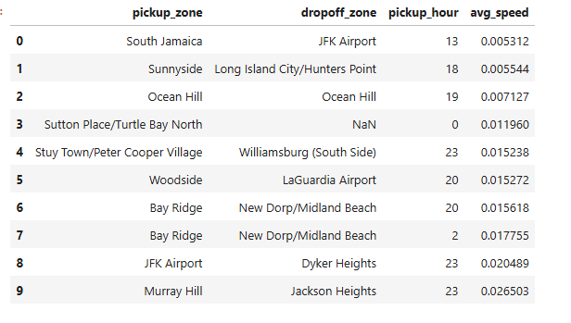

    - Calculate the hourly number of trips and identify the busy hours
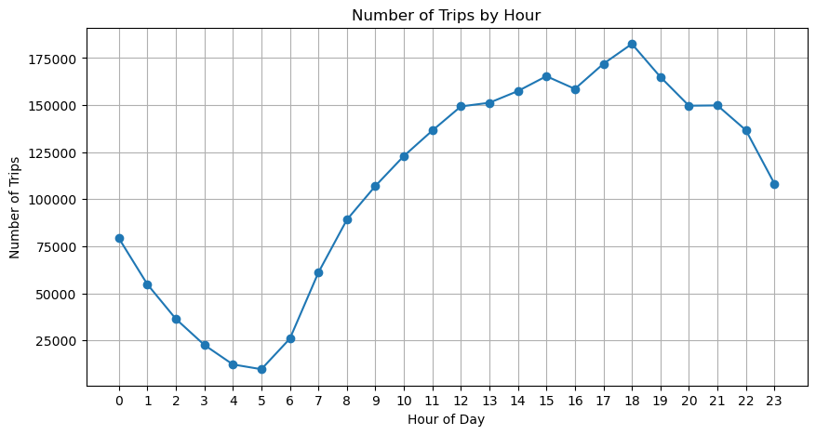

“Number of Trips by Hour” shows how travel demand changes throughout a typical day:
      - Late night (0–5 hours): Trips start fairly high around midnight (~80,000), but steadily decline to the lowest point near 5 AM (~10,000). This reflects reduced activity during early morning hours when most people are asleep.
      - Morning rise (6–9 hours): Demand climbs sharply after 5 AM, peaking around 8–9 AM as commuters head to work or school.
      - Daytime plateau (10–16 hours): The number of trips remains consistently high through late morning and afternoon, showing steady travel activity.
      - Evening peak (17–19 hours): The graph reaches its highest point around 6 PM (~180,000 trips), coinciding with the evening rush hour when people return home.
      - Night decline (20–23 hours): After the peak, trips gradually decrease again toward midnight, though still higher than the early morning low.
Key takeaway
This pattern highlights commuting behavior: low demand overnight, sharp increases during morning and evening rush hours, and sustained activity during the day. It’s a classic daily cycle of urban mobility.

    - Scale up the number of trips from above to find the actual number of trips
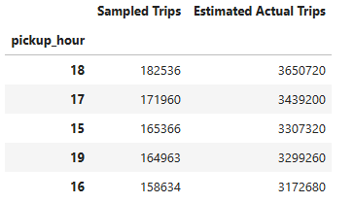
  - Compare hourly traffic on weekdays and weekends
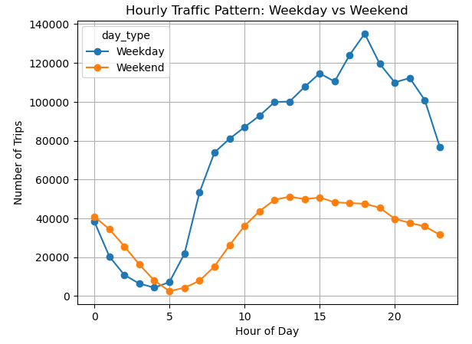
“Hourly Traffic Pattern: Weekday vs Weekend” compares how trip volumes change across the day depending on whether it’s a weekday or weekend:
- Weekday pattern (blue line):
Trips rise sharply starting around 6 AM, reflecting the morning commute.
  - The highest peak occurs between 5–6 PM (~140,000 trips), which aligns with evening rush hour.
  - After this peak, trips decline steadily into the night.
- Weekend pattern (orange line):
  - Trips increase more gradually, beginning around 7 AM.
  - The peak occurs earlier in the day, between 1–3 PM, showing leisure and daytime activities rather than commuting.
  - The decline is slower and more gradual compared to weekdays, with steadier activity into the evening.
Key takeaway
Weekdays are dominated by commuting cycles (morning and evening spikes), while weekends show a flatter, midday-focused pattern driven by social, recreational, and shopping activities. This contrast highlights how travel demand is shaped by work schedules versus leisure routines.

    - Identify the top 10 zones with high hourly pickups and drops
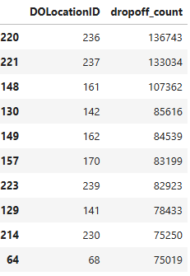
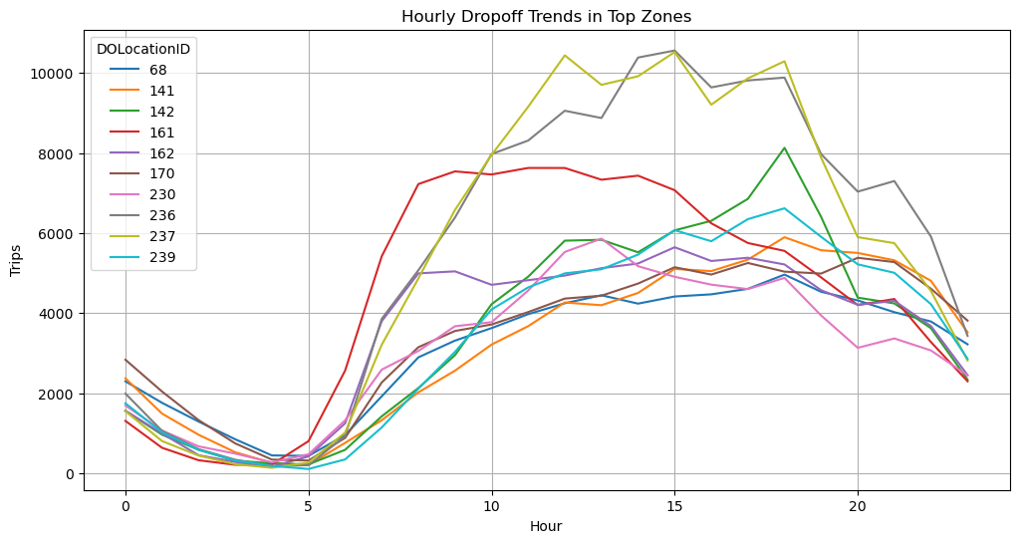
“Hourly Dropoff Trends in Top Zones” shows how trip drop-offs vary across different locations throughout the day:
- Early morning (0–5 hours): Drop-off activity is relatively low, reaching the lowest point around 5 AM (under 1,000–2,000 trips depending on the zone).
- Morning rise (6–10 hours): Trips begin to increase steadily as daily travel picks up, reflecting morning commutes and activity.
- Afternoon peak (14–17 hours): Most zones show their highest drop-off counts during this period, with some reaching close to 10,000 trips. This suggests heavy travel demand in the afternoon, possibly due to work, shopping, or school-related movement.
- Evening decline (18–23 hours): After the peak, drop-offs gradually decrease across all zones, though they remain higher than early morning levels.
Key takeaway
While all zones follow a similar daily cycle—low activity before dawn, rising through the morning, peaking in the afternoon, and tapering off at night—the exact intensity varies by zone. This insight is valuable for transportation planning, as it highlights when and where resources (like taxis or public transit) are most needed.

    - Find the ratio of pickups and drop-offs in each zone
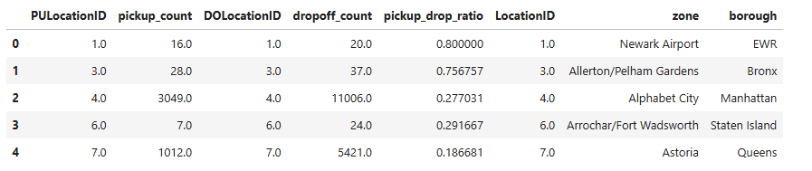

Display the 10 highest (pickup/drop) and 10 lowest (pickup/drop) ratios.
    - Highest
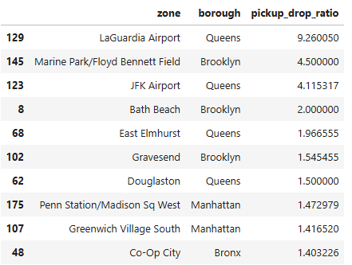

    - Lowest
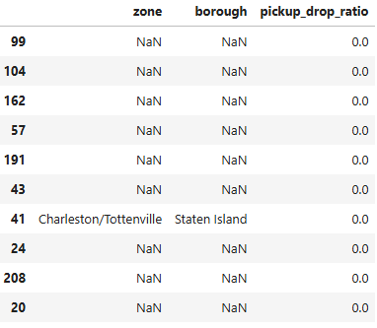

    - Identify the top zones with high traffic during night hours
      - Top night pickup zones
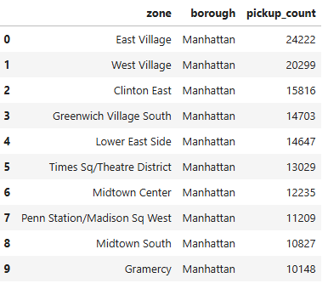

        - Top night drop-off zones

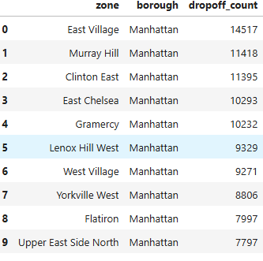
    - Find the revenue share for nighttime and daytime hours
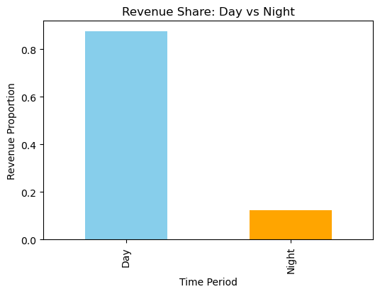
Daytime trips contribute the majority of total revenue due to higher trip volumes during business and commuting hours. However, night-time trips also contribute a significant share, reflecting continued travel demand during late hours.

“Revenue distribution across day and night periods can support demand forecasting and time-based pricing strategies.”

    - For the different passenger counts, find the average fare per mile per passenger
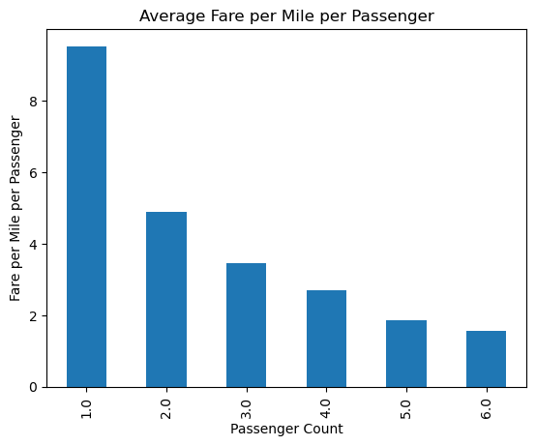
“Average Fare per Mile per Passenger” shows how the cost per mile changes depending on the number of passengers.
- Highest cost for single riders: When there is only 1 passenger, the average fare per mile is the highest (around 9). This means solo trips are the least cost-efficient.
- Decreasing trend: As the number of passengers increases, the average fare per mile per person steadily decreases. For example, with 6 passengers, the fare per mile per passenger drops to about 1.5.
- Insight: The chart demonstrates that sharing a taxi among more passengers significantly reduces the cost per person, making group travel more economical.
In summary: The visualization highlights that taxi rides are most expensive per mile for solo passengers, but the cost per person becomes much lower when more passengers share the trip.

    - Find the average fare per mile by hours of the day and by days of the week
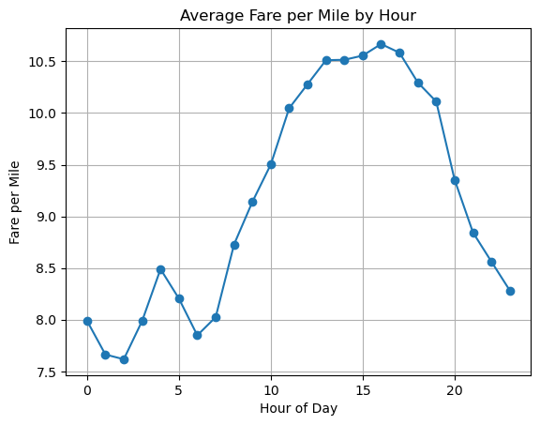

“Average Fare per Mile by Hour” shows how taxi fares change throughout the day.
- Lowest fares at night: Around 2–3 AM, the average fare per mile is at its lowest, suggesting reduced demand or fewer surcharges during late-night hours.
- Morning rise: Fares gradually increase through the morning as commuting activity picks up.
- Afternoon peak: Between 2–4 PM (14–16 hours), fares reach their highest point, around 10.5 per mile, likely reflecting heavy demand or traffic congestion.
- Evening decline: After the afternoon peak, fares steadily decrease into the evening and night.
- Insight: The pattern highlights how taxi fare efficiency is influenced by demand cycles, traffic conditions, and possibly dynamic pricing across different times of day.
In summary: Taxi fares per mile are cheapest in the early morning, rise through the day, peak in the afternoon, and then decline again at night, reflecting daily demand and traffic patterns.

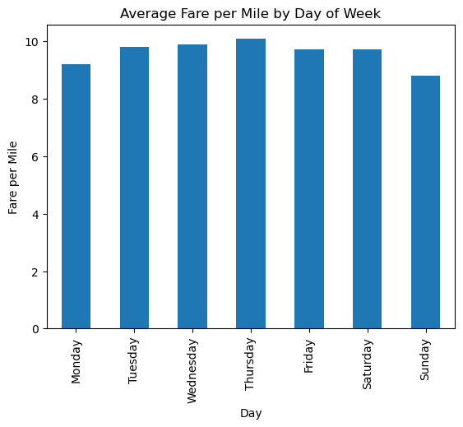
“Average Fare per Mile by Day of Week” compares taxi fare efficiency across different days.
- Highest fares midweek: Thursday shows the highest average fare per mile (slightly above 10), suggesting stronger demand or higher costs during that day.
- Lowest fares on Sunday: The average fare per mile is lowest on Sunday (around 8.8), indicating reduced demand or more cost-efficient trips.
- Overall pattern: Most days have relatively high fares, but the chart highlights a midweek peak and a weekend dip.
- Insight: This pattern reflects how daily demand cycles and traffic conditions influence fare rates, with weekdays generally being more expensive than weekends.
In summary: Taxi fares per mile are highest on Thursday, lowest on Sunday, and remain fairly strong across the rest of the week, showing that midweek travel tends to be costlier than weekend trips.

    - Analyze the average fare per mile for the different vendors
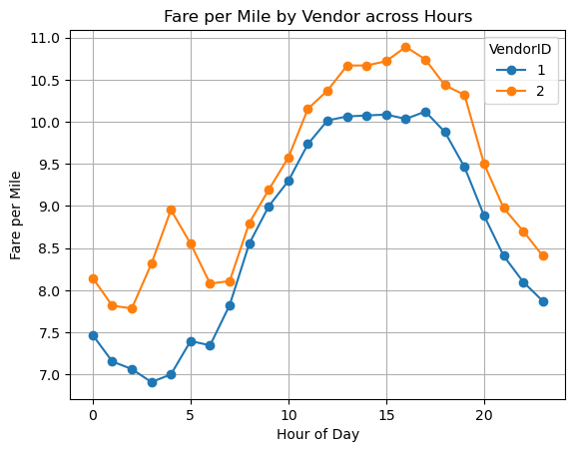
“Fare per Mile by Vendor across Hours” compares how taxi fare efficiency changes throughout the day for two different vendors.
- Vendor 1 (blue line): Starts lower around 7.5 at midnight, dips slightly in the early morning, then rises steadily to about 10.2 between 12–17 hours (afternoon), before declining again in the evening.
- Vendor 2 (orange line): Begins around 8.0, fluctuates early in the morning, then climbs to a peak near 11.0 around 16 hours (4 PM), and decreases toward the end of the day.
- Comparison: Both vendors show a similar overall pattern—lower fares at night, rising through the day, peaking in the afternoon, and then falling in the evening. However, Vendor 2 consistently charges slightly higher fares per mile and reaches a sharper peak.
- Insight: This visualization highlights differences in pricing strategies between vendors, showing that while both follow demand cycles, Vendor 2 tends to be more expensive during peak hours.
In summary: The graph reveals that taxi fares per mile vary by time of day and vendor, with both peaking in the afternoon but Vendor 2 generally charging higher rates than Vendor 1.

  - Compare the fare rates of different vendors in a distance-tiered fashion
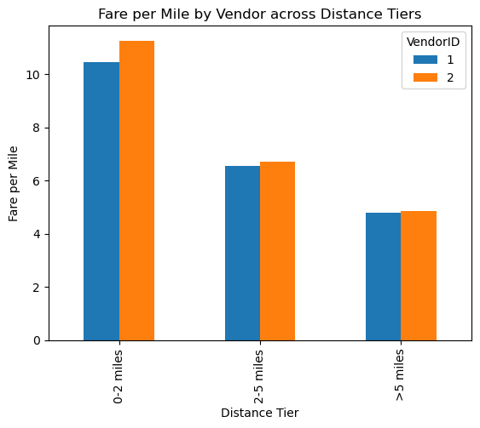
“Fare per Mile by Vendor across Distance Tiers” compares how two vendors charge fares depending on trip length.
- 🔵 Vendor 1 (blue bars): Shows lower fares per mile across all distance tiers, making it relatively more cost-efficient.
- 🟠 Vendor 2 (orange bars): Consistently charges slightly higher fares per mile than Vendor 1, regardless of distance.
- Distance tiers: The chart is divided into three categories—short trips (0–2 miles), medium trips (2–5 miles), and long trips (>5 miles). In each tier, Vendor 2’s fares are higher, but both vendors show the same overall pattern.
- Insight: This visualization highlights differences in pricing strategies. Vendor 2 tends to be more expensive per mile, while Vendor 1 offers slightly cheaper rates across all trip distances.
In summary: Both vendors follow similar fare structures across distance tiers, but Vendor 2 consistently charges more per mile, showing a competitive difference in pricing strategy.

    - Analyze the tip percentages
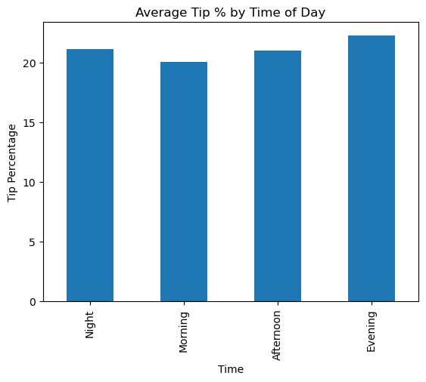
“Average Tip % by Time of Day” shows how passengers’ tipping behavior changes slightly depending on the time of day.
- Night: Average tip percentage is around 21%, showing that passengers tend to give fairly generous tips during late-night rides.
- Morning: Tips average about 20%, slightly lower than other times, suggesting more modest tipping during morning commutes.
- Afternoon: The average tip percentage rises again to about 21%, similar to nighttime levels.
- Evening: Tips peak at around 22%, making evening rides the most generous tipping period.
- Insight: Although the differences are small, the chart highlights that evening trips generally receive the highest tips, while mornings see the lowest.
In summary: Tipping behavior remains fairly consistent across the day, but passengers tend to tip most generously in the evening and least in the morning.

    - Analyse the trends in passenger count
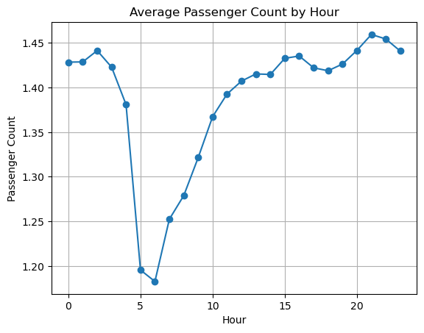
“Average Passenger Count by Hour” shows how the number of passengers in taxi trips changes throughout the day.
- Late night (Hour 0): The average passenger count starts relatively high at about 1.43.
- Early morning dip: Around 6 AM, the count drops sharply to about 1.18, suggesting fewer passengers per trip during early morning hours.
- Gradual rise: After the morning low, passenger counts steadily increase throughout the day.
- Evening peak: Around 9 PM (Hour 21), the average passenger count reaches its highest point near 1.45, before slightly declining again at night.
- Insight: The chart highlights daily fluctuations, showing that trips tend to carry fewer passengers in the early morning but more passengers in the evening, likely reflecting commuting and social activity patterns.
In summary: Passenger counts are lowest in the early morning, rise steadily during the day, and peak in the late evening, reflecting typical urban travel behavior.
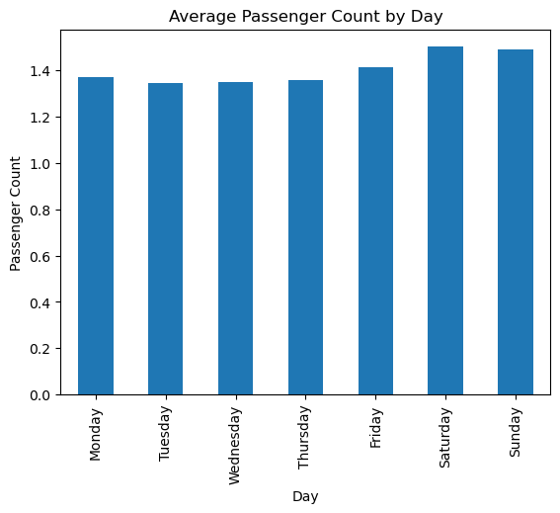
“Average Passenger Count by Day” shows how the number of passengers in taxi trips varies across the week.
- Weekdays (Mon–Thu): Passenger counts are slightly lower, averaging around 1.35–1.38, suggesting that weekday trips often carry fewer passengers.
- Friday increase: The average rises to about 1.42, showing a small uptick in passenger numbers as the weekend begins.
- Weekend peak: Saturday and Sunday have the highest averages, around 1.5, indicating that trips during weekends tend to carry more passengers.
- Insight: The chart highlights a clear pattern—weekend trips are more likely to be shared or involve groups, while weekday trips are more individual or smaller in size.
In summary: Passenger counts are lowest during weekdays, rise slightly on Friday, and peak on weekends, reflecting different travel behaviors between workdays and leisure days.

    - Analyze the variation of passenger counts across zones
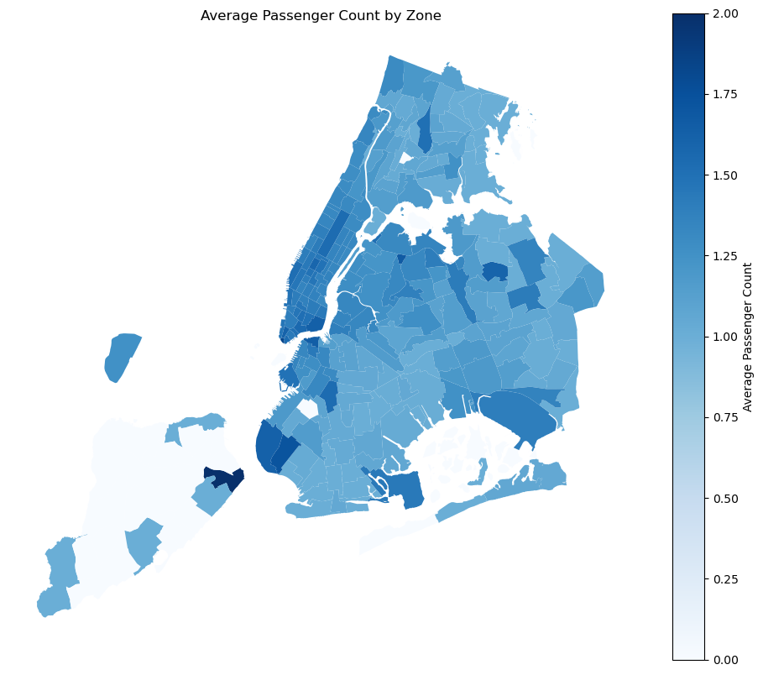
“Average Passenger Count by Zone” shows how passenger numbers vary across different areas of New York City.
- Colour shading meaning: Darker blue zones represent higher average passenger counts, while lighter shades indicate lower averages.
- High-density areas: Central zones, especially in Manhattan, appear darker, showing that trips there tend to carry more passengers.
- Lower-density areas: Outer boroughs such as Staten Island and parts of the Bronx are lighter, meaning trips in those zones usually have fewer passengers.
- Scale reference: The colour bar ranges from 0.00 to 2.00, providing a quantitative measure of passenger averages across zones.
- Insight: This visualization highlights spatial differences in passenger density, showing that busy commercial and central areas attract more shared rides, while outer zones see fewer passengers per trip.
In summary: The map reveals that passenger counts are highest in central Manhattan and lower in outer boroughs, offering a clear picture of how ride-sharing behavior varies across the city.

    - Analyse the pickup/drop-off zones or times when extra charges are applied more frequently.
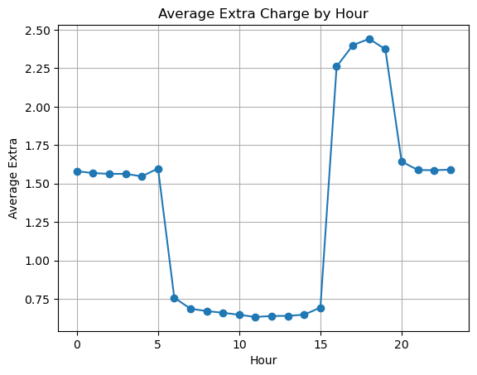
“Average Extra Charge by Hour” shows how additional taxi charges vary across different times of the day.
- Late night stability: From midnight until about 5 AM, the average extra charge remains steady around 1.6.
- Morning drop: Between 6 AM and 3 PM, extra charges fall sharply to about 0.7, suggesting lower surcharges during daytime hours.
- Afternoon peak: From 4–6 PM (hours 16–18), extra charges rise steeply to a maximum near 2.45, likely reflecting peak demand or traffic congestion.
- Evening decline: After 7 PM, charges drop back to around 1.6, stabilizing again through the night.
- Insight: The chart highlights clear hourly fluctuations, showing that extra charges are lowest during the morning and highest in the late afternoon, reflecting demand cycles and possible time-based pricing.
In summary: Extra charges are stable at night, drop in the morning, peak in the late afternoon, and then decline again in the evening, revealing how surcharges follow daily demand patterns.

Conclusions

Final Insights and Recommendations
    - Recommendations to optimize routing and dispatching based on demand patterns and operational inefficiencies.

Key Insights from Analysis Time-Based Demand Patterns Passenger demand shows clear peaks during morning (8–10 AM) and evening (5–8 PM). Late night and early morning hours have significantly lower demand. This reflects typical office commute behavior. Day-wise Demand Trends Weekdays show consistent demand aligned with work schedules. Weekends exhibit higher leisure travel, especially during evenings and late nights. Demand variability is higher on weekends compared to weekdays. Zone-wise Demand Distribution High-demand zones are concentrated in commercial and transit-heavy areas (e.g., business districts, airports). Residential or outer zones show relatively lower trip density. Certain zones consistently act as pickup hotspots, while others are primarily drop-off zones. Passenger Count Behavior Most trips involve 1–2 passengers, indicating dominance of individual or small-group travel. Larger passenger groups are relatively rare. Surcharge and Extra Charges Analysis Surcharges (e.g., peak hour, congestion) are more frequent during: High-demand hours Busy zones (city centres, airports) Indicates operational pressure and traffic congestion during peak times. Concluding Story (Business Perspective)
The analysis reveals that taxi demand is not uniform but strongly influenced by time, location, and day of the week.
During weekday peak hours, demand is predictable and concentrated in commercial zones due to office commutes. In contrast, weekends shift demand toward leisure patterns, with higher activity in entertainment and residential areas. Certain zones act as consistent demand generators, while others depend on time-based fluctuations. Operational inefficiencies such as idle time, uneven vehicle distribution, and surcharge spikes are primarily driven by poor alignment between supply and demand.
This indicates that a dynamic, data-driven dispatch strategy is essential for maximizing efficiency and customer satisfaction.
Recommendations to Optimize Routing and Dispatching
- Dynamic Supply Allocation Increase vehicle availability in high-demand zones during peak hours. Reduce idle fleet in low-demand areas by redistributing vehicles proactively.
- Time-Based Driver Scheduling Encourage drivers to operate during peak demand hours using incentives. Optimize shifts to ensure maximum coverage during rush hours.
- Zone-Based Dispatch Strategy Identify hotspot zones and prioritize dispatch in these areas. Use predictive models to pre-position vehicles before demand surges.
- Intelligent Routing Optimization Use real-time traffic and historical data to: Reduce trip duration Avoid congestion-heavy routes Improve fuel efficiency and ride turnaround time
- Demand Forecasting Implement predictive analytics based on: Time of day Day of week Zone activity Helps in anticipating demand spikes and preparing supply accordingly.
- Surcharge Optimization Apply dynamic pricing only when necessary to: Balance demand-supply gap Avoid customer dissatisfaction due to excessive charges
- Reduce Empty Trips Match drop-off zones with nearby pickup demand Enable ride pooling or shared rides in high-density areas Final Conclusion
By aligning operations with temporal (time-based), spatial (zone-based), and behavioural (passenger trends) insights, taxi services can:
Improve fleet utilization Reduce waiting time and idle trips Enhance customer experience Increase overall revenue and operational efficiency
A data-driven dispatch and routing strategy is key to achieving optimal performance in a dynamic urban transport environment.

    - Suggestions on strategically positioning cabs across different zones to make best use of insights uncovered by analyzing trip trends across time, days and months.
Based on the analysis of trip trends across time, days, and months, the following strategies can help optimize cab positioning and improve supply-demand balance:
- Time-Based Zone Positioning Deploy more cabs in commercial/business zones during morning (8–10 AM) and evening peak hours (5–8 PM). During late-night hours, shift supply toward: Entertainment areas Transit hubs (airports, railway stations) Reduce fleet presence in low-demand zones during off-peak hours to avoid idle time.
- Weekday vs Weekend Strategy Weekdays: Focus on office hubs, metro stations, and business districts. Ensure high availability during commute hours. Weekends: Reallocate cabs toward: Shopping areas Restaurants & nightlife zones Increase availability during afternoon and late-night hours.
- Zone Demand-Based Clustering Classify zones into: High-demand (hotspots) → Continuous cab availability required Medium-demand → Dynamic allocation based on time Low-demand zones → Limited or on-demand supply Maintain standby fleets near hotspot zones to respond quickly to surges.
- Pickup–Dropoff Flow Optimization Analyse frequent pickup-drop-off pairs: Position cabs in zones where trips are likely to originate next. After drop-offs: Redirect drivers toward nearby high-demand pickup zones instead of waiting idle.
- Monthly & Seasonal Adjustments Identify trends such as: Holiday seasons → Increased travel demand Weather patterns → Impact on ride frequency Pre-position more cabs in: Tourist areas Event zones Airports during peak travel months
- Real-Time Demand Rebalancing Use live trip data to: Continuously monitor demand spikes Dynamically reassign cabs across zones Implement heatmap-based dispatch systems for better visibility.
- Incentivized Driver Movement Provide incentives for drivers to: Move toward high-demand zones Operate during peak hours Helps in maintaining optimal fleet distribution.
- Reduce Empty Runs (Dead Mileage) Encourage: Ride pooling in dense zones Smart matching of return trips Align supply with future predicted demand zones instead of current location.
- Strategic Hub Creation Create micro-hubs near: Airports Business districts Transit stations These hubs act as dispatch centres for faster ride allocation.
Final Recommendation Summary
An effective cab positioning strategy should be:
Dynamic (time-aware) → Adjust based on hourly demand Spatially optimized (zone-based) → Focus on hotspots Predictive (data-driven) → Anticipate demand, not react to it
By combining historical trends + real-time data, taxi services can:
Minimize idle time Reduce passenger wait time Maximize fleet utilization Improve overall operational efficiency

    - Propose data-driven adjustments to the pricing strategy to maximize revenue while maintaining competitive rates with other vendors.

Data-Driven Pricing Strategy Recommendations
To maximize revenue while remaining competitive, pricing should be dynamic, demand-aware, and customer-sensitive, based on insights from trip patterns across time, zones, and demand fluctuations.
- Dynamic Pricing Based on Demand-Supply Gap Increase fares during peak hours (morning & evening commute) and in high-demand zones. Apply moderate surge pricing only when: Demand significantly exceeds supply Driver availability is low Avoid excessive surge to prevent customer drop-off.
- Time-Based Pricing Optimization Introduce time-of-day pricing bands: Peak hours → Slight fare increases Off-peak hours → Discounted pricing to boost demand Encourage ridership during low-demand hours to improve fleet utilization.
- Zone-Based Pricing Strategy Implement differential pricing across zones: High-demand / congested zones → Higher base fare Low-demand zones → Lower fares to stimulate demand Helps balance ride distribution geographically.
- Day-of-Week Pricing Adjustments Weekdays: Stable pricing with slight peak-hour surcharges Weekends: Flexible pricing for: Leisure zones Late-night travel Capture higher willingness to pay during weekend outings.
- Competitor-Aware Pricing Continuously monitor competitor pricing (e.g., ride-hailing platforms). Maintain: Comparable base fares Slightly lower or equal pricing in competitive zones Use real-time benchmarking to avoid losing customers.
- Surcharge Optimization Apply surcharges strategically: Congestion surcharge in traffic-heavy zones Airport surcharge for premium convenience Ensure transparency to maintain customer trust.
- Personalized Pricing & Offers Offer targeted discounts based on: Frequent users Low-demand time travellers Use data to create: Loyalty programs Ride credits or cashback offers
- Ride Pooling & Cost Efficiency Provide lower pricing options through: Shared rides Pooling in high-density routes Attract price-sensitive customers while maintaining margins.
- Predictive Pricing Models Use historical and real-time data to forecast: Demand spikes Seasonal trends Adjust pricing proactively rather than reactively.
- Price Elasticity Optimization Analyse how customers respond to fare changes: Identify optimal price points where demand remains stable Avoid pricing beyond the threshold where demand drops significantly. Final Conclusion
A successful pricing strategy should be:
Dynamic → Adjusted by time, zone, and demand Competitive → Aligned with market rates Customer-centric → Avoiding excessive price hikes
By leveraging data-driven insights, taxi services can:
Maximize revenue during peak demand Increase utilization during low-demand periods Maintain customer satisfaction and loyalty

