

**Project Development Plan**

**For**

**EV Charging Network Reservation System**

Prepared by: Navjot Singh

40014477

Concordia University

16-02-2018

# **Table of Content**

1. Table of Content 2

2. Introduction 3

1.1. Objectives of the project 3

1.2. Scope statement 3

1.3. Stakeholder profiles 3

3. Product and deliverables 4

4. Project interfaces 5

5. Software development process 6

6. Project process activities and schedule 7

7. Project milestones 8

8. Development facilities 9

9. Development risks 11

10. Control methods 11

11. References 11

# **Introduction**

## Objectives of the project

Main objective of the system is to utilize the various electric vehicle charging stations which will lead to increase the customer satisfaction rate.

## Scope statement

System’s scope is quite limited. It mitigates the problem related to the electric vehicle reservation system’s charging stations effective reservation. Now, All the systems reserve the charging point based on first-come-first serve technique which is not founded effective and users not able to utilize the charging stations. Our solution will try to find the way how system will reserve the charging points so that maximum number of vehicles get the charging point.

## Stakeholder profiles

“Individuals or groups who are actively involved in the project, affected by the project, or who can influence its Outcome”.

User population of system is: All of those who have electric vehicle and want to charge their EV’s at charging stations.

Different charging stations and their owner, workers and everybody whosoever working at different stations.

Professor Mr. Wang and Teaching Assistant Miss Jie Gao they invest in the system and want effective outcome from the system.

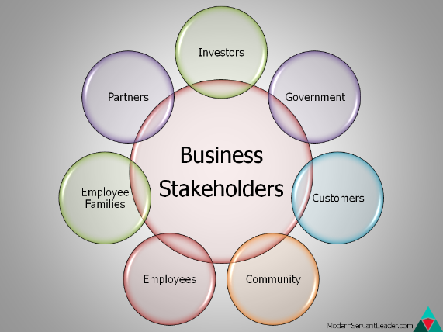

All the other users who are indirectly affected by the electric vehicle. For ex-: Vehicle users’ family member, friends etc.

As it is an individual project, I will play the role of project manager, programmer, tester, quality analyst, etc.

# **Product and deliverables**

Electric vehicle reservation system will help electric vehicle users to reserve the system in a way so that maximum number of users can get charging points in their preferred time window.

System will process the user request and assign them one charging point in given time slot.

**User request format is:** Vehicle-Type Time-Window Charger Type(Level)

System will get the Dataset as an input which contains the user request in above mentioned format. After that system will process it and generate the effective solution for all the users.

After processing system will show the reserved point for each user on Gantt chart which gives users better view of their reserved slot at station point.

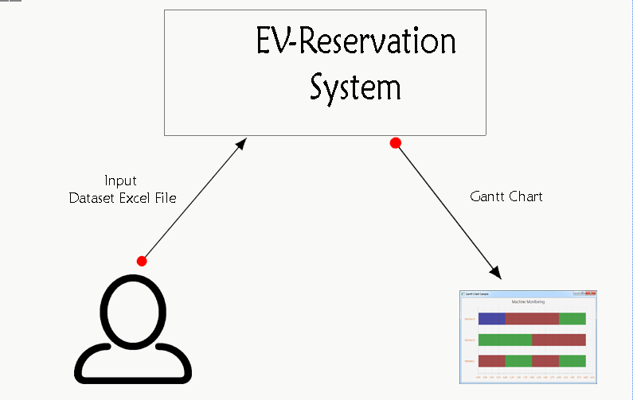

**Major Deliverables of System:**

* Processed Data in form of Excel File
* Gantt chart which is based on processed data excel file.
* Each phase’s outcome in well documented format

# **Project interfaces**

System needs to integrate with two libraries for implementing reservation algorithm effectively.

* **Apache POI** for processing excel file(dataset) and after processing given dataset system will generate the excel file which will help to generate the Gantt chart.

<!-- https://mvnrepository.com/artifact/org.apache.maven.plugins/maven-dependency-plugi -->

<dependency>

<groupId>org.apache.maven.plugins</groupId>

<artifactId>maven-dependency-plugin</artifactId>

<version>3.0.2</version>

</dependency>

* **JFree Chart** library will be used to generate the Gantt chart which is the final output of system.

<!-- https://mvnrepository.com/artifact/org.jfree/jfreechart -->

<dependency>

<groupId>org.jfree</groupId>

<artifactId>jfreechart</artifactId>

<version>1.5.0</version>

</dependency>

# **Software development process**

For this project I selected waterfall development model. Reason why I chose this model is because of fixed set of requirements and the length of project which is almost more than 3 months. Client’s major focus is on quality attributes of the system rather than functionalities.

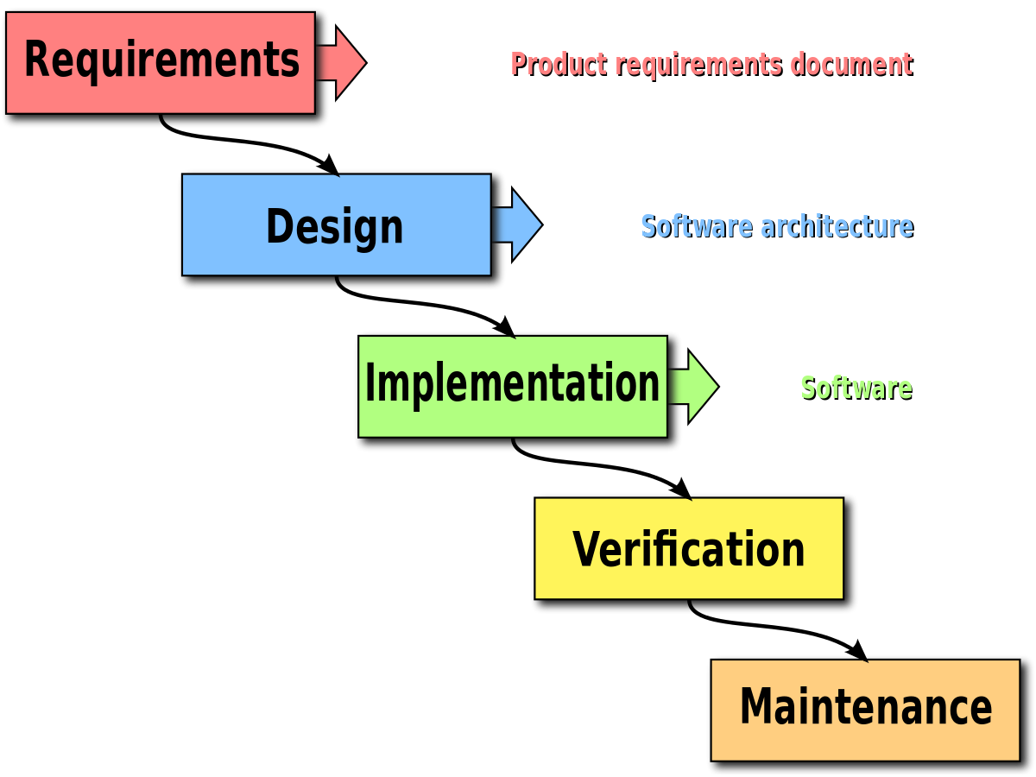

Its the stages are logical and necessary: project manager defines project, business-analyst is eliciting requirements, designer transforms them to software requirements specifications, developer performs coding, then tester verifies the application.

# **Project process activities and schedule**

These are the major activities of the system:

Requirement gathering, Review, Development and Design plan, Design review, Implementation, Testing (unit and integration), Acceptance Testing, and System Release.

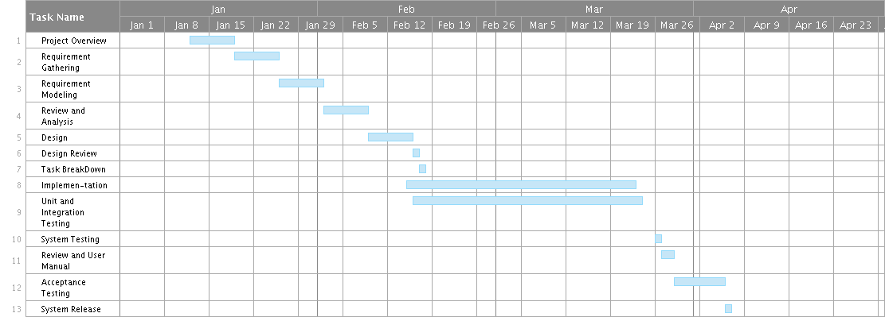

.

# **Project milestones**

In each phase of waterfall model there is well documented report which assists to manage the progress and maintenance phase of the project.

Following list describes the output of each phase-:

* **Requirement Gathering:** Software Requirement Specification Document
* Requirement Review: Stable set of requirements
* **Design:** Software development plan well formatted using various estimation, scheduling techniques which defines how the further phases will be managed and which methodology used to implement the system.
* **Implementation:** After the tools and techniques defined programmes will start writing the code to implement the system. After this phase generated document contains the detail information about the code. Like which function doing what etc. Also, the separate document created by the programmers which contains the information about the unit tests.
* **Verification:** Integration, system, and regression testing done in this phase to verify the system doing what expected from it. Test document in created in this phase which describes the failures and pass tests which helps to trace the verification of the system with its outcome.

# **Development facilities**

* Programming Languages: Java8, JavaFx,
* Libraries: Apache POI, JFree Chart



* IDE-: IntelliJ, SceneBuilder, Eclipse

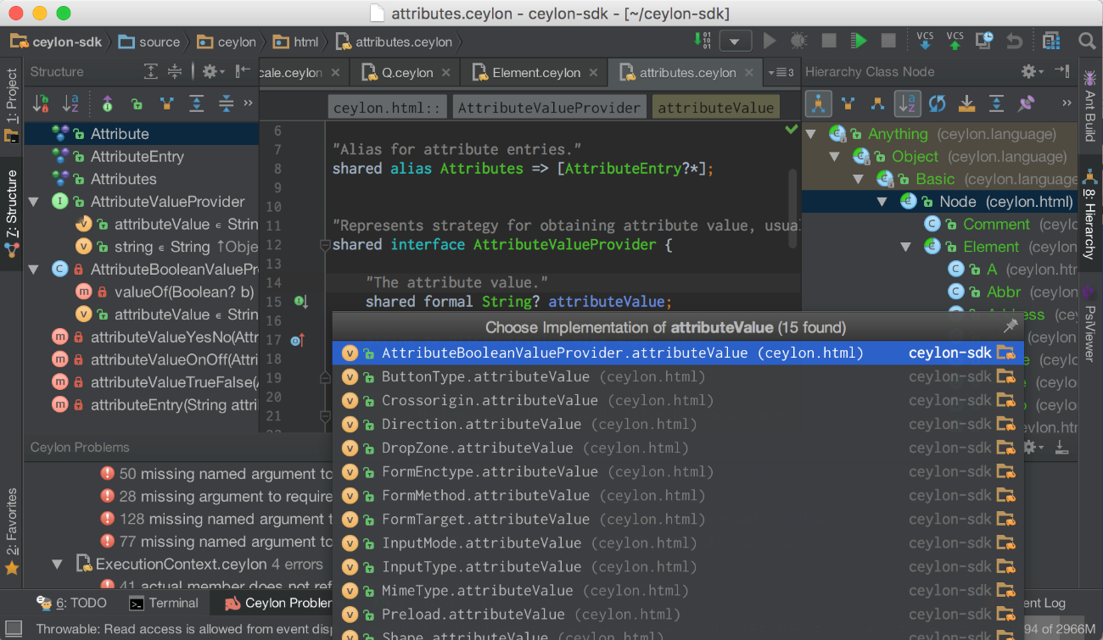

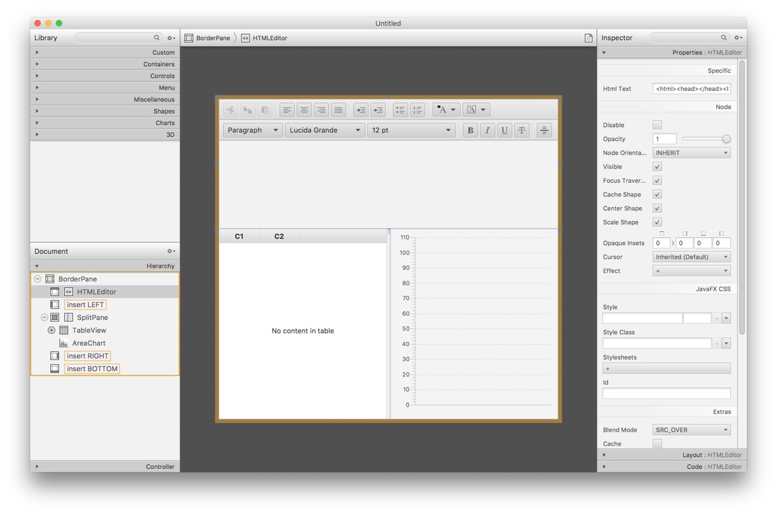

* Hardware Tools: Laptop or computer with minimum configuration of 2gb RAM, dual core processor, and 500gb hard disk.

# **Development risks**

In every software development life cycle this is the main focusing area because in every application there might be ample numbers of risks. Risk is combination of the probability of an event and its negative consequence. According to ISO/IEC there are two main categories for risk management process. These are:

* Risk Assessment
* Risk Control

Can be performed at the beginning of the project development and reassessed at the beginning of the iterations

In this project I analyze Major development risk is dependency of the system on external libraries which might break the system in future if there are any changes. Like new version of library.

------- **Mitigation Solution:** I will use dependency resolution system rather than externally downloading and using those libraries. Dependency resolution system will automatically at run time manage f there is any change in the given library.

# **Control methods**

Methods for monitoring and control the project progress. There are some measurement techniques which we can use to monitor the status of project.

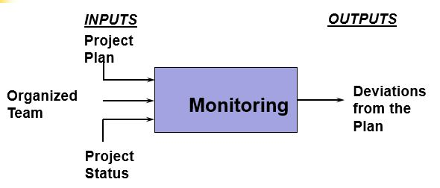

**Activity tracking indicators:**

**Planned Value (PV):** for a given task, PV is defined as the effort planned for that task translated into cost.

**Earned Value (EV):** % of PV of the work actually completed by a given point in time on the project schedule.

**Actual Cost (AC):** The total of costs on tasks that have actually been completed by a given point in time on the project schedule.

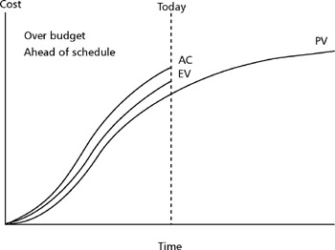

Fig: Interpreting indicators EV, PV, AC

The above table shows that The EV is higher than the PV, the project is ahead of schedule. If EV is lower than the PV means project is behind schedule.

So, these all indicators helps to control the progress of the project. Measuring is concerned with

1) Collecting

2) Validating and

3) Analyzing project status information

Control concerns the application of corrective measures when the actual status does not conform to the expected status state of work products quantity and quality of work products, state of the development process calendar, budget, resources, and risk factors.

# **References**

* <https://upload.wikimedia.org/wikipedia/commons/thumb/e/e2/Waterfall_model.svg/800px-Waterfall_model.svg.png>
* <https://ceylon-lang.org/images/screenshots/1.3.0/intellij/intellij-darcula.png>
* <http://i.imgur.com/H5sMdPK.png>
* <https://www.smartsheet.com/blog/gantt-chart-excel>
* <http://searchsoftwarequality.techtarget.com/definition/waterfall-model>
* <https://en.wikipedia.org/wiki/Waterfall_model>
* <https://www.tutorialspoint.com/sdlc/sdlc_waterfall_model.htm>
* <https://cosmic-sizing.org/cosmic-fsm/>
* <http://techno-soft.com/software-project-monitoring-control-process.html>
* <https://www.stakeholdermap.com/project-management/project-monitoring-and-control.html>
* <https://www.informatik.tu-darmstadt.de/fileadmin/_migrated/content_uploads/08_-_Project_Monitoring_and_Control.pdf>
* <https://b78c5353a874f3d0a1abb4ba-radiantforestllc.netdna-ssl.com/wp-content/uploads/2012/11/business-stakeholder-circle.png>