

Software Requirements Specification

for

EV Charging Network Reservation System

Prepared by: Navjot Singh

40014477

Concordia University

09-02-2018

Table of Contents

Table of Contents ii

1. Introduction 1

1.1 Purpose 1

1.2 Intended Audience and Reading Suggestions 1

1.3 Project Scope 1

1.4 References 1

2. Overall Description 2

2.1 Product Perspective 2

2.2 Product Features 2

2.3 User Classes and Characteristics 2

2.4 Operating Environment 3

2.5 Design and Implementation Constraints 3

2.6 Assumptions and Dependencies 3

3. System Features 4

4. External Interface Requirements 6

4.1 User Interfaces 6

4.2 Software Interfaces 8

4.3 Communications Interfaces 8

5. Other Nonfunctional Requirements 8

5.1 Performance Requirements 8

5.2 Security Requirements 8

5.3 Software Quality Attributes 9

6. Other Requirements 9

Appendix A: Analysis Models 9

# Introduction

## Purpose

The purpose of this document is to define and communicate the software requirement of “Electric Vehicle Reservation System”. The requirements are documented to means to provide a common understanding of stakeholders. The requirements will be verified through reviews. Diagrams and detailed use cases it contains apply UML notations and description.

## Intended Audience and Reading Suggestions

This document is for all the stakeholders (Developers, end-users, project manager, etc.). It provides the well-structured stable set of requirements documented in well-mannered standard format, which assists them to understand what an application need to deliver. For more understanding refer to the reference section which includes all the details of various papers or reports that are used for preparing this document.

## Project Scope

Electric Vehicle Reservation is an interactive standalone application with graphical interface. The goal is to develop a reservation system using the software engineering processes. Application will be tested with various test cases and techniques. Major purpose is of application is effective utilization of charging stations with respect to the customers. Application does not need any special expertise or skills.

## References

* <https://www.uml-diagrams.org/use-case-diagrams.html>
* <https://www.projectsmart.co.uk/requirements-gathering.php>
* <https://www.mockplus.com/blog/post/user-persona-template>
* <https://xtensio.com/user-persona/>
* <https://en.wikipedia.org/wiki/Charging_station>
* <https://pluginamerica.org/understanding-electric-vehicle-charging/>
* <https://www.draw.io/>

# Overall Description

## Product Perspective

Electric Vehicle Reservation system is a window based java application. It is a single-mode application in which user gives a dataset as an excel sheet input and after processing it system will generate the Gantt chart which represent the allocation of charging ports of different stations.

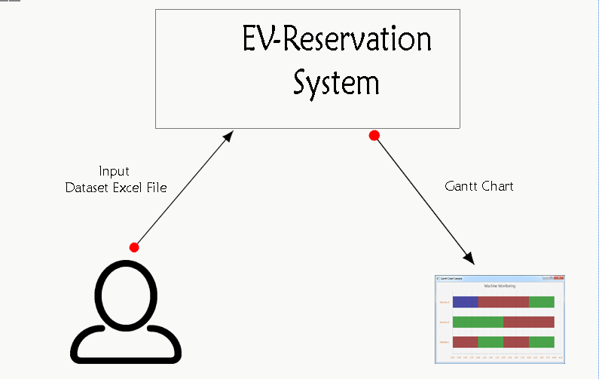

## Product Features

1. Excel file Dataset is loaded
2. Dataset will be processed
3. Gantt chart generated based on processing

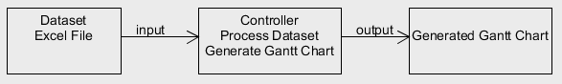

## User Classes and Characteristics

Electric vehicle reservation system has a massive user base they all will use it for reserving a time slot for different stations based on their vehicles required level of charging.

Here, I will represent all the users as a single level of user who comes under the category of expert. By expert I mean who know that how to use the system.

The representation of such user profile in personas would be as follows:

|  |  |
| --- | --- |
| Persona | Major User |
| Photo |  |
| Name | Stuart Thiel |
| Job | Professor |
| Demographics | 39 years old, married, father of one |
| Goals | He is a passionate professor who devotes proper time to his professional and personal matters. He is dexterous in his work and knows technicality of different charging levels. He always prefers charging station which is nearest to the university. |
| Context of Work | He is a professor at a Concordia university. Always charge his car during the day time. His preferred time-window is 1:00pm to 4:00pm. |

## Operating Environment

Electric Vehicle Reservation System is a standalone application, which is developed in java8 programming language. It is a window based application which does not require any special environment.

## Design and Implementation Constraints

Application does not have any implementation or design related constraints. It has one major constraint which is related to the output format.

Output must be Gantt chart which will show the reserved station points.

## Assumptions and Dependencies

* Electric Vehicle recharge reservation system has two library dependencies.

1. For processing Excel file: Apache POI
2. For Gantt chart generation: JFree Chart.

# System Features

* Utilization of different stations charging points.
* Electric vehicle user will ask to reserve a charging point at one station which provides their compatible type of charger.
* 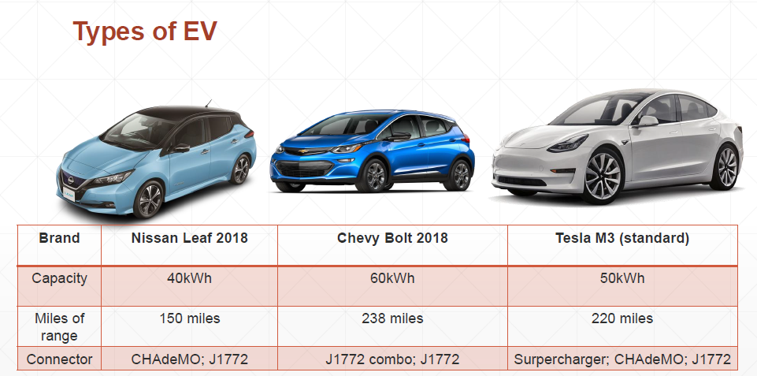Each station has only one type of charging points
* User will give their time window in which they want to charge their vehicle and distance that they want to travel after charging
* System will calculate the time required to charge the vehicle based on the given distance that user want to travel

**Different Constraints:**

1. Charging point is selected based on the Type of Charger
2. System will reserve time slot if it is available in user given time window
3. If **time needed to charge is > time window**, system will reserve the full window
4. Reserved slot can be modified to utilize the charging point but it must be managed in effective manner so that maximum number of user can get time slot in their given window
5. Rejection of vehicle request is based on their given window, System will try to find a charging point if there is no availability even after modifying the assigned vehicles then System will reject that vehicle.
6. Finally, system assigned all the charging points and generates the Gantt chart which is outcome of system.

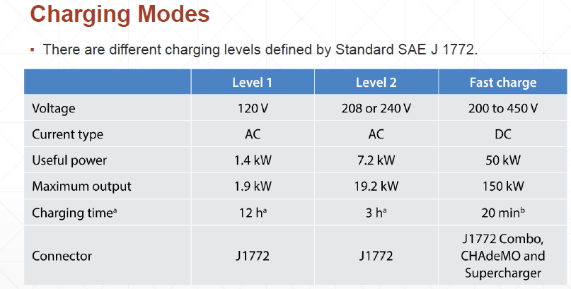

**Use Case Diagram:**

* **General Brief Use Case**

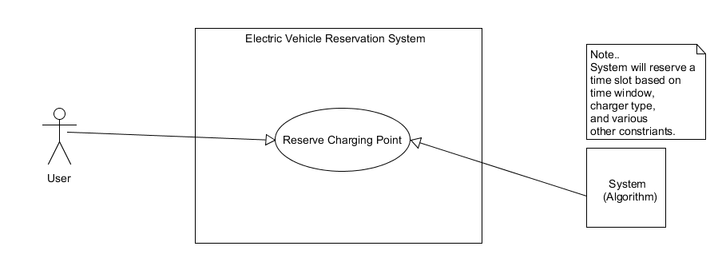

**Use Case Scenario:**

|  |  |
| --- | --- |
| **Use Case:** | UC1 |
| **Name:** | Reserve Charger Point |
| **Priority:** | High |
| **Primary Actor:** | End-User (Electric Vehicle) |
| **Actor’s Goal:** | Get charging point |
| **Secondary Actor:** | System(Algorithm) |
| **Precondition:** | Station must have a charging point for given time window |
| **Post Condition:** | Time slot is reserved |
| **Main Scenario:** | * User will give the preferred time window and distance   🡨 System will process the dataset and find slot for user  🡨 Time slot is reserved based on distance and time window |
| **Alternate Scenario:** | 🡨 Time slot is not available in preferred time window. |

.

# External Interface Requirements

## User Interfaces

1. **Interface1:**

User will click on the **button GetDataSet** to get the excel file from the user.

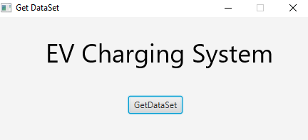

1. **Interface2:**

File Chooser will ask user to choose an excel file.

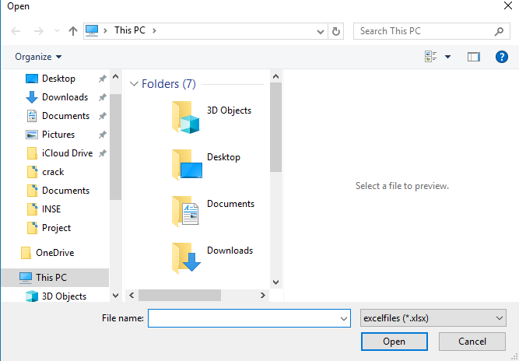

1. **Interface3:**

Final Output Gantt Chart.

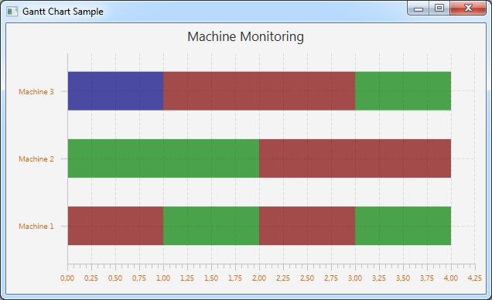

## Software Interfaces

1. **JFreeChart:**

It will get the processed data and generate the Gantt Chart.

1. **Apache POI:**

Used to process an excel file.

## Communications Interfaces

Parallel Streams used to process the excel file as a stream which assists to make an application robust.

# Other Nonfunctional Requirements

## Performance Requirements

Application must be responsive in terms of number of vehicles at time need to reserve a charging point at ant station based on their level of charger.

## Security Requirements

Reservation information must be processed and stores in secured way so that during the updating of different time slots later will not break the system’s performance as well as anyone can not able to update the others reserved slots.

## Software Quality Attributes

* **Availability:**

System must be available all the time so that whenever any user need to reserve any timeslot they can reserve it.

* **Correctness:**

It basically related to the output part. After processing the user request in our case, it will be Dataset in the form of excel file system always generate effective as well as correct results in the form of Gantt Chart.

* **Flexibility:**

Application supposed to be extendible in a sense that may be later needing to integrate it with other components or adding new feature to it does not generate any issues.

* **Reliability:**

It refers to the failure-free software at selected interval of time. Electric Vehicle Reservation system should be reliable at any point of time so that end users able to reserve a time slot at any time.

* **Robustness:**

There are some cases when use give erroneous input to the system so system must able to handle those cases in such a way that which assists users to get back to the right place and system will perform as expected by the user.

* **Testability:**

System should be testable so that before deliver to the end user it is validated and verified with numerous test cases. Testability refers to make the product viable solution. For requirement documentation there is review stage in which testing of requirements helps to identify the errors in requirement document.

# Other Requirements

Appendix A:  Analysis Models

* **Data Flow Diagram:**

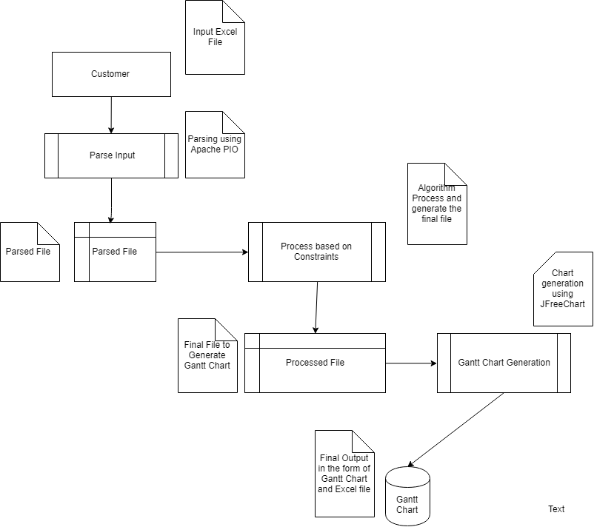

* **State Transition Diagram:**

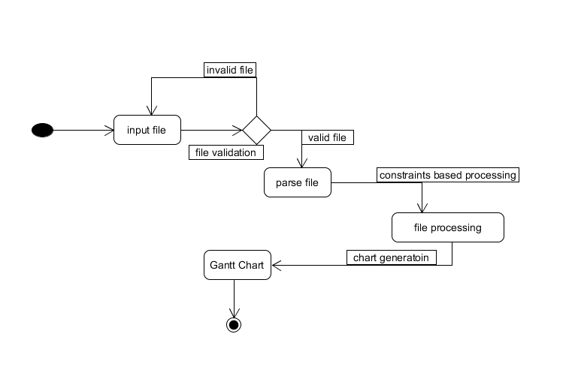

**Actions:**

1. Valid file selected
2. Parsing of file took place based on the valid file constraint
3. Parsed file then processed based on various constraints
4. File processing action triggers the new event to generate Gantt Chart.
5. Chart generation action changes the state from processing to Final State which is Gantt Chart generation.

* **Class Diagram**

**Vehicle** Class has a **variable** name **ChargerType: String**

