

**PROJECT REPORT**

On

**FORENSIC EXPERT SYSTEM**

Submitted to

**LOVELY PROFESSIONAL UNIVERSITY**

in partial fulfilment of the requirements for the award of degree of

**Master in Computer Applications**

**Submitted By Supervised By**

**Navjot Singh Mr.Parvesh Mor**

**11302225 Assistant Professor**

**LOVELY FACULTY OF TECHNOLOGY & SCIENCES**

**LOVELY PROFESSIONAL UNIVERSITY**

**PUNJAB**

**[August-December, 2014]**

**DECLARATION**

I hereby declare that the project work entitled **Forensic Expert System** is an authentic record of my own work carried out at **VentuePact**, as requirements of Industry Internship project for the award of degree of MCA 5th SEM, Lovely Professional University, Phagwara , Punjab, under the guidance of Mr Parvesh Mor (Internal Supervisor) and Mr Ritesh Tandon (External Supervisor).

The matter reported in this project has not been submitted earlier anywhere else for the award of any other award of Diploma/Degree.

**Date:** 29th November 2014

**Place:** Lovely Professional University

**Team Members University Registration Number Signature**

Anukool Srivastav 11305839 ……………………………

Navjot Singh 11302225 ……………………………

**CERTIFICATE**

This is to certify that the Major Project report entitled “**Forensic Expert System**” submitted by Anukool Srivastav (11305839), Navjot Singh (11302225) has been carried out under my guidance & supervision in VenturePact. The project report is approved for submission towards partial fulfilment of the requirement for the award of degree Master of Computer Applications from Lovely Professional University, Jalandhar, Punjab.

………………………… ………………………….. .……………………….

**External supervisor Internal Supervisor Training Coordinator**

Mr Ritesh Tandon Mr Parvesh Mor Mr Abhishek Sharma

Sr. Software Developer Asst. Professor Industry Co-ordinator

VenturePact,LPU School of Computer Application Lovely InfoTech,LPU

**Acknowledgement**

This project is a welcome and challenging experience for us as it took a great deal of hard work and dedication for its successful completion. It is our pleasure to take this opportunity to thank all those who help us directly or indirectly in preparation of this report.

There are a number of people that We would like to acknowledge for continuing support and kind help that they has been offered to us. Firstly, a huge thanks to our extremely inspiring, extraordinary and kind mentor Mr Charanjit Singh Bhalla, thanks for believing in us and guiding us, it has been an honour to be your student. Without their guidance and support, this paper would not have seen light of the day. It gives us immense in expressing a deep sense of gratitude and sincere thanks to Lovely Professional University. I also extend my thanks to other Faculties for their Cooperation during my project.

We would also like to express thanks to my fellow graduates students for being there with us in our every problem. Last but not the least we thanks our family for their boost, your patience, your understanding and for caring about us and support in every sphere.

Anukool Srivastav

Navjot Singh

**Table of Content**

1. Company Profile…......................................................................................................................7

 Name of the Organization...........................................................................................7

* Products of VenturePact………………......................................................................8

2. Profile of Problem.......................................................................................................................9

 Existing System...........................................................................................................9

➢ Disadvantage...................................................................................................9

 Introduction To “Forensic System”............................................................................9

➢ Advantage........................................................................................................9

3. Project Analysis.........................................................................................................................10

 Product Definition......................................................................................................10

 Feasibility Analysis....................................................................................................10

➢ Technical Feasibility Study............................................................................10

➢ Economic Feasibility Study...........................................................................10

➢ Legal Feasibility Study...................................................................................11

➢ Time Feasibility Study...................................................................................11

 Project Plan................................................................................................................11

4. Software Requirement Analysis & Tools..................................................................................13

 Introduction................................................................................................................13

 General Description...................................................................................................13

➢ Android...........................................................................................................13

➢ Android SDK..................................................................................................14

➢ JAVA..............................................................................................................14

➢ SQLite...........................................................................................................15

➢ XML...............................................................................................................15

➢ E draw Max....................................................................................................15

➢ SQLite browser.............................................................................................16

➢ SPECIFIC REQUIREMENT.........................................................................16

✓ Hardware............................................................................................16

✓ Software.............................................................................................16

5. Design........................................................................................................................................20

 Data Flow Diagram....................................................................................................20

➢ 0 Level DFD...................................................................................................21

➢ 1 Level DFD...................................................................................................22

✓ DFD for Admin Module.....................................................................23

✓ DFD for Investigator Module.............................................................23

✓ DFD for Public User Module.............................................................24

 Flow Charts...............................................................................................................25

 Use Case Diagram.....................................................................................................26

 Activity Diagram.......................................................................................................27

 ER Diagram...............................................................................................................28

 Database Design........................................................................................................29

➢ Table Structure...........................................................................................................32

6. Testing.......................................................................................................................................36

 Functional Testing.....................................................................................................36

 Structural Testing.......................................................................................................36

 Unit Testing...............................................................................................................37

 Integration Testing.....................................................................................................37

 System Testing...........................................................................................................37

 Acceptance Testing....................................................................................................38

7. Test Cases of Project.................................................................................................................40

 Test Cases for Add User Activity..............................................................................44

 Test Cases for Add Case Activity..............................................................................48

 Test Cases for Add Evidence Activity.......................................................................52

 Test Cases for Login Activity…................................................................................54

8. Implementation..........................................................................................................................58

 Implementation of the Project....................................................................................59

➢ Conversion Plan.............................................................................................60

 Post Implementation & Software Maintenance.........................................................60

9. Project Legacy...........................................................................................................................61

 Current Status of Project............................................................................................62

 Future Scope & Enhancement...................................................................................63

 Technical Skill Learn.................................................................................................62

10. User Manual............................................................................................................................63

 Screenshot of Front End............................................................................................67

➢ Investigator User Module.............................................................................67

 User Manual for Admin Module...............................................................................67

11. Source Code............................................................................................................................68

12. Bibliography………………………………………………………………………………..100

1. **COMPANY PROFILE**

* **Name of the Organization** venturepact_logo

**Overview:**

VenturePact is an online marketplace that connects businesses with pre-screened software development firms. The marketplace provides a transparent platform where companies can get customized pitches, see a firm’s ratings, inspect a verified portfolio, get their standard FAQs answered and make secure payments. It is founded by Mr Pratham Mittal and Randy Rayess.

They have pre-screened hundreds of software development firms in different verticals and provide extensive data around each including client reviews & ratings, validated portfolios and employee profiles. This transparency lets businesses make a better & faster decision regarding which firm to go with for their high risk projects.

**Clients:**

ESPN, Flip Kart, Adidas, Yale University, BMW, Ashoka

**Offices:**

Its offices are located in New York City & Philadelphia.

**Services:**

**Mobile applications:** Technologies served: IOS, Android, Symbian, Blackberry (6 more)

**Web applications**: Technologies served: Ruby, php, Python, Java (32 more)

**Business applications:** Platforms served: SAP, Oracle (16 more)

**Wearable& Internet of things** Technologies: Google Glass, Galaxy Watch, iBeacon

**UI/UX Design** categories: SaaS UI/UX, Mobile UI/UX, Mobile & Web Ad design

**Big data & data visualization:** Technologies served: Hadoop, MapReduce, and R (11 more)

* **Products of VenturePact**

1. **MidWife – A Healthcare App**

MidWife is a healthcare app, helping maternity in remote locations. App helps ladies who are in remote locations and gives information on their medical history, treatment and follow-ups. App also provides items available with a shopping cart.

1. **RetailCo – An Ecommerce App**

RetailCo is an iPhone app, which provides details of products in store. The app gives easy access to stores having products. The app gives the user the nearest store location withDistance. App also tells whether offers are available with the store or not.

1. **MatchMaker**

MatchMaker is a website providing social networking to people.

1. **AirCare** Founder : George Xiangwen Zend

Aircare is a medical app where doctor and patient can communicate directly using video chat.

1. **Boupp** Founder : Parisa

Boupp is a website providing fashion products, Multiple franchise companies can put their products. Companies can get advanced data results for the products.

1. **Accompliss**Founder : Justin

Accompliss is a hotel management app, App allows customers to call room service, food, spa, room booking etc.

1. **FireFly** Founder : Aziz

FireFly is browser sharing website, where two users can share there browser in real-time and can view the live actions.

1. **SmartyPal** Founder : Prasanna

SmartyPal is a kids app where kids can read stories and app gives animation affects for the characters involved.

1. **Profile of Problem**

**Existing System**

Current forensic expert systems are based on manual gathering of evidences that are found at the crime location and storing the details in the papers. These systems have drawback of manipulation of the evidences before they are available to the forensic experts.Expert systems are computer programs that contain subject-specific knowledge. Expert systems can analyse a given set of data with the same skill as a human expert. In the forensic community, an expert system can assist forensic analysts with the routine processing of single source samples and can streamline sample processing workflow by alerting the analyst to those samples that require more thorough manual review as specified in the user defined rules.

**Disadvantage**

* Unauthorised modification of the Evidences
* Waste of time in collecting and storing the evidences manually
* Difficulty in searching cases

**Introduction to “Forensic Expert System”**

Our proposed system will have interface available to collect and capture all the details of the evidences and store them at single place called server dynamically. These evidences can be viewed and used by the forensic experts to solve the cases. This system helps to resolve the issue of manipulation of collected evidences by automatically uploading all the collected evidences that can be accessed by only authorized person only like the forensic experts head.

The goal of this forensics app is to perform a structured investigation while maintaining a documented chain of evidence to find out exactly what happened to different cases and who was responsible for it.

**Advantage**

* Ease and quick access to the evidences
* Generation of reports of each cases and their evidences
* Different module/form to capture each type of evidence
* Synchronization of collected evidences to save on server
* Easy maintenance of records compare to manual system

1. **Project Analysis**

 **PRODUCT DEFINITION**

“Forensic Expert System” is an android App which helps the forensic experts and investigatorsto easily manage different type of cases. It provides user friendly interface with separate user account facility and modification rights. The app also facilitates users to easily add different type of evidence for each case. In this project we use Java and for designing purpose XML language and SQLite as database. So it’s a fully functional application having nice user interface and best functionality.

* **FEASIBILITY ANALYSIS**

The feasibility study is an evaluation and analysis of the potential of the proposed project which is based on extensive investigation and research to support the process of decision making. Various issues of feasibility analysis considered in project are as follows:-

* **Technical Feasibility Study**

Technically we analyses that it is possible to develop such system with Java Because Java is pure object oriented language which provides enough functions to implement various functionalities. Various design issues of app can be resolved by using XML and front-end validations can be implement with the help of java. MYSQL Can is used as database which is compatible with PHP for implementing web services at server side.

* **Economic Feasibility Study**

This app is also economically feasible because it can easily be deployed on Google play.Google offers the Google Play service in which programmers can offer their Android application toAndroid users. Google phones include the Google Play application which allows installing applications.Google Play also offers an update service, e.g. if a programmer uploads a new version of hisapplication to Google Play, this service will notify existing users that an update is available and allow toinstall it.

* **Legal Feasibility Study**

Since the project needs no copyright, patenting, and doesn’t intent to have any relation with anybody else’s intellectual property rights, it can be considered as a legally feasible project

* **Time Feasibility Study**

As it has been more probable (as per the requirements, functions, and performance specifications of the system) that the project can be completed within the given time frame, it is considered that the undertaking this project is feasible in the context of time.

* **PROJECT PLAN**

Project planning is performed basically in the large organization where it requires effective management to control and to find the desired result. Project planning for an organization has following steps:

* Acquiring and organizing the tools and resources for the project.
* Preparation of well-defined schedule for events of the project.
* Proper evaluation of progress of project development.
* Establishing various standards for the project by which we can find the standard output.

We had the time from August 2014 to November 2014 for the project preparation thus within this duration we had to estimate everything to prepare this project. According to the first step we acquired the resources and organize them in well-defined manner so that there we should not face any problem. The second thing is distributing the time stamp into small time unit according to the module of the project. This is the term as schedule the task according to the event happened in the project. We distributed the time into different module of the whole part of the project development.

Evaluating the progress of project development is to measure the functionality of the project by comparing with the requirement criteria. It is told that we cannot do anything if we have not properly measure the task which you are going to do. This is a project which has everything in it so the proper plan is much necessary. Initially, the project must establish the objectives of each phase of development. Each phase must be of a controllable size, and every task within the project must be performed with responsibility. We first established the objectives of each phase and at last we guessed that the objectives that have been established are met in the proper time.

1. **SOFTWARE REQUIRMENT ANALYSIS & TOOLS**

**Introduction**:

One of the most difficult tasks is that the selection of the software, once system requirement is known is determining whether a particular software package fits the requirements. After initial selection further security is needed to determine the desirability of particular software compared with other candidates. This section first summarizes the application requirement question and then suggests more detailed comparisons:

**GENERAL DESCRIPTION**

* **Android**

Android is a modern, open source operating system and SDK for mobile devicesdeveloped by Google. With it you can create powerful mobile applications. This becomes even more attractive when your applications can access Web services, which means you; need to speak the language of the Web: XML. In this article, you will see different options for working with XML on Android and how to use them to build your own Android applications.

-The Linux kernel 2.6-which includes useful drivers that allow for example Wi-Fi or Bluetooth.

-The library written in C and C + + that provide higher level functionality such as an HTML engine, or adatabase (SQLite).

-A runtime environment for applications based on a virtual machine, made for inefficient machines such astelephones. The aim is to translate JAVA in machine language understood by Android.

-A JAVA framework that allows applications running on the virtual machine to organize and cooperate.

**Why Android is better..?**

This is a list of features in the Android operating system.

* Applications

Android includes most of the time many Google applications like Gmail, YouTube or Maps.These applications are delivered with the machine most of the time, except in certain cases, such as somephones running android on which the provider has replaced Google applications by its own applications.

* Widgets

With android, it is possible to use widgets which are small tools that can most often getinformation. These widgets are directly visible on the main window.

* Android Market

This is an online software store to buy applications. Developers who created applicationscan add them into the store, and these applications can be downloaded by users, they can be both free andpaid.

* Multitasking

Android allows multitasking in the sense that multiple applications can run simultaneously.With Task Manager it is possible view all running tasks and to switch from one to another easily.

* Messaging

SMS and MMS are available forms of messaging, including threaded text messaging and Android Cloud to Device Messaging (C2DM) and now enhanced version of C2DM, Android Google Cloud Messaging (GCM) is also a part of Android Push Messaging service.

* Voice based features

Google search through voice has been available since initial release.[4] Voice actions for calling, texting, navigation, etc. are supported on Android 2.2 onwards.[5] As of Android 4.1, Google has expanded Vce Actions with ability to talk back and read answers from Google's Knowledge Graph when queried with specific commands.[6] The ability to control hardware has not yet been implemented.

* Connectivity

Android supports connectivity technologies including GSM/EDGE, Wi-Fi, Bluetooth, LTE, CDMA, EV-DO, UMTS, NFC, IDEN and WiMAX.

* Bluetooth

Supports voice dialing and sending contacts between phones, sending files (OPP), accessing the phone book (PBAP), A2DP and AVRCP. Keyboard, mouse and joystick (HID) support is available in Android 3.1+, and in earlier versions through manufacturer customizations and third-party applications.[12]

* Media support

Android supports the following audio/video/still media formats: WebM, H.263, H.264, AAC, HE-AAC (in 3GP or MP4 container), MPEG-4 SP, AMR, AMR-WB (in 3GP container), MP3, MIDI, Ogg Vorbis, FLAC, WAV, JPEG, PNG, GIF, BMP, WebP.[3]

* External storage

Most Android devices include microSD slot and can read microSD cards formatted with FAT32, Ext3 or Ext4 file system. To allow use of high-capacity storage media such as USB flash drives and USB HDDs, many Android tablets also include USB 'A' receptacle. Storage formatted with FAT32 is handled by Linux Kernel VFAT driver, while 3rd party solutions are required to handle other popular file systems such as NTFS, HFS Plus and exFAT.

* Java support

While most Android applications are written in Java, there is no Java Virtual Machine in the platform and Java byte code is not executed. Java classes are compiled into Dalvik executables and run on Dalvik, a specialized virtual machine designed specifically for Android and optimized for battery-powered mobile devices with limited memory and CPU. J2ME support can be provided via third-party applications.

* Storage

SQLite, a lightweight relational database, is used for data storage purposes.

**The basics of creating Android apps:**

To begin to program for Android I needed some basics, because some elements are very different, even if programming an application in Android uses the Java language, therefore, an object oriented language. Firstly, in an Android application, there is no main method:

public static void main(String[] args){...}

This method that allows to launch a program in java is not present in an application android. This example is only the first of a long list.

**Activity:**

An activity is a user interface that allows the user to interact with the screen, to perform actions.For example, a text messaging application could have an activity that displays a list of contacts to sendmessages. Once the contact is selected , activity could send information to a second activity that couldserve to send the message to the contact.

When an application is launched, what it displays is the result of an activity. At the code level, forcreate an activity; you must create a class that extends the Activity class. An activity has a requiredonCreate () method. It is the main method. To interact with the program, through the activity, there must besomething displayed, that is why the activity, contains what is called views.

**View:**

a View is the basic building block for user interface components. A View occupies a rectangular areaon the screen. View is the base class for widgets, which are used to create interactive UI components(buttons, text fields, etc.).There is differents kinds of views, for example a ListView is able to display only aninteractive list of what you want to display, while a WebView allows you to to display a web page. As saidbefore, A view occupies a rectangular area on the screen. To organise these rectangles on the screen, thereis a text file written in XML for every different screen.

* **Android SDK**

The Android software development kit (SDK) includes a comprehensive set of development tools.[8] These include a debugger, libraries, a handset emulator based on QEMU, documentation, sample code, and tutorials. Currently supported development platforms include computers running Linux (any modern desktop Linux distribution), Mac OS X 10.5.8 or later, and Windows XP or later. For the moment one can also develop Android software on Android itself by using the AIDE - Android IDE - Java, C++ app and the Java editor app. The officially supported integrated development environment (IDE) is Eclipse using the Android Development Tools (ADT) Plugin, though IntelliJ IDEA IDE (all editions) fully supports Android development out of the box,[9] and NetBeans IDE also supports Android development via a plugin.[10] Additionally, developers may use any text editor to edit Java and XML files, then use command line tools (Java Development Kit and Apache Ant are required) to create, build and debug Android applications as well as control attached Android devices (e.g., triggering a reboot, installing software package(s) remotely)

* **Java**

Java is a programming language and computing platform first released by Sun Microsystems in 1995. There are lots of applications and websites that will not work unless you have Java installed, and more are created every day. Java is fast, secure, and reliable. From laptops to datacentres, game consoles to scientific supercomputers, cell phones to the Internet, Java is everywhere.

If you want to get started with application development, Google provides a Java API to get started and compiles your files into classes. Why did Android prefer Java for its development platform? There are multiple reasons such as; Java is a commonly used language and many programmers know it, it can run on a virtual machine (VM) so no need to recompile for different phones, better security, many development tools available for Java, and Java is a known industry language with most phones compatible with it.Though Google provides the Java API, Android does not use JVM to execute class files. Rather, it uses Dalvik Virtual Machine (DVM). The class files are compiled into Dalvik Executable (DEX) format, and bundled as Android Package (APK) along with other resources.With Java, if you are aware of object-oriented programming principles, creating applications for android will be much simpler than IOS app development.

* **XML on Android**

Xml means Extensible Mark-up Language. Android provides a straightforward XML vocabulary that corresponds to the View classes and subclasses. The goal of using Android's XML vocabulary is to quickly design UI layouts and the screen elements they contain, in the same way that creating web pages in HTML with a series of nested elements.

The Android platform is an open source mobile development platform. It gives you access to all aspects of the mobile device that it runs on, from low level graphics, to hardware like the camera on a phone. With so many things possible using Android, you might wonder why you need to bother with XML. It is not that working with XML is so interesting; it is working with the things that it enables. XML is commonly used as a data format on the Internet. If you want to access data from the Internet, chances are that the data will be in the form of XML

**Intent:**

An activity can of course start another one, even if it but to do this, it will need a special objectcalled Intent. Intent is basis description of an operation to be performed. It can launch an Activity, send abroadcastIntent to any interested Broadcast Receiver components, and communicate with a backgroundService. An Intent performs binding between the code in different applications. it can be thought of as thelink between activities. It is possible to add some informations to an Intent, thanks to an object calledbundle, that you add to the intent thanks to the method :

Intent.putExtras(Bundle objetbunble );

**Android Manifest:**

AndroidManifest.xml file is necessary for all android applications and must have this name in itsroot directory. In the manifest you can find essential information about the application for the Androidsystem, information’s that the system must have before it can run any of the application's code. Here iswhat you can find in the Android manifest:

-The name of the Java package for the application. The package name serves as a unique identifierfor the application.

-The description of the components of the application : the activities, services, broadcast receivers,and content providers that the application is composed of and under what conditions they can belaunched .

-The processes that will host application components.

-The permissions the application must have in order to access protected parts of the API andinteract with other applications.

-The permissions that others are required to have in order to interact with the applicationscomponents.

-The minimum level of the Android API that the application requires.

-The list of the libraries that the application must be linked against.

* **IDE for Android**

Android Studio is a new Android development environment based on IntelliJ IDEA. It provides new features and improvements over Eclipse ADT and will be the official Android IDE once it's ready. On top of the capabilities you expect from IntelliJ, Android Studio offers:

* Flexible Gradle-based build system
* Build variants and multiple APK generation.
* Expanded template support for Google Services and various device types.
* Rich layout editor with support for theme editing.
* Lint tools to catch performance, usability, version compatibility, and other problems.
* ProGuard and app-signing capabilities.
* Built-in support for Google Cloud Platform, making it easy to integrate Google Cloud Messaging and App Engine.
* **SQLite for databases**

SQLite is an in-process library that implements a self-contained, server less, zero-configuration, transactional SQL database engine. It is the one database, which is zero-configured, that means like other database you do not need to configure it in your system. SQLite engine is not a standalone process like other databases; you can link it statically or dynamically as per your requirement with your application. The SQLite accesses its storage files directly.

Android provides several ways to store user and app data. SQLite is one way of storing user data. SQLite is a very light weight database which comes with Android OS. In this tutorial I’ll be discussing how to write classes to handle all SQLite operations.

* SQLite does not require a separate server process or system to operate (server less).
* SQLite comes with zero-configuration, which means no setup or administration needed.
* A complete SQLite database is stored in a single cross-platform disk file.
* SQLite is very small and light weight, less than 400KiB fully configured or less than 250KiB with optional features omitted.
* SQLite is self-contained, which means no external dependencies.
* SQLite transactions are fully ACID-compliant, allowing safe access from multiple processes or threads.
* SQLite supports most of the query language features found in the SQL92 (SQL2) standard.
* SQLite is written in ANSI-C and provides simple and easy-to-use APl

To use a database, we will create a class called Helper. This class will allow us to manipulate thedatabase from any other class that has instantiated the object Helper. This class has elements and methodsvery specific . First specific objects: a SQLitedatabase, and a class called openHelper that we will also create.

private SQLiteDatabase db;

OpenHelper openHelper = new OpenHelper(this.context);

this.db = openHelper.getWritableDatabase();

The class OpenHelper extends SQLiteOpenHelper. This class is used to actually create one table orseveral tables in a database, and fill the table in the moment of its creation, al this in the method onCreate(). this class allows to update the version of the table with the method onUpgrade (). The method OnCreatewill be called only once, after that the table is created this method will no longer serve. For the class Helper,you can add all the methods used to select, add, edit or delete entries in the table.

* **Access to Web Services (JSON)**

Web service is software functionality that can be invoked through the internet using common protocols

* like a remote function(s) you can call by contacting a program on a web server
* many web services accept parameters and produce results
* can be written in PHP and contacted by the browser in HTML and/or Ajax code
* service's output might be HTML but could be text, XML, JSON or other content

The ability to describe sets of data in JSON format is a natural extension to the JavaScript language. Service Now supports a web service interface that operates on the JSON object as the data input and output format.

The JSON web service is provided by a platform-level processor similar to the services for SOAP, WSDL, CSV, Excel, and XML. Like those services, the JSON service is triggered by the standalone JSON URL parameter.

* **E-draw Max for diagrams**

E-draw Max enables students, teachers and business professionals to reliably create and publish various kinds of diagrams to represent any ideas. E-draw Max is an all-in-one diagram software that makes it simple to create professional-looking flowcharts, organizational charts, network diagrams, business presentations, building plans, mind maps, science illustration, fashion designs, UML diagrams, workflows, program structures, web design diagrams, electrical engineering diagrams, directional maps, database diagrams and more.

* **SQLite browser**

DB Browser for SQLite is a light GUI editor for SQLite databases, built on top of Qt. The main goal of the project is to allow non-technical users to create, modify and edit SQLite databases using a set of wizards and a spread sheet-like interface.

* **Specific Requirements**

**Software Requirements**

For developing the application the following are the Software Requirements:

**Operating System:** Windows 7  
**Language:** SDK, Java  
**Tools:** Android Studio  
**Technologies used:** Java, XML.  
**Debugger:** Android Dalvik Debug Monitor service For running the application the following are the Software Requirements:  
**Operating System :** Android 2.4.1 or higher versions  
**Network :** Wi-Fi Internet or cellular Network 3  
**Tools :** Different API’s and JSON data

**Hardware Requirements**

For developing the application the following are the Hardware Requirements:  
**Processor :** Adreno or higher  
**RAM :** 256 MB  
**Space on disk :** minimum 512MB For running the application:  
**Device :** Android version 2.4.1 and higher  
**Minimum space to execute :** 8.0M

1. **DESIGN**

Design is the first step into the development phase for any engineered product or system. Design is a creative process. A good design is the key to effective system. The term "design" is defined as "the process of applying various techniques and principles for the purpose of defining a process or a system in sufficient detail to permit its physical realization".

* **Data Flow Diagram (DFD)**

**Notation Used**

* **Process**

A function is represented using a circle. This sign is called a process or a bubble. Bubbles are annotated with the names of the corresponding functions.

* **External Entity**

An external entity such as a librarian, a library member, etc. is represented by a rectangle. The external entities are essentially those physical entities which is external to the software system that interact with the system by inputting data to the system or by consuming the data produced by the system. In addition to the human users, the external entity symbols can be used to represent external hardware and software such as application software

* **Data Flow**

A directed arc or an arrow is used as a data flow sign. A data flow sign represents the data flow occurring between two processes, or between an external entity and a process, in the direction of the data flow arrow. Data flow signs are usually annotated with the corresponding data names.

* **Data Store**

A data store represents a logical file. It is represented using two parallel lines. A logical file can represent either a data store sign, which can represent either a data structure, or a physical file on disk. Each data store is connected to a process by means of a data flow sign. The direction of the data flow arrow shows whether data is being read from or written into a data store. A arrow flowing in or out of a data store implicitly represents the entire data of the data store and hence connecting to a data store need not be annotated with the name of the corresponding data items.

* **0 Level DFD**

A 0 level DFD defines the boundary between the system and outer environment. Such diagrams represent the system at the centre with no details of its interior structure. The main objective of this diagram is to focus attention on external factors and events that are important during development of a set of system requirements.

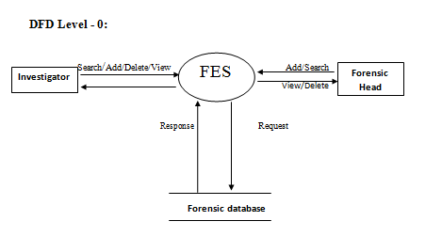

Fig1:DFD Level0

* **Data flow diagram (level 1)**

This shows the system divides into sub systems each of which deals with one or more of the data flow or form an external agent and which together provide all of the functionality of the system as a whole.

**DFD for Admin (Forensic Head/Expert):**

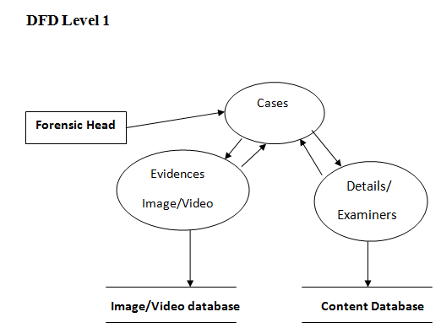

Fig2:DFD Level1

**DFD of Admin (Forensic Head/Expert) for Cases Module:**

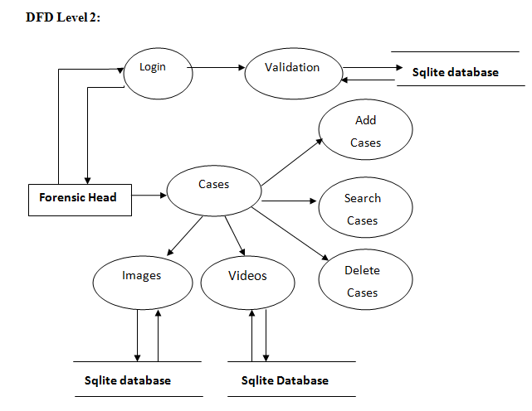 Fig3:DFD Level2

**DFD of Admin (Forensic Head/Expert) for Users Module:**

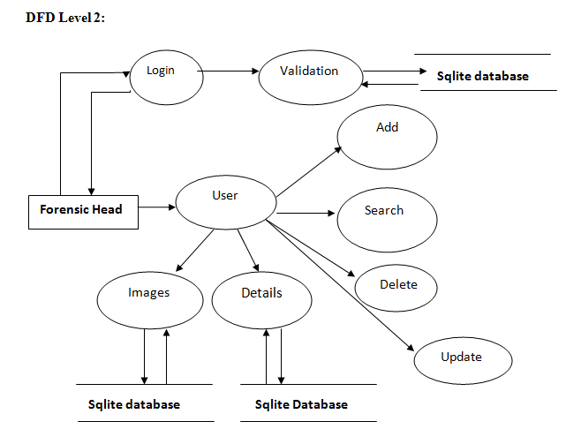

Fig4: DFD Level2

**DFD of Investigators for Users Modules:**

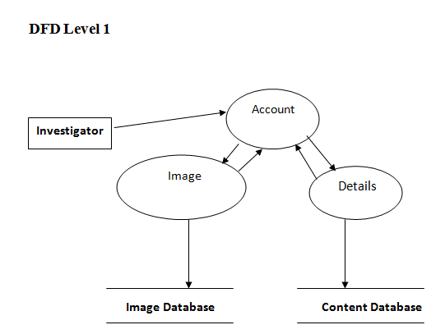

Fig5: DFD Level1

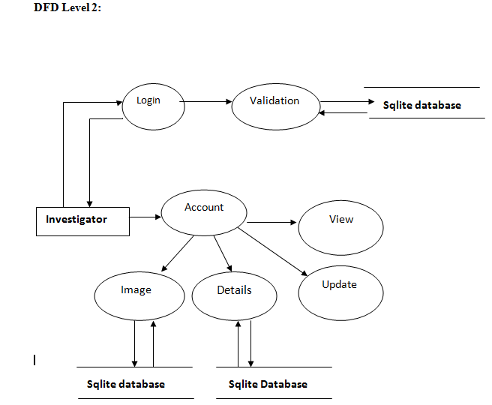

Fig6: DFD Level2

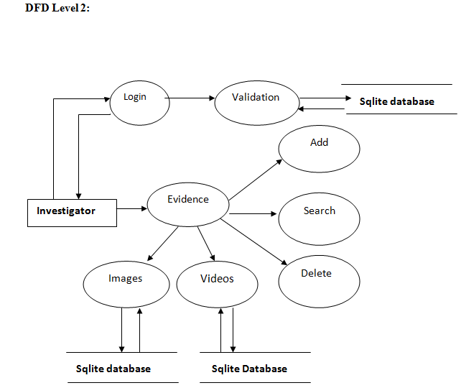

Fig7: DFD Level2

**DFD for Admin Module:**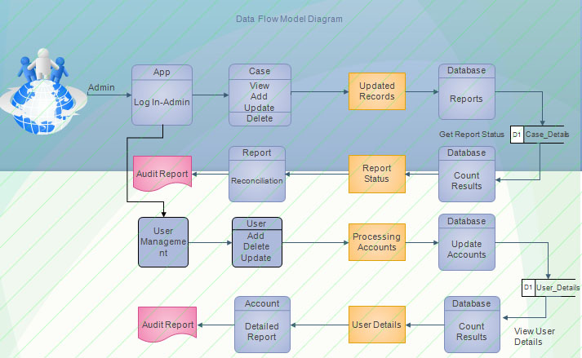

Fig8: DFD of Admin

**DFD for Investigator Module:**

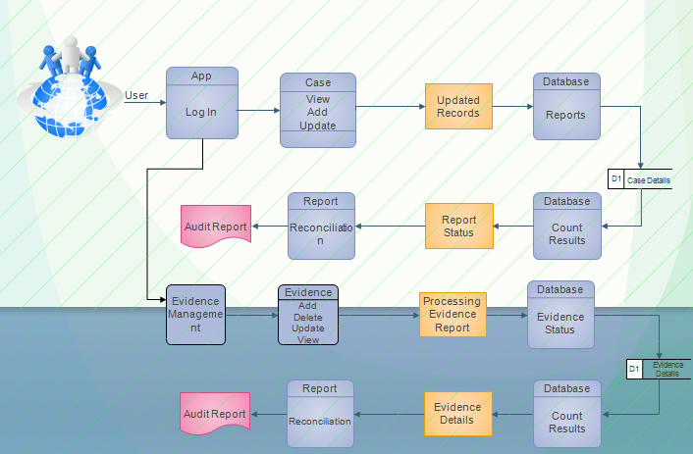

Fig9: DFD of User

* **FLOW CHART**

A Flow Chart Represent is an algorithm or process showing a step by step execution detail. Flow charts are help to visualize what is going on and thereby help the viewer to understand a process, find the flows, and the bottlenecks. The two most or common type of boxes in flow charts are

* A Process step usually called activity and donated as a rectangular box.
* A decision usually denoted as a diamond.

Fig10: Flowchart of Application

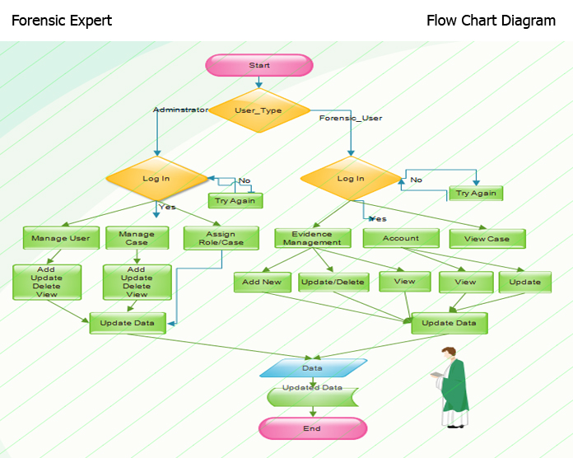

* **USE CASE DIAGRAM**

A use case diagram at its simplest is a representation of a user's interaction with the system and depicting the specifications of a use case. A use case diagram can portray the different types of users of a system and the various ways that they interact with the system. This type of diagram is typically used in conjunction with the textual use case and will often be accompanied by other types of diagrams as well.

**USE CASE DIAGRAM for Investigators:**

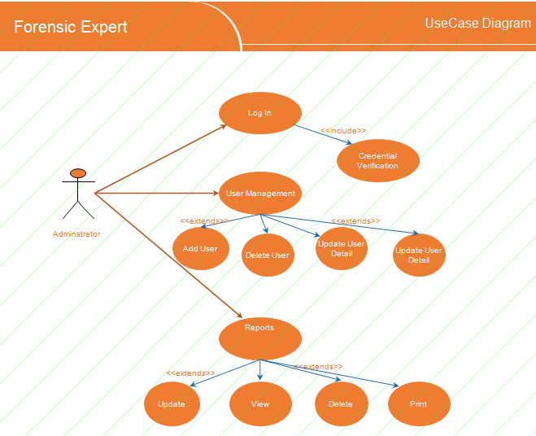

Fig11: Use Case of Admin

**USE CASE DIAGRAM for Admin:**

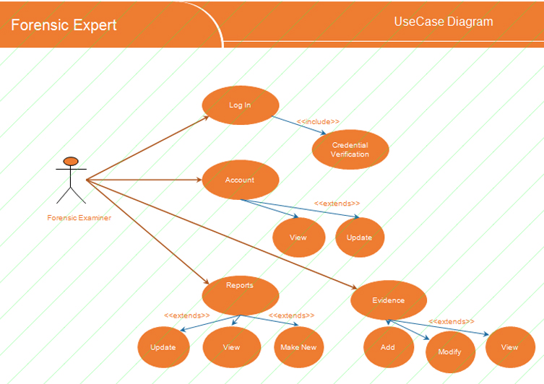

Fig12: Use Case of Forensic Examiner

* **E-R DIAGRAM**

**For Investigators to add evidences:**

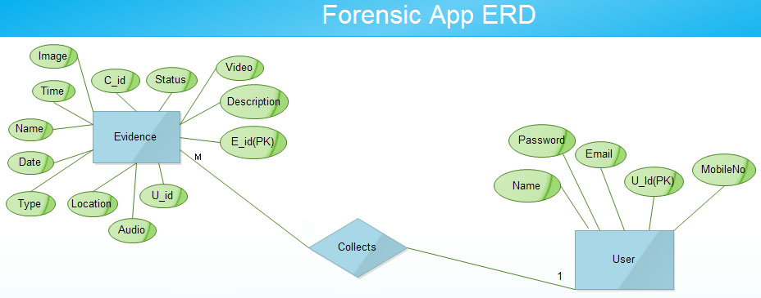

Fig13: ERD

**For Investigators to add images:**

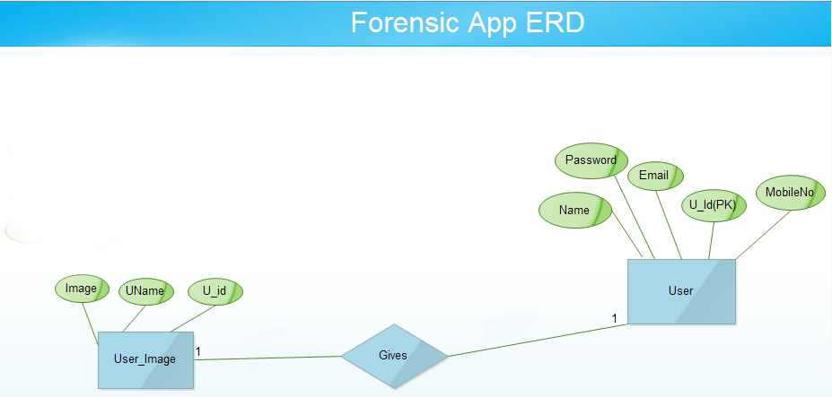

Fig14: ERD

**For Admin to add cases:**

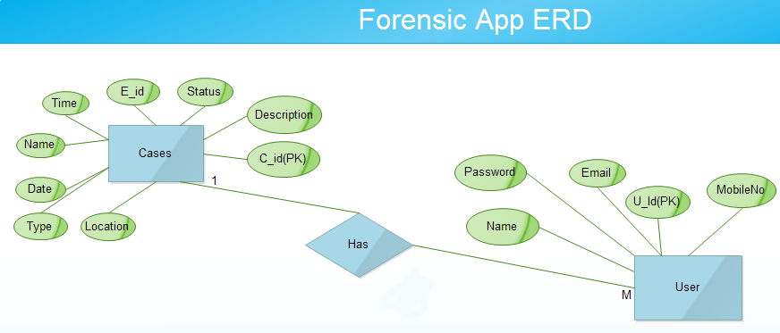

Fig15: ERD

**For cases to add evidences:**

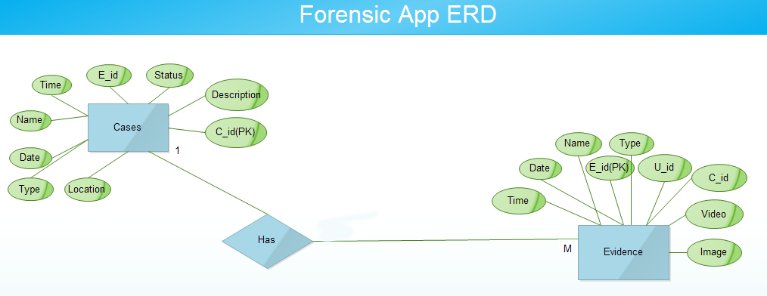

Fig16: ERD

**ER – Diagram:**

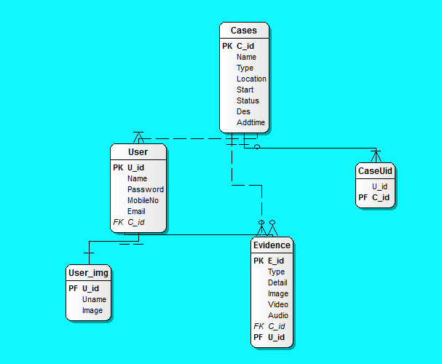

Fig17: ERD-Detail

* **ACTIVITY DIAGRAM**

**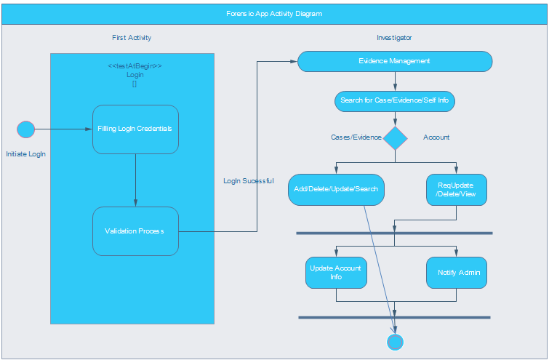**

Fig18: Activity Diagram of Investigator

**DATABASE DESIGN**

**Database structure:**

**admin\_details**

|  |  |  |
| --- | --- | --- |
| Column Name | Column Type | Description |
| user\_id | integer | Primary\_key |
| Name | Text |  |
| Password | Text |  |
| Mob no | Integer |  |
| email | Text |  |

Table- **admin\_details**

**user\_datail**

|  |  |  |
| --- | --- | --- |
| user\_id | integer | Primary\_key |
| user\_name | Text |  |
| image | BLOB |  |

Table- **user\_detail**

**Evidence\_detail**

|  |  |  |
| --- | --- | --- |
| Evidence\_id | integer | Primary\_key |
| Caes\_id | Text |  |
| Investigator\_id | integer | Foreign key |
| type | Text |  |
| detail | Text |  |
| image | Text |  |
| Start | Text |  |
| end | Text |  |
| video | Text |  |

Table- **Evidence\_detail**

**case\_detail**

|  |  |  |
| --- | --- | --- |
| Case\_id | integer | Foreign key |
| name | varchar | Primary\_key |
| type | varchar |  |
| location | varchar |  |
| Status | Text |  |
| start | text |  |
| adddtime | Text |  |
| Desr | Text |  |

Table- **case\_detail**

victim\_details 1

|  |  |  |
| --- | --- | --- |
| Case\_no | Integer | Primary key |
| Victim\_name | Varchar |  |
| Ssn. | Varchar | unique |
| DOB | Varchar |  |
| Contact | Varchar |  |

Table- **victim\_details1**

**Case\_user 1**

|  |  |  |
| --- | --- | --- |
| case\_id | integer | Primary\_key |
| user\_id | Text |  |

Table- **Case\_user 1**

➢ **Table structure**

**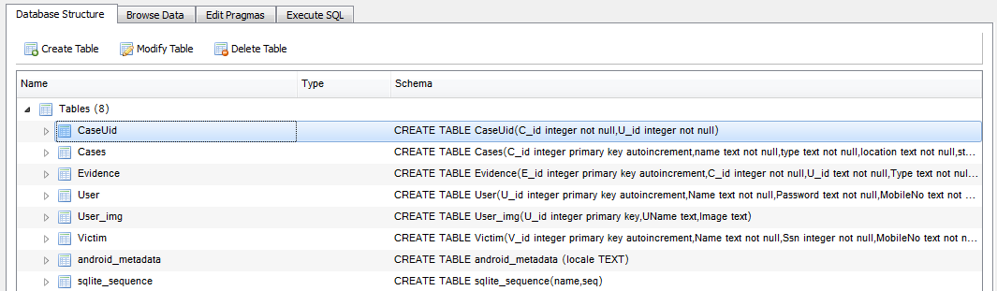**

**Fig 19: DB Structure**

**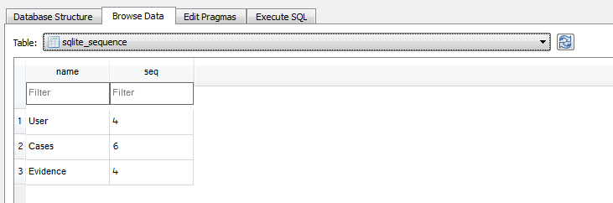**

**Fig 20: sqlite\_sequence**

**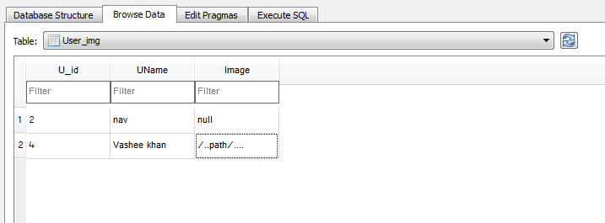**

**Fig 21: User\_img**

**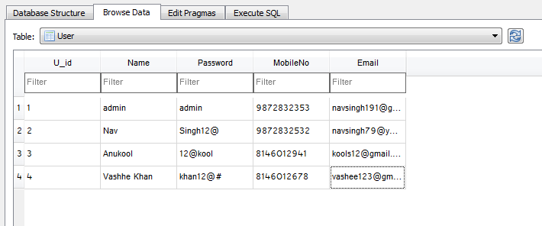**

**Fig 22: user**

**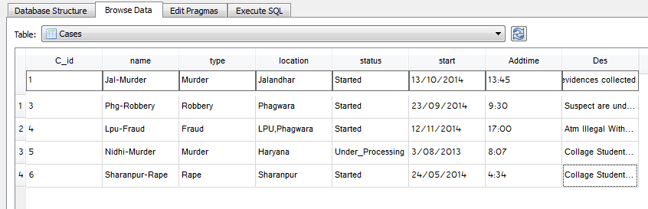**

**Fig23: Cases**

**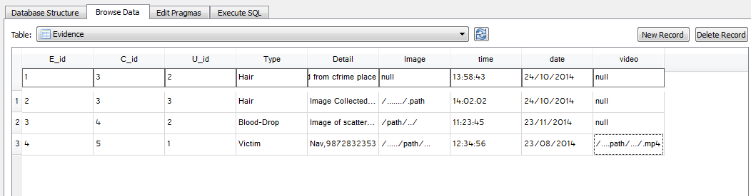**

**Fig 24: Evidence**

1. **TESTING**

Software testing is an investigation conducted to provide information about the quality of the product or service under test. Software testing can also provide an objective, independent view of the software to allow the business to appreciate and understand the risks at the software implementation. Software testing is any activity aimed at evaluating an attribute or capability of a program or system and determining that it meets its required results. Software Testing is the process of executing a program or system with the intent of finding errors. Software testing can also be stated as the process of validating and Adding that a software program/application/product.

**Testing Objectives:**

The main objectives of testing is to uncoCase a host of errors, systematically and with minimum effort ant time, starting formally, we can say,

* Testing is the process of executing a program with the intent of finding errors.
* A successful test is one that uncoCases an as yet of finding errors.
* A good test case is one that has a high probability of finding errors, if it exits.
* The tests are independent to detect possible errors.
* The software more or less confirms to the quality and reliable standards.
* **Functional Testing**

**Functional Testing** also called behavioural testing focuses on the functional requirements of the software. That is, it enables the software engineer to derived sets of input conditions that will fully exercise all functional requirements for a program.

Black Box Testing is a testing strategy, which does not need any knowledge of internal design or code etc. As the name "black box" suggests, no knowledge of internal logic or code structure is required. The types of testing under this strategy are totally based/focused on the testing for requirements and functionality of the work product/software application. It attempts to find errors in the following categories:

Incorrect or missing functions

* Interface errors
* Errors in data structures or external data base access
* Behaviour or performance errors
* **Structural Testing**

**Structural Testing,** also called glass-box testing, is a test case design philosophy that uses the control structure described as part of component level design to derive test cases. Structural testing strategy deals with the internal logic and structure of the code. This testing is also called as glass, structural, open box or clears box testing. In order to implement white box testing, the tester has to deal with the code and hence is needed to possess knowledge of coding and logic i.e. internal working of the code. White box test also needs the tester to look into the code and find out which unit/statement/chunk of the codes malfunctioning. Using white-box testing methods, one can derive test cases that:

* Guarantee that all independent paths within a module have been exercised at least once
* Exercise all logical decisions on their true and false sides
* **Unit Testing**

A Unit is the small testable piece of software that can be compiled for example functions, procedures, classes, and interface. It is generally written by the programmer and is done after coding Rigorous use of unit tests helps catch defects prior to customer testing and minimizes the cost of correcting defects by identifying them when they are the cheapest to fix. In computer programming, a **unit test** is a procedure used to validate that a particular module of source code is working properly. The procedure is to write test cases for all functions and methods so that whenever a change causes a regression, it can be quickly identified and fixed.

Unit testing focuses verification effort on the smallest unit of software design-the software component or module. Using the component-level design description as a guide, important control paths are tested to uncover errors within the boundary of the module. The relative complexity of tests and the errors those tests uncover is limited by constrained scope established for unit testing. The unit test focuses on the internal processing logic and data structures within the boundaries of a component. This type of testing can be conducted in parallel for multiple components.

* **Integration Testing**

It is a systematic technique for constructing the software architecture while at the same time conducting tests to uncover errors interfacing. The objective is to take unit tested components and build a program structure that has been dictated by design.

It is the testing phase, in which whole project developed in J2EE will be tested with integrating it with the various modules for the correct functionality. If working fine, then it will be integrated together with the other modules for purpose of creation of the whole System.

* **System Testing**

It is a series of different tests whose primary purpose is to fully exercise the computer-based system. Although each test has a different purpose, all work to verify that systemelements have been properly integrated and performed allocated functions. It is the type of testing in which all the modules are integrated together to form the whole system, then this whole system is tested against various efficiency based tests, that also test the accuracy of the system, working as a whole.

* **Acceptance Testing**

This testing is performed with realistic data of the user to demonstrate that the software is working satisfactory. Testing here focuses on the external behaviour of the system, the internal logic of the program is not emphasized. Unlike the other test phases, an objective of acceptance testing is not to actively look for faults.

**(a) Alpha Testing:**

Alpha testing is testing of an application when development is about to complete. Minor design changes can still be made as a result of alpha testing. Alpha testing is typically performed by a group that is independent of the design team, but still within the company, e.g. in-house software test engineers, or software QA engineers.

**(b) Beta Testing:**

Beta testing is testing of an application when development and testing are essentially completed and final bugs and problems need to be found before the final release. Beta testing is typically performed by end-users or others, not programmers, software engineers or test engineers.

1. **TEST CASES OF PROJECT**

**MODULE-1 (Add USER Activity)-**

|  |  |  |
| --- | --- | --- |
| **TEST SUIT ID**  Forensic Expert  App | **CREATED BY**  Navjot Singh | **CREATED ON**  31-10-2014 |
| IMPLEMENTED BY: Navjot Singh | | IMPLEMENTED ON: 02-11-2014 |

**Pre-Requisites:**

**Name:**

Valid Classes: A-Z,a-z,spaces,Numeric(0-9).

Valid Range: Min-1, Max- 25. Please Enter a Name.

Invalid Classes: Special characters,Alphanumeric values,Float values,Fraction values.

Invalid range: Less than 1 & more than 25.

**Email:**

Valid Classes: A-Z,a-z,Numeric,Alphanumeric values,Float values,Special characters: . \_ @

Valid Range: Max:50.Email id is mandatory.

Invalid Classes:Special characters except: . \_ @,Fraction values, Email Id without domain,Upper or lower case with space,Registration through one id is done then,again user can't use that id.

Invalid Range: More than 50.

**Contact Number:**

Valid Classes:Numeric values(0-9).

Valid Range: Fix-10.Contact number is mandatory.

Invalid Classes:Alphanumeric,Special characters,Float values,Fraction values,A-Z,a-z,Alphanumeric with special characters.

Invalid Range:Less than 10 or more than 10.

**Description:**

Valid Classes:A-Z,a-z,Spaces,Numeric,Float Values ,Alphanumeric,Special characters: # - . / ( ) [ ],Alphanumeric with special characters.

Valid Range: Min-1, Max:200.Address is Required.

Invalid Classes:Fraction values,Special characters except: # - . / ( ) [ ]

Invalid Range: Less than 1 & more than 200.

**Account Details-**

**Login Id:**

Valid classes: Numeric(0-9).

Valid Range: Numeric Auto-Generated.

**Password:**

Valid Classes:A-Z,a-z,Spaces,Numeric,Alphanumeric values,Float values,Numeric(0-9).

Valid Range: Min-6,Max-20.Password is mandatory.

Invalid Class: Spaces,Decrypted Password.

Invalid Range: Not be Empty.

**Upload Image:**

Valid Class: User may select an image.

**Add Button:**

Valid Class: After filling all information click on register button.

Invalid Classes: Without selecting any information or one information.

Table: Add User Test Case

|  |  |  |  |  |  |  |  |  |
| --- | --- | --- | --- | --- | --- | --- | --- | --- |
| **Test Case ID** | **Description** | **Expected Result** | **Actual Result** | **Remarks** |  |  | |  |
| TC Reg01 | Input any characters less than 1 . | It must not be allowed to enter less than 1 . | It is not allowed to enter less than 1 . | Pass. |  |  | |  |
| TC Reg02 | Input any upper case character value(e.g.- AD) in “Name” field. | Upper case must be accepted. | Upper case are allowed. | Pass. |  |  | |  |
| TC Reg03 | Input any lower case character(e.g.- ar) value in “Name” field. | Lower case must be accepted. | Lower case are allowed. | Pass. |  |  | |  |
| TC Reg04 | Input any lower case or upper case multiple strings with one spaces(e.g.- sw ty) in “Name” field. | Lower or upper case multiple strings with one spaces must be accepted. | Lower or upper case multiple strings with one spaces are allowed. | Pass. |  |  | |  |
| TC Reg05 | Input numeric values(0-9)(e.g.- 45) in the “Name” field. | It must be allowed to enter numeric value(0-9) in “Name' field. | It is allowed to enter numeric value(0-9) in “Name' field. | Pass. |  |  | |  |
| TC Reg06 | Input any characters within range of(1-25) in “Name” field. | It must be allowed to be entered only range of (1-25) characters. | It is allowed to be entered only range of (1-25) characters. | Pass. |  |  | |  |
| TC Reg07 | Input only upper or lower case character with spaces in “Email” field. | Lower or upper case characters with spaces must not be accepted. It must shown a validation error message.(Enter Email in correct format). | It is not accepting the lower or upper case with spaces. It is displaying an error.(Enter Email in Correct Format). | Pass. |  |  | |  |
| TC Reg08 | Input any special characters: other than . \_ @  with alphabetic values(e.g.-a%) in “Email” field. | Special characters other than .,\_& @ must not be accepted and it must shown a validation error message.(Enter Email in correct format). | Special characters other than .,\_& @ are not allowed and it is displaying a validation error message.(Enter Email in correct format). | Pass. |  |  | |  |
| TC Reg09 | Input any number of character less than 1 in Email Field. | Characters must not be accepted less than 1 .It must display a validation error message.(Enter Email in correct format). | Characters are not allowed less than 1 .It is displaying a validation error message.(Enter Email in correct format). | Pass. |  |  | |  |
| TC Reg10 | Registration through one Email id is done earlier. Then, again user is registering with same Email Id. | It must display a error message. It will not be allowed to register more than one time with same Email Id . | It is not allowing to register more than one time with same Email Id. | Pass. |  |  | |  |
| TC Reg11 | Input any Fraction values(e.g.-6/5) in “Email Id” field. | Fraction values must not be accepted. It must display a validation error message.( Enter Email In Correct Format). | It is not allowing fraction values and is display a validation error message.( Enter Email In Correct Format). | Pass. |  |  | |  |
| TC Reg12 | Input only lower case character values(e.g.-er) in “Email Id” field. | Lower case must be accepted. | Lower case are accepted. | Pass. |  |  | |  |
| TC Reg13 | Input only upper case character values(e.g.-ET) in “Email Id” field. | Upper case must be accepted. | Upper case are accepted. | Pass. |  |  | |  |
| TC Reg14 | Input any(0-9) number (e.g.- 432) in “Email Id” field. | Numbers must be allowed to be entered. | Numbers are allowed to be entered. | Pass. |  |  | |  |
| TC Reg15 | Input special characters: . \_ @  with alphabetic values(e.g.- se@gmail.com) in “Email Id” field. | Special characters : . \_ @ must be allowed to be entered. | Special characters : . \_ @ are allowed to be entered. | Pass. |  |  | |  |
| TC Reg16 | Input any alphanumeric values(e.g.- as23) in “Email Id” field. | Alphanumeric values must be allowed to be entered. | Alphanumeric values are allowed to be entered. | Pass. |  |  | |  |
| TC Reg17 | Input any Float values(e.g.-4.6) in “Email Id” field. | Float values must be accepted. | Float values are allowed. | Pass. |  |  | |  |
| TC Reg18 | Input any number of character within range (1-50) in “Email Id” field.. | Characters must be accepted. | Characters are allowed. | Pass. |  |  | |  |
| TC Reg19 | Entering special characters (e.g.-\*&^)in the “Contact No.” field. | It must not be allowed to enter special characters. It must display a validation error message.(Please Enter Correct Contact Number ) | It is not accepting special characters. It is displaying a validation error message.(Please Enter Correct Contact Number ) | Pass. |  |  | |  |
| TC Reg20 | Try to enter more than or less than 10 numeric values in “Contact No.” field. | User can not enter more than or less than 10 numeric values in the “Contact No.” field. | User are not allowed to enter more than or less than 10 numeric values in the “Contact No.” field. | Pass. |  |  | |  |
| TC Reg21 | Input float values(e.g.-3.8) in “Contact No.” field. | It must not be allowed to enter float values in “Contact No.” filed. It must display a validation error message.(Please Enter Correct Contact Number) | It is not allowed to enter float values in “Contact No.” filed. It is displaying a validation error message.(Please Enter Correct Contact Number) | Pass. |  |  | |  |
| TC Reg22 | Input fraction values(e.g.- 2/7) in “Contact No.” field. | It must not be allowed to enter fraction values in “Contact No.” filed. It must display a validation error message.(Please Enter Correct Contact Number) | It is displaying a validation error message.(Please Enter Correct Contact Number) | Pass. |  |  | |  |
| TC Reg23 | Entering lower case character(e.g.-tery) in the “Contact No.” field. | It must not be allowed to enter lower case character. It must display a validation error message.(Please Enter Correct Contact Number) | It is not accepting lower case character. It is displaying a validation error message.(Please Enter Correct Contact Number ) | Pass. |  |  | |  |
| TC Reg24 | Entering upper case character  (e.g.- EWSA) in the “Contact No.” field. | It must not be allowed to enter upper case character. It must display a validation error message.(Please Enter Correct Contact Number) | It is not accepting upper case character. It is displaying a validation error message.(Please Enter Correct Contact Number ) | Pass. |  |  | |  |
| TC Reg25 | Input alphanumeric values (e.g.-Sa3)in the “Contact No.” field. | It must not be allowed to enter alphanumeric values. It must display a validation error message.(Please Enter Correct Contact Number) | It is not accepting alphanumeric values. It is displaying a validation error message.(Please Enter Correct Contact Number ) | Pass. |  |  | |  |
| TC Reg26 | Input alphanumeric with special characters (e.g.- As3@)in “Contact No.” filed. | It will not be allowed to enter alphanumeric with special characters in “Contact No.” field. It must display a validation error message.(Please Enter Correct Contact Number) | It is not accepting alphanumeric with special characters values. It is displaying a validation error message.(Please Enter Correct Contact Number) | Pass. |  |  | |  |
| TC Reg27 | Input Numeric values(0-9)(e.g.-32) in “Contact No.” field. | Numeric values(0-9) must be accepted. | Numeric values(0-9) are accepted. | Pass. |  |  | |  |
| TC Reg28 | Input 10 digit Number in “Contact No” field. | Input must be accepted. | It is accepted. | Pass. |  |  | |  |
| TC Reg29 | Entering more than 200 characters in “Description” field. | It must not be allowed to enter more than 200 characters to be entered. | It is allowed to enter more than 200 characters. | Pass. |  |  | |  |
| TC Reg30 | Input special characters except : # - . /( ) [ ] in the Description” field. | It must only allow # - . / ( ) [ ] these characters. | It allows all the special characters. | Fail. |  |  | |  |
| TC Reg31 | Input float values(e.g.-8.4) in “Description” field. | It must allow to enter float values in “Description” field. | It is allowing to enter float values in “Description” field. | Pass. |  |  | |  |
| TC Reg37 | Input fraction values(e.g.- 3/2) in “Description” field. | It must be allowed to enter fraction values in “Description” field. | It is allowing to enter fraction values in “Description” field. | Pass. |  |  | |  |
| TC Reg38 | Input lower case characters(e.g.-rt) in “Description” field. | Lower case characters must be allowed. | Lower case characters are allowed. | Pass. |  |  | |  |
| TC Reg39 | Input upper case characters(e.g.- SDE) in “Description” field. | Upper case characters must be allowed. | Upper case characters are allowed. | Pass. |  |  | |  |
| TC Reg40 | Input alphanumeric values(e.g.- aS2) in “Description” field. | Alphanumeric values must be allowed. | Alphanumeric values are allowed. | Pass. |  |  | |  |
| TC Reg41 | Input alphanumeric values with special characters (e.g.- As2@)in “A Description” field. | It must allow all the alphanumeric values with special characters in the multi line text field. | It allows all alphanumeric with special characters. | Pass. |  |  | |  |
| TC Reg42 | Input only lower or upper case with spaces in “Password” field. | It must not be allowed. | It is allowing in “Password” field.. | Fail |  |  | |  |
| TC Reg43 | Input any characters less than 6 or more than 20 in “Password” field. | Characters must not be accepted less than 6 or more than 20 in “Password” field. | Characters are not accepted less than 6 or more than 20 in “Password” field. | Fail. |  |  | |  |
| TC Reg44 | Input only lower case(wqb) in “Password” field. | It must be allowed to enter lower case in the field. | It is allowing to enter lower case in the field. | Pass. |  |  | |  |
| TC Reg45 | Input only upper case(e.g.- AS) in “Password” field. | It must be allowed to enter upper case in the field. | It is allowing to enter upper case in the field. | Pass. |  |  | |  |
| TC Reg46 | Input Special characters with alphabetic values(e.g.- asD@) in “Password” field. | It must be to enter Special characters with alphabetic values allowed. | It is allowing to enter Special characters with alphabetic values allowed. | Pass. |  |  | |  |
| TC Reg47 | Input any(0-9) numbers (e.g.- 234) in “Password” field. | Numbers(0-9) must be allowed to be entered. | Numbers are allowed. | Pass. |  |  | |  |
| TC Reg48 | Input any alphanumeric values(as2S) in “Password” field. | Alphanumeric must be allowed. | Alphanumeric are allowed. | Pass. |  |  | |  |
| TC Reg49 | Input any float values(e.g.- 5.7) in “Password” field. | Float values must be allowed to be entered. | Float values are allowed to be entered. | Pass. |  |  | |  |
| TC Reg50 | Input any characters within range of(0-n) in “Password” field. | Characters must be accepted within range of(0-n). | Characters are accepted within range of(0-n). | Pass. |  |  | |  |
| TC Reg51 | Password No Empty. | A message must appear that “Password not providing”. | A message is displaying that “Password not providing”. | Pass. |  |  | |  |
| TC Reg52 | Select button to browse image in(PNG,JPG,BMP,JPEG) “Upload Image” field. | It must select an image of format(PNG,JPG,BMP,JPEG). | It is accepting image of format(PNG,JPG,BMP,JPEG).. | Pass. |  |  | |  |
| TC Reg53 | Don't Select button to browse image in “Upload Image” field. | It must display a default image. | It is displaying a default image. | Pass. |  |  | |  |
| TC Reg54 | Click on “Add” button without selecting “Image button”. | There is message account added without image. | Image not provided. | Pass. |  |  | |  |
| TC Reg83 | Click on “Add” button without selecting “Name”. | It is an error & message must be highlighted.( Please Enter Name ). | It is an error & message is highlighted.(Please Enter Name ). | Pass. |  |  | |  |
| TC Reg84 | Click on “Add” button without selecting “Email id”. | It is an error & message must be highlighted( Email Id is Mandatory ). | It is an error & message is highlighted.(Email Id is Mandatory ) | Pass. |  |  | |  |
| TC Reg85 | Click on “Add” button without selecting “Contact No”. | It is an error & message must be highlighted.( Contact Number is Mandatory ) | It is an error & message is highlighted.(Contact Number is Mandatory ) | Pass. |  |  | |  |
| TC Reg86 | Click on “Add” button without selecting “Description”. | It is an error & message must be highlighted.(Description is Required ) | It is an error & message is highlighted.(Description is Required ) | Pass. |  |  | |  |
| TC Reg87 | Click on “Add” button without selecting “Password”. | It is an error & message must be highlighted.(Password is Mandatory ) | It is an error & message is highlighted.(Password is Mandatory) | Pass. |  |  | |  |
| TC Reg88 | Click on “Add” button after filling all the information. | Toast displayed that account is added. | Account Added. | Pass. |  |  | |  |
| TC Reg89 | Click on “Add” button for filling information again. | It must clear all the information and reset the page. | It is clearing all the information and reset the page. | Pass. |  |  | |  |
|  |  |  |  |  |  |  | |  |
| **User Interface (UI) and Graphical User Interface (GUI) Testing-** | | | | |  |  | | |
| **User Interface:** Spellings are properly checked and are in proper format. | | | | |  | |  | | |
| **Graphical User Interface:** Logo,Textboxes,Buttons, and colors are properly arranged. | | | | |  | |  | | |
|  | | | | |  | |  | | |

**MODULE-2 (Add Case FORM)-**

|  |  |  |
| --- | --- | --- |
| **TEST SUIT ID**    Forensic Expert  App | **CREATED BY**  Navjot Singh | **CREATED ON**  1-11-2014 |
| IMPLEMENTED BY: Navjot Singh | | IMPLEMENTED ON: 02-11-2014 |

**Pre-Requisites:**

**Type:**

Valid Classes: Select from Auto Textbox.

Valid Range: Selected Index Only.

Invalid Classes: Special characters except: **.\_ @**. Fractions.

Invalid Range: Editing Selected Case Name.

**Name:**

Valid Classes: Alphanumeric.

Valid Range: Min-1.

Invalid Range: Less than 1.

**Location:**

Valid Classes: Alphanumeric.

Valid Range: Min-1.

Invalid Range: Less than 1.

**Status:**

Valid Classes: Alphanumeric.

Valid Range: Min-1.Status is mandatory.

Invalid Range: Less than 1.

**Investigators:**

Valid Classes: Select from Auto text either by name or Id.

Valid Range: Min-1.

Invalid Range: Less than 1.

**Start-Date:**

Valid Classes: Select from Date Time Picker.

Valid Range: Must be Selected.

Invalid Range: Not Selected.

Table: Add Case Test Case

|  |  |  |  |  |
| --- | --- | --- | --- | --- |
| **Test Case ID** | **Description** | **Expected Result** | **Actual Result** | **Remarks** |
| TC Case 01 | Click on “Add” button without selecting Any Field. | It is an error & Validation message must be highlighted (Invalid Field). | It is displaying a validation error message (Invalid Field) | Pass |
| TC Case 02 | Click on “Add” button without selecting Case Type. | It is an error & Validation message must be highlighted (Select Case Type). | It is displaying a validation error message  (Select Case Type.) | Pass |
| TC Case 03 | Click on “Add” button after filling all the information. | “Case successfully added” alert message indicating successful registration must be displayed. | It is displaying message  “Case successfully added” . | Pass |
| TC Case 04 | Input any special characters: other than selected  with alphabetic values in “Type” field. | Special characters other than selected must not be accepted and it must shown an validation error message.(Select type in correct format). | It is not allowing characters except. and it is displaying a validation error message.(Select Case type in correct format). | Pass |
| TC Case 05 | Input only upper or lower case or numeric character with spaces in “Investigator” field. | Lower or upper case characters with spaces will be accepted & Validation message must be highlighted. | It is allowing lower and upper case. | Pass |
| TC Case 11 | Input Any special characters: with alphabetic values in “Location” field. | It must be allowed to be entered. | It is allowing special characters with alphabetic values. | Pass |
| TC Case 12 | Input only upper case character values in “Location” field. | Upper case will be accepted. | It is allowing upper case characters. | Pass |
| TC Case 13 | Input only lower case character values in “Location” field. | Lower case will be accepted. | It is allowing lower case characters. | Pass |
| TC Case  14 | Display CaseId after Adding a Case. | Toast will be Displayed with CaseId. | Toast will be Displayed with CaseId. | Pass |
|  |  |  |  |  |
| **User Interface (UI) and Graphical User Interface (GUI) Testing-** | | | | |
| **User Interface:** Spellings are properly checked and are in proper format. | | | | |
| **Graphical User Interface:** Logo,Textboxes,buttons,datetime picker and colors are properly arranged. | | | | |
| **Device Compatibility Testing-** | | | | |
| **Test Case ID** | **Description** | **Expected Result** | **Actual Result** | **Remarks** |
| TC Case 15 | Check whether the Activity is loaded on different Devices. | Activity must be loaded on given Device. | It is loaded on given Device. | Pass. |

**MODULE-3 (USER LOGIN Activity)-**

|  |  |  |
| --- | --- | --- |
| **TEST SUIT ID**  Forensic Expert  App | **CREATED BY**  Navjot Singh | **CREATED ON**  03-11-2014 |
| IMPLEMENTED BY: Navjot Singh | | IMPLEMENTED ON: 04-11-2014 |

**Pre-Requisites:**

**Login Name:**

Valid classes:A-Z,a-z,Numeric(0-9),Alphanumeric.

Valid Range: Min-1.Enter login id.

Valid Classes: Any valid user name.

Invalid Range: Empty.

**Password:**

Valid Classes:A-Z,a-z,Spaces,Numeric,Alphanumeric values,Float values,Numeric(0-9).

Valid Range: Min-1.Password is mandatory.

Invalid Range: Less than 1.

|  |  |  |  |  |  |
| --- | --- | --- | --- | --- | --- |
| **Test Case ID** | | **Description** | **Expected Result** | **Actual Result** | **Remarks** |
| TC Log 01 | | Input only lower case characters in “Name” field. | Lower case must be accepted. | It is Acceptable, Lower case is accepted. | Pass |
| TC Log 02 | | Input only upper case characters in “Name” field. | Upper case must be accepted. | It is Acceptable, Upper case is accepted. | Pass |
| TC Log 03 | | Input any special characters with alphabetic values in “Name” field. | Special characters can be accepted. | It is Acceptable, special characters are accepted. | Pass |
| TC Log 04 | | Input any(0-9) numeric values in “Name” field. | It must be allowed to enter. | It is Acceptable and it is allowing to enter. | Pass |
| TC Log 05 | | Input any float values in “Name” field. | Float values must allowed. | It is Acceptable, | Pass |
| TC Log 06 | | Input Fraction values in “Name” field. | Fraction values must be allowed to be entered. | It is Acceptable, Fraction values is accepting. | Pass |
| TC Log 07 | | Input any number of characters within range of(1-n) in “Name” field.. | It must be accepted only this range(1-n). | It is Acceptable and it is allowing to enter. | Pass |
| TC Log 08 | | Input only upper case and lower case in “Password” field. | It must allowed lower and upper case in the field. | It is Acceptable and it is allowing to enter. | Pass |
| TC Log 09 | | Input only Lowercase an Upper case in “Password” field. | It must allowed lower and upper case in the field. | It is Acceptable and it is allowing to enter. | Pass |
| TC Log 10 | | Input only lower or upper case with spaces in “Password” field. | It must not be allowed. | It is Acceptable and Spaces is not accepting and alert is displaying (“Unauthorized Login”) | Pass |
| TC Log 11 | | Input Special characters with alphabetic values in “Password” field. | It must be allowed. | It is Acceptable and special characters with alphabetic values in “Password” field entered. | Pass |
| TC Log 12 | | Input any(0-9) number or alphanumeric values in “Password” field. | Numbers(0-9) must be allowed to be entered. | It is Acceptable and Numbers(0-9) is allowing to be entered. | Pass |
| TC Log 13 | | Input any alphanumeric values in “Password” field. | Alphanumeric must be allowed. | It is Acceptable and Alphanumeric is allowing to be entered. | Pass |
| TC Log 14 | | Input any float values in “Password” field. | Float values must be allowed to be entered. | It is Acceptable and Float values is allowing to be entered. | Pass |
| TC Log 15 | | Input any fraction values in “Password” field | fraction values must be allowed to be entered. | It is Acceptable and fraction values is allowing to be entered. | Pass |
| TC Log 16 | | Input any characters within range of(1-n) in “Password” field. | Characters must be accepted within range of(1-n). | It is Acceptable and Characters be accepted within range of(1-20). | Pass |
| TC Log 17 | | Input any characters less than 1 “Password” field. | Input must not be accepted and error message must be display. | It is Acceptable and characters less than 1 “Password” field is not accepting and alert is displaying (“Unauthorized Login”) | Pass |
| TC Log 18 | | Click on “Login” button without providing Credentials. | It is an error & message must be highlighted. | It is Acceptable and Click on “Login” button without selecting Name It is an error & validation message is highlighting(“Enter Name”). | Pass |
| TC Log 19 | | Click on “Login” button without selecting Password. | It is an error & message must be highlighted. | It is Acceptable and Click on “Login” button without selecting Password It is an error & validation message is highlighting(“Enter Password”). | Pass |
| TC Log 20 | | Click on “Login” button after filling all the information. | User must be logged into the system. | It is Acceptable and fraction values is allowing to be entered and User is logging into the system. | Pass |
| **User Interface (UI) and Graphical User Interface (GUI) Testing-** | | | | | |
| **User Interface:** Spellings are properly checked and are in proper format. | | | | | |
| **Graphical User Interface:** Logo,Textboxes,Buttons and colors are properly arranged. | | | | | |
| **Device Compatibility Testing-** | | | | | |
| **Test Case ID** | **Description** | | **Expected Result** | **Actual Result** | **Remarks** |
| TC Log21 | Check whether the App is working properly on every device. | | App must be Installed on given device. | It is installed on given device. | Pass. |

**MODULE-4 (Add Evidence Activity)-**

|  |  |  |
| --- | --- | --- |
| **TEST SUIT ID**  Forensic Expert  App | **CREATED BY**  Navjot Singh | **CREATED ON**  04-11-2014 |
| IMPLEMENTED BY: Navjot Singh | | IMPLEMENTED ON: 04-11-2014 |

**Pre-Requisites:**

**Case Name**

Valid Classes: Select from Auto Textbox.

Invalid Classes: Altering the selected case name.

Valid Range: Only Selected Name.

Invalid Range: Less than 1 .

**Evidence Type**

Valid Classes: Select from Auto Textbox or type your own.

Invalid Classes: only numeric or special characters.

Valid Range: Must Provide.

Invalid Range: Less than 1.

**Evidence Name**

Valid Classes:A-Z,a-z,Spaces,Special characters,Alphanumeric.

Valid Range:Max 200.

Invalid Range:More than 200.

**File**

Valid Classes:Only “Image /Video/Audio” file can be Uploaded.

Invalid Classes:Other than “Image/Video/Audio” file .

Valid Range: Select only one at a time either image/video/audio.

Invalid Range try to selecting multiple at a same time.

Table: Add Evidence Test Case

|  |  |  |  |  |
| --- | --- | --- | --- | --- |
| **Test Case ID** | **Description** | **Expected Result** | **Actual Result** | **Remarks** |
| TC Evi01 | Click on “Add” button without selecting any field. | It is an error & Validation message must be highlighted.(Please Provide Information.) | It is Acceptable(user can not live these field blank and Validation message is highlighting.(Please Provide Information.) | Pass |
| TC Evi 02 | Click on “Add” button without selecting Case | It is an error & Validation message must be highlighted(Please Enter Case Name). | It is Acceptable (Validation message is highlighting(Please Enter Case Name).) | Pass |
| TC Evi 03 | Click on “Add” button without selecting Type . | It is an error & Validation message must be highlighted(Please select type). | It is Acceptable Validation message is highlighting(Please select type). | Pass |
| TC Evi 04 | Click on “Add” button without entering name . | It is an error & Validation message must be highlighted(Please Provide name.). | It is Acceptable Validation message is highlighting(Please Provide name.). | Pass |
| TC Evi 05 | Input Numeric, Alphanumeric in “Name” field. | It must be accepted any numeric and Alphanumeric values. | It is Acceptable.(User can enter any numeric and Alphanumeric values because it is allowed). | Pass |
| TC Evi 06 | Input Other than selected case name in “Case” field.. | It must not be accepted any alteration in selected case name. | It is Acceptable.(User can not enter any values because it is not allowed). | Pass |
| TC Evi 07 | Input A-Z,a-z,Spaces,Dot in “Type” field.. | A-Z,a-z,Spaces,Dot must be allowed to be entered. | It is Acceptable.(User can enter A-Z,a-z,Spaces,Dot in “Qualification” field). | Pass |
| TC Evi 08 | Input more than 50 characters in “Description” field.. | It is accepted more than 50 characters . | It is Acceptable(User can enter more than 50 characters because it is allowed) . | Pass |
| TC Evi 09 | Input characters within (1-50) range in “Qualification” field.. | It is acceptable and user must be enter within (1-50) range. | It is Acceptable.(User can not exceeded these range and it not accept more than 50 characters because it is not allowed). | Pass |
| TC Evi 10 | Click on “Add” button without selecting “Type”. | It is an error & Validation message must be highlighted((Please enter type).). | It is Acceptable(Validation message is highlighting(Please enter Type). | Pass |
| TC Evi 11 | Input Numeric,Alphanumeric in “UniCasesity” | It must not accept any numeric and Alphanumeric values. | It is Acceptable( It is not allowed to enter through user). | Pass |
| TC Evi 12 | Input Other than A-Z,a-z,Spaces, Dot in “UniCasesity ” field.. | It is not accept any numeric and Alphanumeric values.. | It is Acceptable( It is not allowed to enter through user). | Pass |
| TC Evi 13 | Input A-Z,a-z,Spaces,Dot in “UniCasesity ” field.. | A-Z,a-z,Spaces,Dot must be allowed to be entered. | It is Acceptable(A-Z,a-z,Spaces,Dot is allowed to be entered by user.) | Pass |
| TC Evi 14 | Input more than 50 characters in “Qualification” field.. | It must not accepted more than 50 characters . | It is Acceptable( It is not allowed to enter through user). | Pass |
| TC Evi 15 | Input characters within (1-50) range in “Qualification” field.. | It must be acceptable and user must be enter it in (1-50) range. | It is Acceptable(It is not allowed to enter through user more than (1-50) range). | Pass |
| TC Evi 16 | Click on “Submit” button without selecting Document Description . | It must be an error & Validation message must be highlighted(Please Describe your Qualification.).. | It is Acceptable Validation message is highlighting(Please Describe your Qualification.). | Pass |
| TC Evi 17 | Input A-Z,a-z,Spaces,Special characters,Alphanumeric in Document Description .. | A-Z,a-z,Spaces,Special characters,Alphanumeric must be allowed to enter. | It is Acceptable and user have permission to enter A-Z,a-z,Spaces,Special characters,Alphanumeric. | Pass |
| TC Evi 18 | Input more than 200 characters in “Description”. | more than 200 characters in “Description” is allowed and more than 200 characters are acceptable. | It is Acceptable(more than 200 characters in “Description” is allowed and more than 200 characters are acceptable.). | Pass |
| TC Evi 19 | Input characters within (1-N) range in “Description”. | characters within (1-N) range in “Document Description” must be allowed. | It is Acceptable(only characters within (1-N) range in “Document Description” are allowed.) | Pass |
| TC Evi 20 | Click on “Add” button without selecting “File”. | It must be accepted . | It is Acceptable. | Pass |
| TC Evi 21 | Upload Other than “Image/Video/Audio” file then Click on “Add” Button. | It must be an error . | It is an Error. | Pass |
| TC Evi 22 | Upload more than 500kb Image file then Click on “Add” Button. | It must be allowed. | It is Acceptable. | Pass |
| TC Evi 23 | Upload more than 500kb image file then Click on “Add” Button. | It must be allowed. | It is Acceptable | Pass |
| TC Evi 24 | Upload Image file Within(1kb-Nkb) the click on “Submit” button. | Image file Within(1kb-Nkb) must be Accepted and user can upload. | It is Acceptable(Image file Within(1kb-Nkb) must be Accepted and user can upload.) | Pass |
| TC Evi 25 | Upload Video file Within(1kb-Nkb) the click on “Add” button. | Video file Within(1kb-Nkb) must be Accepted and user can upload. | It is Acceptable(Video file Within(1kb-Nkb) is Accepted and user can upload.) | Pass |
| TC Evi 26 | Click on “Add” button after selecting all field correctly. | Alert must be displayed. ”Evidence Successfully Added”. | It is Acceptable(Alert will be displayed. ” Evidence Successfully Added”). | Pass |
| **User Interface (UI) and Graphical User Interface (GUI) Testing-** | | | | |
| **User Interface:** Spellings are properly checked and are in proper format. | | | | |
| **Graphical User Interface:** Logo,Textboxes,Buttons and colors are properly arranged. | | | | |
| **Device Compatibility Testing-** | | | | |
| **TestCase ID** | **Description** | **Expected Result** | **Actual Result** | **Remarks** |
| TC Qua 27 | Check whether the App is working properly on every device. | App must be Installed on given device. | It is installed on given device. | Pass. |

1. **IMPLIMENTATION**

*  **Implementation of the Project**

Implementation is the process of having system personally checked out and put new equipment into use, trained users, installed the new application and construct and file of data needed to use it. Depending on the size of the organization that will be involved in using the application and the risk associated with its users, system developers may choose to pilot (test) the operation in only one area of the firm, say in one department or with only one or two persons. Regardless of the implementation strategy use, developers strive to ensure that the system’s initial use in trouble. Once installed, applications are often used for many years. However, both the organization and the user will change, and the environment will be different over weeks and months. Therefore, the application will undoubtedly have to be maintained, modifications and change will be made to software’s, file or procedures to meet emerging user requirement. In the sense, Implementation is an on-going process.

Following activities will be performed for implementation:

* Study Requirements and Design document
* Decide methodology of development
* Select and customize coding standards
* Develop units
* Code
* Self-test will be done before submitting it to Code
* Review
* Code review will be done by peers, by the method of walkthrough
* Unit test by test engineers.
* Integration of components
* Integration testing
* Preparation of Installable
* Release to testing team
* Outputs
* Integrated and tested units
* Peer Review
* Code Review Log
* Defect List
* **Conversion Plan**

The Conversion Plan describes the strategies involved in converting data from an existing system to another hardware or software environment. It is appropriate to re-examine the original system’s functional requirements for the condition of the system before conversion to determine if the original requirements are still valid. Various Types of conversion are as follows:-

* Intra language conversion is a conversion between different versions of the same computer language or different versions of a software system, such as a database management system (DBMS), operating system, or local area network (LAN) management system.
* Inter language conversion is the conversion from one computer language to another or from one software system to another.
* Same compiler conversions use the same language and compiler versions. Typically, these conversions are performed to make programs conform to standards, improve program performance, convert to a new system concept, etc. These conversions may require some program redesign and generally require some reprogramming.
* **Post Implementation and Software Maintenance**

Software Maintenance is the last part of the System Development Life Cycle which is actually the implementation of the post-implementation review plan. Software maintenance is a very broad activity that includes error corrections, enhancements of capabilities, deletion of obsolete capabilities, and optimization. Because change is inevitable, mechanism must be developed for evaluation, controlling and making modifications. There are four types of maintenance:

➢ Corrective Maintenance

➢ Adaptive Maintenance

➢ Perfective Maintenance

➢ Preventive Maintenance

When this system is installed it is used for long period. The average life of a system is 4 to 6 years and maximum used for 10 years. However, this period of use brings with it the need to continually maintain the system, but this system can be modified and new technologies can be used which are prevalent in market at that period of time. Software maintenance requires an accurate maintenance plan to be prepared during the software development. It should specify how users will request modifications or report problems. The budget should include resource and cost estimates. A new decision should be addressed for the developing of every new system feature and its quality objectives. Software maintenance takes more effort than all other phases of software life cycle, but it has not been given as much importance as it deserved. It is an admitted fact that approximately 60 to 70% effort is spent on maintenance phase of software development life cycle.

1. **PROJECT LEGACY**

**CURRENT STATUS OF THE PROJECT**

The Designing phase has been almost completed of the project which consists of following modules. The different modules of the project are:

* Investigator Module
* Admin Module

In User Module, Anonymous user can visit all the links like adding, viewing, updating and deletion of the evidences. In the Register User module, new investigator can be added by only admin to get access to app. Can post their requirements and know about current status of the request.

The Investigator cannot register other. For deletion of any evidence it first needs to get access s from admin/expert.

The Administrators module will be protected by user id and password. Ordinary users of the software will not be permitted to enter into this area of the software. This module will be focusing on the security of each evidence of the cases.

* **FUTURE SCOPE AND ENHANCEMENT**
* This website could be created to access all the data available on server side.
* Message Alert Facility Could be included when any new investigator is added
* Analysis module can to create to determine the location of most crimes
* Increase the ratio of cases solved per year
* Web services can be enhanced to collect more information of project.
* **TECHNICAL SKILL LEARN**
* We have learnt XML, Advanced Java.
* Android Mobile operating system development
* In Sqlite database, we have learned about Normalizing Data, Query handling and some new features of Sqlite
* Working with MYSQL for back-end database on web server.
* In managerial Skills, we have learned about works, Group effort and Coordination in group, and the way to work on the Live Projects.

1. **User manual: A complete document of the app**

Fig24: Login Screen Fig25: Admin Screen

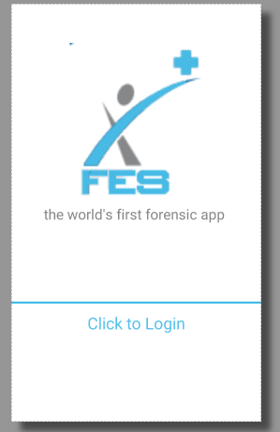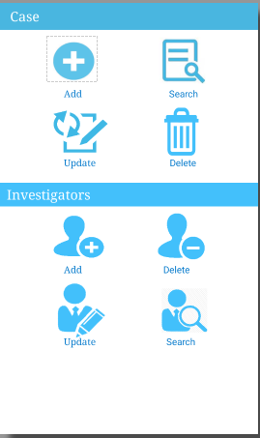

Fig24: Login Screen Fig25: Admin Screen

**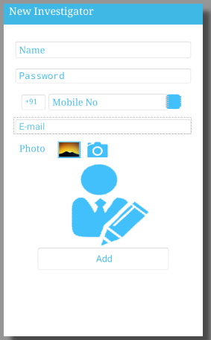 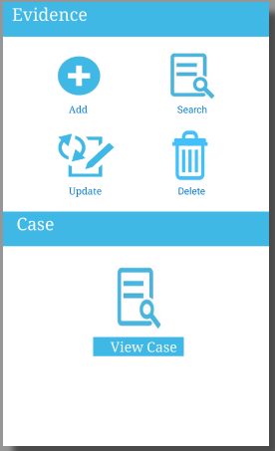**

Fig26: Add User Fig27: User Screen

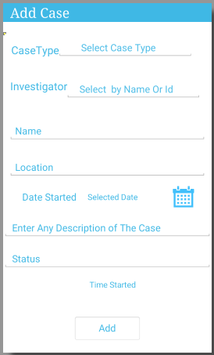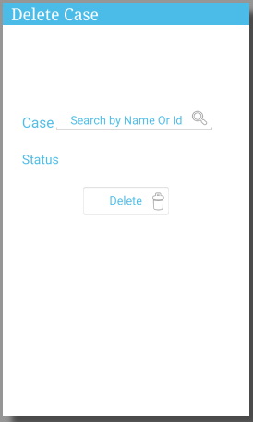

Fig28: Add Case Screen Fig29: Delete Case Screen

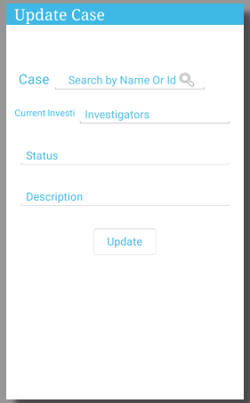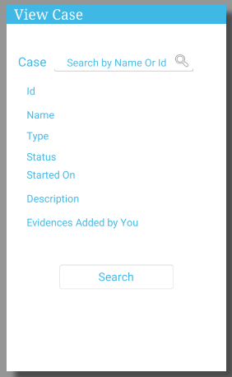

Fig30:Update Case Screen Fig31: Search Case Screen

**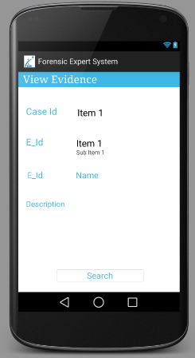**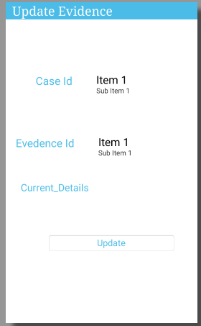

Fig32: View Evidence Screen Fig33: Update Evidence Screen

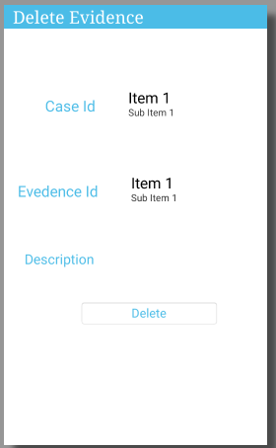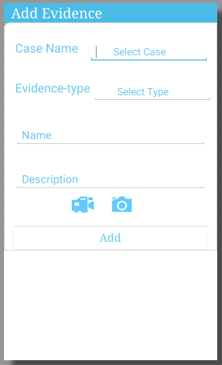

Fig34: Delete Evidence Screen Fig35: Add Evidence Screen

1. **Source code**

**Activities in the Project**

* DBAdapter.java
* Splash.java
* Login.java
* logout.java
* admin.java

* investigator.java
* newuser.java
* deleteuser.java
* searchuser.java
* updateUser.java
* myaccnt.java
* addcase.java
* deletecase.java
* viewcase.java
* modifycase.java
* addevidence.java
* delete\_evdnc.java
* upevdnc.java
* changepwd.java
* searchevidence.java

**DBAdapter activity code:**

package com.example.anukoolsrivastav.forensics;

import android.content.Context;

import android.content.ContentValues;

import android.database.sqlite.SQLiteDatabase;

import android.database.Cursor;

import android.database.SQLException;

import android.database.sqlite.SQLiteException;

import android.database.sqlite.SQLiteOpenHelper;

import android.graphics.BitmapFactory;

import android.os.NetworkOnMainThreadException;

import android.util.Log;

import android.widget.Toast;

import java.util.ArrayList;

import java.util.DuplicateFormatFlagsException;

import java.util.List;

public class DBAdapter

//extends SQLiteOpenHelper

{

public static final String KEY\_ROWID = "U\_id";

public static final String KEY\_NAME = "Name";

public static final String KEY\_UNAME = "UName";

public static final String KEY\_PASSWORD= "Password";

public static final String KEY\_MOBILENO = "MobileNo";

public static final String KEY\_EMAIL= "Email";

//Database

public static final String DATABASE\_NAME = "ForensictDB.db";

//Tabes

public static final String DATABASE\_TABLE = "Cases";

public static final String TABLE\_NAME = "User\_img";

public static final String DATABASE\_TABLE1 = "User";

public static final String DATABASE\_TABLE2 = "Victim";

public static final String DATABASE\_TABLE3 = "Evidence";

public static final int DATABASE\_VERSION =1 ;

private DatabaseHelper DBHelper;

private SQLiteDatabase db;

public DBAdapter(Context ctx)

{

this.context = ctx;

DBHelper = new DatabaseHelper(context);

}

private static class DatabaseHelper extends SQLiteOpenHelper

{

DatabaseHelper(Context context)

{

super(context, DATABASE\_NAME, null, DATABASE\_VERSION);

}

@Override

public void onCreate(SQLiteDatabase db)

{

db.execSQL("CREATE TABLE IF NOT EXISTS User(U\_id integer primary key autoincrement,Name text not null,Password text not null,MobileNo text not null,Email text not null)");

db.execSQL("CREATE TABLE IF NOT EXISTS Victim(V\_id integer primary key autoincrement,Name text not null,Ssn integer not null,MobileNo text not null,Email text not null)");

db.execSQL("CREATE TABLE IF NOT EXISTS Cases(C\_id integer primary key autoincrement,name text not null,type text not null,location text not null,status text not null,start text not null,Addtime text not null,Des text not null)");

db.execSQL("CREATE TABLE IF NOT EXISTS Evidence(E\_id integer primary key autoincrement,C\_id integer not null,U\_id text not null,Type text not null,Detail text not null,Image text ,time not null,date text not null)");

db.execSQL("CREATE TABLE IF NOT EXISTS User\_img(U\_id integer primary key,UName text,Image text)");

db.execSQL("CREATE TABLE IF NOT EXISTS CaseUid(C\_id integer not null,U\_id integer not null)");

ContentValues initialValues = new ContentValues();

initialValues.put(KEY\_ROWID,"1");

initialValues.put(KEY\_NAME,"admin");

initialValues.put(KEY\_PASSWORD,"admin");

initialValues.put(KEY\_MOBILENO,"9872832353");

initialValues.put(KEY\_EMAIL,"navsingh191@gmail.com");

db.insert(DATABASE\_TABLE1, null, initialValues);

//db.insert()

}

@Override

public void onUpgrade(SQLiteDatabase db, int oldVersion, int newVersion) {

//db.execSQL("DROP TABLE IF EXISTS " + DATABASE\_TABLE1);

// db.execSQL("DROP TABLE IF EXISTS " + DATABASE\_C);

//db.execSQL("DROP TABLE IF EXISTS " + DATABASE\_C1);

// db.execSQL("INSERT INTO User (Name,Password,MobileNo,Email) VALUES (Admin,Admin,9872832353,abc)");

// onCreate(db);

}

}

public DBAdapter open() throws SQLiteException

{

db = DBHelper.getWritableDatabase();

return this;

}

public void close()

{

DBHelper.close();

}

public void insertRecord(String name,String pass,String no,String mail)

{

//String id1=id;

String n=name;

String n2=pass;

String n3=no;

String n4=mail;

ContentValues initialValues = new ContentValues();

initialValues.put(KEY\_NAME,name);

initialValues.put(KEY\_PASSWORD,pass);

initialValues.put(KEY\_MOBILENO,no);

initialValues.put(KEY\_EMAIL,mail);

db.insert(DATABASE\_TABLE1, null, initialValues);

}

public long insertRecord1(String name,String pass,String no,String mail)

{

ContentValues initialValues = new ContentValues();

initialValues.put(KEY\_NAME, name);

initialValues.put(KEY\_PASSWORD, pass);

initialValues.put(KEY\_MOBILENO, no);

initialValues.put(KEY\_EMAIL, mail);

return db.insert(DATABASE\_TABLE1, null, initialValues);

}

//Insert Case

public long insertcase(String name,String type,String loc,String status,String start,String time,String dec)

{

ContentValues initialValues = new ContentValues();

// initialValues.put("U\_id",u\_id);

initialValues.put("name",name);

initialValues.put("type",type);

initialValues.put("location",loc);

initialValues.put("status",status);

initialValues.put("start",start);

initialValues.put("Addtime",time);

initialValues.put("Des",dec);

return db.insert(DATABASE\_TABLE, null, initialValues);

}

public Cursor getRecord12(String rowid)throws SQLiteException

{

String where=(KEY\_ROWID + "='"+ rowid+"'")+" OR "+(KEY\_NAME + "='"+ rowid+"'" );

Cursor m=db.query(true,DATABASE\_TABLE1,new String[]{KEY\_ROWID,KEY\_NAME,KEY\_PASSWORD,KEY\_MOBILENO,KEY\_EMAIL},where,null,null,null,null,null);

if(m!=null)

{

m.moveToFirst();

}

return m;

}

public String getRecordEmail(String email)throws SQLiteException

{

String mail=null;

Log.d("getRecordEmail","21");

Cursor m=db.query(true,DATABASE\_TABLE1,new String[]{KEY\_ROWID,KEY\_NAME,KEY\_PASSWORD,KEY\_MOBILENO,KEY\_EMAIL},KEY\_EMAIL+"='"+email+"'",null,null,null,null,null);

Log.d("getRecordEmail","22");

Log.d("Cursor is ",m.toString());

if(m!=null)

{

Log.d("getRecordEmail","23");

m.moveToFirst();

Log.d("getRecordEmail","24");

Log.d("Column Index is ",m.getColumnIndex("Email")+"");

int index=m.getColumnIndex("Email");

Log.d("Total Records ",m.getCount()+"");

if(m.getCount()==0)

{mail="";}

else{

mail=m.getString(index);}

Log.d("getRecordEmail","25");

Log.d("getRecordEmail",mail);

}

return mail;

}

public String getRecordEmailUP(String email,String ddi)throws SQLiteException

{

String mail=null;

String where=(KEY\_ROWID + "!='"+ ddi+"'" )+" AND "+(KEY\_NAME + "!='"+ ddi+"'" )+" AND "+(KEY\_EMAIL + "='"+email+"'" );

Log.d("getRecordEmail","21");

Cursor m=db.query(true,DATABASE\_TABLE1,new String[]{KEY\_ROWID,KEY\_NAME,KEY\_PASSWORD,KEY\_MOBILENO,KEY\_EMAIL},where,null,null,null,null,null);

Log.d("getRecordEmail","22");

Log.d("Cursor is ",m.toString());

if(m!=null)

{

Log.d("getRecordEmail","23");

m.moveToFirst();

Log.d("getRecordEmail","24");

Log.d("Column Index is ",m.getColumnIndex("Email")+"");

int index=m.getColumnIndex("Email");

Log.d("Total Records ",m.getCount()+"");

if(m.getCount()==0)

{mail="";}

else{

mail=m.getString(index);}

Log.d("getRecordEmail","25");

Log.d("getRecordEmail",mail);

}

return mail;

}

public Cursor getRecordEmail1(String email)throws SQLiteException

{

Cursor m=db.query(true,DATABASE\_TABLE1,new String[]{KEY\_ROWID,KEY\_NAME,KEY\_PASSWORD,KEY\_MOBILENO,KEY\_EMAIL},KEY\_EMAIL+"='"+email+"'",null,null,null,null,null);

if(m!=null)

{

m.moveToFirst();

}

return m;

}

public String getRecordMobile(String mobile)throws SQLiteException

{

String mobile1=null;

Cursor m1=db.query(true,DATABASE\_TABLE1,new String[]{KEY\_ROWID,KEY\_NAME,KEY\_PASSWORD,KEY\_MOBILENO,KEY\_EMAIL},KEY\_MOBILENO+"='"+mobile+"'",null,null,null,null,null);

if(m1!=null)

{

m1.moveToFirst();

Log.d("getRecordEmail","26");

Log.d("Column Index is ",m1.getColumnIndex("MobileNo")+"");

int index=m1.getColumnIndex("MobileNo");

Log.d("Total Records ",m1.getCount()+"");

if(m1.getCount()==0)

{

mobile1="";

}

else{

mobile1=m1.getString(index);}

Log.d("getRecordMobile","25");

Log.d("getRecordMobile",mobile1);

}

return mobile1;

}

// //delete record by id

public boolean deleteRecord(String rowid) {

boolean b=false;

// return db.delete("User", "U\_id" + "=" + rowid, null) > 0;

String where=(KEY\_ROWID + "='"+ rowid+"'")+" OR "+(KEY\_NAME + "='"+ rowid+"'" );

// Cursor m1 = db.query(true, DATABASE\_TABLE1, new String[]{KEY\_ROWID, KEY\_NAME, KEY\_PASSWORD, KEY\_MOBILENO, KEY\_EMAIL}, KEY\_ROWID + "='" + rowid + "'", null, null, null, null, null);

Cursor m1 = db.query(true, DATABASE\_TABLE1, new String[]{KEY\_ROWID, KEY\_NAME, KEY\_PASSWORD, KEY\_MOBILENO, KEY\_EMAIL}, where, null, null, null, null, null);

if (m1 != null) {

m1.moveToFirst();

Log.d("getRecordEmail", "26");

Log.d("Column Index is ", m1.getColumnIndex("MobileNo") + "");

// int index=m1.getColumnIndex("MobileNo");

Log.d("Total Records ", m1.getCount() + "");

if (m1.getCount() == 0) {

// mobile1="";

return b;

}

else {

//mobile1=m1.getString(index);}

// Log.d("getRecordMobile","25");

// Log.d("getRecordMobile",mobile1);

String where2=(KEY\_ROWID + "='"+ rowid+"'")+" OR "+(KEY\_NAME + "='"+ rowid+"'" );

// b= db.delete("User", "U\_id" + "=" + rowid, null) > 0;

b=db.delete("User", where2, null) > 0;

}

}

return b;

} //update

/\* public boolean updateRecord(long rowid)

{

return db.update("User", "set Name = Nav","where u\_id=1",null) > 0;

}\*/

public int updateRecord(String id,String Name,String MobileNo,String Email)

{

int f=0;

// return db.delete("User", "U\_id" + "=" + rowid, null) > 0;

String where=(KEY\_ROWID + "='"+ id+"'")+" OR "+(KEY\_NAME + "='"+ id+"'" );

// Cursor m1 = db.query(true, DATABASE\_TABLE1, new String[]{KEY\_ROWID, KEY\_NAME, KEY\_PASSWORD, KEY\_MOBILENO, KEY\_EMAIL}, KEY\_ROWID + "='" + rowid + "'", null, null, null, null, null);

Cursor m1 = db.query(true, DATABASE\_TABLE1, new String[]{KEY\_ROWID, KEY\_NAME, KEY\_PASSWORD, KEY\_MOBILENO, KEY\_EMAIL}, where, null, null, null, null, null);

if (m1 != null) {

m1.moveToFirst();

Log.d("getRecordEmail", "26");

Log.d("Column Index is ", m1.getColumnIndex("MobileNo") + "");

// int index=m1.getColumnIndex("MobileNo");

Log.d("Total Records ", m1.getCount() + "");

if (m1.getCount() == 0) {

// mobile1="";

return f;

}

else {

//mobile1=m1.getString(index);}

// Log.d("getRecordMobile","25");

// Log.d("getRecordMobile",mobile1);

String where2=(KEY\_ROWID + "='"+ id+"'")+" OR "+(KEY\_NAME + "='"+ id+"'" );

// b= db.delete("User", "U\_id" + "=" + rowid, null) > 0;

ContentValues initialValues = new ContentValues();

initialValues.put("Name",Name);

initialValues.put("MobileNo",MobileNo);

initialValues.put("Email",Email);

//if (c!=null) {

f= db.update("User", initialValues,where2, null);

// b=db.delete("User", where2, null) > 0;

}

}

//Cursor c = getRecord(2);

return f;

//}

// else

// return 0;

}

**LOGIN activity:**

package com.example.anukoolsrivastav.forensics;

import android.animation.Animator;

import android.animation.AnimatorListenerAdapter;

import android.annotation.TargetApi;

import android.app.Activity;

import android.app.LoaderManager.LoaderCallbacks;

import android.content.ContentResolver;

import android.content.Context;

import android.content.CursorLoader;

import android.content.Intent;

import android.content.Loader;

import android.database.Cursor;

import android.graphics.Typeface;

import android.net.Uri;

import android.net.wifi.WifiManager;

import android.os.AsyncTask;

import android.os.Build.VERSION;

import android.os.Build;

import android.os.Bundle;

import android.provider.ContactsContract;

import android.text.TextUtils;

import android.util.Log;

import android.view.KeyEvent;

import android.view.MotionEvent;

import android.view.View;

import android.view.View.OnClickListener;

@TargetApi(Build.VERSION\_CODES.HONEYCOMB) //implements LoaderCallbacks<Cursor>

public class Login extends Activity {

private static final String SOAP\_ACTION = "http://tempuri.org/login";

private static final String METHOD\_NAME = "login";

private static final String NAMESPACE = "http://tempuri.org/";

private static final String URL = "http://anukool.somee.com/Service.asmx";

/\*\*

\* A dummy authentication store containing known user names and passwords.

\* TODO: remove after connecting to a real authentication system.

\*/

private EditText e1;

private EditText e2;

ProgressBar webservicePG;

String username, password;

DBAdapter db = new DBAdapter(this);

@Override

protected void onCreate(Bundle savedInstanceState) {

super.onCreate(savedInstanceState);

setContentView(R.layout.activity\_login);

webservicePG = (ProgressBar) findViewById(R.id.progressBar1);

TextView txt = (TextView) findViewById(R.id.textView);

Typeface font = Typeface.createFromAsset(getAssets(), "FontleroyBrownNF.ttf");

txt.setTypeface(font);

e1 = (EditText) findViewById(R.id.user);

e2 = (EditText) findViewById(R.id.pass);

Button login = (Button) findViewById(R.id.log\_in);

final WifiManager wifiManager = (WifiManager) this.getSystemService(Context.WIFI\_SERVICE);

// Button pwd = (Button) findViewById(R.id.button);

login.setOnClickListener(new OnClickListener() {

@Override

public void onClick(View view) {

localDb(); //Call to local db

if(wifiManager.isWifiEnabled())

{

new Asynccs().execute();

Toast.makeText(getBaseContext(), "Yup", Toast.LENGTH\_LONG).show();

}

else

{

Toast.makeText(getBaseContext(), "Wi-fi Not available", Toast.LENGTH\_LONG).show();

}

} }); }

public void localDb()

{

db.open();

Cursor m=db.getRecord12("1");

m.moveToFirst();

String name=m.getString(m.getColumnIndex("Name"));

m.close();

e1=(EditText)findViewById(R.id.user);

e2=(EditText)findViewById(R.id.pass);

String userName=e1.getText().toString();

String password=e2.getText().toString();

// fetch the Password form database for respective user name

String storedPassword=db.getSinlgeEntry(userName);

String id=db.getid12(userName);

// check if the Stored password matches with Password entered by user

if(password.equals(storedPassword))

{

webservicePG.setVisibility(View.INVISIBLE);

if (userName.equals(name))

{

Intent h = new Intent(Login.this, admin.class);

h.putExtra("UserName",name);

startActivity(h);

Toast.makeText(Login.this, "Congrats Admin: Login Successfull", Toast.LENGTH\_LONG).show();

finish();

}

else

if(password.equals(storedPassword))

{

Toast.makeText(Login.this, "Congrats: Login Successfull", Toast.LENGTH\_LONG).show();

Intent home = new Intent(Login.this, investigator.class);

//home.putExtras(lName);

startActivity(home);

finish();

} }

else

{

Toast.makeText(Login.this, "User Name or Password does not match", Toast.LENGTH\_LONG).show();

} }

public class Asynccs extends AsyncTask<String, String, String> {

@Override

protected String doInBackground(String... strings) {

String h;

try {

SoapObject Request1 = new SoapObject(NAMESPACE, METHOD\_NAME);

Request1.addProperty("name", e1.getText().toString());

Request1.addProperty("pwd", e2.getText().toString());

//texttxt.setText(logintxt.getText().toString());

SoapSerializationEnvelope envelope = new SoapSerializationEnvelope(SoapEnvelope.VER11);

envelope.dotNet = true;

envelope.setOutputSoapObject(Request1);

HttpTransportSE androidHttpTransport = new HttpTransportSE(URL);

try {

androidHttpTransport.call(SOAP\_ACTION, envelope);

final SoapPrimitive result = (SoapPrimitive) envelope.getResponse();

Login.this.runOnUiThread(new Runnable() {

@Override

public void run() {

//String resultData=result.getProperty(0).toString();

//test.setText( result.toString());

// Toast.makeText(getBaseContext(),result.toString(),Toast.LENGTH\_LONG).show();

// Log.d("hi","login done");

if (result.toString().equals("wel")) {

Log.d("hi", "login done");

Toast.makeText(getBaseContext(), " login successful", Toast.LENGTH\_LONG).show();

}

}

});

} catch (Exception e) {

e.printStackTrace();

}

} catch (Exception er) {

Toast.makeText(getApplicationContext(), "Try Again", Toast.LENGTH\_LONG).show();

}

return null;

}

}

**NewUser Activity:**

package com.example.anukoolsrivastav.forensics;

import android.app.Activity;

import android.content.ContentValues;

import android.content.Context;

import android.content.Intent;

import android.database.Cursor;

import android.database.sqlite.SQLiteDatabase;

import android.graphics.Bitmap;

import android.graphics.BitmapFactory;

import android.graphics.Color;

import android.net.Uri;

import java.util.Date;

/\*\*

\* Created by Anukool Srivastav on 26-09-2014.

\*/

public class newuser extends Activity

{

String err;

File pic;

String DB\_NAME = DBAdapter.DATABASE\_NAME;

String a,b,c,d,number;

String imageFileName;

int img=0; // Environment.getExternalStorageDirectory() + "/test.db";

String TABLE\_NAME = "User\_Image";

TextView tv0,textView;

EditText tv11,tv2,tv3,tv4;

OutputStream imagefile=null;

Button add,gal1,cam1,con;

private String selectedImagePath;

private static final int PICK\_CONTACT=1;

int a1=1;

ImageView first;

private static final int SELECT\_PICTURE = 1;

@Override

protected void onCreate(Bundle savedInstanceState)

{

super.onCreate(savedInstanceState);

setContentView(R.layout.add\_user);

gal1=(Button)findViewById(R.id.gal);

cam1=(Button)findViewById(R.id.cam);

con=(Button)findViewById(R.id.con);

tv3=(EditText) findViewById(R.id.tv3);

gal1.setEnabled(true);

//pic = getDir("User\_Images",Context.MODE\_PRIVATE);

first=(ImageView)findViewById(R.id.userimage);

gal1.setOnClickListener(new View.OnClickListener() {

@Override

public void onClick(View v) {

a1=2;

Intent intent = new Intent();

intent.setType("image/\*");

intent.setAction(Intent.ACTION\_GET\_CONTENT);

startActivityForResult(

Intent.createChooser(intent, "Select Picture"),SELECT\_PICTURE);

}

});

con.setOnClickListener(new View.OnClickListener() {

@Override

public void onClick(View v) {

Intent intent = new Intent(Intent.ACTION\_PICK, ContactsContract.Contacts.CONTENT\_URI);

intent.setType(ContactsContract.CommonDataKinds.Phone.CONTENT\_TYPE);

a1=3;

startActivityForResult(intent,PICK\_CONTACT );

}

});

cam1.setOnClickListener(new View.OnClickListener() {

@Override

public void onClick(View v) {

a1=1;

Intent intent=new Intent(MediaStore.ACTION\_IMAGE\_CAPTURE);

startActivityForResult(intent,0);

}

});

// EditText etcity= ((EditText) findViewById(R.id.city));

// tv11.setFilters(new InputFilter[]{filter(tv11,get)});

}

public void onActivityResult(int requestCode, int resultCode, Intent data) {

if (a1 == 2)

{

if (resultCode == RESULT\_OK)

{

if (requestCode == SELECT\_PICTURE)

{

Uri selectedImageUri = data.getData();

selectedImagePath = getPath(selectedImageUri);

System.out.println("Image Path : " + selectedImagePath);

first.setVisibility(View.VISIBLE);

// image1.setImageURI(selectedImageUri);

int a1 = 200, b = 200;

Bitmap bitmap = BitmapFactory.decodeFile(selectedImagePath);

try {

pic = getDir("User\_Images",Context.MODE\_PRIVATE);

String timeStamp = new SimpleDateFormat("yyyyMMdd\_HHmmss").format(new Date());

imageFileName = "JPEG\_" + timeStamp+".jpg";

imagefile = new FileOutputStream(pic+"/"+imageFileName);

// img++;

}

catch(Exception e)

{

}

bitmap.compress(Bitmap.CompressFormat.JPEG, 80, imagefile);

bitmap = Bitmap.createScaledBitmap(bitmap, a1, b, true);

first.setImageBitmap(bitmap);

//String nmm=first.get

Toast.makeText(getApplication(),"ok"+imageFileName,Toast.LENGTH\_LONG).show();

img=1;

}

}

}

if (a1 == 3) {

switch (requestCode) {

case (PICK\_CONTACT):

if (resultCode == RESULT\_OK) {

// Get the URI that points to the selected contact

Uri contactUri = data.getData();

// We only need the NUMBER column, because there will be only one row in the result

String[] projection = {

ContactsContract.CommonDataKinds.Phone.NUMBER};

Cursor cursor = getContentResolver()

.query(contactUri, projection, null, null, null);

cursor.moveToFirst();

// Retrieve the phone number from the NUMBER column

int column = cursor.getColumnIndex(ContactsContract.CommonDataKinds.Phone.NUMBER);

number = cursor.getString(column);

Toast.makeText(this, "contact info : " + number, Toast.LENGTH\_LONG).show();

//String[] ary = number.toString().split("");

//Toast.makeText(this, "contact info : " + ary[0], Toast.LENGTH\_LONG).show();

tv3.setText("");

char[] stringArray;

//convert string into array using toCharArray() method of string class

stringArray = number.toCharArray();

String as = "";

if (stringArray[0] == '0') {

for (int i = 1; i < stringArray.length; i++) {

// tv3.append(stringArray[i]);

as += stringArray[i];

}

// }

Toast.makeText(this, "contact info : " + as, Toast.LENGTH\_LONG).show();

tv3.setText(as);

// Do something with the phone number...

} else if (stringArray[0] == '9' && stringArray[1] == '1') {

for (int i = 2; i < stringArray.length; i++) {

// tv3.append(stringArray[i]);

as += stringArray[i];

}

// }

Toast.makeText(this, "contact info : " + as, Toast.LENGTH\_LONG).show();

tv3.setText(as);

} else if (stringArray[0] == '+' && stringArray[1] == '9' && stringArray[2] == '1') {

for (int i = 3; i < stringArray.length; i++) {

// tv3.append(stringArray[i]);

as += stringArray[i];

}

// }

Toast.makeText(this, "contact info : " + as, Toast.LENGTH\_LONG).show();

tv3.setText(as);

} else {

Toast.makeText(this, "contact info : " + number, Toast.LENGTH\_LONG).show();

tv3.setText(number);

}

} } }

if (a1 == 1)

{

super.onActivityResult(requestCode, resultCode, data);

if(resultCode==RESULT\_OK)

{

int a1 = 200, b = 200;

//Bitmap bm=(Bitmap) data.getExtras().get("data");

// photoImage.setImageBitmap(bm);

Uri selectedImageUri = data.getData();

selectedImagePath = getPath(selectedImageUri);

Toast.makeText(this, "Image saved successfully "+resultCode+requestCode+selectedImagePath, Toast.LENGTH\_LONG).show();

System.out.println("Image Path : " + selectedImagePath);

//int a1 = 200, b = 200;

Bitmap bitmap = BitmapFactory.decodeFile(selectedImagePath);

try {

pic = getDir("User\_Images",Context.MODE\_PRIVATE);

String timeStamp = new SimpleDateFormat("yyyyMMdd\_HHmmss").format(new Date());

imageFileName = "JPEG\_" + timeStamp+".jpg";

imagefile = new FileOutputStream(pic+"/"+imageFileName);

Toast.makeText(this, "Image saved successfully "+pic+"/"+imageFileName, Toast.LENGTH\_LONG).show();

// img++;

}

catch(Exception e)

{

}

bitmap.compress(Bitmap.CompressFormat.JPEG, 40, imagefile);

// bitmap.compress(Bitmap.CompressFormat.JPEG, 40, imagefile);

bitmap = Bitmap.createScaledBitmap(bitmap, a1, b, true);

first.setImageBitmap(bitmap);

img=1;

}

} }

public String getPath(Uri uri) {

String[] projection = { MediaStore.Images.Media.DATA };

Cursor cursor = managedQuery(uri, projection, null, null, null);

int column\_index = cursor

.getColumnIndexOrThrow(MediaStore.Images.Media.DATA);

cursor.moveToFirst();

return cursor.getString(column\_index);

}

public boolean onCreateOptionsMenu(Menu menu)

{

// Inflate the menu; this adds items to the action bar if it is present.

//final TextView tv=(TextView)findViewById(R.id.tv1);

getMenuInflater().inflate(R.menu.admin, menu);

menu.add(0, Menu.FIRST, Menu.NONE,"My Account").setIcon(R.drawable.user);

SubMenu sub1=menu.addSubMenu(0,Menu.FIRST+1,Menu.NONE,"Change Password");

SubMenu sub3=menu.addSubMenu(0,Menu.FIRST+2,Menu.NONE,"Logout");

int positionOfMenuItem0 = 0; // or whatever...

MenuItem item = menu.getItem(positionOfMenuItem0);

SpannableString s = new SpannableString("My Account");

s.setSpan(new ForegroundColorSpan(Color.argb(255, 67, 192, 251)), 0, s.length(), 0);

item.setTitle(s);

int positionOfMenuItem1 = 1; // or whatever...

MenuItem item1 = menu.getItem(positionOfMenuItem1);

SpannableString s1 = new SpannableString("Change Password");

s1.setSpan(new ForegroundColorSpan(Color.argb(255,67,192,251)), 0, s1.length(), 0);

item1.setTitle(s1);

int positionOfMenuItem2 = 2; // or whatever...

MenuItem item2 = menu.getItem(positionOfMenuItem2);

SpannableString s2 = new SpannableString("LogOut");

s2.setSpan(new ForegroundColorSpan(Color.argb(255,67,192,251)), 0, s2.length(), 0);

item2.setTitle(s2);

//tv.setText("Six Clicked");

return true;

}

**Add Case Activity:**

package com.example.anukoolsrivastav.forensics;

import android.app.DatePickerDialog;

import android.app.Dialog;

import android.content.Context;

import android.content.DialogInterface;

import android.content.Intent;

import android.graphics.Color;

import org.ksoap2.SoapEnvelope;

import org.ksoap2.serialization.SoapObject;

import org.ksoap2.serialization.SoapPrimitive;

import org.ksoap2.serialization.SoapSerializationEnvelope;

import org.ksoap2.transport.HttpTransportSE;

/\*\*

\* Created by Anukool Srivastav on 24-09-2014.

\*/

public class addcase extends ActionBarActivity implements OnClickListener {

ArrayList<String> items=new ArrayList<String>();

// ArrayList<String> items1=new ArrayList<String>();

private static final String SOAP\_ACTION = "http://tempuri.org/myCases";

private static final String METHOD\_NAME = "myCases";

private static final String NAMESPACE = "http://tempuri.org/";

private static final String URL = "http://anukool.somee.com/Service.asmx";

Spinner id,invstr1;

private ImageButton ib;

private Calendar cal;

private int day;

private int month;

private int year;

private TextView tv1;

String[] toArr,toArr1,uniques;

String a="",b="";

EditText status,loc,dec,tv11,name;

ArrayAdapter<String> dataAdapter;

List<String> labels;

AutoCompleteTextView actv;

MultiAutoCompleteTextView actv1;

Button btn;

TextView ctp;

String ctype,cstype;

String id1;

TextView txtdate1;

DBAdapter db=new DBAdapter(this);

@Override

protected void onCreate(Bundle savedInstanceState)

{

final WifiManager wifiManager = (WifiManager) this.getSystemService(Context.WIFI\_SERVICE);

super.onCreate(savedInstanceState);

setContentView(R.layout.add\_case);

ib = (ImageButton) findViewById(R.id.imgbtn);

cal = Calendar.getInstance();

day = cal.get(Calendar.DAY\_OF\_MONTH);

month = cal.get(Calendar.MONTH);

ctp = (TextView) findViewById(R.id.ctp);

year = cal.get(Calendar.YEAR);

tv1 = (TextView) findViewById(R.id.textView);

btn = (Button) findViewById(R.id.button);

ib.setOnClickListener(this);

items.add("Actual / grievous bodily harm, wounding & other assaults");

items.add("Armed robbery");

items.add("Arson");

items.add("Burglary, robbery & theft");

items.add("Road traffic accidents");

final ArrayAdapter<String> adapter = new ArrayAdapter<String>(this, R.layout.spinner, items);

actv = (AutoCompleteTextView) findViewById(R.id.auto2);

actv.setAdapter(adapter);

db.open();

labels = db.getTableValues12();

dataAdapter = new ArrayAdapter<String>(this, R.layout.spinner, labels);

actv1 = (MultiAutoCompleteTextView) findViewById(R.id.auto1);

actv1.setTokenizer(new MultiAutoCompleteTextView.CommaTokenizer());

actv1.setAdapter(dataAdapter);

name=(EditText) findViewById(R.id.name);

actv1.setOnClickListener(new OnClickListener()

{

@Override

public void onClick(View v) {

actv1.addTextChangedListener(new TextWatcher() {

@Override

public void beforeTextChanged(CharSequence s, int start, int count, int after) {

}

@Override

public void onTextChanged(CharSequence s, int start, int before, int count)

{

a="";

b="";

}

@Override

public void afterTextChanged(Editable s) {

} }); } });

//Case Type

actv.setOnClickListener(new OnClickListener() {

@Override

public void onClick(View v) {

actv.addTextChangedListener(new TextWatcher() {

@Override

public void onTextChanged(CharSequence s, int start, int before, int count)

{

// actv.setText("");

ctype="";

ctp.setText("");

ctp.setVisibility(View.GONE);

//ctp.setEnabled(false);

}

actv.setOnItemClickListener(new AdapterView.OnItemClickListener() {

@Override

public void onItemClick(AdapterView<?> parent, View arg1, int pos,

long id)

{

ctype =adapter.getItem(pos);

Toast.makeText(getApplicationContext(), " Selected " + ctype, Toast.LENGTH\_LONG).show();

if(ctype.equals("Others"))

{

ctp.setVisibility(View.VISIBLE);

ctp.setEnabled(true);

}

else

{

ctp.setVisibility(View.GONE);

ctp.setText("");

}

}

});

//Add Case Into Database

btn.setOnClickListener(new OnClickListener()

{

@Override

public void onClick(View v)

{

// String[] uniques;

//Storing Time Hodden from user

db.open();

Calendar c1 = Calendar.getInstance();

SimpleDateFormat sdf1 = new SimpleDateFormat("h:m:s a");

String strdate1 = sdf1.format(c1.getTime());

txtdate1 = (TextView) findViewById(R.id.textView1);

txtdate1.setText(strdate1);

toArr=actv1.getText().toString().split(",");

if(toArr!=null) {

for (int i = 0; i < toArr.length; i++) {

a += db.getRecordcase(toArr[i]) + ",";

}

//Toast.makeText(getApplicationContext(), " " + a, Toast.LENGTH\_LONG).show();

toArr1 = a.split(",");

// String b="";

Set<String> set = new HashSet<String>();

Collections.addAll(set, toArr1);

uniques = set.toArray(new String[0]);

//println(uniques);

for (int p1 = 0; p1 < uniques.length; p1++) {

b += uniques[p1] + ",";

Toast.makeText(getApplicationContext(), "univalues" + uniques[p1], Toast.LENGTH\_LONG).show();

}

// Toast.makeText(getApplicationContext(), "repet tu baad " + b, Toast.LENGTH\_LONG).show();

}

Long cui;

Long id = db.insertcase(name.getText().toString().trim(), ctype, loc.getText().toString().trim(), status.getText().toString().trim(), tv1.getText().toString().trim(), txtdate1.getText().toString().trim(), dec.getText().toString().trim());

Toast.makeText(getApplicationContext(), "Record Added", Toast.LENGTH\_LONG).show();

id1 = db.getcaseid(name.getText().toString());

int cid= Integer.parseInt(id1);

Toast.makeText(getApplicationContext(), "Case Id is " + id1, Toast.LENGTH\_LONG).show();

for (int p11 = 0; p11 < uniques.length; p11++)

{

// b += uniques[p1] + ",";

cui=db.insertcaseusers(cid,Integer.parseInt(uniques[p11]));

Toast.makeText(getApplication(),"Users "+uniques[p11].toString(),Toast.LENGTH\_LONG).show();

}

// Web service code

if(wifiManager.isWifiEnabled())

{

new Asynccs().execute();

}

else

{

Toast.makeText(getBaseContext(), "Wi-fi Not available", Toast.LENGTH\_LONG).show();

}

b="";

a="";

}

db.close();

}

});

}

public class Asynccs extends AsyncTask<String, String, String> {

@Override

protected String doInBackground(String... strings) {

try {

SoapObject Request1 = new SoapObject(NAMESPACE, METHOD\_NAME);

Request1.addProperty("C\_id", id1.toString());

Request1.addProperty("name", name.toString());

Request1.addProperty("type", ctype.toString());

Request1.addProperty("loc", loc.toString());

Request1.addProperty("status",status.toString());

Request1.addProperty("sDate",tv1.toString());

Request1.addProperty("sTime",txtdate1.toString());

Request1.addProperty("desc",dec.toString());

//texttxt.setText(logintxt.getText().toString());

SoapSerializationEnvelope envelope = new SoapSerializationEnvelope(SoapEnvelope.VER11);

envelope.dotNet = true;

envelope.setOutputSoapObject(Request1);

HttpTransportSE androidHttpTransport = new HttpTransportSE(URL);

try {

androidHttpTransport.call(SOAP\_ACTION, envelope);

final SoapPrimitive result = (SoapPrimitive) envelope.getResponse();

addcase.this.runOnUiThread(new Runnable() {

@Override

public void run() {

//String resultData=result.getProperty(0).toString();

//test.setText( result.toString());

// Toast.makeText(getBaseContext(),result.toString(),Toast.LENGTH\_LONG).show();

// Log.d("hi","login done");

if (result.toString().equals("added")) {

Log.d("hi", "Case Added Successfully");

Toast.makeText(getBaseContext(), "Case Added Successfully", Toast.LENGTH\_LONG).show();

}

} });

} catch (Exception e) {

e.printStackTrace();

}

} catch (Exception er) {

Toast.makeText(getApplicationContext(), "Try Again", Toast.LENGTH\_LONG).show();

}

return null;

}

}

@Override

public void onClick(View v) {

showDialog(0);

}

@Override

@Deprecated

protected Dialog onCreateDialog(int id) {

DatePickerDialog dialog = new DatePickerDialog(this, datePickerListener,year,month,day);

dialog.getDatePicker().setMaxDate(new Date().getTime());

return dialog;

// return new DatePickerDialog(this, datePickerListener, year, month, day);

}

private DatePickerDialog.OnDateSetListener datePickerListener = new DatePickerDialog.OnDateSetListener()

{

public void onDateSet(DatePicker view, int selectedYear,

int selectedMonth, int selectedDay) {

tv1.setText(selectedDay + " / " + (selectedMonth + 1) + " / "

+ selectedYear);

}

};

**Add Evidence Activity:**

package com.example.anukoolsrivastav.forensics;

import android.app.Activity;

import android.app.AlertDialog;

import android.content.DialogInterface;

import android.content.Intent;

import android.database.Cursor;

import android.graphics.Bitmap;

import android.graphics.BitmapFactory;

import android.graphics.Color;

import android.net.Uri;

import android.os.Bundle;

import android.os.Environment;

/\*\*

\* Created by Anukool Srivastav on 28-09-2014.

\*/

public class addevidence extends Activity {

ArrayList<String> items=new ArrayList<String>();

Spinner id;

@Override

protected void onCreate(Bundle savedInstanceState) {

super.onCreate(savedInstanceState);

setContentView(R.layout.add\_evidence);

items.add("1");

items.add("2");

id =(Spinner)findViewById(R.id.spinner);

ArrayAdapter<String> adapter = new ArrayAdapter<String>(this,R.layout.spinner, items);

id.setAdapter(adapter);

// Button btn = (Button) findViewById(R.id.cam);

/\* btn.setOnClickListener(new View.OnClickListener() {

@Override

public void onClick(View v) {

selectImage();

}

});\*/

}

/\* ImageView v= (ImageView) findViewById(R.id.imageView);

private void selectImage() {

final CharSequence[] options = {"Take Photo", "Choose from Gallery", "Cancel"};

AlertDialog.Builder builder = new AlertDialog.Builder(addevidence.this);

builder.setTitle("Add Photo!");

builder.setItems(options, new DialogInterface.OnClickListener() {

@Override

public void onClick(DialogInterface dialog, int item) {

if (options[item].equals("Take Photo")) {

Intent intent = new Intent(MediaStore.ACTION\_IMAGE\_CAPTURE);

File f = new File(android.os.Environment.getExternalStorageDirectory(), "temp.jpg");

intent.putExtra(MediaStore.EXTRA\_OUTPUT, Uri.fromFile(f));

startActivityForResult(intent, 1);

} else if (options[item].equals("Choose from Gallery")) {

Intent intent = new Intent(Intent.ACTION\_PICK, android.provider.MediaStore.Images.Media.EXTERNAL\_CONTENT\_URI);

startActivityForResult(intent, 2);

} else if (options[item].equals("Cancel")) {

dialog.dismiss();

}

} });

builder.show();

}

@Override

protected void onActivityResult ( int requestCode, int resultCode, Intent data){

super.onActivityResult(requestCode, resultCode, data);

if (resultCode == RESULT\_OK) {

if (requestCode == 1) {

File f = new File(Environment.getExternalStorageDirectory().toString());

for (File temp : f.listFiles()) {

if (temp.getName().equals("temp.jpg")) {

f = temp;

break;

}

}

try {

Bitmap bitmap;

BitmapFactory.Options bitmapOptions = new BitmapFactory.Options();

bitmap = BitmapFactory.decodeFile(f.getAbsolutePath(),

bitmapOptions);

v.setImageBitmap(bitmap);

String path = android.os.Environment

.getExternalStorageDirectory()

+ File.separator

+ "Phoenix" + File.separator + "default";

f.delete();

OutputStream outFile = null;

File file = new File(path, String.valueOf(System.currentTimeMillis()) + ".jpg");

try {

outFile = new FileOutputStream(file);

bitmap.compress(Bitmap.CompressFormat.JPEG, 85, outFile);

outFile.flush();

outFile.close();

}

} else if (requestCode == 2) {

Uri selectedImage = data.getData();

String[] filePath = {MediaStore.Images.Media.DATA};

Cursor c = getContentResolver().query(selectedImage, filePath, null, null, null);

c.moveToFirst();

int columnIndex = c.getColumnIndex(filePath[0]);

String picturePath = c.getString(columnIndex);

c.close();

Bitmap thumbnail = (BitmapFactory.decodeFile(picturePath));

Log.w("path of image from gallery......\*\*\*\*\*\*\*\*\*\*\*\*\*\*\*\*\*\*.........", picturePath + "");

v.setImageBitmap(thumbnail);

} }

}\*/

public boolean onCreateOptionsMenu(Menu menu) {

// Inflate the menu; this adds items to the action bar if it is present.

//final TextView tv=(TextView)findViewById(R.id.tv1);

getMenuInflater().inflate(R.menu.admin, menu);

menu.add(0, Menu.FIRST, Menu.NONE,"My Account").setIcon(R.drawable.user);

SubMenu sub1=menu.addSubMenu(0,Menu.FIRST+1,Menu.NONE,"Change Password");

SubMenu sub3=menu.addSubMenu(0,Menu.FIRST+2,Menu.NONE,"Logout");

int positionOfMenuItem0 = 0; // or whatever...

MenuItem item = menu.getItem(positionOfMenuItem0);

SpannableString s = new SpannableString("My Account");

s.setSpan(new ForegroundColorSpan(Color.argb(255, 67, 192, 251)), 0, s.length(), 0);

item.setTitle(s);

int positionOfMenuItem1 = 1; // or whatever...

MenuItem item1 = menu.getItem(positionOfMenuItem1);

SpannableString s1 = new SpannableString("Change Password");

s1.setSpan(new ForegroundColorSpan(Color.argb(255,67,192,251)), 0, s1.length(), 0);

item1.setTitle(s1);

int positionOfMenuItem2 = 2; // or whatever...

MenuItem item2 = menu.getItem(positionOfMenuItem2);

SpannableString s2 = new SpannableString("LogOut");

s2.setSpan(new ForegroundColorSpan(Color.argb(255,67,192,251)), 0, s2.length(), 0);

item2.setTitle(s2);

//tv.setText("Six Clicked");

return true;

}

@Override

public boolean onOptionsItemSelected(MenuItem item) {

if(item.getItemId()==1)

{

Intent cases8 = new Intent(addevidence.this,myaccnt.class);

startActivity(cases8);

}

if(item.getItemId()==3)

{

Intent cases8 = new Intent(addevidence.this,Login.class);

cases8.setFlags(Intent.FLAG\_ACTIVITY\_NEW\_TASK |Intent.FLAG\_ACTIVITY\_CLEAR\_TASK );

startActivity(cases8);

//finish();

}

if(item.getItemId()==2)

{

Intent cases8 = new Intent(addevidence.this,change.class);

startActivity(cases8);

//finish();

}

return true;

}

}

**My Account :**

package com.example.anukoolsrivastav.forensics;

import android.app.Activity;

import android.content.Intent;

import android.graphics.Color;

import android.os.Bundle;

import android.text.SpannableString;

import android.text.style.ForegroundColorSpan;

import android.view.Menu;

import android.view.MenuItem;

import android.view.SubMenu;

import android.widget.TextView;

/\*\*

\* Created by Anukool Srivastav on 26-09-2014.

\*/

public class myaccnt extends Activity {

String a;

@Override

protected void onCreate(Bundle savedInstanceState)

{

super.onCreate(savedInstanceState);

setContentView(R.layout.my\_account);

Bundle getName = getIntent().getExtras();

a=getName.getString("user");

TextView tv;

tv=(TextView)findViewById(R.id.editText8);

tv.setText(a);

}

public boolean onCreateOptionsMenu(Menu menu) {

// Inflate the menu; this adds items to the action bar if it is present.

//final TextView tv=(TextView)findViewById(R.id.tv1);

getMenuInflater().inflate(R.menu.admin, menu);

menu.add(0, Menu.FIRST, Menu.NONE,"My Account").setIcon(R.drawable.user);

SubMenu sub1=menu.addSubMenu(0,Menu.FIRST+1,Menu.NONE,"Change Password");

SubMenu sub3=menu.addSubMenu(0,Menu.FIRST+2,Menu.NONE,"Logout");

int positionOfMenuItem0 = 0; // or whatever...

MenuItem item = menu.getItem(positionOfMenuItem0);

SpannableString s = new SpannableString("My Account");

s.setSpan(new ForegroundColorSpan(Color.argb(255, 67, 192, 251)), 0, s.length(), 0);

item.setTitle(s);

int positionOfMenuItem1 = 1; // or whatever...

MenuItem item1 = menu.getItem(positionOfMenuItem1);

SpannableString s1 = new SpannableString("Change Password");

s1.setSpan(new ForegroundColorSpan(Color.argb(255,67,192,251)), 0, s1.length(), 0);

item1.setTitle(s1);

int positionOfMenuItem2 = 2; // or whatever...

MenuItem item2 = menu.getItem(positionOfMenuItem2);

SpannableString s2 = new SpannableString("LogOut");

s2.setSpan(new ForegroundColorSpan(Color.argb(255,67,192,251)), 0, s2.length(), 0);

item2.setTitle(s2);

//tv.setText("Six Clicked");

return true;

}

@Override

public boolean onOptionsItemSelected(MenuItem item) {

if(item.getItemId()==1)

{

Intent cases8 = new Intent(myaccnt.this,myaccnt.class);

startActivity(cases8);

}

if(item.getItemId()==3)

{

Intent cases8 = new Intent(myaccnt.this,Login.class);

cases8.setFlags(Intent.FLAG\_ACTIVITY\_NEW\_TASK |Intent.FLAG\_ACTIVITY\_CLEAR\_TASK );

startActivity(cases8);

//finish();

}

if(item.getItemId()==2)

{

Intent cases8 = new Intent(myaccnt.this,change.class);

startActivity(cases8);

// finish();

}

return true;

}

}

\

**Search Evidence:**

package com.example.anukoolsrivastav.forensics;

import android.app.Activity;

import android.content.Intent;

import android.graphics.Color;

import android.os.Bundle;

import android.text.SpannableString;

import android.text.style.ForegroundColorSpan;

import android.view.Menu;

import android.view.MenuItem;

import android.view.SubMenu;

import android.widget.ArrayAdapter;

import android.widget.Spinner;

import java.util.ArrayList;

public class searchevdnc extends Activity {

ArrayList<String> items=new ArrayList<String>();

ArrayList<String> items1=new ArrayList<String>();

Spinner id,id2;

@Override

protected void onCreate(Bundle savedInstanceState) {

super.onCreate(savedInstanceState);

setContentView(R.layout.search\_evidence);

items.add("1");

items.add("2");

id =(Spinner)findViewById(R.id.spinner);

ArrayAdapter<String> adapter = new ArrayAdapter<String>(this,R.layout.spinner, items);

id.setAdapter(adapter);

items1.add("1");

items1.add("2");

id2 =(Spinner)findViewById(R.id.spinner2);

ArrayAdapter<String> adapter1 = new ArrayAdapter<String>(this,R.layout.spinner, items1);

id2.setAdapter(adapter1);

}

public boolean onCreateOptionsMenu(Menu menu) {

// Inflate the menu; this adds items to the action bar if it is present.

//final TextView tv=(TextView)findViewById(R.id.tv1);

getMenuInflater().inflate(R.menu.admin, menu);

menu.add(0, Menu.FIRST, Menu.NONE,"My Account").setIcon(R.drawable.user);

SubMenu sub1=menu.addSubMenu(0,Menu.FIRST+1,Menu.NONE,"Change Password");

SubMenu sub3=menu.addSubMenu(0,Menu.FIRST+2,Menu.NONE,"Logout");

int positionOfMenuItem0 = 0; // or whatever...

MenuItem item = menu.getItem(positionOfMenuItem0);

SpannableString s = new SpannableString("My Account");

s.setSpan(new ForegroundColorSpan(Color.argb(255, 67, 192, 251)), 0, s.length(), 0);

item.setTitle(s);

int positionOfMenuItem1 = 1; // or whatever...

MenuItem item1 = menu.getItem(positionOfMenuItem1);

SpannableString s1 = new SpannableString("Change Password");

s1.setSpan(new ForegroundColorSpan(Color.argb(255,67,192,251)), 0, s1.length(), 0);

item1.setTitle(s1);

int positionOfMenuItem2 = 2; // or whatever...

MenuItem item2 = menu.getItem(positionOfMenuItem2);

SpannableString s2 = new SpannableString("LogOut");

s2.setSpan(new ForegroundColorSpan(Color.argb(255,67,192,251)), 0, s2.length(), 0);

item2.setTitle(s2);

//tv.setText("Six Clicked");

return true;

}

@Override

public boolean onOptionsItemSelected(MenuItem item) {

if(item.getItemId()==1)

{

Intent cases8 = new Intent(searchevdnc.this,myaccnt.class);

startActivity(cases8);

}

if(item.getItemId()==3)

{

Intent cases8 = new Intent(searchevdnc.this,Login.class);

cases8.setFlags(Intent.FLAG\_ACTIVITY\_NEW\_TASK |Intent.FLAG\_ACTIVITY\_CLEAR\_TASK );

startActivity(cases8);

// finish();

}

if(item.getItemId()==2)

{

Intent cases8 = new Intent(searchevdnc.this,change.class);

startActivity(cases8);

//finish();

}

return true;

}

}

1. **Bibliography**

Below the list of websites that we have gone through for the development of the application:

**Internet:**

1. <http://androidsourcecode.blogspot.in/2010/10/android-reading-inbox-sms.html>
2. [www.vogella.com/tutorials/**AndroidSQLite**/article.htm](http://www.vogella.com/tutorials/AndroidSQLite/article.htm)
3. [www.codeproject.com/.../how-to-**get**-**data-from-database-in-android**](http://www.codeproject.com/.../how-to-get-data-from-database-in-android)
4. <http://stackoverflow.com/questions/17794551/fetch-data-from-existing-sqlite-database>

**Various Books Followed:**

1. Android Programming Guide for Beginners
2. Android Application development by O’Really Publication
3. Android Recipes Apress by Dave Smith publication

**Attendance-:**

|  |  |  |  |  |  |
| --- | --- | --- | --- | --- | --- |
| Date/Month | August | September | October | November | December |
| 1 |  | P | p | P |  |
| 2 |  | P | Holiday | Sunday |  |
| 3 |  | P | Holiday | P |  |
| 4 | P | P | Holiday | A |  |
| 5 | P | P | Holiday | A |  |
| 6 | P | P | Holiday | Holiday |  |
| 7 | Sunday | Sunday | Holiday | P |  |
| 8 | P | P | Holiday | P |  |
| 9 | P | P | P | Sunday |  |
| 10 | P | P | P | P |  |
| 11 | P | P | P | P |  |
| 12 | P | P | P(Sunday) | P |  |
| 13 | P | P | P | A |  |
| 14 | P | Sunday | P | P |  |
| 15 | Holiday | P | P | A |  |
| 16 | P | P | P | Sunday |  |
| 17 | Sunday | P | P | P |  |
| 18 | P | P | P | P |  |
| 19 | P | P | Sunday | P |  |
| 20 | P | P | P | P |  |
| 21 | P | P | P | P |  |
| 22 | P | P | P | P |  |
| 23 | P | P | P | P |  |
| 24 | Sunday | P | P | P |  |
| 25 | P | P | P | P |  |
| 26 | P | P | sunday | P |  |
| 27 | P | P | P | P |  |
| 28 | P | P | P |  |  |
| 29 | P | P | P |  |  |
| 30 | P | P | P |  |  |
| 31 | Sunday | P | P |  |  |

**MONTHLY GRADING**

(By external internship in-charge from organization)

Name of the student: Navjot Singh Registration Number : 11302225

Project Title: Forensic expert system

Name of Organization & Address: VenturePact

Month: **September, 2014**

|  |  |
| --- | --- |
| **Parameter** | **Grade(A+/A/B+/B/C+/C/D/E)** |
| **Punctuality** | A+ |
| **Regularity of Work** | A |
| **Improvement in Learning** | A |
| **Self-motivation/ Dedication/Initiative** | B |
| **Technical Competency** | A |
| **Discipline & Sincerity** | B+ |
| **Problem Solving Capability** | A |

**Date** 15/10/2014 **Authorized Signatory** \_\_\_\_\_\_\_\_\_\_\_\_\_\_\_\_\_

**Name** Sandeep Verma **Designation** Software Developer

**MONTHLY GRADING**

(By external internship in-charge from organization)

Name of the student: Navjot Singh Registration Number : 11302225

Project Title: Forensic expert system

Name of Organization & Address: VenturePact

Month: **October, 2014**

|  |  |
| --- | --- |
| **Parameter** | **Grade(A+/A/B+/B/C+/C/D/E)** |
| **Punctuality** | A+ |
| **Regularity of Work** | A |
| **Progress in work since last appraisal** | A |
| **Improvement in Learning** | A |
| **Self-motivation/ Dedication/Initiative** | B |
| **Technical Competency** | B+ |
| **Discipline & Sincerity** | B+ |
| **Problem Solving Capability** | A |

**Date** 21/11/2014 **Authorized Signatory** \_\_\_\_\_\_\_\_\_\_\_\_\_\_\_\_\_

**Name** Sandeep Verma **Designation** Software Developer

**MONTHLY GRADING**

(By external internship in-charge from organization)

Name of the student: Navjot Singh Registration Number : 11302225

Project Title: Forensic expert system

Name of Organization & Address: VenturePact

Month: **November, 2014**

|  |  |
| --- | --- |
| **Parameter** | **Grade(A+/A/B+/B/C+/C/D/E)** |
| **Punctuality** | A+ |
| **Regularity of Work** | A |
| **Progress in work since last appraisal** | A |
| **Improvement in Learning** | A |
| **Self-motivation/ Dedication/Initiative** | B |
| **Technical Competency** | B+ |
| **Discipline & Sincerity** | A |
| **Problem Solving Capability** | B+ |

**Date** 27/11/2014 **Authorized Signatory** \_\_\_\_\_\_\_\_\_\_\_\_\_\_\_\_\_

**Name** Sandeep Verma **Designation** Software Developer