Design documentation

**User interface screens** **2**

**User interface documentation** **5**

**Flow diagram** **6**

# User interface screens

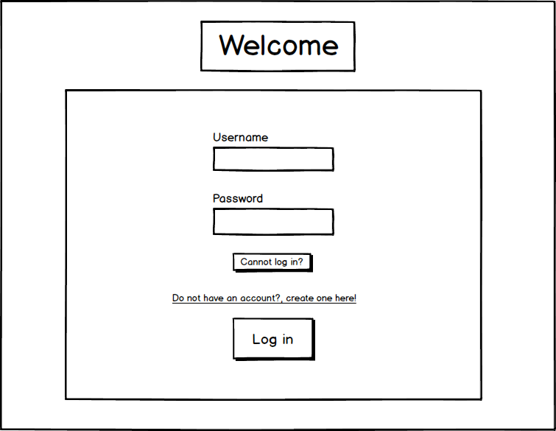

**Figure 1: Initial login**

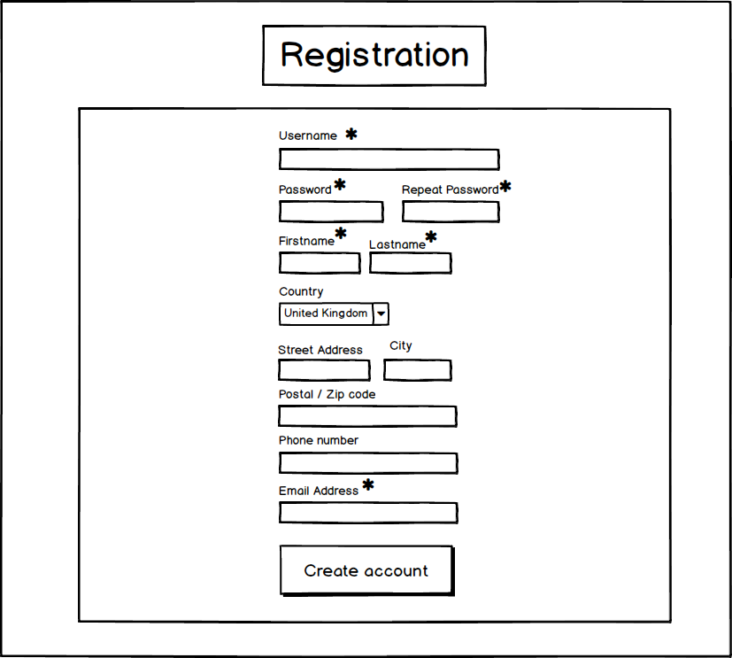

**Figure 2: Registration**

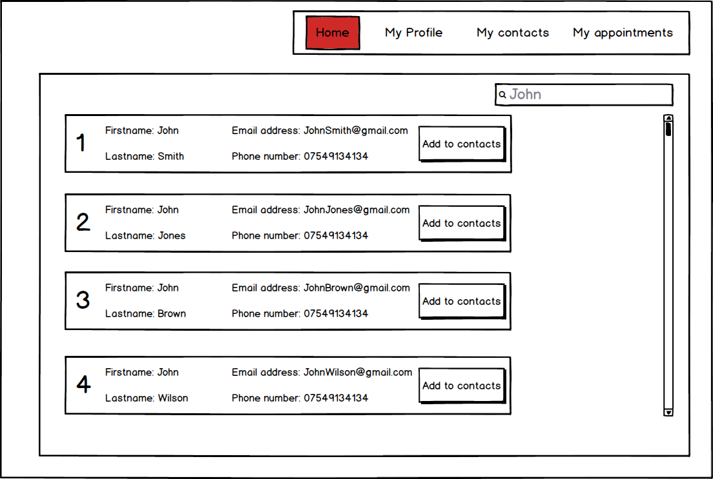

**Figure 3: Home (Contact search)**

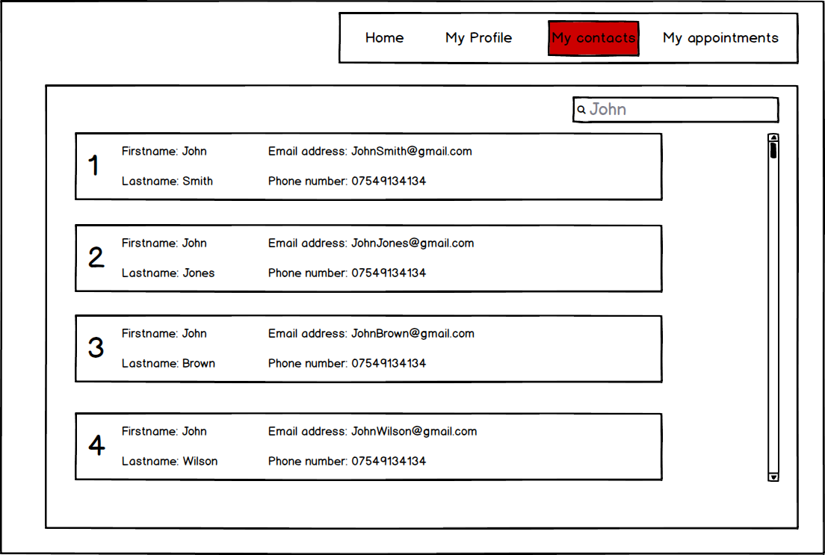

**Figure 4: My contacts**

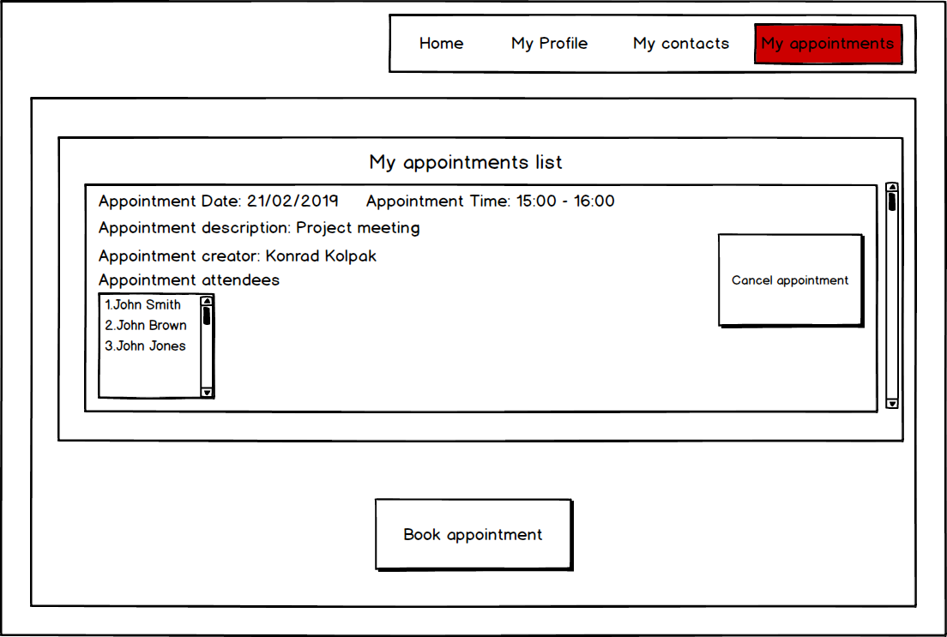

**Figure 5: My appointments**

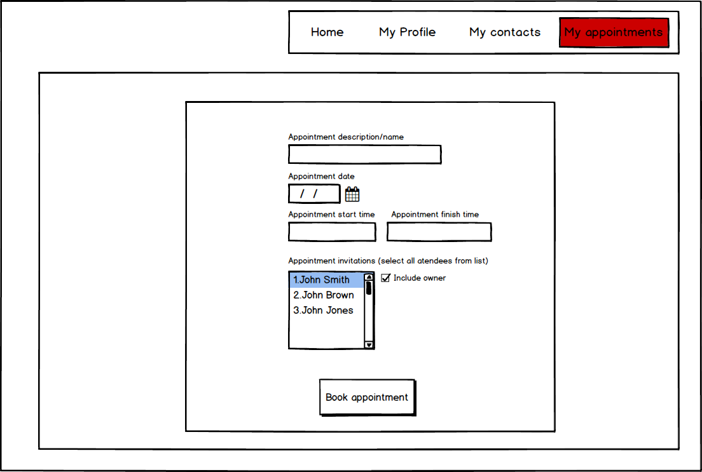

**Figure 6: Book appointment**

# User interface documentation

The first screen which the user will see is the login page **(Figure 1)**. Every user must log in to use the system. If the user has forgotten his password or username he will be able to get it emailed back when pressed ‘cant log in?’. Users are able to create an account by pressing on the ‘Do not have account…’ link, which will redirect them to account creation page **(Figure 2).** Users who have an account, upon successful authentication with the server, users will be redirected to the Home page **(Figure 3).**

Account creation page **(Figure 2)** uses asterisks to show which fields are required by the users to fill. When the ‘Create account’ button is pressed, the server will validate all inputs, and show any error messages in a popup window.

Home page **(Figure 3)** will display a list of all other registered users. The user will be able to search for specific users using a search box at the top-right position of the screen, all of the other users will be displayed in a list, displaying their visible profile information such as first name, last name, phone number and email address. The user will be able to add them to his own contact list in order to easily book appointments.

Navigation at the top will be shown in all of the screens which require authentication.

My contacts **(Figure 4)** will show a list of added contacts, this screen is very similar in terms of design to the **(Figure 3)**, the only difference is that the only contacts displayed are the ones which were added to the personal list.

Users will be able to see all of their appointments in the appointments screen **(Figure 5)**. In order to book an appointment, users will need to press on ‘Book Appointment’, which will redirect to Book appointment screen **(Figure 6)**.

# Flow diagram



 