Project 2 Proposal:

Team Name: D 3nvironmentalist

Team Members: Stephanie Robalino, David Solomon, Rosario Chiovaro, Jon Little, Michael Legg, Cesar Rodriguez

Topic: Climate Change

Inspiration: <https://www.buzzfeednews.com/article/peteraldhous/climate-change-maps-ice-sea-level-rise>

Topic /Charts:

* [Carbon Dioxide Levels](https://climate.nasa.gov/vital-signs/carbon-dioxide/)
* [Global Mean Sea Level](https://climate.nasa.gov/vital-signs/sea-level/)
* [Global AVG. Temperature Index](https://github.com/D-3nvironmentalist/Project-2/tree/master/assets/data)
* [Artic Ice Minimum](https://climate.nasa.gov/vital-signs/arctic-sea-ice/)

Rosario/Michael – Upload to SQL DB

Stephanie/ – Python Flask/API-

Jon/Michael – Heat map Global Average Temperature

David – Artic Ice Minimum

Rosario/ Stephanie/ Cesar – Carbon Monoxide & Global Mean Sea Level

Group – HTML/CSS/JS (choose JS library we haven’t learned)- Presentations

[JS Library to choose](https://getflywheel.com/layout/best-javascript-libraries-frameworks-2020/)

Drop down- each topic

Techniques:

1. Panda clean / SQL Clean and keep DB
2. Use JSON file and CSV data files
3. Use D3 possible viz
4. Create dropdown menu of years of data
5. Create a Heat map country.

Visual Example:

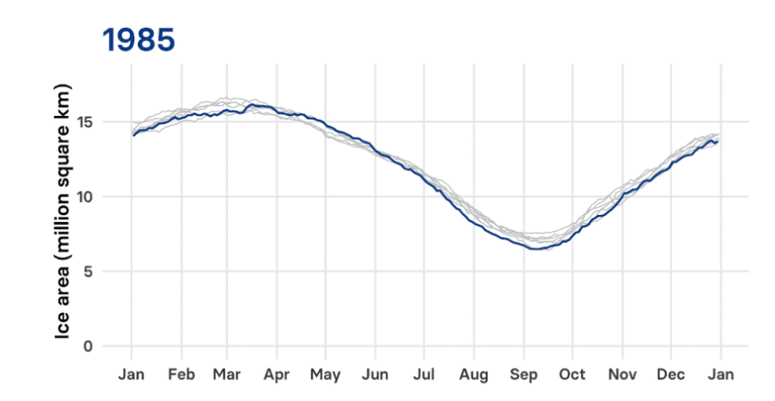

DataSets:

* OpenWeather -<https://openweathermap.org/>
* NASA - <https://data.giss.nasa.gov/gistemp/>
* <https://climate.nasa.gov/system/internal_resources/details/original/1929_Arctic_data_1979-2019.txt>
* <https://climate.nasa.gov/vital-signs/carbon-dioxide/>