Joint CP Controlled Workflow Proposal
Product and API specification for approval
Document | Value
Status | Approval draft. No implementation is authorized by this document.
Prepared for | Mconnect product, mobile, web, backend, IAM and QA owners
Platforms | Android, iOS and web CP detail
Date | 4 September 2026
Decision needed | Approve the workflow, authorization rule, API contract and completion ownership model

Decision Summary
Joint CP should become a permission-controlled two-person workflow rather than a CP type that any staff member can create. The creator and first participant must be an active GM or SM who has the Joint CP IAM permission. The second participant may be any active staff member. Each participant receives an independent tracked trip, but the shared CP can enter OTP completion only when both staff are verified within 50 metres. The first participant to submit a valid OTP and proof photo becomes the outcome owner; the other participant must submit required remarks. The CP reaches Completed only after both contributions exist.
Implementation boundary: This proposal defines the intended behavior and proposed integration contract. Approval must happen before Android, iOS, web, backend, database or IAM changes begin.

Goals
- Prevent invalid Joint CP combinations such as two BDO staff without an eligible GM or SM first participant.
- Make authorization server-controlled through IAM while retaining the GM or SM role guard.
- Track both participants independently and present both routes clearly in CP detail.
- Require physical co-location before OTP and completion can begin.
- Avoid duplicate outcomes by assigning exactly one outcome owner and one remarks contributor.
- Make incomplete contribution states visible and recoverable across app restarts and network interruptions.

Non Goals
- This proposal does not implement or deploy the feature.
- It does not change normal single-staff CP creation or completion.
- It does not infer Joint CP permission from reporting hierarchy alone.
- It does not merge both staff locations into one trip or one device session.

Authorization and Participant Rules
Rule | Required behavior | Server authority
Creator | Signed-in user must be active, have role GM or SM, and hold marketing.joint_cp.create through the effective IAM template. | Required
Feature visibility | Hide the Joint CP toggle when the signed-in user fails either the role or IAM check. | Revalidate on create
First participant | Prefill the creator. Allow editing only to active GM or SM staff who also hold the Joint CP IAM permission. | Required
Second participant | Show all active staff without department, role or reporting filters. Exclude the selected first participant. | Required
Distinct members | First and second participant IDs must differ. | Required
Two BDO combination | Impossible because the first participant must satisfy the GM or SM plus IAM rule. | Required
Permission changes | If permission or employment state changes before submit, reject creation and refresh eligible options. | Required

IAM Permission
Proposed permission key: marketing.joint_cp.create
The permission controls whether Joint CP creation is available. The role guard remains mandatory. A BDO who receives the permission by mistake must still fail server validation. If the business instead wants IAM alone to authorize any role, that must be approved as an explicit change because it would permit the BDO-plus-BDO case this proposal is designed to prevent.
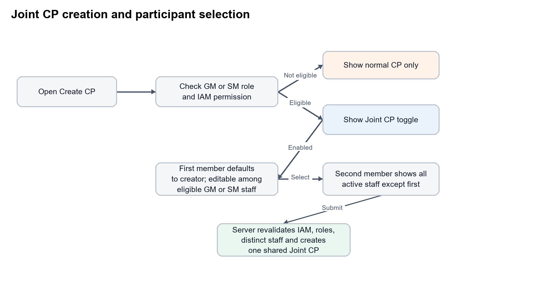
Figure 1. Creation authorization and participant selection flow

Mobile and Web Creation Experience
1. The Create CP form loads the signed-in user's effective permissions and role.
2. Eligible users see a Joint CP toggle above the normal CP purpose selector. Other users see only normal CP creation.
3. When Joint CP is enabled, the first member is prefilled with the creator and remains editable.
4. The first-member picker lists only active GM or SM staff with the effective Joint CP permission.
5. The second-member picker lists every active staff member except the selected first member. It remains searchable and has no role, team, department or reporting filter.
6. Changing either member clears stale validation, proximity and completion state.
7. Submission creates one shared Joint CP record and two linked participant trip assignments in one transaction.

Tracking and Route Presentation
Each participant owns a separate trip session linked to the same Joint CP. Start, location samples, pauses, offline buffering, sync state and finish events remain attributed to the participant who produced them. One participant's app process or network state must not stop or overwrite the other participant's tracking.
Participant | Trip ownership | CP detail route | Required detail data
Member 1 | Own linked field visit and tracking session | Blue line | Name, role, start/end, distance, duration, path points and sync status
Member 2 | Own linked field visit and tracking session | Orange line | Name, role, start/end, distance, duration, path points and sync status

Color assignment is based on participant slot, not role: first participant is blue and second participant is orange. The legend must display both names. Individual route visibility must remain correct if the selected first participant is not the creator.
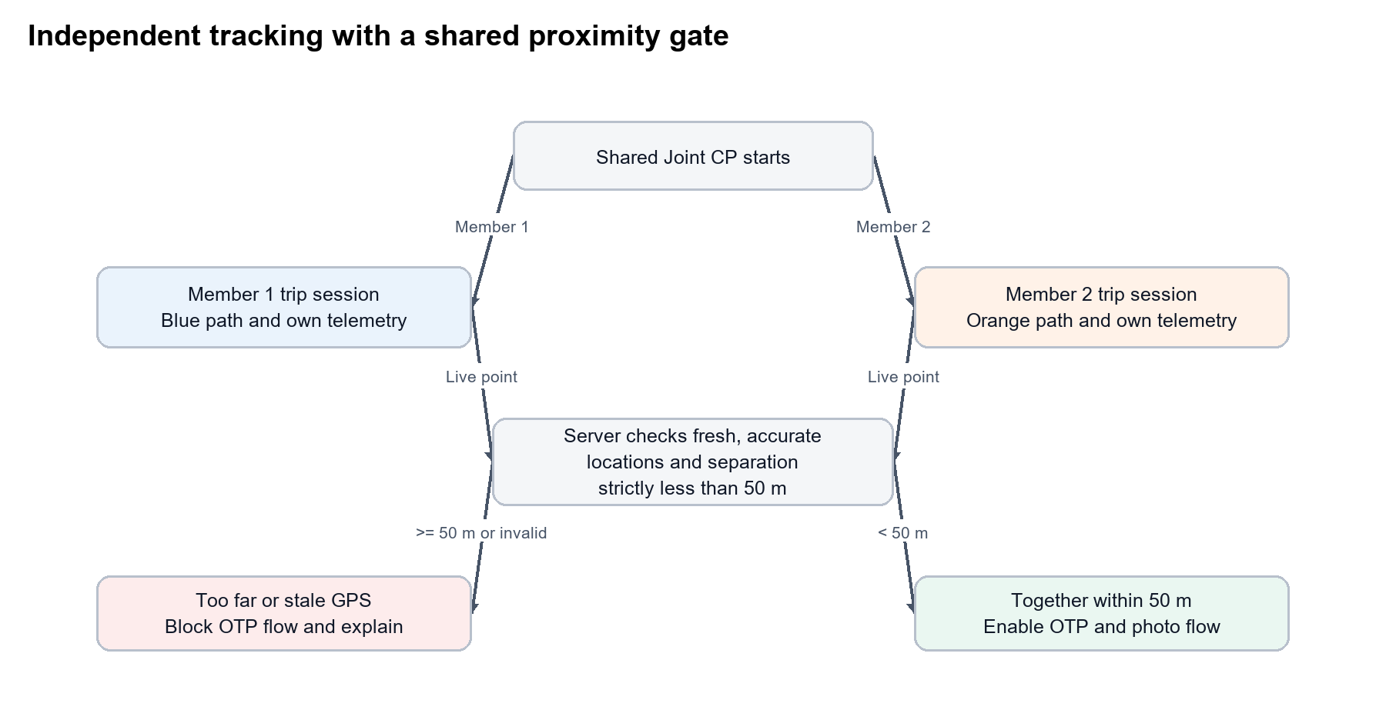
Figure 2. Separate trip tracking and shared proximity validation

Fifty Metre Proximity Guard
The server must validate both participants' latest trusted locations immediately before OTP issuance or verification. Completion is eligible only when the calculated separation is strictly less than 50 metres. The client display is informative; the server result is authoritative.
Condition | Result | User message
Both fresh and accurate; distance < 50 m | Enable OTP and photo flow | Both staff are together. You can continue.
Distance >= 50 m | Keep completion swipe disabled | Joint CP completion is blocked. Both assigned staff must be within 50 metres. Current separation: {distance} m. Move closer and try again.
Either location is stale | Keep completion swipe disabled | Waiting for a fresh location from {staffName}. Keep both apps open with location enabled.
Either accuracy is unacceptable | Keep completion swipe disabled | Location accuracy is too low to confirm that both staff are together. Move to an open area and retry.
Either trip not active | Keep completion swipe disabled | Both assigned staff must start their Joint CP trip before completion.

Recommended validation inputs: location age no more than 60 seconds, reported horizontal accuracy no worse than 30 metres, and server-side geodesic distance calculation. These thresholds are proposed for approval and should be configurable without an app release.

Completion Ownership and Handshake
Before either contribution exists, both participants may enter the OTP and proof-photo flow after the proximity guard passes. The first successful server submission containing a valid OTP and proof photo atomically claims outcome ownership. This prevents both devices from opening and submitting competing outcome forms.
State | Outcome owner sees | Other member sees | Shared CP status
Ready | OTP and photo flow | OTP and photo flow | In progress
Evidence claimed | Outcome form | Required remarks form | Awaiting contributions
Outcome first | Waiting for {otherName} remarks | Required remarks form | Awaiting remarks
Remarks first | Outcome form | Waiting for {ownerName} outcome | Awaiting outcome
Both submitted | Completion confirmation | Completion confirmation | Completed

Outcome Owner
- Must submit the normal CP outcome form appropriate to the selected CP purpose.
- Must not be able to submit a second outcome after the first accepted outcome.
- After submitting first, sees a non-dismissible progress dialog until the other participant's remarks arrive or the user leaves the screen.
- Dialog text: Waiting for {otherName} remarks to complete this Joint CP.

Remarks Contributor
- Sees a required remarks field instead of the outcome form after another member claims evidence ownership.
- Cannot submit blank or whitespace-only remarks.
- May attach no outcome and cannot overwrite the outcome owner's selection.
- If remarks are submitted first, sees: Waiting for {ownerName} to complete the outcome.
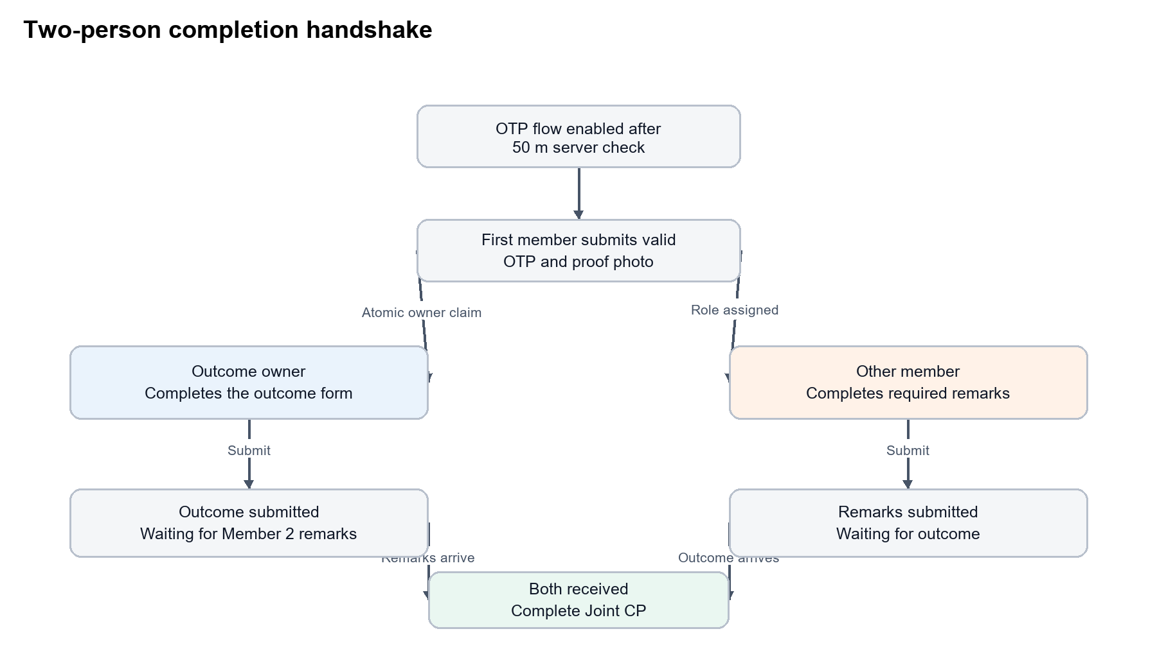
Figure 3. Atomic outcome ownership and two-person completion handshake

Concurrency and Recovery
- The evidence claim must be atomic. If both devices submit together, exactly one becomes outcome owner and the other receives the latest state plus the remarks assignment.
- Every mutation uses an idempotency key. Network retry returns the original accepted contribution without duplication.
- The server stores the workflow state. App restart, rotation, backgrounding or device change reloads the same owner, remarks assignee and waiting state.
- Uploaded proof must remain linked while later outcome or remarks requests retry.
- The CP reaches Completed only through one server transaction after both valid contributions exist.

Proposed Data Model
Field | Type | Purpose
jointCpEnabled | Boolean | Distinguishes Joint CP workflow from normal CP purpose
jointPurpose | Enum | Canonical CP purpose selected from the normal CP type list
participants | Array of exactly two | Participant ID, slot, role snapshot and assignment state
participantFieldVisitIds | Map | Links each participant to their independent tracked trip
evidenceOwnerStaffId | Staff ID nullable | Set atomically by first valid OTP and photo submission
remarksAssigneeStaffId | Staff ID nullable | The participant who did not claim evidence ownership
outcomeContribution | Object nullable | Outcome, notes, actor and timestamp
remarksContribution | Object nullable | Required remarks, actor and timestamp
completionState | Enum | ready, awaiting_outcome, awaiting_remarks or completed
proximityAudit | Object | Both points, ages, accuracy, measured distance and decision timestamp

Proposed API Contract
Endpoint names below are proposed for review. Existing CP, OTP, storage and tracking endpoints may be extended instead, provided the transaction, authorization and response behavior remains the same.

Eligibility and Pickers
GET /api/marketing/clientPlaceVisits/joint/options
Returns canCreateJointCp, the effective permission decision, eligibleFirstMembers and all active secondMembers. The backend must apply IAM and role rules; clients use the response directly and do not widen it locally.

Atomic Creation
POST /api/marketing/clientPlaceVisits/create
Extend the existing create request with jointCpEnabled, jointPurpose and two ordered participant IDs. The server validates the creator, first member, second member and distinctness, then creates one CP plus two linked field visits atomically.

Proximity Status
GET /api/marketing/clientPlaceVisits/joint/{id}/proximity
Returns eligible, measuredDistanceMetres, both location timestamps and accuracy values, reasonCode and a human-readable message. OTP issue and verify endpoints must repeat this check inside their own mutation; this GET alone cannot authorize completion.

Evidence and Owner Claim
POST /api/marketing/clientPlaceVisits/joint/{id}/claim-evidence
Accepts OTP verification reference, proof storage ID and idempotency key. Atomically assigns evidenceOwnerStaffId and remarksAssigneeStaffId, or returns the already-selected assignment when another participant won the race.

Outcome and Remarks
POST /api/marketing/clientPlaceVisits/joint/{id}/outcome
POST /api/marketing/clientPlaceVisits/joint/{id}/remarks
Each endpoint authorizes only its assigned participant. Each response returns the complete shared workflow state. The second accepted contribution triggers one atomic completion transaction and closes both linked participant trips without deleting their paths.

Shared State and Routes
GET /api/marketing/clientPlaceVisits/joint/{id}
Returns participants, assignment state, contribution status, waiting copy, completion status and both route series. Web and mobile should consume the same source so blue and orange paths, names and completion state cannot disagree.

Required Error Codes
Code | When used | Client action
JOINT_CP_FORBIDDEN | Creator lacks role or IAM permission | Hide/close Joint CP and refresh permissions
FIRST_MEMBER_INELIGIBLE | First participant is not an active permitted GM or SM | Refresh first-member picker
DUPLICATE_PARTICIPANT | Both participant IDs are the same | Require a different second member
PARTICIPANT_INACTIVE | Either participant is no longer active | Refresh participant options
TRIPS_NOT_ACTIVE | One or both participant trips have not started | Show who still needs to start
LOCATION_STALE | A required live location is too old | Wait for fresh telemetry
LOCATION_INACCURATE | Accuracy does not meet policy | Ask staff to improve GPS accuracy
PARTICIPANTS_TOO_FAR | Measured distance exceeds 50 metres | Disable completion and show measured distance
CONTRIBUTION_ROLE_CHANGED | Another device claimed outcome ownership | Reload and show assigned form
ALREADY_COMPLETED | A retry reaches an already-completed CP | Treat as success and show final state

Audit and Security Requirements
- Record permission source, creator, selected participants and role snapshots at creation.
- Record both proximity points, timestamps, reported accuracy, calculated distance and allow/block result for each OTP attempt.
- Record OTP verifier, proof storage ID, outcome owner claim, outcome submission and remarks submission with server timestamps.
- Do not trust role, permission, distance, owner or completion state supplied only by a client.
- Do not expose staff outside the authenticated user's authorized organization even though the second picker has no business-role filter.
- Retain both tracking paths after completion and cancellation according to the existing retention policy.

Edge Cases
Scenario | Expected behavior
First member changed after second selected | Keep second only if still distinct and active; otherwise clear it.
Permission revoked after form load | Server rejects create with no partial rows.
One participant offline | Their route buffers locally; proximity and completion wait for fresh synced location.
Both submit OTP/photo simultaneously | One atomic winner gets outcome; loser gets required remarks assignment.
Outcome owner closes app | Other member may submit remarks; CP remains awaiting outcome until owner returns.
Remarks member closes app | Outcome may be saved; CP remains awaiting remarks until that member returns.
One contribution request times out | Retry with the same idempotency key and return existing state.
Cancellation during waiting state | Use existing authorized cancellation policy, close both trips atomically, retain audit and paths.
GPS spoofing or mock-location signal | Apply the existing GeoTrack tamper policy and block trusted proximity when policy requires.

Acceptance Criteria
1. A user without either the GM or SM role, or without the IAM permission, cannot see or create Joint CP.
2. An eligible creator sees self prefilled as first member and can replace self only with another active permitted GM or SM.
3. The second picker is searchable and shows all authorized active staff except the first member, without role, team, department or reporting filters.
4. The backend rejects two BDO participants and every request with an ineligible first member, even if the client is modified.
5. Creation produces one shared Joint CP and exactly two linked independently tracked participant trips in one transaction.
6. CP detail shows Member 1 as a blue path and Member 2 as an orange path with a correct name legend and separate distance, duration and timestamps.
7. OTP and proof flow stays disabled when either trip is inactive, location is stale/inaccurate, or separation exceeds 50 metres.
8. At exactly 50 metres or above, the server blocks the flow and returns the measured distance; only a value below 50 metres is eligible.
9. The first valid OTP plus photo submission atomically owns the outcome. The other participant receives only the required remarks form.
10. Exactly one outcome and one remarks contribution are stored, including simultaneous submission and network retry tests.
11. After the first contribution, the correct waiting message names the other participant and survives app restart.
12. The CP enters Completed statistics only after both contributions are accepted, and both route histories remain available.
13. Android, iOS and web show the same participants, contribution status, final outcome, remarks and two routes from the shared server state.

Approval Decisions
Decision | Proposed choice | Approval
Authorization | GM or SM role AND marketing.joint_cp.create IAM permission | Approve / Change
First participant | Editable among active permitted GM or SM staff | Approve / Change
Second participant | All authorized active staff except first | Approve / Change
Distance threshold | Strictly less than 50 metres | Approve / Change
Location freshness | 60 seconds | Approve / Change
Maximum location accuracy | 30 metres | Approve / Change
Outcome ownership | First valid OTP plus photo submission | Approve / Change
Remarks | Required from the non-owner participant | Approve / Change
Route colors | Member 1 blue; Member 2 orange | Approve / Change
API shape | Extend create plus dedicated joint state/contribution routes | Approve / Change

Implementation Gate
Development begins only after product, IAM, backend, mobile and web owners approve the decisions above. The approved version should then be converted into separate backend API, Android, iOS, web detail and QA work items with one shared contract and staged rollout plan.

