DOING PHYSICS WITH PYTHON

QUANTUM MECHANICS

VISIBLE SPECTRUM DISPLAY

Ian Cooper

matlabvisualphysics@gmail.com

DOWNLOAD DIRECTORY FOR PYTHON SCRIPTS

qmSpectrum.py

GitHub

Google Drive

The Python code qmSpectrum.py can be used to produce a plot of the visible spectrum for the wavelength range from 380 nm to 780 nm. The script uses the fill_between plot function to give the spectrum. The colour for each wavelength is calculated from the function colour(wL) where wL is the wavelength of the light from 380 nm to 780 nm.

The plot of for the visible spectrum is shown below.

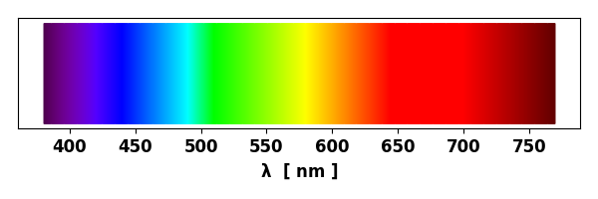

HYDROGEN: BALMER SERIES VISIBLE SPECTRUM

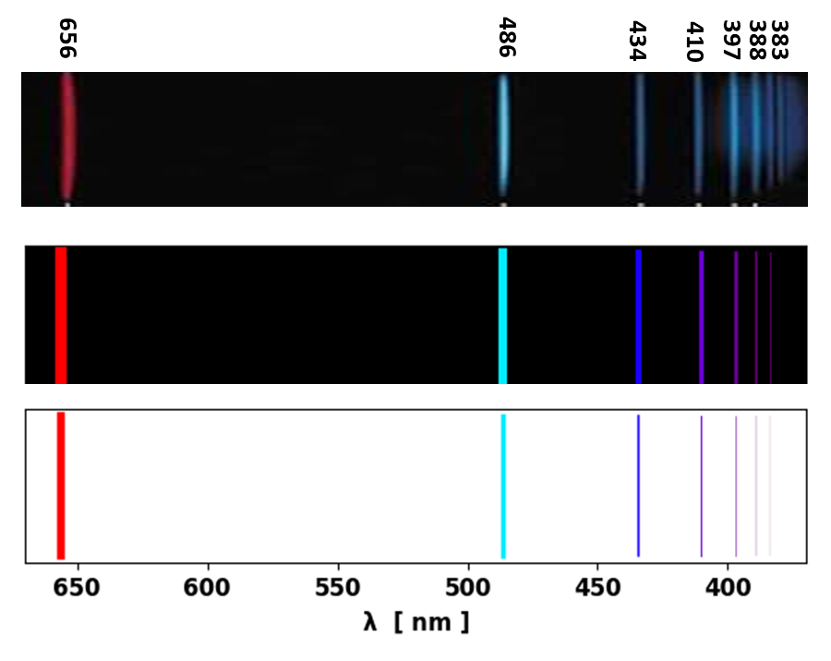
Balmer series spectrum for the visible components. Top is an image of the spectrum and the lower two spectrum are created using the code qmSpectrum.py.

