DOING PHYSICS WITH PYTHON
NEUROSCIENCE
HINDMARSH – ROSE MODEL
BURSTING BEHAVIOUR OF NEURONS

Ian Cooper
Please email me any corrections, comments, suggestions or additions: matlabvisualphysics@gmail.com

DOWNLOAD DIRECTORIES FOR PYTHON CODE
Google drive
GitHub

ns25_HR.py
Uses odeint function to solve two / three coupled first order differential equations which describe a bursting neuron. For different models, it may be necessary to make small changes to the Python Code.

ns25HR_bifurcation.py ns25_HR_bifurcationR.py
Bifurcation diagrams for ISI (inter-spike-interval)

INTRODUCTION
The Hindmarsh–Rose (HR) model is a three-dimensional model and can reproduce all kinds of dynamic behaviours under different parameter values, which can accurately describe the voltage and current change on the nerve fibre. An analysis of the dynamic behaviour of the HR model can give a comprehensive understanding of the characteristics and response of a neurone.

The nervous system has very strong nonlinear characteristics, in particular, the system dynamics and its topological structures are sensitive to the parameter variation, the external input and the dynamic environment. Under different sets of parameter values, the HR model can generate different nonlinear behaviour that includes static, tonic spiking, periodic bursting and chaotic behaviour and so on.

NEURON BURSTING MODEL
The Hindmarsh - Rose model considers the following system of three coupled ODEs to generate action potentials
(1)
where x is the membrane potential, y is the fast current that associated with the gating dynamics of 𝑁𝑎⁺ or 𝐾⁺ ions, z is the slow current corresponding to the dynamics of calcium 𝐶𝑎²⁺ channel, x_{R} resting potential, I_{ext} is the external current stimulus. The variable y is known as a recovery variable, and z a recovery variable called an adaptation current. The constant x_{R} is determined from the x-y coordinates (x_{C1}, y_{C1}) of the stable equilibrium point (left most) of the model for I(t) = 0 and without adaption (r = 0). The external current stimulus pulse I_{ext} (t) is specified its height and duration.

If r = 0 which gives , then only two coupled ODEs are necessary to describe the system.

(2)

This model is similar to the Fitzhugh-Nagumo model except that the time rate of change of the recovery variable includes a quadratic term rather than a linear term in x.

Figure 1 shows an intracellular recording of a neuron in the visceral ganglion of the small snail, lymnaea stagnalis when it was stimulated by a short depolarizing current stimulus. After the current excitation, a series of action potentials are generated (bursting). The cell is usually silent, but when depolarized for about 100 ms, it spikes several times and then continues to spike even after the cessation of the current stimulus before the membrane potential falls to a value less than its initial value.

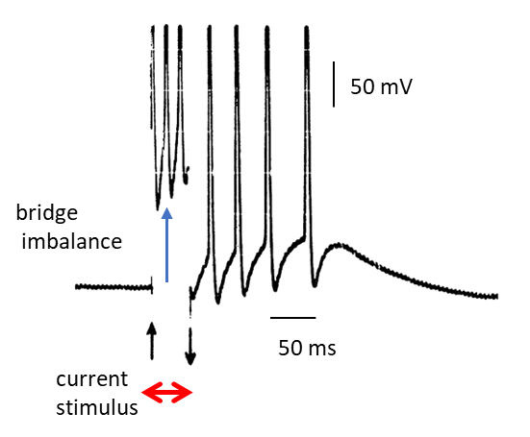
Fig. 1. Intracellular recording of a neuron in the visceral ganglion of the small snail, lymnaea stagnalis. [Hindmarsh & Rose].

The neuron bursting model can be used to simulate a bursting neuron and the results of the model can be compared with recordings of neurons to external current stimuli as shown in figure 1. The set of equations 1 are solved in Python (Spyder) using the odeint function. The solution of the set of equations 1 give the time evolution of the three variables: membrane potential x, recovery variable y and the adaptation current z in response to an external current stimulus I_{ext}.

The firing behaviour of a neuron can be better understood more easily by examining the quiver x-y phase portrait which shows the vector field by x-y arrows of unit length, the x-y trajectory, the x and y nullclines, the equilibrium (critical) points x_{C} and y_{C}, the initial conditions x₀ and y₀ and the final values for x(t) and y(t). The simulation results are also shown in streamplots.

The nullclines for x and y are obtained from equation 1 by setting and
x-nullcline (cubic function in x)
(2A)
y-nullcline (quadratic function in x)
(2B)

The critical points x_{C} and y_{C} are the points of intersection of the two nullclines where and . The critical points are found by finding the roots of the polynomial

There are three equilibrium points, the stable, saddle, and unstable shown in figure 2 when I_{ext} = 0 and z(t) = 0. The x-nullcline is a function of I_{ext}(t). When I_{ext}(t) changes, the position of the x-nullcline change in the phase portrait. So, the nature and location of the critical points depends on the external current stimulus.
The stability of an critical point in a dynamical system can be determined by analysing the eigenvalues of the Jacobian matrix evaluated at that point. If all eigenvalues have negative real parts, the equilibrium is stable (attracts nearby trajectories). If at least one eigenvalue has a positive real part, the equilibrium is unstable (repels nearby trajectroies). The imaginary parts of the eigenvalues can indicate oscillatory behaviour around the equilibrium.
Negative Real Parts
If all eigenvalues of the Jacobian have negative real parts, the equilibrium point is asymptotically stable. This means that any small perturbation from the equilibrium will be damped out over time, and the system will return to the equilibrium.
Positive Real Parts
If at least one eigenvalue has a positive real part, the equilibrium is unstable. This indicates that some perturbations from the equilibrium will grow over time, and the system will move away from the equilibrium.
Zero Real Parts
If some eigenvalues have a real part of zero, the stability analysis using the Jacobian is inconclusive. Further analysis using higher-order terms or other techniques may be needed to determine stability.

Complex Eigenvalues
Complex eigenvalues with non-zero real parts indicate oscillatory behaviour around the critical points. The sign of the real part determines whether the oscillations decay (stable) or grow (unstable).

Consider a system of differential equations:
dx/dt = f(x, y)
dy/dt = g(x, y)

To analyse the stability of a critical point (x_{C}, y_{C}), by first compute the Jacobian matrix
Then, we find the eigenvalues of J(x_{C}, y_{C}) and determine the stability based on their real parts.

SIMULATIONS

I_{ext} = 0 response of HR system ns23HR.py
Assume that the HR system is disturbed from its equilibrium and any external current stimulus becomes zero. Then the HR system will evolve to the stable fixed point as shown in the following figures.

Figure 2 shows the variety of plots that are used to analyse the HR mode when I_{ext} = 0. A summary of the model parameters is displayed in the Console Window.

Model parameters: r = 0.0020 s = 4.0000 I0 = 0.0000
Initial values: x0 = 1.5000 y0 = 0.0000 z0 = 0.2000
Simulation time: t2 = 1000

Critical values and Eigenvalues
xC = -1.618 yC = -12.09
eV = [-18.488 -0.075]
STABLE

xC = -1.0 yC = -4.0
eV = [-10.099 0.099]
UNSTABLE

xC = 0.618 yC = -0.91
eV = [0.781+1.734j 0.781-1.734j]
Unstable: osc growth

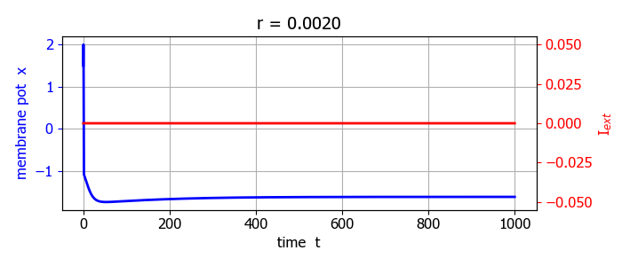
Fig. 2A. Time evolution of the membrane potential x (I = 0).

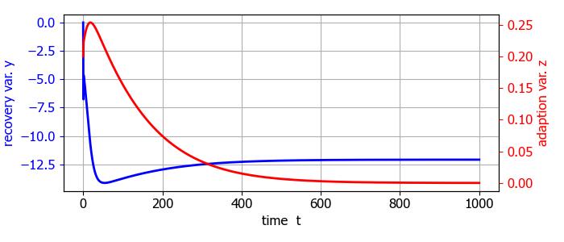
Fig. 2B. Time evolution of the recovery variables y and z (I = 0). The HR system evolves to the stable critical point (-1.618, -12.090, 0).

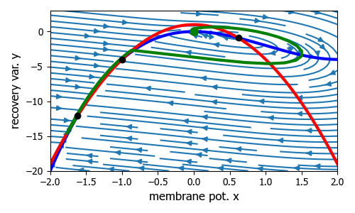
Fig. 2C. x – y phase portrait (streamplot) I = 0.

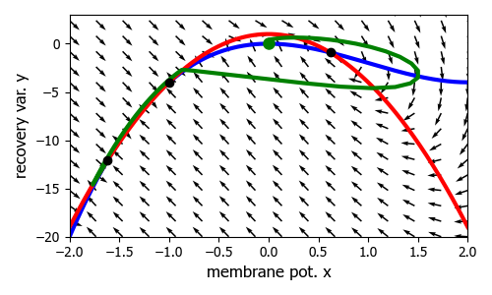
Fig. 2D. x – y phase portrait (quiver plot) I = 0. After the initial orbit around unstable critical point, the trajectory is towards the stable critical point. Blue curve is the x-nullcline (cubic) and the red curve is the y-nullcline (parabolic). Green dot (initial conditions), black dots show the critical points. For I = 0 there are three fixed points and the stable fixed point is (-0.168, 12.090)

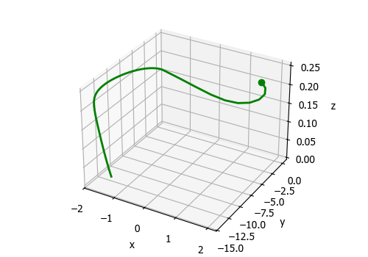
Fig. 2E. [3D] trajectory. Green dot shows the start of the trajectory .

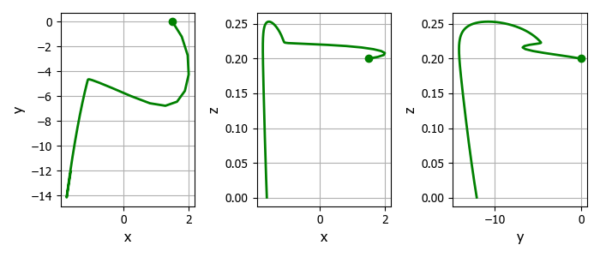
Fig. 2F. Phase portrait plots. Green dot (initial conditions).

For the case in which I_{ext}(t) = 0, there are three critical points. The critical point at is a stable. The critical point at is unstable (oscillating growth). If the initial conditions are set near this equilibrium point, the x-y trajectory then it will be attracted to the limit cycle surrounding this unstable critical point and the neuron will fire repetitively even without any external current stimulus (figure 2G).
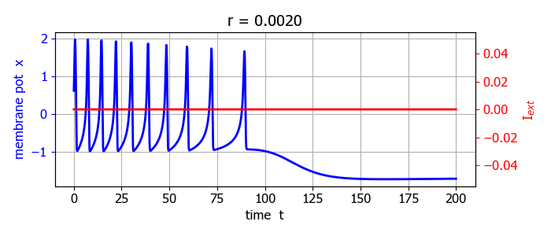
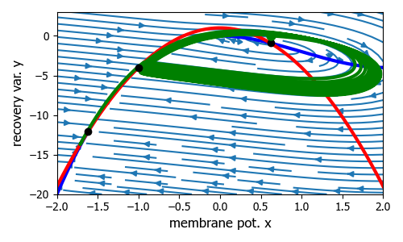
Fig. 2G. The neuron can fire repetitively even without any external current stimulus.
The critical point at is a saddle point. If the initial conditions are set near the saddle point, then the x-y trajectory will either be attracted to the limit cycle and a spike train will occur or be attracted to the stable critical point and the neuron will not fire (figure 2H).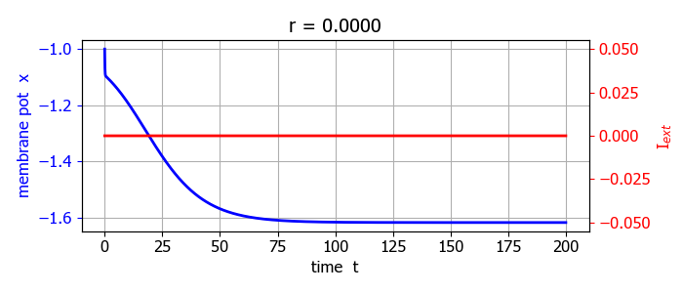
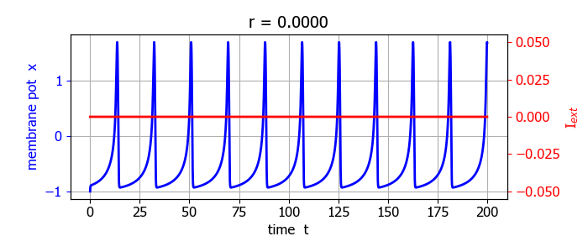
Fig. 2H. Time evolution plots for the current stimulus I_{ext} = 0,
adaptation current z = 0 (r = 0). Thus, the phase space is divided into two regions. Depending on the initial conditions, the trajectory will be attracted to the limit cycle and the cell fires continuously or the trajectory is deflected to the stable equilibrium point and no firing occurs.
Square pulse current stimulation

The model parameters were chosen so that the neuron does not fire for zero current stimulus. In this case there are three critical points, one stable and two unstable.
Model parameters: r = 0.0010 s = 1.0000
External current stimulus: I0 = 0.0000 width DT = 20
Initial values: x0 = 0.5000 y0 = -6.0000 z0 = 0.0000
Simulation time: t2 = 200
Critical values and Eigenvalues
xC = -1.618 yC = -12.09 eV = [-18.488 -0.075]
STABLE

xC = -1.0 yC = -4.0 eV = [-10.099 0.099]
UNSTABLE

xC = 0.618 yC = -0.91 eV = [0.781+1.734j 0.781-1.734j]
UNSTABLE: osc growth

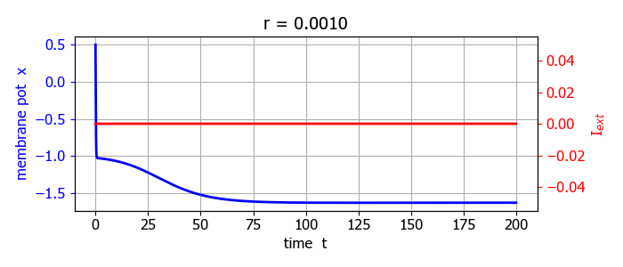

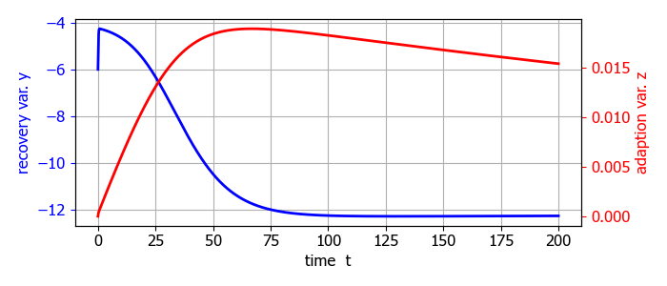
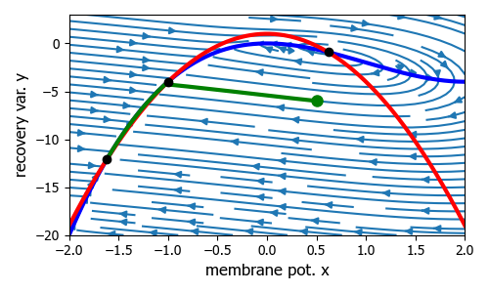
Fig. 3A. Response of HR system when I_{ext} = 0.

Model parameters: r = 0.0010 s = 1.0000
External current stimulus: I0 = 0.2500 width DT = 30
Initial values: x0 = 0.5000 y0 = -6.0000 z0 = 0.0000
Simulation time: t2 = 200

Critical values and Eigenvalues
xC = (-1.341+0.179j) yC = (-7.835+2.403j)
eV = [-1.4345e+01+2.467j -4.0000e-03+0.05j ]
STABLE: osc decay
xC = (-1.341-0.179j) yC = (-7.835-2.403j)
eV = [-1.4345e+01-2.467j -4.0000e-03-0.05j ]
STABLE: osc decay
xC = (0.683+0j) yC = (-1.33+0j)
eV = [0.849+1.846j 0.849-1.846j]
UNSTABLE: osc growth

An intracellular recording of a neuron in the visceral ganglion of the small snail lymnaea stagnalis is shown in figure 3B. In the HR model it is not entirely possible to the model variables to biological quantities. But the model can be used to gain insights into bursting behaviour. By carefully selecting the model parameters, the spiking pattern of the snail (figure 3B) can be reproduced when a small external current square pulse is applied to the system.

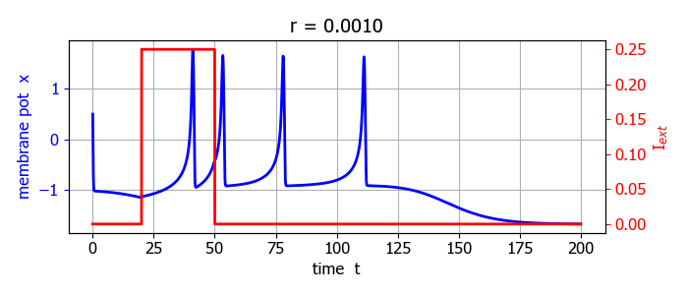
Fig. 3B. When the adaption current is added to the model, the response is an isolated burst of action potential and the membrane potential has similar characteristics of the intracellular recording of a neuron in the visceral ganglion of the small snail lymnaea stagnalis.

The short current pulse results in exciting the neuron with the x-y trajectory attracted to the limit cycle centred on the single unstable critical point (0.683, -1.330). The neuron fires during the time of the pulse and continues to fire briefly after the end of the pulse stimulus before the hyperpolarization causes the trajectory goes to the zero current stable critical point (-0.618, -12.090).
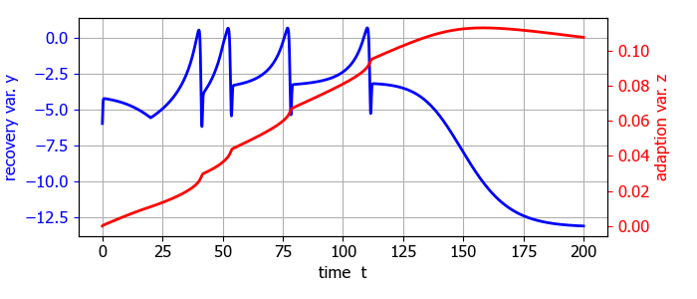
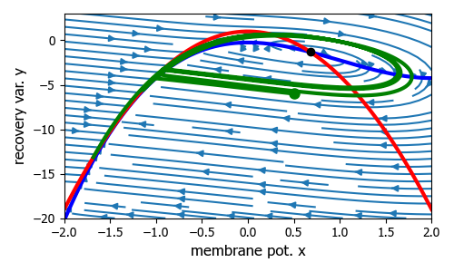

Fig. 3C. Phase portrait plot and time evolution plots. The neuron is stimulated by a current pulse of height 0.25 and duration 30.

If the current stimulus increases, then x-nullcline will move down and move up when the current stimulus decreases. So, if the current stimulus changes with time, this may result in a transition between one, two or three critical points and cause different firing patterns.
For an increasing current stimulus, the phase point moves into the limit cycle and each time an action potential occurs, the adaptation current z is incremented and the x nullcline will be displaced upward on successive cycles. The firing rate will decrease as the x nullcline and y nullcline become closer together at the saddle point until the two nullclines cross each other and the firing stops and the phase point slowly moves downward in the narrow channel between the x nullcline and the y nullcline towards the stable equilibrium point . This slow left and downward movement of the phase point gives rise to the hyperpolarizing of the membrane potential. After a long time, the adaptation current z will relax back to zero and the final membrane potential x will move the stable critical point.
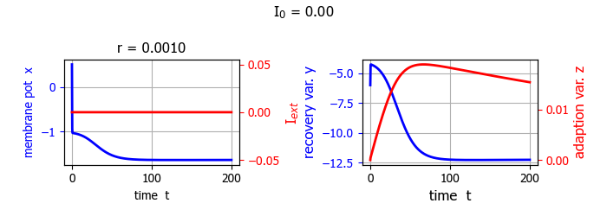
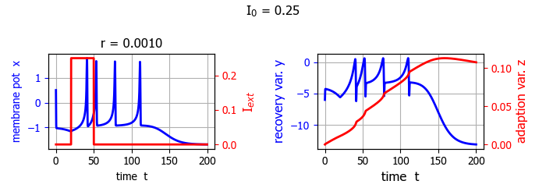
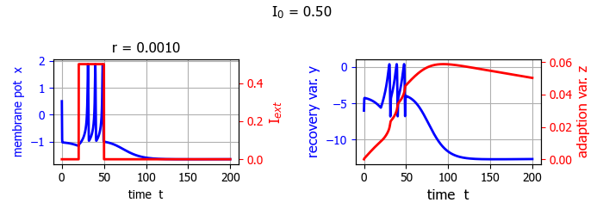
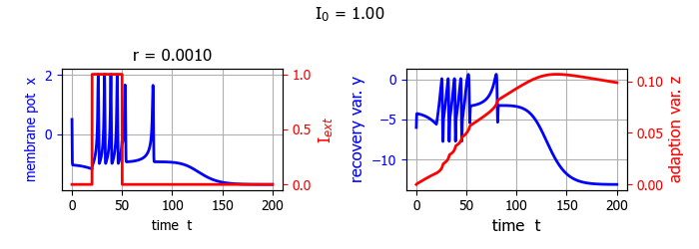
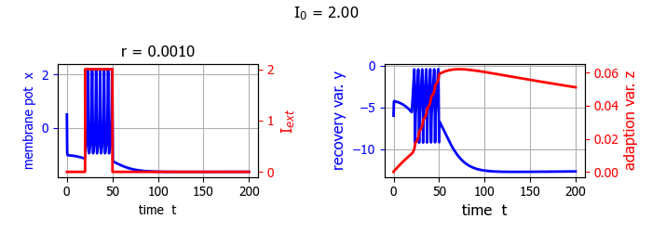
Fig. 3D. Time evolution of x, y and z as a function of I₀.
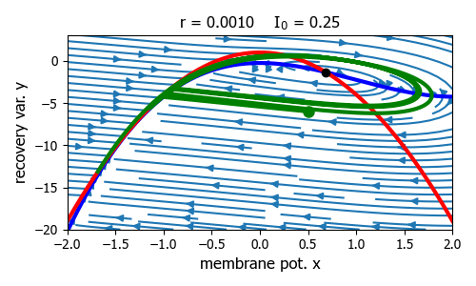
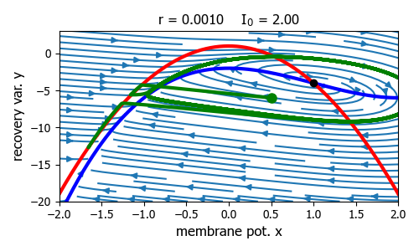
Fig. 3E. Phase portraits. As the current increases, the x-nullcline moves down.
I_{ext} = 3.25 Bursting behaviour ns25HR.py
The chaotic behaviour of the HR system is shown by numerical
analysis in different regions of the parameters space by time series and phase portraits, and bifurcation diagrams.
Console Summary
Model parameters: r = 0.0020 s = 4.0000 I0 = 3.2500
Initial values: x0 = 0.0000 y0 = -15.0000 z0 = 0.2000
Simulation time: t2 = 4000
Critical values and Eigenvalues
xC = (-1.58+1.081j) yC = (-5.637+17.078j)
eV = [-14.327+16.474j -0.134 +0.259j]
Stable: osc decay
xC = (-1.58-1.081j) yC = (-5.637-17.078j)
eV = [-14.327-16.474j -0.134 -0.259j]
Stable: osc decay
xC = (1.16+0j) yC = (-5.725+0j)
eV = [0.962+2.784j 0.962-2.784j]
Unstable: osc growth
time span for plots: 2400.0 --> 4000.0

An important phenomenon in neuron activity is the transition between spiking and bursting. Spiking is represented by a generation of action potentials, while bursting is represented by a membrane potential changing from resting to repetitive firing state. We can see these phenomena looking at time series and phase portraits, but bifurcation diagrams do not give any information on this ‘fast – slow’ motion.

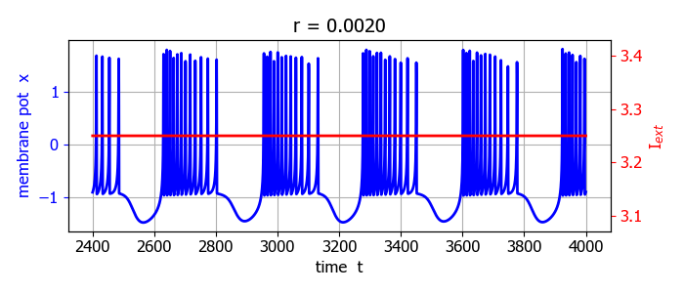
Fig, 4A. Time evolution plot of the membrane potential x (transient fluctuations removed). The rapid spiking corresponds to the fast motion and the slow motion to the time interval between the burst of spiking.

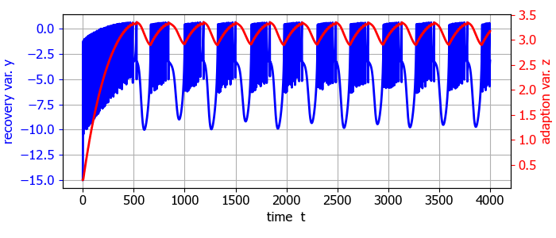
Fig, 4A. Time evolution of the recovery variables y and z.

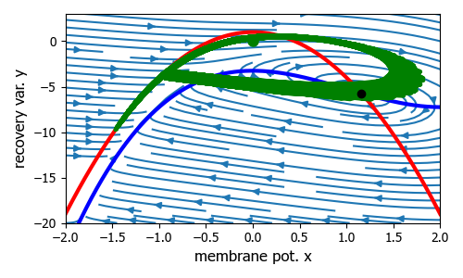
Fig. 4C. x-y phase portrait (streamplot). The black dot shows the single critical point (intersection of the x nullcline and the y nullcline). The green curve shows the phase portrait orbit and the green dot the initial conditions.

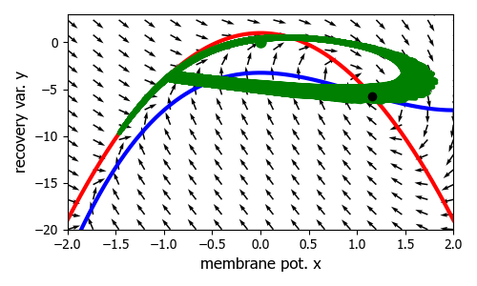
Fig. 4D. x-y phase portrait (quiver plot).

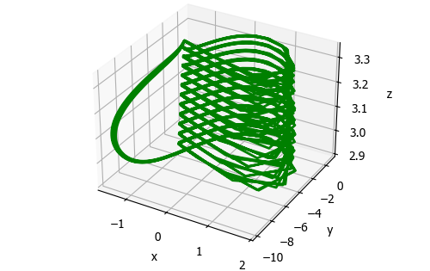
Fig. 4E. [3D] plot of the (x, y, z) orbit in the time interval from 2400 to 4000. The fast dynamics is the spiking part of time series while slow dynamics is the resting part.

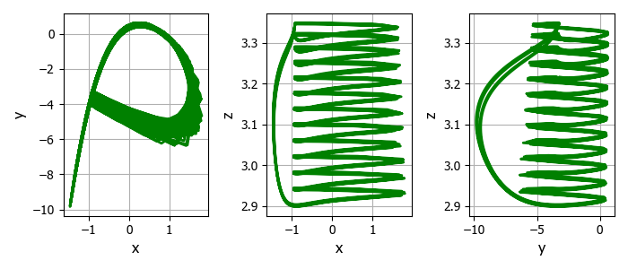
Fig. 4F. Phase portrait plots. The fast dynamics corresponds
to the right part of the attractor, the part where we observe spirals, while slow dynamics is on the left of the figures.

BIFURCATION DIAGRAMS
In the dynamics of neurons, the location of bifurcation values is important to determine the transition between a quiescent state and an oscillatory one, and also between different kinds of oscillatory motion. A bifurcation corresponds to a qualitative change of the information transmitted through the axon of the neuron.
Dynamic behaviours of the HR model as a function of external current stimulus I_{ext} [Chen]
HR model is capable of reproducing all the dynamic behaviours exhibited in real biological neuron cells. The external stimulus I_{ext} is the control parameter . The other values are:
r = 0.005 s = 4.0 x_{R} = -1.6 x(0) = 0.1 y(0) = 1.0 z(0) = 0.2

By varying the parameter I, the membrane potential x presents different state characteristics. Different bursting patterns as described by the membrane potential x are shown in figure 5 as the external current stimulus is increased.

When 𝐼_{ext} =1.5, then the neuron produces regular bursting (single-cycle bursting). When increasing I_{ext} to 1.8, 2.3, 2.8, the system exhibits another kind of regular bursting state: period-doubling, period-3 and period-4 bursting behaviours in turn. For I_{ext} = 3.2, the system becomes chaotic and the topological stability is changed. For I_{ext} = 3.58, the system returns to a stable single-cycle bursting state, with a higher spike rate than for 𝐼_{ext} =1.5. In both instances, the spiking is relatively regular indicating that the corresponding firing process can be relatively stable.

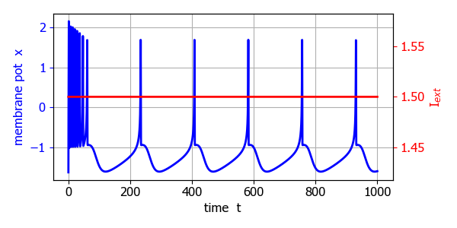
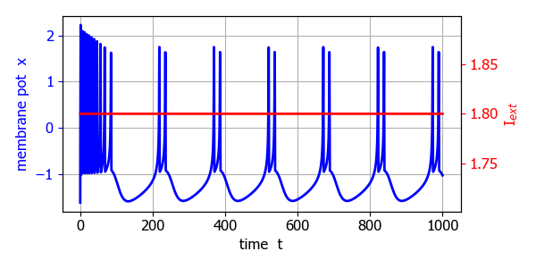

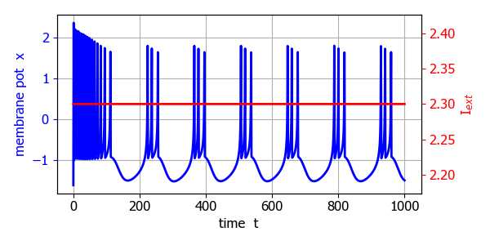

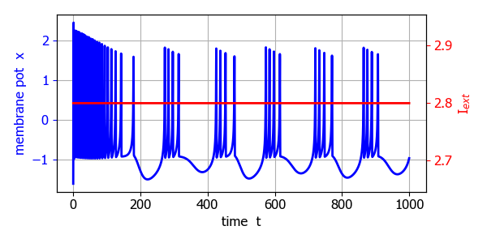

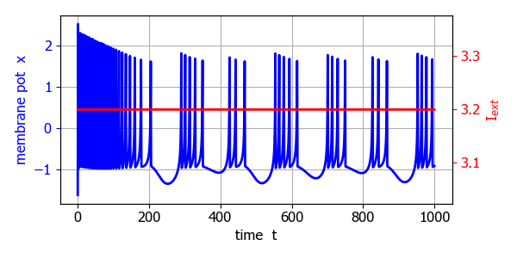
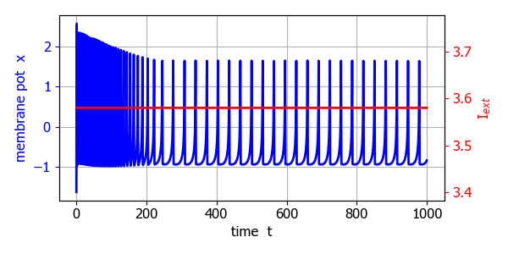
Fig. 5. Time response of membrane potential for different external current stimuli. ns25HR.py

The interspike interval (ISI) is one of the most used physiological indicators. It thought that information may be carried by ISI sequences of neuronal firing and some neurons encode information through chaotic ISI sequences. Fring patterns of neurons can be divided into periodic and aperiodic as shown in the bifurcation diagram (figure 6) of the ISI as a function of the external current stimulus which ranges from 1.0 to 4.0.

The bifurcation diagram (figure 6) indicates that the dynamic characteristics of the HR system shown by the interspike interval sequence is consistent with the time evolution of the membrane potential (figure 5).
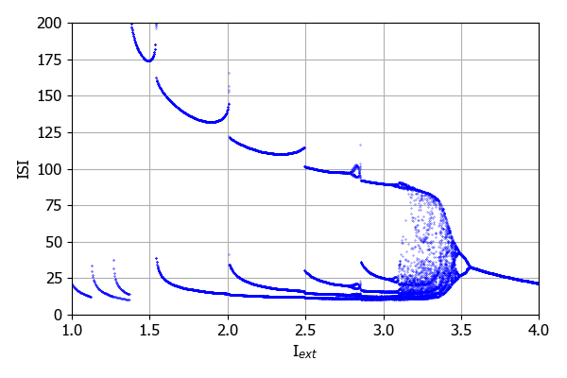
Fig. 6. Bifurcation diagram for ISI, control variable is the external current stimulus I_{ext}.

Starting from I = 1.0, the HR model experiences period-1,2,3,4 bursting state as the current stimulus increases to about 3.2. In the range 3.2 < I < 3.5, the ISI sequence becomes unstable and enters a chaotic state. When I > 3.5 the ISI sequence returns to a stable single-period state. We can conclude that, the system dynamics and topology of the HR model become more and more complex with the increase of parameter I at first, and when it reaches to a critical point, the system reverts back to a simple state. During this process, the topological structure of the system changes from stable to unstable and then to stable.

Dynamic behaviours of the HR model as a function of recovery
The recovery variable r is another important parameter, which is related to the calcium 𝐶𝑎²⁺ concentration and is significant to many neurological disorders. Different value of r can induce different firing patterns of the HR model. We can take r as the control parameter, and fix the external current stimulus at I = 3.0, while all the other parameters are kept as the same as mentioned in previous section. With the variation of r from 0.005 to 0.050, different dynamic behaviours of the HR neural system are observed. The initial state is 𝑥₀ = 0.10, 𝑦₀, = 1.00, and z₀ = 0.20. Figure 7 shows the time evolution of the membrane potential x for a set of r values and figure 8, the bifurcation diagram with r as the control variable.

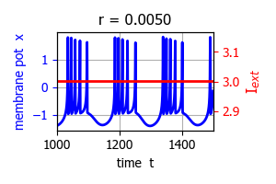 | 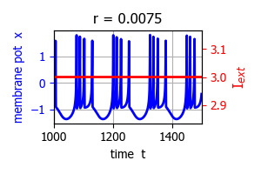
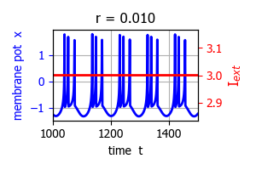 | 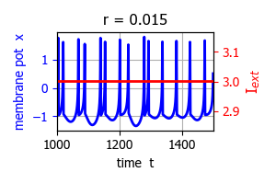
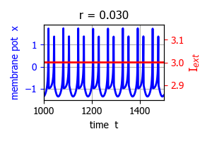 | 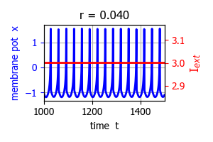

Fig. 7. Time evolution of the membrane potential x as a function of the recovery variable r. ns25HR.py

Figures 7, and 8 show that the HR system has a rich dynamic behaviour as the recovery variable r changes. The state is unstable and chaotic at the beginning for r < ~0.006 and it gradually becomes periodic bursting period-4 state when 𝑟 ~0.007 and periodic-2 state when 𝑟 ~ 0.020). It becomes period-1 state when 0.038 < r < 0.05. In addition, the system topology and stability also change accordingly from unstable chaotic to regular stable periodic state, which can be seen from the ISI bifurcation diagram (figure 8).
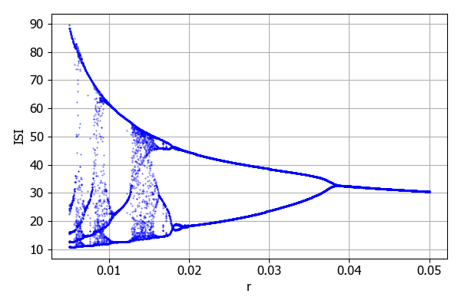
Fig. 8. Bifurcation diagram of ISI as a function of the recovery variable r with constant current I = 3.00. ns25bifurcationR.py

CONCLUSION
The bursting neuron model only gives a qualitative explanation of the bursting behaviour of real neurons and it may be difficult to relate model parameters to biological features. However, the model does provide insights into the behaviour of why neurons can exhibit bursting patterns.

REFERENCES
This document is based upon the paper by J. L. Hindmarsh and R. M. Rose: A model of neuron bursting using three coupled first order differential equations
Proceedings of the Royal Society of London. Series B, Biological Science, Volume 221, Issue 1222, (Mar 22, 1984)87-102.

Topology identification and dynamical pattern recognition for Hindmarsh–Rose neuron model via deterministic learning
Danfeng Chen, Junsheng Li, Wei Zeng, Jun He
https://pmc.ncbi.nlm.nih.gov/articles/PMC9871131/

https://pmc.ncbi.nlm.nih.gov/articles/PMC3365907/

https://www.youtube.com/watch?v=r0FGoVkQjwE&t=144s

Lyapunov exponent
https://ipython-books.github.io/121-plotting-the-bifurcation-diagram-of-a-chaotic-dynamical-system/

https://scicomp.stackexchange.com/questions/36013/numerical-computation-of-lyapunov-exponent

