DOING PHYSICS WITH PYTHON
A BRIEF INTRODUCTION TO NEURAL SYSTEMS

Ian Cooper
Any comments, suggestions or corrections, please email me at
matlabvisualphysics@gmail.com

DOWNLOAD DIRECTORIES FOR PYTHON CODE
Google drive GitHub

NEURAL SYSTEMS
Our body functions are controlled by electrical and chemical systems. We can measure many of these electrical signals to obtain useful information about the functioning of our bodies:
EMG electromyogram (muscle function)
ECG electrocardiogram (heart function)
EEG electroencephalogram (brain functions)
ERG electroretinogram (eye functions)

The central nervous system consists of the brain, spinal cord and the peripheral nerves. The central nervous system controls voluntary functions. Neurons transfer information to the spinal cord and brain from sensors sensitive to sound, light, smell, temperature, feel, etc. In response, signals are sent from the brain through the spinal cord to activate muscles. The autonomous nervous system controls involuntary functions such as the inner organs, heart and intestines. This system cannot be controlled voluntarily.

Neurons or nerve cells are the elementary processing units in the central nervous system. The neurons form an intricate network of connections. The human nervous system consists of about 10¹¹ interconnected neurons. There are about 10⁴ cell bodies of cortical neurons and several kilometres of connections within a volume element of 1 mL. There are about 10 000 different types of neurons. This complex network of neurons receives processes and transmits information from one part of the body to another. When a neuron receives an appropriate stimulus, it produces electrical pulses called action potentials that are propagated along its cable-like structure. When a pulse reaches the end of the nerve cell, other neurons or muscle cells may be activated. There are three types of neurons: sensory neurons (receive stimuli from sensory organs), interneurons (transfer information from one neuron to another), and motoneurons (transfer information about the control of muscle cells). The sending neuron is referred to as the presynaptic cell and the receiving neuron as the postsynaptic cell. In the vertebrate cortex, a single neuron can connect to more than 10⁴ postsynaptic neurons.
A typical neuron consists of three functionally distinct parts (figure 1):
- Dendrites: input part - collects signals from other neurons and transmits them to the soma.
- Soma: processing part – if the total non-linear input signal from the dendrites is greater than some threshold, an output signal is generated.
- Axon: output part – electric signals propagated away from the soma to other neurons across junctions known as synapses. Some neurons are extremely long, for example, the axon connecting our toes with the spine can be more than 1 m long. Human axons are very thin with diameters about 20, however, the giant squid has an axon of about 0.5 mm diameter.

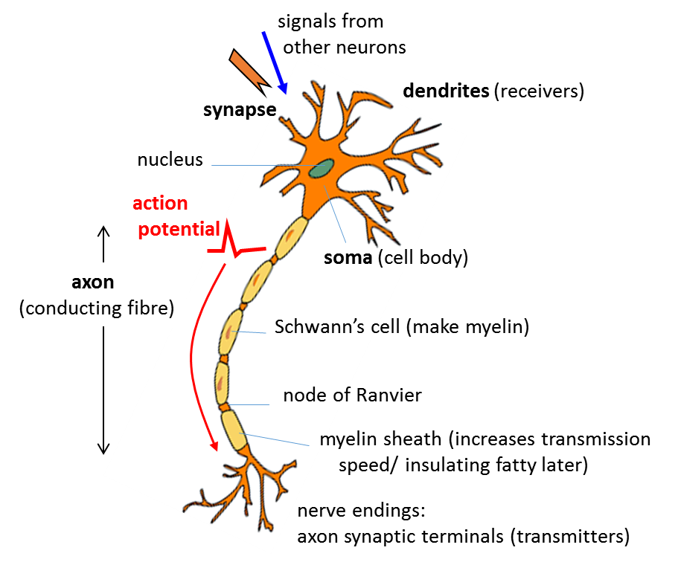
Fig. 1. Sketch showing the main parts of a neuron.

Body fluids are good electrical conductors because salts and other molecules dissociate into positive and negative ions. The inside of an axon is filled with an ionic fluid that is separated from the surrounding body fluid by a thin membrane that is from about 5 nm to 10 nm thick. The ionic solutes in the extracellular fluid are mainly Na⁺ and Cl⁻ ions. In the intracellular fluid, the positive ions are mainly K⁺ and the negative ions are mainly large negatively charged organic ions. Hence, there is a large concentration of Na⁺ ions outside the axon and a large concentration of K⁺ ions inside the axon. The concentration of the different ion species does not equalize by diffusion because of the special properties of the cell membrane. In the resting state when the axon is non- conducting, the axon membrane is highly permeable to K⁺ ions, slightly permeable to Na⁺ ions and impermeable to large negative organic ions. More K⁺ ions leak out of the cell than Na⁺ ions that leak into the cell. This leaves the inside of the cell more negative than the outside. A potential difference therefore exists across the cell membrane because of the difference in the concentration of ions in the extracellular and intracellular fluids. This potential difference is called the membrane potential v_{m}(t). The outside of the cell is taken as the reference potential 0 V. The resting membrane potential has a strong negative polarization and is constant at about -65 mV. This negative membrane potential restricts the further diffusion of the K⁺ to the outside of the cell, so equilibrium is established where the electrical forces balance the chemical forces.

The mechanism for the generation of an electrical signal by a neuron is conceptually simple. When a neuron receives a sufficient stimulus from another neuron, the permeability of the cell membrane changes. As a result of the changes in membrane permeability, the sodium ions first rush into the cell while the potassium ions flow out of it. The movement of the ions across the membrane constitutes an electric current signal which propagates along the axon to its terminations. These membrane currents depolarize the cell so that the interior of the cell becomes positive and a neuronal voltage signal is generated. These short voltage pulses are called spikes or action potentials and have a duration of less than a few milliseconds and have a peak about +20 mV (figure 2). The action potential propagates along an axon without a change in shape.
Fig. 2. Action potential produced by an external current pulse (J_{ext} = 1.0x10⁻⁴ A.cm⁻² and duration 0.10 ms) at a temperature of 18.5 ºC. The plot was created using the Hodgkin-Huxley Model with the Python Coder pyNS003.py

A sequence of spikes from a neuron is called a spike train and the timing between spikes maybe regular of irregular. A single spike does not carry useful information. It’s the pattern or timing of the spikes that is important in the neural dynamics of the brain. The minimal time interval between two spikes of a single neuron is called the absolute refractory period. It is not possible for a neuron to generate a second spike in this period, even with a strong input. In a short-time interval called the relative refractoriness phase after the absolute refractory, it is difficult, but not impossible to excite another action potential.
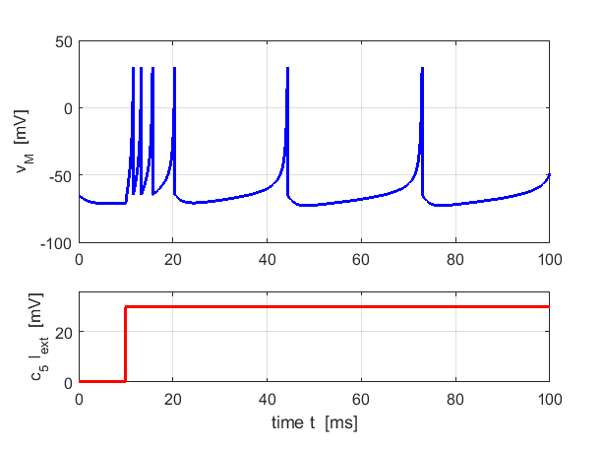
Fig. 3. An example of a spike train known as tonic spiking with spike frequency adaption (Izhikevich Model).

The synapse is the junction between axons of presynaptic neurons and the dendrites of postsynaptic neurons. There are two types of synapses in which neurons are coupled together, chemical and electrical.

Chemical synapses are the most common synapses in the vertebrate brain. The chemical synapse is the very small gap between a terminal axon of the presynaptic neuron and the dendrites of the postsynaptic neuron. This gap is called the synaptic cleft. The action potential arriving at the termination of the axon of the presynaptic neuron triggers a complex chain of complex bio-chemical events:
- Release of a neurotransmitter into the synaptic cleft
- Detection of the neurotransmitter by specialized receptors in the postsynaptic neuron
- Ion channels open up in the postsynaptic membrane leading to an influx of ions from the extracellular fluid into the cell causing a change in membrane potential generating the postsynaptic potential.

The release of neurotransmitters may be excitatory and increase the membrane potential which may lead to the generation of a spike or if the change in membrane potential is negative (no spike can be produced), the synapse is inhibitory. The cell membrane is depolarized by an input at an excitatory synapse which reduces the negative polarization. An input that increases the negative polarization of the membrane even further is called hyperpolarizing.

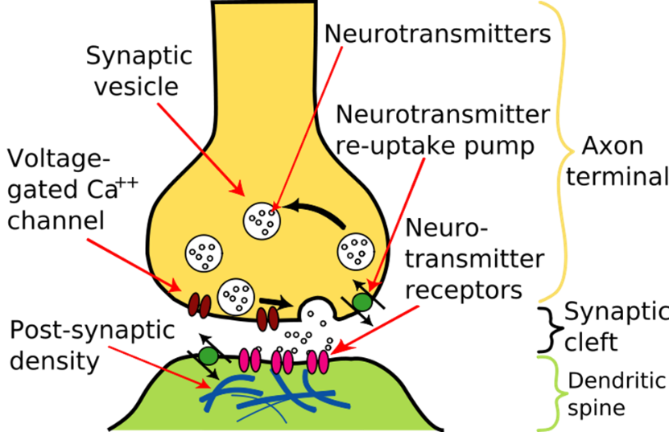
Fig. 4. Schematic diagram of the synapse of a neuron

We can consider the role of the synapses in the time evolution of the membrane potential . Consider two neurons labelled m and n. When neuron m is in its resting state . Let the neuron n be the presynaptic neuron which fires a spike at time t = 0. The response for t > 0 of the postsynaptic neuron m can be expressed as

where the right- hand side of equation 1 defines the postsynaptic potential (PSP). If we have an excitatory postsynaptic potential (EPSP) and if we have an inhibitory postsynaptic potential (IPSP). Figure 5 shows a schematic diagram of the change in the membrane potential caused by a presynaptic excitatory input stimulus using the leaky integrate-and-fire neuron model.

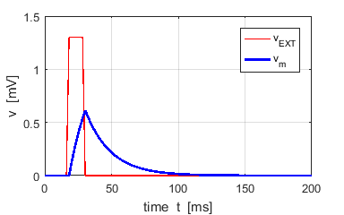
Fig. 5. A neuron receives an external excitatory voltage input stimulus from a set of presynaptic neurons. The membrane potential increases to a voltage less than the threshold voltage v_{TH} = 1.0 mV and then falls to its resting potential . (Leaky integrate-and-fire neuron model)

The neuron m receives a PSP each time the neuron n fires. Also, the neuron m will receive PSPs from not only neuron n but also from many neurons. We assume the total PSP input to neuron m is the sum of the PSPs produced from the repeated firing of many neurons. This linearity however breaks down if too many input spikes arrive during a short interval. Single EPSPs have ~ 1 mV amplitudes and the threshold value for spike initiation is ~ 25 mV above the resting potential. Therefore, about 20-50 presynaptic spikes within a short time window are necessary for the firing of an action potential (short duration voltage pulse with an amplitude ~ +100 mV). After the firing of the action potential, the membrane potential undergoes a phase of hyperpolarization below the resting value called the spike-after-potential (figure 2). The action potential once generated propagates along the axon of the neuron to the synapses of other neurons. Figure 6 shows a schematic diagram of the series of input stimuli that triggers an action potential. Spiking neuron models such as integrate-and-fire model (LIF) model are referred to as Spike Response Models (SRM). Spike Response Models provide are a useful conceptual framework for the analysis of neuronal dynamics and neuronal coding.

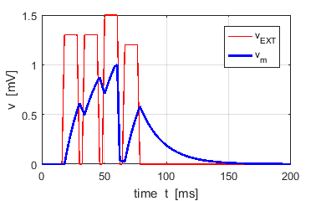
Fig. 6. A schematic diagram for the triggering of an action potential due to the summation of a series of input stimuli from a set of presynaptic neurons. (LIF model only resets the membrane potential to the resting value when the membrane potential reaches the threshold potential).

