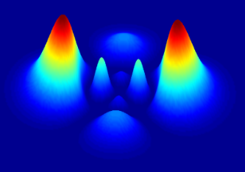

DOING PHYSICS WITH PYTHON

QUANTUM MECHANICS

FDTD

MOTION OF AN ELECTRON IN AN ELECTRIC FIELD
Ian Cooper
matlabvisualphysics@gmail.com

DOWNLOAD DIRECTORY FOR PYTHON SCRIPTS
qmS02A.py Propagation of a Gaussian pulse in a semiconductor. FDTD method is used to solve the [1D] time dependent Schrodinger equation. The simulation time is determined by the number of time steps Nt. The Code is run with different time steps to observe the time evolution of the wavefunction and the energies of the electron.
qmS03A.py Time evolution of the wavepacket and its energies, including the animation of the wavefunction.

GitHub

Google Drive

Finite Difference Time Development method
Motion of an electron in an electric field
We can simulate the propagation of an electron in an n-type semiconductor when an applied constant electric field exists in the material when it is connected to a battery (figure 1)
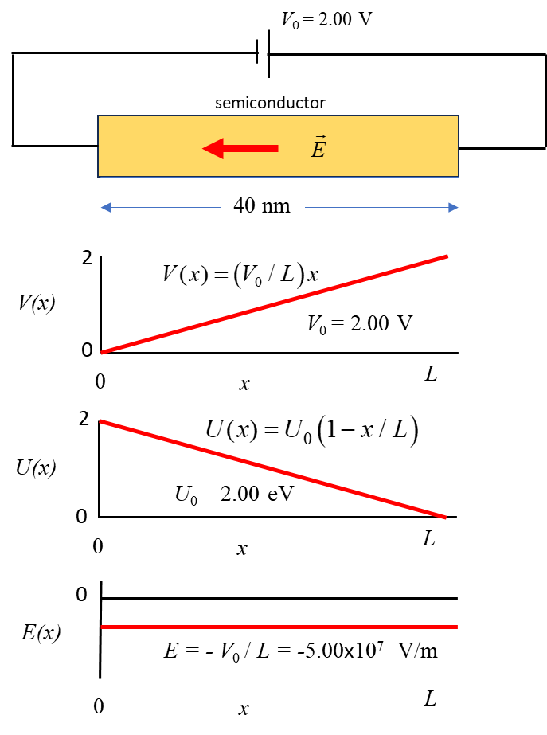

Fig. 1. An n-type semiconductor connected to a battery. The battery creates a potential difference across the semiconductor resulting in electrons within the semiconductor experiencing a constant electric field.
A Gaussian wavepacket is used to present the electron. The parameters for the wavepacket are its wavelength wL, width s and initial center position xC.

Figure 1 shows the relationship between the battery voltage V, potential energy U and electric field . Note that the potential energy is expressed in electron volts (eV) and not in joules (J). However, the potential energy must be in joules when used in the Schrodinger equation which is solved by the FDTD method.

The electric field strength is -5.00x10⁷ V.m⁻¹. This seems like an extremely intense field, but it is not uncommon when we are dealing with very small structures on the nanometer scale.

Simulations
Figure 2 (zero electric field) and figure 3 (non-zero electric field as shown in figure 1) show the results of the simulations using the Code qmS02A.py. The number of time steps is increased manually to show the time evolution for successive time intervals. The Code qmS03A.py gives animated plots for the time evolution of the probability density.

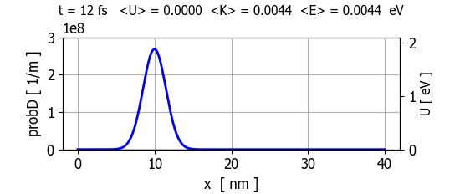
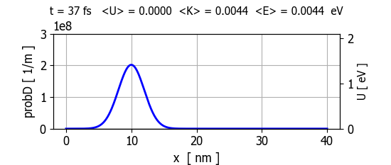
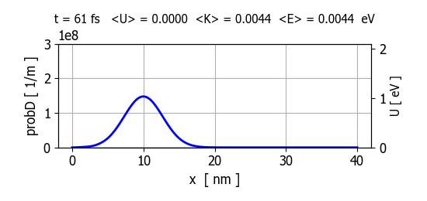
Fig. 2. Electron in zero electric field. The wavepacket representing the electron spreads with time and the location of the electron becomes more and more uncertain.
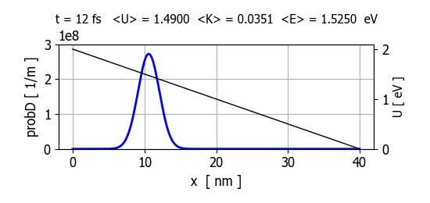
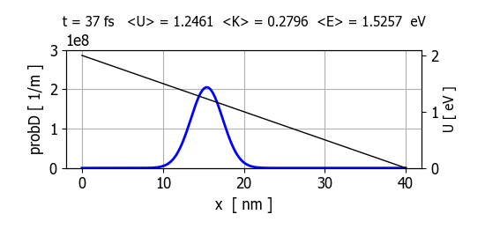
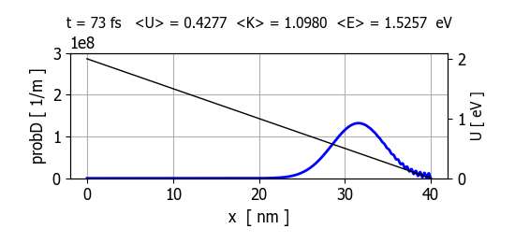
Fig. 3. The electric field acts on the electron to accelerate it towards the lower potential region just like a ball rolling down an incline continually picks up speed. The loss in PE energy is balanced by the gain its KE.
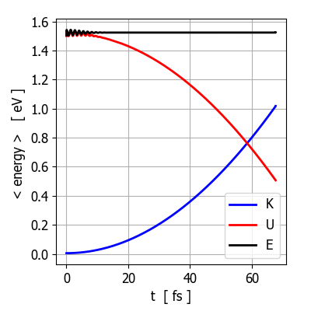
Fig. 4. The time evolution of the total energy E, potential energy U and kinetic energy K of the electron within the semiconductor. The total energy E remains constant while the potential energy U of the system decreases as the kinetic energy K increases. qmS03A.py

ANIMATION (zero electric field)

ANIMATION (non-zero electric field)

Animation creates with the Code qmS03A.py

