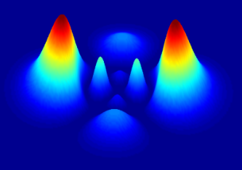

DOING PHYSICS WITH PYTHON

QUANTUM STATISTICS

PROBABILITY DISTRIBUTIONS

M-B B-E F-D

Ian Cooper
matlabvisualphysics@gmail.com

DOWNLOAD DIRECTORY FOR PYTHON CODES
GitHub | Google Drive

PYTHON CODES
qmSM01.py
Simulation of the M-B, B-E and F-D distributions for the placing 6 balls into 8 energy levels 0E, 1E, 2E, … , 8E such that the total energy of the system E_{max} = 8.
qmSM07.py
Equations describing the M-B, B-E and F-D distributions.

INTRODUCTION
In this article, we introduce the laws of statistical physics and discuss systems of particles that obey either classical or quantum mechanics. We will show how a fixed amount of energy may be shared between the particles of a system in thermal equilibrium at an absolute temperature T.

Maxwell-Boltzmann distribution concerns the distribution of a given amount of energy between identical but distinguishable particles. The Maxwell velocity distribution is a special case is the Maxwell-Boltzmann distribution and forms the basis of the kinetic theory of gases and defines the distribution of speeds for a gas at a certain temperature. Classical distribution e.g. ideal gases
- There is no limit on the number of particles and the particles are distinguishable.
- There is no limit on the number of particles per state.
- The total energy of the system is fixed.

Boltzmann distribution gives the probability that a system will be in a certain state as a function of that state's energy and the temperature of the system and applies to designable particles. Classical distribution

Bose-Einstein distribution describes the statistical behavior of integer spin particles (bosons) on the ways in which the particles may occupy a set of available discrete energy states. These particles are indistinguishable and do not obey the Pauli exclusion principle, and there is no limit on the number of particles per quantum state. Quantum distribution e.g. photons
- There is no limit on the number of particles and the particles are indistinguishable.
- There is no limit on the number of particles per state.
- The total energy of the system is fixed.

Fermi-Dirac distribution describes the possible ways in which a system of indistinguishable (fermions: half-integral spin) particles can be distributed among a set of energy states occupied by only one particle. These particles are indistinguishable obeying the Pauli exclusion principle, and there can be no more than one particle per quantum state. Quantum distribution e.g. electrons, protons, and neutrons, all with spin 1/2.
- The particles are indistinguishable.
- There is a limit of 1 particle per state (particles opposite spin can occupy a discrete energy level).
- The total energy of the system is fixed.

To compare differences in the three distributions, we will consider systems for six particles which have a total energy fixed at 8E. Each particle can have energies of 0E, 1E, 2E, 3E, 4E, 5E, 6E, 7E, 8E. Thus, therefore are nine allowed energies levels and 20 macrostates as shown in Table 1 where the numbers in the arrays show the number of particles in an energy level. For example, macrostate 5
3,1,1,0,0,1,0,0,0
Emax = 3(0E) + 1(1E) + 1(2E) + 1(5E) = 8E

The columns labelled MB, BE, FD show the number of microstates for each macrostate. The probability of observing a given macrostate is simply the number of its microstates divided by the total number of microstates.

From the population of the energy states (Table 1), we can compute the relative probability that an energy state is populated for the three probability distributions.

Table 1. qmSM01.py variable macroS
 |  | MB | BE | FD
0 | 5,0,0,0,0,0,0,0,1 | 6 | 1
1 | 4,1,0,0,0,0,0,1,0 | 30 | 1
2 | 4,0,1,0,0,0,1,0,0 | 30 | 1
3 | 3,2,0,0,0,0,1,0,0 | 60 | 1
4 | 4,0,0,1,0,1,0,0,0 | 30 | 1
5 | 3,1,1,0,0,1,0,0,0 | 120 | 1
6 | 2,3,0,0,0,1,0,0,0 | 60 | 1
7 | 4,0,0,0,2,0,0,0,0 | 15 | 1
8 | 3,1,0,1,1,0,0,0,0 | 120 | 1
9 | 3,0,2,0,1,0,0,0,0 | 60 | 1
10 | 2,2,1,0,1,0,0,0,0 | 180 | 1 | 1
11 | 1,4,0,0,1,0,0,0,0 | 30 | 1
12 | 3,0,1,2,0,0,0,0,0 | 60 | 1
13 | 2,2,0,2,0,0,0,0,0 | 90 | 1 | 1
14 | 2,1,2,1,0,0,0,0,0 | 180 | 1 | 1
15 | 1,3,1,1,0,0,0,0,0 | 120 | 1
16 | 0,5,0,1,0,0,0,0,0 | 6 | 1
17 | 2,0,4,0,0,0,0,0,0 | 15 | 1
18 | 1,2,3,0,0,0,0,0,0 | 60 | 1
19 | 0,4,2,0,0,0,0,0,0 | 15 | 1
 | Total microstates | 1287 | 20 | 3

Maxwell-Boltzmann
For the Maxwell-Boltzmann distribution, each of the 20 arrangements can be decomposed into many distinguishable microstates. For example:
Macrostate 1: one particle has energy 8E, therefore the other 5 particles have zero energy. But any one of the 6 particles could have energy 8E, therefore there are 6 microstates for macrostate 1.
Macrostate 2: one particle has energy 7E, so another particle must have energy 1E. Therefore, the number of microstates is (6)(5) = 30 since the any of the 6 particles can have energy 7E and any of the 5 remaining particles can have energy 1E.

We can continue this process, and you will find that there are 20 macrostates and 1287 microstates. The number of microstates for the each of the 20 macrostates is given by
microstates
where N is the total number of particles and n_{i} is the number of particles with energy E_{i}.
Macrostate 1: n₀ = 5 and n₈ = 1 N_{MB} = 6!/[(5!)(1!)] = 6
Macrostate 2: n₀ = 4 and n₇ = 1 N_{MB} = 6!/[(4!)(1!)] = (6)(5) = 30
The probability of observing a given macrostate (probS) is simply the number of its microstates (microS) divided by the total number of microstates (Nmicro).
probS = microS / NmicroS
From Table 1
Nmicro = 1287
Macrostate 5: microS = 120 probS[5] = 120/1287 = 0.0932

We can now calculate the number of particles (nMD) in a given energy state
nMB = zeros(nE)
for c in range(nE):
nMB[c] = sum(macroS[:,c]*probS)

probS
array([0.004662 , 0.02331002, 0.02331002, 0.04662005, 0.02331002, 0.09324009, 0.04662005, 0.01165501, 0.09324009, 0.04662005, 0.13986014, 0.02331002, 0.04662005, 0.06993007, 0.13986014, 0.09324009, 0.004662, 0.01165501, 0.04662005, 0.0116550

For energy state 1
nMB[1] array([0., 1., 0., 2., 0., 1., 3., 0., 1., 0., 2., 4., 0.,
2., 1., 3., 5., 0., 2., 4.])
and the probability of an energy state being occupied is
probMB = nMB/N N = 6
probMB[1] 0.256
probMB array([0.38461538, 0.25641026, 0.16317016,
0.0979021 , 0.05439005, 0.02719503, 0.01165501,
0.003885 , 0.000777 ])

It is much simpler to calculate the probability of an energy state being occupied for both the Bose-Einstein and Fermi-Dirac distributions because there is only a single microstate for each macrostate. The probability of an energy state being occupied is the total number of particles in an energy state divided by the total number of particles in all energy states.

Bose-Einstein distribution: 20 macrostates
120 = 20x6 total number of particles
nBE = np.sum(macroS,axis = 0)
array([49., 31., 18., 9., 6., 3., 2., 1., 1.])
num = np.sum(macroS, axis = None) 6
probBE = nBE/num array([0.40833333, 0.25833333, 0.15,
0.075, 0.05, 0.025, 0.01666667,
0.00833333, 0.00833333])

Fermi-Dirac distribution: 3 macrostates
18 = 3x6 total number of particles
macroFD = zeros([3,nE])
macroFD[0,:] = macroS[10,:]
macroFD[1,:] = macroS[13,:]
macroFD[2,:] = macroS[14,:]
nFD = np.sum(macroFD,axis = 0)
array([6., 5., 3., 3., 1., 0., 0., 0., 0.])
num = 18
probFD = nFD/num array([0.33333333, 0.27777778,
0.16666667,0.16666667, 0.05555556, 0. , 0. , 0. ,
0. ])

The relative probabilities for the occupation of the energy levels are shown in figure 1 for the three distributions. The Bose–Einstein distribution gives results similar, but not identical, to the
Maxwell–Boltzmann distribution. In general, the Bose–Einstein distribution tends to have more particles in the lowest energy levels. At higher energies, the curves come together and both exhibit a rapid decrease in probability with increasing energy. However, the Fermi-Dirac distribution is distinctly different in shape from the Maxwell–Boltzmann or Bose–Einstein curves (figure 1) where the higher energy states are unpopulated.
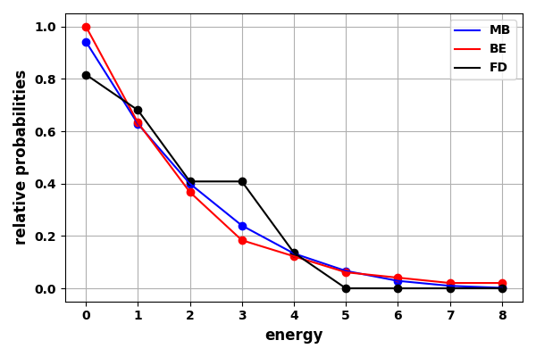
Fig. 1. Relative probability distribution functions for an a system of 6 particles with a total energy of 8E. qmSM01.py

The values of the relative probabilities are displayed in the Console Window.

state probMB_R probBE_R probFD_R
0 0.942 1.000 0.816
1 0.628 0.633 0.680
2 0.400 0.367 0.408
3 0.240 0.184 0.408
4 0.133 0.122 0.136
5 0.067 0.061 0.000
6 0.029 0.041 0.000
7 0.010 0.020 0.000
8 0.002 0.020 0.000

DISTRIBUTION FUNCTIONS
Statistical physics describes the distribution of a fixed amount of energy among a number of particles that are identical and indistinguishable in any way (quantum particles) or identical particles that are distinguishable (classical particles).

For systems described by continuous distributions of energy levels, the number of particles per unit volume with energy between E and E + dE is given by
where g(E) is the density of states (number of energy states per unit
volume in the interval dE) and f(E) is the distribution function and gives the probability that a particle is in the energy state E.

Three distinct distribution functions are used, depending on whether the particles are distinguishable and whether there is a restriction on the number of particles in a given energy state:

Maxwell–Boltzmann Distribution (Classical)
The particles are distinguishable, and there is no limit on the number of particles in a given energy state.

The Maxwell-Boltzmann distribution is shown in figure 2 for temperatures 300 K and 3000 K.
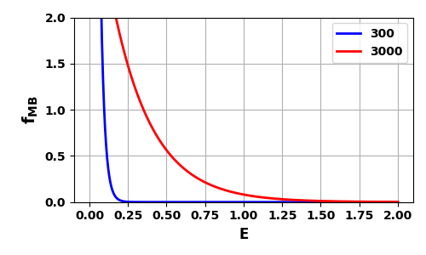
Fig. 2. Maxwell–Boltzmann distribution function at temperatures 300 K and 3000 K. The areas under the curves are normalized to one. qmSM07.py

Bose–Einstein Distribution (Quantum)
The B-E distribution is derived by maximizing the number of ways of distributing the indistinguishable quantum particles among the allowed energy states subject to the three constraints:
- A fixed number of particles
- A total energy
- No constraints on the number of particles in any energy state.
where f(E) is the probability of finding a particle in a particular state of energy E at a given absolute temperature T. The constant B depends upon the temperature and particle density. However, for systems of bosons that are not fixed in numbers with temperature the value of B = 1. Thus, for such systems which include photons and phonons, the B-E distribution can be express as
photons and phonons
The number of particles per unit volume with energy between E and E + dE and the total number of particles per unit volume N/V are given by

The Bose-Einstein distribution is shown in figure 3 for temperatures 300 K and 3000 K. Figure 3 shows that there is a very high probability of finding the bosons in the lowest energy states. This very high probability for bosons to have low energies means that at low temperatures most of the bosons fall into the ground state. When this happens, a new phase of matter with different physical properties may occur. This change of phase is called a Bose–Einstein condensation (BEC). For helium at a temperature below 2.18 K, helium becomes a liquid and is a mixture of the normal liquid and a phase with all molecules in the ground state. The ground state phase, called liquid helium II, exhibits many interesting properties, for example, the viscosity of the liquid is zero.
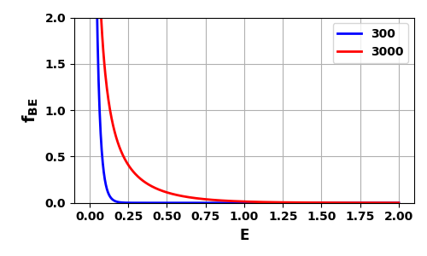
Fig. 3. The Bose-Einstein distribution for temperatures at 300 K and 3000 K. The areas under the curves are normalized to one. qmSM07.py

Fermi–Dirac Distribution (Quantum)
To obtain the Fermi–Dirac distribution we stipulate that only one particle can occupy a given quantum state. Particles that obey the Fermi–Dirac distribution are called fermions and are observed to have half integral spin. Examples of fermions include electrons, protons, and neutrons, all with spin 1/2. The particles are indistinguishable, and there can be no more than one particle per quantum state.

where E_{F} is the Fermi energy. At T = 0 K, all levels below E_{F} are filled and all levels above E_{F} are empty.
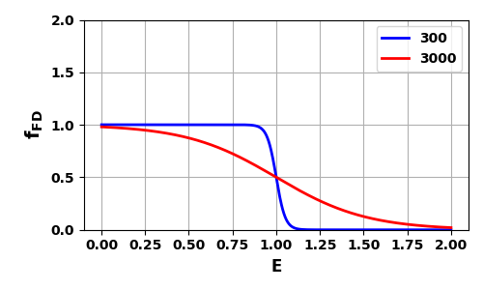
Fig. 4. The Fermi-Dirac distribution for temperatures at 300 K and 3000 K. The areas under the curves are normalized to one. The probability of finding a particle with an energy equal to the Fermi energy is exactly 1/2 at any temperature. qmSM07.py

A comparison of the M-B, B-E, and F-D distribution functions at 3000 K is shown in figure 5. For large energies E, all occupation probabilities decrease to zero exponentially as . For small values of E, the F-D probability saturates at 1 as required by
the Pauli exclusion principle

The M-B probability constantly increases but remains finite, but the B-E probability tends to infinity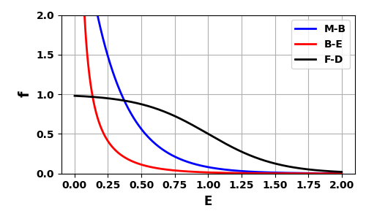
Fig. 5. A comparison of the M-B, B-E, and F-D distribution functions at 3000 K.

The Console Window shows the probabilities for energy less than 0.25 (E < 0.25) being occupied.
Probability E < 0.25 occupied
MB BE FD
0.611 0.945 0.236
The BE distribution is the one that is most populated in the lowest most energy states.

