DOING PHYSICS WITH PYTHON

[2D] NON-LINEAR DYNAMICAL SYSTEMS
HOMOCLINIC BIFURCATIONS
Ian Cooper
matlabvisualphysics@gmail.com

DOWNLOAD DIRECTORIES FOR PYTHON CODE
Google drive GitHub

ds1511.py

A homoclinic bifurcation occurs when a periodic orbit collides with a saddle point, leading to significant changes in the dynamics of a system, often resulting in chaotic behaviour. A homoclinic bifurcation is a type of bifurcation in dynamical systems where a trajectory (orbit) returns to a saddle point in the phase space. Specifically, it involves a homoclinic orbit, which is an orbit that starts and ends at the same saddle equilibrium point. As parameters in the system change, the nature of these orbits can lead to the creation or destruction of periodic orbits, significantly altering the system's dynamics.

Homoclinic bifurcations typically occur in systems with saddle points, where the stable and unstable manifolds of the saddle intersect. This intersection can lead to complex dynamics, including chaotic behaviour. Unlike local bifurcations, which only affect the behaviour near a fixed point, homoclinic bifurcations can have global implications, affecting the entire phase space and leading to changes in the topology of trajectories. At the bifurcation point, the period of the periodic orbit approaches infinity, indicating a transition from periodic to non-periodic behaviour.

In phase portraits, a homoclinic bifurcation can be visualized as a limit cycle colliding with a saddle point, leading to the disappearance of the limit cycle and the emergence of homoclinic orbits. Homoclinic bifurcations are often associated with chaotic dynamics, as they can lead to the creation of infinitely many periodic orbits in the vicinity of the bifurcation point.

Homoclinic bifurcations are crucial in understanding the behaviour of dynamical systems, particularly in the context of chaos and stability. They illustrate how small changes in parameters can lead to significant and often unpredictable changes in system behaviour, making them a key area of study in mathematical and applied sciences.

Consider the example
Fixed points
The fixed points of the system are (-1, 0), (0, 0), and (+1, 0). The fixed point (0, 0) is a saddle and the other two are centres. The phase space orbit is dependent upon the initial conditions (x(0), y(0)).

To study the behaviour of the system, it is best to consider an initial value of r = -0.900 and then run the simulation ds1511.py for small positive increments in r. The phase space orbit depends upon the initial conditions x(0) and y(0), so they have to be chosen with care. The critical value for the bifurcation parameter is rc ~ -0.865. So, we need to consider values of r < r_{c} and r > r_{c}.

r < r_{c}
The fixed points and eigenvalues for r = -0.900 are:
(-1,0) ev = [ 1.02 -2.925] unstable
(0, 0) ev = [ 0.647 -1.547] unstable
(+1, 0) ev = [0.05+0.999j 0.05-0.999j]
oscillations: a stable limit cycle and as r increases,
the limit cycle passes closer to a saddle point at the Origin

r > r_{c}
The fixed points and eigenvalues for r = -0.800 > rc are:
(-1,0) ev = [ 1.052, -2.852] unstable
(0, 0) ev = [ 0.677 -1.477] unstable saddle
(+1, 0) ev = [0.1+0.995j 0.1-0.995j]
the limit cycle swells and breaks the connection to the
fixed point at the Origin and the loop is destroyed into the
saddle, creating a homoclinic orbit.

Graphical analysis
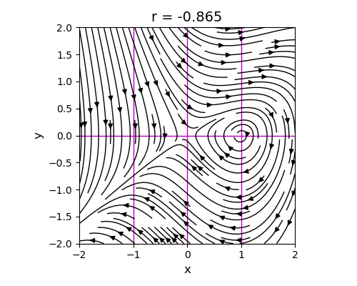
Fig. 1. Phase portrait (streamplot). The magenta lines are the x nullcline (horizontal) and the y nullclines (vertical).

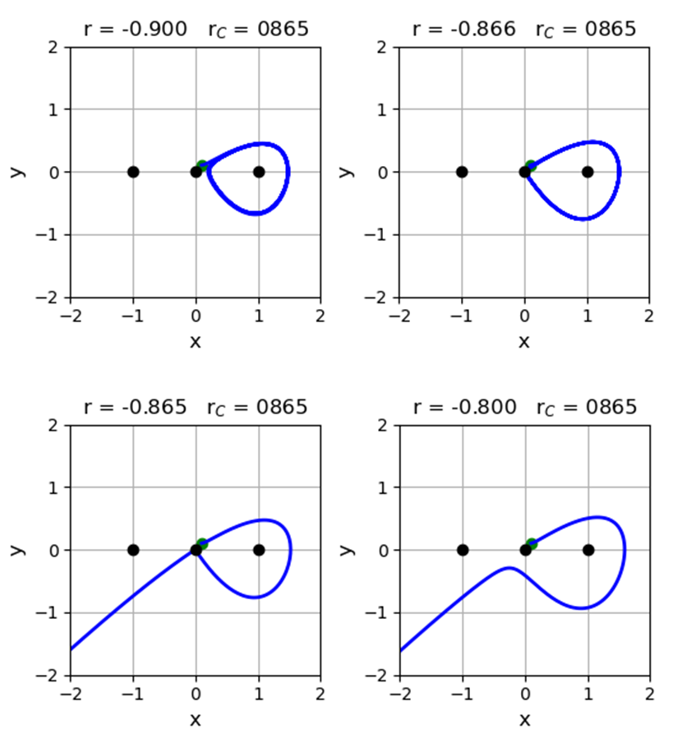
Fig. 2. Trajectories in phase space. For trajectories with r > r_{C}, the trajectories will diverge to infinity.

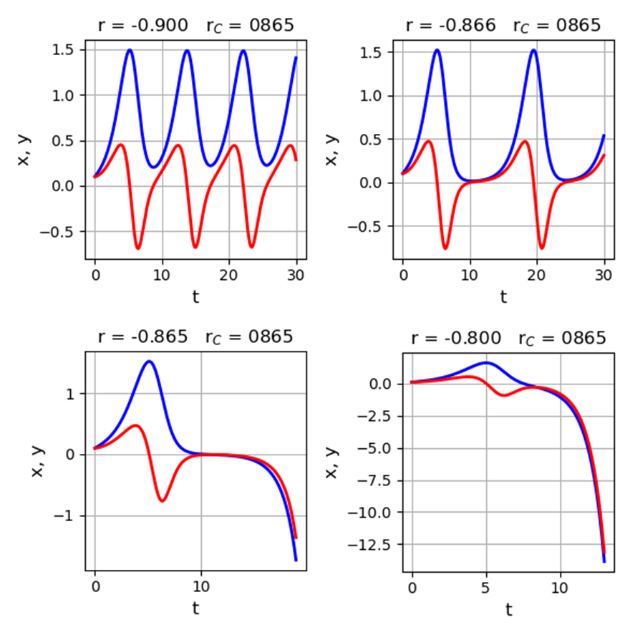
Fig. 3. x and y time evolution of trajectories.

The key to this bifurcation is the behaviour of the unstable manifold of the saddle. Look at the branch of the unstable manifold that leaves the Origin: after it loops around, it either hits the Origin veers off
to one side or the other.

