DOING PHYSICS WITH PYTHON

QUANTUM MECHANICS
HYDROGEN LIKE SPECIES
He⁺ Li⁺⁺ Li
Ian Cooper
matlabvisualphysics@gmail.com

DOWNLOAD DIRECTORY FOR PYTHON SCRIPTS
qmH01.py Solution to the [3D] Schrodinger equation for the hydrogen like species: eigenvalues and eigenfunctions

GitHub

Google Drive

SINGLE ELECTRON SPECIES: H, He⁺, Li⁺⁺, Li

Both the helium ion He⁺, lithium ion Li⁺⁺, and Li (valence electron) can be modelled as single electron atoms. In the modelling the mass of the electron is used and not the reduced mass of the electron and nucleus. The only variable that needs to be change from the hydrogen simulations is the atomic number:
Z(H) = 1 Z(He⁺) = 2 Z(Li⁺⁺) = 3.

In each case, the shapes of the wavefunction for all combinations of n, l and m_{l} are the same since all three species can be modelled as single electron.

The main differences between the three species are the binding energies E_{Bn} of the electron (E_{Bn} = -E_{n}), the expectation radii, and peak probability density radii r_{Peak}.

The Bohr model gives for the binding energies of the electron and the radii for the allowed stable circular orbits of the electron in single electron species.

The Python Code qmH01.py can be used to computed the binding energies, expectation values for the radius and the radii for the peak in the probability density function.

Warning: have to be careful with array indices since n > l. For example, if l = 2, the first elements in the arrays for the eigenvalues and eigenvalues will be for the state n = 3.

Hydrogen H Z = 1
Input parameters and Console display when l = 0 for Bohr predictions and simulation results:
grid point N = 999
Z = 1
rMax = 5.0 nm
ang. mom. quantum no. L = 0
magnetic quantum no. mL = 0

Energy [eV] separation [nm]
State n EBohr Esim rBohr
1 13.598 13.567 0.053
2 3.399 3.398 0.212
3 1.511 1.510 0.477
4 0.850 0.850 0.847
5 0.544 0.544 1.324
6 0.378 0.376 1.906
7 0.278 0.250 2.594
8 0.212 0.095 3.389
Good agreement for states 1 to 6. For better accuracy need to increase rMax.

- The energy eigenvalues E only depend upon n and are independent of l and m_{l}.
- The expectation value < r > and the r value for the peak in the in the probability are dependent upon both n and l but not m_{l}

H Simulations for states with n = 3
Eigenstate: n = 3 L = 0 mL = 0
rMax = 5.0 nm
EBohr = 1.511 eV rBohr = 0.477 nm
EB = 1.510 eV rPeak = 0.691 nm <r> = 0.715 nm

Eigenstate: n = 3 L = 1 mL = 0
rMax = 5.0 nm
EBohr = 1.511 eV rBohr = 0.477 nm
EB = 1.511 eV rPeak = 0.636 nm <r> = 0.662 nm

Eigenstate: n = 3 L = 2 mL = 1
rMax = 5.0 nm
EBohr = 1.511 eV rBohr = 0.477 nm
EB = 1.511 eV rPeak = 0.476 nm <r> = 0.556 nm

Note: In the three cases, only when l = 2, that is , l_{max} = n-1 does the maximum in the probability density occur at the Bohr radius .
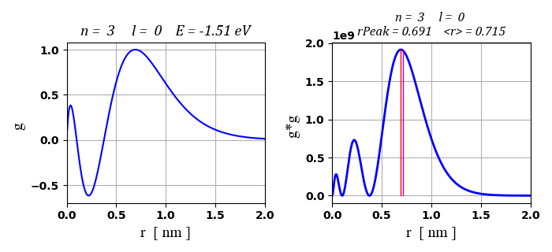
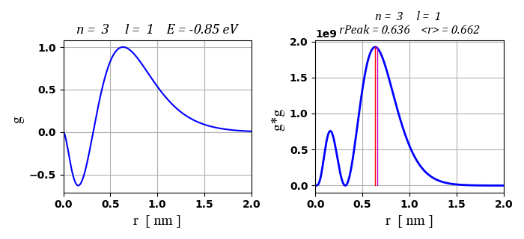
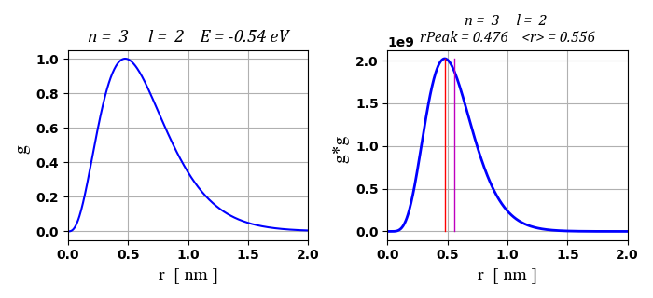
Fig. 1. Eigenfunctions and probability density for n = 3. The number of peaks in the probability density is equal to (n – l).
Helium He⁺ Z = 2
Input parameters and Console display when l = 0 for Bohr predictions and simulation results:
Z = 2 rMax = 2.0 nm
ang. mom. quantum no. L = 0
magnetic quantum no. mL = 0
Energy [eV] separation [nm]
State n EBohr Esim rBohr
1 54.391 54.313 0.026
2 13.598 13.593 0.106
3 6.043 6.042 0.238
4 3.399 3.399 0.424
5 2.176 2.174 0.662
6 1.511 1.427 0.953
7 1.110 0.601 1.297

Good agreement for states 1 to 5. For better accuracy need to increase rMax for higher states.
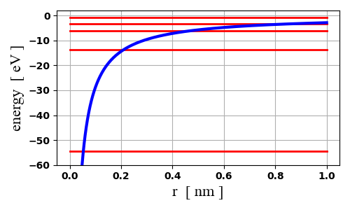
Fig. 2. Energy level diagram for He⁺.
He⁺ Simulations for with n = 3

Eigenstate: n = 3 L = 0 mL = 0
rMax = 2.0 nm
EBohr = 6.043 eV rBohr = 0.238 nm
EB = 6.042 eV rPeak = 0.347 nm <r> = 0.357 nm

Eigenstate: n = 3 L = 1 mL = 0
rMax = 2.0 nm
EBohr = 6.043 eV rBohr = 0.238 nm
EB = 6.044 eV rPeak = 0.319 nm <r> = 0.331 nm

Eigenstate: n = 3 L = 2 mL = 0
rMax = 2.0 nm
EBohr = 6.043 eV rBohr = 0.238 nm
EB = 6.043 eV rPeak = 0.238 nm <r> = 0.278 nm

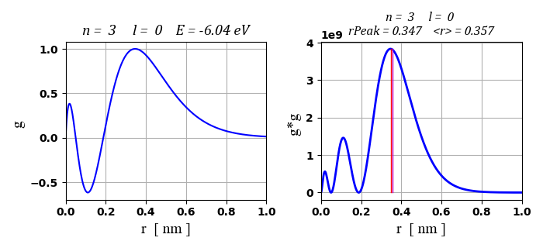
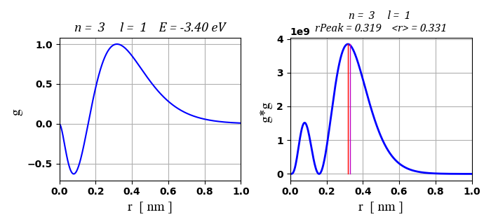
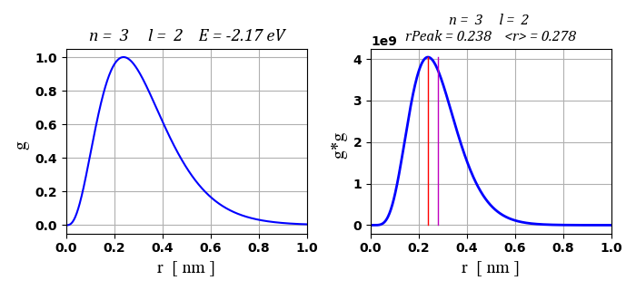
Fig. 3. He⁺ Eigenfunctions and probability density for n = 3. The number of peaks in the probability density is equal to (n – l). The He⁺ plots are the same as H plots except for the length scaling of the radius.
Lithium Li⁺⁺ Z = 3
Input parameters and Console display when l = 0 for Bohr predictions and simulation results:
Z = 3 Energy [eV] separation [nm]
State n EBohr Esim rBohr
1 122.379 122.316 0.018
2 30.595 30.591 0.071
3 13.598 13.597 0.159
4 7.649 7.606 0.282
5 4.895 3.857 0.441

The measured value for the 3rd ionization energy of lithium is 122 eV which is in excellent agreement with the modelling predications.

Successive ionization energies for the lithium atom:
1st 5.3917 eV 2nd 75.64 eV 3rd 122.45 eV

Li⁺⁺ Simulations for with n = 3

Eigenstate: Z = 3 n = 3 L = 0 mL = 0
rMax = 0.8 nm
EBohr = 13.598 eV rBohr = 0.159 nm

Eigenstate: Z = 3 n = 3 L = 1 mL = 0
rMax = 0.8 nm
EBohr = 13.598 eV rBohr = 0.159 nm
EB = 13.598 eV rPeak = 0.212 nm <r> = 0.221 nm

Eigenstate: Z = 3 n = 3 L = 2 mL = 0
rMax = 0.8 nm
EBohr = 13.598 eV rBohr = 0.159 nm
EB = 13.598 eV rPeak = 0.159 nm <r> = 0.185 nm
Neutral lithium atom Li
The lithium atom (Z = 3) has a nucleus containing three protons and surrounding it are three electrons. The electronic configuration of lithium in its ground state is 1s² 2s¹. The inner two most electrons are tightly bound to the nucleus in a complete shell. However, the single 2s electron is only weakly bound. This 2s electron can be easily removed from the atom (very low ionization energy).

So, we can model the neutral lithium atom in a similar manner to the hydrogen atom. The single 2s electron is bound to a +3 charged nucleus but this electron is screened from the nucleus by the two 1s electrons of total charge -2. In a simple model, we can use an effective Z_{eff} value to account for the nuclear charge and the screening effect for the two inner most electrons in running our simulation. For the outer most valence electron, the ground state is 2s and the higher states are 2p, 3s, 3p, 3d, 4s, 4p, 4d, 4f, … . There is also some electron-electron repulsion, but this is generally not significant.

In running the simulations, the goal is to find the value of effective nucleus charge given by Z_{eff} by a trial-and-error approach by matching the computed binding energy for a state with the accepted value.

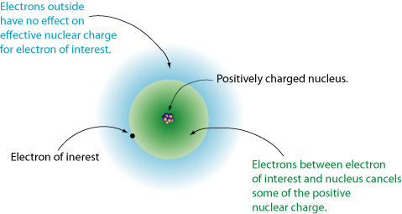
Fig. 4. The valence electron is screened from the full effects of the charge on the nucleus.

Table 1 gives a summary of how the energy levels depend upon the principal quantum number and the orbital quantum number for the neutral lithium atom. A comparison is made between the experimental determine energy levels and the energy levels predicted by adjusting the effective nuclear charge that would be experienced by the valance electron. The Code qmH01.py calculates the probability of locating the valance electron within a distance of the Bohr radius a₀ from the nucleus.

Table 1 Screening effects of the two inner most electrons.
State | Lithium  E_{B} (eV)  experiment | Lithium  E_{B} (eV)  simulation | Z_{eff}  sim | prob  r < a0 | rMax  [nm]
1s
2s | 5.39 | 5.40 | 1.260 | 3.22 | 2
2p | 3.54 | 3.54 | 1.020 | 0.32 | 2
3s | 2.02 | 2.01 | 1.155 | 0.94 | 2
3p | 1.58 | 1.57 | 1.020 | 0.11 | 2
3d | 1.51 | 1.51 | 1.000 | 0.00 | 2
4s | 1.05 | 1.05 | 1.113 | 0.38 | 3
4p | 0.87 | 0.87 | 1.010 | 0.05 | 4
4d | 0.85 | 0.85 | 1.002 | 0.00 | 4
4f | 0.85 | 0.85 | 1.000 | 0.00 | 4

The greater overlap of the valence electron with the two 1s electrons in lithium, then the screening is less, thus the greater binding energy of the valence electron as shown in figure 5. We see that there is a greater overlap between the orbitals for the two 1s electrons and the 2s orbital compared with the 2p orbital and so for 2p electron there is greater shielding. This is best illustrated by considering the probability of locating the valance electron within a distance of the Bohr radius a₀ from the nucleus. This accounts for the large energy gap between the 2s and 2p energy levels.
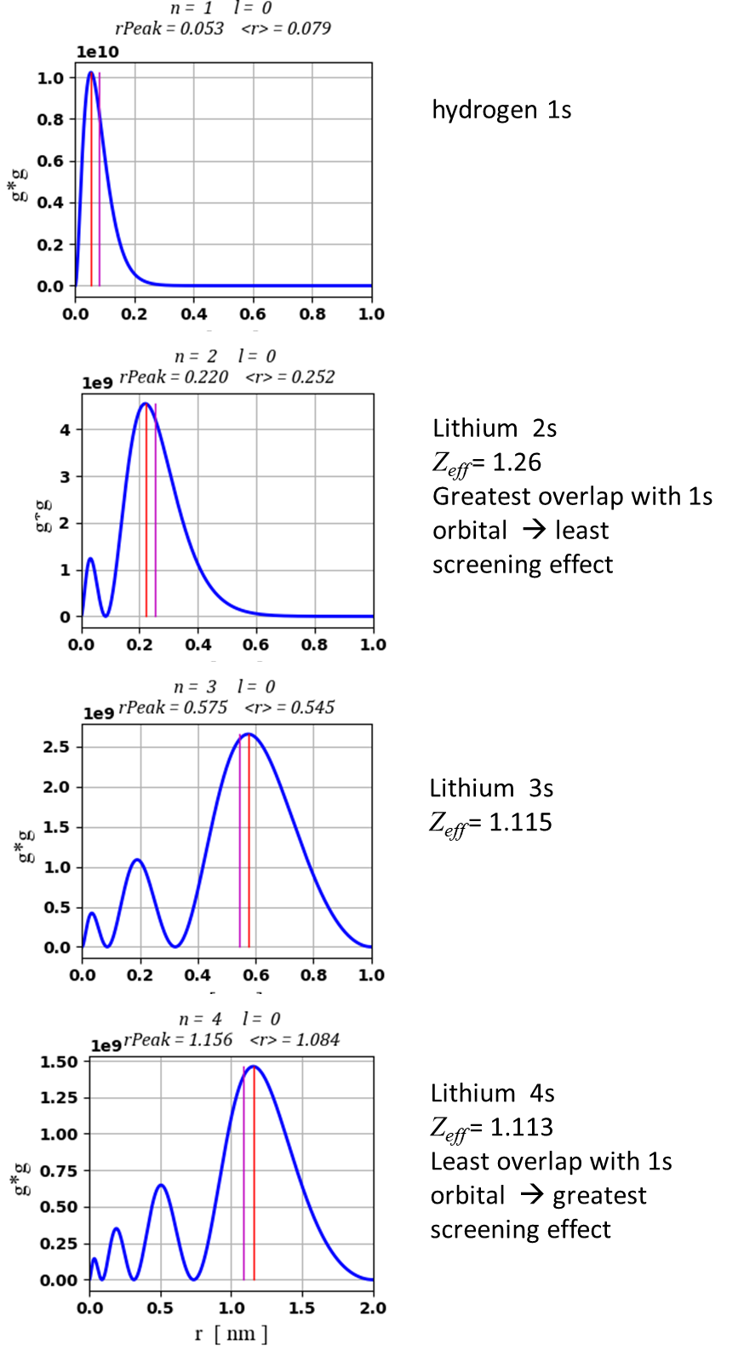
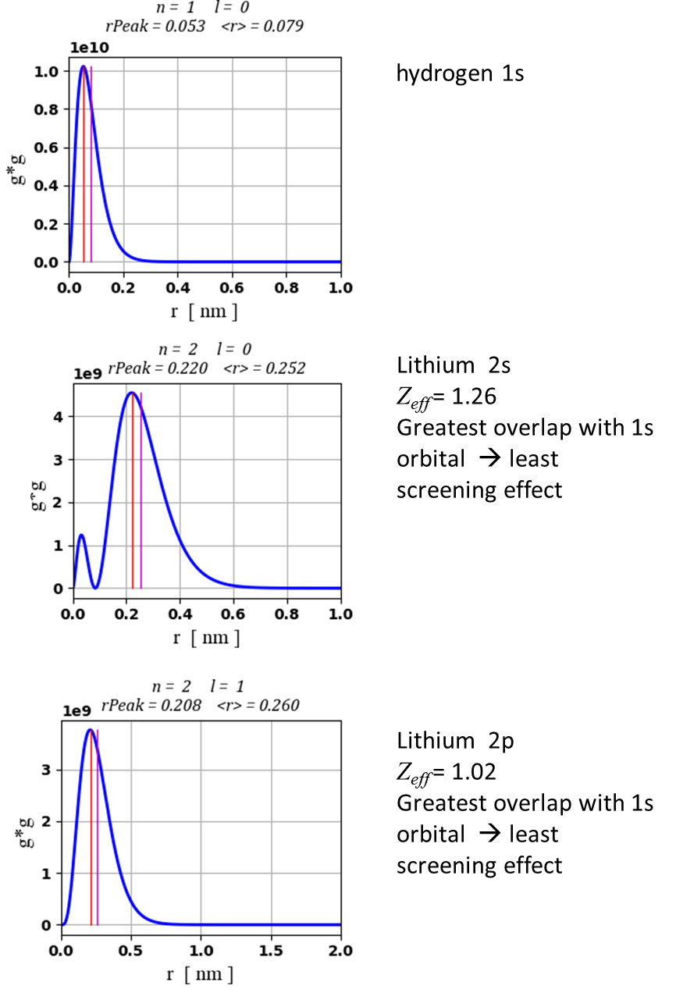
Fig. 5. Probability density for different states.

The probability of finding the 3d electron inside the core is small, for a 3p electron the probability is slightly larger and for the 3s electron it is much larger still. Clearly, for an electron inside the core the effective nuclear charge is substantially greater than for an electron outside for which Z_{eff} ≈ 1. If the electron lies within the stronger field, there is a greater coulomb attraction, hence, its associated binding energy is expected to be greater.

The order of the shielding effects is:
2s < 2p 3s < 3p < 3d 4s < 4p < 4d < 4f

So. the binding energies are order as:
2s > 2p 3s > 3p > 3d 4s > 4p > 4d > 4f

That is, for a given principal quantum number n, the states of higher angular momentum (higher l) have lower binding energies than those of smaller angular momentum in multi-electron atoms.

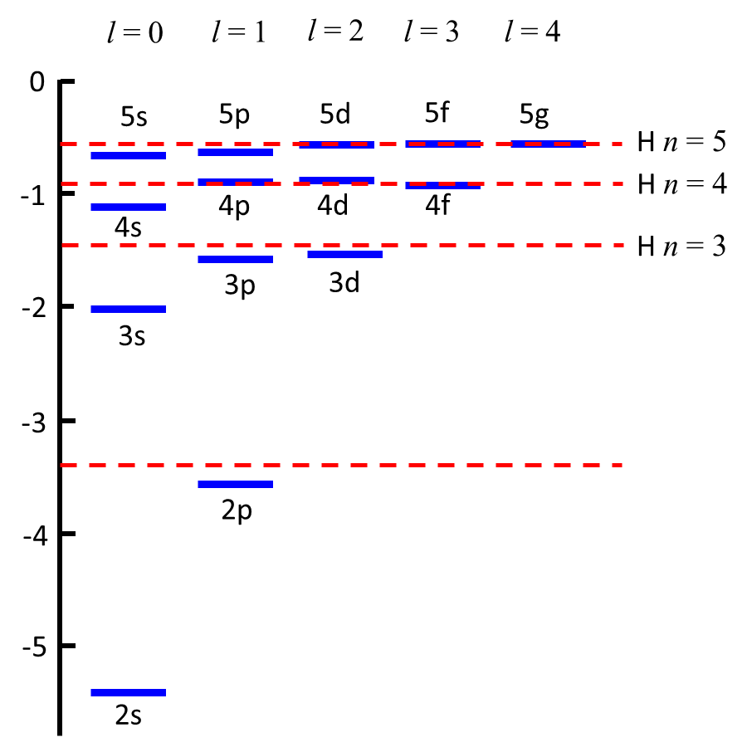
Fig. 6. Schematic energy level diagram for valance electron of a lithium atom. The red dashes show the energy levels for hydrogen.

