DOING PHYSICS WITH PYTHON

COMPUTATIONAL NEUROSCIENCE
IZHIKEVICH MODEL FOR SPIKING NEURON NETWORKS
Ian Cooper
Any comments, suggestions or corrections, please email me at
matlabvisualphysics@gmail.com

DOWNLOAD DIRECTORIES FOR PYTHON CODE
Google drive GitHub

mnsIZH03.py

INTRODUCTION
A spiking neural network (SNN) simulation using the Izhikevich neuron model in Python is discussed below. Spiking neural networks (SNNs) represent a class of artificial neural networks that closely emulate the neuronal dynamics observed in the biological brain. Neurons within an SNN communicate via discrete spikes, firing only when their membrane potential exceeds a specific threshold. This spike-based communication is event-driven, mirroring the way biological neurons interact.

The Izhikevich model for a neuron can be used to simulate a sparse network of ~10³ spiking cortical neurons with ~10⁶ synaptic connections. Based upon the anatomy of a mammalian cortex, ratio of excitatory to inhibitory neurons is taken to be 4 to 1 with inhibitory synaptic connections stronger than the excitatory synaptic connections.

Broadly speaking, we can distinguish between neurons as excitatory and inhibitory. When excitatory neurons fire action potential, other neurons also increase their activity. Inhibitory neurons, when fired, actually decrease the activity of other neurons they are connected to, maintaining the stability of neural circuit.

Regular spiking cells are used to model all excitatory neurons and fast spiking neurons for the inhibitory neurons.

Also, each neuron receives a noisy thalamic input (presynaptic input into areas of the cerebral cortex from the thalamus). All neurons have different dynamics for heterogeneity. This is done by assigning to each neuron a range of values for the parameters a, b, c and d using the uniformly distributed variables r_{e} and r_{i} which vary from 0 to 1.

The time evolution of the membrane potential v and the recovery variable u are described in terms of the differential equations
(2)

The after-spike resetting relationship is
(3)

Input current stimulus I(t) in the network is a critical component that drives neuronal activity. It is composed of external inputs and the synaptic currents derived from other neurons within the network. Each neuron’s input current is calculated by summing the products of the synaptic weights S and the membrane potentials v of all presynaptic neurons:

where
is the total input current to neuron i at time t
represents external inputs to neuron, which could include random noise or specific stimuli patterns

is the synaptic weight from neuron j to neuron i
is the membrane potential of the presynaptic neuron
N is the total number of neurons in the network.

Table 1. Dimensions, values (typical) and units.
Parameter | Unit | Description
t | ms | time
v | mV | membrane potential
dv/dt | mV.ms⁻¹ | time rate of change in membrane potential
u | mV | recovery variable
I | A | synaptic current or injected DC-current
c₁ = 0.04 mV⁻¹.ms⁻¹ c₂ = 5 ms⁻¹ c₃ = 140 mV.ms⁻¹
c₄ = 1.0 ms⁻¹ c₅ = 1.0 mV.ms⁻¹.A⁻¹
External current stimulus: step input height I₀
I_{ext} = c₅ I mV.ms⁻¹
a ~ 0.02 ms⁻¹ determines the time scale of the recovery variable u. The larger the value of a the quicker the recovery.
b ~ 0.20 [dimensionless] describes the sensitivity of the recovery variable u to the subthreshold fluctuations of the membrane potential v. Large values of b couple u and v more strongly resulting in possible subthreshold oscillations and low-threshold spiking dynamics.
c ~ -65 mV gives the after-spike reset value of the membrane potential v caused by the fast high-threshold K⁺ conductances.
d ~ 6 mV describes after-spike reset of the recovery variable u caused by slow high-threshold Na⁺ and K⁺ conductances.

Various choices of the parameters a, b, c and d result in the various intrinsic firing patterns. In order to make the simulation more realistic, we will also consider two types of neurons in our network: excitatory (N_{e}) and inhibitory neurons (N_{i}). We will implement these neurons types in such a way, that they differ in their intrinsic properties, such as the parameters a, b, c, and d of the Izhikevich model. We achieve this by adding for each neuron of each type a random value to the respective parameter. By assigning different parameter values to these neuron types, we can capture the diverse spiking behaviours observed in biological neural networks.

Excitatory cells (regular spiking cells and chattering cells)
a = 0.02 b = 0.20
Bias distribution: variations in c and d
c = - 65 + 15 r_{e}² d = 8 – 6 r_{e}²
r_{e} = 0 corresponds to regular spiking cell
r_{e} = 1 corresponds to the chattering cell
Regular spiking cells: c = -65 d = 8
Chattering cells c = -50 d = 2

Inhibitory cells (fast spiking cells)
c = -65 d = 2.0
Fast Spiking cells: variations in a and b
a = 0.02 + 0.08 r_{i} b = 0.25 - 0.05 r_{i}

In order to simulate a network of Izhikevich neurons, we need to extend this model to multiple neurons and define the synaptic connections between them. The network structure can be represented by a connectivity matrix S where S_{ij} denotes the synaptic weight from a presynaptic neuron j to a postsynaptic neuron i.

- Positive values (S_{ij} > 0) indicate excitatory synaptic connections, meaning that the presynaptic neuron’s firing tends to increase the postsynaptic neuron’s membrane potential, making it more likely to fire.
- Negative values (S_{ij} < 0) indicate inhibitory synaptic connections, where the presynaptic neuron’s firing reduces the postsynaptic neuron’s likelihood of firing by lowering its membrane potential.

This connectivity matrix S not only determines the presence and absence of synaptic connections but also quantifies their strength, profoundly influencing the network dynamics. The overall behaviour of the network – such as its ability to exhibit patterns like synchronization, oscillations, or even chaotic activity – depends on the layout and weights of these connections.

In our simulation, we will initialize the synaptic weights randomly, reflecting the diverse connectivity patterns observed in biological neural networks. The overall behaviour of the network, such as its ability to exhibit patterns like synchronization, oscillations, or even chaotic activity depends on the layout and weights of these connections.

SIMULATIONS
The Python Code mnsIZH03.py simulates a network with ~800 excitatory and ~200 inhibitory neurons which reflects the common ratio of excitatory to inhibitory neurons in the mammalian cortex (4:1).

Simulation 1
Model parameters (default values) and Code:
a = 0.02*ones((N,1)) b = 0.20*ones((N,1))
c = -65*ones((N,1)) d = 2.0*ones((N,1))
# Biases random number 0 to 1
np.random.seed(0) re = np.random.rand(Ne,1)
ri = np.random.rand(Ni,1)
# modified coefficients
a[Ne:N] = 0.02 + 0.08*ri b[Ne:N] = 0.25 - 0.05*ri
c[0:Ne] = -65 + 15*re**2 d[0:Ne] = 8 - 6*re**2
# Stimulus matrix
S = zeros((N,N)) S1, S2 = 0.5, -1
S[:,0:Ne] = S1 * np.random.rand(Ne+Ni, Ne)
S[:,Ne:N] = S2*np.random.rand(Ne+Ni, Ni)
# Input current
I[0:Ne] = 5 * np.random.randn(Ne, 1)
I[Ne:N] = 2 * np.random.randn(Ni, 1)
# Sum synaptic contributions for fired neurons in previous time
step
I += np.sum(S[:, fired], axis=1).reshape(-1, 1)

Figure 1 shows activity of all the neurons that fired action potential at each time step, the percentage of neurons that produce a spike each time step, and the time evolution of a typical excitatory and inhibitory neuron. Figure 2 is a plot of the current stimulus for each neuron at each time step. Another time evolution plot of the mebrane potential for an excitatory neuron and an inhibitory neuron is shown in figure 3 and the time evolution of the recovery variable in figure 4. Figure 5 shows the power spectral density for the percentage of spikes function.

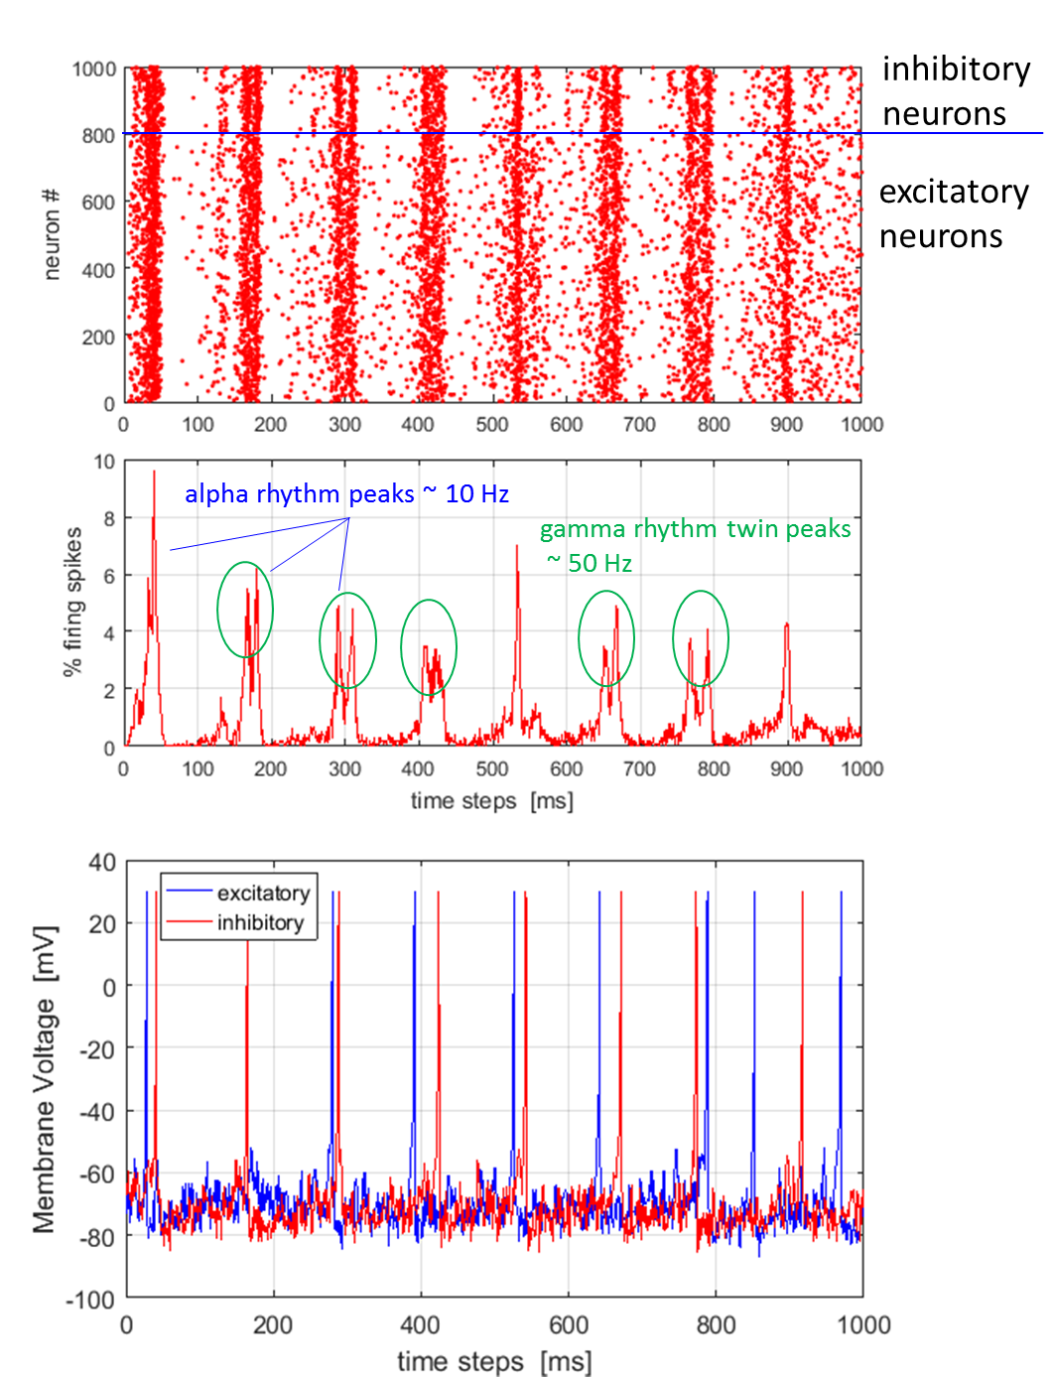
Fig. 1. Network of 10³ randomly coupled spiking neurons (800 excitatory and 200 inhibitory) with 10⁶ synaptic connections. Top: spike-train raster plot shows episodes of alpha rhythms (single widely spaced peaks) and gamma band rhythms (double closely spaced peaks). Bottom: Typical spiking activity of an excitatory neuron and an inhibitory neuron (peaks normalized to +30 mV).
What we can occasionally observe in the plots, a synchronous firing pattern emerging in the network, where groups of neurons fire together in a coordinated manner. These episodes repeat with a frequency of about 10 Hz and about 40 Hz (remaining peaks). This behavior is associated with the firing patterns of the brain’s alpha and gamma oscillations, respectively (figure 5). Between these episodes, the network exhibits a more irregular, Poisson-like firing pattern. The observed firing patterns demonstrate the network’s ability to exhibit complex spiking dynamics, even though the neurons in the network are connected randomly and no synaptic plasticity rules are implemented. The neurons organize themselves into synchronous firing patterns or assemblies, exhibiting a collective rhythmic behavior. This rhythmic behavior corresponds to that of the mammalian cortex in awake states.

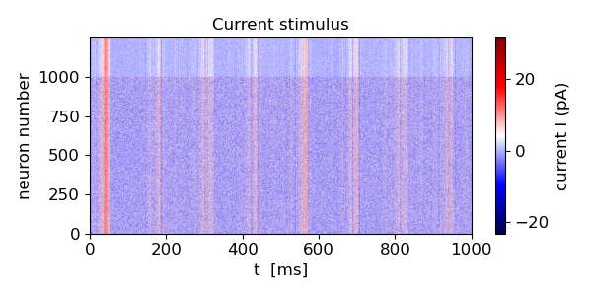
Fig. 2. Neuron current stimulus.
We can see in figure 2, how the inputs currents of the neuron peak synchronously with the observed clusters of spiking events. This synchronous behavior is a result of the network’s connectivity and the synaptic weights between the neurons. In our model, the input current I for each neuron includes contributions from the spikes of other neurons, as defined by the connectivity matrix S. This means that when a neuron fires as its membrane potential v surpasses a threshold value and this influences the input currents of other neurons according to the synaptic weights . > 0, (excitatory connection), it will increase the input current I_{i} of neuron i when neuron j spikes. If < 0, (inhibitory connection), it will decrease I_{i} .

If there are episodes of synchronous firing, where many neurons fire nearly simultaneously, these spiking events contribute collectively to significant peaks in the input currents of neurons connected to them. And this exactly what we observe in the figure 2. This synchronous behavior between spikes and input currents is an important aspect of how neural networks function, both in biological and artificial contexts. It underscores the interconnected nature of neurons, where the action of one neuron can influence many others, leading to complex behaviors such as oscillations, waves of activity, and even synchronized firing patterns seen in various neural processes and disorders.
The membrane potential and recovery variable time evolumtion plots of one exemplary excitatory neuron (blue) and an inhibitory neuron (red) in the network are shown in figures 3 and 4.:
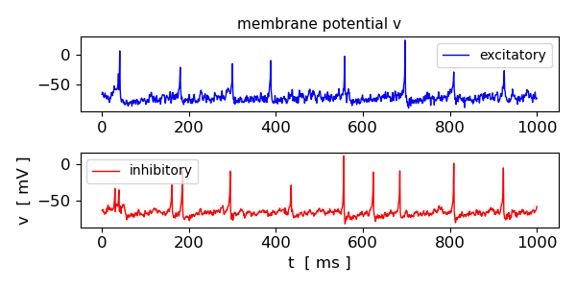
Fig. 3. Time evolution of the mebrane potential for an excitatory neuron and an inhibitory neuron.

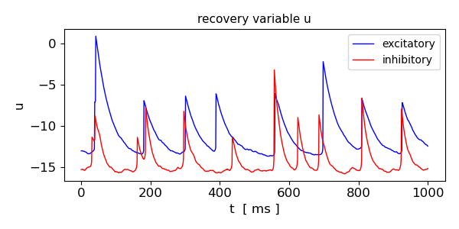
Fig. 4. Time evolution of the recovery variable for an excitatory neuron and an inhibitory neuron.

Figures 4 and 5 show Poisson-like spiking patterns of both neuron types along with distinct spiking events that correlate with the spiking clusters within the network. The recovery variable u of the inhibitory neuron exhibits a different behavior with lower amplitudes compared to the excitatory neuron. This difference in the recovery variable dynamics is a result of the different parameter values assigned to the two neuron types, reflecting the ability to assign diverse spiking behaviors to different neuron populations in the network.

The Foureir transform of the number of firings at each time step is shown in figure 5. Figure 5 shows a distinct each near 8 Hz which may correspond to the episodes of the alpha rhythms. However, the Fourier transform does not indicate the gamma rythym oscillations.
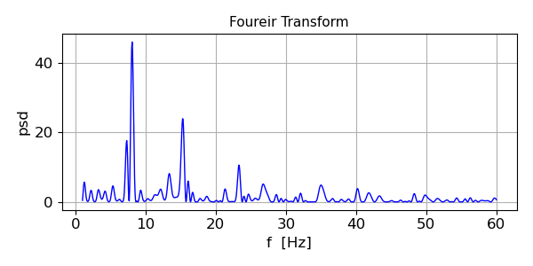
Fig. 5. Power spectrum density (psd): Fourier transform of the number of firings at each time step.

Neural activity in the neocortex is highly irregular and the origin of this irregular activity may be in the tight balance between excitatory and inhibitory synaptic inputs. Highly fluctuating net input currents whose means are below threshold results in action potentials being generated by the fluctuations. Neural activity in this state is chaotic in the sense that slight changes in initial conditions leads to drastically different patterns of spike times. The network of neurons in the asynchronous state displays activity that looks random where the firing rate at which action potentials are emitted stochastically.

Figure 1 shows that the network exhibits cortical-like asynchronous dynamics. The neurons self-organize into assemblies in which different neurons asynchronously emit action potentials and they exhibit collective rhythmic behaviour in the frequency range corresponding to that of the mammalian cortex in the awake state and although the network is connected randomly and there is no synaptic plasticity. The alpha rhythm corresponds to the normal bursts of electrical activity within the frequency range from 8 to 13 Hz in the cerebral cortex of a drowsy or inactive person. The gamma rhythm is the burst of electrical activity at higher frequencies than the alpha rhythm within a frequency between 25 and 100 Hz with 40 Hz a typical value.

A neuron network is a group of neurons that synapse and associate with one another to collectively perform a specific function or task. One important feature of the plots derived from the neuron network simulations is the difference between its dense and sparse regions. At the denser regions, where a distinct vertical line can be seen, a majority of the neurons will fire at the same time. Within the sparser regions, individual neurons do not tend to collectively fire, leading to a very random looking output pattern. Notice that denser areas do not occur frequently, or for much longer after the initial stimulation is given to the network. These regions actually correspond to alpha brain waves, which range in frequency from 8-12 Hz. These wave types are usually present when an individual is performing a task that requires a moderate amount of effort or attention. On the other hand, the sparse regions where neurons activate more often, are representative of gamma brain waves, ranging from 30-90 Hz. These occur when an individual performs cognitive and motor tasks that require a large deal of energy and focus. The type of brain waves a neuron network exhibit can tell a great deal about the function and
behaviour of that particular network.

Ostojic (2014) concluded from his modelling of sparsely connected network of spiking neurons of excitatory and inhibitory leaky integrate-and-fire (LIF) neurons that they can display two different types of asynchronous activity when at rest:
- For weak overall synaptic couplings and/or strong inhibition, the network is in the well-known asynchronous state, in which individual neurons fire irregularly at rates that are constant in time.
- For overall synaptic couplings that are strong and/or inhibition is just strong enough to balance excitation, a new type of resting state emerges. In that state the neurons still fire irregularly and asynchronously, but the firing rates of individual neurons fluctuate strongly in time and across neurons. This new state is called the heterogeneous asynchronous state.

Ostojic: “The two regimes of spontaneous asynchronous activity have different computational properties, as seen in their responses to temporally varying inputs. In the classical asynchronous state, the responses of different neurons are highly redundant, which favours a reliable transmission of information but limits the capacity of the network to perform nonlinear computations on the stimuli. In the heterogeneous asynchronous state, the responses of different neurons to the input instead strongly vary. This variability in the population degrades the transmission of information but provides a rich substrate for a nonlinear processing of the stimuli, as performed, for instance, in decision-making and categorization.”
Simulation 2 Altering the connectivity S within the network
Strong excitatory and strong inhibitory synaptic weights
By altering the synaptic weights in the connectivity matrix S, we can observe how the network dynamics change and generate
different spiking patterns.
S1, S2 = 0.60, -1.6 # 2
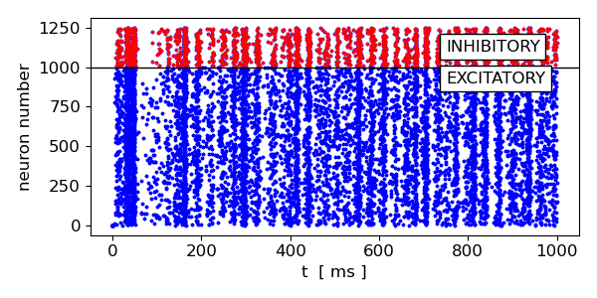

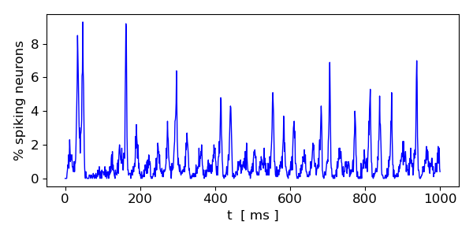
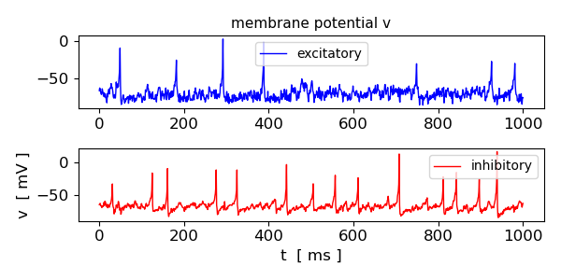
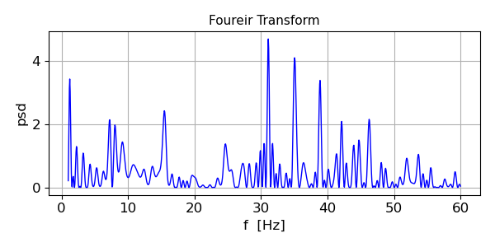
By increasing both the excitatory and inhibitory synaptic weights, we observe a more synchronized firing pattern in the network. This synchronous behaviour is due to the stronger synaptic connections, which lead to more pronounced interactions between neurons. However, the frequency of the synchronous firing episodes has now changed with more higher frequency components.

Simulation 3
Strong excitatory and weak inhibitory synaptic weights
S1, S2 = 0.60, -0.6 # 3
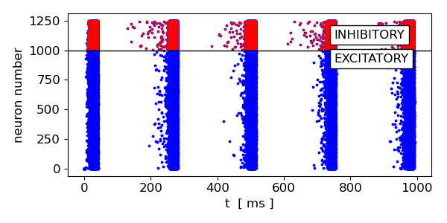
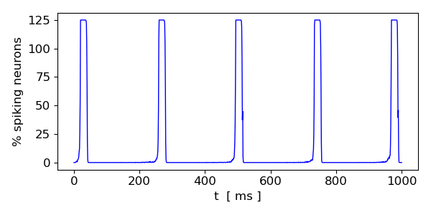
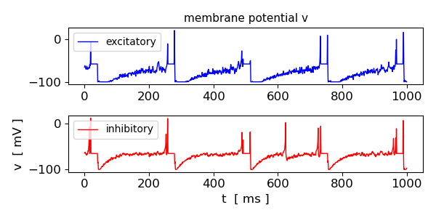
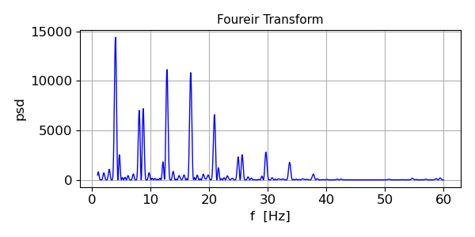
By decreasing the inhibitory synaptic weights, the firing patterns change even more dramatically, with less frequent and longer-lasting synchronous firing episodes of heavily synchronized neurons.

Simulation 4
Weak excitatory and very weak inhibitory synaptic weights
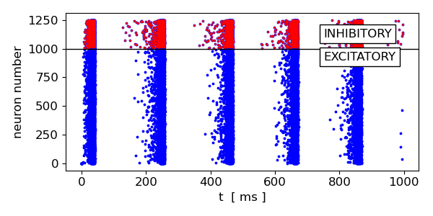
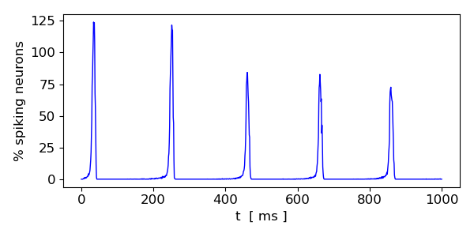
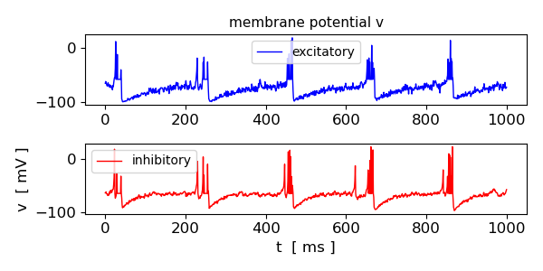
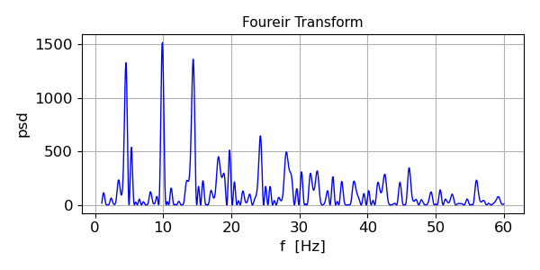
If we additionally decrease the excitatory synaptic weights as well, the frequency of synchronous firing episodes becomes higher and, as expected, the synchronicity between neurons decreases.

Simulation 5
Very weak excitatory & very weak inhibitory synaptic weights
S1, S2 = 0.10, -0.1 # 5
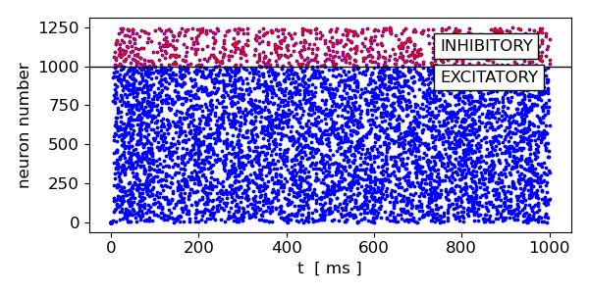
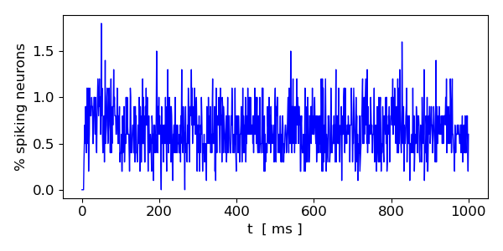
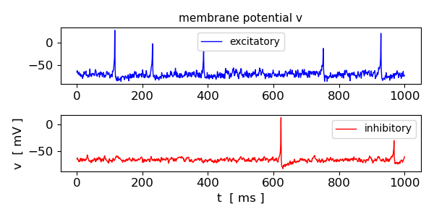
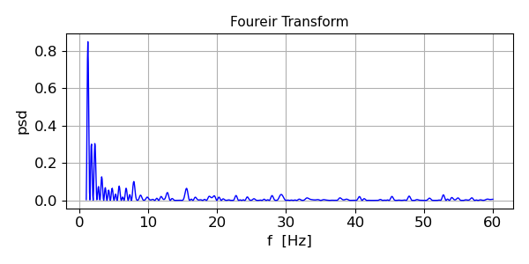
Setting both excitatory and inhibitory synaptic weights to very low values, the network exhibits a more irregular firing pattern with almost no recognizable synchronicity between neurons

These results demonstrate how the network dynamics are shaped by the synaptic weights and how different connectivity patterns can lead to distinct spiking behaviours. By adjusting the synaptic weights, we can observe a wide range of network behaviours, from synchronous firing to irregular spiking patterns, reflecting the diverse dynamics observed in biological neural networks.

Simulation 6 Changing the neuron types
In addition to altering the synaptic weights, we can also change the neuron types in the network to observe how different spiking behaviours emerge. We simulate a network with different types of neurons.

By simulating various neuron type combinations, we can observe a wide range of spiking behaviours in the network, each exposing distinct firing patterns. It demonstrates how the intrinsic properties of neurons, such as their parameter values in the Izhikevich model, can shape the network dynamics and lead to diverse spiking behaviours. By combining different neuron types and synaptic weights, we can explore the rich repertoire of spiking patterns that can emerge in neural networks, reflecting the complexity and adaptability of biological neural system

For example, we can change the variable a from the default a = 0.02 to a = 0.10 (fast spiking neuron)
Connectivity matrix S1, S2 = 0.5, -1

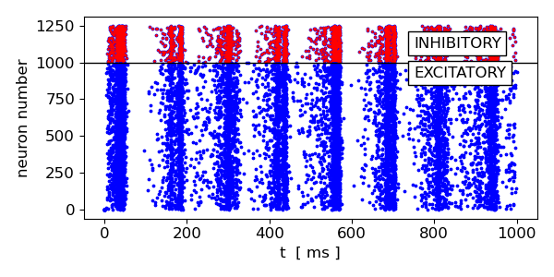
a = 0.02*ones((N,1))
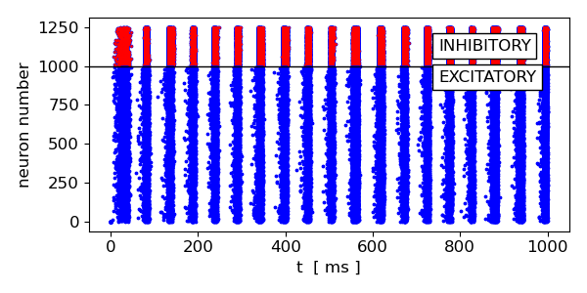
a = 0.10*ones((N,1))

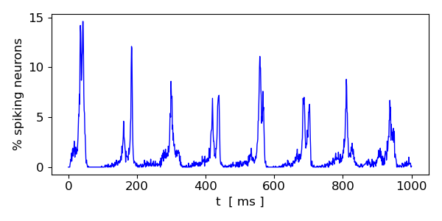
a = 0.02*ones((N,1))
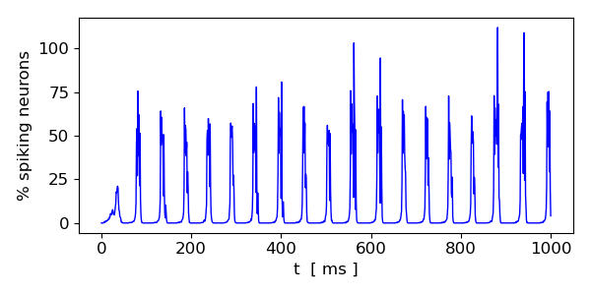
a = 0.10*ones((N,1))


a = 0.02*ones((N,1))
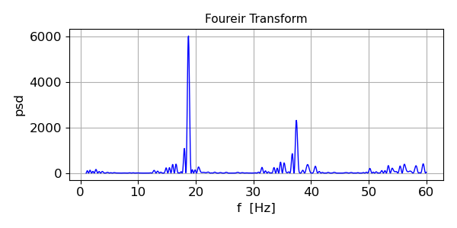
a = 0.10*ones((N,1))

Simulation 7 Changing the ratio N_{e} / N_{i}


N_{e} = 1000 N_{i} = 250 N_{e} / N_{i} = 4.00

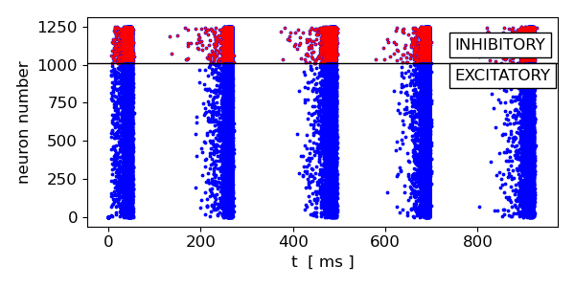
N_{e} = 1010 N_{i} = 240 N_{e} / N_{i} = 4.21

Again, slight changes in the N_{e} / N_{i} ratio can lead to very different firing patterns of the network.
SUMMARY
In this exploration of the Izhikevich neuron model applied to spiking neural networks, we’ve demonstrated its capability to simulate complex neural dynamics that mirror biological processes.

Adjusting network parameters and connectivity, we can see how different neuronal behaviours can be elicited, which enhances our understanding of neural circuit functionality and adaptability.

The analysis of both single and collective neuron spiking behaviour, made computationally possible by Izhikevich’s model, can reveal a lot of valuable information about the functions of a neuron or network. Changes in spiking dynamics of individual neurons is thought to relate to the ever-shifting topology of neuron networks, and even entire brain areas. From the change in behaviour of just one neuron, entire neural processes can be elucidated. The neuron network simulation is helpful in that it reveals how an adjustment in the ratio of inhibitory to excitatory neurons is displayed in the of size and distribution of alpha and gamma brain waves. Interestingly, disruption to brain wave patterns is often indicated in many neuro-pathologies, such as Alzheimer’s disease, depression, and tinnitus.

REFERENCES
Izhikevich, Simple model of spiking neurons, 2003, IEEE Transactions on Neural Networks, Vol. 14, Issue 6, pages 1569-1572

Izhikevich, Eugene M., (2010), Dynamical systems in neuroscience: The geometry of excitability and bursting.

Simulating spiking neural networks with Izhikevich neurons - Fabrizio Musacchio

https://github.com/FabrizioMusacchio/izhikevich_model/blob/main/izhikevich_neuron_network_model.py

https://www.fabriziomusacchio.com/blog/2024-05-19-izhikevich_network_model/

https://sites.math.rutgers.edu/~zeilberg/Bio25/Projects/Project6.pdf

https://colab.research.google.com/github/john-s-butler-dit/Basic-Introduction-to-ython/blob/master/W2%20Spiking%20Model%20-%20Izhikevch%20Model.ipynb

https://github.com/nuric/izhinet

https://medium.com/@hamxa26/simulating-brain-circuits-using-python-40387560d7f9

https://www.nature.com/articles/s41598-025-01876-5

