DOING PHYSICS WITH PYTHON
COMPUTATIONAL OPTICS
RAY (GEOMETRIC) OPTICS
MATRIX METHODS IN GAUSSIAN OPTICS
TWO CONVERGING LENS COMPOUND OPTICAL SYSTEM
Ian Cooper
Please email me any corrections, comments, suggestions or additions: matlabvisualphysics@gmail.com

DOWNLOAD DIRECTORIES FOR PYTHON CODE
Google drive

GitHub

S006.py

The Python Code S006.py is used to plot three ray paths from an input point to a set of output points located at a fixed in a compound optical system of two converging simple lens. The ABCD matrix method in the paraxial approximation is used as the basis of the computations.

IMAGE FORMATION PROCESS SIMULATIONS
Figure 1 shows the geometry of the compound lens optical system, a summary of the simulation parameters, and a summary of the ABCD matrix procedure for the calculation the output vector from the input vector where y is the height a point and a is the elevation of the ray from that point.

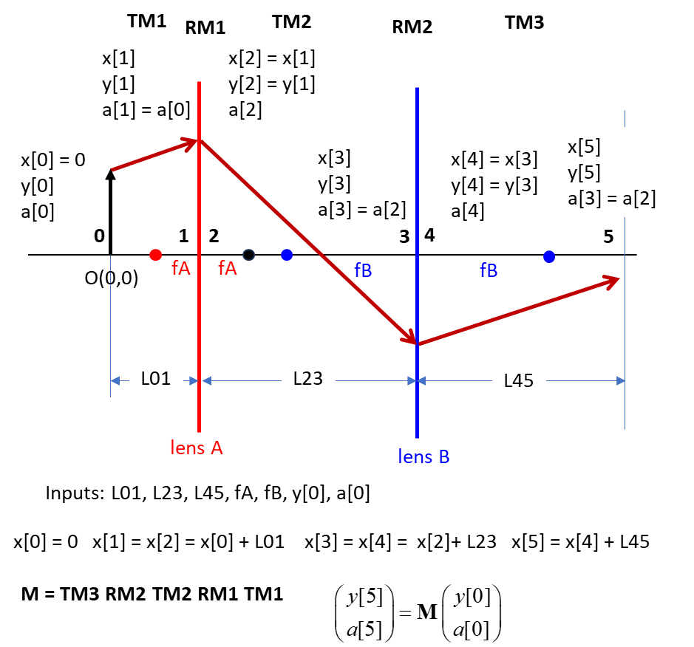
Fig. 1. Summary of the ABCD matrix ray tracing procedure.

SIMULATIONS
A summary of the simulation parameters is displayed in the Console Window.
3 ray paths through a two converging lens optical system
Optical axis limits: X1 = -20 X2 = 40
focal lengthS: fA = 5.00 fB = 8.00
Translations: L01 = 8.0 L23 = 20.0 L45 = 20.0
Input (object): height y[0] = 0.50
Input (object): elevations a0deg = 18.0 0.0 -18.0 deg
Intermediate image lens A: xA = 21.333 height yA = -0.833
Output image lens B: xB = -12.000 height yB = -5.000
Transverse magnification: mT = -10.000
Angular magnification mA = -2.000

The result of the computation is shown in figure 2. The final image is a virtual image that is inverted, and magnified. The transverse magnification of the image is -10.00 and the angular magnification is -2.00.

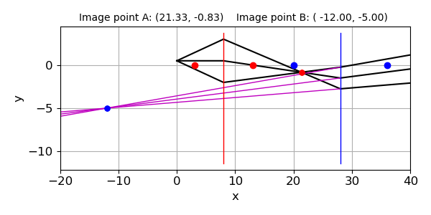
Fig. 2. Three rays-paths through the two converging lens compound optical system (black solid lines). The magenta lines are draw from the final image point and represent virtual rays. The red vertical line and red dots on the optical axis show the position of lens A and its focal points, while the blue line and blue dots are for lens B. The red dot off the optical axis shows the image point from lens A (intermediate image). The blue dot located off the optical axis is the final image point of the optical system.

You can use the program for numerical calculations on microscopes. In the console Window, numerical answers are displayed. The plot figure is not so useful for very large magnifications of the image.

Typical textbook example: microscope
A microscope has an objective lens of 10.0 mm focal length and an eyepiece of 25.0 mm. The distance between the objective and eyepiece lens is 232.7 mm. What is the magnification if the object is in sharp focus when it is 10.5 mm from the objective.
S006.py
3 ray paths through a two converging lens optical system
Optical axis limits: X1 = -100 X2 = 300
focal lengths: fA = 10.00 fB = 25.00
Translations: L01 = 10.5 L23 = 232.7 L45 = 25.0
Input (object): height y[0] = 1.00
Input (object): elevations a0deg = 18.0 0.0 -18.0 deg
Intermediate image lens A: xA = 220.500 height yA = -20.000
Output image lens B: xB = -3.539 height yB = -217.391
Transverse magnification: mT = -217.391
Angular magnification: mA = -9.251
Lens A sA0 = 10.50 sA1 = 210.00
Lens B sB0 = 22.70 sB1 = 246.74

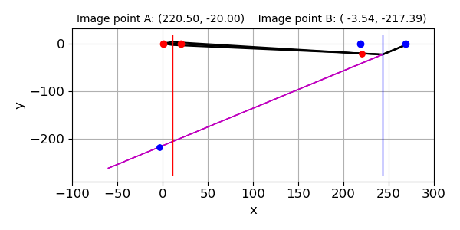
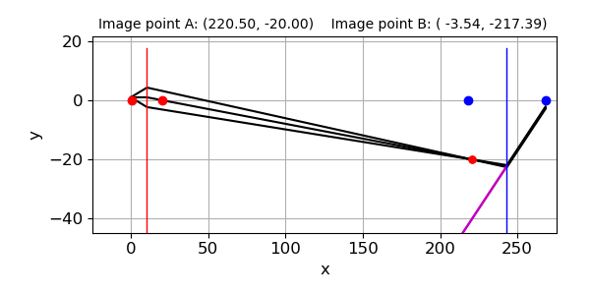
This example is about a compound microscope which uses converging lens to produce large magnification. A short-focus lens, the objective (lens A), is placed near the near the object. The objective lens produces a real, inverted, and magnified image. The eyepiece (lens B) further magnifies this inverted image and produces a virtual image about 250 mm from the eyepiece. This distance of 250 mm gives the most distinct vision for our eyes.

