DOING PHYSICS WITH PYTHON
A REALISTIC THREE-DIMENSIONAL MODEL FOR THE FLIGHT OF A GOLF BALL

Ian Cooper
matlabvisualphysics@gmail.com

DOWNLOAD DIRECTORIES FOR PYTHON CODE

Google drive

GitHub

golf3D02.py
Solves the differential equation using the function odeint for the flight of the golf ball.

golf3Dw.py
Miscellaneous calculations.

The analysis of the flight of the golf ball is done from the perspective of a right-hand golfer.

INTRODUCTION
Surprisingly, we can predict and describe the flight of a golf ball from a small number of parameters where every golf shot can be explained. In this article, a model is developed that can be used to predict the flight of a golf ball using Python. The predictions can be compared to real-life data and data recorded by Trackman devices.

TrackMan uses dual-radar technology to track both the movement of your club and the entire flight of the golf ball. The basic measurements are categorized into Club Data (what the club does) and Ball Data (what the ball does). The picture below shows a typical screen output from Trackman.

In later sections of this article, the terms shown in the following picture will be explained. The simulation conventions for positive and negative quantities are different to the sign conventions used by Trackman.

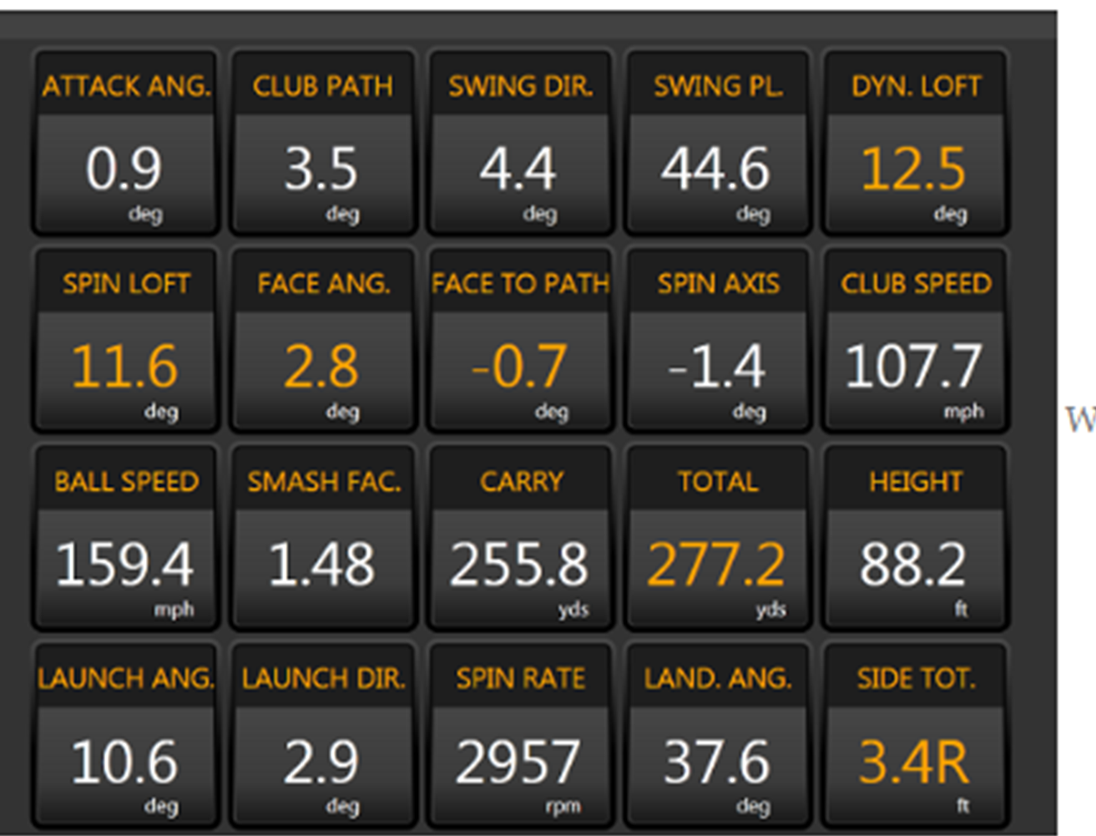

Statistics for hitting a golf ball by PGA professionals are easily found be searching the web. Such data is used in the simulations to estimate model parameters used as inputs and to compare model predictions with real-life data. For example,
https://www.trackman.com/blog/golf/introducing-updated-tour-averages

Table 1 shows a summary of data for the average of PGA professional golfers. The data from Table 1 was used for many of the simulations for inputs and for comparing simulation predictions with the average for PGA golfers.
Table 1.
Woods/ Hybrid | driver | 3-wood | 5-wood | hybrid
loft [deg] | 5-13 | 14-16 | 17-19 | 19-20
v_{club} [km/h] | 184 | 176 | 170 | 163
smash factor | 1.49 | 1.47 | 1.47 | 1.47
v_{ball} [m/s] | 76.2 | 71.8 | 69.3 | 66.6
launch angle [deg] | 10.4 | 9.3 | 9.7 | 10.2
attack angle [deg] | -0.9 | -2.3 | -2.5 | -2.4
spin rate [rpm] | 2545 | 3663 | 4322 | 4587
carry [m] | 258 | 228 | 214 | 211
max height [m] | 32 | 29 | 26 | 28
land angle [deg] | 39 | 44 | 48 | 49

Irons | 3 | 4 | 5 | 6 | 7 | 8 | 9 | PW
loft [deg] | 18-21 | 21-23 | 23-27 | 26-31 | 30-35 | 35-39 | 39-44 | 45.47
v_{club} [km/h] | 160 | 157 | 154 | 150 | 147 | 142 | 139 | 134
smash factor | 1.46 | 1.44 | 1.41 | 1.39 | 1.34 | 1.33 | 1.29 | 1.24
v_{ball} [m/s] | 65.3 | 62.7 | 60.2 | 58.1 | 54.8 | 52.6 | 50.0 | 46.3
launch angle [deg] | 10.3 | 10.8 | 11.9 | 14.0 | 16.1 | 17.8 | 20.0 | 23.7
attack angle [deg] | -2.5 | -2.9 | -3.4 | -3.7 | -3.9 | -4.2 | -4.3 | -4.7
spin rate [rpm] | 4404 | 4782 | 5280 | 6204 | 7124 | 8078 | 8793 | 9316
carry [m] | 199 | 192 | 182 | 172 | 161 | 150 | 139 | 130
max height [m] | 27 | 28 | 30 | 29 | 31 | 30 | 29 | 29
land angle [deg] | 48 | 49 | 50 | 50 | 51 | 51 | 52 | 52

MODEL PARAMETERS
A mathematical model of a golf ball’s flight reveals the rich physics underlying a seemingly simple sporting action. By combining Newtonian mechanics with aerodynamic principles, we obtain a system of equations that captures the essential behaviour of the ball in flight. Although real-world conditions introduce additional complexity, the model remains a powerful tool for analysing performance, guiding equipment design, deepening our appreciation of the science behind the game, and the mathematics explains the elegance of a well-struck shot.

The predictions of this mathematical model can be compared with real data recorded by Trackman devices. The model explains many aspects of the flight of a golf ball and why we use so many clubs. It explains how we you can achieve greater distances off the tee and the ways in which the flight of the ball can be controlled.

CONSTANTS
Mass of the head of a driver club m_{club} = 0.200 kg
Mass of golf ball m = 45.93x10⁻³ kg
Radius of golf ball r = 21.335x10⁻³ m
Cross sectional area of golf ball [m²]
Acceleration due to gravity g = 9.81 m.s⁻²
Density of air is a function of temperature, air pressure and humidity
Air temperature T₀ = 20 º C = 293 K
Atmospheric pressure 1.013x10⁵ Pa
Air density = 1.2041 kg.m⁻³
The higher the temperature the more moisture in the air
(greater humidity), then the lower the density of air

CARTESIAN COORDINATE SYSTEM AND DYNAMICAL QUANTITIES
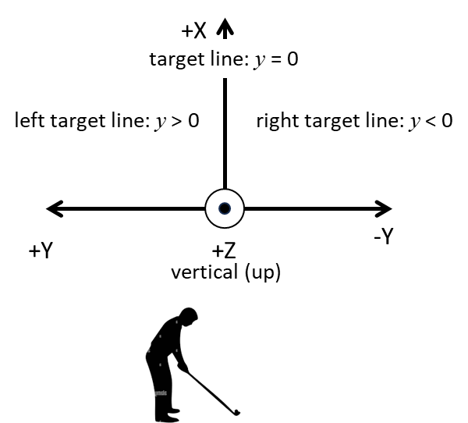

t time [s], T flight time [s]
Position of ball
XY-plane z = 0: horizontal plane (level ground)
X-axis : target line x > 0
Y-axis : lateral movement of ball
lateral shift (lateral displacement) y
y > 0 (left target line)
y < 0 (right target line)
Z-axis : vertical direction
Displacements [m]
Initial displacement: Origin (0,0,0)
Final displacement: landing spot
Carry [m]
Range x_{F} [m]
Maximum height H [m]
Vertical landing position z_{f} [default z_{f} = 0 m]
can simulate landing above or below Origin

Velocity of ball [m.s⁻¹]
Acceleration of ball [m.s⁻²]
Net force acting on ball during flight [N]
Club head speed at impact [km.h⁻¹] [m.s⁻¹]
Ball speed at impact [m.s⁻¹]
All angles are given in degrees and expressed in radians for calculations. Vertical angles directed in +Z direction are positive and horizontal angles directed in +Y direction (left) are positive.

Spin (spin rate, angular velocity) [rpm] [rad.s⁻¹]
spin around the X-axis
spin around the Y-axis produces lift (backspin)
spin around the Z-axis gives curvature of the ball
left or right of the target line (sidespin)

Spin decay constant p [s⁻¹]
The spin of the golf ball decreases over time and can be modelled by the exponential function

WHAT HAPPENS AT IMPACT?

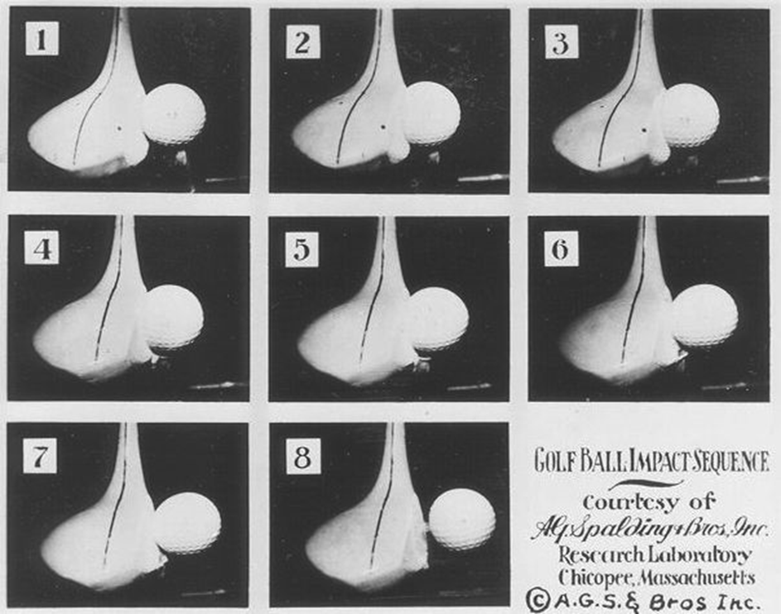
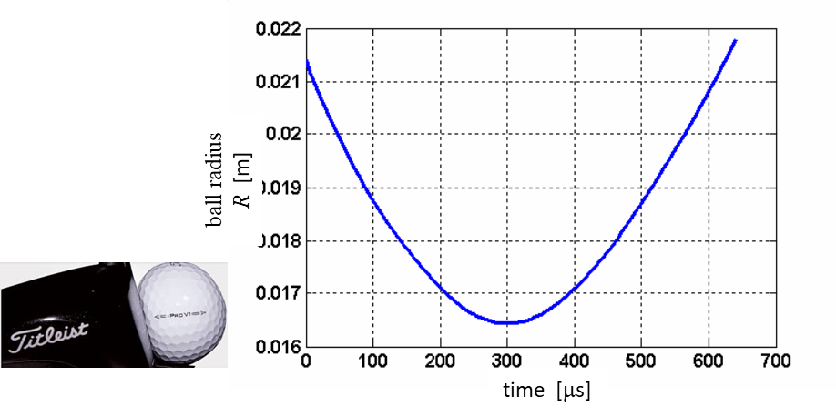
Change in radius of the golf ball during impact
The contact (resultant) force between golf club and golf ball can be consider to have a normal component and a tangential component . The normal force causes the compression and restitution of ball and the initial flight direction. The tangential force produces the spin as the ball slides then rolls along the club face during impact.

It is the rolling of the ball across the club face that produces the spin.
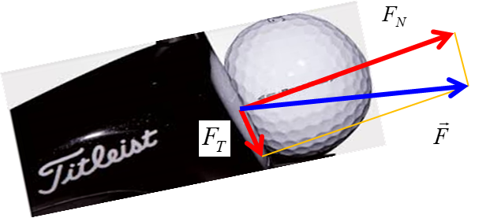
The tangential force F_{T} would produce an anticlockwise rotation of the ball (backspin). The ball mainly rolls across the club face due to the friction between the club face and the ball. There is also some initial slipping of the ball along the surface (no friction between club and ball).

Initially the ball slides up the club face, because there isn't enough friction yet between club face and ball. Then the ball starts to compress on the club face, which creates the very large contact force between the club face and the ball.

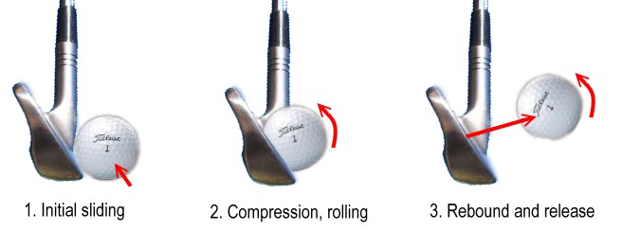
This force of compression does two important things:
- It begins to accelerate the ball with a horizontal component, not just the vertical motion up the club face.
- It creates a lot of friction between ball and club face. So, instead of sliding up the club face, the ball begins to roll instead. The ball continues accelerating upwards (due to the loft) and horizontally (due to the compressive force). The sliding has turned completely into roll, so the upwards acceleration increases the speed of roll.
- At some point, the momentum absorbed from the clubhead through acceleration has the ball moving faster than the clubhead. In other words, the elastic rebound of the ball's acceleration allows the ball to release from the club head. At this instant, its launch conditions are determined: initial speed of ball, launch angles (vertical and horizontal), and the spin of the ball (angular velocity).

BERNOULLI’S PRINCIPLE
Bernoulli's principle states that faster-moving air produces lower pressure, which, when applied to a spinning golf ball creates aerodynamic lift and is called the Magnus effect.

Fast-moving fluids exert less pressure than slow-moving fluids

The rotating golf ball drags the air around it in the direction of the spin. Backspin causes the top of the ball to move in the same direction as the airflow, resulting in higher velocity and lower pressure. Conversely, the bottom of the ball moves against the airflow, causing lower velocity and higher pressure. The pressure difference (high pressure underneath, low pressure on top) results in an upward Magnus force, allowing the golf ball to rise, stay in the air longer, and travel further.

The dimples on a golf ball play a crucial role, as they trigger turbulent airflow that allows the air to follow the ball’s surface more closely, enhancing the lift effect and significantly reducing drag. Without this spin-induced Bernoulli lift, a golf ball would follow a strict, shorter parabolic trajectory.
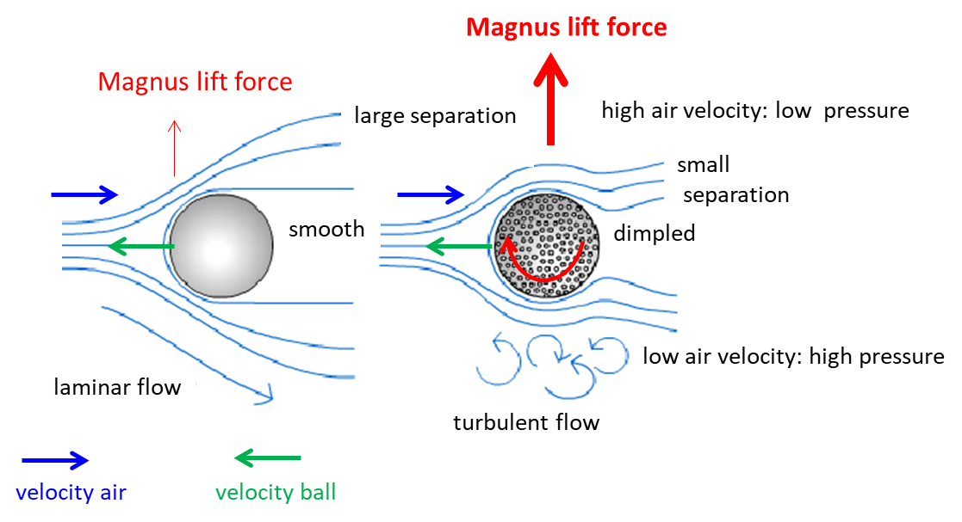

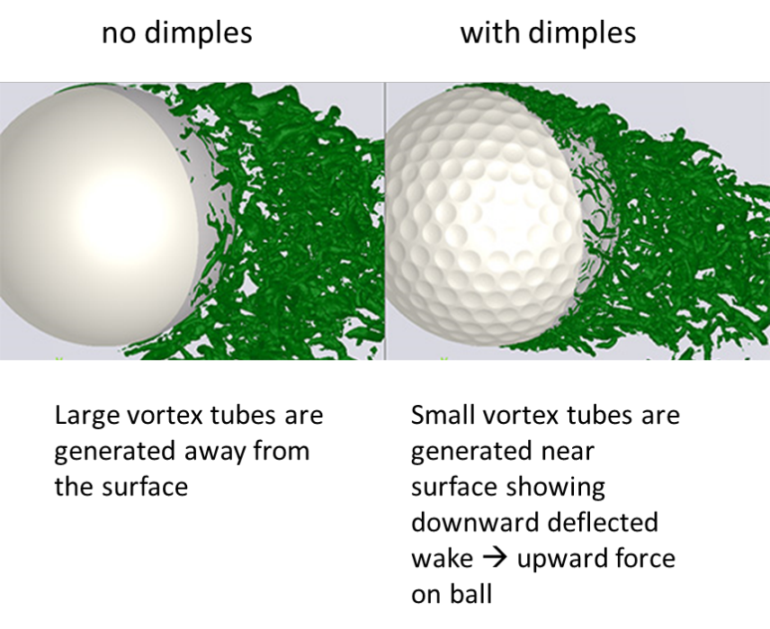
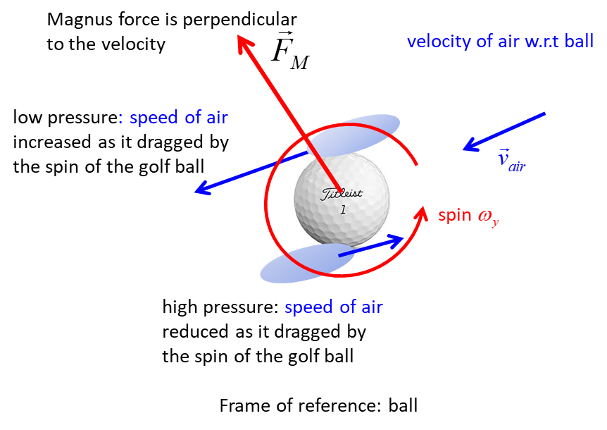

FORCES and NEWTON’S SECOND LAW
Developing a mathematical model for the flight of a golf ball requires combining Newton’s laws with empirical aerodynamic relationships to capture the forces that shape the ball’s trajectory. The primary forces acting on a golf ball in flight are the gravitation force (weight), the aerodynamic drag and the Magnus force which arises because of the spin of the golf ball.

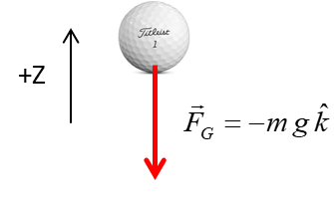
Gravitational force (weight)
The gravitational force acts vertically downward

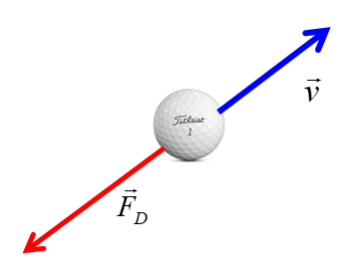
Aerodynamic drag
The aerodynamics drag (air resistance or drag) always opposes the forward motion of the golf ball causing the flight of the ball to departs from a parabolic path, thus reducing its range.
Drag coefficient C_{D} is a function of v and .

Magnus force
The flight of a golf ball is fascinating where aerodynamics plays a prominent role. The golf ball drags some of the air around it as it spins producing an asymmetrical flow. This results in pressure gradients around the ball causing the flight of the ball to depart from a straight and parabolic path. The air pressure decreases at points where the speed of the air increases and the air pressure increases where the speed of the air is reduced (Bernoulli’s Principle).
high air speed low pressure low air speed high pressure

This pressure gradient force is known as the Magnus effect. It is the Magnus force that causes the ball to lift and swerve. The Magnus force is in a direction which is perpendicular to the velocity vector and perpendicular to the spin axis. The Magnus force and its x, y, and z components:
There is very little rotation of the ball around the X-axis .

X-component
opposes (deceleration) the motion in the +X
accelerates the motion in the +X
Y-component produces the swerve of the ball
ball curves to the right (-Y direction)
ball curves to the left (+Y direction)
When the ball is struck with sidespin , then the ball rotates around the Z-axis
Draw / Hook (Z spin axis points in the direction of the +Z-axis)
the ball curves to the left (+Y direction)
Fade / Slice (Z spin axis points in the direction of the -Z-axis)
the ball curves to the right (-Y direction)

Z-component produces the lift
lift always acts vertically upwards (+Z direction)
causes the ball to stay in the air longer
Since , so, when the ball is struck with backspin , the spin axis points in the direction of the negative Y-axis
and the ball will experience lift for the duration of the flight.

SPIN (spin rate, angular velocity)
Golf spin, comprising backspin and sidespin controls a ball's flight. It is generated by club-ball friction, and swing speed. Backspin is achieved by hitting down onto the ball and sidespin when the club face angle is not aligned with the club path angle.

DRAG C_{D} COEFFICIENT AND LIFT COEFFICIENT C_{L}
The values of C_{D} and C_{L} are very dependent on the nature of the surface of the ball. For example, the shape, size and pattern of the dimples. The surface of the ball affects the asymmetrical boundary-layer separation and a downward deflected wake that together result in the upward acting lift force and the swerve on the ball. As example, a dimpled ball will be subjected to a much large lift force than smooth ball.
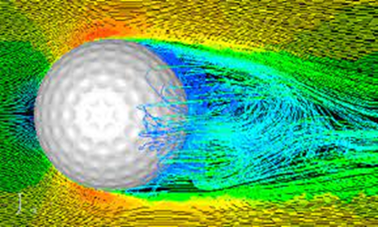
The surface of a golf ball and its dimple pattern have a large impact on the values of the drag and lift coefficients.

The C_{D} and C_{L} values also change significantly with the speed of the ball and its rate of spin. In the Python Code the values for C_{D} and C_{L} for a given v and are specified by the function cdcl(v,w).
CD max = 0.518 min = 0.247 CL max = 0.464 min = 0.104

EQUATION OF MOTION FOR FLIGHT OF GOLF BALL
The equation of motion of the golf ball (Newton’s Second Law) is
The equation of motion is solved using the Python Code golf3D02.py using the function odeint.

Launch parameters
Examination of the equations for the forces acting on the golf ball during its flight shows that the trajectory of the golf ball is completely predictable given the parameters for the two vectors:
- Initial velocity of ball
- Initial angular velocity
launch speed of ball
launch angle (vertical launch angle)
launch direction (horizontal launch angle, azimuthal
angle)

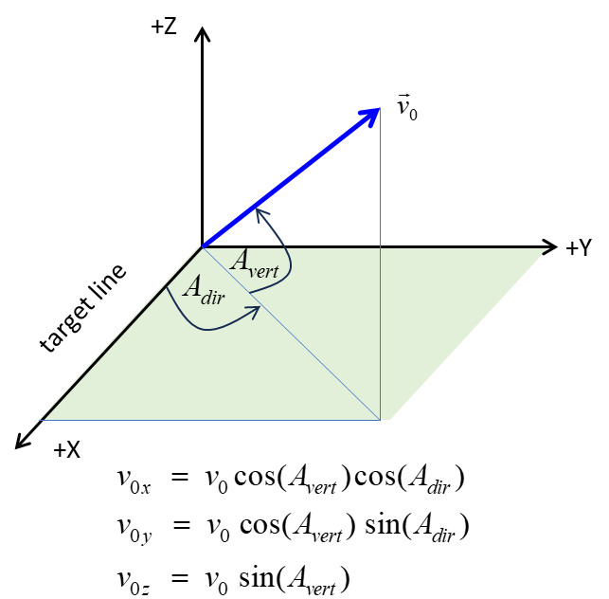

The launch angle (vertical launch angle) A_{vert} is the vertical angle which the ball is launched relative to the ground.

The launch direction angle A_{dir} refers to the horizontal angle left (A_{dir} > 0) or right (A_{dir} < 0) of the target line immediately after impact. The launch angle is also known as the azimuth angle. The launch direction is determined by a combination of the club's face angle (where the clubhead is pointing) and the club path (the direction the clubhead is moving).

Smash factor
The initial (launch) speed of the ball only depends upon the clubhead speed v_{club} at impact and the smash factor S.

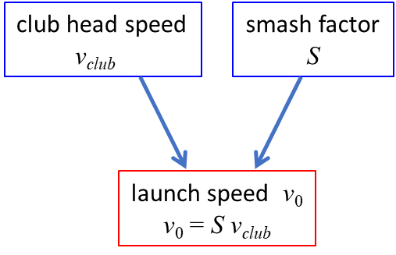

The smash factor S is determined by the effectiveness of energy transfer from clubhead to ball. That is, the smash factor is merely a measure of how efficiently you translated club speed into ball speed and is not purely a measure of how well you struck the ball.

It is mainly determined by the strike point of ball on club and the “qualities” golf club and of the golf ball (golf ball compression measures how much a ball resists deformation (squishing) upon impact. Ratings range from 30 (very soft) to 120 (very hard). Matching your swing speed to the right compression rating may optimizes energy transfer, maximizing distance and feel for your specific game). If you hit a perfect shot with the driver, the smash factor would be S_{driver} ~ 1.50. Optimizing the smash factor increases distance without needing a higher swing speed. Due to higher loft, a 7-iron has a smash factor around 1.35–1.39, and for wedges, 1.20–1.25. The absolute maximum smash factor for a driver is most likely near 1.54.

To improve your smash factor, the most important thing is hitting the ball in the centre of the face, or slightly high-toe, rather than the heel or low on the face. A positive (upward) attack angle with the driver helps maximize the smash factor. A low smash factor results in lost distance due to off-centre hits which is often common among higher-handicap golfers.
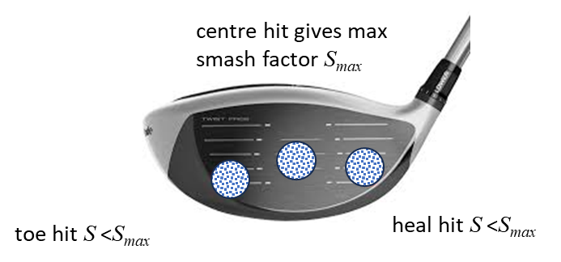

https://www.trackman.com/blog/golf/smash-factor

GOLF IS ALL ABOUT ANGLES AND SPIN
Golf is all about angles. In this section, the angles which are necessary in modelling the flight of a golf ball are discussed in detail and then how these terms are used.

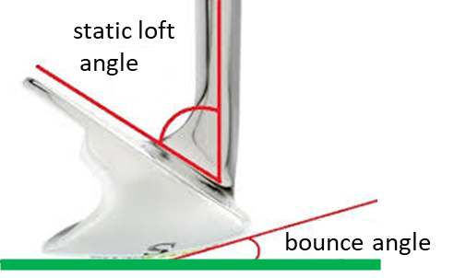
The spin given to the ball at impact is very dependent on the static loft of the club, A_{staticLoft}. The static loft is the angle formed between the club face and a vertical plane. The higher the loft then the greater the launch angle and the greater backspin given to the ball when struck by the club. Drivers and woods have the smallest static loft angles while wedges have the highest loft angle.
Typical loft angles
driver: 9º – 12.5º 3-wood: 15º 5-wood: 20º
pitching wedge: 45º gap wedge: 52º sand wedge 58º
lob wedge: 62º
Golf club bounce is the angle between the leading edge and the lowest point of a wedge's sole. The bounce acts as a skid plate to prevent the club from digging too deeply into turf or sand. Thus, it allows the club to glide through the turf, reducing chunked shots.

- Higher bounce (10°+): Best for soft, fluffy sand, lush turf, and players with steep attack angles who take deep divots. Opening the club face increases the effective bounce, making it more useful in soft bunkers.
- Mild bounce (7º – 10º): Versatile option for normal conditions and a variety of swing types.
- Low Bounce (4°–6°): Ideal for tight lies, firm turf, hard sand, and "sweeper" swings that pick the ball clean.

Shaft lean is the angle A_{shaftLean} where the hands and club handle lead the club head towards the target at impact. It delofts the club, compresses the ball, and promotes a descending strike for maximum distance and control. It is primarily created by shifting weight forward and body rotation, not by manually pushing hands forward.

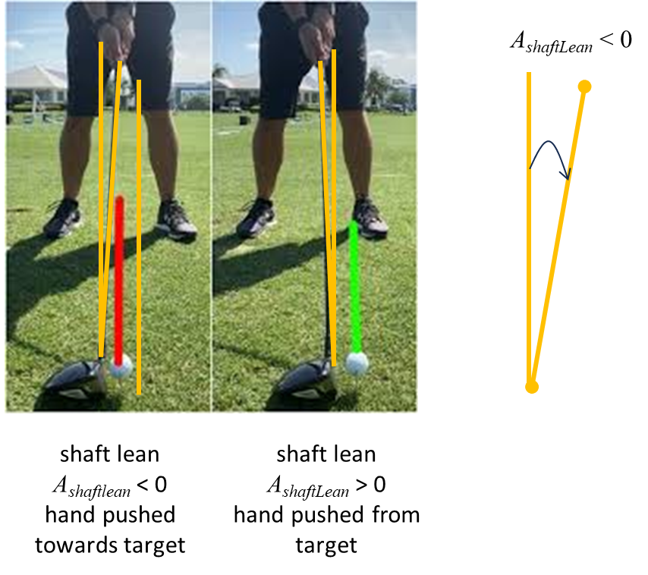

Dynamic loft angle A_{dynamicLoft} is the actual loft of your club face at the moment of impact and depends upon the static loft of the club and your hand position. A forward lean shaft for the irons gives a lower dynamic loft, allowing you to compress the ball, produce optimal launch angles, and maximize your distance.

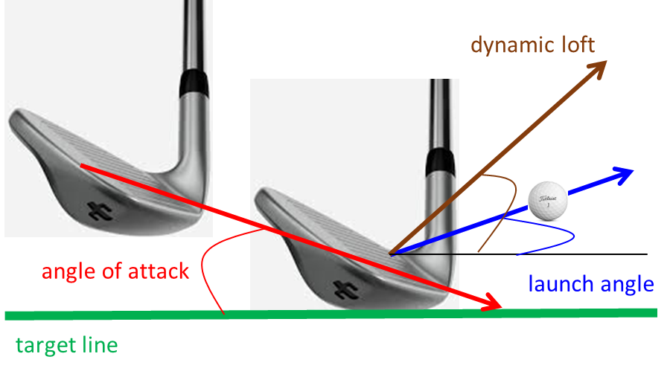

- Forward Shaft Lean: At impact, your hands must be slightly ahead of the ball (closer to the target). This leans the shaft forward and delofts the club.
- Flipping: You should always avoid flipping where the clubhead passes your hands before impact. This flipping adds loft and causes weak, high, or thin shots.
- Lead Wrist Flexion: For the perfect hand position, your lead wrist should be flat or slightly bowed at impact. This squares the club face and prevents the club from releasing too early.
- Too Much Loft: Causes the ball to launch too high ("ballooning"), increasing spin and reducing overall distance.
- Too Little Loft: Produces a low, piercing trajectory with excessive roll, making it difficult to control distances.
- Neutral Lead Hand: Place the grip in the fingers and heel pad of your lead hand rather than deep in the palm. When looking down, you should comfortably see two knuckles.
- Thumb Placement: Your lead thumb should rest slightly off-center on the right side of the shaft, which helps create a proper "V" shape pointing toward your trailing shoulder.
- Consistent Grip Size: Ensure the grip size is comfortable and consistent across all your clubs to avoid unnatural adjustments

The angle of attack (attack angle) A_{attack} refers to the vertical direction (upward or downward) the club head is traveling at the moment of maximum compression with the ball. A positive (+) number indicates an upward strike, while a negative (-) number indicates a downward strike. Optimal play requires a downward attack angle for irons (striking ball then turf) and an upward attack angle for drivers (hitting on the upswing to maximize distance and control).
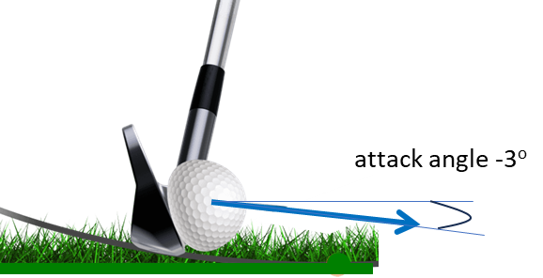
A narrow downswing will typically encourage a steeper, more downward angle of attack, whereas a wider downswing will typically promote a shallower, less downward angle of attack
Typical Attack Angles
- Driver: +1° to +5° (Upward strike is ideal)
- Fairway Woods: 0° to -3° (Slightly descending)
- Mid-Irons (6–8): -3° to -6° (Downward strike)
- Short Irons/Wedges: -4° to -8° (Steeper downward strike)
- PGA Tour Driver: -0.9° (slightly downward) to +2.1°
- LPGA Tour Driver: +2.8° to +3° (significantly upward)
- PGA Tour 6-Iron: -3.7° to -4.3°
- Male Amateur Driver: -0.9° to -1.2° (most amateurs hit down, losing distance)

Why Attack Angle Matters
- Driver (+2° to +5°): Hitting up on the ball increases launch angle and reduces spin, maximizing carry distance.
- Irons (-3° to -5°): A descending blow is required to hit the ball first and then the turf, producing consistent compression and control.
- Wedges (-5° to -8°): A steeper downward angle provides the high spin and control needed for short approach shots.

A typical amateur mistake is hitting down on the driver (-2°), which increases spin and reduces distance by 5-10 m.

Attack Angle is the king of the parameters in my opinion. It plays a significant role in determining the club path and the quality of the strike. I have often said that if a golfer can learn to manage the Attack Angle, then they can manage their ball flight.
Andrew Rice Berkeley Hall Golf Club, SC, US

Club face angle A_{face} is the direction the club face points (left or right) at impact relative to the target line, serving as the primary factor (75-85%) in determining the initial starting direction of the golf ball. For a square club face the contribution to the direction angle A_{dir} is zero and the ball will initially travel along the target line. A closed club face has its normal pointing to the left and so the ball will initially head left to the target line . An open club face has its normal pointing to the right and so the initial direction of the ball is to the right .

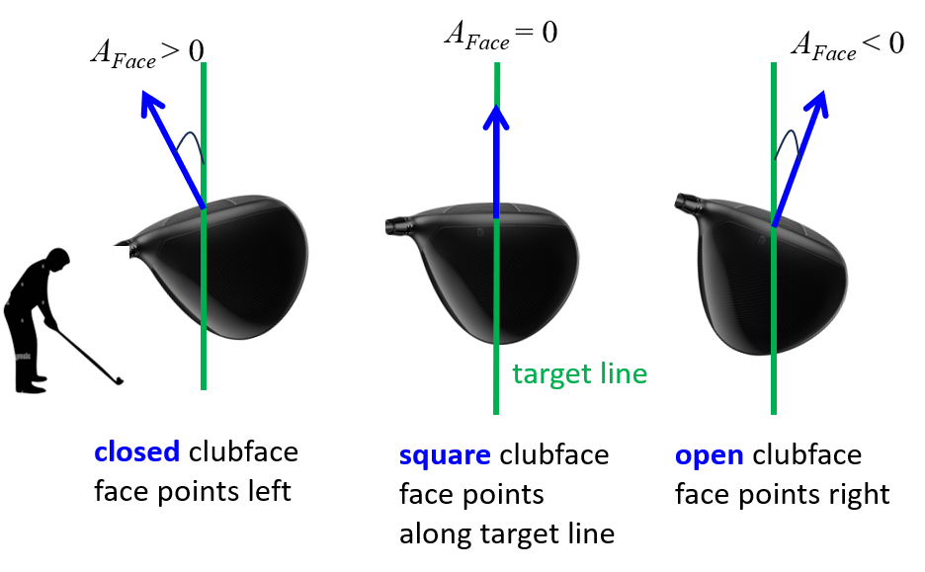

Club path (swing)
A_{Path} is the horizontal direction the clubhead travels at impact relative to the target line. The club path is a key factor in determining the direction angle and whether a shot curves as a fade, draw, slice, or hook. If the swing is along the target line, then . For an in-to-out swing path and the ball will head to the right. For an out-to-in swing path (over-the-top) and the ball will head to the left relative to the target line.
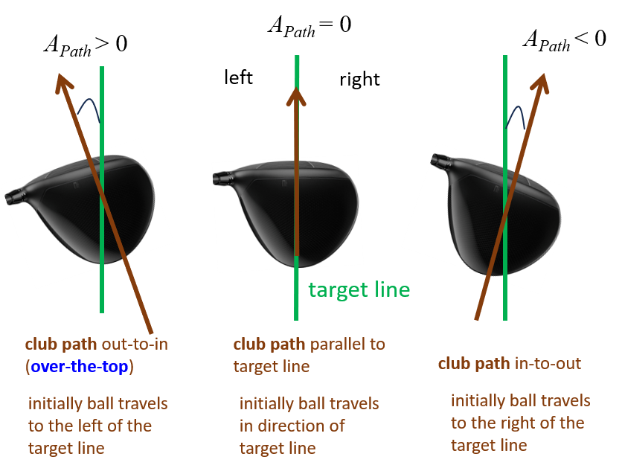
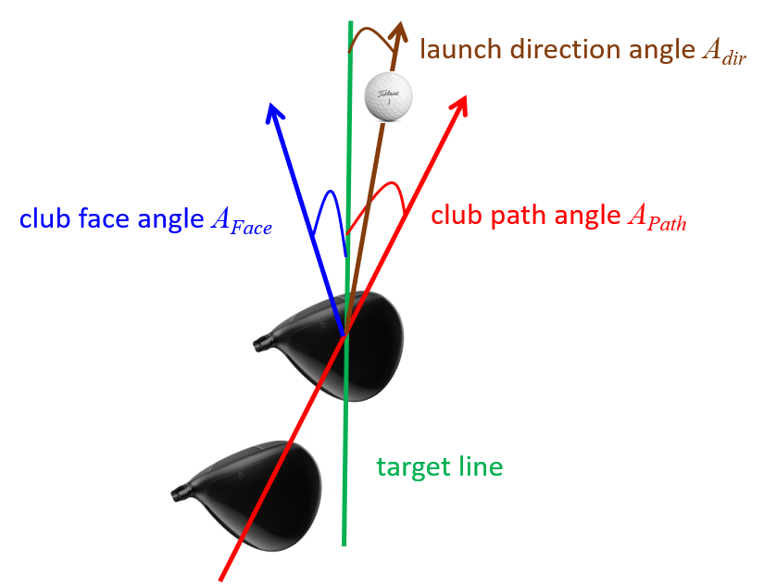
The ball will always start between the direction of the club face and the direction of the club path. To a good approximation, the launch direction A_{dir} is directed along the line of the normal to the club face

The ball may not initially travel in the direction of the normal to the club face because of the compression of the ball and the friction between club and ball causing the ball to rotate across the face of the club.

Instead of hitting the ball strictly on the zero-degree target line, many professionals and skilled amateurs slightly manipulate their launch direction to intentionally shape the ball's flight (e.g., hitting a controlled draw or fade).

The face-to-path angle A_{facePath} is the difference between where the club face is pointing A_{face} and the direction the club is swinging A_{Path} at the exact moment of impact.

Spin Loft A_{spinLoft} is the angle difference between your dynamic loft and the angle of attack.
spin loft = dynamics loft - angle of attack
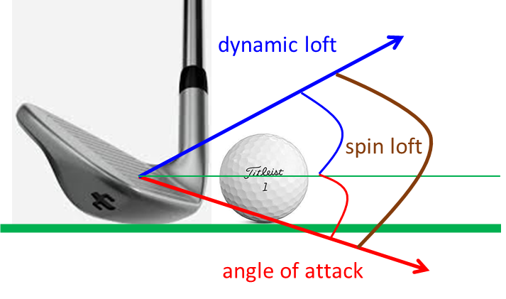

Gear effect: If impact is toward toe or heel (off-centre strikes), clubhead twists during collision which causes a torque to add extra sidespin to the ball. This is known as the gear effect and it can be huge for the driver since the centre of mass (CM) of the club head is well back from the club face.
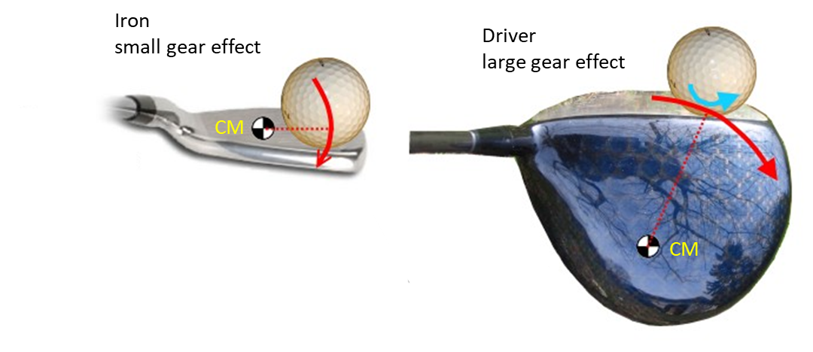
The above figure shows two off-centre impacts, one on an iron and the other on a driver. Both are toe impacts, which means it is to the toe side of the CM of the clubhead. The impact between the club and ball creates a clockwise torque on the club (red arrows) as the CM of the club wants to continue moving forward in a straight line (Newton’s first law). This torque wants to twist the club.

The CM of the iron is close to the club face. So, where the club face and ball meet, this rotation (the red arrow) consists of the club face ‘falling away’ from the ball. This results in loss of distance due to incomplete the momentum transfer from the club to ball (reduced smash factor). Very little spin is given to the ball and the open club face of the club may result in the ball flying off to the right.

The driver is a completely different story. Its CM is well behind the club face. When the driver head rotates around its CM, the whole face of the club moves sideways. Look at the direction of the red arrow where the club face and ball meet; it is mostly parallel to the club face, with only a bit of "falling away". So, the club face is moving to the right while the ball is compressed on it. The result is that the ball starts to rotate so its surface doesn't slide along the club face (remember it's compressed so sliding is difficult). This rotation is the blue arrow in the figure. If the clubhead is rotating clockwise as shown, then the ball rotates counter-clockwise. It's as if the clubhead and ball were a pair of gears, with their teeth meshing where they meet.

That's why a toe hit with a driver tends to hook. For all the same reasons, a heel hit with a driver tends to slice. You don't have this effect with an iron so much. The CM of an iron head isn't in the face; it is slightly behind the face. New design irons heads have their CM further and further back, to make them more forgiving and higher launching.
Toe strike: head twists open draw / hook tilt
Heel strike: head twists closed fade slice tilt
The swing plane is the angled path the club travels, often visualized as a plane of glass extending from the ball to the shoulders, with the shaft operating between the shoulders and hips. Proper swing plane ensures consistent, centred contact by aligning the club through the backswing and downswing. A good plane generally sits between 45-50 degrees for a driver, with shorter clubs having a steeper angle.
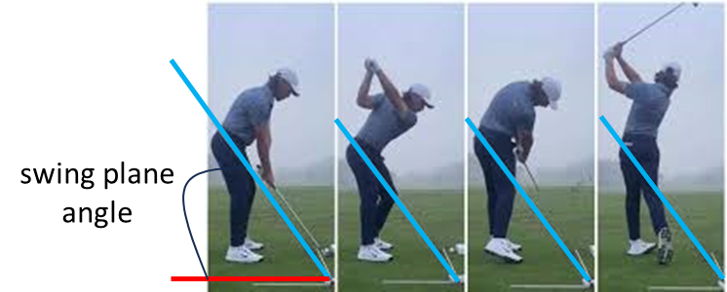

Notice how swing plane is very close to 45 degrees.

Swing direction is the horizontal, 3D direction the clubhead is moving (measured from knee-high to knee-high in the downswing) relative to the target line.
- Positive (+): Club is moving to the right of the target (In-to-Out).
- Negative (-): Club is moving to the left of the target (Out-to-In). Over the Top: A negative swing direction often indicates an "over the top" move.
Swing Direction = Attack Angle + Club Path
Unlike the angle for the club path which looks only at impact, swing direction is the overall direction of the swing arc during the downswing.

Typical Swing Direction Numbers
- Amateur Driver: usually ranges from -1 to -3 degrees.
- Scratch Golfer: usually around -0.9 degrees.

Understanding this metric helps identify if you are cutting across the ball (negative) or swinging from the inside (positive). Most amateur golfers cut across the ball (negative swing direction)

https://www.trackman.com/blog/golf/what-is-swing-direction

ANGULAR VELOCITY AND SPIN
Spin refers to the rotation of the golf ball around its axis during flight. The technical term for spin is angular velocity and it is a vector quantity.

The direction of the vector is given by the right-hand thumb rule. The right-hand thumb rule for angular velocity dictates that if you curl the fingers of your right hand in the direction of an object's rotation, your extended thumb points in the direction of the angular velocity vector . This vector defines the axis of rotation (spin axis) and is perpendicular to the plane of rotation. The spin axis is the axis around which the golf ball spins and is referred as the tilt of the ball's rotational axis relative to the horizon.

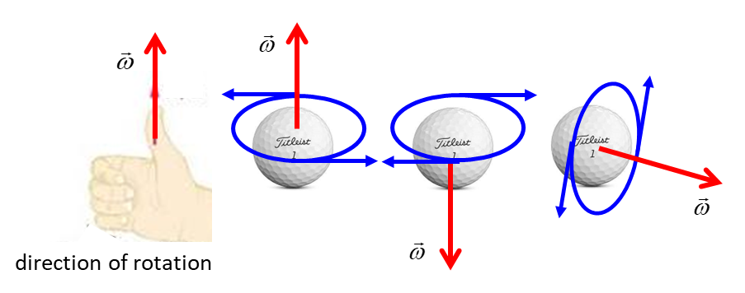
Understanding spin axis is crucial for controlling ball flight. It explains why a ball with high backspin (like a wedge) curves less, and how to correct a slice or hook by adjusting the club face-to-path relationship rather than just trying to swing "harder".

A spinning golf ball’s angular velocity is largely determined by the orientation of its spin axis at impact and can be broken down into two components:
backspin (lift)
sidespin (curvature),

The contact force that produces golf ball spin is a combination of normal force due to compression of the ball and a tangential force due to friction (shear) acting along the club face.
- At impact the normal force F_{N} primarily determines the direction of the initial launch velocity of the ball.
- The tangential force F_{T} acts to give the ball its spin after launch.

The contact force acts on the golf ball for the duration of the impact between ball and club. If this force does not pass through the ball’s centre ( vector from ball centre to contact point), then a torque created is and thus spin.

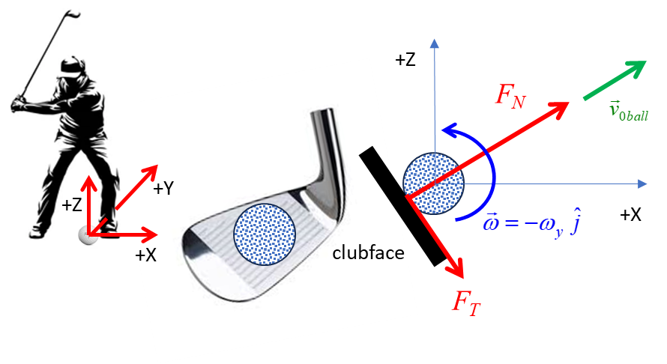
Backspin at impact

Rotation about the +Y axis:
VERTICAL LIFT
The spin loft angle determines the backspin imparted to the ball at impact. You can think of spin loft as a measure of 'ball compression'.

Rotation about the +Z axis:
HORIZONTAL CURVATURE

High spin rates are generated by a combination of high club head speed, high loft of the club, and large attack angle.

The spin axis tilt angle A_{spinAxis} is often called side tilt or spin axis angle. The spin axis tilt angle is the angle of the of the angular velocity vector measured with respect to the Y-axis (relative to the horizon) immediately after separation of the ball from the club face.
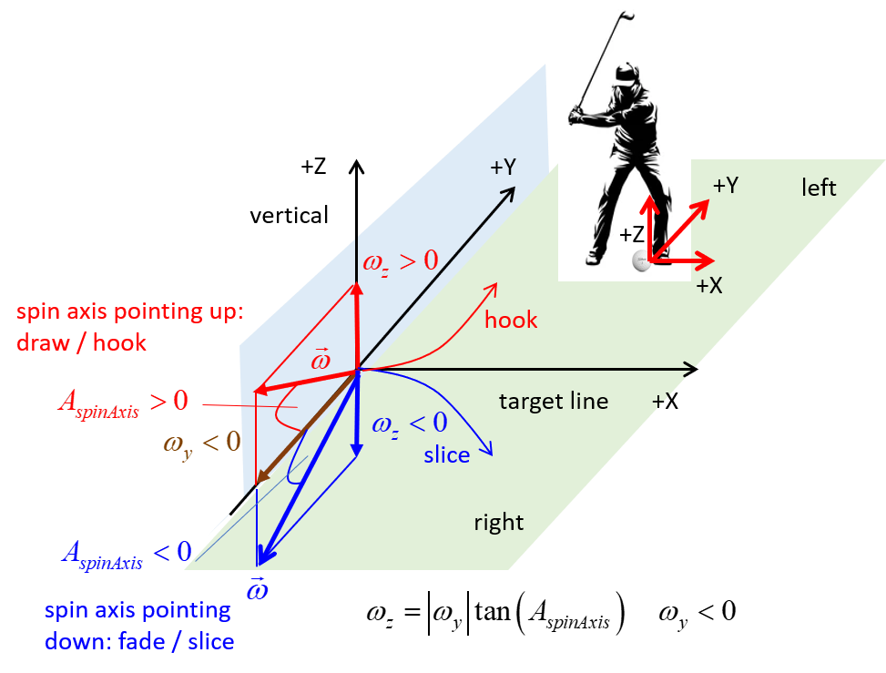

The spin axis tilt angle A_{spinAxis} defines the direction of the ball's rotation.
If you know the backspin and the spin axis tilt angle A_{spinAxis}, then you can predict the sidespin

The spin axis tilt angle A_{spinAxis} depends on: the face-to-path angle A_{facePath}, the spin loft angle A_{spinLoft}, the friction between club face and ball, ball compression, gear effect G, (strike location, club head centre of mass), club speed, lie of the ball, ball position.

face-to-path angle
usually

Spin loft angle

A rough approximation for the spin axis tilt angle A_{spinAxis} is
Spin axis tilt
where k is a proportionally constant (depends on strike/friction/ball compression ( k ~ 0.6 – 1.2).

VERTICAL MOTION OF THE GOLF BALL

BACKSPIN
Spin around the Y-axis and the Magnus force

The backspin component is the rotation around a horizontal axis (Y-axis) that runs perpendicular to the target line. The backspin is produced by the ball rolling across the face of the club at impact due to the tangential friction force between the club head and the golf ball. It is the backspin that gives the lift force which can enhance the height and length of the ball's flight. Also, it is the ball’s backspin that helps the ball stop quickly on the green.

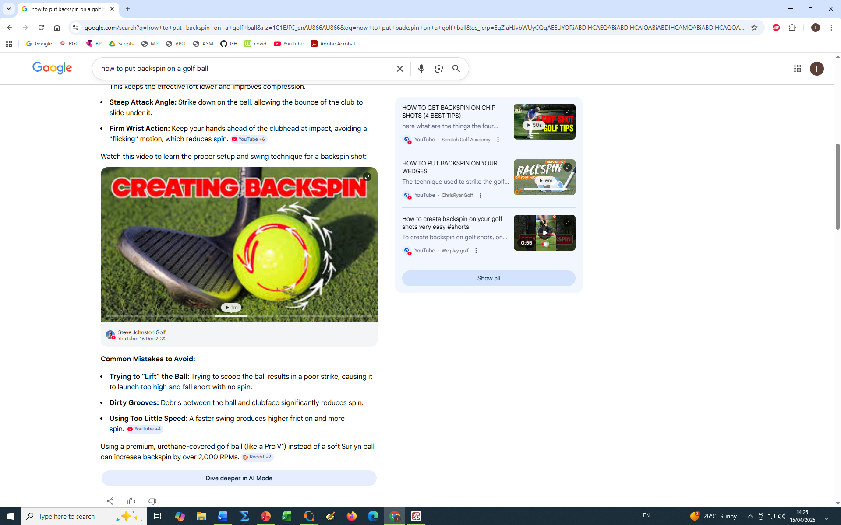

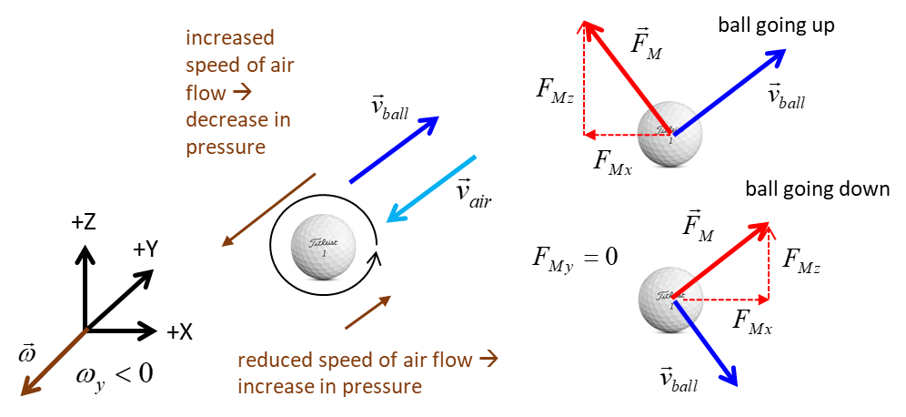

The Magnus force is created by the pressure gradient across the spinning ball and its direction is perpendicular to the direction the ball is travelling. The Magnus force can be resolved into two perpendicular components. If backspin is applied to the ball, then the two components of the Magnus force are the lift and the drag.
LIFT
BALL GOING UP: Magnus force enhances the drag and it is directed in the -X direction.
BALL GOING DOWN: Magnus force weakens the drag and is directed in the +X direction

The backspin imparted to the golf ball generates upward lift, counteracting gravity and extending the ball’s flight time. However, the spin also generates a force opposing the motion of the ball when it is rising. Thus, for maximum range there is an optimal spin rate that is not too low or too high.
higher spin loft → more backspin
greater club head speed more backspin

For the simulations, the backspin of the ball at impact can be found using recorded Trackman data directly or by using the empirical relationship that predicts the backspin as a function of the clubhead speed at impact and the loft of the club. The empirical relationship was found by fitting the Trackman data for club head speed and the static loft to give the best fit relationship. The relationships for woods and irons are different. For woods with static loft less than 18.3º a linear relationship is used but for irons where the static loft is greater than 18.3º a sine function relationship is used. The Python Code golf3DC.py for the backspin is
#%% BACKSPIN PREDICTION FROM TRACKMAN DATA
loftD = array([8,14,17,19,20,23,26,30,35,39,45])
vClubM = array([115,110,106,100,98,96,94,92,89,87,84])
loft = np.radians(loftD)
vClub = 1.6*vClubM
wP = array([2545,3663,4322,4404,4782,5280, 6204,7124,8078,8793,9316])
slope = (wP[2]-wP[0]) / (loftD[2]-loftD[0])
b = wP[0] - slope*loftD[0]
w = 118*vClub*sin(loft) - 1600
w[loftD < 18.3] = slope * loftD[loftD < 18.3] + b

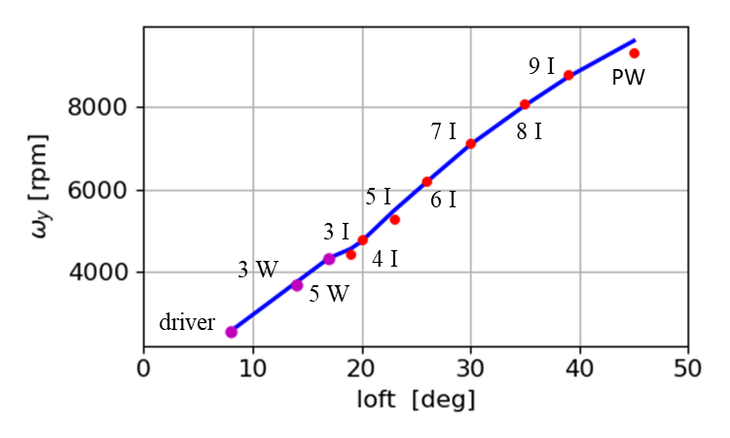
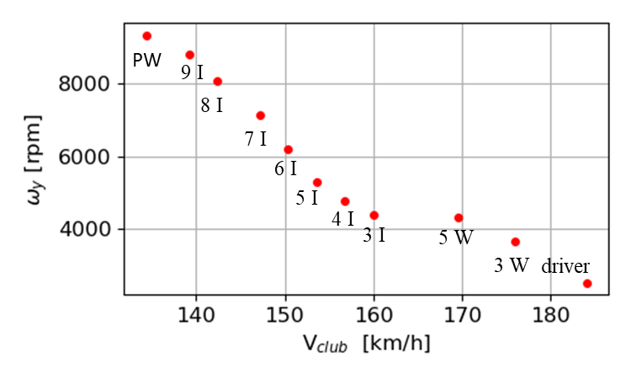
Hitting up with a driver increases launch speed and lowers spin.
Hitting down with irons decreases launch speed and increases spin.
Impact Point: Centre hits produce optimal results. Heel strikes tend to induce spin that causes curvature to the left, while toe strikes induce curvature to the right. The driver has the lowest loft, greatest club head speed, and the lowest backspin. The pitching wedge has the greatest loft, lowest club head speed, and the largest backspin.

HORIZONTAL MOTION OF THE GOLF BALL
CURVE: SIDESPIN
straight hits, draws and hooks, fades and slices

The horizontal motion of the golf ball is highly dependent upon a combination of parameters such as club face angle, club path and contact area of ball on club. The sidespin impacted to the ball at impact is responsible for the horizontal curvature of the ball in flight.
Understanding how golf physics works is the secret to controlling your ball flight. The sidespin is a result of the tilting the ball's spin axis, which is primarily dictated by how open or closed your club face is relative to the swing path, combined with your club speed.

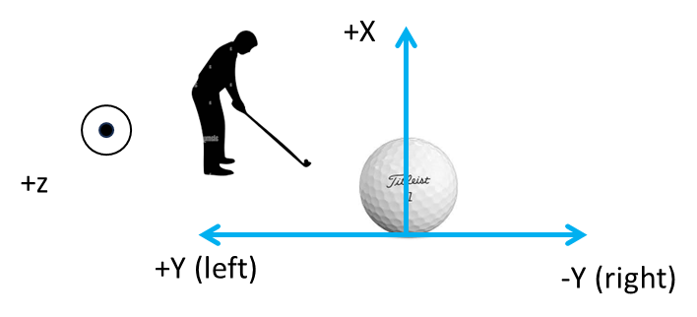

The difference between club face and club path determines the tilt of the spin axis, and that tilt decides the curve.

Gear effect G
Spin axis tilt
where G is the gear effect (off-centre hits: toe or heel) ( k ~ 0.6 to 1.2. the greater the club head speed, the greater the value of k. The gear effect parameter G depends on the distance d from the sweet stop to the contact point and the moment of inertia of the club head
G > 0 heel hit draw / hook
G > 0 heel hit draw / hook

bigger face-to-path angle
more spin axis tilt more sidespin greater curvature

bigger spin loft
more backspin (stabilizes the ball) less spin axis tilt
smaller curvature
wedges: high spin loft → less curvature
driver: low spin loft → more curvature

Draw / Hook: The ball spins anticlockwise around the Z-axis and the tilt of the spin axis is in the +Z direction (up ). At impact, the club face is closed (face-to-path angle).
When club face is pointed to the left of the swing path, the tilt of the spin axis creates draws and hooks. To hit a draw, aim slightly right of the target with an in-to-out swing path, but closing the face relative to that path.
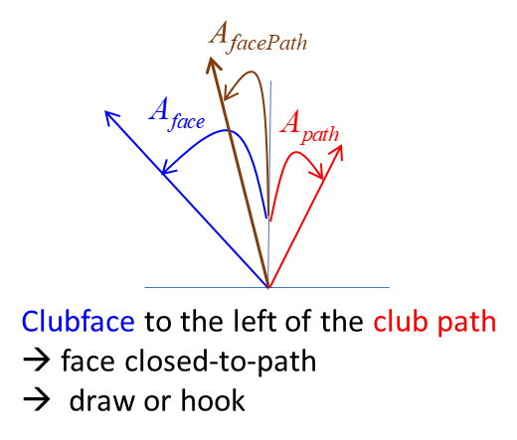
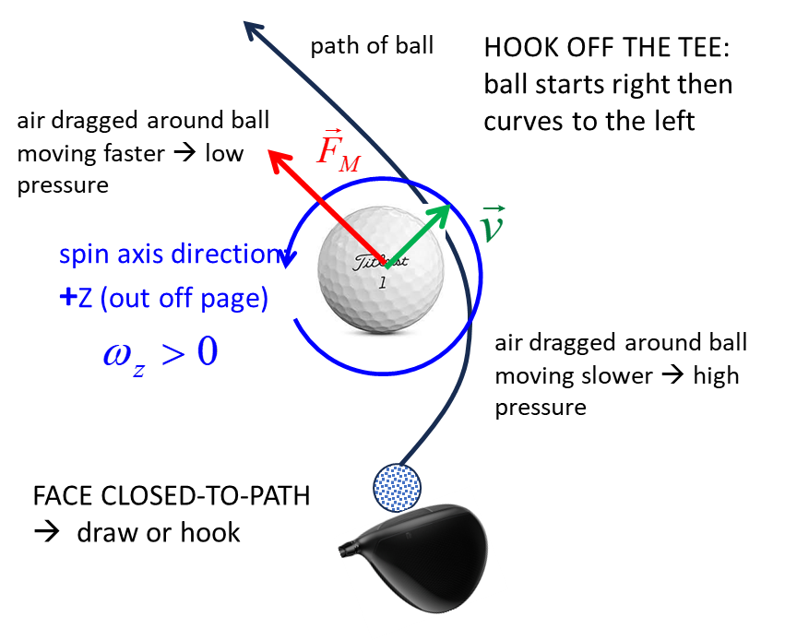

Fade / Slice: The ball spins clockwise around the Z-axis and the tilt of the spin axis is in the -Z direction (down ). At impact, the club face is open (face-to-path angle ).

When the club face is pointed to the right of the swing path, the tilt of the spin axis creates a fades and slices. If your path is swinging to the right but your face is aiming even further right, the ball will curve to the right. To hit a Fade, aim slightly left of the target with an out-to-in swing path, but leaving the face slightly open to that path.
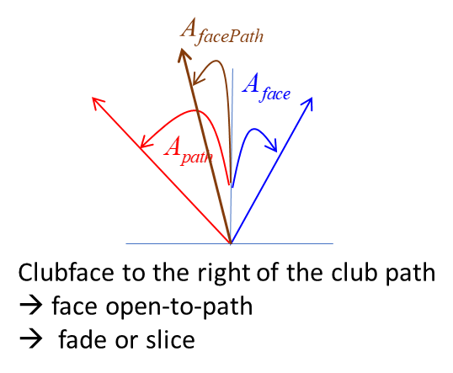
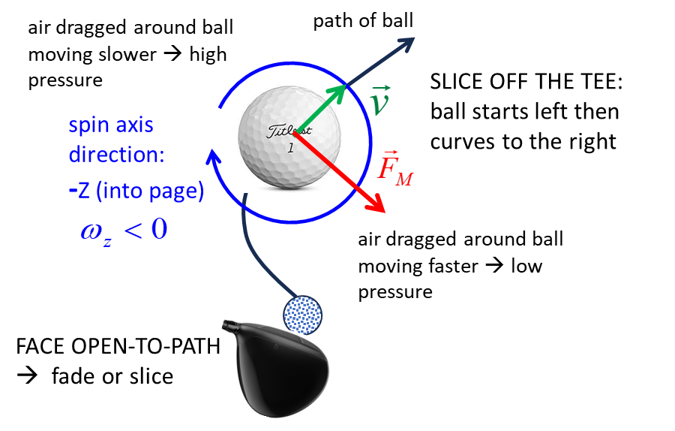

https://www.youtube.com/watch?v=yUp6R8pBYaU

When a ball hits the toe or heel of a driver, the clubhead twists, imparting spin to the ball. A toe hit produces a draw, while a heel hit produces a fade, which often contradicting the swing path.

You don't need a perfectly zero face-to-path angle to play great golf. In fact, most PGA Tour players intentionally use a small face-to-path angle (around 1° to 3°) to shape the ball with a reliable draw or fade, rather than trying to hit a perfectly straight shot every time.
Most teaching professionals recommend keeping the face-to-path angle within the range ±2° for tightly controlled shots.,

Many golfers look at the curve instead of the start line — but the start line is the #1 diagnostic tool in the game. Improving the club face angle, club path angle and face-to-path-relationship can lead to a 5-10 reduction in your handicap.

LANDING: BALL HITTING THE GROUND
Displacement on landing
Final velocity of ball (landing) [m.s⁻¹]
Landing angle (descent angle) [deg]
The golf landing angle, or descent angle , is the vertical angle at which the ball strikes the ground relative to the horizon. It is a critical factor for "stopping power" on greens, with a steeper angle allowing the ball to stop faster. If the landing angle falls below 45 degrees , the ball is more likely to bounce and roll excessively, making it harder to control on firm greens.
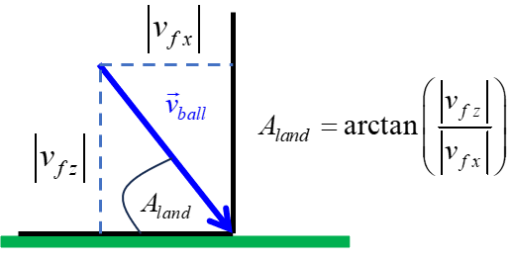
Typical Landing Angles
Driver: 35º–40º, aiming for maximum carry and roll.
7-Iron: A good, controlled landing angle is around 45º–50º
Wedges: Often exceed 50 degrees for maximum stopping power on greens. Higher lofted clubs naturally create higher launch angles and lower horizontal velocity, resulting in steeper landing angles . Higher backspin keeps the ball in the air longer (increases peak height) and creates a steeper descent. Hitting a fade generally produces a higher peak height and steeper landing angle, while a draw creates a lower, shallower trajectory.

WHY DO GOLF CLUBS HAVE GROVES ON THEIR FACE ?
Golf clubs have grooves on the face primarily to improve control and consistency. The groves help create the conditions to achieve spin and produce predictable shots. The main reasons grooves exist are:
1. Channel Away Grass, Water, Dirt
When the ball is struck from the fairway, rough, or wet conditions, debris can get trapped between the ball and club face. Grooves act like tyre tread: they help move moisture and grass away so more of the club face contacts the ball. Without grooves: less friction, more slipping at impact, lower spin, and less control.
2. Increase Friction for Spin Control
Especially on wedges and short irons, grooves help the cover of the ball grip the face during the tiny contact time (~0.5 ms). This helps generate backspin, which allows for shots to stop quickly on greens, more predictable pitch/chip shots, and better distance control .
3. Consistent Performance from Rough
From long grass, a smooth face would slide under the ball unpredictably. Grooves help maintain some spin even when grass is present.

Spin is created by tangential friction force during collision:
$$τ=rF_{t}$$where is the applied torque on ball, $r$ is the ball radius, and $F_{t}$ is the tangential friction force. Grooves help preserve that tangential friction force in real playing conditions.

On a perfectly clean, dry lie, a completely smooth face could sometimes create similar spin to grooves. Grooves matter most when conditions are imperfect.

Drivers are designed for launch and low spin, so deep grooves are less important than on wedges.

You often get “high-flyers” when hitting out of the rough, especially if the grass is damp. The grass between club face and ball lubricates the contact, allowing more sliding to take place. The results are less spin, and a much higher launch angle, because of the reduced friction on the face the ball slides upwards more. Therefore, the ball takes off much closer to the direction the club face is pointing.

HITTING A GOLF BALL
Metric | What it controls | How it affects spin axis
Club head Path | Curve direction | Sets the reference direction for face-to-path
Club face | Start line | Determines whether spin axis tilts up or down
Face-to-Path | Curve amount | Larger difference more tilt more curve
Spin Axis Angle (tilt) | Actual curvature | Tilt up draw/hook; tilt down fade/slice

- Push-slice → face right, path even more right (face open to path).
- Pull-hook → face left, path even more left (face closed to path).
- Straight pull → face and path both left, matched.
- Straight push → face and path both right, matched.

SIMULATIONS golf3D02.py
The default parameters for the simulations are taken from the statistics of PGA golfers (Table 1). By varying the input parameters, you can model most types of commonly played golf shots. The model predictions can used to compare the flights of the golf ball for PGA golfers and amateur golfers. Through the stimulations you can learn how to control of the ball’s spin and it is the spin that determines the flight.

INPUTS (parameters that a golfer can control)
v_{club} speed of golf club at impact
A_{staticLoft} static loft angle of club (club selection)
S smash factor (contact point of ball on club)
A_{face} club face angle at impact
A_{path} path of club at impact
A_{attack} attack angle at impact
A_{shaftLean} shaft lean at impact
G gear effect angle (toe / heel hits)

OUTPUTS (model calculations)
face-to-path-angle
Dynamic loft angle
Vertical launch angle
Horizontal launch angle
Spin loft angle
Spin axis tilt angle
Backspin
Sidespin
Landing (decent) angle
Functions of time:
flight time max(t), displacement (x, y, z), landing position (), carry C, range R = x_{F} , lateral shift y, maximum height max(z), velocity (), acceleration (), backspin , sidespin , drag force (), Magnus force ().

SIMULATION 1 So, why do we need all these golf clubs?
How good are the model predictions?
Golfers carry up to 14 clubs used for different distances, lies, and course conditions. Each club has a unique loft, length, and weight designed to hit the ball a specific distance and trajectory, allowing for precise shots from tee to green rather than trying to force one club to do everything.

We can simulate the flight of a golf ball hit from the driver to the pitching wedge using the data obtained from the web on the averages for players on the PGA tour.

Table 2 summaries the results of the simulations for the golf clubs from driver to pitching wedge. The model predictions are in close agreement with the published data for male PGA touring professionals. The simulations also predict very well the progressively increasing carry distance from the pitching wedge to the driver. The driver produces the largest carry, greatest maximum height, the smallest landing angle and the biggest increment in carry between adjacent clubs.

Table 2: Data (PGA professional male golfer) and simulated predictions for different golf clubs.
speed of club at impact, v_{club}
launch speed of ball, v_{ball}
vertical launch angle, A_{vert}
loft of club, loft
smash factor S
initial Y-axis spin , |rpmY|
azimuthal angle, spin axis angle,
range max(x), R max high, H flight time,
landing (descend) angle, A_{land}

Driver
v_{Club} = 184 kph loft = 8º S = 1.49 A_{vert} = 10.4º v_{ball} = 76.2 m.s⁻¹
R = 246 m (258) H = 31.0 m (32) A_{land} = 41º (39º)
|rpmY| = 2545 rpm (2545) = 7.3 s

3-wood
v_{Club} = 176 kph loft = 35º S = 1.47 A_{vert} = 9.3º v_{ball} = 71.9 m.s⁻¹
R = 225 m (228) H = 28.9 m (29) A_{land} = 42º (44º)
|rpmY| = 3729 rpm (3663) = 7.1 s

5-wood
v_{Club} = 170 kph loft = 17º S = 1.47 A_{vert} = 9.3º v_{ball} = 69.4 m.s⁻¹
R = 214 m (214) H = 29.1 m (26) A_{land} = 44º (48º)
|rpmY| = 4321 rpm (4322) = 7.0 s

Hybrid
v_{Club} = 163 kph loft = 19º S = 1.47 A_{vert} = 10.2º v_{ball} = 66.6 m.s⁻¹
R = 203 m (211) H = 28.2 m (28) A_{land} = 44º (49º)
|rpmY| = 4321 rpm (4715) = 6.8 s

3-iron
v_{Club} = 160 kph loft = 18º S = 1.46 A_{vert} = 10.3º v_{ball} = 64.9 m.s⁻¹
R = 198 m (199) H = 26.4 m (27) A_{land} = 43º (48º)
|rpmY| = 4519 rpm (4404) = 6.8 s

4-iron
v_{Club} = 157 kph loft = 21º S = 1.44 A_{vert} = 10.8º v_{ball} = 62.8 m.s⁻¹
R = 189 m (192) H = 26.4 m (28) A_{land} = 44º (49º)
|rpmY| = 5095 rpm (4782) = 6.6 s

5-iron
v_{Club} = 154 kph loft = 23º S = 1.41 A_{vert} = 11.9º v_{ball} = 60.3 m.s⁻¹
R = 179 m (182) H = 26.6 m (30) A_{land} = 45º (50º)
|rpmY| = 5561 rpm (5280) = 6.5 s

6-iron
v_{Club} = 150 kph loft = 26º S = 1.39 A_{vert} = 14.0º v_{ball} = 57.9 m.s⁻¹
R = 169 m (172) H = 28.5 m (29) A_{land} = 47º (50º)
|rpmY| = 6225 rpm (6204) = 6.5 s

7-iron
v_{Club} = 147 kph loft = 30º S = 1.34 A_{vert} = 16.1º v_{ball} = 54.7 m.s⁻¹
R = 155 m (161) H = 28.9 m (31) A_{land} = 48º (51º)
|rpmY| = 7146 rpm (7124) = 6.3 s

8-iron
v_{Club} = 142 kph loft = 35º S = 1.33 A_{vert} = 17.8º v_{ball} = 52.5 m.s⁻¹
R = 146 m (150) H = 29.0 m (30) A_{land} = 48º (51º)
|rpmY| = 8092 rpm (8078) = 6.2 s

9-iron
v_{Club} = 139 kph loft = 39º S = 1.29 A_{vert} = 20.0º v_{ball} = 49.8 m.s⁻¹
R = 137 m (139) H = 28.6 m (29) A_{land} = 49º (52º)
|rpmY| = 8810 rpm (8793) = 6.1 s

PW-iron
v_{Club} = 134 kph loft = 45º S = 1.24 A_{vert} = 23.7º v_{ball} = 60.3 m.s⁻¹
R = 124 m (130) H = 28.6 m (29) A_{land} = 50º (52º)
|rpmY| = 9676 rpm (9316) = 5.9 s
The trajectories of a golf ball: irons 6, 5, 4, 3, hybrid, woods 5, 3, and driver (from left to right: decreasing loft). Apart from the driver, the incremental range between clubs is relatively constant and the maximum height reaches by the ball in flight is also relatively constant (H ~ 30 m). The landing angle A_{land} is steeper the higher the loft of the club.
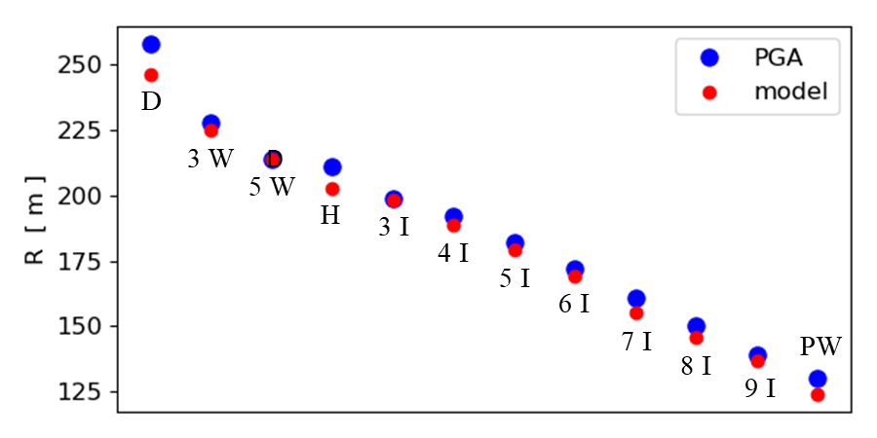
The range R for the PGA professional and the model prediction.

The model is very good at predicting the range of the golf ball as the type and loft of the golf club is varied. Considering that the values of C_{D} and C_{L} are only approximated and that the PGA data are average value, there is an excellent agreement of the model predictions and the real-life data. So, we can have confidence that the predictions of the model are realistic.

Why does the length of the golf club make a difference?
Golf club length directly impacts distance, accuracy, and control by changing the swing arc and leverage. Longer clubs provide the potential for greater club head speed, but shorter clubs provide better control (greater accuracy).
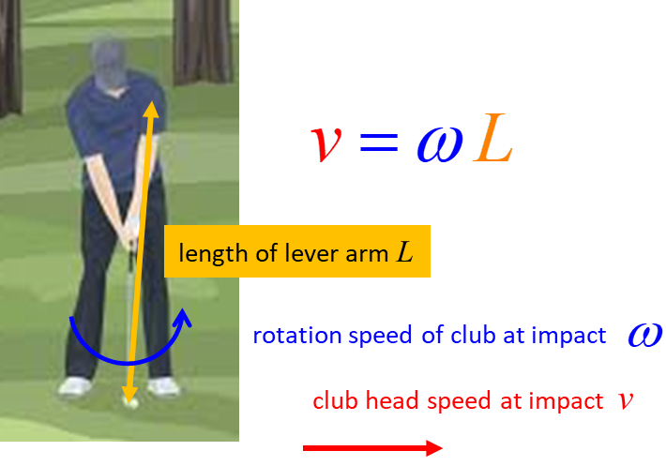

The standard incremental variation in the lengths of irons is designed to allow for a consistent swing feel while offering a gradual change in distance.

Generally, a longer shaft (like in a driver) creates a wider arc with greater lever arm L for greater club head speed at impact. Wedges with shorter shafts allow for a more upright consistent stance and more precise centred hits.

The tempo of the swing is related to the rotational speed of the club head . The length of the swing arc is determined by the length of the club and arm system L. The speed of the club head is v is determined by the product of the rotational speed and the length of the lever arms L
So, for a given tempo , a longer club and/or longer arms means greater club head speed. Tall players with longer arms have an advantage because they can have greater club head speed and therefore, hit the ball further. As a club gets longer, it feels heavier, which can alter your tempo.

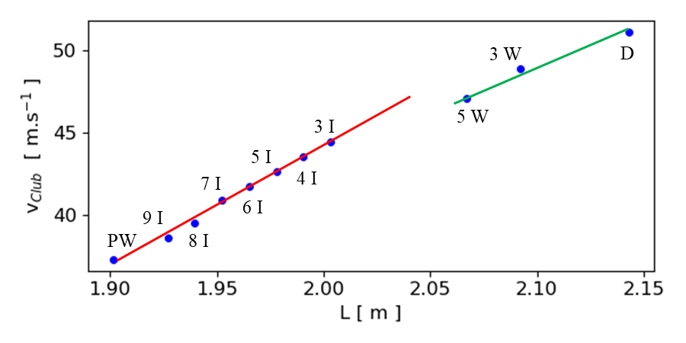
Plot of v_{club} vs L for PGA golfers (golf3DC.py). The slope of the straight lines is equal to the rotational speed at impact. PGA golfers have a consistent swing tempo but with a slower rotational speed for woods compared to hitting their irons.

SIMULATION 2 DYNAMICS FOR HITTING A 7-IRON
We can model the trajectory for a 7-iron and analyse the dynamics of the motion in great detail.

Typical data for the average PGA Tour professional hitting a 7-iron:
- Club head speed ~ 147 km.h⁻¹
- Attack angle -3º to – 5º (this descending blow ensures crisp contact, compressing the ball first before the club interacts with the turf. This creates the optimal launch angle and high spin rate required to hold greens).
- Forward shaft 6º to 10º (this amount of lean effectively delofts the club creating a lower dynamic loft and helps to give a downward angle of attack). If a golfer lacks this shaft lean, the clubhead will pass the hands too early (often called "flipping"), causing weak, high ballooning shots or fat contact behind the ball.

Amateur golfers, by contrast, tend to have much flatter or more positive attack angles, often sweeping the ball or even hitting slightly upward. While a steep -5° works beautifully for tour pros, amateur golfers, especially those with slower swing speeds often benefit from a slightly shallower attack angle (around -1° to -3°) to maximize carry distance and achieve the ideal peak height for stopping power.
Console summary for PGA male golfer (default values)
Inputs
vClub = 147.0 km/h S = 1.34 Static loft = 30.0 deg
Aface = 0.0 deg Apath = 0.0 deg
AshaftLean = -10.0 deg Aattack = -5.0 deg Gear Effect G = 0.0 deg

Outputs: Launch parameters
v0 = 54.72 m/s Avert = 16.2 deg Adir = 0.0 deg
Initial spin [rpm]: backspin rpmY = -7146 sidespin rpmZ = 0
AfacePath = 0.0 deg AdynamicLoft = 20 deg
AspinLoft = 25.0 deg AspinAxis = 0 deg

Outputs: flight of golf ball
flight time = 6.3 s max height = 29.1 m
Carry = 155 m Range = 155 m
lateral shift = 0.0 m
Landing angle = 48 deg

The flight of the golf ball can be examined in detail by graphical means as shown by the following plots for a male PGA golfer hitting a 7-iron.
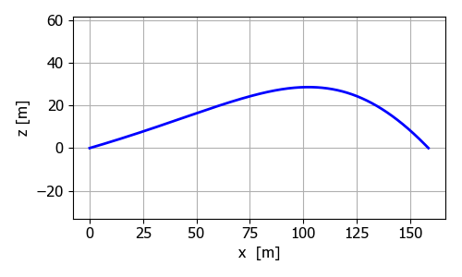
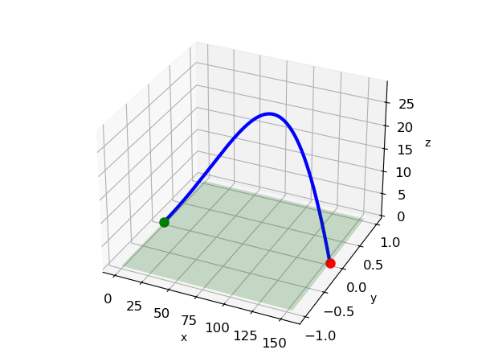
XZ trajectory and [3D] view of trajectory of the golf ball struck by a PGA golfer using a 7-iron. The trajectory is characterised by the slow rise in the height of the ball due to the lift force exceeding the gravitational force and then the more rapid decline in the height after the peak height is reached.
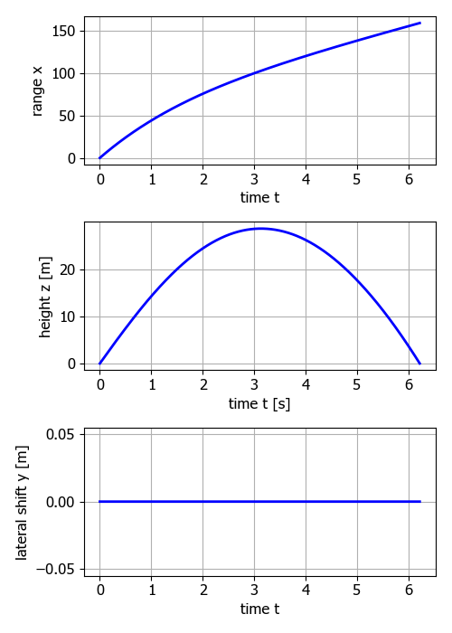
Displacement components for flight of the golf ball (7-iron).
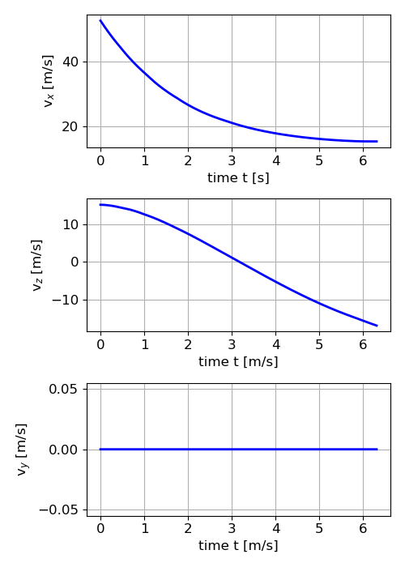
Velocity components of golf ball (7-iron).

The maximum height of the golf ball occurs when the vertical velocity is zero (v_{z} = 0). While the ball is rising there is a more rapid decrease in the horizontal velocity v_{x} then when the ball is falling. This is caused by horizontal component of the Magnus force retards the horizontal motion only when the ball is going up.
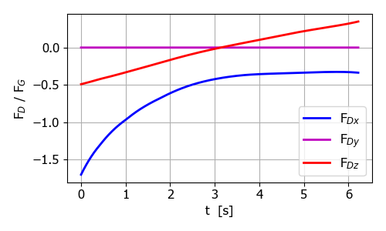
Drag force F_{D} acting on golf ball compared to F_{G}.

The magnitude || decreases as the v_{x} decreases during the flight of the golf ball. F_{Dz} is negative when the ball is rising and positive as the ball falls. That is, the drag force always opposes the motion whether the ball is going up or down.
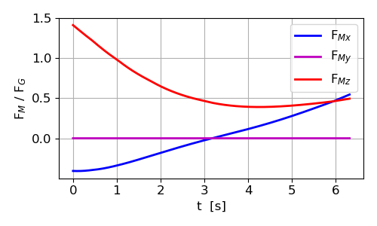
Magnus force F_{M} acting on golf ball compared to F_{G}.
As the ball is rising, the x component of the magnus F_{Mx} is negative, thus it opposes the horizontal motion of the ball. However, when the ball is falling, the x component of the Magnus force F_{Mx} acts to accelerate the ball in the +X direction. At first, the z component of the Magnus force is greater than the weight of the golf ball. This is why a golf ball can fly much further than when only the gravitational force acts upon the ball. This is an observable phenomenon – you often see the ball climb upwards after hitting the ball.

Simulation 7-iron shot 18 handicap golfer
Inputs
vClub = 128.0 km/h S = 1.30 Static loft = 30.0 deg
Aface = -1.0 deg Apath = 1.0 deg
AshaftLean = -5.0 deg Aattack = -1.0 deg Gear Effect G = 0.0 deg

Outputs: Launch parameters
v0 = 46.22 m/s Avert = 21.1 deg Adir = -0.5 deg
Initial spin [rpm]: backspin rpmY = -6016 sidespin rpmZ = -430
AfacePath = -2.0 deg AdynamicLoft = 25 deg
AspinLoft = 26.0 deg AspinAxis = -4 deg

Outputs: flight of golf ball
flight time = 5.7 s max height = 25.1 m
Carry = 128 m Range = 127 m
lateral shift = -5.4 m right
Landing angle = 47 deg
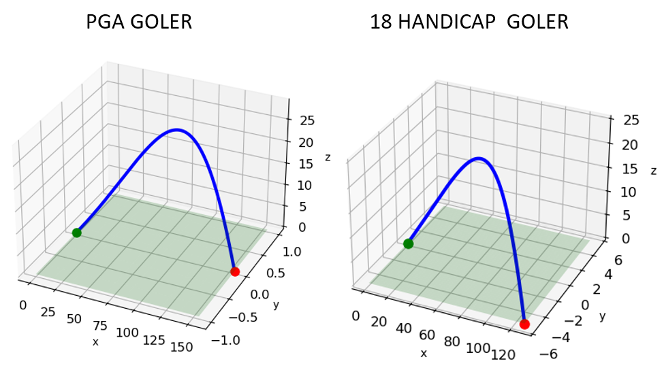
The 18-handicap golfer does not hit the ball straight on average compared to a PGA golfer because of the non-zero club face and club path angles. The range for the 18-handicpap golfer is less than the PGA golfer (127 m < 155 m) because of the lower club head speed (128 km.h⁻¹ < 147 km.h⁻¹) and lower smash factor (1.30 < 1.34).

SIMULATION 3 STRAIGHT HITS, PULLS AND PUSHES
The launch direction angle A_{dir} refers to the horizontal angle left or right of the target line immediately after impact. The launch angle is scientifically known as the azimuth angle. Sometimes the angle is called the horizontal launch angle.
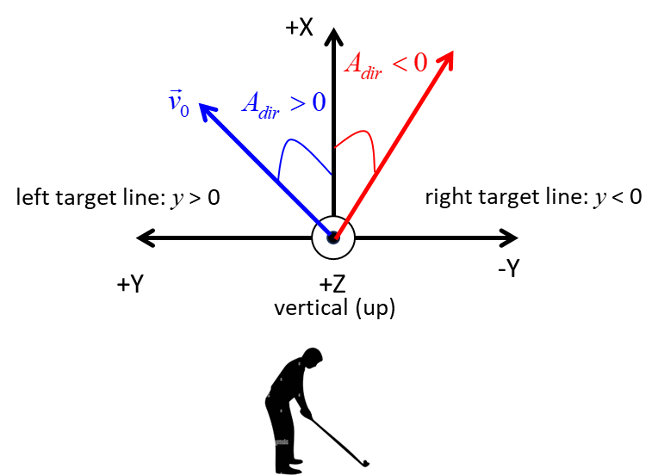
The launch direction is determined by a combination of the club's face angle (where the clubhead is pointing) and the club (swing) path (the direction the clubhead is moving).

A straight hit along the target line, or a straight hit to the left (pull) or a straight hit to the right (push) occurs when the club face angle and the club path angle are equal.

The important parameter for straight hits is the face-to-path angle.
When A_{facePath} = 0, then spin axis tilt angle is also zero, A_{spinAxis} = 0.

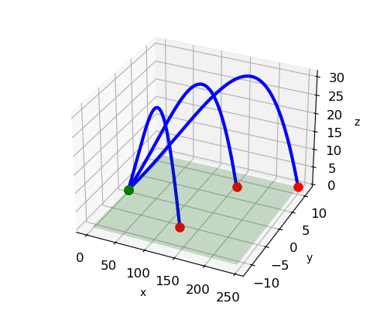
The [3D] trajectories: Driver (pull to the left – closed club face and club path out-to-in): A_{dir} = 2.5º m), 7-iron (pull to the left– closed club face and club path out-to-in: A_{dir} = 2.5º m), and pitching wedge (push to the right – open club face and club path in-to-out / over-the-top: A_{dir} = -2.5º m).

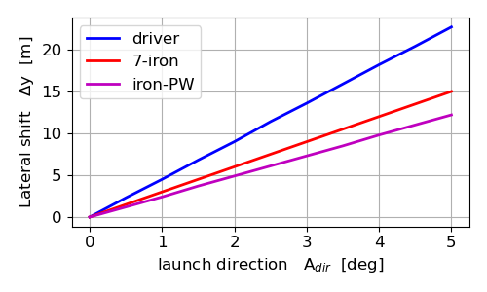
The lateral shift as a function of the launch direction A_{dir} for the driver, 7-iron, and pitching wedge. The lateral shift is proportional to the launch angle .

To hit an accurate straight shot within 4.00 m of the target line requires the club face angle to be equal to the club path angle and the launch direction A_{dir} to be less than: driver 0.9º, 7-iron 1.3º, pitching wedge 1.6º. The golf shot is very sensitive to the launch direction angle. So, you can see that it is not an easy task to hit a straight shot, especially with the driver. To improve your accuracy then it is most important to have the club face square to the target line and the club path also along the target line.

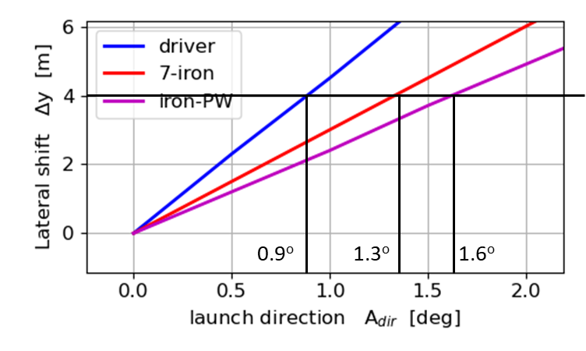

SIMULATION 4 LAUNCH ANGLE A_{vert}
We can ask the question – how important is the launch angle in determining the carry of the golf ball !!!

The launch angle (vertical launch angle) A_{vert} is the vertical angle which the ball is launched relative to the grounds. The following diagram shows the parameters that determine the launch angle of the ball.
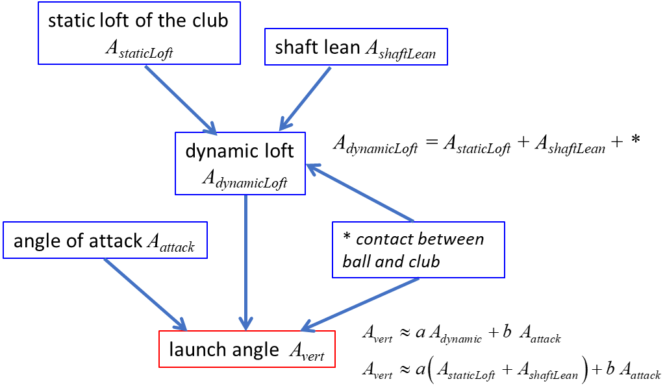

The vertical launch angle A_{vert} is usually much closer to the static loft A_{staticLoft} then either the angle of attack A_{attack} or shaft lean A_{shaft} and can be approximated by
Irons:
Driver:
General:
With a driver, the ball tends to follow loft more strongly than with irons.

The ball does not launch exactly at the club face angle because:
- Ball compresses on face
- Friction changes vertical force vector
- Collision time deforms ball/club
- Gear effect can alter spin and launch slightly

To Increase Launch Angle
- Use club with higher static loft
- Reduce forward shaft lean
- Hit more upward
- Driver: tee the ball higher

To Lower Launch Angle
- Use club of lower static loft
- Hit more downward
- Driver: tee the ball lower

Ball Position: Playing the ball further forward in your stance (closer to your lead foot) naturally encourages an upward angle of attack, resulting in a higher launch. Conversely, playing it back in the stance produces a lower launch angle.

Strike Location: Hitting the ball higher on the club face (higher on the "sweet spot") generally increases launch angle and reduces spin due to gear effect. Hitting it low on the face yields a lower launch.

Shaft Flex (bending): A shaft that is too flexible for your swing speed will bend during the downswing, effectively adding dynamic loft and increasing the launch angle. A shaft that is too stiff will resist this bending, leading to a lower launch. Also factors like wrist hinge and swing path play a minor role.

To answer this question, we can consider simulations for the carry for the driver, and 7-iron as a function of the launch angle.

7-iron
Varying the vertical launch angle from 10º to 20º does not have any noticeable effect on the carry . Increasing the launch angle increases the maximum height of the ball in flight . So, to make the ball go higher in the air, you need to increase the launch angle by having less shaft lean towards the lead foot, decrease the angle of attack to hit more up on the ball, and play the ball more forward in the stance.

The descent angle A_{land} is very dependent upon the launch angle . The carry does not vary greatly with the launch angle but with a lower launch angle it gives a smaller descent angle which may give the ball more roll when the ball hits the ground and hence greater distance off the tee.

DRIVER With the driver than is an optimal launch angle of about 14º to give the greatest carry. The carry C decreases rapidly for launch angles greater than the optimal angle. Sometimes, with the driver you hit under the ball giving it a large launch angle and the ball does not carry very far.
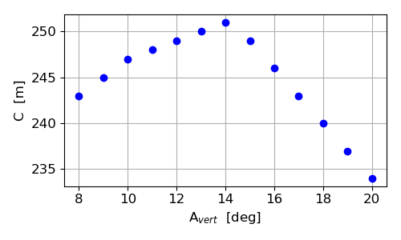
As the launch angle increases from 8º to 20º the maximum height increases from 24.8 m to 55.2 m, and the descent angle increases from 37º to 49º. A smaller launch angle may result in the ball rolling more after landing giving an increase in the distance from the tee because of a smaller descent angle.
SIMULATION 5 DRAWS AND HOOKS
The ball’s curvature is largely determined by the relationship between the club path angle (the direction the club is moving) and the club face angle (where the club is pointing) at impact.
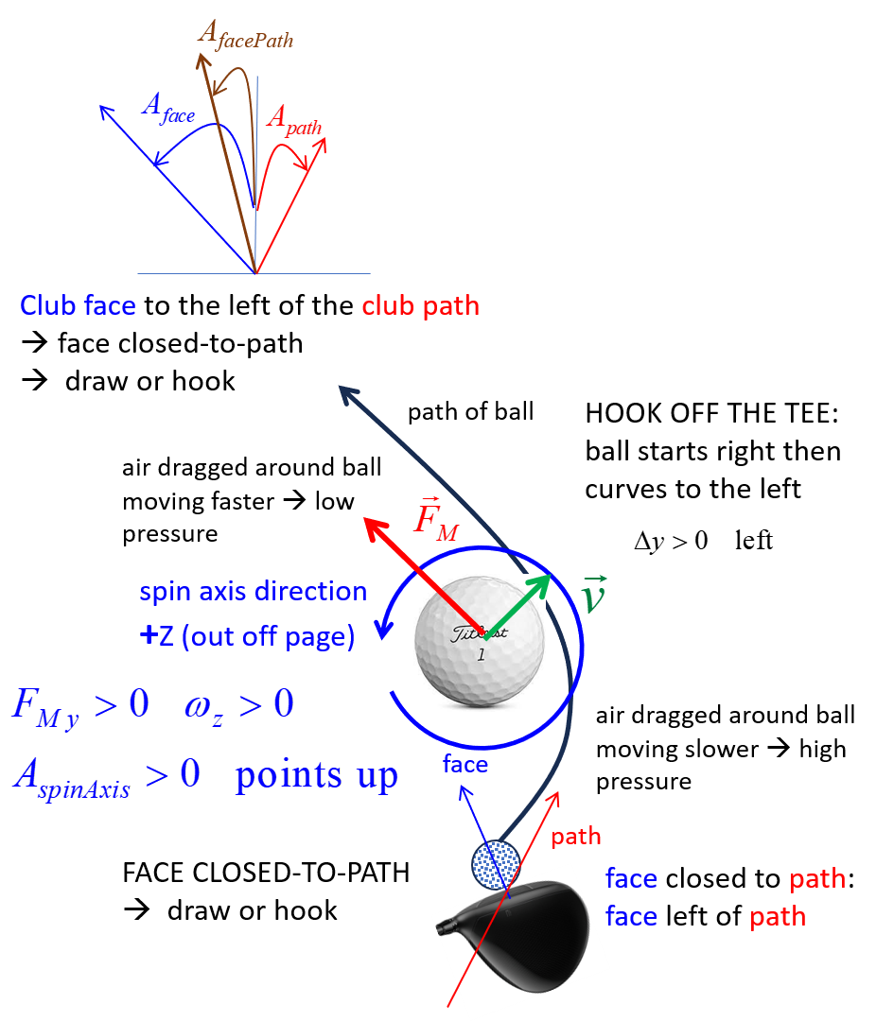
A draw is a controlled, playable shot that curves slightly from right to left, traveling further than a straight shot. A hook is an exaggerated, often accidental version of a draw that curves too sharply to the left, frequently missing your target.

Simulation 5.1 A big Hook with the Driver
Inputs
vClub = 184.0 km/h S = 1.50 Static loft = 10.0 deg
Aface = 0.5 deg Apath = -1.5 deg
AshaftLean = 0.0 deg Aattack = 1.0 deg Gear Effect G = 0.0 deg
Outputs: Launch parameters
v0 = 76.67 m/s Avert = 8.7 deg Adir = 0.0 deg
Initial spin [rpm]: backspin rpmY = -2939 sidespin rpmZ = 648
AfacePath = 2.0 deg AdynamicLoft = 10 deg
AspinLoft = 9.0 deg AspinAxis = 12 deg
Outputs: flight of golf ball
flight time = 7.0 s max height = 27.5 m
Carry = 241 m Range = 239 m
lateral shift = 26.5 m left
Landing angle = 41 deg

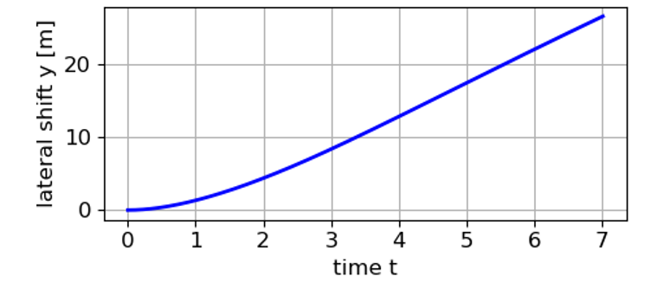

The driver is a difficult golf club to hit the ball straight along the target line. For even small angle for the club face (0.5º left) and club path (1.5º right) the ball when lands its lateral shift is 26.5 m to the left of the target line.

Simulation 5.2 A controlled draw with the Driver
Inputs
vClub = 184.0 km/h S = 1.50 Static loft = 10.0 deg
Aface = -2.0 deg Apath = -3.0 deg
AshaftLean = 0.0 deg Aattack = 1.0 deg Gear Effect G = 0.0 deg
Outputs: Launch parameters
v0 = 76.67 m/s Avert = 8.7 deg Adir = -2.2 deg
Initial spin [rpm]: backspin rpmY = -2939 sidespin rpmZ = 324
AfacePath = 1.0 deg AdynamicLoft = 10 deg
AspinLoft = 9.0 deg AspinAxis = 6 deg

Outputs: flight of golf ball
flight time = 7.1 s max height = 28.2 m
Carry = 243 m Range = 243 m
lateral shift = 3.7 m left
Landing angle = 40 deg
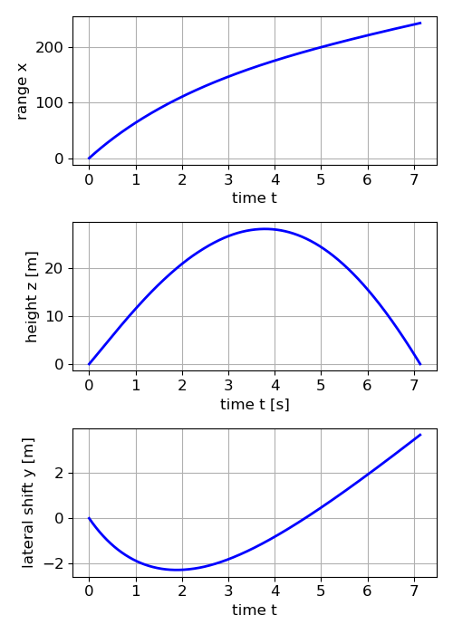
It is often better to try and hit a controlled draw than a straight shot. In this simulation the lateral shift is only 3.7 m left of the target line and the carry is 2 m further than for simulation 5.1 (lateral shift 26.5 m).

If we reverse the signs of the club face angle and the club path angle for a fade, then the fact-to-path angle has the same magnitude (1.0º) and the carry is the same (243 m) and the ball is deflected 3.7 m to the right (fade). In the simulations, the controlled draw and fade have the same carry. However, a draw often travels further than a fade because drawing the ball typically promotes a shallower angle of attack, a lower launch angle, and less backspin, which translates into more penetrating ball flight and greater roll upon landing.
Simulation 5.3 Gear Effect
What happens if you strike the toe of the club instead of the middle of the driver? This can result in a large gear effect and a reduced smash factor. The trajectory is now characterized by a savage hook and loss in distance off the tee.

Inputs
vClub = 184.0 km/h S = 1.40 Static loft = 10.0 deg
Aface = -2.0 deg Apath = -3.0 deg
AshaftLean = 0.0 deg Aattack = 1.0 deg Gear Effect G = 3.0 deg
Outputs: Launch parameters
v0 = 71.56 m/s Avert = 8.7 deg Adir = -2.2 deg
Initial spin [rpm]: backspin rpmY = -2939 sidespin rpmZ = 1295
AfacePath = 1.0 deg AdynamicLoft = 10 deg
AspinLoft = 9.0 deg AspinAxis = 24 deg
Outputs: flight of golf ball
flight time = 6.2 s max height = 21.3 m
Carry = 216 m Range = 213 m
lateral shift = 32.4 m left
Landing angle = 38 deg
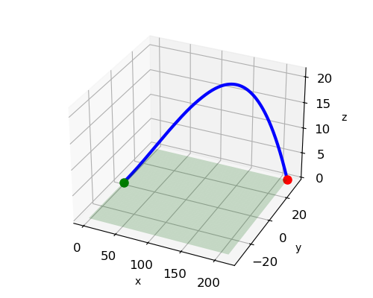
The lateral shift has increased from 3.7 m left to 32.4 m left. The carry has decreased from 243 m to 216 m.

Simulation 5.4 Draw with a pitching wedge
Inputs
vClub = 130.0 km/h S = 1.24 Static loft = 45.0 deg
Aface = 0.5 deg Apath = -1.5 deg
AshaftLean = 0.0 deg Aattack = -2.0 deg Gear Effect G = 0.0 deg
Outputs: Launch parameters
v0 = 44.78 m/s Avert = 38.0 deg Adir = 0.0 deg
Initial spin [rpm]: backspin rpmY = -9339 sidespin rpmZ = 304
AfacePath = 2.0 deg AdynamicLoft = 45 deg
AspinLoft = 47.0 deg AspinAxis = 2 deg
Outputs: flight of golf ball
flight time = 6.6 s max height = 42.2 m
Carry = 105 m Range = 105 m
lateral shift = 1.7 m left
Landing angle = 58 deg

The lateral shift with a pitching wedge is much less than the lateral shift for a driver for the same fact-to-path angle. This is because for the pitching wedge: slower club speed, much greater static loft, greater spin loft, and small carry.

SIMULATION 6 FADES AND SLICES
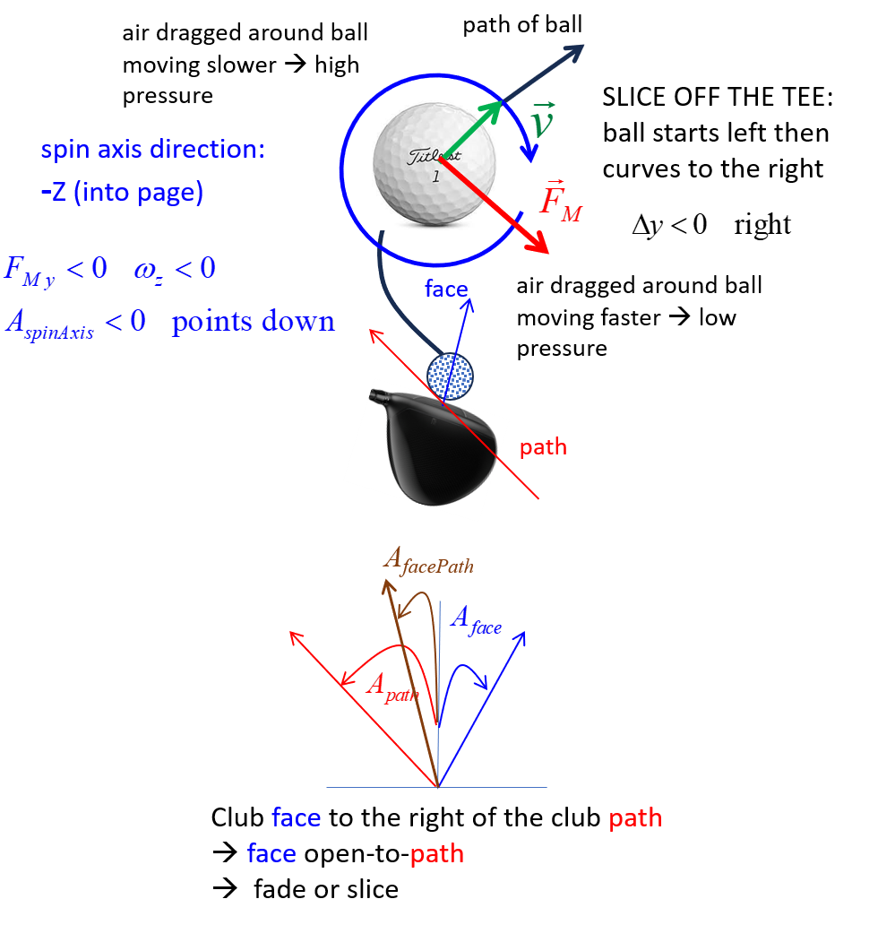

Simulation 6.1 Driver: 18-handicapper golfer
A carry 180 m for a driver by an18-handicapper golfer is typical.
Inputs
vClub = 152.0 km/h S = 1.40 Static loft = 12.0 deg
Aface = 0.0 deg Apath = 0.0 deg
AshaftLean = 0.0 deg Aattack = 0.0 deg Gear Effect G = 0.0 deg
Outputs: Launch parameters
v0 = 59.11 m/s Avert = 10.2 deg Adir = 0.0 deg
Initial spin [rpm]: backspin rpmY = -3334 sidespin rpmZ = 0
AfacePath = 0.0 deg AdynamicLoft = 12 deg
AspinLoft = 12.0 deg AspinAxis = 0 deg
Outputs: flight of golf ball
flight time = 5.7 s max height = 18.2 m
Carry = 180 m Range = 180 m
lateral shift = 0.0 m
Landing angle = 34 deg

A typical 18-handicapper is mostly inconsistent off the tee because they try to swing too fast thinking that the extra club head speed will give them more distance. This is usually not the case as shown in simulation 6.2:
- The ball is not struck at the centre of the club which reduces the smash factor and promotes the gear effect.
- The club face angle and club path are less aligned increasing the face-to-path angle.
Simulation 6.2 Swinging the driver too fast
Inputs
vClub = 160.0 km/h S = 1.30 Static loft = 12.0 deg
Aface = -2.0 deg Apath = 1.0 deg
AshaftLean = 0.0 deg Aattack = 0.0 deg Gear Effect G = -2.0 deg
Outputs: Launch parameters
v0 = 57.78 m/s Avert = 10.2 deg Adir = -1.2 deg
Initial spin [rpm]: backspin rpmY = -3334 sidespin rpmZ = -1367
AfacePath = -3.0 deg AdynamicLoft = 12 deg
AspinLoft = 12.0 deg AspinAxis = -22 deg
Outputs: flight of golf ball
flight time = 5.2 s max height = 15.6 m
Carry = 167 m Range = 164 m
lateral shift = -30.2 m right
Landing angle = 34 deg
By swinging too fast the carry is reduced from 180 m to 167 m and the lateral shift has increases from 0 m to 30 m to the right of the target line.
Bending the ball
To hit a perfectly straight shot along the target line requires , so A_{spinAxis} = 0 which means zero side spin and the ball’s spin is pure backspin and the spin axis is directed in the -Y direction. If the spin axis tilt angle is not 0° , sidespin is imparted and the ball will curve
- left
- right .
- Face angle mostly controls start line
- Face relative to path controls spin axis tilt

The greater the magnitude of the face-to-path angle A_{facePath}, then the greater the curvature since more side spin is generated at impact.

SIMULATION 7 Motions compared
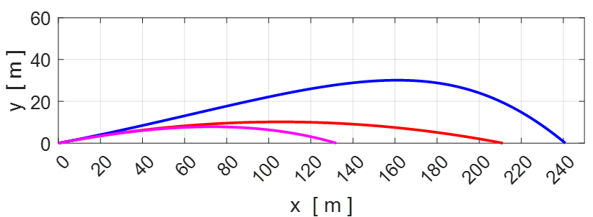

Driver: The red curve corresponds to the parabolic path where the force acting on the ball is its weight (C_{D} = 0 and C_{L} = 0). The magenta curve corresponds to the motion of the ball when only the drag force and gravitational forces act (C_{L} = 0). The blue curve shows the path of a hexagonal dimpled golf ball with both drag and lift. Without the lift force acting, a golf ball would travel a much smaller distances off the tee.
clubhead speed at impact = 185.4 m.s⁻¹
smash factor = 1.40, launch angle = 10.9º
initial velocity of ball v₀ = 74.7 m.s⁻¹
spin of ball w_{y} = 2686 rpm

SIMULATION 8 ENVIRONMENTAL CONDITIONS
We can model how the flight of a golf ball depends upon the environmental conditions. We will consider the case when the driver is used with input parameters:
The flight of a golf ball under three different environmental conditions.
T = 30º and high humidity

T = 20º hot and normal humidity

T = 10º cold and dry (low humidity)

With the identical impacts, a golf ball will travel further in hot and humid conditions compared with a cold and dry day. The difference in carry was 14 m between the hot and humid day compared with the cold dry day. Also, the ball lands with a greater horizontal speed at a smaller angle, hence more run after landing on the hot and humid day.

REFERENCES

https://www.researchgate.net/publication/318276568_THREE_DIMENSIONAL_GOLF_BALL_FLIGHT

http://aero-comlab.stanford.edu/Papers/golf_ball_sports_engineering_2019.pdf

https://www.math.union.edu/~wangj/courses/previous/math238w13/Golf%20Ball%20Flight%20Dynamics2.pdf

https://math.libretexts.org/Bookshelves/Differential_Equations/A_First_Course_in_Differential_Equations_for_Scientists_and_Engineers_(Herman)/03%3A_Numerical_Solutions/3.05%3A_Numerical_Applications/3.5.03%3A_The_Flight_of_Sports_Balls

https://pythonnumericalmethods.studentorg.berkeley.edu/notebooks/chapter12.02-3D-Plotting.html

Very interesting
https://www.upyourclub.com/ball-flight-laws/

https://www.researchgate.net/publication/237196163_The_run_of_a_golf_ball

https://vuir.vu.edu.au/1415/1/mclaughlinvol1.pdf putting

https://pure.ulster.ac.uk/ws/portalfiles/portal/89304055/JSET_19_0012R2_SEP_rev_ESW_KJ_PURE.pdf

https://www.tutelman.com/golf/design/swing2.php

https://www.acoustics.asn.au/conference_proceedings/ICSV14/papers/p240.pdf

