DOING PHYSICS WITH PYTHON
A ONE-DIMENSIONAL MODEL FOR THE COLLISION BETWEEN A GOLF CLUB AND GOLF BALL

Ian Cooper
matlabvisualphysics@gmail.com

DOWNLOAD DIRECTORIES FOR PYTHON CODE
Google drive
GitHub

golfSpring.py
Solves the equations of motion for the impact of a golf club on a golf ball using a finite difference method.

[1D] MODEL FOR THE COLLISION BETWEEN CLUB AND BALL
A [1D] model is presented to describe the collision between the head of the golf club and golf ball. The system consists of the head of the golf club, the golf ball, a spring and damper connecting the two masses. Table 1 gives a summary of the model parameters.

Table 1. Model parameters.
m_{C} = 0.200 kg mass of golf club
m_{B} = 46x10⁻³ kg mass of golf ball.
R = 22x10⁻³ m radius of golf ball
D = 44x10⁻³ m diameter of golf ball
(length of spring)

u_{C} [m.s⁻¹] initial speed of golf club
u_{B} = 0 m.s⁻¹ initial speed of golf ball
v_{C} [m.s⁻¹] speed of golf club
v_{B} [m.s⁻¹] speed of golf ball
x_{C} [m] position of golf club
x_{B} [m] position of golf ball
k [N.m⁻¹] spring constant
b [N.s.m⁻¹] damping constant
F [N] force
K [J] kinetic energy
P [N.s] momentum
S = v_{B} / u_{C} smash factor
COE = (v_{B} – v_{C})/u_{C} coefficient of
restitution
I initial values
F final values

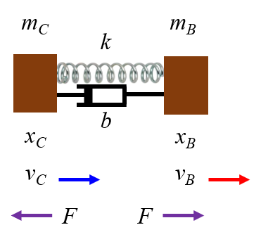
Fig. 1. Diagram of the model for the impact between club and ball.

The input variables are the initial positions and speeds of club and ball, the spring constant k, and the damping constant b. The output variables are the positions and velocities of the club and ball; the contact force of club and ball; the smash factor ; the coefficient of restitution ; and the initial and final values of the momentum and kinetic energy.

The equations of motion for the club and ball are:

The equations of motion are solved in Python (golfSpring.py) using the finite difference method.

How can we determine suitable values for the spring constant and damping constant? How good is our simple model?

The paper
ANALYSIS OF GOLF BALL SPIN MECHANISM
AT IMPACT BY FEM
Woo-Jin Roh, Chong-Won Lee
14th International Congress on Sound and Vibration
was used to estimate values the values of k and b and to compare the predictions from a finite element method with our simple model. The simple model can be used to compare launch velocities for golf balls with different compression (hardness).

The normal contact force causes the compression and restitution of ball and is primarily responsible for the initial launch speed of the golf ball. The tangential component of the contact force creates the spin. The tangential force takes positive and negative values as the ball rolls and slides along the club face during impact. The positive and negative tangential forces create and reduce the backspin rate

A primary factor that affects the ball’s release speed is the club’s initial velocity before impact. The larger the club’s initial velocity is, the larger the ball’s release speed. The backspin rate is also a very important factor. The larger the club’s loft angle and initial velocity are, the larger the ball’s backspin rate becomes. The golf ball is crushed by the force that is transferred from the club head during impact after it slips or rolls along the club face and finally it takes off the golf club. These initial conditions are generated by the short impact time when a golfer hits a golf ball.

The results of the finite element method by Roe and Lee are shown in figures 2 and 3. The model used the parameters for the club:
club head mass 0.210 kg; loft 11.5º, and momentum of inertia 1.526x10⁻⁴ kg.m².

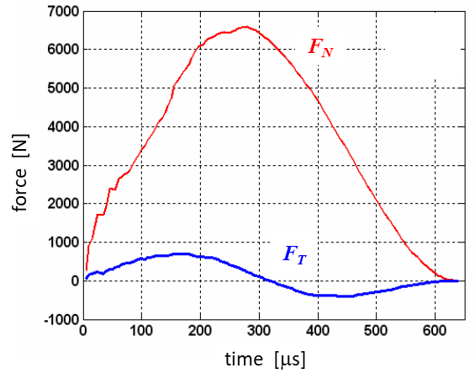
Fig. 2. Normal force and tangential force acting on ball. The impact time is approximately 600 μs (0.6 ms). Maximum normal force is 6600 N at 280µs.
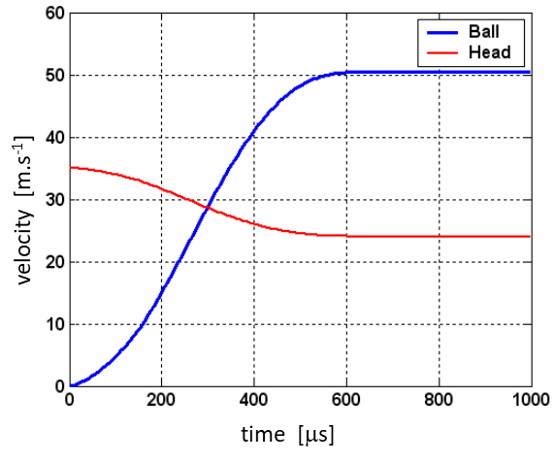
Fig. 3. Velocity plots for the club and ball.
Club: initial velocity 35 m.s⁻¹. final
velocity 24 m.s⁻¹.
Ball: final velocity 50 m.s⁻¹.
Duration of contact between club and
ball is about 600 µs.
During a high-speed impact, a golf ball drastically deforms, flattening into a D-shape as it absorbs energy via its elastic core. This deformation lasts for about 600 μs before the ball springs back with the ball regaining its spherical shape after losing contact releasing stored energy to accelerate away. This elastic deformation is crucial for transferring energy: the ball stores energy upon compression and releases it upon rebound, affecting speed and distance. The normal force causes the compression and restitution of the ball and has a maximum value of 6600 N at 280 µs. The force of restitution is increasing when the ball is compressing, and it is maximized by the maximum deformation of ball. As the deformation reduces and the ball starts to recover its spherical shape.
Back of envelope calculations to calculate average contact force (normal component) F_{N} and contact distance

impulse on ball = change of in momentum of ball
average contact force F_{N} = 3828 N

Work done on ball = change in kinetic energy of ball

At impact, the average normal force compressing the golf ball is 3828 N, the contact time is 600 , and the contact distance is 70% the radius R of the golf ball. The smash factor is S = 1.43 and the coefficient of restitution is COR = 0.74.
Momentum is conserved in the collision
initial momentum P_{I} = 7.35 N.s
final momentum P_{F} = 7.34 N.s

An inelastic collision occurs between the club and ball
initial kinetic energy K_{I} = 128.6 J
final kinetic energy K_{F} = 117.9 J
The energy lost in the collision is 8.3% of the initial kinetic energy.

The Python Code golfSpring.py is used to solve the simple model shown in figure 1 by a trail-an-error approach to find values of the spring constant k and damping constant b to match the results given in the paper by Roe and Lee. A reasonable agreement between the finite difference method and the simple finite difference method is found with the values k = 1.00x10⁶ N.m⁻¹ and b = 9.00 N.s.m⁻¹.
Simulation parameters
spring constant k = 1.00e+06
damping constant b = 9.00
U1 = 35.00 U2 = 0.00
V1 = 21.50 V2 = 54.84
P1 = 7.35 P2 = 7.03
K1 = 128.62 K2 = 117.61
S = 1.57 COR = 0.95
contact time = 621 us
contact displacement / diameter = 0.41
max contact force = 6799 N
Impulse applied to ball J = 2.68 N.s
Momentum gained by ball PB = 2.52 N.s
Energy efficiency (percentage) E = 91

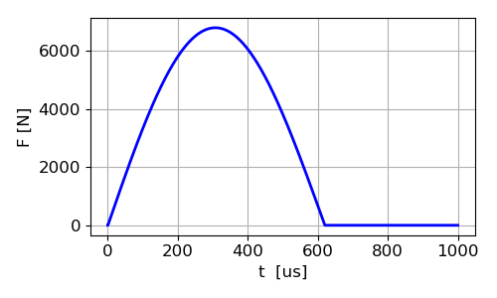
Fig. 4. Contact force: max force 6799 N, contact time 621 µs. Area under plot: impulse applied to ball J = 2.68 N.s Gain in momentum of ball during impact P_{B} = 2.52 N.s
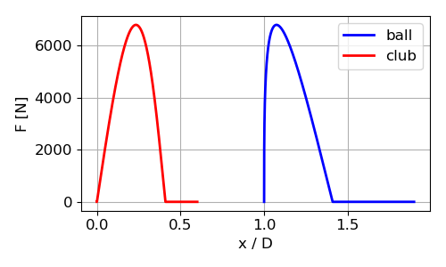
Fig. 5. Contact force acting on club and ball.
Contact displacement / diameter = 0.41

What if we have a perfectly elastic collision?
To simulate a perfectly elastic collision between the club and ball, the damping constant is set to zero, b = 0.
spring constant k = 1.00e+06
damping constant b = 0.00
U1 = 35.00 U2 = 0.00
V1 = 22.41 V2 = 57.55
P1 = 7.35 P2 = 7.35
K1 = 128.62 K2 = 128.81
S = 1.64 COR = 1.00
contact time = 611 us
contact displacement / diameter = 0.41
max contact force = 6808 N
Impulse applied to ball J = 2.64 N.s
Momentum gained by ball PB = 2.64 N
Energy efficiency (percentage) E = 100

In an elastic collision, both the momentum and kinetic energy are conserved. The maximum value of the smash factor is S = 1.64 and this value is independent upon the initial speed of the golf club. Also, for an elastic collision the release the speed of the ball is independent of the stiffness of the ball. The contact time is longer for a softer golf ball.

k = 1.0x10⁶ N.m⁻¹ Δt = 611 µs v_{BF} = 58 m.s⁻¹
k = 0.50x10⁶ N.m⁻¹ Δt = 864 µs v_{BF} = 58 m.s⁻¹

Club speed simulation: A higher club speed will result in a greater release speed of the ball
spring constant k = 1.00e+06 N.m⁻¹
damping constant b = 9.00 N.s.m⁻¹

u_{Club} [m.s⁻¹] | 35 | 50
v_{Club} [m.s⁻¹] | 21.5 | 30.7
v_{Ball} [m.s⁻¹] | 54.8 | 78.4
F_{max} [N] | 6799 | 9713
S | 1.57 | 1.57
COR | 0.95 | 0.95
contact time [µs] | 621 | 620
contact displacement/D | 0.41 | 0.59
energy efficiency E | 91% | 91%

With a greater club speed:
- Ball’s release speed is greater
- Greater magnitude of the contact force between club and ball
- Smash factor and coefficient of restitution are the same
- Contact time between club and ball is the same
- Ball is squashed more, greater contact displacement
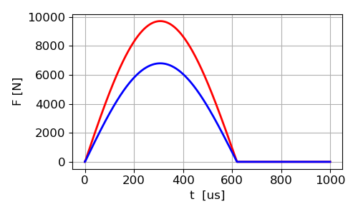
Fig. 6. A greater club head speed creates a larger contact force during the collision, but the contact time is the same.
u_{C} = 35 m.s⁻¹ u_{C} = 50 m.s⁻¹

Compression ratings of golf balls
You can buy golf balls with different stiffness and this stiffness is called the compression of the ball.
- Low Compression (30–60): Soft feel, easy to deform; best for slow swing speeds under 130 kmph.
- Mid Compression (61–85): Balanced feel; ideal for moderate speeds of 130-160 kmph.
- High Compression (86–110+): Firm feel, requires fast swing speeds (160+ kmph) to fully deform and spring off the face.

If there was a perfectly elastic collision between club and ball then the compression would not make a difference. In this simple model, the compression of the ball is related to the values of the spring constant k and damping constant b. The higher the compression is assumed to be modelled by higher spring constant values and lower damping.
Simulations: b = 9.0 N.s.m⁻¹

k [N.m⁻¹] | 0.5x10⁶ | 1.0x10⁶ | 2.0x10⁶
u_{Club} [m.s⁻¹] | 35 | 35 | 35
v_{Club} [m.s⁻¹] | 21.1 | 21.5 | 21.8
v_{Ball} [m.s⁻¹] | 53.7 | 54.9 | 55.8
F_{max} [N] | 4802 | 6799 | 9627
S | 1.53 | 1.57 | 1.59
COR | 0.93 | 0.95 | 0.97
contact time [µs] | 883 | 621 | 438
contact displacement/D | 0.58 | 0.41 | 0.29
energy efficiency E | 88% | 91% | 94%

For a given non-zero damping coefficient and a given club head speed, the greater the ball’s compression (stiffness) results in:
- Greater club head speed at release
- Greater ball speed at release
- Greater maximum contact force
- Greater maximum value of the smash factor
- Greater the COE
- Shorter compact time
- Smaller compression distance of the ball during impact
- Greater efficiency in transferring energy from club to ball

Is there a difference between a new golf ball and an old ball in the release speed?
A valid assumption is that the old ball will have less stiffness (lower k value) and greater damping (higher b value).

Old ball:
- Lower club speed and ball speed on release
- Smaller contact force
- Smaller smash factor
- Smaller COE
- Longer contact time
- Greater deformation of the ball
- Less efficiency in transferring energy from club to ball

 | k = 1.00e+06 N.m⁻¹  b = 9.00 N.s.m⁻¹ | k = 0.50x10⁶ N.m⁻¹  b = 12.00 N.s.m⁻¹
u_{Club} [m.s⁻¹] | 35 | 35
v_{Club} [m.s⁻¹] | 21.50 | 20.71
v_{Ball} [m.s⁻¹] | 54.84 | 52.44
F_{max} [N] | 6799 | 4799
S | 1.57 | 1.50
COR | 0.95 | 0.91
contact time [µs] | 621 | 890
contact displacement/D | 0.41 | 0.58
energy efficiency E | 91% | 84%

REFERENCES

https://www.scribd.com/document/743110709/Development-and-use-of-one-dimensional-models-of-a-golf-ball

https://nvlpubs.nist.gov/nistpubs/jres/34/jresv34n1p1_a1b.pdf

