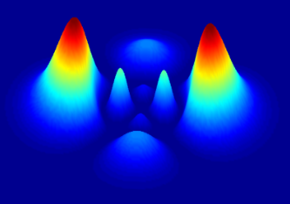

DOING PHYSICS WITH PYTHON

QUANTUM MECHANICS

FDTD

CONDUCTION BAND OF A SEMICONDUCTOR
Ian Cooper
matlabvisualphysics@gmail.com

DOWNLOAD DIRECTORY FOR PYTHON SCRIPTS
qmS02.py Propagation of a Gaussian pulse in a semiconductor. FDTD method is used to solve the [1D] time dependent Schrodinger equation. The simulation time is determined by the number of time steps Nt. The Code is run with different time steps to observe the time evolution of the wavefunction and the energies of the electron.
qmS03.py Time evolution of the wavepacket and its energies, including the animation of the wavefunction.

GitHub

Google Drive

Finite Difference Time Development method
The Conduction Band of a Semiconductor
We can simulate the propagation of an electron in an n-type semiconductor. A Gaussian wavepacket is used to present the electron. The parameters for the wavepacket are its wavelength wL, width s and initial center position xC.

When two n-type semiconductors with different doping levels are placed next to each other, the Fermi levels will align (U = 0). In this case, when the semiconductor to the left of the junction is more heavily doped than the one on the right there is a step in the conduction band. For the simulations, the potential energy for the conduction band are:
U_{fermi} = 0 U_{left} = 0.10 eV U_{right} = 0.20 eV

The more heavily doped semiconductor on the left has its potential energy closer to the Fermi level.

An electron going from left to right in this step potential will have some chance to penetrate and some chance it will be reflected at the step.

For the propagation of the electron in a semiconductor material, one must take into account the elective mass:

effective mass mEFF Si = 1.08, Ge = 0.067, GaAs = 0.55
free space electron mass me = 9.109x10⁻³¹ kg
semiconductor m = mEFF*me

Figure 1 shows the propagation of the wavepacket (real and imaginary parts of the wavefunction) at time steps 1000, 2000, 3000 and figure 2 the propagation of the probability density function through a silicon semiconductor material. The figures were produced with the Python Code qmS02.py.

The electron initially has a potential energy of 0.1 eV because it begins in a conduction band at 0.1 eV. After about 60 fs, most of the waveform has penetrated to the conduction band at 0.2 eV, and much of the initial kinetic energy has been exchanged for potential energy as the total energy of the electron is conserved at a value of 0.452 eV.

Figure 4 shows the time evolution of the energies of the electron and figure 5 an animation of the time evolution of the wavepacket created with the Python Code qmS03.py. Note: that the total energy is conserved and the electron gains potential energy at the expense of kinetic energy as it enters the region of lower doping. The probability of finding the electron in the semiconductor material is one, as the wavefunction is normalized. The expectation values of the potential energy, kinetic energy and total energy are calculated for the energy values shown.
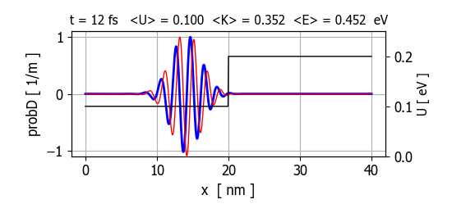
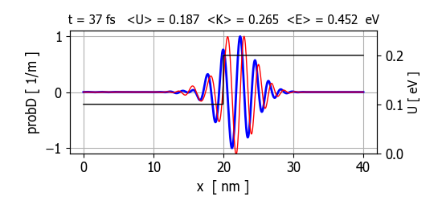

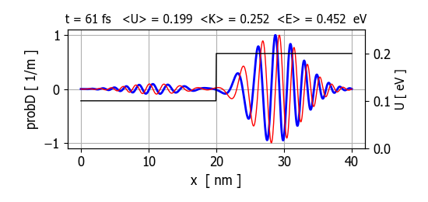
Fig. 1. Propagation of the wavepacket representing the electron though a silicon semiconductor material which is more heavily doped in the left region from x = 0 to x = 20 nm.
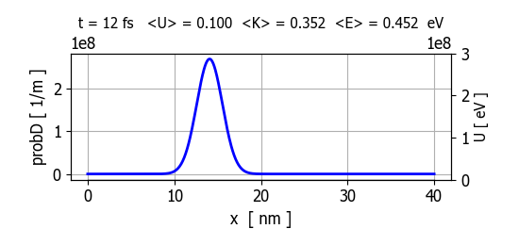
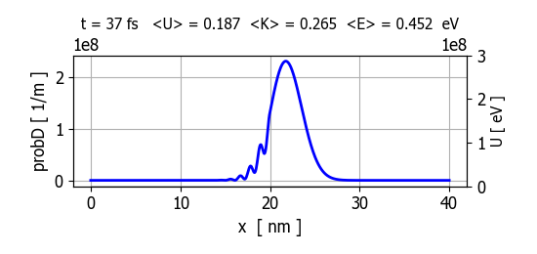
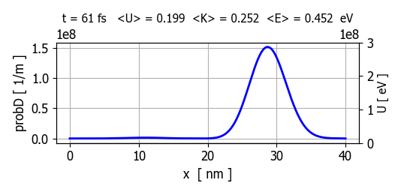
Fig. 2. Time evolution of the probability density. At t = 37 fs, you can observer the interference fringes due to superposition of the incident and reflected parts of the wavepacket.
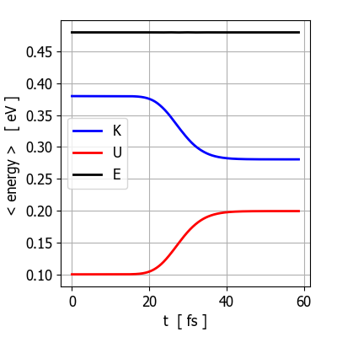

Fig. 4. Time evolution of the potential, kinetic and total energies of the electron.

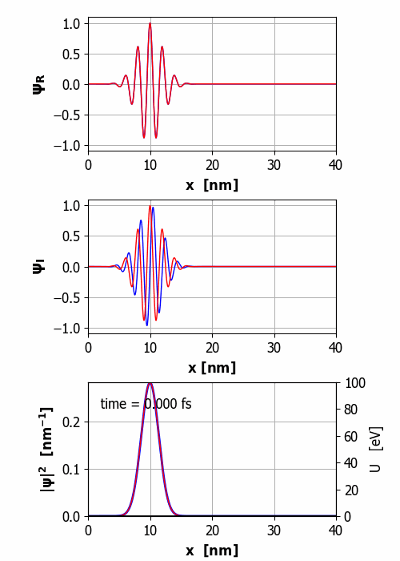

Fig. 5. Animation of the wavepacket propagating through the semiconductor. Note: the spreading of the wavepacket as it propagates.
ANIMATION

