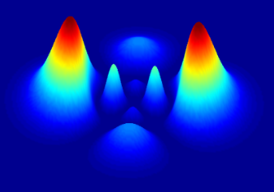

DOING PHYSICS WITH PYTHON

QUANTUM MECHANICS
DOUBLE POTENTIAL WELLS
COVALENT BONDING
Ian Cooper
matlabvisualphysics@gmail.com

DOWNLOAD DIRECTORY FOR PYTHON SCRIPTS
qmCB.py qmCB01.py

GitHub

Google Drive

COVALENT BONDING
We can use a crude model of two square potential energy wells to investigate the covalent bond between two atoms. The eigenvalues and eigenfunctions can be found in Python using a matrix method. Using this model, you can’t hope to predict actual numbers, but you can gain insights into the phenomenon of covalent bonding

The mathematical complexities of dealing with atoms in [3D] are considerable, but many of the most important features of atomic binding are shown by the mathematically simple problem of binding between two [1D] square potential wells.

Consider two square potential wells of depth U₀, width x_{w}, separation distance x_{s} and boundary distance x_{b} (figure 1) each containing one electron.
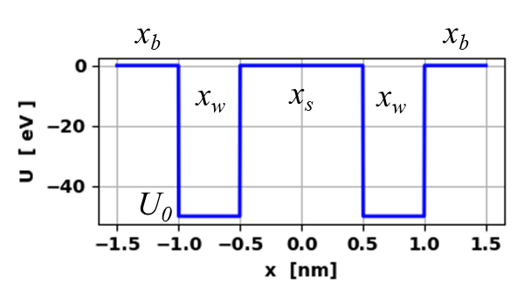
Fig. 1. Double square potential well. qmCB.py

The first step is we can compute the eigenvalues and eigenvectors for one of the single square wells by setting xs = 0 in the Code qmCB.py. The default values for the simulations are: number of grid point N = 999, eigenvalues returned M = 50, boundary distance xb = 0.50 nm, well width xw = 0.50 nm and well depth U0 = -50. The square potential well and the energy eigenvalues for the single electron are displayed in figure 2.

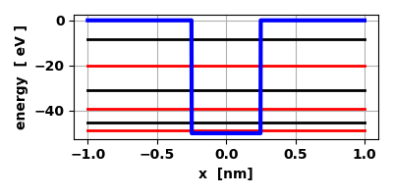
Fig. 2. The square potential well and the energy eigenvalues for the single electron. The red lines are for the symmetric eigenvalues (n = 1,3,5) and the black lines for the asymmetric eigenvalues (n = 2,4,6)
E1 = -48.77690 E2 = -45.12026 E3 = -39.07222
E4 = -30.72087 E5 = -20.25092 E6 = -8.15976
qmCB.py

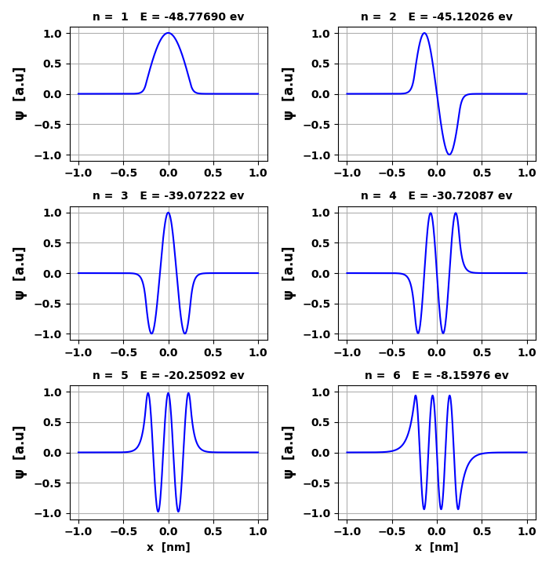
Fig. 3. The wavefunctions for the first six bound states for the single square well. qmCB.py

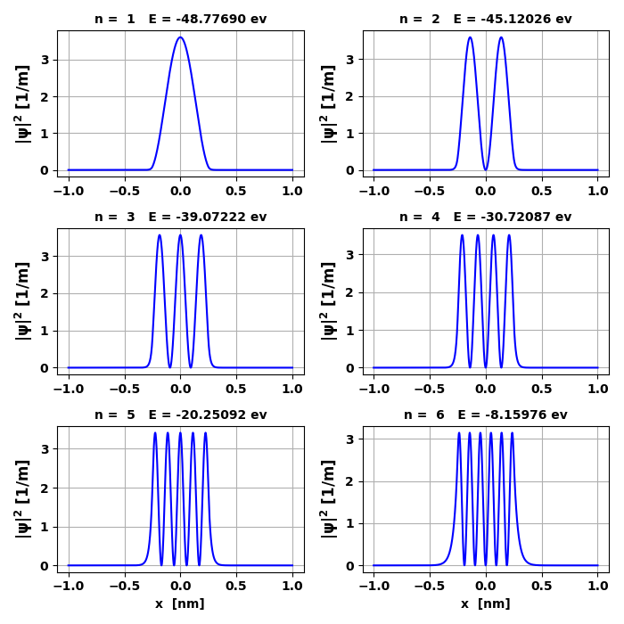
Fig. 4. The probability densities for the first six eigenstates fof the single square well. qmCB.py

For the double well simulations it is best to start with the two wells far apart and investigate what happens as we bring them together. We will only consider the ground state (n = 1) and the first excited state (n = 2). The ground state is a symmetric wavefunction since the sign of the wavefunction is the same in both wells. But, the wavefunction for the first excited state is antisymmetric since the wavefunction has opposite signs in the two wells as shown in figure 5.
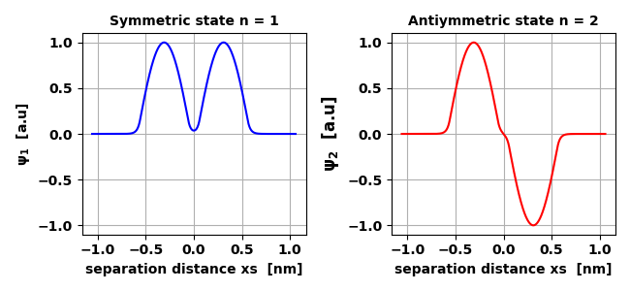
Fig. 5. Wavefunctions for the ground state, n =1 (symmetric) and for the first excited state, n = 2 (antisymmetric).

When the wells are far apart (no interaction), the binding energies of the lowest symmetric state (n = 1) and the antisymmetric state (n = 2) of the system are the same. As the separation distance x_{s} decrease we observe a slitting of each energy level. For the symmetric ground state, the energy of the system decreases. But, for the antisymmetric case it rises slowly as plotted in figure 6. In figure 6, the energies are shown with respect to the energy of the system as .

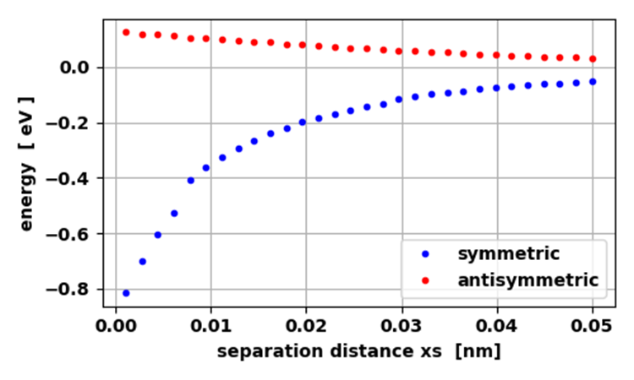
Fig. 6. Energy of symmetric and antisymmetric states as a function of separation distance for the two square wells. qmCB01.py

As the wells approach each other, the ground state probability of finding one of the electrons between the wells increases rapidly as though the electrons were moving back and forth between the wells. It is often said that the electrons resonate between the two wells and the attractive force between the two wells is due to the resonant exchange of electrons between them. We have ignored the concept of spin. However, the two electrons can both have the same ground state spatial eigenfunction only if they have opposite spin.

A crucial feature of this model, which applies to bringing two atoms together is:
When two identical systems approach one and another and interact, each nondegenerate energy level is split into two levels.
The greater the interaction, the greater the splitting becomes as shown in figure 7 for separation distances x_{S} = 0.050 nm and x_{S} = 0.01 nm.
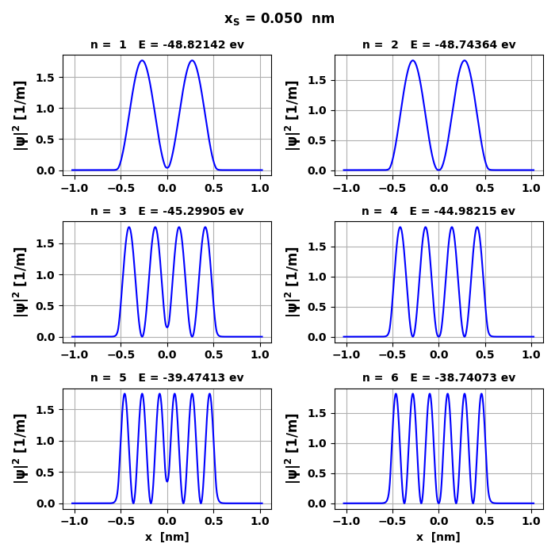
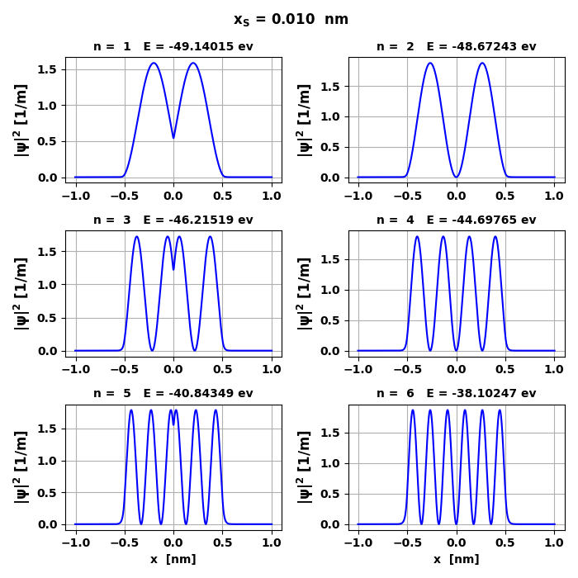
Fig. 7. Only for the symmetric states is the probability of the electrons being located in the region between the two atoms is high whereas for the antisymmetric states it is zero. qmCB.py

In general, for N interacting particles there is an N-fold splitting of energy levels. When N is very large, as in when many atoms interact to form a solid, what was for each atom a sharp energy level may spread out into a broad band of energies.
Figure 8 shows the splitting of the energy levels due to the interact between the two wells. The smaller the separation distance bewteen the wells, the greater the interaction and the greater the splitting of the energy levels. The splitting of an energy level is greater for a state with a higher principle quantum number n. When there is a split in an energy level, the symmetic state energy is always less than the antisymmetric energy level.
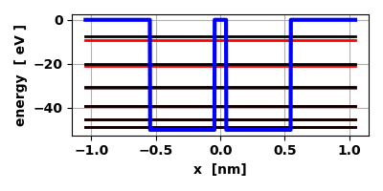
Fig. 8. The potential energy function (blue), the symmetric energy levels (red) and the antisymmetic energy levels (black). qmCB.py

Next, we have to consider the repuslion of the two nuclei which are represented by the two wells. We assume that Coulomb’s law applies and therefore, the nucleare repulsion energy is proportional to 1/r. The Coulomb repulsion of the nuclei offsets the bonding attraction of the electrons to stabilize the molecule at that separation for which the total energy is minimal as shown in figure 9.

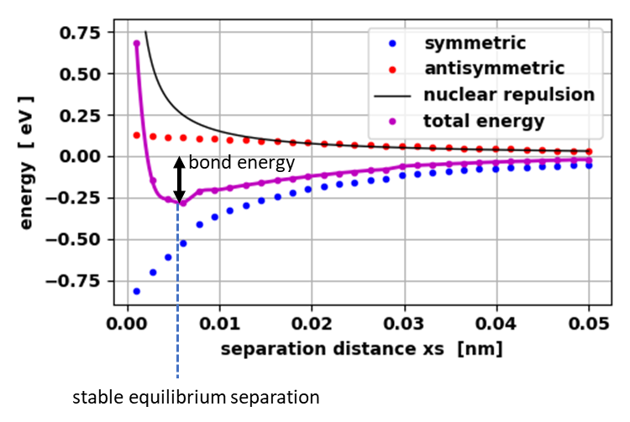
Fig. 9. The total molecular energy for the bonding orbital of our double well. The stable equilibrium separation distance occurs when the total energy of the system is a minimum. qmCB01.py

