DOING PHYSICS WITH PYTHON

IZHIKEVICH MODEL FOR ACTION POTENTIALS
AND SPIKE TRAINS

Ian Cooper
Any comments, suggestions or corrections, please email me at
matlabvisualphysics@gmail.com

DOWNLOAD DIRECTORIES FOR PYTHON CODE
Google drive GitHub

mnsIZH01.py
Uses Runge-Kutta method to solve the system differential equation
INTRODUCTION
Most neurons are excitable in that they can fire a voltage spike when stimulated. In developing useful brain models we want to account for and explain the patterns produced by spiking neurons. To do this we must satisfy two requirements:
- The model must be computationally simple.
- The model must be able to produce the rich firing patterns exhibited by real biological neurons.

The Hodgkin–Huxley-type models are computationally prohibitive, since they can be used only to simulate a handful of neurons in real time. However, the use of integrate-and-fire models are computationally effective, but the models are unrealistically simple and incapable of producing the rich spiking and bursting dynamics exhibited by cortical neurons.

An interesting model to consider was proposed by E. M. Izhikevich. It can be used to compute a wide range of neuron spiking patterns for cortical neurons. The Izhikevich model presented is biologically plausible as the Hodgkin–Huxley model, yet as computationally efficient as the integrate-and-fire model. The value of four parameters a, b, c and d used in the model can be changed to reproduce the firing patterns for the spiking and bursting behaviour of the known types of cortical neurons. Cortical neurons are the primary excitatory (pyramidal) and inhibitory (interneuron) cells, totalling 10–16 billion in the human cerebral cortex, organized into six distinct functional layers. They are responsible for high-level cognitive functions, including memory, perception, and voluntary movement. They are characterized by complex dendritic trees and rapid signal processing.

The time evolution of the membrane potential v is described in terms of the differential equations
(2)

The after-spike reset relationship is
(3)
where v is the membrane potential of the neuron (the fast variable of the system). u is the membrane recovery variable of the neuron (the slow variable of the system). The membrane recovery variable u provides negative feedback to the membrane potential v

The recovery variable u accounts for the activation of the K⁺ currents and inactivation of the Na⁺ currents. The term was obtained by fitting the spike initiation dynamics of a real cortical neuron so that the membrane potential v has units of mV and the time t is in ms. The model does not have a fixed threshold (as most real neurons) and depending on the history of the membrane potential prior to a spike, the threshold potential may be in the range from -55 mV to -40 mV. The resting potential in the model is between -70 mV and -50 mV depending on the value of the parameter b. In biological neurons, the Na⁺ ions enter into the neuron to increase the voltage of the neuron. At a certain point, the floodgates open and Na⁺ ions come rushing into the neuron. This causes the voltage inside the neuron to shoot right up (spike). But it is this point where the K⁺ gates open up, and a ton of K⁺ ions shoot out of the neuron, causing the voltage to drop right down.

Table 1. Dimensions, values (typical) and units.
Parameter | Unit | Description
t | ms | time
v | mV | membrane potential
dv/dt | mV.ms⁻¹ | time rate of change in membrane potential
u | mV | recovery variable
I | A | synaptic current or injected DC-current
c₁ = 0.04 mV⁻¹.ms⁻¹ c₂ = 5 ms⁻¹ c₃ = 140 mV.ms⁻¹
c₄ = 1.0 ms⁻¹ c₅ = 1.0 mV.ms⁻¹.A⁻¹
External current stimulus: step input height I₀
I_{ext} = c₅ I mV.ms⁻¹
a ~ 0.02 ms⁻¹ determines the time scale of the recovery variable u. The larger the value of a the quicker the recovery.
b ~ 0.20 [dimensionless] describes the sensitivity of the recovery variable u to the subthreshold fluctuations of the membrane potential v. Large values of b couple u and v more strongly resulting in possible subthreshold oscillations and low-threshold spiking dynamics.
c ~ -65 mV gives the after-spike reset value of the membrane potential v caused by the fast high-threshold K⁺ conductances.
d ~ 6 mV describes after-spike reset of the recovery variable u caused by slow high-threshold Na⁺ and K⁺ conductances.

Various choices of the parameters a, b, c and d result in the various intrinsic firing patterns that can be computed.
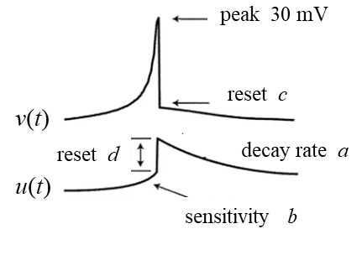
The variables a, b, c and d used in the Izhikevich model are sufficient to reproduce neocortical and thalamic neuron activities.

A neuron can be stimulated by the injection of DC current pulse via an electrode and the response of the membrane potential recorded. When a step-input current is used to stimulate a neuron, the neuron continues to fire a sequence of spikes called a spike-train. From such investigations, it is found that neocortical neurons in the mammalian brain can be classified into several firing patterns. Most of these recorded firing patterns can be reproduced computationally using the Izhikevich Model.

SIMULATIONS
The following simulations show the spike-train patterns for a step input current that causes the neuron to continually fire. The spike-train pattern depends upon the values of the four parameters a, b, c and d and the input current I.

Figure 1 show the step input current that acts to stimulate the neuron. The height of the step is given by I₀. The input is given by the variable .
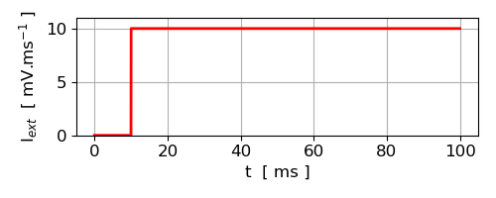
Fig. 1. Step input current stimulus, I₀ = 10.

Table 2. Neuron Spiking Patterns
Spiking pattern | a | b | c | d
1 Regular spiking (RS) | 0.02 | 0.2 | -65 | 8
2 Intrinsically Bursting (IB) | 0.02 | 0.2 | -54 | 4
3 Chattering (CH) | 0.02 | 0.2 | -50 | 2
4 Fast Spiking (FS) | 0.1 | 0.2 | -65 | 2
5 Thalamocortical (TC) | 0.02 | 0.25 | -65 | 0.05
6 Resonator (RZ) | 0.1 | 0.26 | -65 | 8
7 Low-threshold Spiking (LTS) | 0.02 | 0.40 | -65 | 2

The Regular Spiking (RS), Intrinsically Bursting (IB), and Chattering (CH) neurons are all sub-types of excitatory cortical neurons. Fast spiking (FS) and low-threshold spiking (LTS) neurons are inhibitory.

1 Regular spiking (RS): Excitatory Cortical Cells:
The most common type of excitatory neurons in the mammalian neocortex are regular spiking cells that fire spikes with decreasing frequency. Prolonged stimuli cause the neurons to fire a few times in short periods, and then periods increase. It has spike frequency adaptation. If we increase the injected DC-current, we also increase the frequency.

Neuron tonic spiking is a firing pattern where a neuron produces a continuous, steady train of action potentials in response to sustained input, rather than bursts or isolated spikes. It acts as a reliable, ongoing signal, often contrasted with bursting or phasic modes to encode information. Tonic firing is steady whereas, bursting neurons fire in high-frequency groups followed by silence. Tonic firing can be perfectly regular, or it may exhibit spike-frequency adaptation where the firing rate slows down over time.

For RS neurons, their initial response to a stimulus is a series of small spikes. Eventually, there is a frequency adaptation and the inter-spike period increases with increasing time. This is caused by the hyper-polarization that occurs after each spike, causing absolute and relative refractory periods. These periods represent intervals of time in which a single neuron must pause before releasing another action potential.

If the external current stimulus is less than a critical value, then no spiking will occur. If a = 0.02, b = 0.20, c = -65, d = 8 then

I₀ = 3.2 no spike is produced

I₀ = 3.3 Phasic spiking: neuron fires a single spike then remains
quiescent

I₀ = 20 > I₀ = 10 gives a spike train with a shorter interspike interval

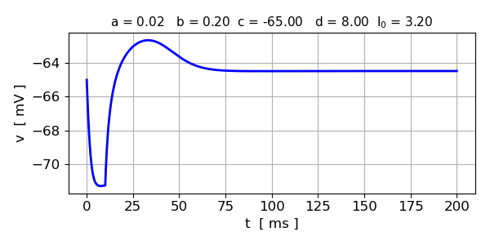
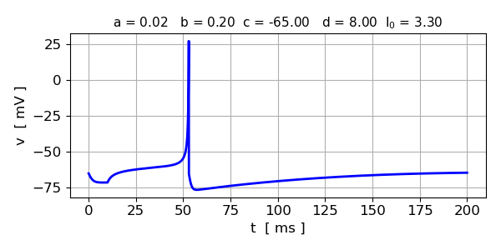
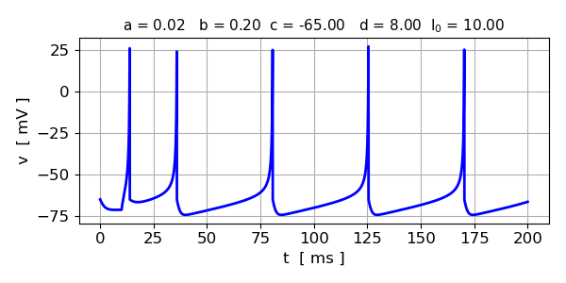
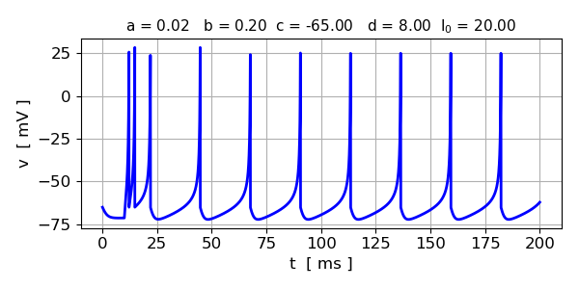
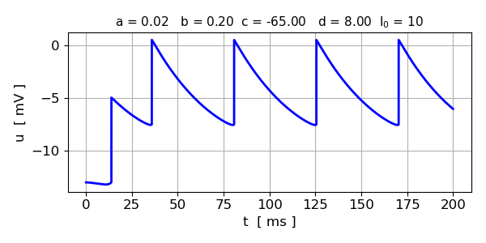

Mixed Mode
Excitatory neurons in the mammalian cortex can exhibit a phasic burst at the start of the stimulus and then switch to the tonic spiking mode.
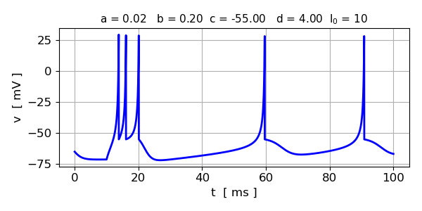

2 Intrinsically Bursting (IB)

Intrinsically Bursting (IB) neurons — First, we fire a ton of bursts, but after a while, we end up with normal spiking. This is because the u builds up over time. c = -54 mV (high), d = 4 (large)

IB neurons will first respond to an input with a bursting pattern of
closely timed spikes. This is able to occur because after the end phase of one spike, this particular type of neuron does not return to it’s resting membrane potential, nor does it hyperpolarize beyond it. After this first burst, IB neurons will experience adaptation and begin to exhibit a spiking pattern closer to that of a RS neuron. CH neurons send out multiple bursts, with fairly consistent refractory periods between each event.
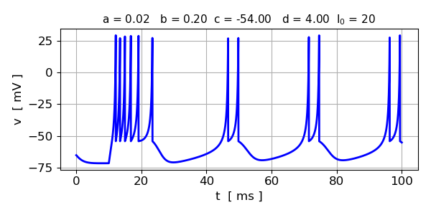

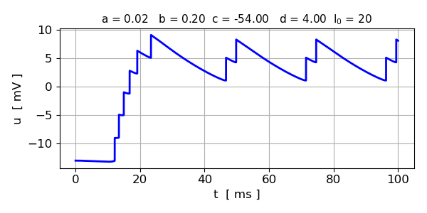

Phasic bursters
Set of closely spaced spikes are generated and then remains quiescent afterwards.
Phasic bursting importance:
- May overcome synaptic failure and reduce noise.
- Postsynaptic signal is stronger than that of a single spike.
- Selective communication between neurons (interspike frequency within the burst encodes communication channels).
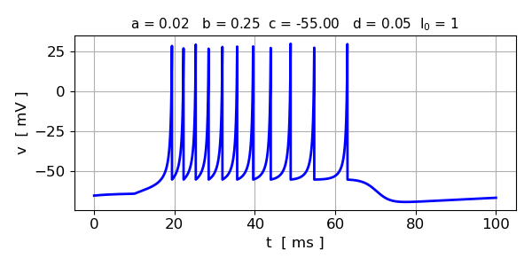

3 Chattering (CH)
Some excitatory neutrons such as chattering neurons in a cat cortex fire periodic bursts of closely spaced spikes when stimulated and may contribute to the gamma frequency oscillations in the brain. The interburst frequency can be as high as 50 Hz. CH neurons send out multiple bursts, with fairly consistent refractory periods between each event. The frequency inside of bursts can be as high as 40 Hz.
c = -50 mV (very high reset voltage)
d = 2 (moderate after-spike jump in u)

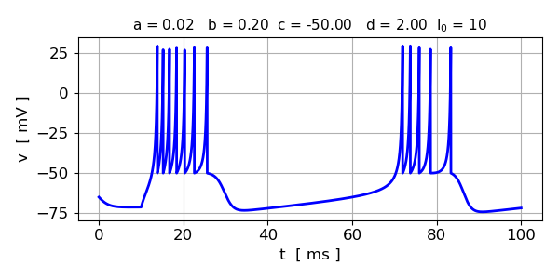
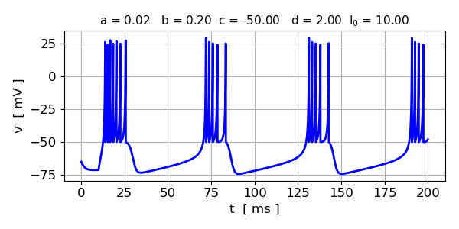
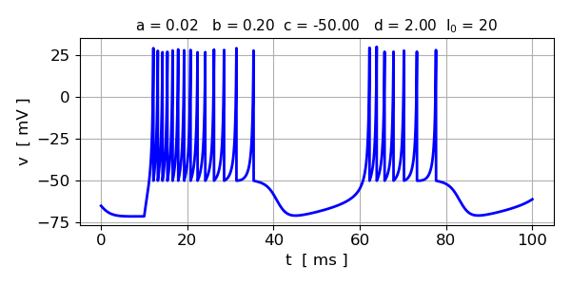

4 Fasting spiking (FS) neurons: Inhibitory Cortical Cells:
The Fast Spiking (FS) and Low-Threshold Spiking (LTS) neurons are both sub-classes of inhibitory cortical neurons. FS neurons fire singular action potentials at a high frequency because their fast recovery parameter prevents the adaptation or slowing down of its spiking pattern. LTS neurons are similar to FS neurons in that they fire action potentials at high frequency, however, this kind of neuron will eventually experience adaptation. Neurons fire periodic trains of action potentials with extremely high frequency practically without any adaptation (slowing down). Larger value of a gives a faster decay for u.
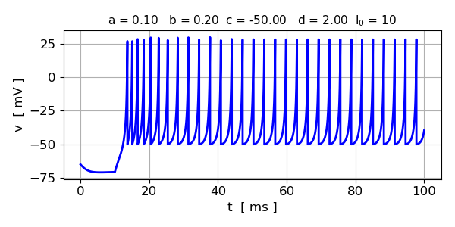

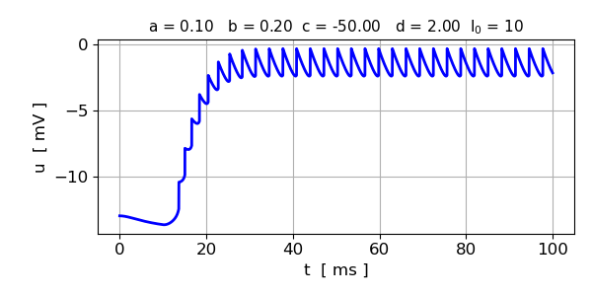

5 Thalamocortical (TC) neurons
Thalamocortical (TC) neurons are excitatory relay cells in the thalamus that transmit sensory, motor, and arousal information to the cerebral cortex via "thalamocortical radiations". Primarily targeting layer 4, they form a key point-to-point topography essential for perception, attention, and sleep-wake regulation.

Izhikevich’s model can accurately reflect the behaviour of Thalamo-Cortical (TC) neurons, whose axons extend between the Cerebral Cortex and the Thalamus, an area of the brain that acts as a gateway for signal transmission. Though TC neurons can exhibit multiple kinds of spiking patterns, when they start at a resting membrane potential, they exhibit a firing behaviour similar to that of
RS neurons
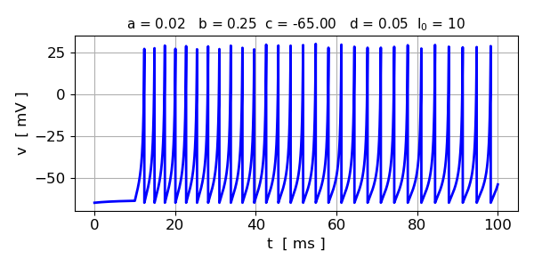

6 Resonator (RZ) neurons
Resonator (RZ) dynamics in which a neuron can respond to subthreshold oscillations. These resonate to the rhythm of the inputs, rather than their magnitudes.

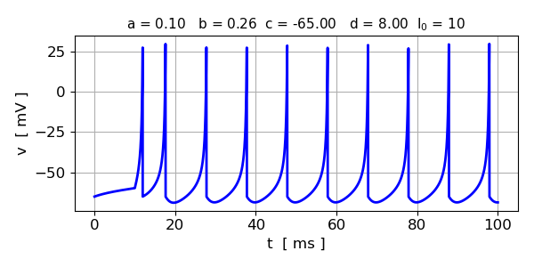

7 Low-Threshold Spiking (LTS) neurons
Spiking at low thresholds. The intervals increase with respect to time.
LTS neurons are similar to FS neurons in that they fire action potentials at high frequency, however, this kind of neuron will eventually experience adaptation.

Neurons can also fire high-frequency trains of action potentials, but with a noticeable spike frequency adaptation. These neurons have low firing thresholds, which is accounted for by b = 0.4 in the model.
Because of large b value hence low threshold, spikes are produced before external pulse is switched on.

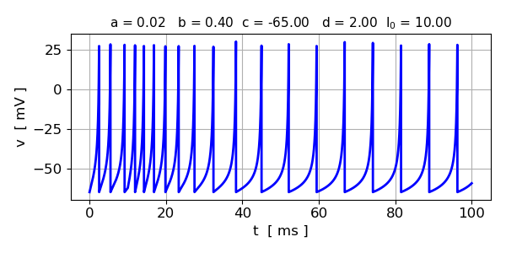
REFERENCES

https://medium.com/geekculture/the-izhikevich-neuron-model-fb5d953b41e5

https://sites.math.rutgers.edu/~zeilberg/Bio25/Projects/Project6.pdf

https://www.izhikevich.org/publications/hybrid_spiking_models.pdf

https://www.pnas.org/doi/10.1073/pnas.0712231105

https://reference-global.com/download/article/10.61822/amcs-2024-0033.pdf

