DOING PHYSICS WITH PYTHON

THE MORRIS-LECAR MODEL FOR A NEURON

Ian Cooper
Any comments, suggestions or corrections, please email me at
matlabvisualphysics@gmail.com

DOWNLOAD DIRECTORIES FOR PYTHON CODE
Google drive GitHub

mnsET03.py
Runga-Kutta method to solve systems ODEs

INTRODUCTION

The Morris-Lecar (M-L) model is a well-known model to explain the oscillating potential behaviour of barnacle muscle fibres. Experiments where a depolarisation current was applied to the muscle fibre resulted in electrical activity in the fibre which were found to arise from voltage gated K⁺ and Ca²⁺ channels, and a K⁺ current activated by intracellular Ca²⁺. Voltage clamp experiments showed that the action of these channels was not affected in the way predicted by the Hodgkin and Huxley model for the squid giant axon [5], therefore some other model was required.

The M-L model for changes in the membrane potential v assumes the cell to behave like a capacitor which is leaking charge through a variety of conductances which depend upon the capacitor potential. The biological origins of these charge leakages are both the applied depolarising current I_{ext}, as well as a general leakage current (conductance g_{L} with reversal voltage E_{L}), leakages through the Ca²⁺ current (peak conductance g_{Ca} with reversal voltage E_{Ca}) and leakage through the K⁺ current (peak conductance g_{K} with reversal voltage E_{K}). The parameters controlling the opening and closing the ion channels are m for Ca²⁺ and u for the K⁺. m and u give the fraction a gate is open at any time (m,u = 0 gates are totally closed, and m,u = 1, the gates are totally open). m and u are referred to as the gate variables.

Thus, Morris and Lecar proposed the following model

1A
1B

2A
2B
2C

where v₁, v₂, v₃, v₄ are threshold parameters for the voltage gated ion channels. The subscript I identifies steady-state values for m and u . The constant governs the speed of the K⁺ dynamics.

Equation 2A: The Ca²⁺ current changes much faster than the K⁺ current, therefore, the Ca²⁺ current is always in equilibrium with its activation curve. v₁ is the midpoint potential at which the calcium current is half-activated, i.e., m_{I} = 0.5 and we assume v₂ is a constant, corresponding to the steepness of the activation voltage dependence.
Equation 2B: The steady-state K⁺ activation u_{I} is a voltage-dependent function where v₃ is the activation midpoint potential at which the K⁺ current is half activated, and v₄ denotes the slope factor of the K+ activation.
Equation 2C: Describes the time constant with respect to the K⁺ activation.

In this model u_{I} (the proportion of K⁺ channels open) is a time
dependent variable since changes in v alter the value of u with a time lag controlled by where is itself dependent on v, and the parameter is a constant that can be changed for running different simulations. However, the fraction of open Ca²⁺ channels m has no such complicated time dependency and the value of m depends on v but is independent of time. The assumption made here is that any time lag in m is short enough that it may be neglected and m_{I} is assumed to be in steady state. The depolarizing current I_{ext} is assumed to be temporally constant. Again, note that m is not a dynamic variable. The reason for this is that we have assumed that the time constant for m is short enough that m is always in steady state, m_{I}. The idea of fast and slow processes is arguably one of the most important concepts in modelling

The pair of differential equations is solved in Python using the Runge-Kutta method (RK4) using the Code mnsET03.py. The response of the neuron can be analysed using time evolution plots and phase plane plots (phase portrait, vector field, nullclines, limit cycles, fixed points). The stimulus current I_{ext} is taken as the main control parameter for most simulations. Table 1 gives a summary of typical values for the model parameters used in different simulations.
Table 1. M-L model parameters and units.
SNLC saddle–node on a limit cycle
 | units | Hopf | SNLC | Homoclinic
t | ms | simulation time ~ 100 – 500 ms
v | mV | membrane potential
u | [ ] | recovery variable
m_{I} (v) | [ ] | Ca²⁺ gate variable
u_{I} (v,t) | [ ] | K⁺ gate variable
 | [ ] | time delay
C | F.cm⁻² | 20 | 20 | 20
E_{Ca} | mV | 120 | 120 | 120
E_{K} | mV | -84 | -84 | -84
E_{L} | mV | -60 | -60 | -60
g_{Ca} | mS.cm⁻² | 4.4 | 4 | 4
g_{K} | mS.cm⁻² | 8 | 8 | 8
g_{L} | mS.cm⁻² | 2 | 2 | 2
v₁ | mV | -1.2 | -1.2 | -1.2
v₂ | mV | 18 | 18 | 18
v₃ | mV | 2 | 12 | 12
v₄ | mV | 30 | 17.4 | 17.4
 | ms⁻¹ | 0.04 | 0.067 | 0.23
I | A.cm⁻² | Assuming that the cell has a total surface area of 10⁻⁶ cm², then 1 μA.cm⁻² corresponds to a 1 pA of total current.  1 pA 1 μA.cm⁻²

Phase space analysis
- The phase portrait is a plot the variables v and u describing a system plotted against each to produce a trajectory in phase space. A phase portrait tells us how the variables interact for a given set of parameters.
- The vector field shows us the direction in which a system will evolve from any location in phase space.
- Nullclines are plotted in phase space that show where the variables do not change.

v-nullcline
u-nullcline
The points of intersection of two nullclines gives the fixed points of the system. Fixed points can be either stable (phase space trajectories converge to a fixed point) or unstable (phase space trajectories diverge from a fixed point and may form a stable limit cycle which is a closed trajectory to which all neighbouring trajectories converge).

Rather than do a lot of complex mathematics, the stability of the fixed points can be implied by the graphical analysis of a simulation.
SIMULATIONS
In all simulations, the stimulus current I_{ext} is taken as the control parameter. The dynamics of the system depends upon the value of I_{ext} and also the initial conditions v[0] and u[0].

SIMULATION 1 Hopf bifurcations
Hopf bifurcation (or Poincaré-Andronov-Hopf) is a local phenomenon in dynamical systems where a stable equilibrium point loses stability as a parameter changes, resulting in the birth of a periodic orbit (limit cycle).

I_{ext} = 0
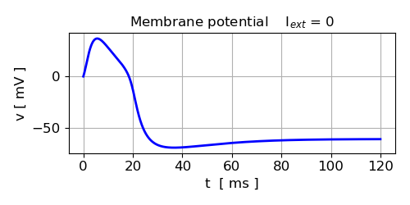
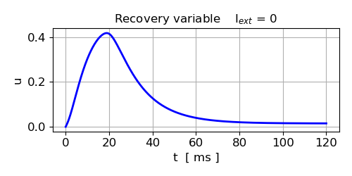
Fig. 1.1. From all initial conditions, the system relaxes to the single fixed point (equilibrium point) v_{E} = 60.9 mV, u_{E} = 0.015
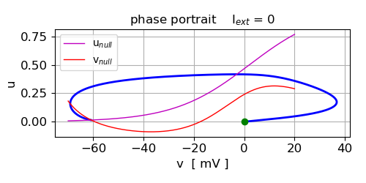
Fig. 1,2. Phase portrait. Green dot shown the initial conditions v[0] and u[0]. The blue curve is the trajectory in phase space. The red curve is the v-nullcline and the magenta curve is the u-nullcline. The fixed point is the point of intersection of the v-nullcline and the u-nullcline .

Python code for nullclines and fixed-point calculations:
vN = linspace(-70,20,599)
# u nullcline
uNu = 0.5 * (1 + np.tanh((vN - v3) / v4))
MI = 0.5 * (1 + np.tanh((vN - v1) / v2))
# v nullcline
uNv = (I - gL*(vN - EL) - gCa*MI*(vN - ECa) ) / (gK*(vN - EK))

# Find indices where sign changes --> steady values for v and u
vu = uNu - uNv

index = np.where(np.diff(np.sign(vu)))[0]
vSS = vN[index]
uSS = 0.5 * (1 + np.tanh((vSS - v3) / v4))
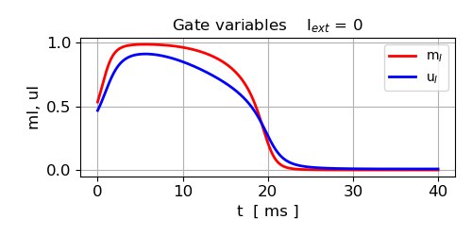
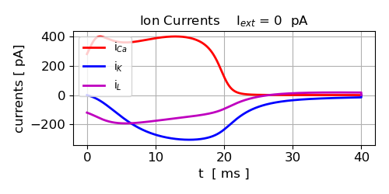
Fig. 1.3. The Ca²⁺ and K⁺ both open increasing the ion currents through the membrane of the neuron. The initial membrane potential is set above the steady value
hence, there is a flow of Ca²⁺ ions into the inside of the cell, while there is a flow of K⁺ ions and leak current flow from the inside to the outside of the cell.
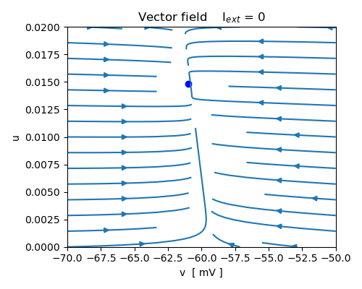
Fig. 1.4. Vector field: All trajectories are attracted to the stable fixed point as seen by following the streamlines. v_{E} = 60.9 mV, u_{E} = 0.015

Python Code for vector field:
#%% Fig 6 Vector field
X = linspace(-70,-50,12); Y = linspace(0,0.02,12)
xx,yy = np.meshgrid(X,Y)
tuI = 0.5 * (1 + np.tanh((xx - v3) / v4))
tmI = 0.5 * (1 + np.tanh((xx - v1) / v2))
ttau = 1 / ( np.cosh((xx - v3) / (2 * v4)) )

xxDot = -gCa*tmI*(xx-ECa)-gK*yy*(xx-EK)-gL*(xx-EL)+I
yyDot = (phi/ttau)*(tuI-yy)

XXDot = xxDot/(sqrt(xxDot**2 + yyDot**2))
YYDot = yyDot/(sqrt(xxDot**2 + yyDot**2))

plt.rcParams['font.size'] = 10
plt.rcParams["figure.figsize"] = (5,4)
fig6, ax = plt.subplots(nrows=1, ncols=1)
ax.set_title('Vector field I$_{ext}$ = %0.0f' %I, fontsize = 12)
ax.set_xlabel('v [ mV ]'); ax.set_ylabel('u')

ax.plot(vSS,uSS, 'bo', ms = 6)
#ax.quiver(xx,yy,XXDot,YYDot)
ax.streamplot(xx,yy,xxDot,yyDot, density = [0.5,0.5])
fig6.tight_layout()
fig6.savefig('a6.png')

I_{ext} = 88.2 pA
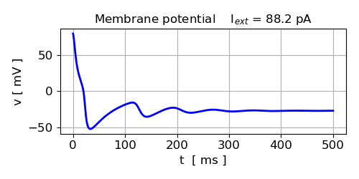
Fig. 1.5. All trajectories are attracted to the stable fixed point
v_{E} = -27.3 mV, u_{E} = 0.123

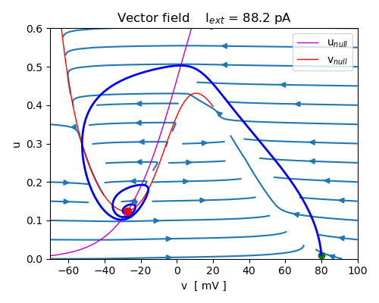
Fig. 1.6. Phase portrait. The trajectory in phase space spirals inwards towards the stable fixed point v_{E} = -27.3 mV, u_{E} = 0.124

I_{ext} = 88.3 pA
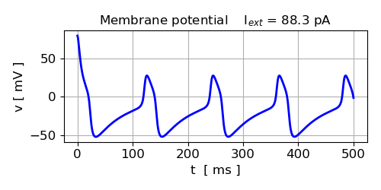
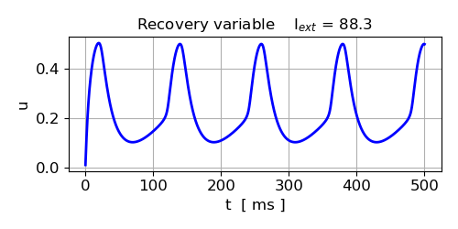
Fig. 1.7. A spike train in initiated by the higher current stimulus.
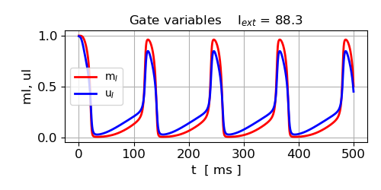
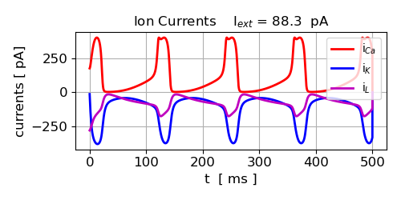
Fig. 1.8. The spike train occurs because the Ca²⁺ and K⁺ channels repeatedly open and close which allows the inflow of Ca²⁺ ions into the cell (positive current) and the outward flow of K⁺ ions out of the cell (negative current).

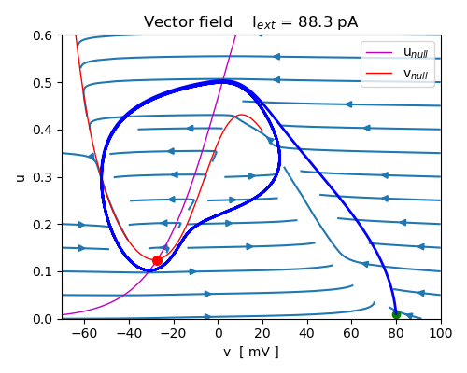
Fig. 1.9. A Hopf bifurcation occurs at 88.2 - 88.3 pA. The single fixed point goes from to stable to unstable and a stable limit cycle is established for the specified initial conditions. Fixed point for I_{ext} = 88.3 pA is v_{E} = -27.26 mV, u_{E} = 0.124

The closed trajectory is called a stable limit cycle because it is
the cyclic curve to which all the neighbouring trajectories converge no matter where in phase space they originate. The trajectories circulate around the steady state in a counterclockwise direction as indicated by the velocity vector field. The limit cycle circulates around the intersection of the two nullclines.

I_{ext} = 217 pA
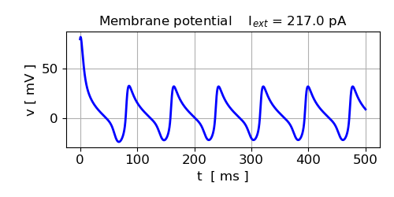
Fig. 1.10. When the stimulus current is increased from 88.3 pA to 217 pA, the spike frequency increases.
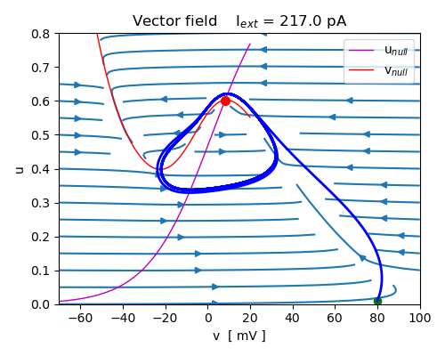
Fig. 1.11. The specified initial conditions, the single fixed point is unstable v_{E} = 8.11 mV, u_{E} = 0.600 and the limit cycle is stable.

I_{ext} = 218 pa
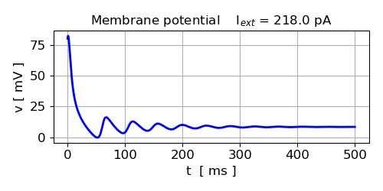
Fig. 1.12. Another bifurcation occurs when the stimulus current is 217-218 pA. The unstable fixed point becomes stable again in a Hopf bifurcation for the specified initial conditions.
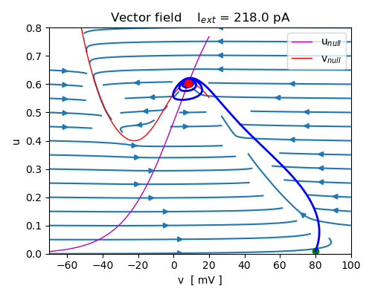
Fig. 1.13. Trajectories spiral inwards to the stable fixed point
v_{E} = 8.261 mV, u_{E} = 0.603.

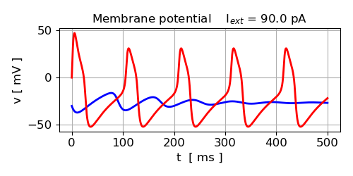
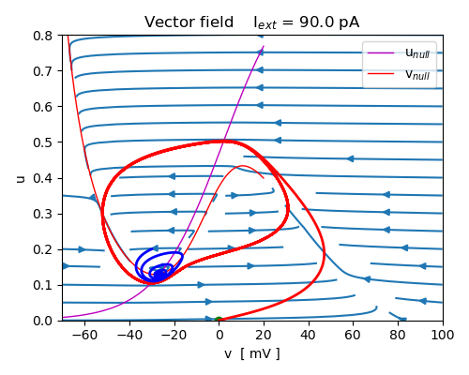
Fig. 1.14. Initial conditions (0.0) and (-30, 0.2) and I_{ext} = 90 pA showing bistability between a stable limit cycle and a fixed point separated by the unstable limit cycle.

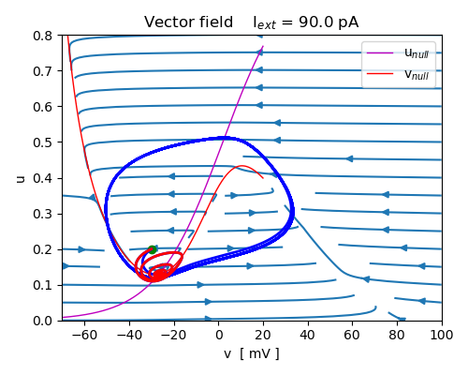
Fig. 1.15. Initial conditions (-30, 0.2). I_{ext} = 90 pA the trajectory (red) relaxes to the fixed point (-26.7, 0.129). However, if I_{ext} = 100 pA, then the trajectory (blue) is a stable limit cycle and the fixed point (-23.2, 0.157) is unstable. Thus, we have a bistability between a stable fixed point and a stable limit cycle.

The Hopf bifurcation is the best-known mechanism through which one can go from a stable fixed point to an oscillation. Importantly, the fixed point persists through the bifurcation. Furthermore, the limit cycles which bifurcate are of small amplitude and are local, in the sense that they lie close to the branch of fixed points. In the M-L model, the bifurcation is subcritical at low currents and supercritical at large currents and there is only one unique fixed point. The fixed point is stable for I_{ext} < 88 pA and I_{ext} > 217 pA. In the stimulus current range that results in a spike train, the frequency of the action potentials varies from about 8 Hz to about 14 Hz.
SIMULATION 2 Saddle Node on a Limit Cycle (SNLC)
The Hopf bifurcation is the best known mechanism through which one can go from a stable fixed point to an oscillation. Importantly, the fixed point persists through the bifurcation. Another mechanism through which an oscillation can emerges from a fixed point is called a saddle–node on a limit cycle (SNLC). Using the parameters listed in Table 1 for the SNCL case, the response of the system is very different. There are now three fixed points only one of which is stable as shown in figure 2.1 for the case when I_{ext} = 0.
The three fixed points (v,u) are
(-59.62, 0) stable
( -9.5, 0.078) unstable – saddle point
(0.13, 0.204) unstable
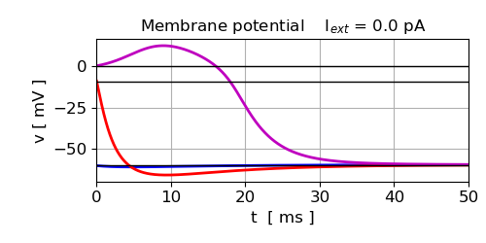
Fig, 2.1. The membrane potential for the fixed points is shown as the black horizontal lines. The red, blue and magenta curves shown the time evolution of the membrane potential for thee sets of different initial conditions. In all cases the membrane potential relaxes to the stable fixed point.
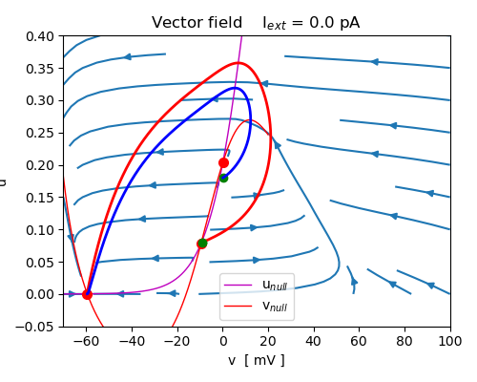

Fig. 2.2. Phase portrait showing two phase space trajectories that are repelled from the two unstable fixed points {( -9.5, 0.078), (0.13, 0.204)} and are attracted to the single fixed point (-59.62, 0).

When the stimulus current is increased to I_{ext} = 39 pA, the membrane potential still relaxes back to the single fixed-point potential. The phase space coordinates for the three fixed points are
(-33.0, 0.006) stable
( -26.2, 0.012) unstable – saddle point
(4.50, 0.297) unstable

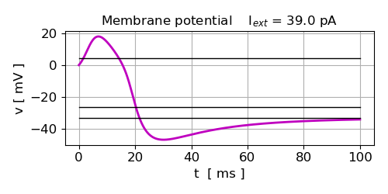
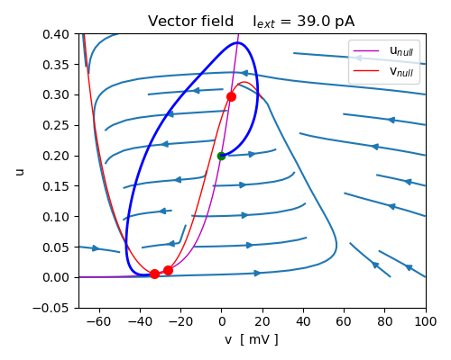
Fig. 2.3. The membrane potential relaxes back to the single fixed point from its initial condition.

A further slight increase in the stimulus current to I_{ext} = 41 pA, results in a saddle node limit cycle bifurcation where the membrane now oscillates producing a spike train as shown in figure 2.4. There is a transition from three fixed points to one fixed point.

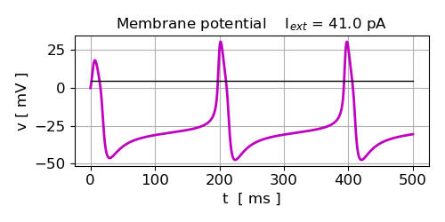

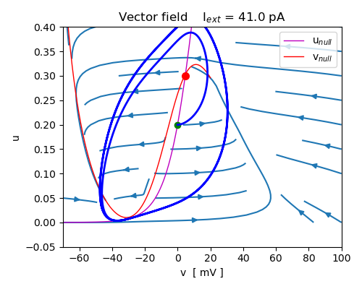
Fig. 2.4. A limit cycle orbits the single fixed point (4.65, 0.30).

As the stimulus current increases to I_{ext} = 115 pA, the frequency of the spike train increases.

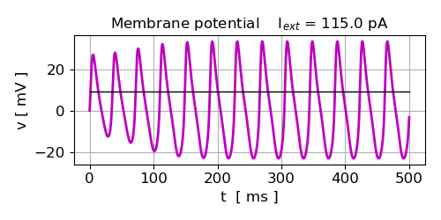
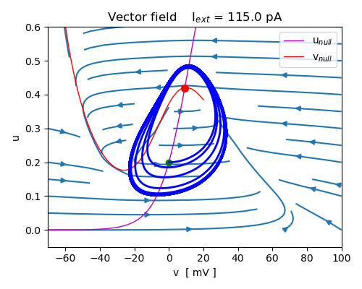
Fig. 2.5. When the stimulus current I_{ext} increases from 41 pA to 115 pA spike trains of increasing frequency are produced.

However, when the stimulus current is Iext = 116 pa, the oscillations in the membrane potential decrease and the membrane potential is attracted to the single fixed point at (9.16, 0.419).

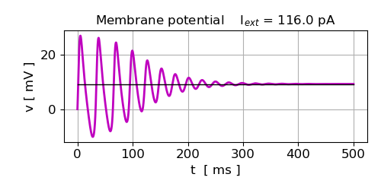
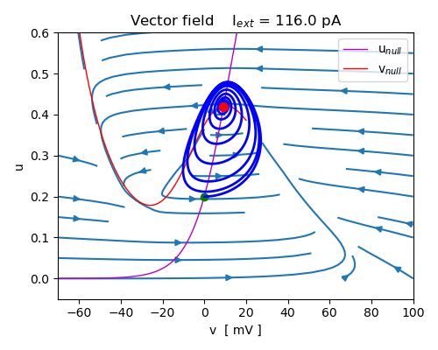
Fig. 2.6. The membrane potential oscillations decrease in amplitude and relaxes to the single fixed point (9.16, 0.419).

SIMULATION 3 Saddle Node Homoclinic bifurcations

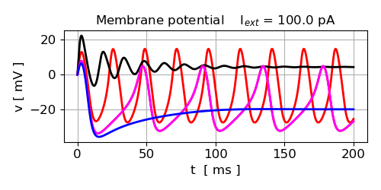
Fig. 3.1. Time evolution plots of the membrane potential for different stimulus currents:
black 200 pA; red 100 pA; magenta 60 pA; blue 50 pA

Oscillations do not occur if there is insufficient stimulus current. In the range of stimulus current that results in spike trains, the frequency of the oscillations increases with stimulus current. When the stimuls current becomes large enough, then the oscillations disappear and the system evolves to a single stable fixed point.

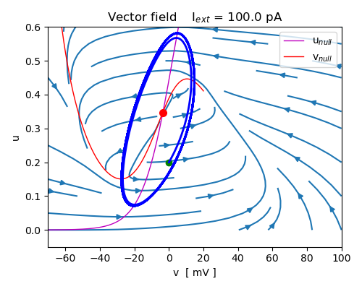
Fig. 3.2. Phase portrait when there is a spike train produced. A stable limit cycle exists surrounding the unstable fixed point (-3.48, 0.348).
REFERENCES

https://frederic-vw.github.io/morris-lecar-2d/

https://pmc.ncbi.nlm.nih.gov/articles/PMC10374513/

https://neuronaldynamics.epfl.ch/online/Ch4.S4.html

