DOING PHYSICS WITH PYTHON

NEURON MEMBRANE
REVERSAL POTENTIAL - NERNST EQUATION
Goldman–Hodgkin–Katz (GHK) equation

Ian Cooper
Any comments, suggestions or corrections, please email me at
matlabvisualphysics@gmail.com

DOWNLOAD DIRECTORIES FOR PYTHON CODE
Google drive GitHub

INTRODUCTION
Electrical activity in neurones is sustained and propagated by ion currents through neurone membranes as shown in figure 1. Most of these transmembrane currents involve four ionic species: sodium Na⁺, potassium K⁺, calcium Ca²⁺ and chloride Cl⁻. The concentrations of these ions are different on the inside and outside of a cell. This creates the electrochemical gradients which are the major driving forces of neural activity. The extracellular medium has high concentration of Na⁺ and Cl⁻ and a relatively high concentration of Ca²⁺. The intracellular medium has high concentration of K⁺ and negatively charged large molecules A⁻. The cell membrane has large protein molecules forming ion channels through which ions (but not A⁻) can flow according to their electrochemical gradients.

The concentration asymmetry is maintained through
- Passive redistribution: The impermeable anions A⁻ attract more K⁺ into the cell and repel more Cl⁻ out of the cell.
- Active transport: Ions are pumped in and out of the cell by ionic pumps. For example, the Na⁺/K⁺ pump, which pumps out three Na⁺ ions for every two K⁺ ions pumped.

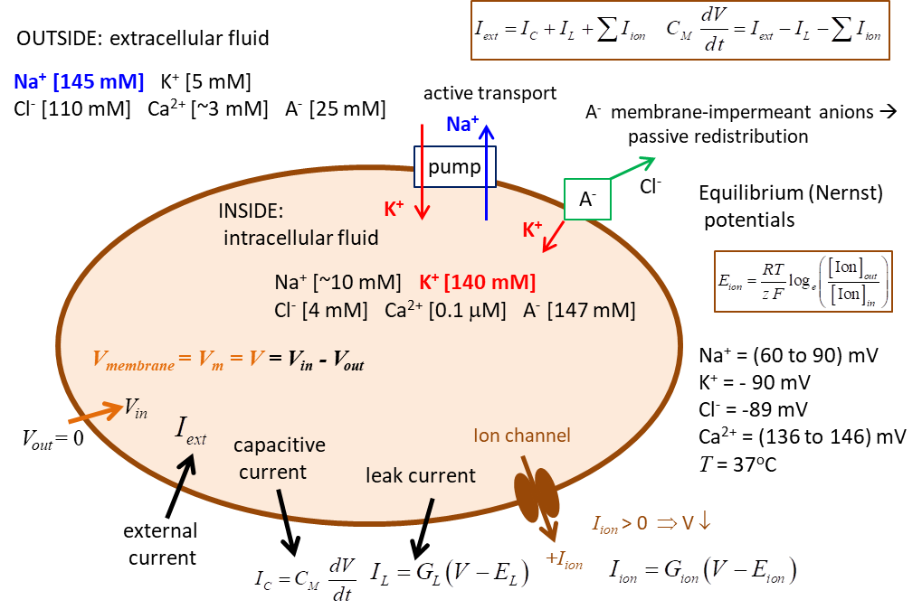
Fig. 1. Electrophysiology of a neurone.

Nernst or Equilibrium Potential
There are two forces that drive each ion species through the membrane channel.
      - Concentration gradient: ions diffuse down the concentration gradient. For example, the K⁺ ions diffuse out of the cell because K⁺ concentration inside is higher than outside.
      - Electric potential gradient: as ions diffuse across the membrane a charge imbalance occurs producing a potential difference between the inside and outside of the cell. For the K⁺ ions exiting the cell, they carry positive charge with them and leave a net negative charge inside the cell (consisting mostly of impermeable anions A⁻), thereby producing the outward K⁺ current.

The positive and negative charges accumulate on the opposite sides of the membrane surface creating an electric potential gradient across the membrane. This potential difference is called the transmembrane potential or membrane voltage
(1)
where the extracellular potential is the reference potential such that .

For example, the membrane potential slows down the diffusion of K⁺, since K⁺ ions are attracted to the negatively charged interior and repelled from the positively charged exterior of the membrane. At some point an equilibrium is achieved. When the concentration gradient and the electric potential gradient exert equal and opposite forces on the ions, the net cross-membrane current is zero. The value of such an equilibrium potential depends on the ionic species and it is given by the Nernst equation
(2)
where [Ion]_{in} and [Ion]_{out} are concentrations of the ions inside and outside the cell respectively, R is the universal gas constant (R = 8.3155 J.mol⁻¹.K⁻¹), T is temperature in degrees Kelvin, F is Faraday’s (F = (96 485 C.mol⁻¹), z is the valence of the ion (z = 1 for Na⁺ and K⁺, z = -1 for Cl⁻, and z = 2 for Ca²⁺). E_{ion} is also called the reversal potential.
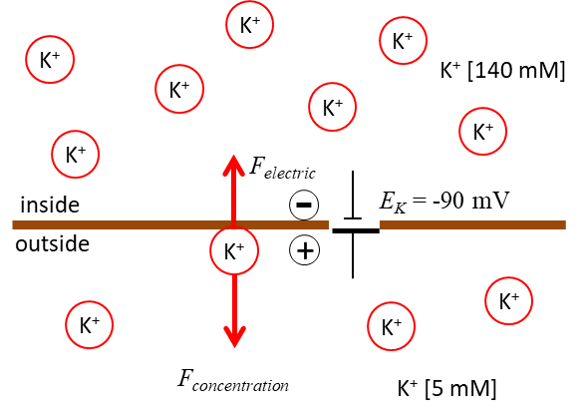
Fig. 2. Diffusion of K⁺ ions down the concentration creates an increasing electric force directed in the direction opposite to the force due to the concentration difference until the diffusion and electrical forces balance each other.

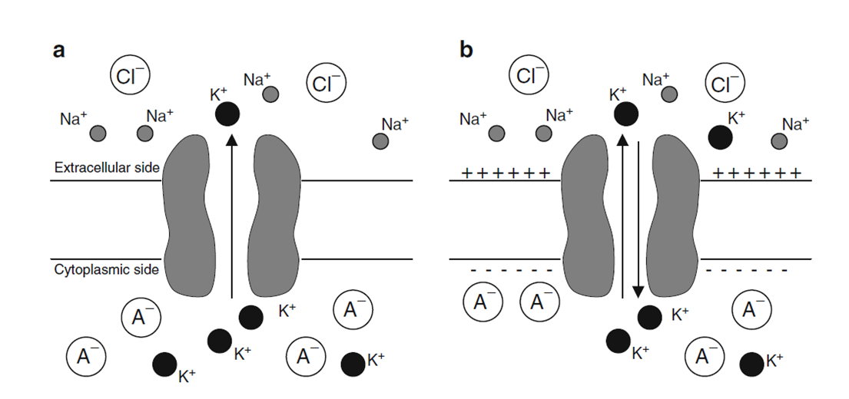
Fig. 3. The K⁺ flux is determined by both the K⁺ concentration gradient and the electrical potential across the membrane.
a For a cell that is permeable only to K⁺, the concentration
gradient of K⁺ moves K⁺ ions out of the cell
b The continued efflux of K⁺ builds up an excess of positive charge on the outside and an excess of negative charge on the inside.
At equilibrium, the electrical and chemical driving forces are equal in magnitude but opposite in direction.

Neurons at rest are permeable to Na⁺ and Cl⁻ in addition to K⁺. Because of their concentration differences, Na⁺ and Cl⁻ ions move into the cell and K⁺ ions move outward. The influx of Na⁺ ions tends to depolarize the cell, whereas the efflux of K⁺ and the influx of Cl⁻ have the opposite effect. The resting potential of the cell membrane is the potential at which there is a balance between these fluxes. It depends on the concentrations of the ions both inside and outside the cell, as well as the permeability of the cell membrane to each of the ions. At rest, many more K⁺ and Cl⁻ channels than Na⁺ channels are open. Hence, the membrane’s resting potential is determined primarily by the K⁺ and Cl⁻ Nernst potentials.

Goldman–Hodgkin–Katz (GHK) equation
The Goldman–Hodgkin–Katz (GHK) equation, gives an explicit expression for how the resting potential depends on the concentrations of ions both inside and outside and the permeabilities of the membrane to the ions. For the membrane to maintain a constant resting potential, the efflux of K⁺ ions must balance the influx of Na⁺ ions. That is, the charge separation across the membrane must be constant. If these steady ion leaks continued unopposed, then K⁺ ions within the cell would become depleted, whereas the concentration of Na⁺ ions inside the cell would increase. This would eventually result in a loss of the ionic gradients, necessary for maintaining the resting potential. The dissipation of ionic gradients is prevented by active pumps that extrude Na⁺ ions from the cell while taking in K⁺. The Na⁺/K⁺ pump is an integral membrane protein that exchanges three Na⁺ ions for two K⁺ ions.

Suppose there are three permeable ions, K⁺, Na⁺, and Cl⁻ with corresponding currents, I_{K}, I_{Na}, and I_{Cl}. At equilibrium, the total current and membrane potential is
I = I_{K} + I_{Na} + I_{Cl} = 0

where the P_{j} ’s are the permeabilities of each of the three ionic species. This is a generalization of the Nernst equilibrium is called the Goldman-Hodgkin–Katz (GHK) equation. With one species, the equation reduces to the Nernst potential.

For example, in the squid axon, the ratios of the permeabilities,
at rest, are P_{K} : P_{Na} : P_{Cl} = 1 : 0:03 : 0.1. The ion concentrations are

Inside [mM] [K⁺] = 400 [Na⁺] = 50 [Cl⁻] = 40

Outside [mM] [K⁺] = 10 [Na⁺] = 460 [Cl⁻] = 540

At room temperature, the steady-state, resting potential is 74mV.

