DOING PHYSICS WITH PYTHON

THE PASSIVE CABLE EQUATION

Ian Cooper
Any comments, suggestions or corrections, please email me at
matlabvisualphysics@gmail.com

DOWNLOAD DIRECTORIES FOR PYTHON CODE
Google drive GitHub

mnsET01.py mnsET02.py
Solution of the cable equation using a finite difference method.

Model parameters:

INTRODUCTION

The passive cable equation in neuroscience models the spread of electrical signals along a neuronal cable (dendrite or axon) over time and space, and is modelled by a partial differential equation. The model is a passive one which means that membrane conductance is fixed. A subthreshold voltage signal that is initiated at one point along
the axon or dendrite will decrease in amplitude with distance from the point of initiation. For example, the signal may correspond to synaptic input from another neuron. Understanding how geometry affects the spread of the signal helps determine whether the synaptic input will cause the cell to fire an action potential.

Assume the membrane is passive, so the analysis is more applicable to dendrites than to axons. Consider a cell that is shaped as a long cable of radius a and the current flow is along a single spatial dimension x, the distance along the cable. The membrane potential depends on the axial x variable and not on the radial. The cable equation is a partial differential equation that describes how the membrane potential depends on currents entering, leaving, and flowing within the neuron. The equivalent circuit is shown in
figure 1.
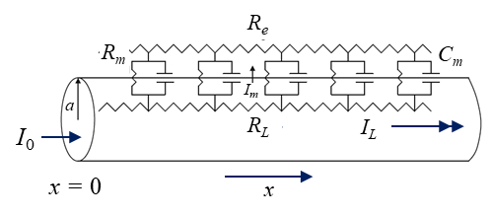
Fig. 1. Equivalent circuit for a uniform passive cable. I_{L} is the longitudinal (axial) current inside of the cable, I_{m} is the current across the membrane (membrane current), R_{L} is the longitudinal resistance (axial) inside the neuron (cytoplasm), R_{e} is the resistance of the extracellular space (assume extracellular space is isopotential, R_{e} = 0) , R_{m} is the membrane resistance (radial), and C_{m} is the membrane capacitance.

The typical problem of cable theory is to determine the distribution of voltage along the length of the cable x and over time t, given a current input I₀(t) at x = 0.

The axial current flowing along the neuron is due to the voltage gradient along the cable. The longitudinal resistance R_{L} grows in proportion to the length of the cable and is inversely proportional to the cross-sectional area of the cable.
where is the specific intracellular resistivity.
Units: R_{L} [] r_{L} [] [m] a [m] I [A] v [V] t [s]

From Ohm’s law, the decrease in with increasing distance is equal the current times the resistance.
The minus sign is because, by convention, ∆v_{m} is positive when voltage increases with x, and I_{L} is positive towards positive x.

The longitudinal current in the limit as is thus
The membrane resistance R_{m} of a cylindrical segment of length ∆x and circumference is
where r_{m} is the specific resistance []. The membrane current can be expressed as
where i_{m} is the specific membrane current [A.m⁻²]

For a passive cable, r_{m} is constant and Ohm’s Law gives the relationship between the membrane voltage v_{m} and the membrane current (radial) I_{m}
After considering all flows into and out of a segment of length , then the capacitor current I_{cap} will charge or discharge the capacitor. Hence, the rate of change of the membrane potential is determined by the membrane capacitance C_{m} [F].
where c_{m} is the specific membrane capacitance [F.m⁻²].

From Kirchhoff’s current law, the change in intracellular axial current is equal to the amount of current that flows across the membrane. Hence,
By dividing both sides of this equation by and letting , we obtain the cable equation
Define the length (space) constant as
and the membrane time constant as
Thus, the cable equation can be expressed as

- The time constant describes membrane potential attenuation over time.
- The length constant describes the attenuation over space.
- The time-derivative term relates to charging of the membrane capacitor.
- The second space-derivative term relates to accumulation of longitudinal currents.

Typical values
cable radius a ~ 5x10⁻⁶ m
specific intracellular resistivity r_{L} ~ 1 .m
specific membrane resistivity r_{m} ~ 1 .m.m²
specific membrane capacitance c_{m} ~ 10⁻² F.m⁻²
space constant ~ 1x10⁻³ m
membrane time constant ~ 10⁻² s

Steady-state solutions of the cable equation
We can calculate the steady-state solution v_{SS}(x) of the cable equation where
To solve this differential equation, we need to specify the cable geometry and the boundary conditions. Consider an infinite cable where and a step current I₀ is injected at x = 0 resulting in the membrane potential at x = 0 to be v₀.

The longitudinal current and membrane potential

The boundary condition is
The solution of the differential equation is
This solution when differentiated and evaluated at x = 0 satisfies the boundary conditions.

Thus, the membrane potential decays exponentially. The distance at which the potential has decayed to 1/e is the space constant
Since the space constant is proportional to the square root of the cable’s radius a, we conclude that thicker axons or dendrites have larger space constants than narrower processes. This means that thicker axons or dendrites are able to transmit signals for greater distances. Thicker cells with a larger space constant are more easily excited and are able to generate faster action potentials.

The input resistance R_{inp} is defined to be the ratio of the steady-state membrane potential to the injected current at x = 0

The input resistance R_{inp} of the cable varies with the -3/2 power of the cable radius. Therefore, the input conductance G_{inp} is directly proportional to the 3/2 power of the cable radius.

The input resistance is important because it is something that can be measured experimentally. Since it is also possible to measure the space constant , one can compute r_{m} and r_{L} from experimental data.
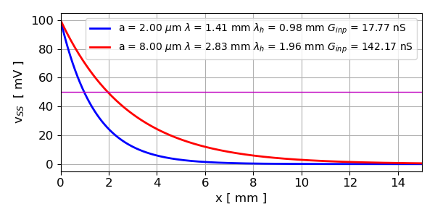
Fig. 2. Steady-state solutions of the cable equation for two values of the cable radius a. The membrane potential decreases exponentially from the stimulus. distance for the membrane potential to decrease by half.
mnsET01.py

Linear potential profile
Let where the linear potential profile is given by
and the cable equation reduces to and the solution for g(t) is of the form . Therefore, the solution can be expressed as
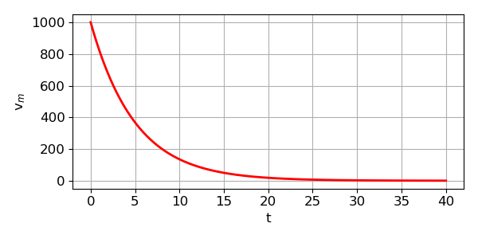
Fig. 3. For all values of x, the membrane potential relaxes to zero with time. mnsET01.py
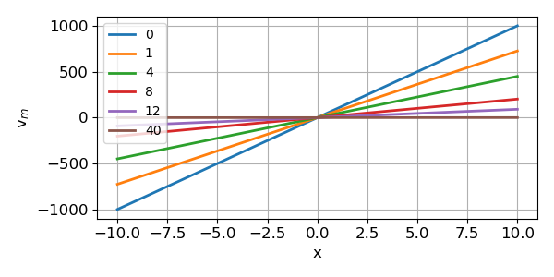
Fig. 4. The linear membrane potential at times 0, 1,4, 8, 12, and 40. For all values of x the membrane potential relaxes towards zero with time. mnsET01.py
Solution of the cable equation using a finite difference method. mnsET02.py

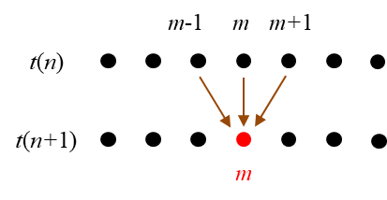
Cable equation

Finite difference equation:
time step m, total steps nT
space step n, total steps nX

for stability of the solution

Boundary Conditions: The membrane potentials at the ends of the cable are set to zero at all time steps.
The stimulus is applied at the centre of the cable.

Stimulus: Membrane potential fixed at the Origin x = 0
v_{m}(t,0) = 100 mV
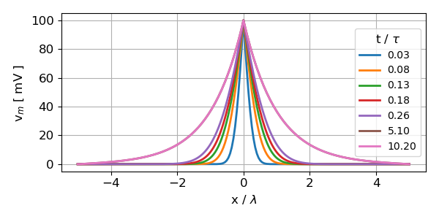
Fig. 5A. Membrane potential fixed at the Origin. Membrane potential along the length of the cable at different times. mnsET02.py
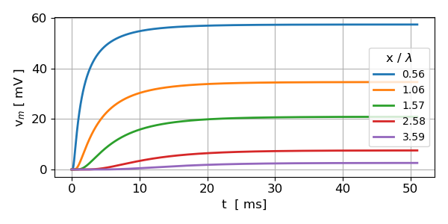
Fig. 5B. Membrane potential fixed at the Origin. Time evolution of the membrane potential at different times positions long the cable. mnsET02.py

Stimulus: Membrane potential at the Origin x = 0 decreases with time with a Gaussian profile.
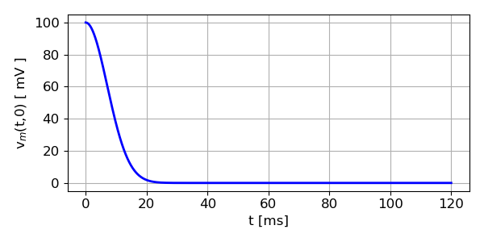
Fig. 6A. Stimulus applied at Origin: Gaussian decrease in membrane potential with time at the Origin x = 0. mnsET02.py

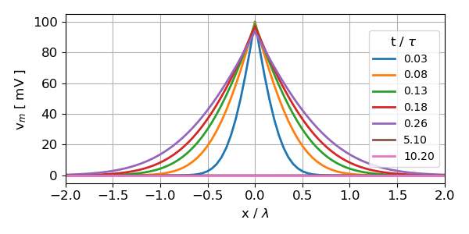
Fig. 6B. Membrane potential along the length of the cable at different times. mnsET02.py

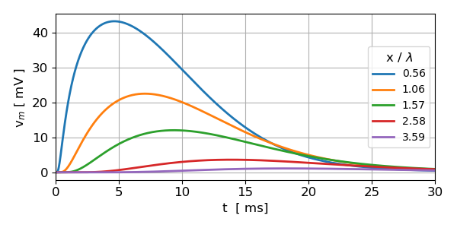
Fig. 6C. The peak in the membrane potential at each time step propagates away from the Origin at a conduction speed v_{cond}.

Theory: Local peak voltage propagates with speed

Simulation: Peak 1
Peak 2
Agrees with theoretical prediction

REFERENCES

https://neuronaldynamics.epfl.ch/online/index.html

https://neuronaldynamics.epfl.ch/online/Ch3.S2.html

https://bernstein-network.de/wp-content/uploads/2021/02/07_Lecture_07_Modelling-morphology.pdf

https://web.njit.edu/~horacio/IntroCompNeuro/downloads/NJIT_IntroCompNeuro_F18_08_CableEquation.pdf

https://arxiv.org/pdf/1301.2885

