PHYS1002 Physics 1 FUNDAMENTALS

Module 3 OSCILLATIONS & WAVES
Text Physics by Hecht
Chapter 10 OSCILLATIONS
Damping and Forced Oscillations
Resonance
Problems
Sections: 10.8
Examples: 10.11

CHECKLIST

There are usually external forces acting on an oscillator in addition to the restoring force.

The motion can be damped so that the oscillations die away.
- Friction, damping, viscous damping, drag force

- Underdamped, critically damped, overdamping.

An external force can drive the oscillations.
- An external source can supply energy to the vibrating system so that the system vibrates at the same frequency as the external source.
- The oscillations can grow in amplitude if the driving frequency approaches the natural frequency of oscillation. This phenomena is known as resonance and the system vibrates at its resonance frequency with large amplitude.
- Self-excited vibrations can occur – the vibrations are initiated and sustained by an energy source that is not oscillatory.

NOTES

Damping

In real oscillating systems, mechanical energy is lost from the system due to frictional or damping forces acting. The oscillation die away with time and the system comes to rest.

When the amplitude of the oscillation decays away very slowly, the system is said to be underdamped. For example, when a tuning fork is set vibrating, the sound of vibrations persists for quite sometime.

A car shock absorber uses viscous damping (frictional force proportional to the speed). When a car hits a pothole, the piston is jerked away from its equilibrium position. Because of the large damping, the piston returns to its equilibrium position without sustained oscillations. This prevents the car from bobbing up-and-down for a long time after hitting a bump. A sports car has a rigid suspension and oscillations maybe damped out in less than a cycle. A luxury car often has a soft suspension and there maybe a few cycles of the oscillations before they die out. You can change the characteristics of the suspension system in some expensive cars.

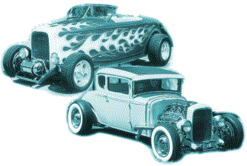 | 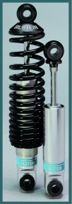

When non-vibratory motion occurs in the shortest time interval, the system is said to be critically damped. The spring system in a moving coil meter is critically damped and also the mechanism on electronic scales to measure mass.

When non-vibratory motion occurs and it takes a long time for the system to come to rest at its equilibrium position, the system is said to be overdamped. Heavy public doors on some building are overdamped to prevent them closing too quickly, giving time for people to enter and so that the doors are do not slam shut. The doors have some hydraulic dashpot (type of shock absorber) to provide the damping.

The figures below show the motion for increasing the damping (damping coefficient b where damping force F_{D} = - b v ).

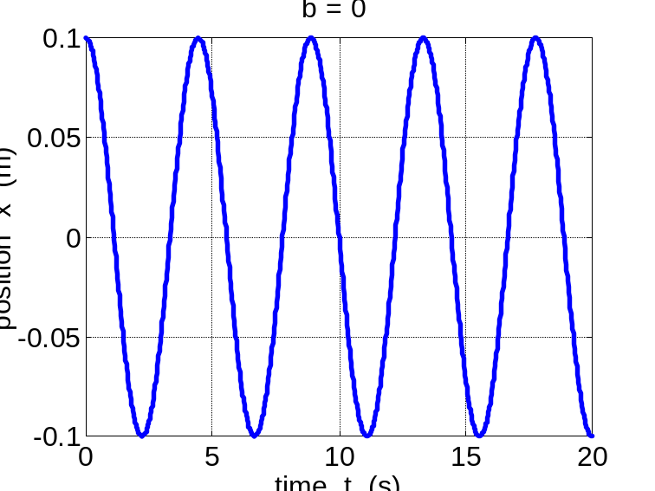
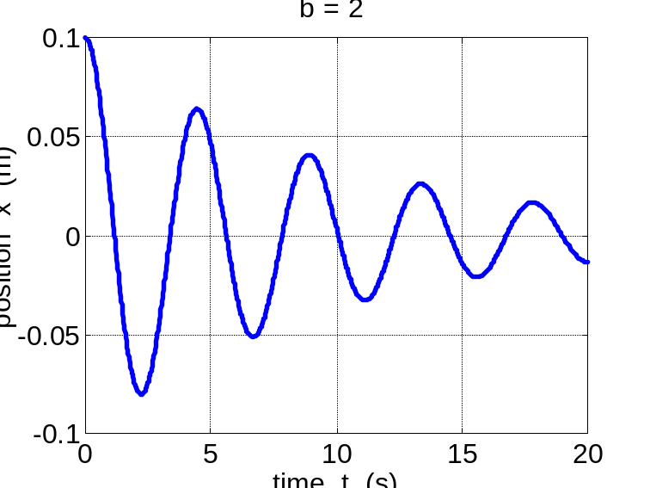
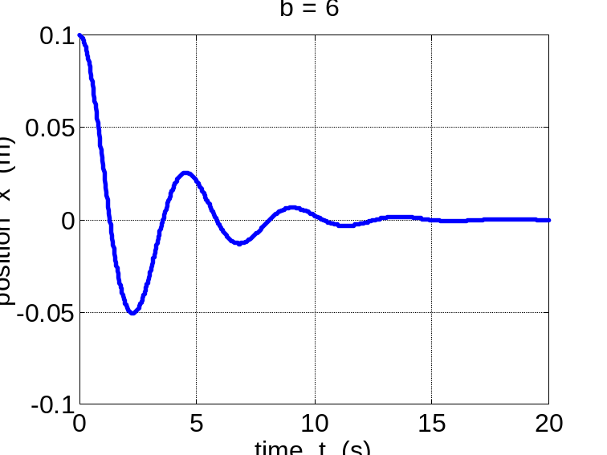

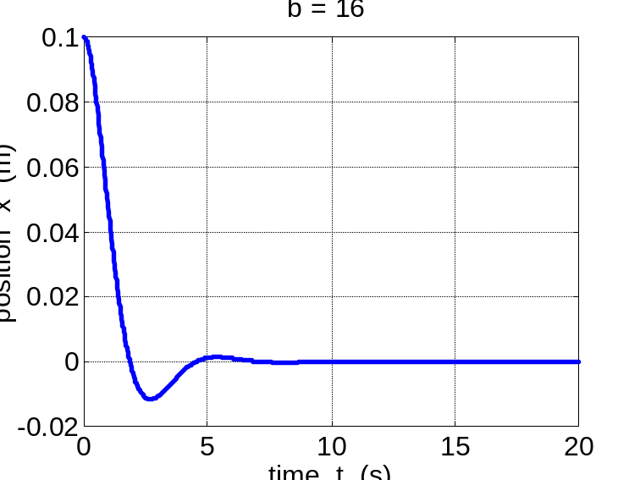
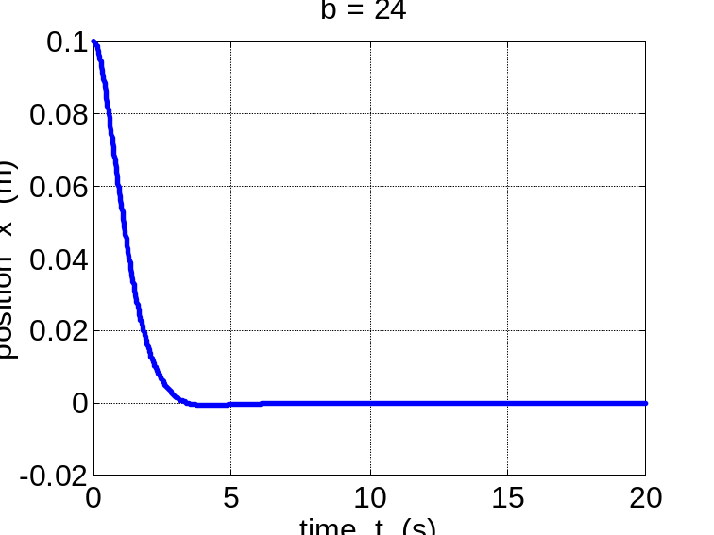
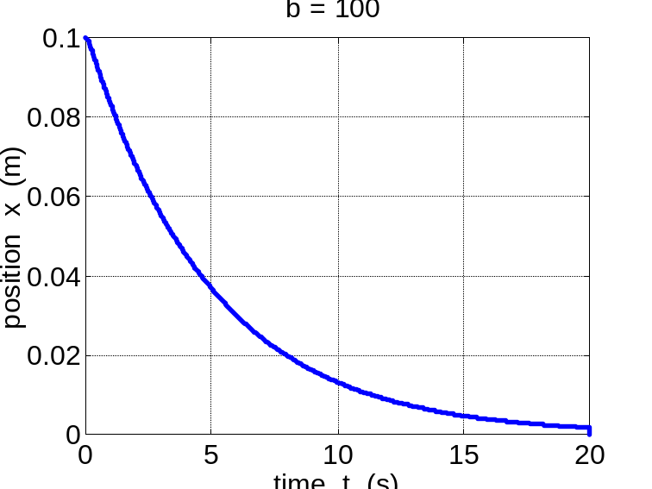

Interest article
http://physicsweb.org/article/news/5/10/15
Buildings and bridges may be among the structures to benefit from a proposed shock absorber that could reduce the force of an impact by up to 98%. Surajit Sen and colleagues at the State University of New York at Buffalo demonstrated the effect with computer simulations, which also showed that it should be possible to turn the absorbed energy into heat. Similar devices could even harness the energy from natural impacts such as ocean waves (S Sen et al 2001 Physica A 299 551).

Granular materials, including sand and soil, have long been used to absorb impacts, but if the grains are all the same size, the shock waves are not always dispersed effectively. Instead, Sen's team simulated a shock wave travelling along a chain of several hundred spherical elastic beads of ever-decreasing size. The beads at one end of the chain were around ten centimetres in diameter, and became progressively smaller.

After the shock wave has passed through the large sphere at the beginning of the chain, it proceeds to the next - slightly smaller - sphere. But the wave cannot be transmitted symmetrically into this sphere. To ensure that its energy is conserved, the wave is forced to stretch out. Its leading edge accelerates away from its trailing edge and this effect occurs every time the wave moves from one bead to the next. As the beads get smaller, the energy of the impulse is distributed and successive beads carry less and less kinetic energy.

Sen's group found that the smallest bead at the other end of the chain feels the initial large impact as a long series of very small shocks. The amplitudes of these mini-shocks are less than 10% of the original impulse. "This very simple system demonstrates that theoretically, any size shock can be absorbed with assemblies of appropriately tapered chains", explains Sen.

Forced Oscillations and resonance

Forced oscillations occur through the application of an external force that adds energy to a system. For example: noises in the home – plumbing, refrigerators, air conditions. A system responds by oscillating at the same frequency as the driving frequency.

When the driving frequency approaches a natural frequency of vibration, the resulting oscillations dramatically increase in amplitude. Resonance occurs when the driving frequency matches the natural frequency and the amplitude of the oscillation reaches a maximum value.

At resonance, most of the energy is added to the mechanical energy of the vibrating system, very little energy is returned to the driving source. The smaller the damping, than the greater the amplitude of vibration.

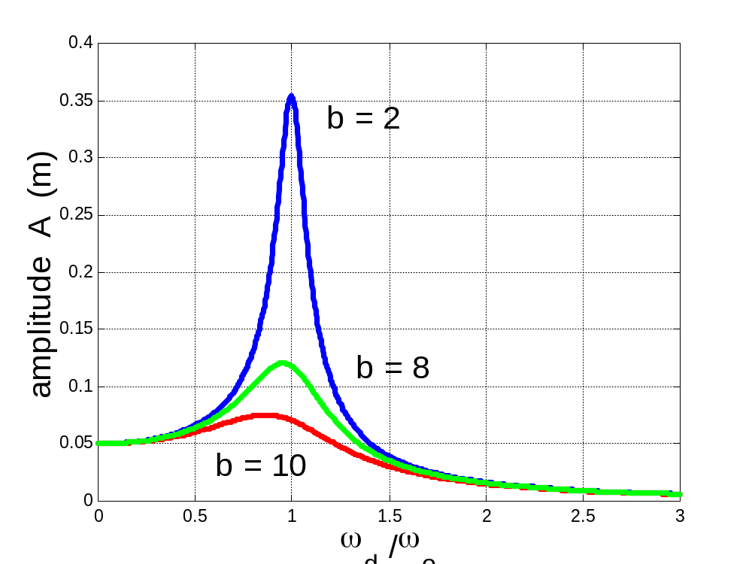

Resonance phenomena occur widely in natural and in technological applications:

Emission & absorption of light  Lasers  Tuning of radio and television sets  Mobile phones  Microwave communications  Machine, building and bridge design  Musical instruments  Medicine – nuclear magnetic resonance, X-rays  Hearing | Nuclear magnetic resonance scan  

A different resonance phenomena is when the driving energy source is not vibratory. The response of the system itself produces the alternations in the applied force to give self-exited vibrations. There are many examples of self-excited vibrations:
Singing
Blowing across the mouth of a flute causes vortices to peel off periodically,
creating a fluctuating pressure.
Musical glasses
Earthquakes – building resonances
Bridges – soldiers break step, Tacoma Narrows (Nov 7, 1940).

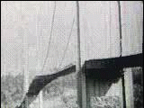 | 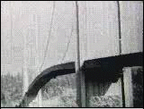 | 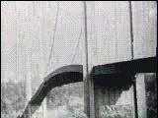
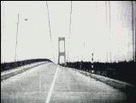 | 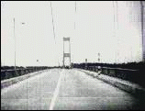 | 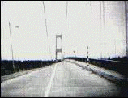

Mathematical modelling for harmonic motion

Newton’s Second Law can be applied to the oscillating system

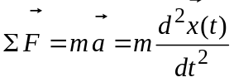

Σ F = restoring force + damping force + driving force

Σ F(t) = - k x(t) - b v(t) + F_{d}(t)

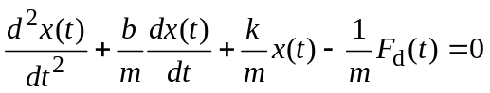

For a harmonic driving force at a single frequency F_{d}(t) = F_{max}cos(ωt + ε).

This differential equation can be solved to give x(t), v(t) and a(t).

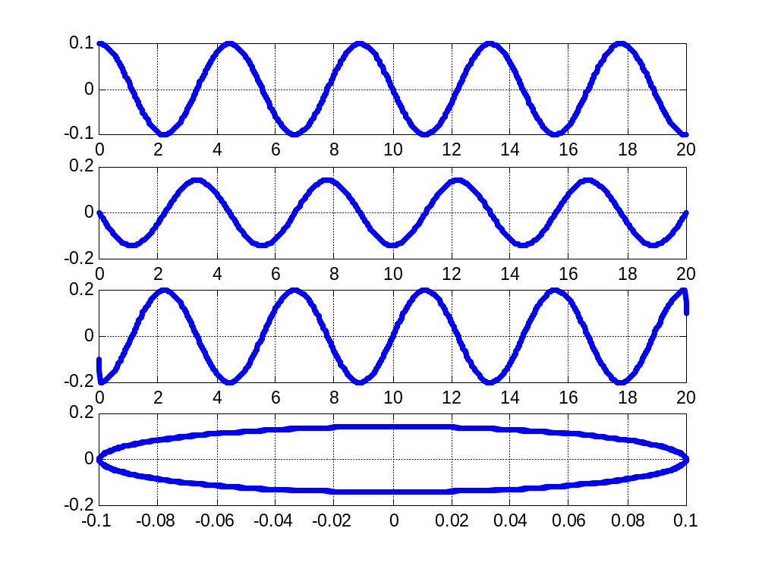
b = 0
b = 0
t
t
t
x
x
v
a
v

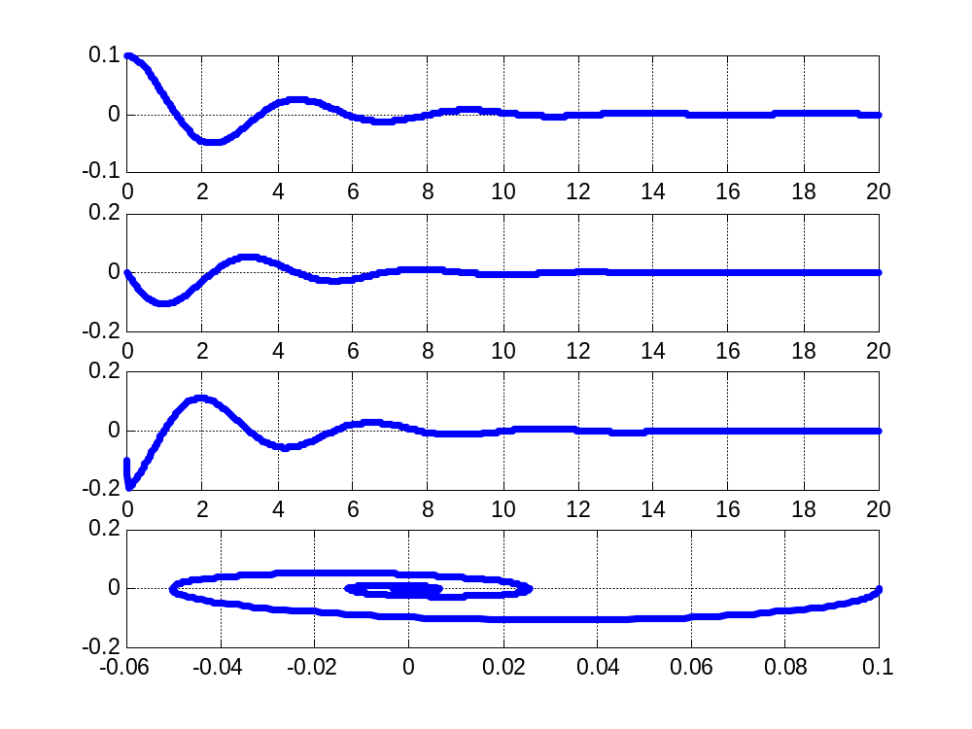
b = 6
t
x
v
a
x
v
x
t
t
t

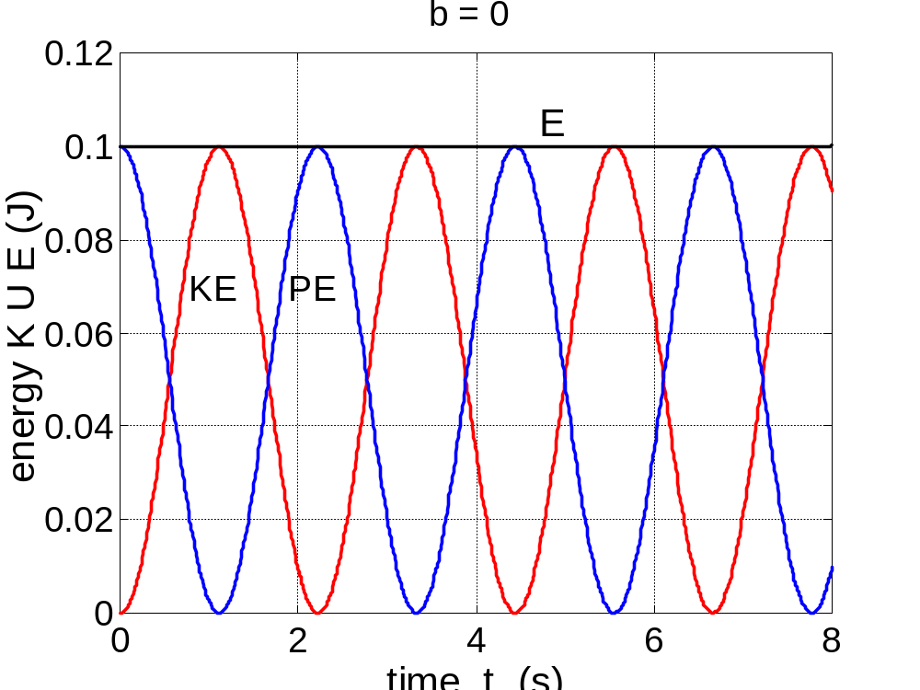
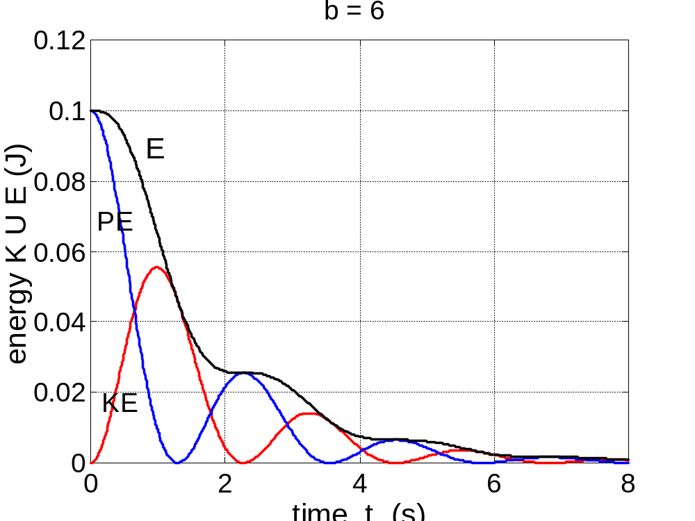

Sinusoidal driving force ω_{d} / ω_{o} = 0.1 | 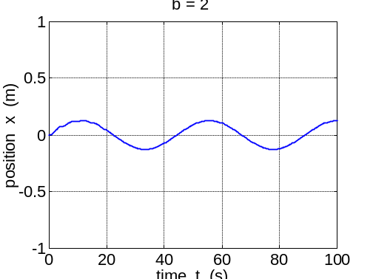
Sinusoidal driving force ω_{d} / ω_{o} = 1 | 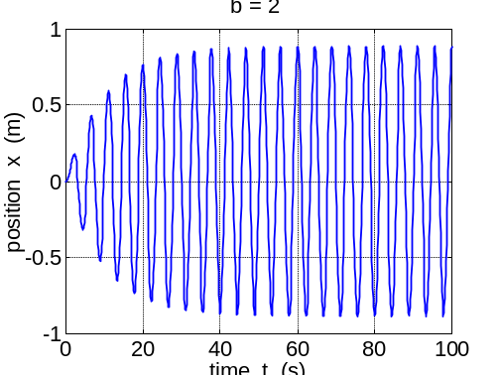
Sinusoidal driving force ω_{d} / ω_{o} = 2 | 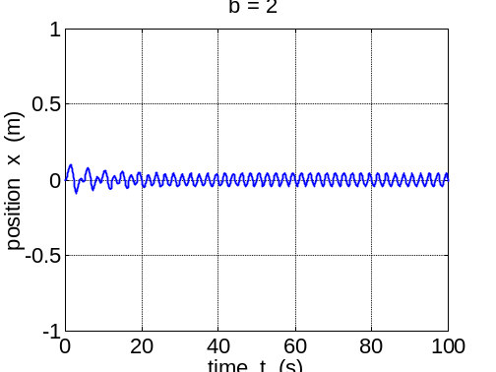
Impulsive force – constant force applied for a short time interval. | 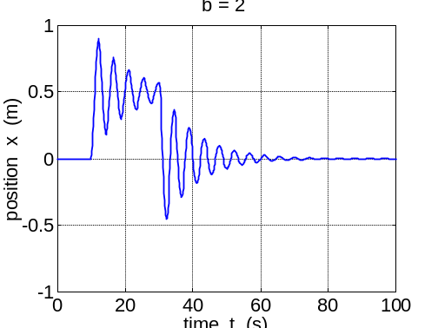

Problem
A spring is hanging from a support without any object attached to it and its length is 500 mm. An object of mass 250 g is attached to the end of the spring. The length of the spring is now 850 mm.
- What is the spring constant?
The spring is pulled down 120 mm and then released from rest.
- Describe the motion on the object attached to the end of the spring.
- What is the displacement amplitude?
- What are the natural frequency of oscillation and period of motion?
Another object of mass 250 g is attached to the end of the spring.
- Assuming the spring is in its new equilibrium position, what is the length of the spring?
- If the object is set vibrating, what is the ratio of the periods of oscillation for the two situations?

Solution
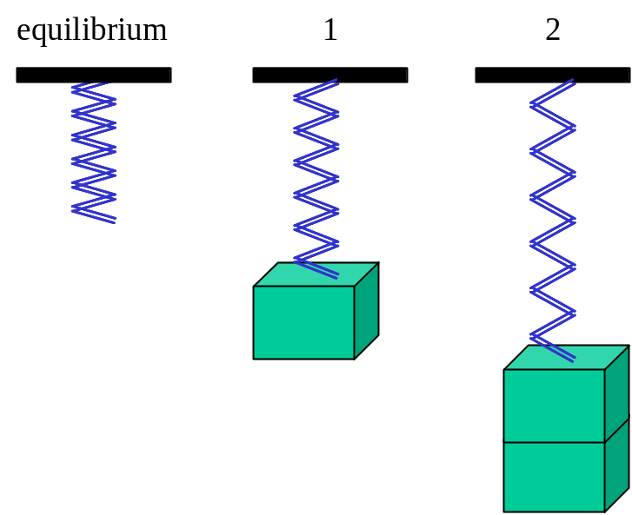
Setup

L₀ = 500 mm = 0.500 m g = 9.8 m.s⁻²
m₁ = 250 g = 0.250 kg m₂ = 0.500 kg
L₁ = 850 mm = 0.850 m L₂ = ? m
x_{1max} = 120 mm = 0.120 m x_{2max} = A₂ = ? m
f₁ = ? Hz T₁ = ? s T₂ / T₁ = ?

Hooke’s Law & SHM: F = k x 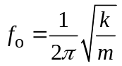

Action

(a) spring constant
Newton’s Laws: m g = k s ⇒ k = m g / s
s₁ = L₁ – L₀ = (0.850 – 0.500) m = 0.350 m
k = m₁ g / s₁ = (0.250)(9.8)/(0.35) = 7.0 N.m⁻¹

(c) amplitude: spring pulled down 120 mm
x_{1max} = A₁ = 0.120 m

(d) frequency and period (does not depend upon amplitude)
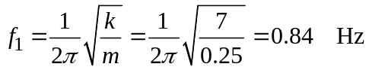
T₁ = 1 / f₁ = 1.2 s

(e)
Newton’s Laws: m g = k s ⇒ s = m g / k
s₂ = m₂ g / k = (0.500)(9.8) / (7.0) = 0.70 m
L₂ = s₂ + L₀ = 0.70 + 0.50 = 1.20 m
(f)
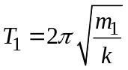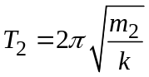
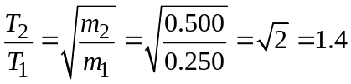

Problem
An 8.00 kg stone is resting on a spring. The spring is compressed 100 mm by the stone. (a) What is the spring constant?
The stone is pushed down an additional 300 mm and released. (b) What is the potential energy of the stone – spring system just before the release? (c) What is the speed of the stone assuming it is released as the spring moves past its equilibrium position. (d) How high above the release position will the stone rise?

Solution
m = 8.00 kg s₁ = 100 mm = 0.10 m
k = ? N.m⁻¹
s₂ = 300 mm = 0.300 m
PE = ? J v(s = 0) = ? m.s⁻¹ h = ? m

Energy PE_{e} = ½ k s² PE_{G} = m g h KE = ½ m v²
Conservation of energy
Forces F_{G} = m g F_{e} = - k s

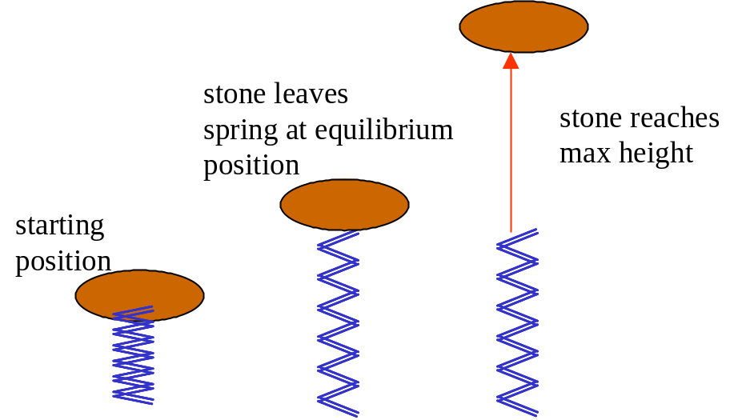

Action
(a) Apply Newton’s Second Law F_{G} = F_{e}
m g = k s₁
k = m g / s₁ = (8)(9.8)/(0.1) = 784 N.m⁻¹

(b) Energy stored in stone-spring system PE_{e} = ½ k s²
PE_{emax} = (½)(784)(0.3)² = 35.3 J where s = s₂

(c) Conservation of energy stone-block system PE_{emax} = KE_{max}
½k s₂² = ½ m v_{max}²
v_{max} = 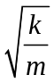 s₂ = 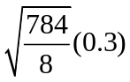= 2.97 m.s⁻¹

(d) Conservation of mechanical energy PE_{G} = ½ m v²
m g h = ½ m v_{max}² = PE_{emax}
h = v_{max}² / 2g = 2.97² / {(2)(9.8)} = 0.450 m
alt. h = PE_{emax} / (m g) = 35.3 / {(8)(9.8)} = 0.450 m
Problem – The Bungee Jump
Consider a person taking a bungee jump. The mass of the jumper is 60.0 kg. The natural length of the bungee cord is 9.00 m. At the bottom of the jump the bungee cord has extended by 18.0 m. (a) What is the spring constant? (b) What is the maximum force exerted on the jumper? (c) What is the maximum acceleration experienced by the jumper? The person misses the ground by 3.00 m. Another person who has a mass of 120 kg takes the same cord (without permission) and takes the plunge. (d) what might happen to this person?
Solution
Setup
m = 60 kg  L_{o} = 9.00 m  s = 18.0 m (measured from natural length)  extended length of cord L = 27.0 m  (a) k = ? N.m⁻¹  (b) F_{max} = ? N  (c) a_{max} = ? m.s⁻²  (d)  distance to ground = (27.0 + 3.0) m  = 30.0 m  m₁ = 120 kg  L = ? m | 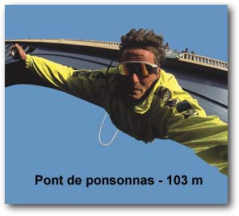

Energy PE_{e} = ½ k s² PE_{G} = m g h KE = ½ m v²
Conservation of energy
Forces F_{G} = m g F_{e} = - k s
Action
(a) Conservation of energy
Loss in gravitational PE = gain in stored elastic potential energy
m g h = ½ k s² h = (9 + 18) m = 27 m
k = 2 mg L / s² = (2)(9.8)(60)(27) / 18² N.m⁻¹ = 98 N.m⁻¹
(b) Max force
equilibrium position is when k x = m g (x extension produced by mass m) x = m g / k = (60)(9.8) / 98 m = 6.0 m
F_{max} = k s_{max} = (98)(18 - 6) N = 1.2×10³ N
s_{max} measured from equilibrium position
The maximum force on the jumper and hence the tension in the cord is 1.2×10³ N. This is not a very large force and it is unlikely that the cord would snap. A danger in bungee jumping is not that the cord will snap but the harness might fail.
(c) max acceleration
a_{max} = F_{max} / m = (1.2×10³ / 60) m.s⁻² = 20 m.s⁻² ≈ 2.0 g’s

(d) Second jumper – conservation of energy
loss in gravitational PE = gain in stored PE
m g (L_{o} + s₂) = ½ k s₂² s₂ measured from natural length of cord
k s₂² – 2 m g s₂ – m g L_{o} = 0
Need to solve quadratic equation to find s
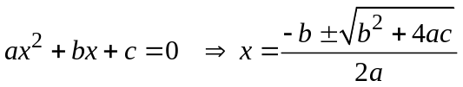
s₂ = 24 m
L₂ = L_{o} + s₂ = (9 + 24) m = 33 m > 30 m
Jumper would most likely crash into the ground and be seriously injured or killed.

Problem

Consider a tractor driving across a field that has undulations at regular intervals. The distance between the bumps is about 4.2 m. Because of safety reasons, the tractor does not have a suspension system but the driver’s seat is attached to a spring to absorb some of the shock as the tractor moves over rough ground. Assume the spring constant to be 2×10⁴ N.m⁻¹ and the mass of the seat to be 50 kg and the mass of the driver, 70 kg. The tractor is driven at 30 km.h⁻¹ over the undulations.
Will an accident occur?

Solution

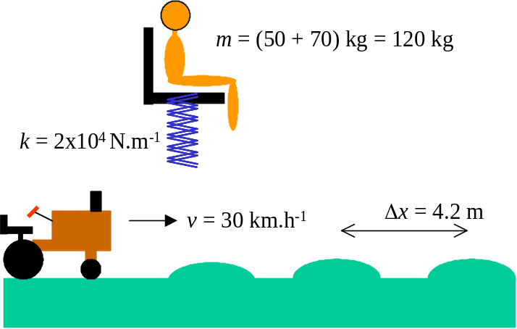
Tractor speed v = Δx / Δt = 30 km.h⁻¹ = (30)(1000) / (3600) m.s⁻¹ = 8.3 m.s⁻¹
The time interval between hitting the bumps (Δx = 4.2 m)
Δt = Δx / v = (4.2 / 8.3) s = 0.51 s
Therefore, the frequency at which the tractor hits the bumps and energy is supplied to the oscillating system of spring-seat-person
f = 1 / Δt = 1 / 0.51 = 2.0 Hz.

The natural frequency of vibration of the spring-seat-person is
f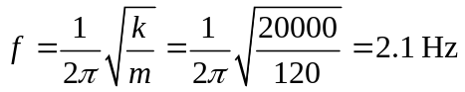
This is an example of forced harmonic motion. Since the driving frequency (due to hitting the bumps) is very close to the natural frequency of the spring-seat-person the result will be large amplitude oscillations of the person and which may lead to an unfortunate accident. If the speed of the tractor is reduced, the driving frequency will not match the natural frequency and the amplitude of the vibration will be much reduced.

