Experiment 3
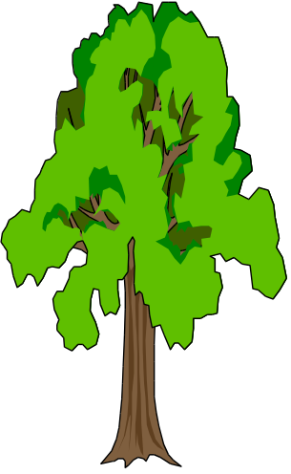
GROWING TREES - IS THIS A SOLUTION TO THE “ENERGY PROBLEM”?

A possible renewable fuel for the future could be the wood from trees. But is this a viable option?

You can carry out a simple experiment to get some evidence to support or reject the possibility of growing trees as an alternative fuel.

You have access to the following equipment:
A thermometer
Test tube, beaker, water, measuring cylinder
Matches (use one match for heating - try to burn the whole match)
Micrometer screw gauge or vernier calipers
Please place burnt matches in beaker to protect table.
At the end, empty beaker in garbage pin and clean beaker and test tube.

Physics knowledge you may require:
Density ρ = m/V
The amount of energy Q (joules, J) needed to raise the temperature of a material of mass m (kilogram, kg) by ΔT (°C) is

Q = mcΔT

where c is the specific heat capacity of the material.
ρ(water) = 1000 kg.m⁻³ = 1 g.mL⁻¹ c(water) = 4180 J.kg⁻¹.°C⁻¹

V(match) = AL V volume, A cross-sectional area, L length

For a family of 3-4 persons, the typical use of energy for hot water heating is in the order of 4000 kWh per year.


Questions you might answer:
How much energy is liberated from one match to heat water?
How much energy from a tree could be utilised to heat water?
How many joules are there in a kilowatt.hour?
How many trees are needed per year to supply the energy requirements for a family with hot water?
How reproducible are your estimates?
How many trees are needed to supply the energy for hot water in Sydney?
Is there a pollution problem with burning trees?

Compare your findings with other groups.
What do you think - is the growing of trees a viable alternative as a fuel?

