**[VISUAL PHYSICS ONLINE](http://www.physics.usyd.edu.au/teach_res/hsp/sp/spHome.htm)**

**PROBLEM P0113A**

Two balls are launched from the top of a cliff. Ball A has an initial velocity of 8.00 m.s-1 at an angle of 30.0o w.r.t. the horizontal and ball B has an initial velocity of 10.0 m.s-1 at 60.0o to the horizontal. The height of the cliff above sea level is 4.00 m.

Ignoring air resistance, calculate:

1. The initial components of the velocity of the two balls.
2. The time taken for both ball to reach their maximum heights.
3. The positions of the two balls (horizontal and vertical components w.r.t Origin) when they are at their maximum heights above sea level. What are the maximum heights of the balls above sea level?
4. The speed of the balls at their maximum height.
5. The **relative position** of ball B w.r.t. ball A when ball A is at its maximum height.
6. The **relative velocity** of ball B when ball A is at its maximum height.
7. The velocities of the balls as they enter the sea water.
8. The flight times for the balls to enter the water.
9. The horizontal distance from the base of the cliff to where the balls enter the sea water.
10. Sketch the following graphs (scaled axes) for both balls: (sy / sy), (sx / t), (sy/t), (vx / t), (vy / t).

To help you gain a better understanding of solving numerical physics problems, you should work through the Matlab code to see how to approach solving such problem. Even if you don’t know about Matlab, you will be able to figure out how I solved the problem. Take note of the letters used to identify the physical quantities.

% sp_projectiles.m

clear all

close all

clc

% INPUT ======================================

g = 9.81;

u = [8 10];

A = [30 60];

h = 4;

ax = 0; ay = - g;

% Initial velocites

ux = u .* cosd(A)

uy = u .* sind(A)

% When both balls are their highest positions

% times, velocities and displacements

tH = -uy ./ ay

sHy = uy.*tH + 0.5 * ay * tH.^2

sHx = ux .* tH

% When ball A is at its highest position:

time tH(1)

% Position of ball B

sAx = sHx(1);

sAy = sHy(1);

sBx = ux(2) * tH(1)

sBy = uy(2) * tH(1) + 0.5*ay*tH(1)^2

sBAx = sBx - sAx

sBAy = sBy - sAy

sBA = sqrt(sBAx^2 + sBAy^2)

angleBA = atan2d(sBAy,sBAx)

% When ball A is at its highest position:

time tH(1)

% velocity of ball B

vAx = ux(1)

vAy = 0

vBx = ux(2)

vBy = uy(2) + ay * tH(1)

vBAx = vBx - vAx

vBAy = vBy - vAy

vBA = sqrt(vBAx^2 + vBAy^2)

anglevBA = atan2d(vBAy,vBAx)

% As the balls enter the water

sy = -h

vAWx = ux(1)

vAWy = -sqrt(uy(1)^2+2*ay*sy)

vAW = sqrt(vAWy^2+vAWy^2)

angleAW = atan2d(vAWy,vAWx)

vBWx = ux(2)

vBWy = -sqrt(uy(2)^2+2*ay*sy)

vBW = sqrt(vBWy^2+vBWy^2)

angleBW = atan2d(vBWy,vBWx)

tAW = (vAWy - uy(1))/ay

tBW = (vBWy - uy(2))/ay

sAWx = ux(1) * tAW

sBWx = ux(2) * tBW

**Solution**

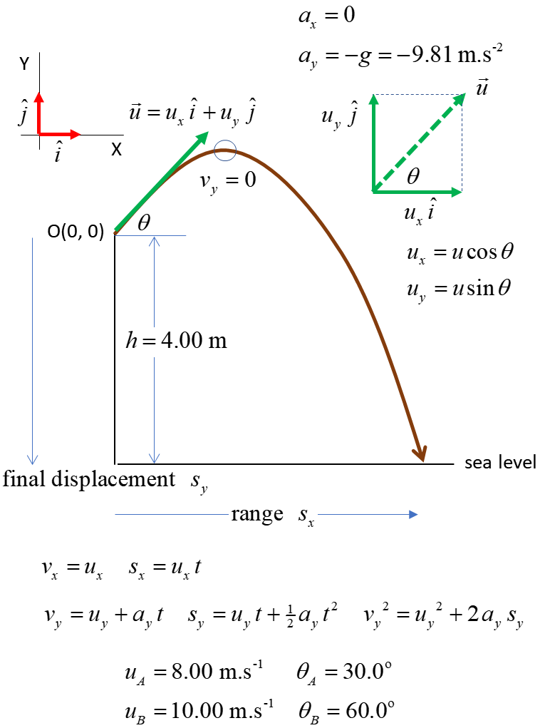

**A**

Initial velocities  

Ball A 

Ball B 

**B**

At the maximum height, the vertical velocity is zero .

Time to reach max height



Ball A  Ball B 

**C**

At the maximum height for both balls:

Horizontal displacement components w.r.t the Origin calculated from 

Vertical displacement components w.r.t. to the Origin are calculated from 

Ball A 

Ball B 

The heights above sea level are

Ball A  Ball B 

**D**

At the maximum heights, the vertical components of the velocity are zero. So, the speeds of the ball are equal to their initial horizontal velocities



**E**

The position of ball A when at maximum height is



The position of ball B at time 

 

 

When ball A is at its highest position, the position of ball B w.r.t to ball A is

Ball A  Ball B 

The relative position of ball B w.r.t. ball A is



The displacement of ball B w.r.t ball A when ball A is at its highest position is



 w.r.t. + X axis

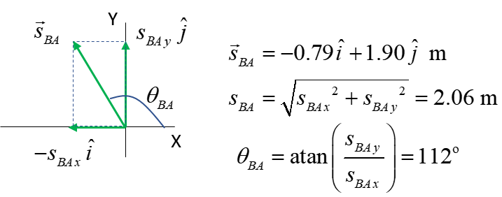

**F**

When ball A is at its height position



The velocity of ball B at time 





Ball A 

Ball B 

The relative velocity of ball B w.r.t ball A is



The velocity of ball B w.r.t ball A when ball A is at its highest position is



 w.r.t. + X axis

**G**

The velocities of the balls can as they enter the water can be found from the equations 

Ball A



Ball B



**H**

The time of flight can be calculated from



Ball A 

Ball B 

**I**

The range of the ball as they enter the water can be calculated from 

Ball A 

Ball B 

Note: in solving kinematics problems with constant equation you never have to solve the quadratic equation because you can use a number of alternative equations

  

**J**

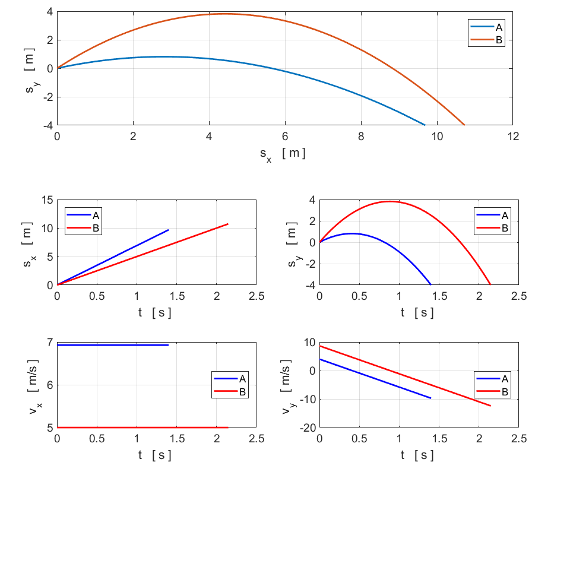

[VISUAL PHYSICS ONLINE](http://www.physics.usyd.edu.au/teach_res/hsp/sp/spHome.htm)

If you have any feedback, comments, suggestions or corrections please email:

Ian Cooper School of Physics University of Sydney

ian.cooper@sydney.edu.au