[**VISUAL PHYSICS ONLINE**](http://www.physics.usyd.edu.au/teach_res/hsp/sp/spHome.htm)

**ONLINE MULTIPLE CHOICE TESTS**

**PHYSICS IS FUN, EXCITING, SIMPLE**

**How to use the Multiple Choice Tests**

At the end of each Module with the link to **EXERCISES** there are multiple sets of Multiple Choice Tests.

Each multiple choice test consists of 10 questions. You get two attempts at each question. If you select the correct answer on your first attempt, you are awarded 2 marks. If you select the correct answer of your second attempt, you are awarded 1 mark, otherwise you get zero marks. You should do the questions in order to view your correct progressive score. After answering each question, you are given your score for the that question and your progressive score plus a very brief summary about the correct answer.

Physics multiple choice questions are different from multiple choice questions in other subjects. When doing the questions, you should use paper, pen and calculator. Most questions are too difficult by just using your “head”.

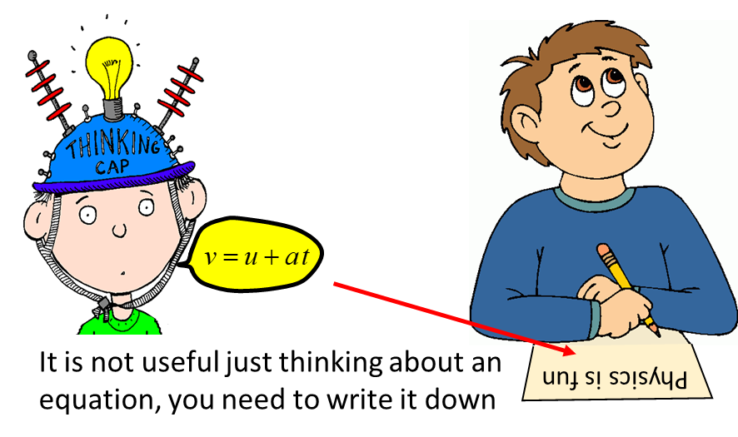

You gaol by doing the questions, is not getting the correct answer, but improving your memory of key concepts and gaining a better understanding. Often, you can learn more by getting a wrong answer. Reflect upon why you answered incorrectly and see if you can change your reasoning. So, next time you will get the correct answer. You should make a set of memory mind maps (MMM) on each topic. These are a powerful learning tool. But, you need to use them. So, for each question, think about what topic is it related too – find the corresponding MMM, review and it and use it to help answer the question. If the MMM is not helpful in answering the question, you must add further information to it. A MMM is something that should evolve.

The best approach to doing the tests is to read and study a question and then STOP. Even, leave the question and **think** about it. Your first step is not “jump in” and select an answer. **Train yourself to think**.

* How do I approach the question?
* Visualise the physics situation.
* Draw a scientific annotated diagram (even for multiple choice questions).
* What type of problem is it?
* What do I know?
* What are the key physics principles and concepts?
* What equations are applicable? Using equations is often a meaningful way to help answer qualitative questions.

**What are physics problems?** How to calculate things? YES – but much more. The most important problem in physics is perception, how to conjure mental images, how to separate the non-essential from the essential and get to the heart of a problem.

**Train yourself: how to ask yourself questions.**

Does a heavy object dropped at the same time and from the same height as alight object strike the ground first?

Does the speed of an object depend upon the speed of an observer?

Just as you develop muscles by exercising, you need to do mental push-ups to train your mind – you need to exercise your mind as well as your body.

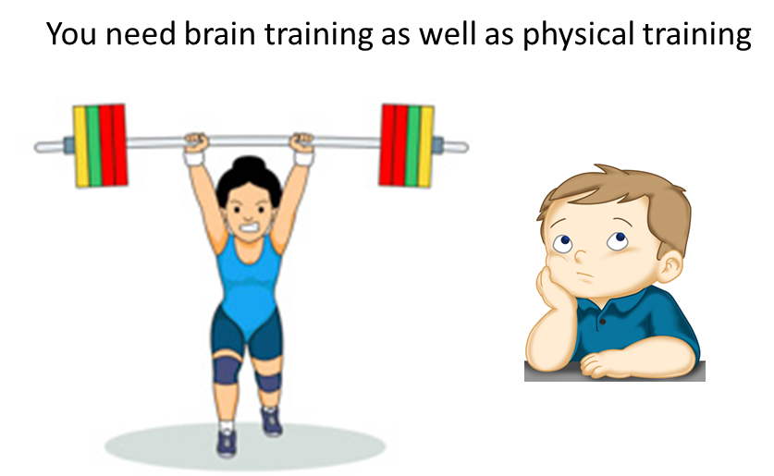

[VISUAL PHYSICS ONLINE](http://www.physics.usyd.edu.au/teach_res/hsp/sp/spHome.htm)

If you have any feedback, comments, suggestions or corrections please email:

Ian Cooper School of Physics University of Sydney

ian.cooper@sydney.edu.au