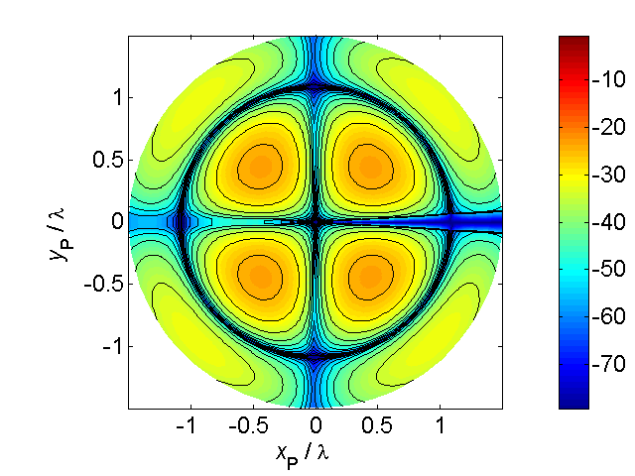

[**VISUAL PHYSICS ONLINE**](http://www.physics.usyd.edu.au/teach_res/hsp/sp/spHome.htm)

**VALUES OF PHYSICAL**

**QUANTITIES AND CONSTANTS**

**FUNDAMANETAL CONSTANTS**

|  |  |  |  |
| --- | --- | --- | --- |
| speed of light | *c* | 3.00×108 | m.s-1 |
| electron charge | *e*, *qe* | 1.602×10-19 | C |
| electron mass | *me* | 9.109×10-31 | kg |
| proton mass | *mp* | 1.6726×10-27 | kg |
| neutron mass | *mn* | 1.6749×10-27 | kg |
| atomic mass unit (amu) | *u* | 1.6605x10-27 | kg |
| Planck’s constant | *h* | 6.626×10-34 | J.s |
| permittivity of free space | *ε0* | 8.85x10-12 | C2.N-1.m-2 |
| Coulomb constant |  | 8.85x10-12 | C2.N.m-2 |
| permeability of free space | *μ0* | 4πx10-7 | T.m.A-1 |
| magnetic force constant |  | 2.0×10-7 | N.A-2 |
| acceleration due to gravity | *g* | 9.81 | m.s-2 |
| Gravitational constant | *G* | 6.67x10-11 | N.m2.kg-2 |
| Avogadro’s number | *NA* | 6.02x1023 | mol-1 |
| Boltzmann’s constant | *k* | 1.38x10-23 | J.K-1 |
| Universal gas constant | *R* | 8.315 | J.mol-1.K-1 |
| Stefan-Boltzmann constant | *σ* | 5.67x10-8 | W.m-2.K-4 |
| Rydberg constant | *R* | 1.0974x107 | m-1 |

**USEFUL DATA**

|  |  |  |  |
| --- | --- | --- | --- |
| absolute zero |  | 0 K | -273.15 oC |
| Earth’s mass | *ME* | 5.97x1024 | kg |
| Earth’s radius | *RE* | 6.38x106 | m |
| Moon’s mass | *Mm* | 7.35x1022 | kg |
| Moon’s radius | *RM* | 1.74x106 | m |
| Sun’s mass | *MS* | 1.99x1030 | kg |
| Sun’s radius | *RS* | 6.96x108 | m |
| Distance: Earth – Sun | *RES* | 1.496x1011 | m |
| Distance: Earth – Moon | *REM* | 3.84x108 | m |

[VISUAL PHYSICS ONLINE](http://www.physics.usyd.edu.au/teach_res/hsp/sp/spHome.htm)

If you have any feedback, comments, suggestions or corrections please email:

Ian Cooper School of Physics University of Sydney

ian.cooper@sydney.edu.au