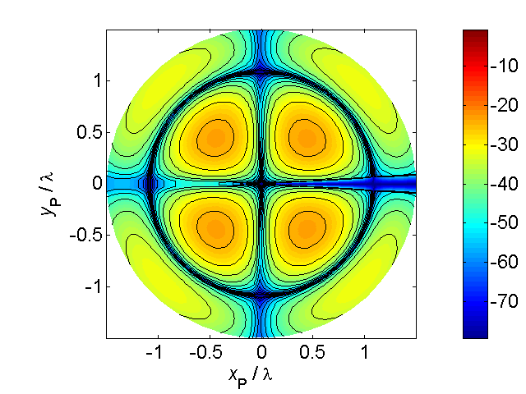

[**VISUAL PHYSICS ONLINE**](http://www.physics.usyd.edu.au/teach_res/hsp/sp/spHome.htm)

**CHANGING UNITS**

A skill that you must master is to change one unit in to another. For example, years into seconds, and km/h to m/s.

**Example 1 Simple time conversions**

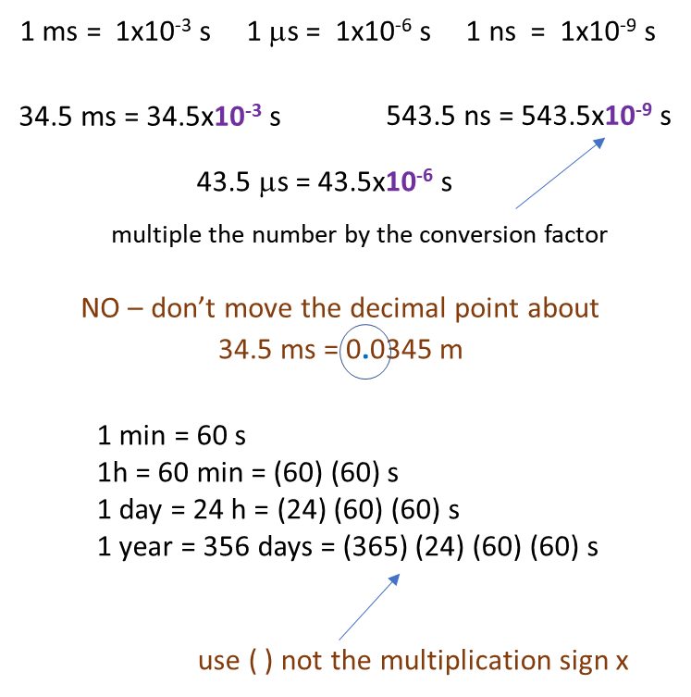

It is often necessary to convert one set of units into another. This can be done by reducing the conversion to a simple algebraic problem. The following examples will illustrate how to do this.

**Example 2**

A car is travelling at a speed of 165 km.h-1. What is the speed of the car in m.s-1 ?

1 km = 103 m 1 h = (60)(60) s = 3.6×103 s

1 km. h-1 = (103) / (3.6×103) m.s-1

165 km.h-1 = (165) (103) / (3.6×103) m.s-1 = 45.8 m.s-1

**Example 3**

The density of a liquid was 1.8 g.mL-1. What is the density in kg.m-3 ?

1 g = 10-3 kg

1 mL = 1 cm3

1 cm = 10-2 m

1 cm3 = (10-2)3 cm3 = 10-6 m3

1 g.mL-1 = (10-3) / (10-6) kg.m-3

1.8 g.mL-1 = (1.8) (10-3) / (10-6) kg.m-3  = 1.8×103 kg.m-3

**Note**

The use of multiplication by powers of 10 (x106).

The use of superscripts:

use m.s-1 not m/s

use kg.m-3 not kg/m3

[VISUAL PHYSICS ONLINE](http://www.physics.usyd.edu.au/teach_res/hsp/sp/spHome.htm)

If you have any feedback, comments, suggestions or corrections please email:

Ian Cooper School of Physics University of Sydney

ian.cooper@sydney.edu.au