[**VISUAL PHYSICS ONLINE**](http://www.physics.usyd.edu.au/teach_res/hsp/sp/spHome.htm)

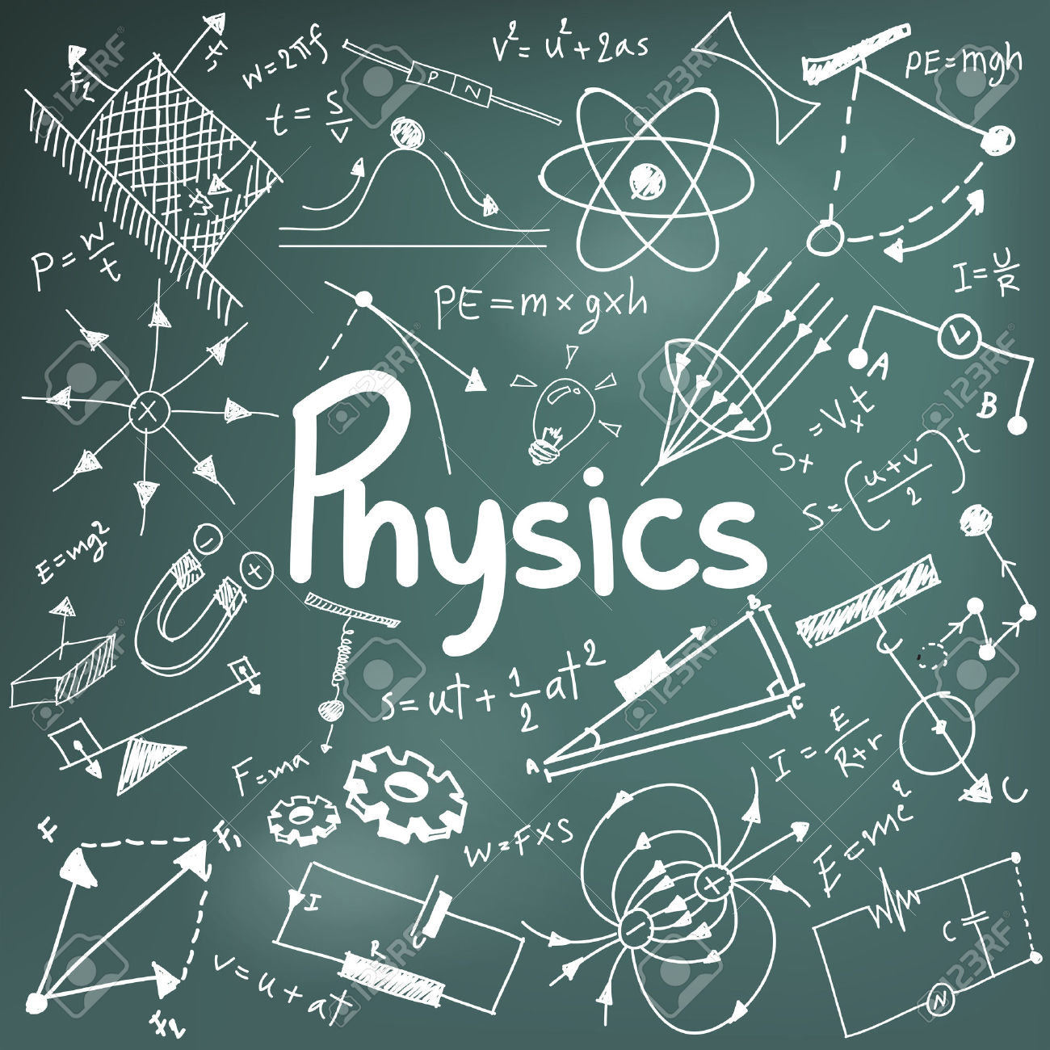

**USING SCIENTIFIC LANGUAGE TO ANSWER PHYSICS QUESTIONS**

A basic goal of science is to explain a wide range of phenomena in terms of a small number of powerful, fundamental physical principles. Learning physics is like learning a foreign language such as Chinese. Not only do you have to know the words and meanings but how to put it all together to have successful communication.

The language in physics is very specific and the meaning of words can be different to when used in everyday speech. You will have to learn the “restricted” meaning of words and how they relate to describing our physical word, and the basis of describing our physical word is in the use of models.

A major goal for yourself is to be able to give good scientific explanations in answering questions correctly.

The following paragraphs highlight the criteria for good scientific explanations, on which you will be assessed continually.

You should repeatedly refer to the criteria, so that in your examinations you will be able to give good scientific explanations in your answers and maximize your marks.

A good answer is not just a collection of words, equations and numbers. Often in physics, a good answer to a question combines features of an essay and a mathematical proof - it clearly and coherently communicates your thinking about a question to someone else and it presents a logically valid chain of reasoning based on established principles.

Just as you can tell the difference between a good essay and a poor one, or a good geometry proof and an inadequate one, you will need to learn to distinguish between good and poor scientific explanations.

**Criteria For Good Scientific Explanations**

**Explanation** based on fundamental physical principles including relevant equations and not just a description. A **description** tells what happened; an explanation tells why it happened, in terms of fundamental scientific principles.

|  |
| --- |
| **Example**  **Description**: The charges spread out all over the surface of the metal.  **Explanation**: The charges spread out all over the surface of the metal because the free electrons in metal repel each other (like charges repel) and arrange themselves at the greatest possible distances from each other. |

Scientific words have very precise meanings and they must be used precisely. Unlike everyday speech, where it is permissible to substitute many different words for each other, there are very few synonyms in science. If you use the wrong word, your statement may be meaningless or utterly incorrect. Here are some important words that are frequently misused by novice students: work, pressure, force, acceleration, velocity, amplitude, charge, charged, field, induce, induction, ionize, ionization, neutralize, potential.

For example, a force and charge are utterly different concepts; they are connected conceptually by the fact that a charged object can exert a force on another charged object.

Here are some examples of meaningless statements from students' answers: "The charge attracts to the positive dipole." and "The metal block is induced by the touching of a positive charge."

**Explanations of physical phenomena can be given as several precise steps (chain argument).**

|  |
| --- |
| **Example** (from Thinking Physics by L.C. Epstein & P G Hewitt):  Mighty Mouse wants to get the ball bearing up and out of the bowl, but the ball is too heavy and the sides of the bowl too steep for Mighty Mouse to support the ball's weight. Write a scientific explanation for Mighty Mouse, so that he/she will know how (and why) to get the ball out of the bowl using his/her own strength and without the aid of such things as levers.  p0040  **Solution**   * Give the ball a series of little pushes. * Each push must be at the right time and in the right direction. * The trick is you must match the rhythm of the pushes to the natural rhythm with which the ball rolls back and forth. * This natural rhythm is called the natural or resonant frequency of vibration. * There is usually more than one way a "thing" can vibrate, or resonate. The ball in the bowl can resonate back and forth or it can resonate around a circle. These different ways are called resonant modes. * Each push then can add a little kinetic energy to the ball. * Eventually, there will be enough kinetic energy added to the ball to get it to the rim and over the top. |

**Diagrams**

Readable, relevant details, labels

Scientists draw diagrams all the time. They use diagrams as a tool to support and guide their own thinking, as well as a device for explaining their ideas to others.

Many students are reluctant to draw diagrams. As reasons for their reluctance students say things like "I'm not good at drawing," "It takes too much time," "It's redundant, because I have to explain everything in words and equations anyhow." A common thread in these statements seems to be the perception that a diagram is a decoration, not a tool. Many students have not yet learned to use diagrams in a way that can guide their own reasoning and prevent many errors.

**Readability**: A diagram must be large enough to see and interpret easily. Do not draw little teeny diagrams in the margin of your paper. Make the diagram big enough that all the important information can be included in it, and can be interpreted easily by a reader. A diagram should not be ornate. Use simple, clean lines.

**Labels:** By labelling all distances, charges, and forces in a diagram, you bring together in one place a great deal of information that is scattered throughout the problem. Once it is recorded on your diagram you do not have to search for it again. Labels help to prevent serious errors. Carefully labelled diagrams significantly reduce the number of errors made in problem solutions.

**Include only relevant details**: A cluttered diagram is hard to interpret. For clarity, include only relevant information. For example, show only excess charges, but do distinguish between charge on a surface and charge inside an object. Do distinguish between free and bound charges - do not make your drawings of polarized molecules in an insulator look the same as a drawing of a polarized metal. These distinctions are important physical distinctions, so diagrams must reflect them unambiguously.

Often a good diagram can bear the major burden of explanation, with little or no accompanying prose required to make the point. A useful diagram is the centrepiece of a good explanation.

**Meaning of verbs**

**account**, **account for**

state reasons for, report on, give an account of, narrate a series of events or transactions

**analyse**

identify components and the relationships among them, draw out and relate implications

**apply**

use, utilize, employ in a particular situation

**appreciate**

make a judgment about the value of something

**assess**

make a judgment of value, quality, outcomes, results or size

**calculate**

determine from given facts, figures or information

**clarify**

make clear or plain.

**classify**

arrange into classes, groups or categories

**compare**

show how things are similar and different

**construct**

make, build, put together items or arguments

**contrast**

show how things are different or opposite

**critically analyse**

add a degree or level of accuracy, depth, knowledge, understanding, logic, questioning, reflection and quality to an analysis or evaluation

**deduce**

draw conclusions

**define**

state the meaning of and identify essential qualities

**demonstrate**

show by example

**describe**

provide characteristics and features

**discuss**

identify issues and provide points for and against

**distinguish**

recognize or note/indicate as being distinct or different from, note difference between things

**evaluate**

make a judgment based on criteria

**examine**

inquire into

**explain**

relate cause and effect, make the relationship between things evident, provide why and/or how

**extract**

choose relevant and/or appropriate details

**extrapolate**

infer from what is known

**identify**

recognize and name

**interpret**

draw meaning from

**investigate**

plan, inquire into and draw conclusions about

**justify**

support an argument or conclusion

**outline**

sketch in general terms; indicate the main features

**predict**

suggest what may happen based on available information

**propose**

put forward (a point of view, idea, argument, suggestion etc.) for consideration or action

**recall**

present remembered ideas, facts or experiences

**recommend**

provide reasons in favour

**recount**

retell a series of events

**summaries**

express concisely the relevant details

**synthesize**

put together various elements to make a whole

[VISUAL PHYSICS ONLINE](http://www.physics.usyd.edu.au/teach_res/hsp/sp/spHome.htm)

If you have any feedback, comments, suggestions or corrections please email:

Ian Cooper School of Physics University of Sydney

ian.cooper@sydney.edu.au