[**VISUAL PHYSICS ONLINE**](http://www.physics.usyd.edu.au/teach_res/hsp/sp/spHome.htm)

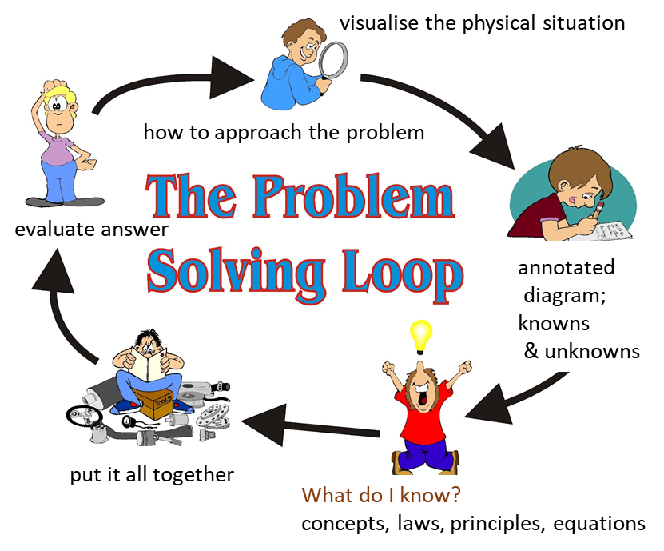

**HOW TO ANSWER PHYSICS QUESTIONS**

**PROBLEM SOLVING TECHNIQUES**

**STUDY SKILLS**

In writing an answer to a question it is often necessary to consider many things simultaneously - it is not possible to write out the answer like you would in copying a passage of text from a book. A **HOW-TO-APPROACH** can help you improve your skills in answering questions for examinations, assignments, tutorials, laboratory, etc.

It is better to think "on paper" than in "your head". It is most important that you put information on paper - this makes it possible to access information more easily than organising ideas in your "minds eye".

In hitting a golf ball well, you would have noticed that golfers spend a lot a time setting themselves up. You need to set yourself up before you attempt your answer. You must **visualise** what the problem is about; determine the problem type (category); know what information is given and think about what you know. After this setup then you can go into action to execute your answer and evaluate it.

To be good at golf requires lots of "quality" practice. The same is for you, to become good at physics requires practice, but remember it is

**only good practice that makes perfect and not the time spent**

There basically four interconnected phases in this HOW-TO APPROACH.

**Identify ⇔ Setup ⇔ Execute ⇔ Evaluate**

**IDENTIFY**

* Identify what the question asking
* Identify the known and unknown physical quantities (units)
* Identify the type of problem (category)

**SETUP need a good memory base and understanding**

* Visualise the physical situation
* ***Diagrams*** - reference frames / coordination system / Origin / directions
* Write down key concepts, principles, equations, assumptions that may be needed to answer the question

**EXECUTE**

* Answer to the question from what you know.
* Numerical questions - solve before calculations - manipulate equations then substitute numbers add comments.

**EVALUATE**

* CHECK - answer reasonable, assumptions, units, signs, significant figures, look at limiting cases

In doing all questions it is good idea to implement the **HOW-TO- APPROACH** problem solving technique. In examinations, using the technique will help you maximize your marks.

Being good at problem solving is essential in physics and you will improve your conceptual understanding and problem solving skills by using this the **HOW-TO-APPRAOCH** problem solving strategy.

To improve your skills at answering examination questions you need to strive to achieve **technical excellence**. When working through the problems suggested in this course, you should implement the **HOW-TO-APPRAOCH** with the aims of improving your physics knowledge and your technical skill at setting out the solutions to the problems.

After completing the questions and reviewing the solutions reflect upon what you have done, compare your written answer with the answers provided and think about how you can improve your technique to achieve excellence.

**HOW TO ACQUIRE KNOWLEDGE AND SKILLS IN PHYSICS**

*When you start a study session in physics say to yourself 10 times*



It is a good idea to limit a study session to no more than 60 minutes, about **45** minutes is an ideal amount of time. Studying your Physics is not like reading a novel. You need to make it an active process and not one in which you only read or make linear summaries that paraphrase the text. Always have a pen and plenty of paper when studying physics.

To gain the maximum benefit from studying a topic, you should consider doing the following:

1. Review and Speed Read each Module.
2. Read each Module and your reference text carefully: identify the terminology and concepts that have to be memorised and try to gain an understanding of the content by using different types of summaries.
3. Use a physical quantities template – summary of symbols, meaning of symbols, units.
4. Use equation templates.
5. Construct ***mindmaps*** or a summary for each topic you are going to study.
6. Work through sample problems, problems and questions.
7. Keep a **study diary**: each week review how many minutes you spend on various activities.

**Memorising and improving your understanding is best done by spending short periods of time reviewing your summaries**

**THINK ON PAPER WITH A PEN IN HAND AND DO NOT THINK TOO MUCH IN YOUR HEAD**



* Don’t just read – use pen and paper to process information
* Summarize what you read and study 🡪 MINDMAPS (concepts maps)
* THINK, VISUALIZE and PROCESS while you are studying
* Memorize your summaries: short term and long term memories are different. **Memory is the most important process in learning**.
* Strive for understanding – it only comes slowly after lots of “memory work” and exposure. Often comes in a “flash”.
* Doing questions that have answers: Read question / process it / think about what it asking / think about what you know / consult your summaries or textbook / review and process the given answer / after a short time interval do the question like in an exam, then check (mark) your answer against the published answer.
* Study sessions 40 to 60 min on physics e.g. doing problems, creating mindmaps
* Review sessions only about 10 minutes. These are short reflection sessions: short term memory 🡪 long term memory.
* ***Reflection***: review / reflect upon a study period a short time after the end of that study period – very beneficial in transferring knowledge to long term memory

**MINDMAPS**

Mindmaps are a very useful tool that can help you gain a better understanding and help you remember large amounts of content. Sample mindmaps will be given throughout the web notes, but the best ones are those that you create.

* Summaries with minimum padding words
* Key words
* Symbols / equation / units
* Colour
* Graphs
* Images – annotated diagrams (difficult to remember words, easy to remember “dramatic images”
* Make mindmaps for each equation – summary of what the equation is telling you

**PREDICT OBSERVE EXPLAIN POE**

The POE strategy was developed by White and Gunstone to uncover individual students’ predictions, and their reasons for making these, about a specific event. Reference: White, R. T., & Gunstone, R. F. (1992). Probing Understanding. Great Britain: Falmer Press.

Assume that you are going to view a demonstration, animation, movie etc on some physical behaviour and that you want maximise your understanding of the physics from the event.

**PREDICT**

* Carefully think about the physical situation associated with the event.
* Write your predictions on what may happen in the event.
* Write a justification for your predictions.

**OBSERVE**

* Carefully observe the event and compare what you see with your predictions.
* Write down your observations.

**EXPLAIN**

* Write an explanation of the event and compare your predictions with the observations. Try to resolve any conflicts you had between your observations ad predictions.

You can search the WEB for more information on **PREDICT OBSERVE EXPLAIN**.

You can try the link [cited: June 2012]

<http://www.learningdesigns.uow.edu.au/tools/info/T3/index.html>

**COMMENTS FROM EXAMINATION MARKERS**

Examiners may write questions that address the syllabus outcomes in a manner that requires candidates to respond by integrating their knowledge, understanding and skills developed through studying the course, including the prescribed focus areas. This reflects the fact that the knowledge, understanding and skills developed through the study of discrete sections should accumulate to a more comprehensive understanding than may be described in each section separately.

* The answer spaces provided are guide to the maximum length of response required. Should use examination time to analyse the question and plan responses carefully, working within that framework to produce clear and concise responses.
* Responses may include the use of dot points, diagrams and/or tables, and should avoid internal contradictions. This is particularly so in holistic questions which need to be logical and well structured.
* Should show evidence of a good knowledge of basic definitions.
* Follow the instructions provided on the examination paper.
* Set out all working for numerical questions.
* Answers should include correct units and correct number of significant figures.
* Do not repeat the question as part of the response.
* Look at the structure of the whole question.
* Use pencils and a ruler to draw diagrams and graphs and other appropriate equipment. A clear plastic ruler helps in plotting points and drawing the line of best fit.

[VISUAL PHYSICS ONLINE](http://www.physics.usyd.edu.au/teach_res/hsp/sp/spHome.htm)

If you have any feedback, comments, suggestions or corrections please email:

Ian Cooper School of Physics University of Sydney

ian.cooper@sydney.edu.au