[**VISUAL PHYSICS ONLINE**](http://www.physics.usyd.edu.au/teach_res/hsp/sp/spHome.htm)

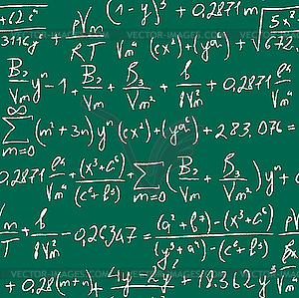

**REARRANGING EQUATIONS**

A very importance and essential skills is to be able to rearrange an equation. This can be difficult but if you follow a well define procedure you will be able to master this skill. Always rewrite the equation with the quantity you want on the **left-hand side** of the equals sign and then perform a series of mathematical operations to both sides of the equation. If you have any difficulties, then do the operations step by step.

**Example**

Find an expression for $T$ from the equation



**Solution**

*T* = ? on left hand side of equation

Rearrange equation step by step









[VISUAL PHYSICS ONLINE](http://www.physics.usyd.edu.au/teach_res/hsp/sp/spHome.htm)

If you have any feedback, comments, suggestions or corrections please email:

Ian Cooper School of Physics University of Sydney

ian.cooper@sydney.edu.au