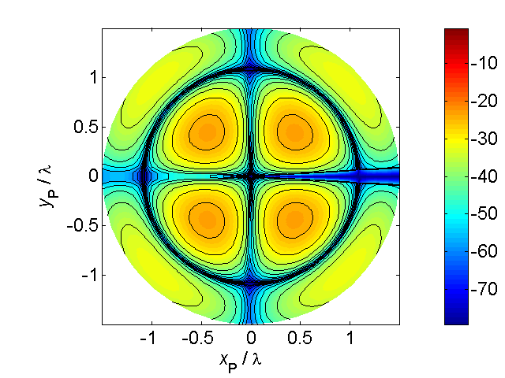

[**HSC PHYSICS ONLINE**](http://www.physics.usyd.edu.au/teach_res/hsp/sp/spHome.htm)

**KINEMATICS**

**PROBLEMS and ANSWERS**

**P1653**

Two tractors labelled A and B are moving around a large field. The centre of the field is taken as the Origin O(0, 0).

Initially tractor A is located at the Origin O(0, 0) while the other tractor B is located a distance of 500 m due East of it.

The tractor A at the Origin moves with a constant speed of 5.00 m.s-1 while the other tractor B moves with a constant speed of 2.00 m.s-1.

Initial (t = 0 s) velocities of tractors A and B:

Case 1: Tractors A and B are both moving due East.

Case 2: Tractor A is moving East and tractor B is moving West.

Case 3: Tractor A is moving East and tractor B in a SW direction.

After a time interval of 100 s, calculate the following quantities for Cases 1, 2 and 3:

1. The displacements of the tractors w.r.t. the Origin.
2. The displacement of tractor A w.r.t. tractor B.
3. The displacement of tractor B w.r.t tractor A.
4. Relative velocity of tractor A w.r.t. tractor B.
5. Relative velocity of tractor B w.r.t. tractor A.

**ANSWER**

*Problem category: relative velocity*

*Visualise the physical situation and think about the displacements and velocities of each tractor.*

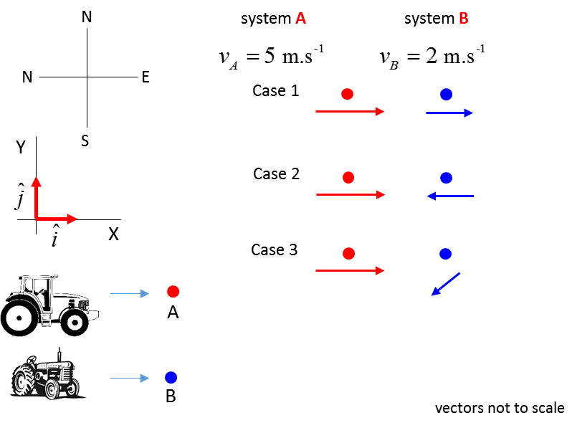

velocity of tractor A w.r.t. ground 

velocity of tractor B w.r.t. ground 

[VIEW animation of the tractors for Cases 1, 2 and 3](http://www.physics.usyd.edu.au/teach_res/hsp/sp/images/ag_tractor1.gif)

**Case 1**



**Event 1 (initial values):**



**Event 2 (final values):**



Since the velocities are constant, the change in displacement is







A. Displacements of systems w.r.t. Origin





B. The displacement of tractor A w.r.t. tractor B



tractor A is 200 m due West of tractor B

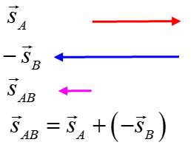

C. The displacement of tractor B w.r.t. tractor A



tractor B is 200 m due East of tractor A

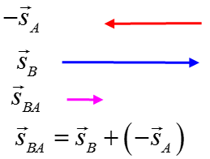

D. Relative velocity of tractor A w.r.t. tractor B





Tractor B see tractor A approaching from the West at 3.00 m.s-1

E. Relative velocity of tractor B w.r.t. tractor A





Tractor A see tractor B approaching from the East at 3.00 m.s-1

**Case 2**



**Event 1 (initial values):**



**Event 2 (final values):**



Since the velocities are constant, the change in displacement is







A. Displacements of systems w.r.t. Origin





B. The displacement of tractor A w.r.t. tractor B



tractor A is 200 m due East of tractor B



C. The displacement of tractor B w.r.t. tractor A



tractor B is 200 m due West of tractor A



D. Relative velocity of tractor A w.r.t. tractor B





Tractor B see tractor A travelling towards the East at 7.00 m.s-1

E. Relative velocity of tractor B w.r.t. tractor A





Tractor A see tractor B travelling towards the West at 7.00 m.s-1

**Case 3**



**Event 1 (initial values):**



**Event 2 (final values):**



Since the velocities are constant, the change in displacement is







A. Displacements of systems w.r.t. Origin





B. The displacement of tractor A w.r.t. tractor B





Tractor A is 200 m in a NE direction from tractor B

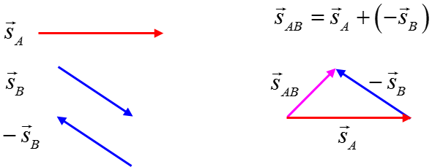

C. The displacement of tractor B w.r.t. tractor A





Tractor B is 200 m in a SW direction from tractor A

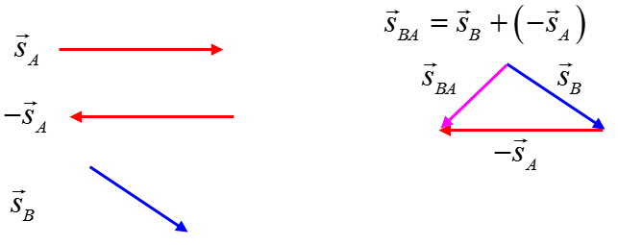

D. Relative velocity of tractor A w.r.t. tractor B





Tractor B see tractor A travelling at 6.56 m.s-1 in the direction of

12.1o N of E

E. Relative velocity of tractor B w.r.t. tractor A



Tractor A see tractor B travelling at 6.56 m.s-1 in the direction of

12.1o W of S