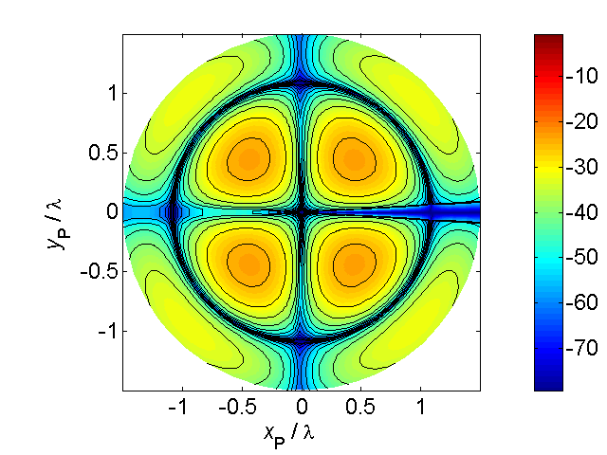

[**HSC PHYSICS ONLINE**](http://www.physics.usyd.edu.au/teach_res/hsp/sp/spHome.htm)

**KINEMATICS**

**PROBLEMS and ANSWERS**

**P1673**



An aircraft is trying to fly due north with a velocity of 200 m.s-1 but is subject to a cross wind blowing from the east at 50 m.s-1. What is the velocity of the plane with respect to the ground?

**ANSWER**

Problem category: relative velocity

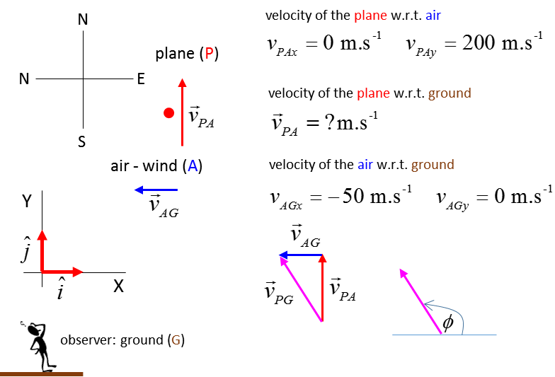





Velocity of the plane w.r.t. the ground

 N.B. on RHS subscripts A “cancel”



Magnitude



Direction (w,r,t. X axis)

 14o W of N