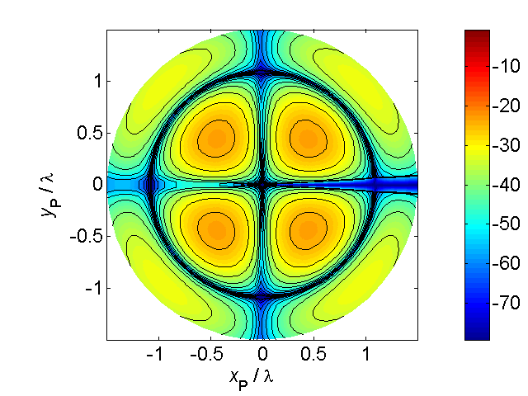

[**HSC PHYSICS ONLINE**](http://www.physics.usyd.edu.au/teach_res/hsp/sp/spHome.htm)

**KINEMATICS**

**PROBLEMS and ANSWERS**

**P1681**

The water in a river flows w.r.t. the ground at a constant velocity . A canoeist moves at a constant velocity w.r.t the water .

In what direction  relative to the ground should the canoeist paddle to travel the minimum distance in crossing the river from one river bank to the other.

In canoeist language, the angle  when measured relative to the current is called the **attack angle**.

How does the angle of attack change as the current increases?

What is the implications of ?

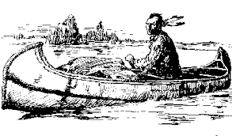**ANSWER**

*Problem category: relative velocity*

*Visualise the physical situation*

The shortest distance across the river is along the straight line which is perpendicular to the river bank. Hence, the resultant velocity of the canoe must be perpendicular to the river current. Using the principle of vector addition, we simply add the vectors for the canoe relative to the water and the water relative to the ground  to give the resultant vector of the canoe relative to the ground . This vector addition gives a right angled triangle. The direction of the vector  is given by the angle attack  as defined in the diagram.

*N.B. The use of subscripts – especially in the vector addition*

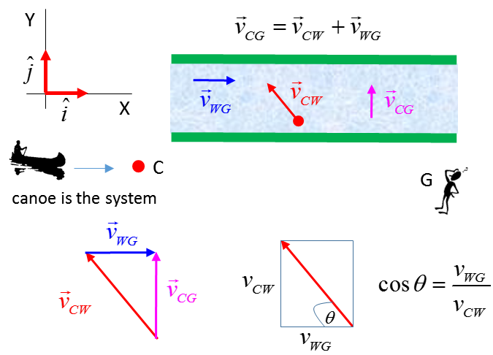

The angle of attack in terms of the speeds is



We can see from this equation, the faster the current , the larger the value of , hence, the smaller the value for the angle  of attack.

What is the implication of ?



but 

hence  is undefined.

The canoeist cannot paddle fast enough for the canoe to go straight across the river, the canoe will be swept downstream with the current.