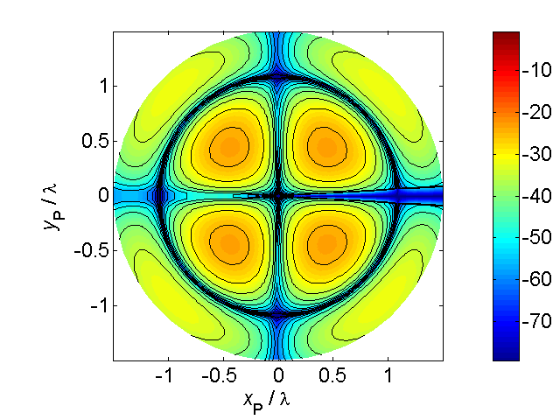

[**HSC PHYSICS ONLINE**](http://www.physics.usyd.edu.au/teach_res/hsp/sp/spHome.htm)

**KINEMATICS EXPERIMENT**

**RECTILINEAR MOTION WITH UNIFORM ACCELERATION**

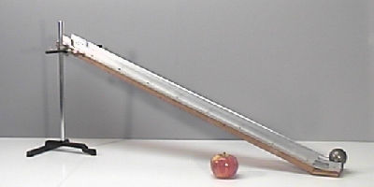

Ball rolling down a ramp

**Aims**

To perform an experiment and do a detailed analysis of the numerical results for the rectilinear motion of a ball rolling down a ramp.

To improve your experimental skills and techniques: in performing an experiment; recording data scientifically; graphical analysis of your results; accessing experimental uncertainties; testing a hypothesis; drawing conclusions from results of the experiment.

**Hypothesis**

A ball rolling in a straight line down an inclined surface will move with a uniform (constant) acceleration.

Testing the validity of the equations for rectilinear motion with uniform acceleration



**Your gaol is to provide evidence to either accept or reject the hypothesis**

In this experiment you will simply measure the time intervals  for a ball the roll different distances  down a ramp.

**Mathematical Analysis**

In all kinematics problems, you need to define your frame of reference (Origin, Coordinate axes, observer, symbols, units, significant figures).

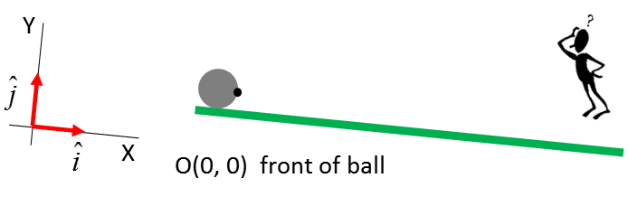

In our frame of reference the ball only travels in the +X direction (rectilinear motion). Therefore, we do not need to be concerned with the vector nature of acceleration, velocity and displacement since we are only dealing with the X components and the component of a vector are scalar quantities.

In our experiment, the ball starts from rest, hence, its initial velocity is zero .

From our hypothesis, the equations describing the motion of the ball down the ramp are



We can measure the time interval  and the distance  but we can’t measure velocity , however, we can do some mathematical tricks to find the velocity.

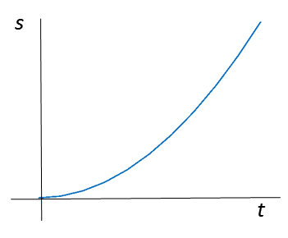

The graph of  against  is a **parabola**. If you plot your data for  and  and get a curved line you can’t conclude that it is a parabola. You can’t come to any definite conclusions about curved lines. You need to transform your data to get a straight line graph.

The graph of  against  is a straight-line graph with the slope equal to .

 slope of  graph is 

The criteria to test our hypothesis is that the graph of  against  is a straight-line and by measuring the slope you can estimate the acceleration of the ball.

***What about the velocity?***

The displacement and velocity are given by the equations





Therefore, if you draw a graph  then this corresponds to the velocity against time graph  and the slope of the line gives the acceleration .

**Equipment and Setup**

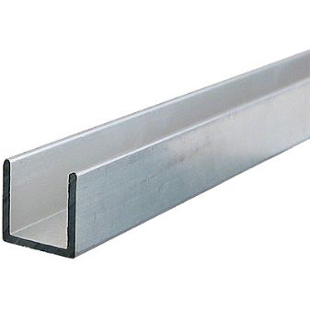The equipment and materials you need for the experiment are:

Inclined surface (> 1 m long). The best ramp to use is a length of aluminium track (available from hardware stores).

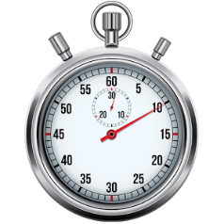

Stop watch

Steel ball (ball bearing) or marble or golf ball

Two small blocks

Metre rule

Graph paper

Set the ramp at a small angle so that you can measure the time intervals with the stopwatch. Start the clock as you release the ball from the block and stop when the ball strikes the lower block. Use a ruler to measure the distance from the front of the ball to the lower block. Record your measurements for the time interval *t* and displacement *s.*

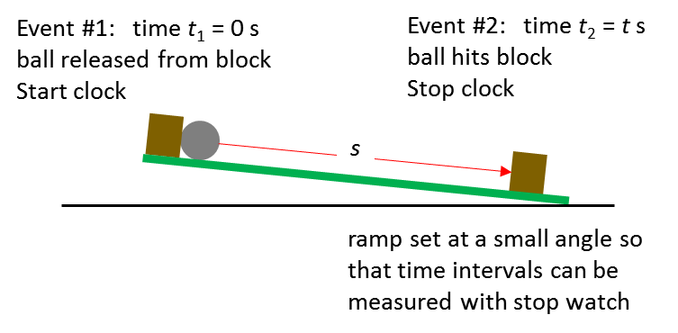

You should plan on how to carry out your experiment. Do a few trail runs of measuring the time for the ball to roll down through different distances but make **no** recordings.

**Think about**

* What is the best angle to set the ramp at?
* What is the longest distance the ball can travel down the ramp?
* What is the shortest distance and shortest time that can be measured with the stopwatch?
* What distance intervals am I going to use (you need at about 10 different distance measurements and for each distance 5 stopwatch recordings). From the spread of your time measurements you can access the **precision** of your numerical results.
* Think about the best way of recording and tabulating your measurements.

Physicist are scientists who are very good at documenting, recording and analysing an experiment. Over time you should aim to improve your skills and techniques in performing all aspects of an experiment.

**Recordings and Analysis**

Tabulate your measurements for the displacement and time with 10 distance measurements and 5 time interval measurements for each distance. Calculate the average time interval for each distance. Calculate the maximum deviation of your time measurements from the average and calculate the maximum percentage difference. This maximum percentage uncertainty is used to estimate the uncertainty in your measurement of the acceleration.

[Sample time measurements (s)

0.45 0.40 0.47 0.48 0.42

average time interval = 0.44 s

max deviation from average = 0.04 s

% uncertainty =(0.04)(100) / 0.440 = 10%

We can assume that the precision of our measurements is 10%.]

Construct another table with 4 columns to record your measurements for *t*, *t*2, *s* and *s* / *t*.

|  |  |  |  |
| --- | --- | --- | --- |
| ***t* [s]** | ***t*2 [s2]** | ***s* [m]** | ***v* = *s*/*t* [m.s-1]** |
|  |  |  |  |
|  |  |  |  |
|  |  |  |  |

Draw the graphs for

1. 
2. 
3. 

Graph (2) 

Is the graph a straight-line?

Estimate the acceleration and its uncertainty.

Graph (2) 

Is the graph a straight-line?

Estimate the acceleration and its uncertainty.

The velocity is defined to be the time rate of change of the displacement



which corresponds to the slope (gradient) of the  graph. Measure the slope of the tangent at two different times on your  and compare your answer for the velocity as predicted from your  graph.

The reverse process of differentiation is integration. The displacement is given by



which correspondents to the area under the  graph. Find the area under your graph for some time interval and compare your answer for the displacement using your  graph.

**Summary and Conclusions**

Write a summary of the experiment and numerical results and what conclusions can you make from the experiment.

Is the hypothesis accepted or rejected? Provide the evidence supporting your decision.

A convenient way to record and analyse your data is to use the **MS EXCEL** spreadsheet.

**DATA ANALYSIS USING MS EXCEL**

Sample results for a ball rolling the ramp were added into an EXCEL spreadsheet as shown below.





The results are displayed in three graphs and a trendline was added to predict the mathematical relationships between the plotted variables.

The **uncertainty** in the **precision** of the measurements is taken as .

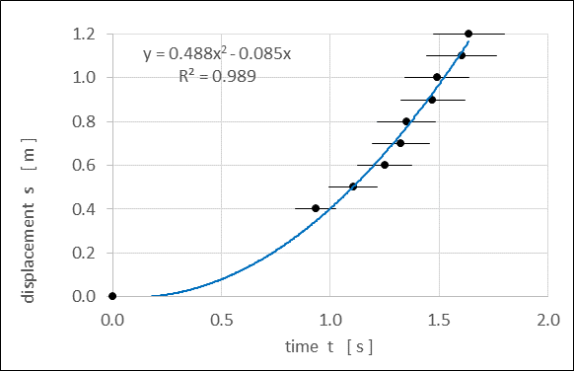

Graph 1. A **parabola** fits the data reasonably well.

The trendline fit gives the equation for the displacement as a function of time as

 

If  the data fits the fitted function perfectly. The is close to 1 therefore a parabola is an acceptable fit to the measurements.

The theoretical relationship between displacement and time for an object moving with uniform acceleration is

 parabola

The coefficient of the term  is small and can be ignored. Hence, the acceleration is . The uncertainty in precision of the measurements is . From Graph 1 we can conclude that the acceleration is constant and its value is



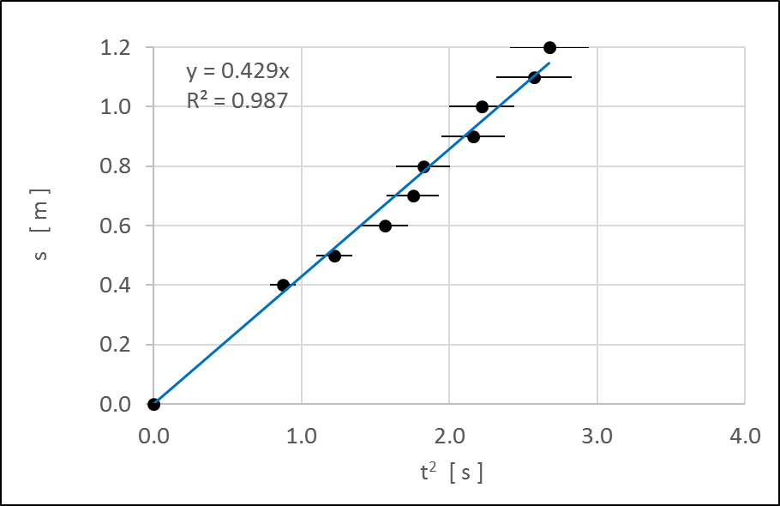

Graph 2. A **linear fit** to the data is acceptable.

The is close to 1 therefore a straight line is an acceptable fit to the measurements.

From the trendline fit to the data, the relationship between displacement and (time)2 is



The theoretical relationship between  and  is

 slope = 



The uncertainty in precision of the measurements is .

The results given by Graph 2 support the hypothesis that the acceleration of the rolling ball is constant and its value is



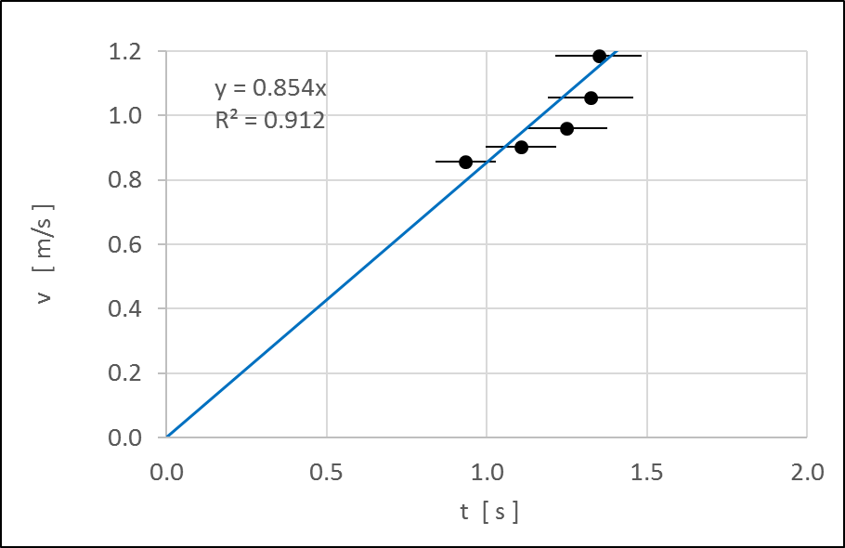

Graph 3. A **linear fit** to the data is acceptable.

The is close to 1 therefore a straight line is an acceptable fit to the measurements.

From the trendline fit to the data, the relationship between velocity and time is



The theoretical relationship between  and  is

 slope = 



The uncertainty in precision of the measurements is .

The results given by Graph 3 support the hypothesis that the acceleration of the rolling ball is constant and its value is



Another way to estimate the acceleration and its uncertainty from a straight line graph is to use the in-built statistical function in EXCEL called **LINEST**.

Linear function y = m x: the LINEST function can be used to find the best value for the slope m and its uncertainty.

Linear function y = m x + b: the LINEST function can be used to find the best value for the slope m and its uncertainty and the best value for the intercept b and its uncertainty.

Sample results are shown in the table below.



By examining the table, the best fits are for the equations of the form y = m x (b = 0) and the best estimate for the acceleration is



Another way to estimate the value for the slopes and intercepts and their uncertainties is to draw a straight line that best fits the data (line of best fit **lbf**) and another line that just fits the data (line of worst fit **lwf**). From the two slopes and intercepts of the two lines you can estimate the best values and their unceratinties.

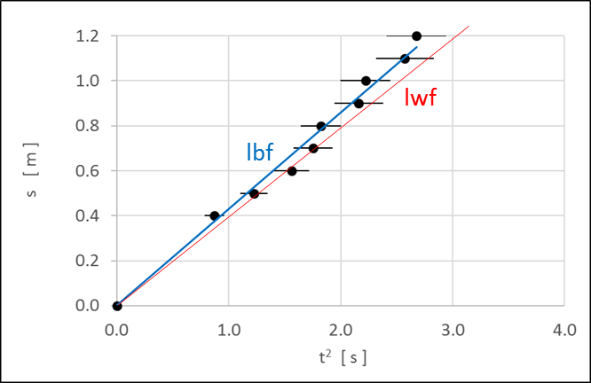

Graph 2A. The line of best fit **lbf** and the line of worst fit **lwf**.

The intercept is zero and the best estimate of the slope is







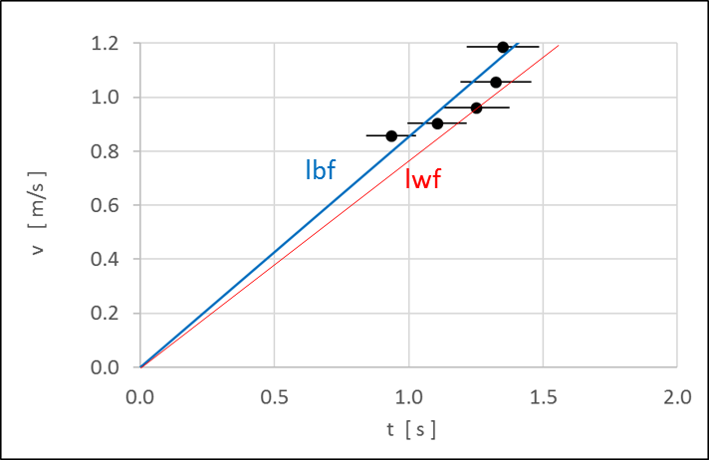

Graph 3A. The line of best fit **lbf** and the line of worst fit **lwf**.

The intercept is zero and the best estimate of the slope is







The velocity is defined to be the time rate of change of the displacement  slope of tangent  graph

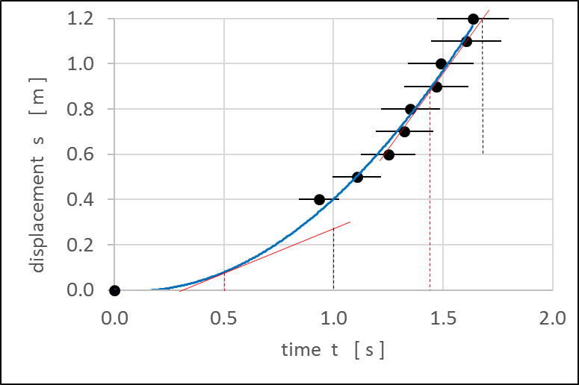

Slope of tangent at time 

slope = rise / run = (0.3 / 0.68) m.s-1 = 0.44 m.s-1

  10% uncertainty

Slope of tangent at time 

slope = rise / run = (0.6 / 0.45) m.s-1 = 1.33 m.s-1

  10% uncertainty

Predictions from Graph (3A) using the ‘lbf’ and ‘lwf’

 

 

Predictions using  

 

 

The displacement is given by

 area under graph

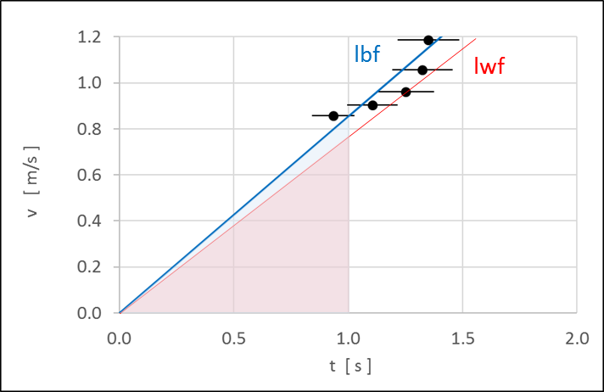

area of a triangle = (0.5) (base) (height)

The area under the graph (‘lbf’ & ‘lwf’) in the 1.0 s time interval is



From Graph 1 the displacement in the 1.0 s interval is 

Predictions using  



Our experimental results are in agreement with the predictions

velocity = slope of tangent  graph

displacement = area under  graph

**CONCLUSIONS**

Graphs 1, 2 and 3 provide strong evidence to **support** the hypothesis that the ball does roll down the ramp in a straight line with a uniform (constant) acceleration.

Different methods to analyse the data give different estimates for the acceleration of the ball down the ramp and the uncertainty in precision of the acceleration.

Assuming  

Statistical analysis 

Lines of ‘lbf’ and ‘lwf’ 

However, the different values for the acceleration are consistent with each other. We can be very confident if we did the identical experiment many times and measured the acceleration we would get a value for the acceleration in the range



**You could repeat this experiment and use electronic timing gates to measure the time interval. Also, you could video the motion of the rolling ball and use Video Analysis Software.**

**Example videos**

<http://serc.carleton.edu/dmvideos/videos/ball_rolling_ra.html>

<https://www.pbslearningmedia.org/resource/lsps07.sci.phys.maf.ballincline/rolling-ball-incline/#.WMXC-_mGNaQ>