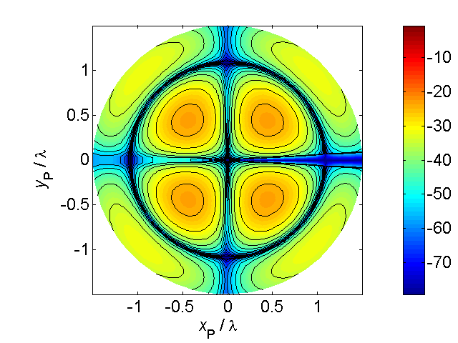

[**HSC PHYSICS ONLINE**](http://www.physics.usyd.edu.au/teach_res/hsp/sp/spHome.htm)

**THE LANGUAGE OF PHYSICS:**

**KINEMATICS**

The objects that make up space are in motion, we move, soccer balls move, the Earth moves, electrons move, . . . . Motion implies change. The study of the motion of objects is called **kinematics**. Since the beginning of “human time” the study of the motions of the heavens has been important. People who had knowledge of the motion of the heavens had power and control over others because they knew about the seasons, eclipses and could make **predictions**. In ancient cultures, people were very frighted during solar and moon eclipses.

Developing theories about the motion of the Sun and planets was very frustrating. Many religions had the Earth at the centre of the Universe. For presenting views opposing the Earth centred Universe one could be burnt alive at the stake.

Developing a consistent theory of motion was difficult. Physical theories are not just discovered, they are creations of the human mind and must be invented and not discovered. It is claimed that the **study of physics** is man’s greatest intellectual achievement. Physics is a creative process and physicists build on the best of the past to create new visions of the future.

A significant time for science was when Nicholas Copernicus (1473 – 1543) concluded from experimental data on the motion of the planets, that the Earth revolved around the Sun. Johannes Kepler (1571 – 1630) was able to decipher accurately and precisely the paths of the planets and produced mathematical laws accounting for the motion of the planets around the Sun.

The work of Galileo Galilei (1564 – 1642) produced a dramatic change in the way science was to be done. Galileo’s ideas overturned the Aristotelian view of the world that had persisted for more than 2000 years. Galileo’s genius was that he realized that the world can be described through mathematics and that that experimentation and measurement were crucial elements in developing scientific theories where approximation were necessary to limit complexity.

Following on from Galileo was Isaac Newton (1642 – 1727), who developed the underlying theory of the causes of motion (**dynamics**). He published one of the most famous books of science in 1686, *Principia*.

**WEB activity**: Use the web to find out more about: Aristotle, Copernicus, Kepler, Galileo and Newton.

**Group discussion**: Why did people such as priests who had scientific knowledge of the seasons and astronomy have control over the bulk of the population in their societies?

**Group discussion**: In the period from the 15th century to the 19th century in Western Europe there was a dramatic change in social, cultural and technological aspects for people but this did not occur in China, which at the beginning of the 15th century could be consider to be more “advanced” socially, culturally and technologically than Europe. Explain why the “no change” in China compared with the scientific and technological developments that occurred in Western Europe in this 400 year period.

Consider the physical situation of a tractor pulling a crate across a paddock as shown in figure (1)

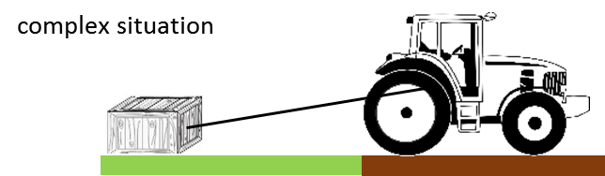

Fig. 1. A complex physical situation of a tractor pulling a crate across a paddock.

**Kinematics** is the branch of classical mechanics which describes the motion of objects without consideration of the masses of those objects nor the forces that may have caused the motion. We will use the example of the tractor and crate to develop the necessary scientific language to describe the motion.

In studying the motion of objects you need to use scientific terms carefully as the meaning of words used in Physics often have a different meaning to the way they are used in everyday speech.

The language you will learn can be used to describe the motion of galaxies, stars, planets, comets, satellites, rockets, golf balls, cars, microscopic objects, and so on. Principles, laws, theories and models will be given to help us understand the physical world surrounding us and to make predictions using mathematical models.

**MODELS AND REAL-LIFE SITUATIONS**

We will often develop simple models that are not necessarily good approximation to the real world but none the less can be quite useful. A physicist is a person who can take a complex situation and begins to understand its working by first creating a simple model which ignores many aspects of the real situation, but by doing this, they can start to develop an understanding of the situation.

In our tractor / crate example to simplify the situation we could make the following simplification and/or approximations:

* The mass of the rope connecting the tractor and crate can be ignored.
* The crate is pulled along a frictionless surface.
* A constant force is applied to the crate by the rope connecting the tractor to the crate.
* Ignore the physical dimensions of the crate and tractor and treat them as point particles.
* An object or sets of objects can be classified as a **System**. By identifying the System of interest and focussing our attention on the System makes it easy to apply the appropriate physical principles.

To improve your physics ability throughout this course it is essential that you learn how to visualise and simplify a physical situation. Often a starting point to answering an examination question is to draw a scientific but simple diagram of the physical situation. People who are good at physics do this automatically. Those that struggle with physics and think it is a “hard” subject do so because they can’t visualise and then draw an appropriate annotated diagram of the situation as part of their answer.

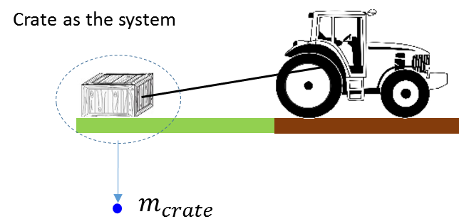

Fig. 2a. The System is the crate and is shown as a dot  in a scientific annotated diagram. To identify the System a circle is often drawn around the object or objects.

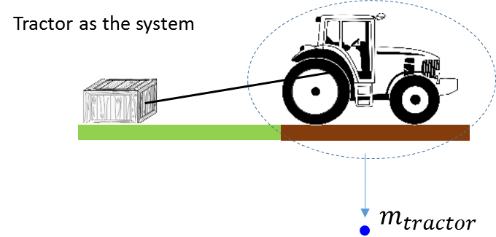

Fig. 2b. The System is the tractor and is shown as a dot  in a scientific annotated diagram.

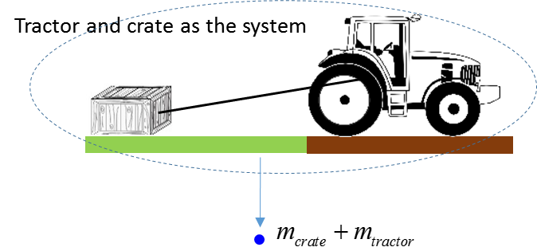

Fig. 2c. The System is the tractor and crate and is shown as a dot  in a scientific annotated diagram.

**PHYSICAL QUANTITIES**

Physical quantities like mass where a single number gives a measurement of the quantity and add together as simple numbers are called **scalar** quantities. Other examples of scalar quantities include time, temperature, volume, density, energy, work, power and electric charge.

Physical quantities that require for their complete specification a positive scalar quantity (**magnitude**) and a **direction** are called **vector quantities**. Examples of vector quantities include displacement, velocity, acceleration, force, momentum, electric fields and magnetic fields.

Physical quantities are represented by **symbols** and often the symbol contains a **subscript**. Subscript are usually numbers and / or letters but also words can also be used.

The symbol  can be used for the physical quantity and the subscript used to identify the System

Mass of tractor 

Mass of crate 

Mass of System (tractor and crate) 

****A vector quantity is written as a bold symbol or a small arrow above the symbol. Often a curved line draw under the symbol is used when the vector is hand written.

*It is most important that you develop the skill of using appropriate symbols with subscripts to identify physical quantities.*

**Events**

A useful idea in describing the motion of a System is to use the term **Event**. For example, to say that the System is located at position (*x*, *y*) at time *t* defines an **Event**.

Event 1: At 2:00 pm the tractor was at the northern end of the paddock. 

Event 2: At 5:00 pm the tractor was at the centre of the paddock. 

The symbol  gives the time, symbol  gives the X position of the tractor and gives  the Y position. The subscript identifies the instance (Event) when the measurements of the location of the tractor were made. So, subscripts are used to identify the System or Event. Double subscript maybe used to define a System and Event or the relative values and their interpretation depends upon the physical situation. When using double subscripts, you need to be very careful of their meaning

 position of tractor at point Q relative to the position P

 displacement of particle A at the time of Event 1

 displacement of particle A at the time of Event 2

 force of System B acting **on** System A

**Units**

A **unit** must always be attached to a physical quantity. You must know the [S.I. units](http://www.physics.usyd.edu.au/teach_res/hsp/u0/t0_433.pdf) for all physical quantities that you encounter during your Physics course. You should possess the necessary skills to change one set off units to another.

Physical quantities should be written in the following format

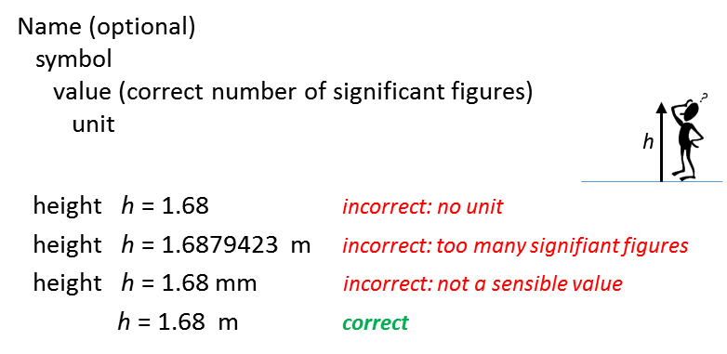

**Change of unit**

Convert 37.6 km.h-1 to ? m.s-1

1 km = 103 m 1 h = 3.6x103 s

1 km.h-1 = 103 / (3.6x103) m.s-1 = (1/3.6) m.s-1

37.6 km.h-1 = (37.6/3.6) m.s-1 = 10.4 m.s-1

**answer written to 3 significant figures**

**Scalar Quantities**

Physical quantities that require only a number and a unit for their complete specification are known as **scalar quantities**.

mass of Pat *mPat* = 75.2 kg

Pat’s temperature *TPat* = 37.4 oC

Pat’s height *hPat* = 1555 mm

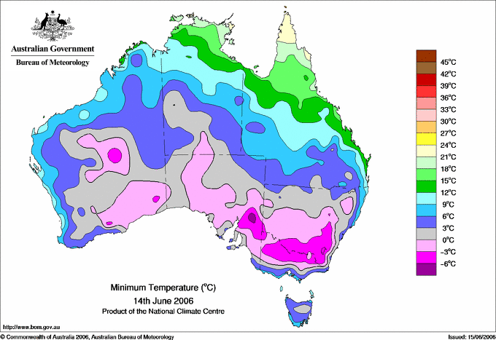

Fig. 3. Scalar temperature field. At each location, the temperature is specified by a number in oC.



Fig. 4. Scalar rainfall field. At each location, the rainfall is specified by a number in mm.

In physics, a **scalar field** is a region in space such that each point in the space a number can be assigned. Examples of scalar fields are shown in figures (3) and (4) for temperature and rainfall distributions in Australia respectively.

**FRAMES OF REFERENCE**

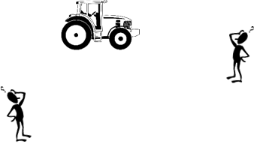What is the location of the tractor ? The answer depends upon the location of an observer. Position is a relative concept. The position of the tractor is different for the two observers.

Therefore, we need to set up a method of specifying the position of a System which is precise and unambiguous. We will consider a two-dimensional universe. The methods we will develop can easily be extended give the position of particles in our real three-dimensional world (in terms of modern physics, time and space are interwoven and a better model is to consider a four-dimensional world [] ).

To clearly specify the position of the tractor in the paddock we need to have a **frame of reference**. A frame of reference should include:

Image result for clip art person

Observer

Origin O(0, 0, 0) reference point

Cartesian coordinate axes (X, Y, Z)

Unit vectors 

Specify the units

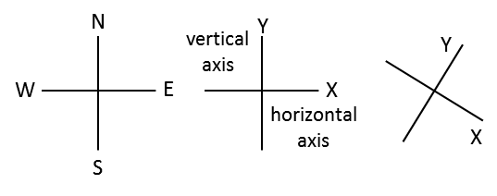

Fig. 5A. Three examples of [2D] Cartesian coordinate System.

The most useful frame of reference in three-dimensions is defined by three perpendicular lines and is referred to as a **Cartesian coordinate System** (figure 5).

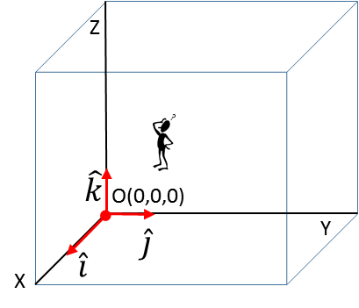

Fig. 5B. Cartesian coordinate System with X, Y and Z axes each perpendicular to each other. The direction of the Z axis is given by the direction of the thumb of the right hand when the fingers of the right hand are rotated from the X axis to Y axis.

The **unit vectors** , ,  give the directions along the Cartesian coordinate axes and allows us to specify a vector and its Cartesian components in a convenient format.

 gives the direction that the X coordinate is increasing (say i-hat)

 gives the direction that the Y coordinate is increasing (j-hat)

 gives the direction that the X coordinate is increasing (k-hat)

*The concept of unit vectors is not usually used at the high school level but using the notation of unit vectors in the “long run” improves your ability to have a better understanding of physical principles.*

**VECTORS magnitude direction components**

Physical quantities that require for their complete specification a positive scalar quantity (**magnitude**) and a **direction** are called **vector quantities**.

Today the wind at Sydney airport is



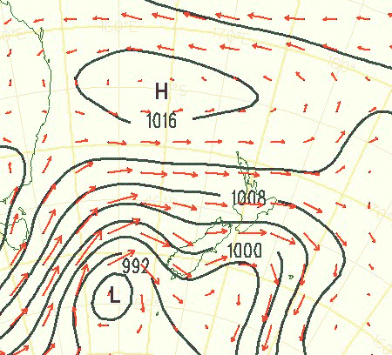

Fig. 6. A magnitude and direction is need to specify the wind. The black lines represent the pressure (scalar) and the red arrows the wind (vector). The length of an arrows is proportional to the magnitude of the wind and the direction of the arrow gives the wind direction.

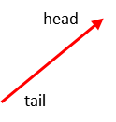A vector quantity can be visualized as a straight arrow. The length of the arrow being proportional to the magnitude and the direction of the arrow gives the direction of the vector.

****A vector quantity is written as a bold symbol or a small arrow above the symbol. Often a curved line draw under the symbol is used when the vector is hand written.

The [2D] vector  is specified in a frame of reference using an XY Cartesian coordinate by its

**Magnitude** (size)  positive scalar quantity

**Direction**   measured w.r.t. X axis 

or

**X component**  projection of vector onto X axis

**Y component**  projection of vector onto Y axis

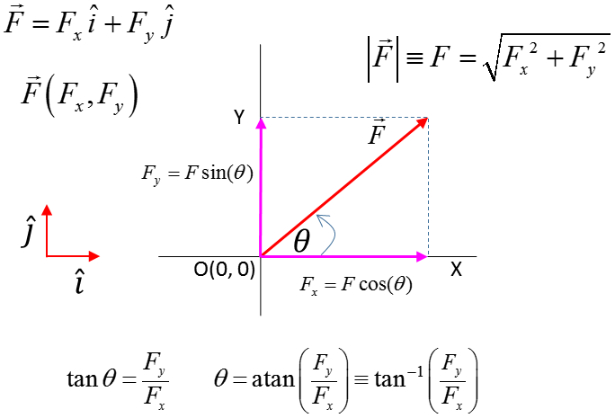

**Resolving a vector into its components**

A vector quantity can be **resolved** into **components** along each of the coordinate axes. To find the components of a vector draw a box around the vector and then draw the two Cartesian components as shown in figure (7).



Fig. 7. Resolving a vector into its X and Y components.

*N.B. The two Cartesian components replace the original vector. Avoid the mistake of many students who add the two components to the original vector, thus counting it twice.*

**Vector algebra**

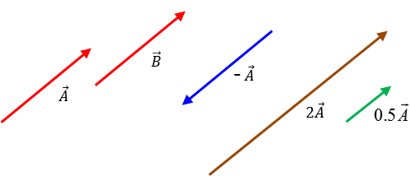

* Two vectors are **equal** if they have the same magnitude and small direction .
* The **negative** of any vector is a vector of the same magnitude and opposite in direction. The vectors  and  are antiparallel.
* **Multiplication of a vector by a scalar**  . The new vector has the same direction and a magnitude .
* **Vector addition**: vectors can be added using a scaled diagram where the vectors are added in a **tail-to-head method** or by adding the components. The sum of the vectors is called the **resultant vector**.

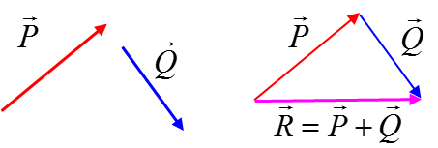



The vector  is the resultant vector.

* **Vector subtraction**: can be found by using the rule of vector addition



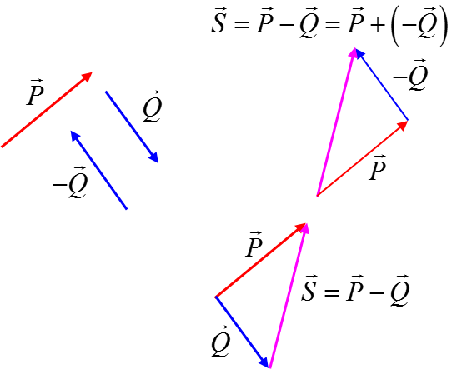

* Two vectors can’t be multiplied together like two scalar quantities. Only vectors of the same physical type can be added or subtracted. But vectors of different types can be combined through scalar multiplication (dot product) and vector multiplication (cross product).
* **Scalar product** or **dot product** of the vectors  and  is defined as



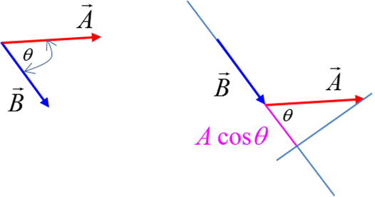

The projection or component of on the line containing  is . The angle between the two vectors is always a positive quantity and is always less than or equal to 180o. Thus, the scalar product can be either positive, negative or zero, depending on the angle between the two vectors .

The result of the scalar product is a scalar quantity. If two vectors are perpendicular to each other, then the scalar product is zero .

This is a wonderful test to see if two vectors are perpendicular to each other.

If the two vectors are in the same direction, then the scalar product is *A B* *.*

* The **vector product** or **cross product** of two vectors  and  is defined as



The magnitude of the vector  is .

The vector  is a unit vector which is perpendicular to both the vectors  and .

The angle between the two vectors is always less than or equal to 180o. The sine over this range of angles is never negative, hence the magnitude of the vector product is always positive or zero .

The direction of the vector product is perpendicular to both the vectors  and . The direction is given by the right hand screw rule. The thumb of the right hand gives the direction of the vector product as the fingers of the right hand rotate from along the direction of the vector  towards the direction of the vector.

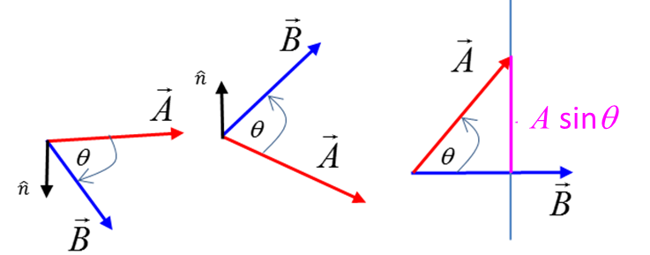

**VECTOR EQUATIONS**

Consider the motion of an object moving in a plane with a uniform acceleration in the time interval *t.* The physical quantities describing the motion are

Time interval  [s]

Displacement  [m]

Initial velocity  [m.s-1]

Final velocity  [m.s-1]

Acceleration  [m.s-2]

The equation describing the velocity as a function of time involves the vector addition of two vectors



The equation describing the displacement as a function of time involves the vector addition of two vectors



The velocity as a function of displacement.

**Warning:** the equation stated in the syllabus is totally incorrect

** this equation is absolute nonsense**

Two vectors can’t be multiplied together. The **correct** equation has to show the scalar product between two vectors



This equation should not be given in vector form but expressed as two separate equations, one for the X components and one for the Y components



**Work and the scalar product**

Consider a tractor pulling a crate across a surface as shown in figure (8).

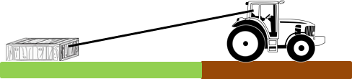

Fig. 8. A crate being pulled by a tractor.

We want to setup a simple model to consider the energy transferred to the crate by the tractor. In physics, to model a physical situation, one introduces a number of simplifications and approximations. So we will assume that the crate is pulled along a frictionless surface by a constant force acting along the rope joining the tractor and crate. We then draw an annotated scientific diagram of the situation showing our frame of reference. The crate becomes the System for our investigation and the System is drawn as a dot and the forces acting on the System are given by arrows as shown in figure (8).

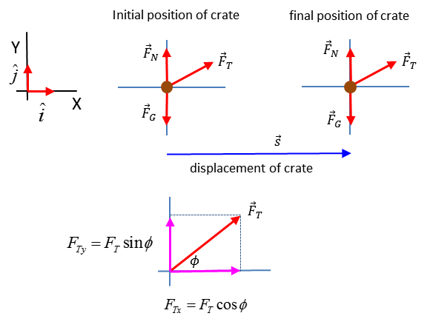

Fig. 9. The System is the cart (brown dot). The forces acting on the System are the force of gravity , the normal force  and the tension of the rope .

Energy is transferred to the System by the action of the forces doing work on the System. Work is often said to be equal to a force multiplied by a distance . This is a poor definition of work. A much better definition of the work done by a constant force causing an object to move along a straight line is to use the idea of scalar (dot) product

 work is a scalar quantity

where the angle  is the angle between the two vectors  and . The angle between the two vectors is always a positive quantity and is always less than or equal to 180o hence .

Work done by the gravitational force and by the normal force are zero because the angle between the force vectors and displacement vector is 90o (cos(90o) = 0).

The work done by the tension force is



hence, the work done on the System is the component of the force parallel to the displacement vector multiplied by the magnitude of the displacement.

The concept of the scalar product is not often used at the high school level, but, by being familiar with the concept of the scalar product you will have a much better understanding of the physics associated with motion.

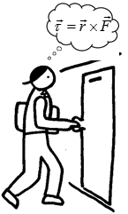**Torque and the vector product**

**What is the physics of opening a door?**

It is the torque applied to the door that is important and not the force.

A force can cause an object to move and a torque can cause an object to rotate. A torque is often thought of as a force multiplied by a distance. However, using the idea of the vector (cross) product we can precisely define what we mean by the concept of torque.

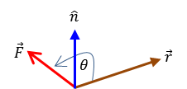



The vector is the torque applied, the vector is the lever arm distance from the pivot point to the point of application of the force . The angle is the angle between the vectors  and . The direction of the torque  is found by applying the right hand screw rule: the thumb points in the direction of the torque as you rotate the fingers of the right hand from along the line of the vector to the vector . The torque is perpendicular to both the position vector and the force .

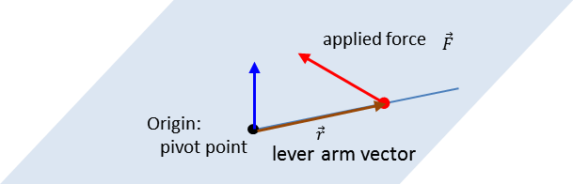

The concepts of unit vectors, scalar product and vector product are not covered in the Syllabus. However, having a more in-depth knowledge will help you in having a better understanding of Physics and will lead to a better performance in your HSC examination.

* **A vector has a magnitude and direction. You can’t associate a positive or negative number to a vector. Only the components of a vector are zero or positive or negative numbers.**
* **Scalars are not vectors and vectors are not scalars.**
* **In answering most questions on kinematics and dynamics you should draw an annotated diagram of the physical situation. Your diagram should show objects as dots; the Cartesian coordinate System, the Origin and observer; the values of given and implied physical quantities; a list unknown physical quantities physical; the units for all physical quantities; principles and equations.**