[**VISUAL PHYSICS ONLINE**](http://www.physics.usyd.edu.au/teach_res/hsp/sp/spHome.htm)

**KINEMATICS**

**DESCRIBING MOTION**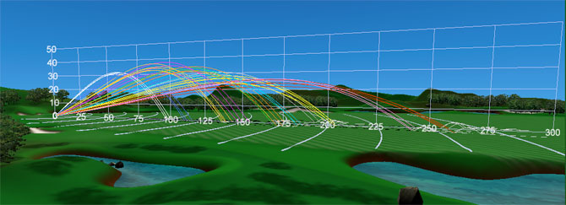

The language used to describe motion is called **kinematics**. Surprisingly, very few words are needed to fully the describe the motion of a System.

**Warning: words used in a scientific sense often have a different interpretation to the use of those words in everyday speech.**

The language needed to fully describe motion is outlined in Table 1.

In analysing the motion of an object or collection of objects, the first step you must take is to define your [frame of reference](http://www.physics.usyd.edu.au/teach_res/hsp/sp/mod1/m1_RefFrames.pdf).

**Frame of reference**

Observer

Origin O(0,0, 0) reference point

Cartesian coordinate axes (X, Y, Z)

Unit vectors 

Specify the units

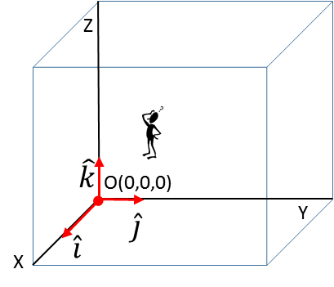

|  |  |  |  |  |
| --- | --- | --- | --- | --- |
| **Physical quantity** | **Symbol** | **Scalar**  **vector** | **S.I.**  **unit** | **Other units** |
| time |  | scalar: | second  s | minute  hour day  year |
| time interval |  | scalar: | second  s | minute  hour day  year |
| distance travelled |  | scalar: | metre  m | mm  km |
| displacement  (position vector) |  | vector | m | mm  km |
| average speed |  | scalar: | m.s-1 | km.h-1 |
| speed  (instantaneous) |  | scalar: | m.s-1 | km.h-1 |
| average velocity |  | vector | m.s-1 | km.h-1 |
| velocity  (instantaneous) |  | vector | m.s-1 | km.h-1 |
| average acceleration |  | vector | m.s-2 |  |
| acceleration  (instantaneous) |  | vector | m.s-2 |  |

Table1. Kinematics: terminology for the complete description of the motion of a System in a plane.

**POSITION DISTANCE DISPLACEMENT**

Consider two tractors moving about a paddock. To study their motion, the frame of reference is taken as a XY Cartesian Coordinate System with the Origin located at the centre of the paddock. The stationary observer is located at the centre of the paddock and the metre is the unit for a distance measurement. The positions of the tractors are given by their X and Y coordinates. Each tractor is represented by a dot and the tractors are identify using the letters A and B.

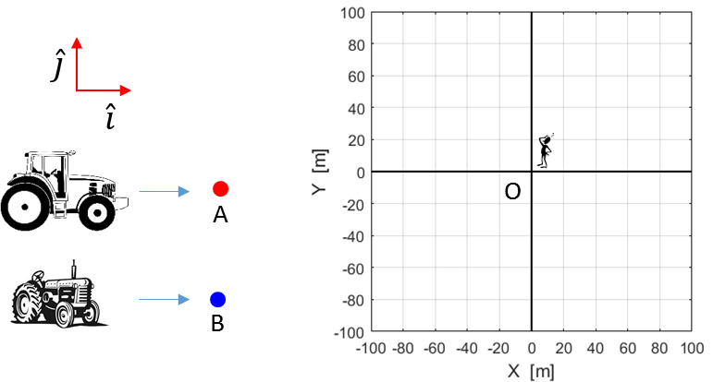

Fig. 1. Frame of reference used to analyse the motion of the two tractors in a plane.

Both tractors move from their initial position at the Origin O(0, 0) to their final position at (60, 80) as shown in figure (2). Tractor **A** follows the **red** path and tractor **B** follows the **blue** path. Event 1 corresponds to the initial instance of the tractor motion and Events 2 and 3 are the instances when the tractors each their final position.

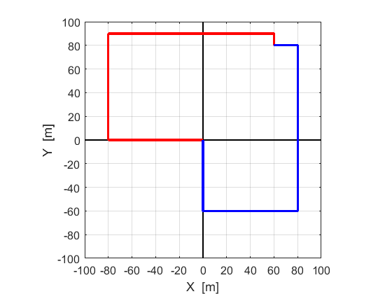

Fig. 2. **RED** path of tractor **A** and **BLUE** path of tractor **B**. Both tractors start at the Origin O(0, 0) and finish at the point (60 m, 80m).

Event 1  tractors A and B at their initial positions

Position of tractors

System A 

System B 

*N.B. The first subscript is used to identify the System and the second the time of the Event. Remember we are using a model – in our model it is possible for both tractors to occupy the same position at the same time.*

Event 2  tractor A arrives at its final position

System A 

Event 3  tractor B arrives at its final position

System B 

**Distance travelled**

Using figure (2), it is simple matter to calculate the distance  travelled by each tractor

System A 

System B 



**Displacement Position Vector**

The change in position of the tractors is called the **displacement**. The displacement only depends upon the initial position (Event 1) and final position (Events 2 and 3) of the System and not with any details of what paths were taken during the time interval between the two Events.

The displacement is represented by the position vector and is drawn as a straight arrow pointing from the initial to the final position as shown in figure (3).

The tractors start at the same position and finish at the same position, therefore, they must have the same displacement, even though they have travelled different distance in different time intervals.

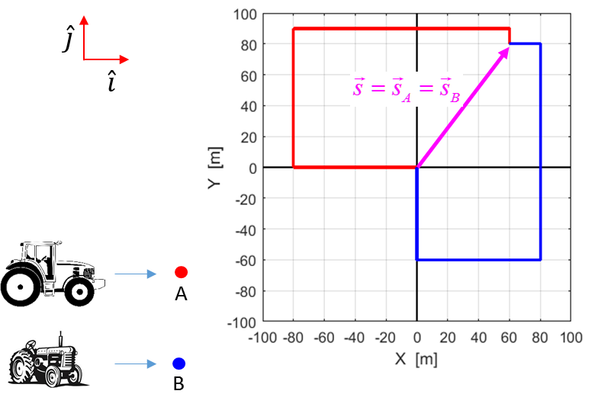

Fig. 3. The displacement of the tractors shown as a position vector.

From figure (3), it is obvious the values for the component of the position vector are

 

The magnitude of the displacement is



The direction of the displacement is given by the angle   that the position vector makes with the X axis



*N.B. The distance travelled (scalar) and the displacement (vector) are very different physical quantities.*

The displacement gives the change in position as a vector, hence we can write the displacements for System A and System B as



*Multiple subscripts look confusing, but, convince yourself that you can interpret the meaning of all the symbols. Once you get “your head around it”, using multiple subscript means that you can convey a lot of information very precisely.*

 X component of the displacement of System A at the time of Event 2.

**AVERAGE SPEED**

**AVERAGE VELOCITY**

“Time is a measure of movement” Aristotle (384 – 322 BC)

The time interval between Event 1 and Event 2 be given by 

  *is one symbol ‘delta t’*

In this time interval, the change in position is given by

distance travelled  *scalar*

displacement  *vector*

The definition of the **average speed** is

(1)  *scalar: zero or a positive constant*

The definition of **average velocity** is

(2)  *vector*

**Warning**: the magnitude of the average velocity is not necessarily equal to the average speed during the same time interval. The same symbol is used for average velocity and average speed hence you need to careful in distinguishing the two concepts.

The average speed and average velocity are different physical quantities.

From the information for the motion of the two trajectories of tractors A and B shown in figure (3), we can calculate the average speed and average velocities of each System.

**System A (tractor A) red path**

Time interval between Event 1 and Event 2



Distance travelled 

Displacement 



Using equations (1) and (2)

Average speed  *scalar*

Average velocity

vector / same direction as the displacement



 

Using the components of the average velocity

magnitude 

direction 

The average speed and average velocity are different physical quantities.

**System B (tractor B) blue path**

Time interval between Event 1 and Event 3



Distance travelled 

Displacement 





Using equations (1) and (2)

Average speed  *scalar*

Average velocity 

**INSTANTANEOUS SPEED INSTANTANEOUS VELOCITY**

On most occasions, we want to know more than just averages, we want details about the dynamic motion of a particle on an instant-by-instant basis.

The definition of average velocity is

(2)  *vector*

If we make the time interval smaller and smaller, the average velocity approaches the instantaneous value at that instant. Mathematically it is written as



This limit is one way of defining the derivative of a function. The **instantaneous velocity** is the time rate of change of the displacement

(3)  definition of instantaneous velocity

In terms of vector components for the displacement and velocity





(4) 

As the time interval approach zero , the distance travelled approaches the value for the magnitude of the displacement . Therefore, the magnitude of the instantaneous velocity is equal to the value of the instantaneous speed. This is **not** the case when referring to average values for the speed and velocity.

**When you refer to the speed or velocity it means you are talking about the instantaneous values. Therefore, on most occasions you can omit the word instantaneous, but you can’t omit the term average when talking about average speed or average velocity.**

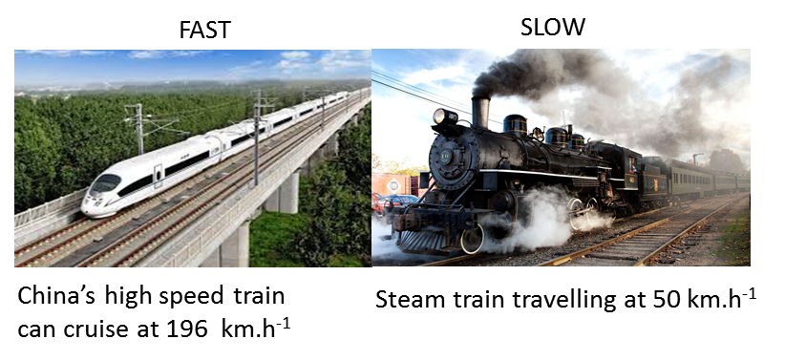

**ACCELERATION**

An acceleration occurs when there is a change in velocity with time.

* Object speeds up
* Object slows down
* Object change’s its direction of motion

The **average acceleration** of an object is defined in terms of the change in velocity and the interval for the change

(6)  definition of average velocity

The **instantaneous acceleration** (**acceleration**) is the time rate of change of the velocity, i.e., the derivative of the velocity gives the acceleration (equation 7).

(7)  definition of instantaneous acceleration

In terms of vector components for the velocity and acceleration





(4) 

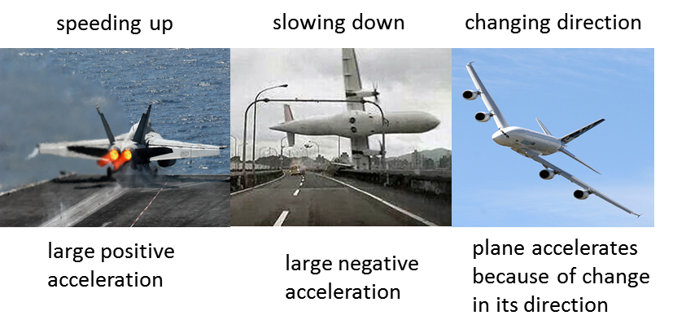

[VISUAL PHYSICS ONLINE](http://www.physics.usyd.edu.au/teach_res/hsp/sp/spHome.htm)

If you have any feedback, comments, suggestions or corrections please email:

Ian Cooper School of Physics University of Sydney

ian.cooper@sydney.edu.au