[**VISUAL PHYSICS ONLINE**](http://www.physics.usyd.edu.au/teach_res/hsp/sp/spHome.htm)

**THE LANGUAGE OF PHYSICS**

**KINEMATICS**



The objects that make up space are in motion, we move, soccer balls move, the Earth moves, electrons move, . . . . Motion implies change. The description of the motion of objects is called **kinematics**. Since the beginning of “human time” the study of the motions of the heavens has been important.

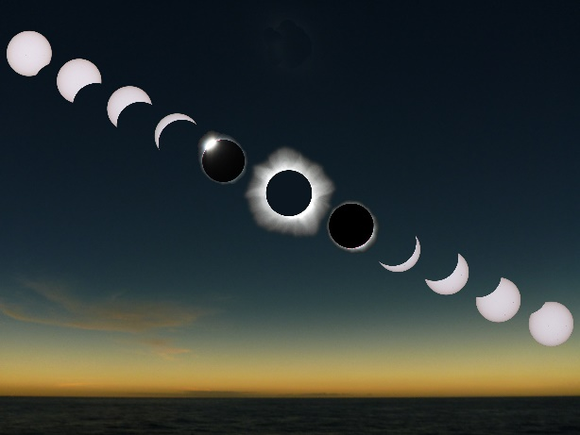People who had knowledge of the motion of the heavens had power and control over others because they knew about the seasons, eclipses and could make **predictions**. In ancient cultures, people were very frightened during solar and moon eclipses.

Developing theories about the motion of the Sun and planets was very frustrating. Many religions had the Earth at the centre of the Universe. For presenting views opposing the Earth centred Universe one could be burnt alive at the stake.

Developing a consistent theory of motion was difficult. Physical theories are not just discovered, they are creations of the human mind and must be invented and not discovered. It is claimed that the **study of physics** is man’s greatest intellectual achievement. Physics is a creative process and physicists build on the best of the past to create new visions of the future.

A significant time for science was when **Nicholas Copernicus** (1473 – 1543) concluded from experimental data on the motion of the planets, that the Earth revolved around the Sun. **Johannes Kepler** (1571 – 1630) could decipher accurately and precisely the paths of the planets and produced mathematical laws accounting for the motion of the planets around the Sun.

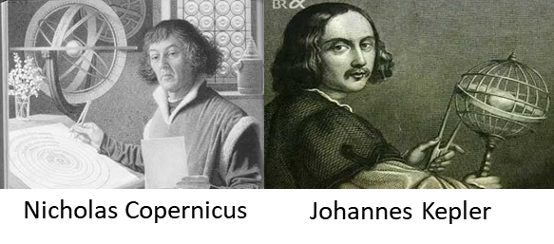

The work of **Galileo Galilei** (1564 – 1642) produced a dramatic change in the way science was to be done. Galileo’s ideas overturned the Aristotelian view of the world that had persisted for more than 2000 years. Galileo’s genius was that he realized that the world can be described through mathematics and that experimentation and measurement were crucial elements in developing scientific theories where approximation was necessary to limit complexity.

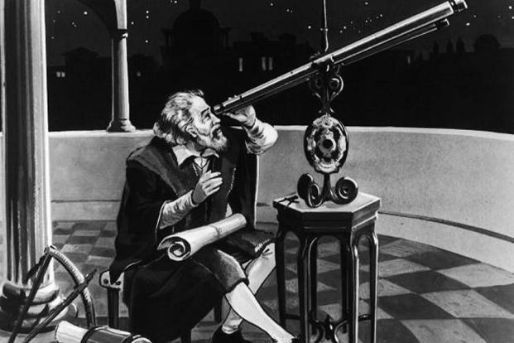

Following on from Galileo was Isaac Newton (1642 – 1727), who developed the underlying theory of the causes of motion (**dynamics**). He published one of the most famous books of science in 1686, *Principia*.

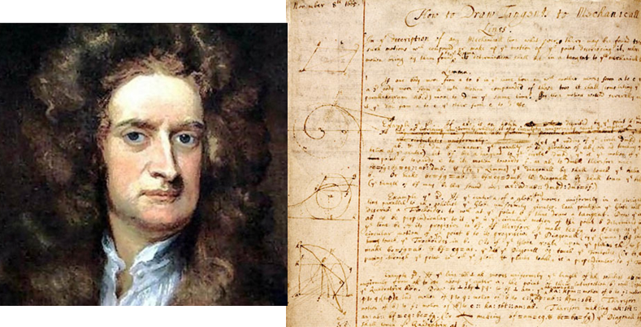

|  |
| --- |
| **WEB ACTIVITY / DISCUSSIONS**  Use the **web** to find out more about: Aristotle, Copernicus, Kepler, Galileo and Newton.  **Group discussion**: Why did people such as priests who had scientific knowledge of the seasons and astronomy have control over the bulk of the population in their societies?  **Group discussion**: In the period from the 15th century to the 19th century in Western Europe there was a dramatic change in social, cultural and technological aspects for people but this did not occur in China, which at the beginning of the 15th century could be considered to be more “advanced” socially, culturally and technologically than Europe. Explain why the “no change” in China compared with the scientific and technological developments that occurred in Western Europe in this 400 year period. |

Consider the physical situation of a tractor pulling a crate across a paddock as shown in figure 1.



Fig. 1. A complex physical situation of a tractor pulling a crate across a paddock.

**Kinematics** is the branch of classical mechanics which describes the motion of objects without consideration of the masses of those objects nor the forces that may have caused the motion. We will use the example of the tractor and crate to develop the necessary scientific language to describe its motion.

In studying the motion of objects, you need to use scientific terms carefully as the meaning of words used in Physics often has a different meaning to the way they are used in everyday speech.

The language you will learn can be used to describe the motion of galaxies, stars, planets, comets, satellites, rockets, golf balls, cars, microscopic objects, and so on. Principles, laws, theories and models will be given to help us understand the physical world surrounding us and to make predictions using mathematical models.

**MODELS AND REAL-LIFE SITUATIONS**

We will often develop simple models that are not necessarily a good approximation to the real world but none the less can be quite useful. A physicist is a person who can take a complex situation and begin to understand its working by first creating a simple model which ignores many aspects of the real situation, but by doing this, they can start to develop an understanding of the situation.

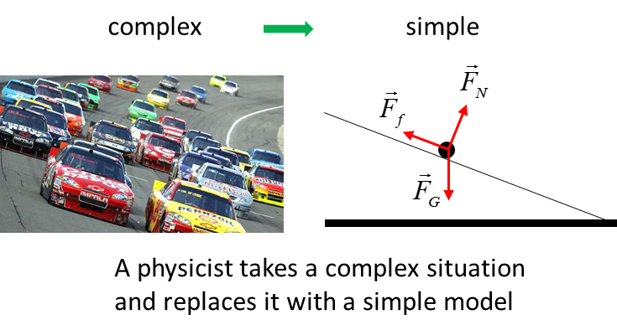

In our tractor / crate example to simplify the situation we could make the following simplification and/or approximations:

* The mass of the rope connecting the tractor and crate can be ignored.
* The crate is pulled along a frictionless surface.
* A constant force is applied to the crate by the rope connecting the tractor to the crate.
* Ignore the physical dimensions of the crate and tractor and treat them as point particles.
* An object or sets of objects can be classified as a **System**. Identifying the System of interest and focusing our attention on the System makes it easy to apply the appropriate physical principles.

To improve your physics ability throughout this course it is essential that you learn how to visualise and simplify a physical situation. Often a starting point to answering an examination question is to draw a scientific but simple diagram of the physical situation. People who are good at physics do this automatically. Those that struggle with physics and think it is a “hard” subject do so because they can’t visualise and then draw an appropriate annotated diagram of the situation as part of their answer.

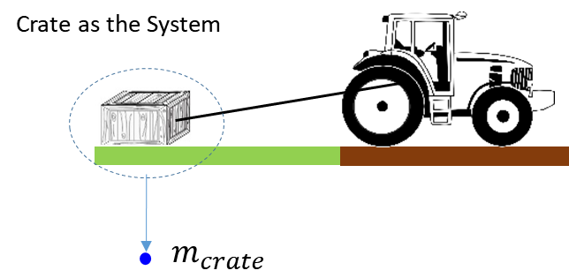

Fig. 2A. The System is the crate and is shown as a dot  in a scientific annotated diagram. To identify the System a circle is often drawn around the object or objects.

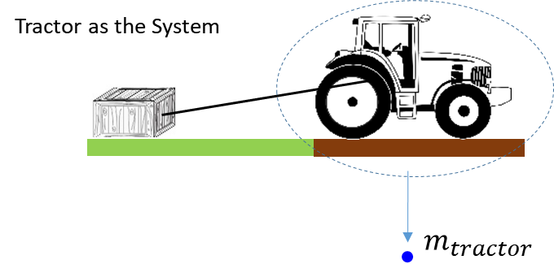

Fig. 2B. The System is the tractor and is shown as a dot  in a scientific annotated diagram.

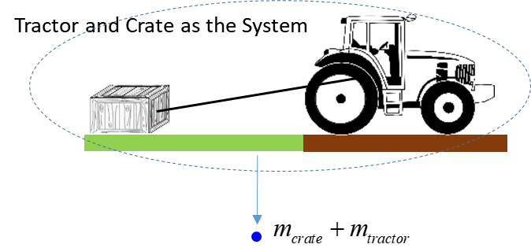

Fig. 2C. The System is the tractor and crate and is shown as a dot  in a scientific annotated diagram.

**PHYSICAL QUANTITIES**

Physical quantities like mass where a single number gives a measurement of the quantity and add together as simple numbers are called **scalar** quantities. Other examples of scalar quantities include time, temperature, volume, density, energy, work, power and electric charge.

Physical quantities that require for their complete specification a positive scalar quantity (**magnitude**) and a **direction** are called **vector quantities**. Examples of vector quantities include displacement, velocity, acceleration, force, momentum, electric fields and magnetic fields.

Physical quantities are represented by **symbols** and often the symbol contains a **subscript**. Subscripts are usually numbers and / or letters but also words can be used.

The symbol  can be used for the physical quantity and the subscript used to identify the System

Mass of tractor 

Mass of crate 

Mass of System (tractor and crate) 

****A **vector quantity** is written as a bold symbol or a small arrow above the symbol. Often a curved line draw under the symbol is used when the vector is hand written.

*It is most important that you develop the skill of using appropriate symbols with subscripts to identify physical quantities.*

**Events**

A useful idea in describing the motion of a System is to use the term **Event**. For example, to say that the System is located at position (*x*, *y*) at time *t* defines an **Event**.

Event 1: At 2:00 pm the tractor was at the northern end of the paddock. 

Event 2: At 5:00 pm the tractor was at the centre of the paddock. 

The symbol  gives the time, symbol  gives the X position of the tractor and gives  the Y position. The subscript identifies the instance (Event) when the measurements of the location of the tractor were made. So, subscripts are used to identify the System or Event. Double subscript may be used to define a System and Event or the relative values and their interpretation depend upon the physical situation. When using double subscripts, you need to be very careful of their meaning

 position of tractor at point Q relative to the position P

 displacement of particle A at the time of Event 1

 displacement of particle A at the time of Event 2

 force of System B acting **on** System A

**Units**

A **unit** must always be attached to a physical quantity. You must know the [S.I. units](http://www.physics.usyd.edu.au/teach_res/hsp/sp/mod0/spSIunits.pdf) for all physical quantities that you encounter during your Physics course. You should possess the necessary skills to change one set of units to another.

Physical quantities should be written in the following format

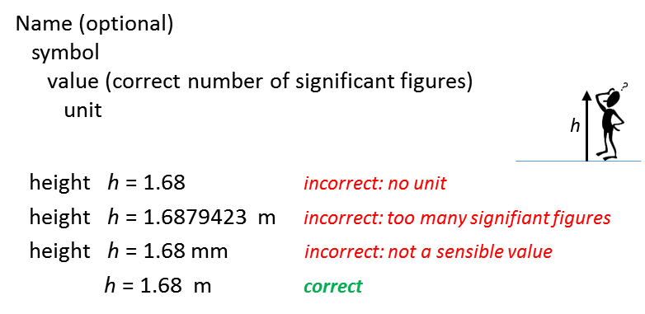

[Review: Significant Figures](http://www.physics.usyd.edu.au/teach_res/hsp/sp/mod0/spSF.pdf)

**Change of unit**

Convert 37.6 km.h-1 to ? m.s-1

1 km = 103 m 1 h = 3.6x103 s

1 km.h-1 = 103 / (3.6x103) m.s-1 = (1/3.6) m.s-1

37.6 km.h-1 = (37.6/3.6) m.s-1 = 10.4 m.s-1

**answer written to 3 significant figures**

[Review: Change of Unit](http://www.physics.usyd.edu.au/teach_res/hsp/sp/mod0/spRearrangeEquations.pdf)

You should watch a Korean historical drama (YouTube)

[Jang Youngil](https://www.youtube.com/watch?v=TOqMGpiR8RQ)

The drama is about the life of a real 15th century scientist, Jang Youngsil (Jang Yeong-Sil). The drama gives an excellent account of the conflicts between science, technology, politics, society, superstition, and culture. The “rich” could control the “poor” by keeping them ignorant and uneducated. It is well worth your while to watch the many episodes taking note of the struggles of scientists and people who had independent thoughts from the ruling classes. The drama goes a long way to explain why there were very few scientific and technological advanced in the eastern cultures since the 15th century until the intervention of the western powers in the 19th century.

[VISUAL PHYSICS ONLINE](http://www.physics.usyd.edu.au/teach_res/hsp/sp/spHome.htm)

If you have any feedback, comments, suggestions or corrections please email:

Ian Cooper School of Physics University of Sydney

ian.cooper@sydney.edu.au