[**VISUAL PHYSICS ONLINE**](http://www.physics.usyd.edu.au/teach_res/hsp/sp/spHome.htm)

**RECTLINEAR MOTION:**

**UNIFORM ACCELERATION**



|  |
| --- |
| **Predict Observe Explain Exercise 1**  Take an A4 sheet of paper and a heavy object (cricket ball, basketball, brick, book, etc). **Predict** what will happen when you drop to the two objects simultaneously. Describe the motion in terms of displacement, velocity and acceleration. **Observe** what happens when you drop the two objects simultaneously. Crumple the paper into a small ball and again drop the two objects. **Explain** – compare your predictions with your observations and explain any discrepancies.  **Predict Observe Explain Exercise 2**  Think about throwing a ball vertically into the air and then catching it. **Predict** the shapes of the curves for displacement, velocity and acceleration vs time graphs. Observe carefully the motion of the ball in flight. Explain - compare your predictions with your observations and explain any discrepancies.  Record your POE exercises so that you can refer to them later, after studying the motion of an object moving with a constant acceleration. It is important to complete these exercises before reading ahead. |

The simplest example of accelerated motion in a straight line occurs when the acceleration is **constant** (**uniform**). When an object falls freely due to gravity and if we ignore the effects of air resistance to a good approximation the object falls with a constant acceleration. A simple model to account for the starting and stopping of a car is to assume its acceleration is uniform. Police investigators use basic physical principles related to motion when they investigate traffic accidents and falls. They often model the event by assuming the motion occurred with a constant acceleration in a straight line

To start our study of rectilinear motion with a constant (uniform) acceleration we need a frame of reference and the object to be represented as a particle. Since the motion is confined to the movement along a straight line we take a coordinate axis along this line. For horizontal motion (e.g. car travelling along a straight road) the X axis is used and for vertical motion (free-fall motion) the Y axis is sometimes used. It is therefore convenient to present the vector nature of the displacement, velocity and acceleration as positive and negative numbers. We will take the Origin of our reference frame to coincide with the initial position of the object (this is not always done, in many books the initial location is not at the )rigin).

[GOTO a Simulation - Workshop on the motion of an object moving with a constant acceleration](http://www.physics.usyd.edu.au/teach_res/hsp/sim/sim5_001.pdf)

The initial state of the particle for motion along the X axis is described by the parameters

acceleration  constant (does not depend on time)

initial time 

initial displacement from origin 

initial velocity  or 

The final state of the particle after a time interval *t* is described by the parameters

acceleration 

final time (time interval for motion) 

final displacement from origin 

final velocity 



Fig. 1. A particle at time  is located at the origin  and at this instant it has a velocity  or . After a time interval , the particle is at position  and at this instant its velocity is .

The sign convention to give the direction for the vector nature is summarised in the table:

|  |  |  |
| --- | --- | --- |
| acceleration | **+**  → +x direction | **⎯**  ← –x direction |
| displacement | **+**  position: right of origin | **⎯**  position: left of origin |
| velocity | **+**  moving in + x direction | **⎯**  moving in –x direction |

The instantaneous acceleration is defined to be the time rate of change of the velocity and is given by equation (1)

(1) 

For the special case of rectilinear motion with constant acceleration, the acceleration is

(2) 

The acceleration corresponds to the slope of the tangent to the velocity vs time graph. If the acceleration is constant at all instants, then the velocity vs time graph must be a **straight line**. You know that the equation for a straight line is usually written as  where  is the slope of the line and  is the intercept.

For our velocity vs time straight line graph

   

Therefore, the straight line describing the rectilinear motion with constant acceleration is given by equation (3)

(3)  variables:  and 

constants:  and 

The intercept at  corresponds to the initial velocity  or  and the slope of the straight line  is the acceleration  of the particle as shown in figure (2).



Fig. 2. The velocity vs time graph for the rectilinear motion of a particle with constant acceleration where  and.

Figure (3) show six velocity vs time graphs with different accelerations and initial velocities. The motion of the particle is also represented by **motion maps** which indicate the direction of the acceleration vector (blue arrow) and a series of arrows representing the velocity vectors (red arrows). In answering questions on kinematics, it is a good idea to include a motion map to help visualise the physical situation and improve your understanding of the physics.

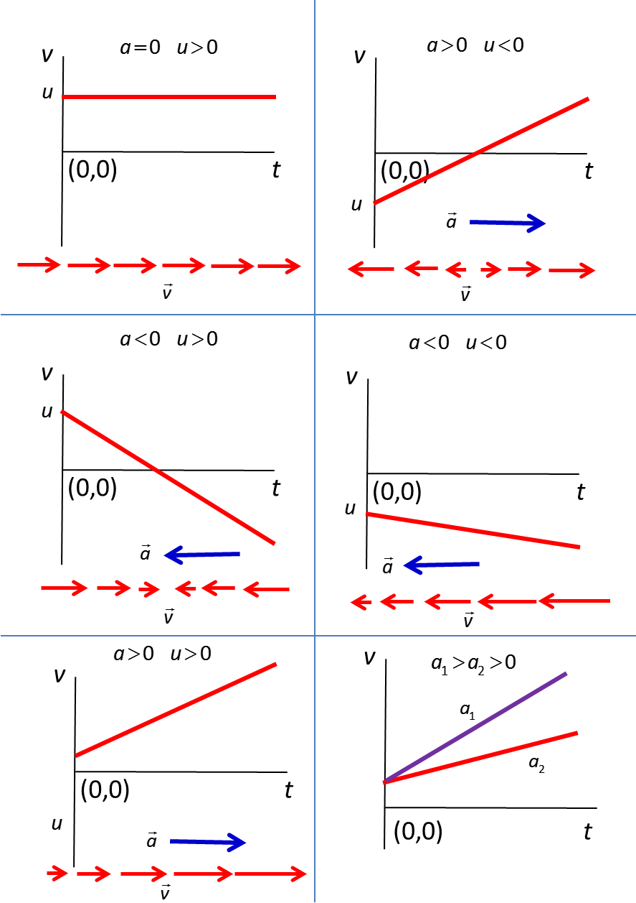

Fig. 3. Velocity vs time graphs for the rectilinear motion of a particle with different accelerations *a* and initial velocities. Motion maps show the change in velocity and direction for the acceleration.

The area under a velocity vs time graph is equal to the change in displacement in that time interval. For constant acceleration, the area under the curve is equal to the area of a triangle plus the area of a rectangle as shown in figure (4).



Fig. 4. The area under a velocity vs time graph is equal to the change in displacement. For the case when the acceleration is constant the area corresponds to the area of a rectangle plus a triangle.

area of rectangle = 

area of triangle = 

displacement =area of rectangle + area of triangle

 using equation (3)



(4)  

Equation (4) can also be derived algebraically. For any kind of motion, the displacement of the particle from the origin is given by the product of its average velocity and the time interval 

(5) 

For uniform acceleration motion along a straight line, the average velocity is equal to the arithmetic mean of the initial and final velocities

(6) 

Eliminating the average velocity from these two equations results in a derivation of equation (4)





(4)  constant acceleration

Equations (3), (4) and (5) all contain the time interval *t*. We can eliminate *t* from these equations to give another useful equation for uniform acceleration.



From equations (3), (5) & (6)

(7) 

The displacement *s*  as a function of time *t* which is given by equation (4) is a **parabolic function** involving two contributions: (1) a displacement due to the initial velocity , and (2) a displacement due to the change in speed with time  as shown in figure (5).

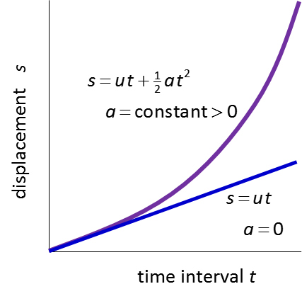

Fig. 5. For the case of constant acceleration, the *s* vt *t* graph is a parabola.

A good approximation for a freely falling particle is that the acceleration is constant. This acceleration is known as the **acceleration due to gravity** *g.* The value of *g* depends upon the position of measurement – its latitude, rocks on the Earth’s surface and distance above sea level. We will take the value of *g* to three significant figures as

 positive constant

**In this simple model, all objects irrespective of their mass, free fall with an acceleration equal to the acceleration due to gravity, *g*.**

Remember that displacement, velocity and acceleration are vector quantities. The direction of the vector along a coordinate axis is expressed as a positive or negative number. For rectilinear kinematics problems, it is absolutely necessary to specify a frame of reference (Coordinate axis and Origin) to make sure that the correct sign is given to the displacement, velocity and acceleration.

**Summary: Motion of a particle moving with a constant acceleration**



(3) 

(4) 

(7) 

(6) 

(5) 

***s* vs *t* graph**

is a parabola

slope = velocity

***v* vs *t* graph**

is a straight line

slope = acceleration (constant)

area under graph = change in displacement

***a* vs *t* graph**

area under graph = change in velocity

All kinematics problems and questions can be answered using this information.

|  |
| --- |
| **EXAMPLE 1**  A cricket ball is projected vertically from the top of a building from a position 40.0 m above the ground below. Consider the three cases:   1. The ball leaves the hand from rest. 2. The ball is projected vertically downward at 12.5 m.s-1. 3. The ball is projected vertically upward at 12.5 m.s-1.   For cases (a), (b) and (c)   1. What are the velocities of the ball after it has been falling for 1.23 s? 2. What are the positions of the ball after it has been falling for 1.23 s? 3. What are the velocities of the ball as it strikes the ground? 4. What are the times of flights for the ball to reach the ground?   For case (c) only   1. What is the time it takes to reach its maximum height? 2. What is the maximum height above the ground reached by the ball? 3. What is the time for the ball to return to the point at which it was thrown? 4. What is the velocity of the ball as it returns to the position at which it was thrown?   **Solution 1**  ***How-to-approach the problem***  ***Identify / Setup***  Draw a sketch of the situations. Include motion maps.  Show the frame of reference (coordinate axis & origin).  State the type (category) of the problem.  Write down all the equations that might be relevant.  Write down all the given and know information including units.  Write down all the unknown quantities including their units.  ***Execute / Evaluate***  Use the equations to find the unknowns.  Check that your answers are sensible, significant figures, units and that you have documented your answer with comments and statements of physical principles.  The problem type is free fall – uniformly accelerated motion in the vertical Y direction:  *a* = -*g* = -9.81 m.s-2 and the displacement *s* corresponds to the changes in the vertical position of the ball.  We can solve the problem using the equations  (1)  (2)  (3)  (4)  (5)  **Case (a)**    Initial state: *t* = 0 *s* = 0 *u* = 0 *a = -g* = -9.81 m.s-2  Final state when *t* = 1.23 s: *s* = ? m *v* = ? m.s-1  Eq(1)  Eq(2)  Final state when *s* = -40.0 m (as ball strikes ground): *v* = ? m.s-1 *t* = ? s  Eq(3)  Eq(1)  **Case (b)**    Initial state: *t* = 0 *s* = 0 *u* = -12.5 m.s-1 *g* = 9.81 m.s-2  Final state when *t* = 1.23 s *s* = ? m *v* = ? m  Eq(1)  Eq(2)  Final state when *s* = -40.0 m (as ball strikes ground): *v* = ? m.s-1 *t* = ? s  Eq(3)  Eq(1)  **Case (c)**    Initial state: *t* = 0 *s* = 0 *u* = +12.5 m.s-1 *g* = 9.81 m.s-2  Final state when *t* = 1.23 s: *s* = ? m *v* = ? m  Eq(1)  Eq(2)  Final state when *s* = -40.0 m (as ball strikes ground): *v* = ? m.s-1 *t* = ? s  Eq(3)  Eq(1)  When the ball is thrown upwards it will slows down as it rises, stops, reverse direction and then falls. At the instant when the ball reaches its maximum height its velocity is zero (the acceleration of the ball is still *a* = -g =-9.81 m.s-2).  Initial state: *t* = 0 *s* = 0 *u* = +12.5 m.s-1 *a* = -*g* = 9.81 m.s-2  Final state when *v* = 0: *t* = ? s *s* = ? m  Eq(1)  Eq(2)    **Comments**   * + Numbers are given to 3 significant figures for convenience. Rounding of numbers may give slightly different answers.   + Note: numbers multiplied together are enclosed in brackets – do not use the multiplication sign (x).   + Units are included after numbers.   + In cases (c) the ball has the same velocity just before it hits the ground as in case (b) because the ball returns to the origin after its upward flight with the same magnitude for its velocity as it was projected upwards. |

**SIMULATIONS using MS EXCEL**

Download the MS EXCEL file

[a_uniform.xls](http://www.physics.usyd.edu.au/teach_res/excel/)

Figure (6) shows the graphical output for a simulation.



Fig. 6. Graphical output from the simulation on uniform acceleration for an objected projected vertically with an initial velocity of 12 m.s-1 (up is the positive direction).

Use the simulation on uniform acceleration to check all the answers to **Example 1.** The simulation can be used to solve most numerical problems on uniform acceleration.

Use the simulation and these notes to review your answers to the **Predict Observe Exercises 1 and 2**.

**Exercise** [m1FreeFall](http://www.physics.usyd.edu.au/teach_res/hsp/sp/mod1/m1FreeFall.htm)

[VISUAL PHYSICS ONLINE](http://www.physics.usyd.edu.au/teach_res/hsp/sp/spHome.htm)

If you have any feedback, comments, suggestions or corrections please email:

Ian Cooper School of Physics University of Sydney

ian.cooper@sydney.edu.au